Node type dc2.large

Number of nodes 2

redshift-cluster-rna.csvpwdknrhzd.ap-south-1.redshift.amazonaws.com:5439/dev

jdbc:redshift://redshift-cluster-rna.csvpwdknrhzd.ap-south-1.redshift.amazonaws.com:5439/dev

Driver={Amazon Redshift (x64)}; Server=redshift-cluster-rna.csvpwdknrhzd.ap-south-1.redshift.amazonaws.com; Database=dev

Onder PROPERTIES

Database name dev

Port 5439

Admin user name awsuser

Scroll door naar beneden…

| **Node role** | **Public IP address** | **Private IP address** |
| --- | --- | --- |
| Compute-0 | 3.109.147.236 | 10.102.0.142 |
| Compute-1 | 65.2.87.70 | 10.102.0.113 |
| Leader | 13.233.41.108 | 10.102.0.176 |

SUBNETS

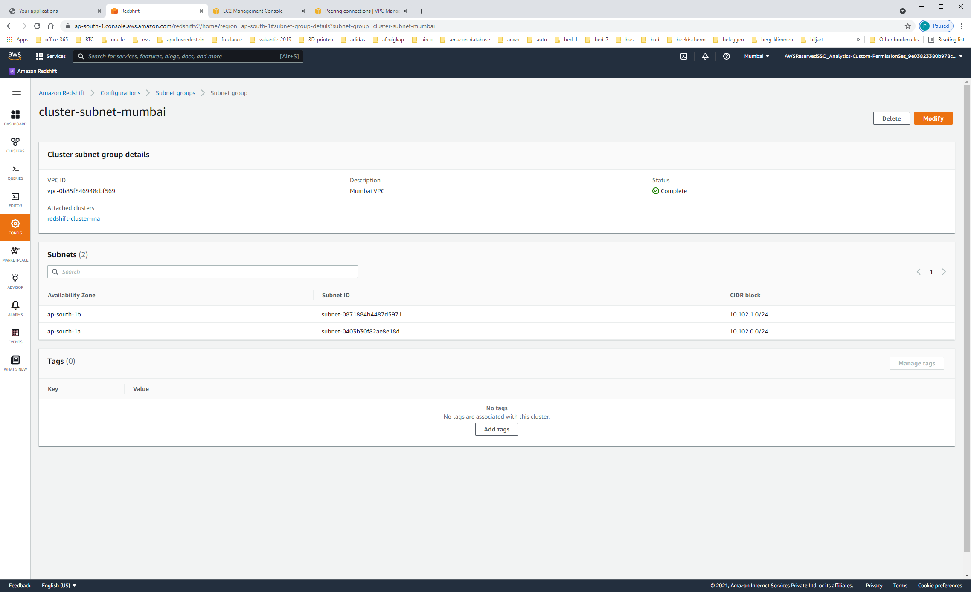

| **Availability Zone** | **Subnet ID** | **CIDR block** |
| --- | --- | --- |
| ap-south-1b | subnet-0871884b4487d5971 | 10.102.1.0/24 |
| ap-south-1a | subnet-0403b30f82ae8e18d | 10.102.0.0/24 |

Vragen we vanuit VPC-DASHBOARD alle SUBNETS op:

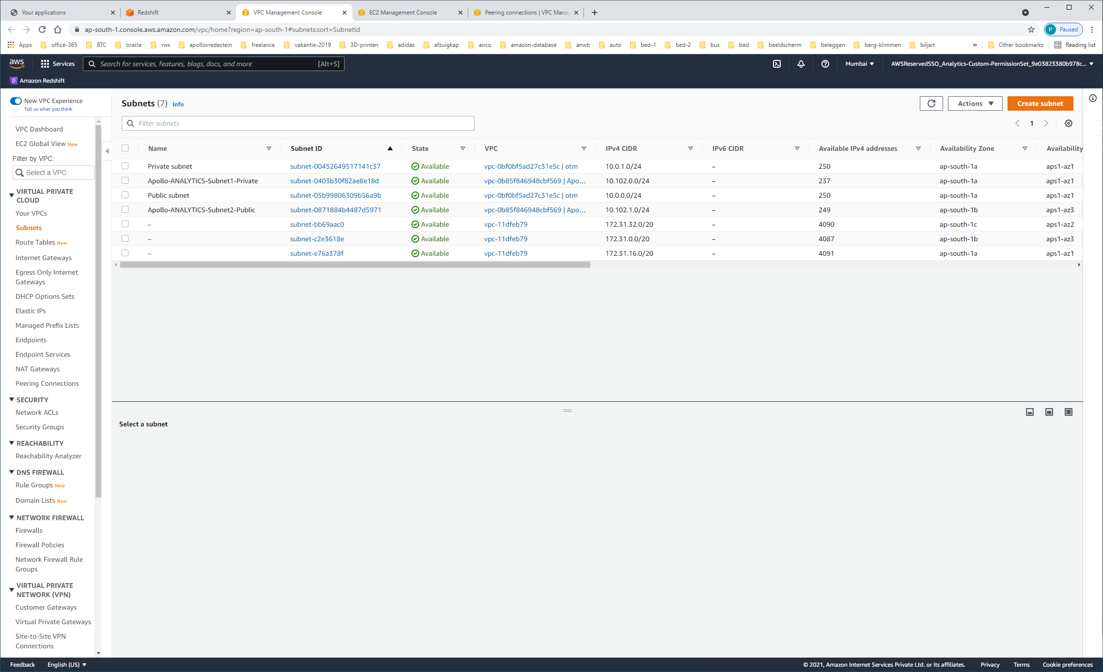

|  |  |  |  |  |
| --- | --- | --- | --- | --- |
| Private subnet | [subnet-00452649517141c37](https://ap-south-1.console.aws.amazon.com/vpc/home?region=ap-south-1#SubnetDetails:subnetId=subnet-00452649517141c37) | Available | [vpc-0bf0bf5ad27c31e5c | otm](https://ap-south-1.console.aws.amazon.com/vpc/home?region=ap-south-1#vpcs:VpcId=vpc-0bf0bf5ad27c31e5c) | 10.0.1.0/24 |
| Apollo-ANALYTICS-Subnet1-Private | [subnet-0403b30f82ae8e18d](https://ap-south-1.console.aws.amazon.com/vpc/home?region=ap-south-1#SubnetDetails:subnetId=subnet-0403b30f82ae8e18d) | Available | [vpc-0b85f846948cbf569 | Apollo-ANALYTICS-VPC-Mumbai](https://ap-south-1.console.aws.amazon.com/vpc/home?region=ap-south-1#vpcs:VpcId=vpc-0b85f846948cbf569) | 10.102.0.0/24 |
| Public subnet | [subnet-05b99806309b56a9b](https://ap-south-1.console.aws.amazon.com/vpc/home?region=ap-south-1#SubnetDetails:subnetId=subnet-05b99806309b56a9b) | Available | [vpc-0bf0bf5ad27c31e5c | otm](https://ap-south-1.console.aws.amazon.com/vpc/home?region=ap-south-1#vpcs:VpcId=vpc-0bf0bf5ad27c31e5c) | 10.0.0.0/24 |
| Apollo-ANALYTICS-Subnet2-Public | [subnet-0871884b4487d5971](https://ap-south-1.console.aws.amazon.com/vpc/home?region=ap-south-1#SubnetDetails:subnetId=subnet-0871884b4487d5971) | Available | [vpc-0b85f846948cbf569 | Apollo-ANALYTICS-VPC-Mumbai](https://ap-south-1.console.aws.amazon.com/vpc/home?region=ap-south-1#vpcs:VpcId=vpc-0b85f846948cbf569) | 10.102.1.0/24 |
| – | [subnet-bb69aac0](https://ap-south-1.console.aws.amazon.com/vpc/home?region=ap-south-1#SubnetDetails:subnetId=subnet-bb69aac0) | Available | [vpc-11dfeb79](https://ap-south-1.console.aws.amazon.com/vpc/home?region=ap-south-1#vpcs:VpcId=vpc-11dfeb79) | 172.31.32.0/20 |
| – | [subnet-c2e3618e](https://ap-south-1.console.aws.amazon.com/vpc/home?region=ap-south-1#SubnetDetails:subnetId=subnet-c2e3618e) | Available | [vpc-11dfeb79](https://ap-south-1.console.aws.amazon.com/vpc/home?region=ap-south-1#vpcs:VpcId=vpc-11dfeb79) | 172.31.0.0/20 |
| – | [subnet-e76a378f](https://ap-south-1.console.aws.amazon.com/vpc/home?region=ap-south-1#SubnetDetails:subnetId=subnet-e76a378f) | Available | [vpc-11dfeb79](https://ap-south-1.console.aws.amazon.com/vpc/home?region=ap-south-1#vpcs:VpcId=vpc-11dfeb79) | 172.31.16.0/20 |

|  |  |
| --- | --- |
| 691959165503 | ATL AWS Root |

Ga via PROPERTIES naar VPC / SECURITY-GROUPS

https://ap-south-1.console.aws.amazon.com/vpc/home?region=ap-south-1#RouteTables:routeTableId=rtb-098276a2fae67f9b0

VPC: [vpc-0b85f846948cbf569](https://ap-south-1.console.aws.amazon.com/vpc/home?region=ap-south-1#vpcs:VpcId=vpc-0b85f846948cbf569)

https://ap-south-1.console.aws.amazon.com/vpc/home?region=ap-south-1#vpcs:VpcId=vpc-0b85f846948cbf569

Ipv4: 10.102.0.0/18

De MAIN-ROUTE-table

| **Destination** | **Target** | **Status** | **Propagated** |
| --- | --- | --- | --- |
| 10.102.0.0/18 | local | Active | No |
| 0.0.0.0/0 | tgw-0309b459256261ebb | Active | No |
| [pl-78a54011](https://ap-south-1.console.aws.amazon.com/vpc/home?region=ap-south-1#ManagedPrefixLists:PrefixListId=pl-78a54011) | [vpce-0742c340f1a592e2a](https://ap-south-1.console.aws.amazon.com/vpc/home?region=ap-south-1#Endpoints:vpcEndpointId=vpce-0742c340f1a592e2a) | Active | No |

Subnets

https://ap-south-1.console.aws.amazon.com/vpc/home?region=ap-south-1#igws:

INTERNET-GATEWAYS

| **Internet gateway ID** | **State** | | | **VPC ID** | **Owner** | |
| --- | --- | --- | --- | --- | --- | --- |
| [igw-0fc21a6a16654e382](https://ap-south-1.console.aws.amazon.com/vpc/home?region=ap-south-1#InternetGateway:internetGatewayId=igw-0fc21a6a16654e382) | | Attached | [vpc-0bf0bf5ad27c31e5c | otm](https://ap-south-1.console.aws.amazon.com/vpc/home?region=ap-south-1#vpcs:VpcId=vpc-0bf0bf5ad27c31e5c) | | | 691959165503 | |
| [igw-3a995852](https://ap-south-1.console.aws.amazon.com/vpc/home?region=ap-south-1#InternetGateway:internetGatewayId=igw-3a995852) | | Attached | [vpc-11dfeb79](https://ap-south-1.console.aws.amazon.com/vpc/home?region=ap-south-1#vpcs:VpcId=vpc-11dfeb79) | | | 691959165503 | |

ELASTIC-IP's

Allocated IPv4 address 35.154.38.148

Type Public IP

Allocation ID eipalloc-0e90bae464089c0ac

Reverse DNS record –

Association ID eipassoc-096758827d6672fc3

Scope VPC

Associated instance ID –

Private IP address 10.0.0.22

Network interface ID [eni-056ccc6ec67e77d64](https://ap-south-1.console.aws.amazon.com/ec2/v2/home#NIC:networkInterfaceId=eni-056ccc6ec67e77d64)

Network interface owner account ID 691959165503

Public DNS ec2-35-154-38-148.ap-south-1.compute.amazonaws.com

NAT Gateway ID [nat-04f47d43b4f295b7d](https://ap-south-1.console.aws.amazon.com/vpc/home#NatGateways:natGatewayId=nat-04f47d43b4f295b7d)

ENDPOINTS

|  |  |
| --- | --- |
| **Endpoint ID**  vpce-0742c340f1a592e2a | **VPC ID**  [vpc-0b85f846948cbf569 | Apollo-ANALYTICS-VPC-Mumbai](https://ap-south-1.console.aws.amazon.com/vpc/home?region=ap-south-1#vpcs:filter=vpc-0b85f846948cbf569) |
| **Status**  available | **Status message** |
| **Creation time**  August 31, 2021 at 7:29:17 PM UTC+2 | **Service name**  com.amazonaws.ap-south-1.s3 |
| **Endpoint type**  Gateway |  |

NAT-GATEWAY

NAT gateway ID nat-04f47d43b4f295b7d

Elastic IP address [35.154.38.148](https://ap-south-1.console.aws.amazon.com/vpc/home?region=ap-south-1#Addresses:public-ip=35.154.38.148)

Subnet [subnet-05b99806309b56a9b / Public subnet](https://ap-south-1.console.aws.amazon.com/vpc/home?region=ap-south-1#subnets:SubnetId=subnet-05b99806309b56a9b)

Connectivity type Public

Private IP address [10.0.0.22](https://ap-south-1.console.aws.amazon.com/vpc/home?region=ap-south-1#Addresses:private-ip-address=10.0.0.22)

REACHABILITY-ANALYZER

[nip-0997caba1d1ae2925](https://ap-south-1.console.aws.amazon.com/vpc/home?region=ap-south-1#NetworkPath:pathId=nip-0997caba1d1ae2925)

tgw-0309b459256261ebb

TRANSIT-GATEWAY

[tgw-0309b459256261ebb](https://ap-south-1.console.aws.amazon.com/vpc/home?region=ap-south-1#TransitGatewayDetails:transitGatewayId=tgw-0309b459256261ebb)

VPC-PEERING-CONNECTION

