https://explore.skillbuilder.aws/learn/course/134/play/31418/aws-cloud-practitioner-essentials-all-modules

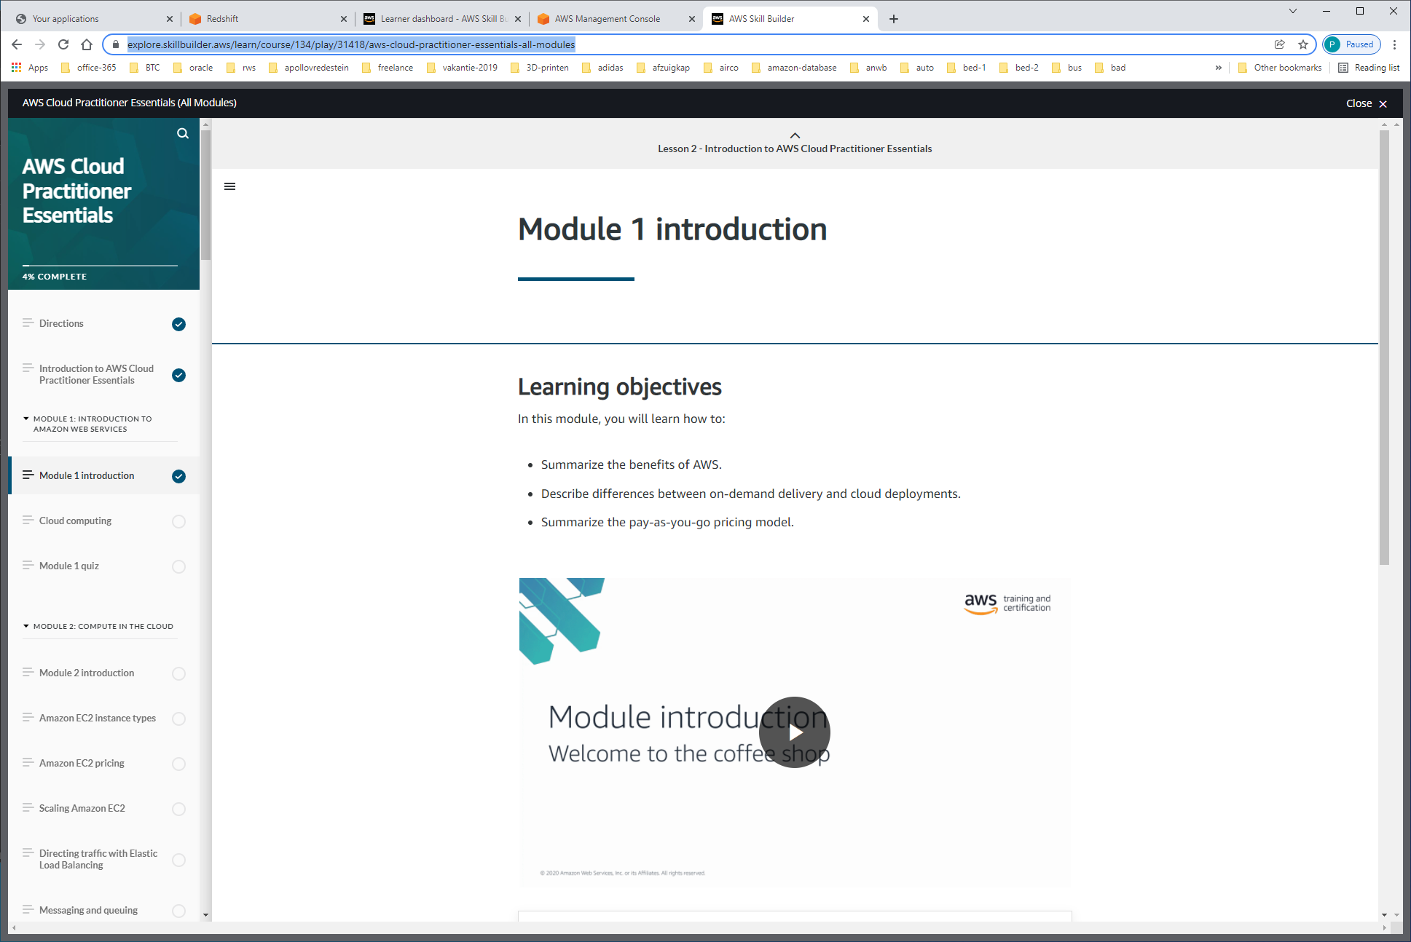

Benefits AWS:

-only pay for what you use

-don't have to worry about capacity constraints

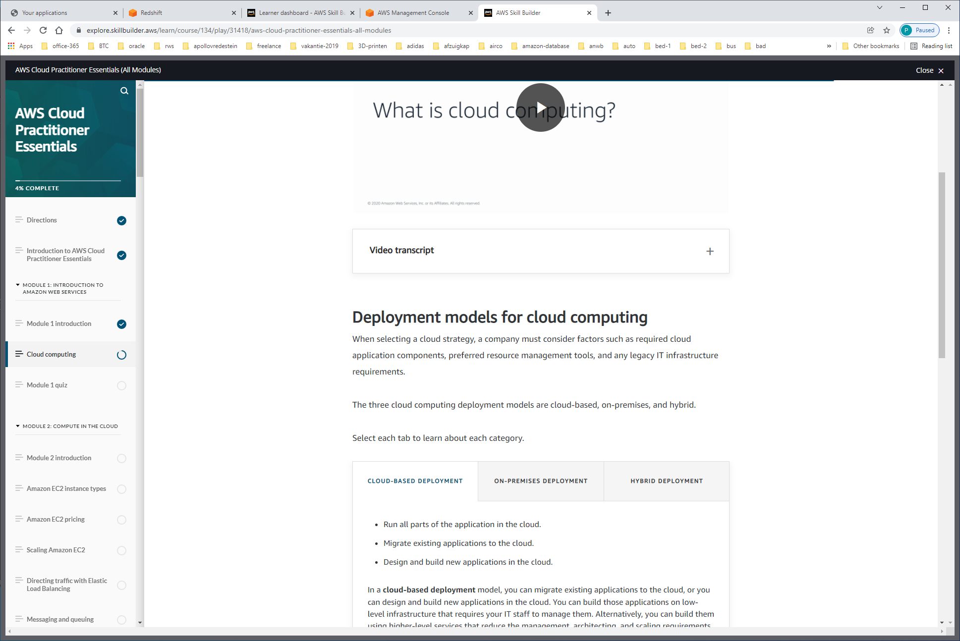

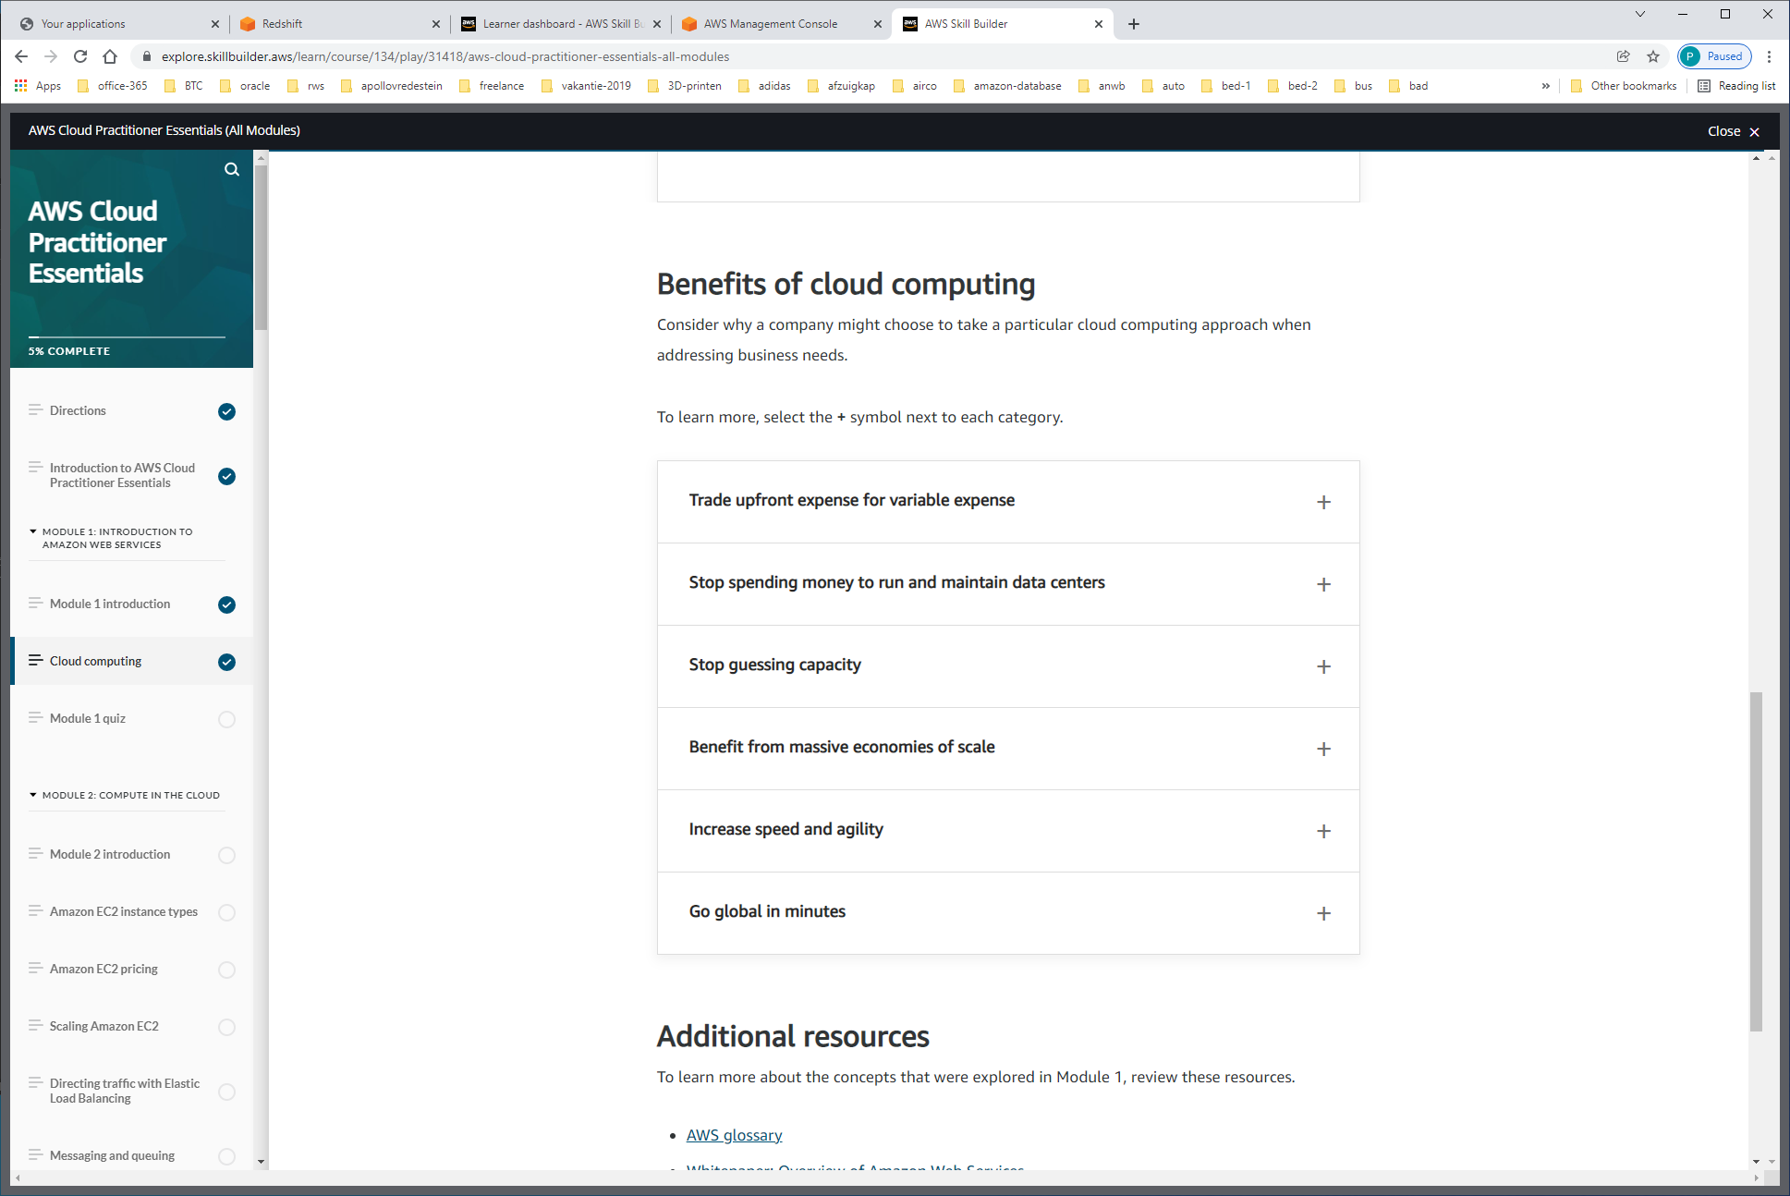

Benefits of cloud computing

1)Trade upfront expense for variable expense

Upfront expense refers to data centers, physical servers, and other resources that you would need to invest in before using them. Variable expense means you only pay for computing resources you consume instead of investing heavily in data centers and servers before you know how you’re going to use them.

2)Stop spending money to run and maintain data centers

Computing in data centers often requires you to spend more money and time managing infrastructure and servers.

A benefit of cloud computing is the ability to focus less on these tasks and more on your applications and customers.

3)Stop guessing capacity

With cloud computing, you don’t have to predict how much infrastructure capacity you will need before deploying an application.

4)Benefit from massive economics of scale

By using cloud computing, you can achieve a lower variable cost than you can get on your own. Because usage from hundreds of thousands of customers can aggregate in the cloud, providers, such as AWS, can achieve higher economies of scale. The economy of scale translates into lower pay-as-you-go prices.

5)Increase speed and agility

The flexibility of cloud computing makes it easier for you to develop and deploy applications. This flexibility provides you with more time to experiment and innovate. When computing in data centers, it may take weeks to obtain new resources that you need. By comparison, cloud computing enables you to access new resources within minutes.

6)Go global in minutes

The global footprint of the AWS Cloud enables you to deploy applications to customers around the world quickly, while providing them with low latency. This means that even if you are located in a different part of the world than your customers, customers are able to access your applications with minimal delays

