[https://aws.amazon.com/training/events/?get-certified-vilt-courses-cards.sort-by=item.additionalFields.startDateSort&get-certified-vilt-courses-cards.sort-order=asc&awsf.get-certified-vilt-courses-type=*all&awsf.get-certified-vilt-courses-series=*all&awsf.get-certified-vilt-audience=*all&awsf.get-certified-vilt-locations=*all&awsf.get-certified-vilt-countries=location%23india&awsf.get-certified-vilt-languages=*all&awsf.get-certified-vilt-courses-level=*all&awsf.get-certified-vilt-courses-tech-category=*all](https://aws.amazon.com/training/events/?get-certified-vilt-courses-cards.sort-by=item.additionalFields.startDateSort&get-certified-vilt-courses-cards.sort-order=asc&awsf.get-certified-vilt-courses-type=*all&awsf.get-certified-vilt-courses-series=*all&awsf.get-certified-vilt-audience=*all&awsf.get-certified-vilt-locations=*all&awsf.get-certified-vilt-countries=location%23india&awsf.get-certified-vilt-languages=*all&awsf.get-certified-vilt-courses-level=*all&awsf.get-certified-vilt-courses-tech-category=*all)

OF via mail AWS

|  |  |  |  |  |
| --- | --- | --- | --- | --- |
| |  |  |  |  | | --- | --- | --- | --- | |  |  | AWS Essentials |  | |
| |  |  |  |  |  |  |  |  |  |  | | --- | --- | --- | --- | --- | --- | --- | --- | --- | --- | | |  | | --- | | Oct 8 | 1:00 PM - 6:00 PM IST **AWS Cloud Practitioner Essentials Day** | | |  | | --- | | [**Register now**](https://4hs3rzdz.r.us-east-1.awstrack.me/L0/https:%2F%2Fpages.awscloud.com%2FTRAINCERT-APAC-alwayson-event-OE-cpe-20211008-reg-event.html%3Fsc_channel=el%26sc_campaign=traincert_apjc_alwayson_apac_fy21_q3_tclever_fle_el%26sc_geo=apac%26sc_country=mult%26sc_outcome=reg%26trkCampaign=apacfy21traincertalwaysonsfdc%26trk=alwayslearning2021_sfdc_em/1/0100017c11593b3f-8d81ea0d-679e-4e56-a902-fe8f66bbd2ba-000000/4rwTK7-O3_sL0Ad-Uib0UDdKwJ0=237) | | |  |  |  |  |  |  |  | | --- | --- | --- | --- | --- | | |  | | --- | | Oct 29 | 1:00 PM - 6:00 PM IST **AWS Cloud Practitioner Essentials Day** | | |  | | --- | | [**Register now**](https://4hs3rzdz.r.us-east-1.awstrack.me/L0/https:%2F%2Fpages.awscloud.com%2FTRAINCERT-APAC-alwayson-event-OE-cpe-20211029-reg-event.html%3Fsc_channel=el%26sc_campaign=traincert_apjc_alwayson_apac_fy21_q3_tclever_fle_el%26sc_geo=apac%26sc_country=mult%26sc_outcome=reg%26trkCampaign=apacfy21traincertalwaysonsfdc%26trk=alwayslearning2021_sfdc_em/1/0100017c11593b3f-8d81ea0d-679e-4e56-a902-fe8f66bbd2ba-000000/gsOu8lX9ZHYbZgIzQ--jrBqKAkU=237) | | |  | | | |
| |  |  |  | | --- | --- | --- | |  | Big Data & Machine Learning |  | |
| |  |  |  |  |  |  |  |  |  |  | | --- | --- | --- | --- | --- | --- | --- | --- | --- | --- | | |  | | --- | | Oct 11 | 10:00 AM - 11:30 AM IST **Machine Learning Basics** | | |  | | --- | | [**Register now**](https://4hs3rzdz.r.us-east-1.awstrack.me/L0/https:%2F%2Fpages.awscloud.com%2FTRAINCERT-APAC-alwayson-event-OE-ml-basics-20211011-reg-event.html%3Fsc_channel=el%26sc_campaign=traincert_apjc_alwayson_apac_fy21_q3_tclever_fle_el%26sc_geo=apac%26sc_country=mult%26sc_outcome=reg%26trkCampaign=apacfy21traincertalwaysonsfdc%26trk=alwayslearning2021_sfdc_em/1/0100017c11593b3f-8d81ea0d-679e-4e56-a902-fe8f66bbd2ba-000000/CoTf7-YZrWqy6GhF8jlGFfqkc0Y=237) | | |  |  |  |  |  |  |  | | --- | --- | --- | --- | --- | | |  | | --- | | Oct 29 | 10:00 AM - 11:30 AM IST **Big Data & Machine Learning** | | |  | | --- | | [**Register now**](https://4hs3rzdz.r.us-east-1.awstrack.me/L0/https:%2F%2Fpages.awscloud.com%2FTRAINCERT-APAC-alwayson-event-OE-big-data-20211029-reg-event.html%3Fsc_channel=el%26sc_campaign=traincert_apjc_alwayson_apac_fy21_q3_tclever_fle_el%26sc_geo=apac%26sc_country=mult%26sc_outcome=reg%26trkCampaign=apacfy21traincertalwaysonsfdc%26trk=alwayslearning2021_sfdc_em/1/0100017c11593b3f-8d81ea0d-679e-4e56-a902-fe8f66bbd2ba-000000/GPpVnZEwQObvnAz4sbS-ASiQjug=237) | | |  | | | |
| |  |  |  | | --- | --- | --- | |  | Developer Readiness |  | |
| |  |  |  |  |  |  |  |  |  |  | | --- | --- | --- | --- | --- | --- | --- | --- | --- | --- | | |  | | --- | | Oct 8 | 10:00 AM - 11:30 AM IST **Amazon DynamoDB for Serverless Architectures** | | |  | | --- | | [**Register now**](https://4hs3rzdz.r.us-east-1.awstrack.me/L0/https:%2F%2Fpages.awscloud.com%2FTRAINCERT-APAC-alwayson-event-OE-dynamodb-20211008-reg-event.html%3Fsc_channel=el%26sc_campaign=traincert_apjc_alwayson_apac_fy21_q3_tclever_fle_el%26sc_geo=apac%26sc_country=mult%26sc_outcome=reg%26trkCampaign=apacfy21traincertalwaysonsfdc%26trk=alwayslearning2021_sfdc_em/1/0100017c11593b3f-8d81ea0d-679e-4e56-a902-fe8f66bbd2ba-000000/igcjSwPsAITqLo105OGxfrK5H4o=237) | | |  |  |  |  |  |  |  | | --- | --- | --- | --- | --- | | |  | | --- | | Oct 11 | 3:00 PM - 4:30 PM IST **Amazon Elastic Kubernetes Service (EKS) Primer** | | |  | | --- | | [**Register now**](https://4hs3rzdz.r.us-east-1.awstrack.me/L0/https:%2F%2Fpages.awscloud.com%2FTRAINCERT-APAC-alwayson-event-OE-eks-20211011-reg-event.html%3Fsc_channel=el%26sc_campaign=traincert_apjc_alwayson_apac_fy21_q3_tclever_fle_el%26sc_geo=apac%26sc_country=mult%26sc_outcome=reg%26trkCampaign=apacfy21traincertalwaysonsfdc%26trk=alwayslearning2021_sfdc_em/1/0100017c11593b3f-8d81ea0d-679e-4e56-a902-fe8f66bbd2ba-000000/sJUS6Homxyao4Y1SqYlkSZmid-U=237) | | |  | | | |
| |  |  |  |  |  |  |  |  |  |  | | --- | --- | --- | --- | --- | --- | --- | --- | --- | --- | | |  | | --- | | Oct 11 | 3:00 PM - 4:30 PM IST **Securing your AWS Cloud** | | |  | | --- | | [**Register now**](https://4hs3rzdz.r.us-east-1.awstrack.me/L0/https:%2F%2Fpages.awscloud.com%2FTRAINCERT-APAC-alwayson-event-OE-security-20211011-reg-event.html%3Fsc_channel=el%26sc_campaign=traincert_apjc_alwayson_apac_fy21_q3_tclever_fle_el%26sc_geo=apac%26sc_country=mult%26sc_outcome=reg%26trkCampaign=apacfy21traincertalwaysonsfdc%26trk=alwayslearning2021_sfdc_em/1/0100017c11593b3f-8d81ea0d-679e-4e56-a902-fe8f66bbd2ba-000000/AnyKJguooyxhmHJiN_L3xcD-zXM=237) | | |  |  |  |  |  |  |  | | --- | --- | --- | --- | --- | | |  | | --- | | Oct 18 | 10:00 AM - 11:30 AM IST **Introduction to Containers** | | |  | | --- | | [**Register now**](https://4hs3rzdz.r.us-east-1.awstrack.me/L0/https:%2F%2Fpages.awscloud.com%2FTRAINCERT-APAC-alwayson-event-OE-containers-20211018-reg-event.html%3Fsc_channel=el%26sc_campaign=traincert_apjc_alwayson_apac_fy21_q3_tclever_fle_el%26sc_geo=apac%26sc_country=mult%26sc_outcome=reg%26trkCampaign=apacfy21traincertalwaysonsfdc%26trk=alwayslearning2021_sfdc_em/1/0100017c11593b3f-8d81ea0d-679e-4e56-a902-fe8f66bbd2ba-000000/u1e0sYhG6v4Y-74ERxd9HOFdmqg=237) | | |  | | | |
| |  |  |  |  |  |  | | --- | --- | --- | --- | --- | --- | | |  |  |  |  |  | | --- | --- | --- | --- | --- | | |  | | --- | | Oct 18 | 3:00 PM - 4:30 PM IST **Building Modern Applications on AWS** | | |  | | --- | | [**Register now**](https://4hs3rzdz.r.us-east-1.awstrack.me/L0/https:%2F%2Fpages.awscloud.com%2FTRAINCERT-APAC-alwayson-event-OE-modern-20211018-reg-event.html%3Fsc_channel=el%26sc_campaign=traincert_apjc_alwayson_apac_fy21_q3_tclever_fle_el%26sc_geo=apac%26sc_country=mult%26sc_outcome=reg%26trkCampaign=apacfy21traincertalwaysonsfdc%26trk=alwayslearning2021_sfdc_em/1/0100017c11593b3f-8d81ea0d-679e-4e56-a902-fe8f66bbd2ba-000000/44ZEPtEHEH0o4QWfl_lBg2FTOAY=237) | | |  | | | |
| |  |  |  | | --- | --- | --- | |  | Exam Readiness |  | |
| |  |  |  |  |  |  |  |  |  |  | | --- | --- | --- | --- | --- | --- | --- | --- | --- | --- | | |  | | --- | | Oct 8 | 9:00 AM - 10:00 AM IST **AWS Certified Cloud Practitioner** | | |  | | --- | | [**Register now**](https://4hs3rzdz.r.us-east-1.awstrack.me/L0/https:%2F%2Fpages.awscloud.com%2FGLOBAL_TRAINCERT_T1_get-certified-cp-apjc-en_20211008_7014z000000rQ0h_RegPage.html%3Fsc_channel=el%26sc_campaign=traincert_apjc_alwayson_apac_fy21_q3_tclever_fle_el%26sc_geo=apac%26sc_country=mult%26sc_outcome=reg%26trkCampaign=apacfy21traincertalwaysonsfdc%26trk=alwayslearning2021_sfdc_em/1/0100017c11593b3f-8d81ea0d-679e-4e56-a902-fe8f66bbd2ba-000000/7LV2ETCJZ2kDn3cY-IaCHnY6MBw=237) | | |  |  |  |  |  |  |  | | --- | --- | --- | --- | --- | | |  | | --- | | Oct 8 | 2:00 PM - 4:30 PM IST **AWS Certified Developer - Associate** | | |  | | --- | | [**Register now**](https://4hs3rzdz.r.us-east-1.awstrack.me/L0/https:%2F%2Fpages.awscloud.com%2FGLOBAL_TRAINCERT_T1_get-certified-cda-apjc-in_20211008_7014z000000rPzUAAU_RegPage.html%3Fsc_channel=el%26sc_campaign=traincert_apjc_alwayson_apac_fy21_q3_tclever_fle_el%26sc_geo=apac%26sc_country=mult%26sc_outcome=reg%26trkCampaign=apacfy21traincertalwaysonsfdc%26trk=alwayslearning2021_sfdc_em/1/0100017c11593b3f-8d81ea0d-679e-4e56-a902-fe8f66bbd2ba-000000/QNoQZgOqc-p9uSnJ1zGF0K21RPc=237) | | |  | | | |
| |  |  |  |  |  |  |  |  |  |  | | --- | --- | --- | --- | --- | --- | --- | --- | --- | --- | | |  | | --- | | Oct 11 | 9:00 AM - 11:30 AM IST **AWS Certified Solutions Architect - Associate** | | |  | | --- | | [**Register now**](https://4hs3rzdz.r.us-east-1.awstrack.me/L0/https:%2F%2Fpages.awscloud.com%2FGLOBAL_TRAINCERT_T1_get-certified-saa-apjc-in_20211011_7014z000000rQ0N_RegPage.html%3Fsc_channel=el%26sc_campaign=traincert_apjc_alwayson_apac_fy21_q3_tclever_fle_el%26sc_geo=apac%26sc_country=mult%26sc_outcome=reg%26trkCampaign=apacfy21traincertalwaysonsfdc%26trk=alwayslearning2021_sfdc_em/1/0100017c11593b3f-8d81ea0d-679e-4e56-a902-fe8f66bbd2ba-000000/D7sl8EvrdzeXIPJK16gdafUcauo=237) | | |  |  |  |  |  |  |  | | --- | --- | --- | --- | --- | | |  | | --- | | Oct 29 | 9:00 AM - 10:00 AM IST **AWS Certified Cloud Practitioner** | | |  | | --- | | [**Register now**](https://4hs3rzdz.r.us-east-1.awstrack.me/L0/https:%2F%2Fpages.awscloud.com%2FGLOBAL_TRAINCERT_T1_get-certified-cp-apjc-en_20211029_7014z000000rQ0X_RegPage.html%3Fsc_channel=el%26sc_campaign=traincert_apjc_alwayson_apac_fy21_q3_tclever_fle_el%26sc_geo=apac%26sc_country=mult%26sc_outcome=reg%26trkCampaign=apacfy21traincertalwaysonsfdc%26trk=alwayslearning2021_sfdc_em/1/0100017c11593b3f-8d81ea0d-679e-4e56-a902-fe8f66bbd2ba-000000/11CxKfhcVSJ2yYQaw-iDSGDio7A=237) | | |  | | | |
| |  |  |  |  |  |  | | --- | --- | --- | --- | --- | --- | | |  |  |  |  |  | | --- | --- | --- | --- | --- | | |  | | --- | | Oct 29 | 2:00 PM - 4:30 PM IST **AWS Certified Solutions Architect - Associate** | | |  | | --- | | [**Register now**](https://4hs3rzdz.r.us-east-1.awstrack.me/L0/https:%2F%2Fpages.awscloud.com%2FGLOBAL_TRAINCERT_T1_get-certified-saa-apjc-in_20211029_7014z000000rQ03AAE_RegPage.html%3Fsc_channel=el%26sc_campaign=traincert_apjc_alwayson_apac_fy21_q3_tclever_fle_el%26sc_geo=apac%26sc_country=mult%26sc_outcome=reg%26trkCampaign=apacfy21traincertalwaysonsfdc%26trk=alwayslearning2021_sfdc_em/1/0100017c11593b3f-8d81ea0d-679e-4e56-a902-fe8f66bbd2ba-000000/xI7Nbe5wF-oRVA83fHJuDimyhAI=237) | | |  | | | |

CONCLUSIE: IN EUROPA IS HET 3,5 UUR EERDER DAN IN INDIA !!!

<https://pages.awscloud.com/APAC-event-OE-alwayslearningen-2021-confirmation.html?aliId=eyJpIjoiK0p0MzRDa2ZRcjVadVJRSyIsInQiOiJFd1BSMnVuTXAxcVQrS0NHUnllUGtRPT0ifQ%253D%253D>

Oct 8 | 1:00 PM - 6:00 PM IST  
**AWS Cloud Practitioner Essentials Day**

Company-name: Apollo Tyres Global R&D B.V.

https://pages.awscloud.com/TRAINCERT-APAC-alwayson-event-OE-ml-basics-20211011-reg-event.html?sc_channel=el&sc_campaign=traincert_apjc_alwayson_apac_fy21_q3_tclever_fle_el&sc_geo=apac&sc_country=mult&sc_outcome=reg&trkCampaign=apacfy21traincertalwaysonsfdc&trk=alwayslearning2021_sfdc_em

Oct 11 | 10:00 AM - 11:30 AM IST  
**Machine Learning Basics**

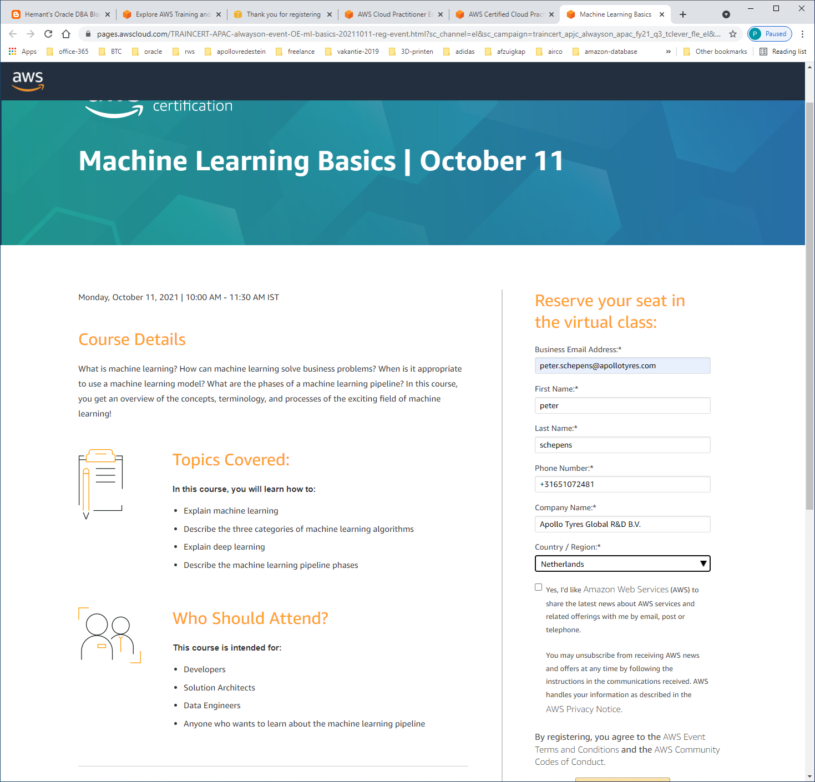

<https://pages.awscloud.com/TRAINCERT-APAC-alwayson-event-OE-big-data-20211029-reg-event.html?sc_channel=el&sc_campaign=traincert_apjc_alwayson_apac_fy21_q3_tclever_fle_el&sc_geo=apac&sc_country=mult&sc_outcome=reg&trkCampaign=apacfy21traincertalwaysonsfdc&trk=alwayslearning2021_sfdc_em>

Oct 29 | 10:00 AM - 11:30 AM IST  
**Big Data & Machine Learning**

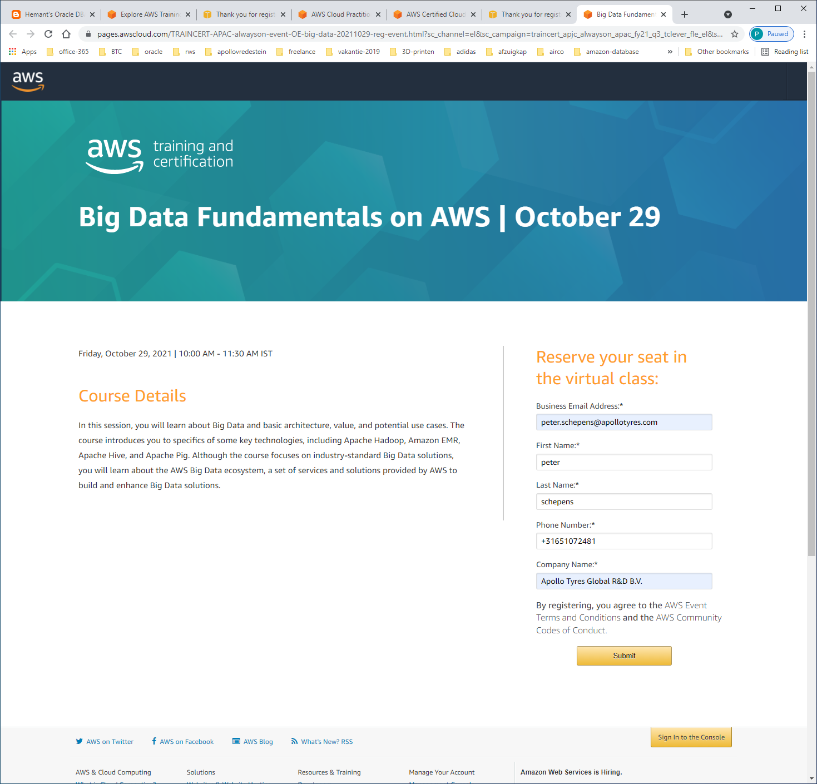

https://pages.awscloud.com/TRAINCERT-APAC-alwayson-event-OE-dynamodb-20211008-reg-event.html?sc_channel=el&sc_campaign=traincert_apjc_alwayson_apac_fy21_q3_tclever_fle_el&sc_geo=apac&sc_country=mult&sc_outcome=reg&trkCampaign=apacfy21traincertalwaysonsfdc&trk=alwayslearning2021_sfdc_em

Oct 8 | 10:00 AM - 11:30 AM IST  
**Amazon DynamoDB for Serverless Architectures**

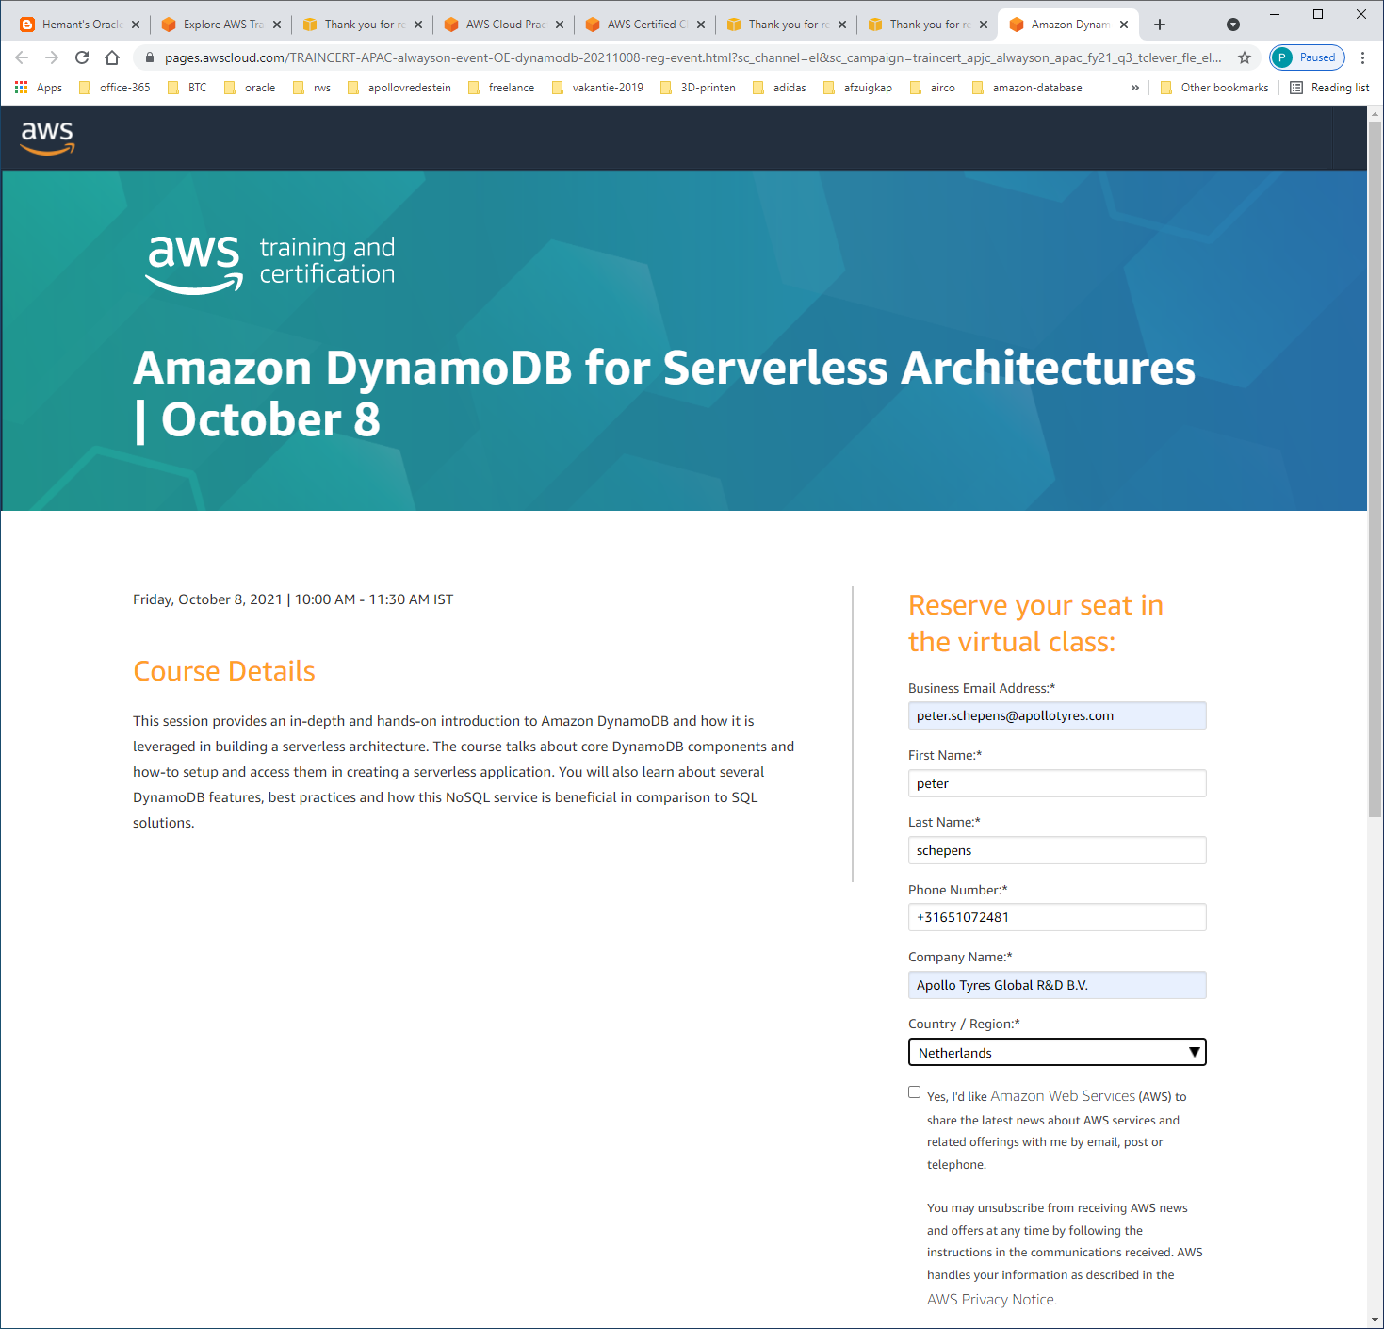

https://pages.awscloud.com/TRAINCERT-APAC-alwayson-event-OE-security-20211011-reg-event.html?sc_channel=el&sc_campaign=traincert_apjc_alwayson_apac_fy21_q3_tclever_fle_el&sc_geo=apac&sc_country=mult&sc_outcome=reg&trkCampaign=apacfy21traincertalwaysonsfdc&trk=alwayslearning2021_sfdc_em

Oct 11 | 3:00 PM - 4:30 PM IST  
**Securing your AWS Cloud**

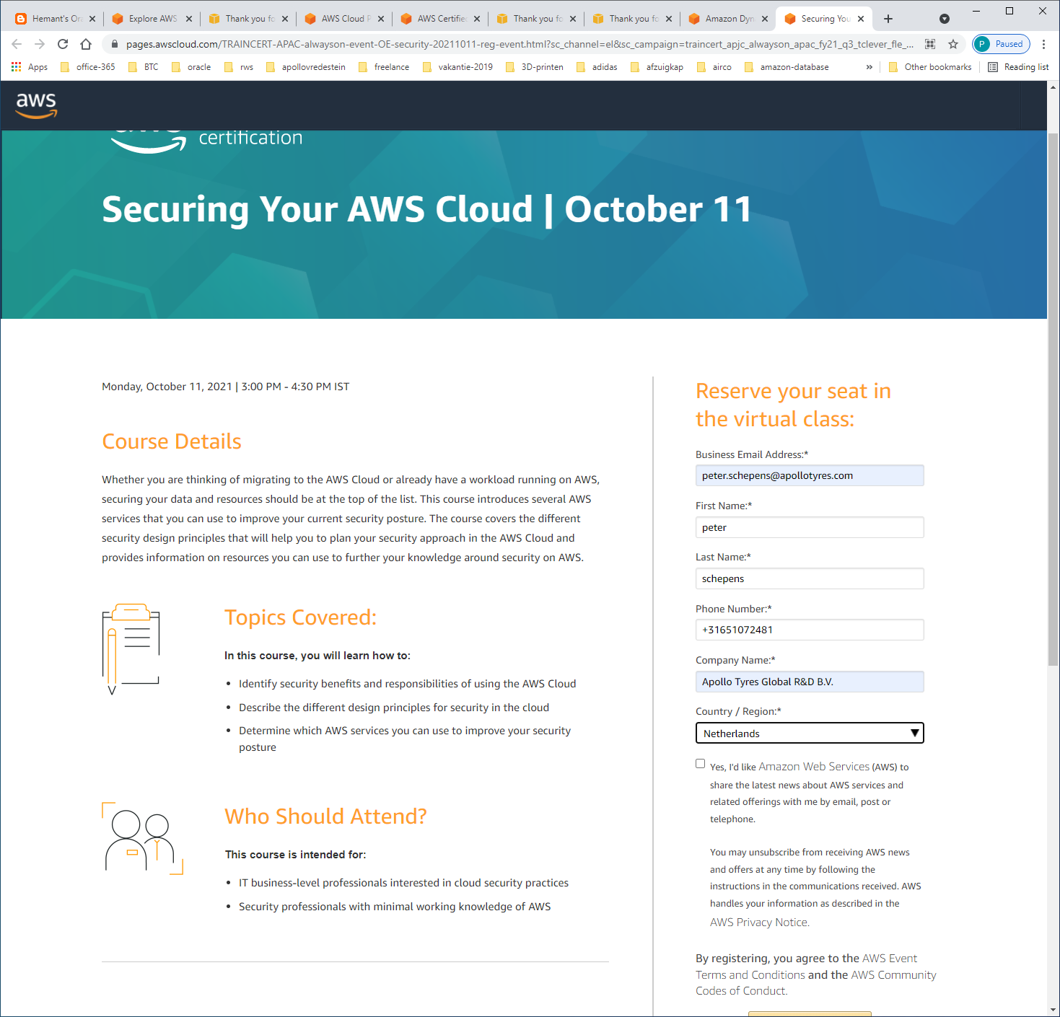

https://pages.awscloud.com/GLOBAL_TRAINCERT_T1_get-certified-cp-apjc-en_20211008_7014z000000rQ0h_RegPage.html?sc_channel=el&sc_campaign=traincert_apjc_alwayson_apac_fy21_q3_tclever_fle_el&sc_geo=apac&sc_country=mult&sc_outcome=reg&trkCampaign=apacfy21traincertalwaysonsfdc&trk=alwayslearning2021_sfdc_em

Oct 8 | 9:00 AM - 10:00 AM IST  
**AWS Certified Cloud Practitioner**

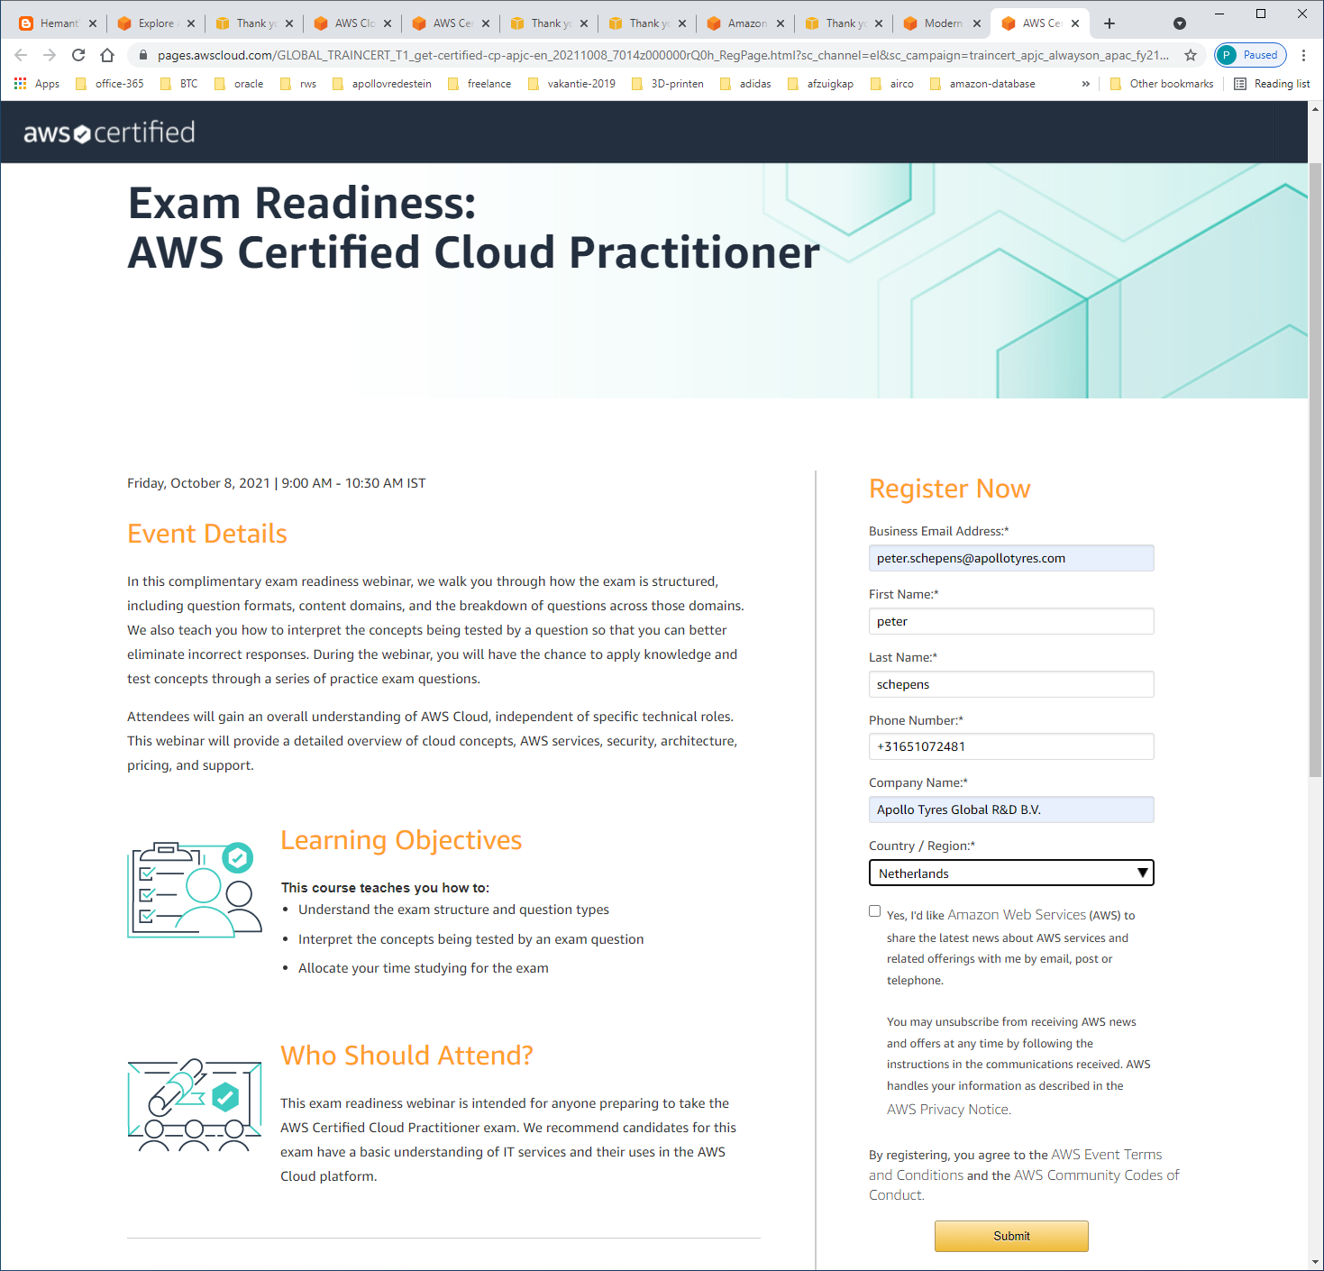

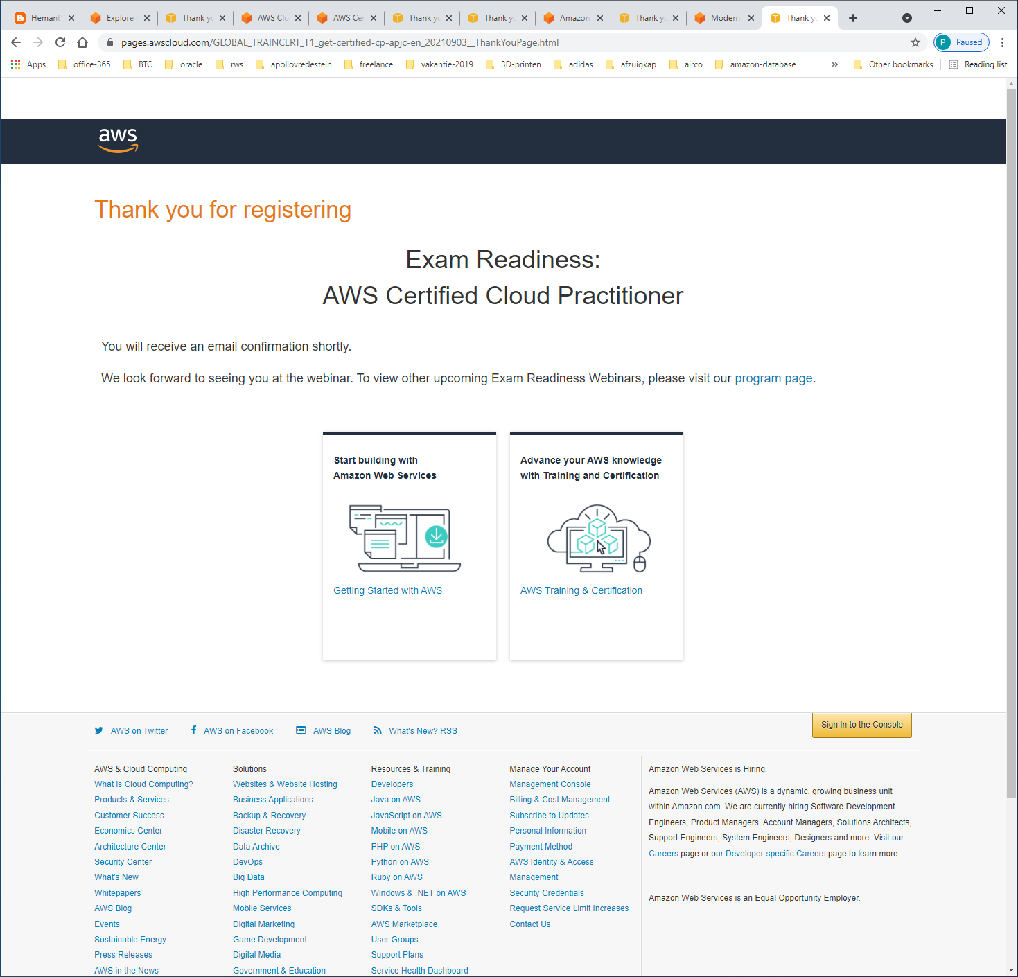

### [Start building with Amazon Web Services](https://aws.amazon.com/getting-started?sc_channel=em&sc_campaign=&sc_publisher=aws&sc_medium=em_&sc_content=event_ev_field&sc_country=us&sc_geo=namer&sc_outcome=event&trk=em_)

[](https://aws.amazon.com/getting-started?sc_channel=em&sc_campaign=&sc_publisher=aws&sc_medium=em_&sc_content=event_ev_field&sc_country=us&sc_geo=namer&sc_outcome=event&trk=em_)

[Getting Started with AWS](https://aws.amazon.com/getting-started?sc_channel=em&sc_campaign=&sc_publisher=aws&sc_medium=em_&sc_content=event_ev_field&sc_country=us&sc_geo=namer&sc_outcome=event&trk=em_)

### [Advance your AWS knowledge with Training and Certification](https://aws.amazon.com/training?sc_channel=em&sc_campaign=&sc_publisher=aws&sc_medium=em_&sc_content=event_ev_field&sc_country=us&sc_geo=namer&sc_outcome=event&trk=em_)

](https://aws.amazon.com/training?sc_channel=em&sc_campaign=&sc_publisher=aws&sc_medium=em_&sc_content=event_ev_field&sc_country=us&sc_geo=namer&sc_outcome=event&trk=em_)

[AWS Training & Certification](https://aws.amazon.com/training?sc_channel=em&sc_campaign=&sc_publisher=aws&sc_medium=em_&sc_content=event_ev_field&sc_country=us&sc_geo=namer&sc_outcome=event&trk=em_)

<https://aws.amazon.com/getting-started/?sc_channel=em&sc_campaign=&sc_publisher=aws&sc_medium=em_&sc_content=event_ev_field&sc_country=us&sc_geo=namer&sc_outcome=event&trk=em_>

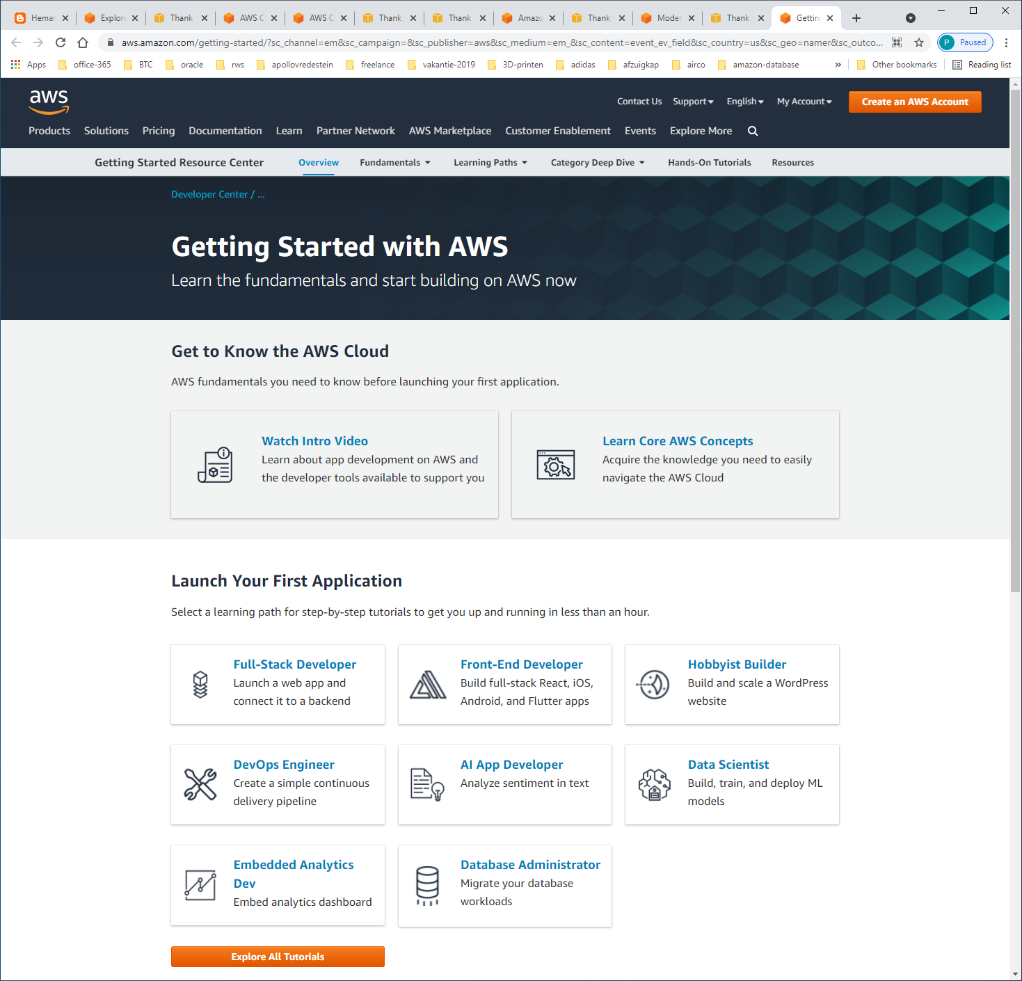

<https://aws.amazon.com/getting-started/learning-path-database-administrator/?e=gs2020&p=gsrc>

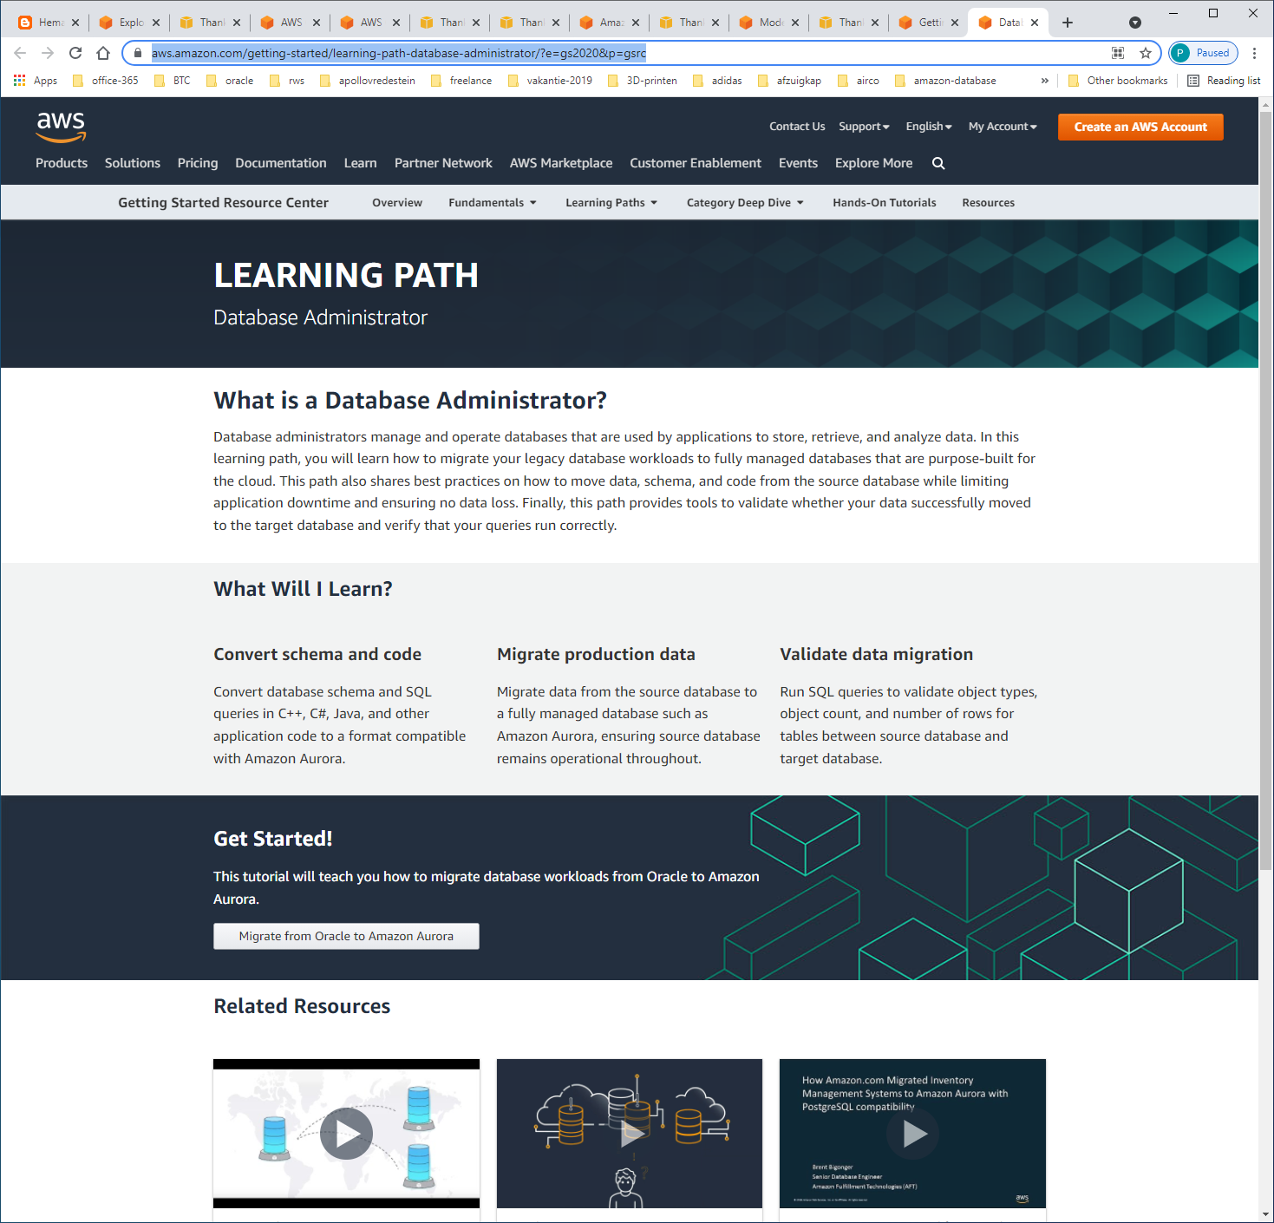

https://pages.awscloud.com/GLOBAL_TRAINCERT_T1_get-certified-saa-apjc-in_20211029_7014z000000rQ03AAE_RegPage.html?sc_channel=el&sc_campaign=traincert_apjc_alwayson_apac_fy21_q3_tclever_fle_el&sc_geo=apac&sc_country=mult&sc_outcome=reg&trkCampaign=apacfy21traincertalwaysonsfdc&trk=alwayslearning2021_sfdc_em

Oct 29 | 2:00 PM - 4:30 PM IST  
**AWS Certified Solutions Architect - Associate**

