Jupyter installeren: https://jupyter.org/

Klik install-the-notebook

# **Installing Jupyter**

Get up and running on your computer

Project Jupyter’s tools are available for installation via the [Python Package Index](https://pypi.org/), the leading repository of software created for the Python programming language.

This page uses instructions with [pip](https://pip.pypa.io/en/stable/), [the recommended installation tool for Python](https://packaging.python.org/en/latest/guides/tool-recommendations/#installation-tool-recommendations). If you require environment management as opposed to just installation, look into [conda](https://docs.conda.io/), [mamba](https://mamba.readthedocs.io/), and [pipenv](https://pipenv.pypa.io/).

## JupyterLab

Install JupyterLab with pip:

pip install jupyterlab

**Note**: If you install JupyterLab with conda or mamba, we recommend using [the conda-forge channel](https://conda-forge.org/).

Once installed, launch JupyterLab with:

jupyter-lab

## Jupyter Notebook

Install the classic Jupyter Notebook with:

**pip install notebook**

To run the notebook:

**jupyter notebook**

To access the notebook, open this file in a browser:

file:///C:/Users/peter.schepens/AppData/Roaming/jupyter/runtime/nbserver-10556-open.html

Or copy and paste one of these URLs:

http://localhost:8888/?token=f6ee87aa7ccd743853513731c9d4c3e1f68fe4f3e9ba41b4

or http://127.0.0.1:8888/?token=f6ee87aa7ccd743853513731c9d4c3e1f68fe4f3e9ba41b4

## Voilà

Install Voilà with:

pip install voila

JupyterLab online bekijken: <https://jupyter.org/try-jupyter/lab/>

Klik linksboven op [+] om een launcher te starten

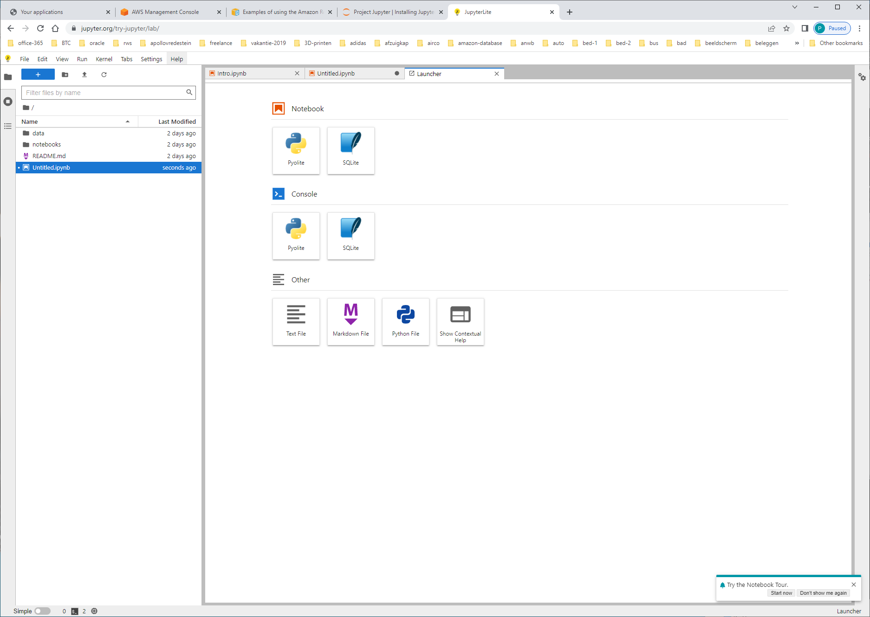

Kies voor [NOTEBOOK] + [PYOLITE]

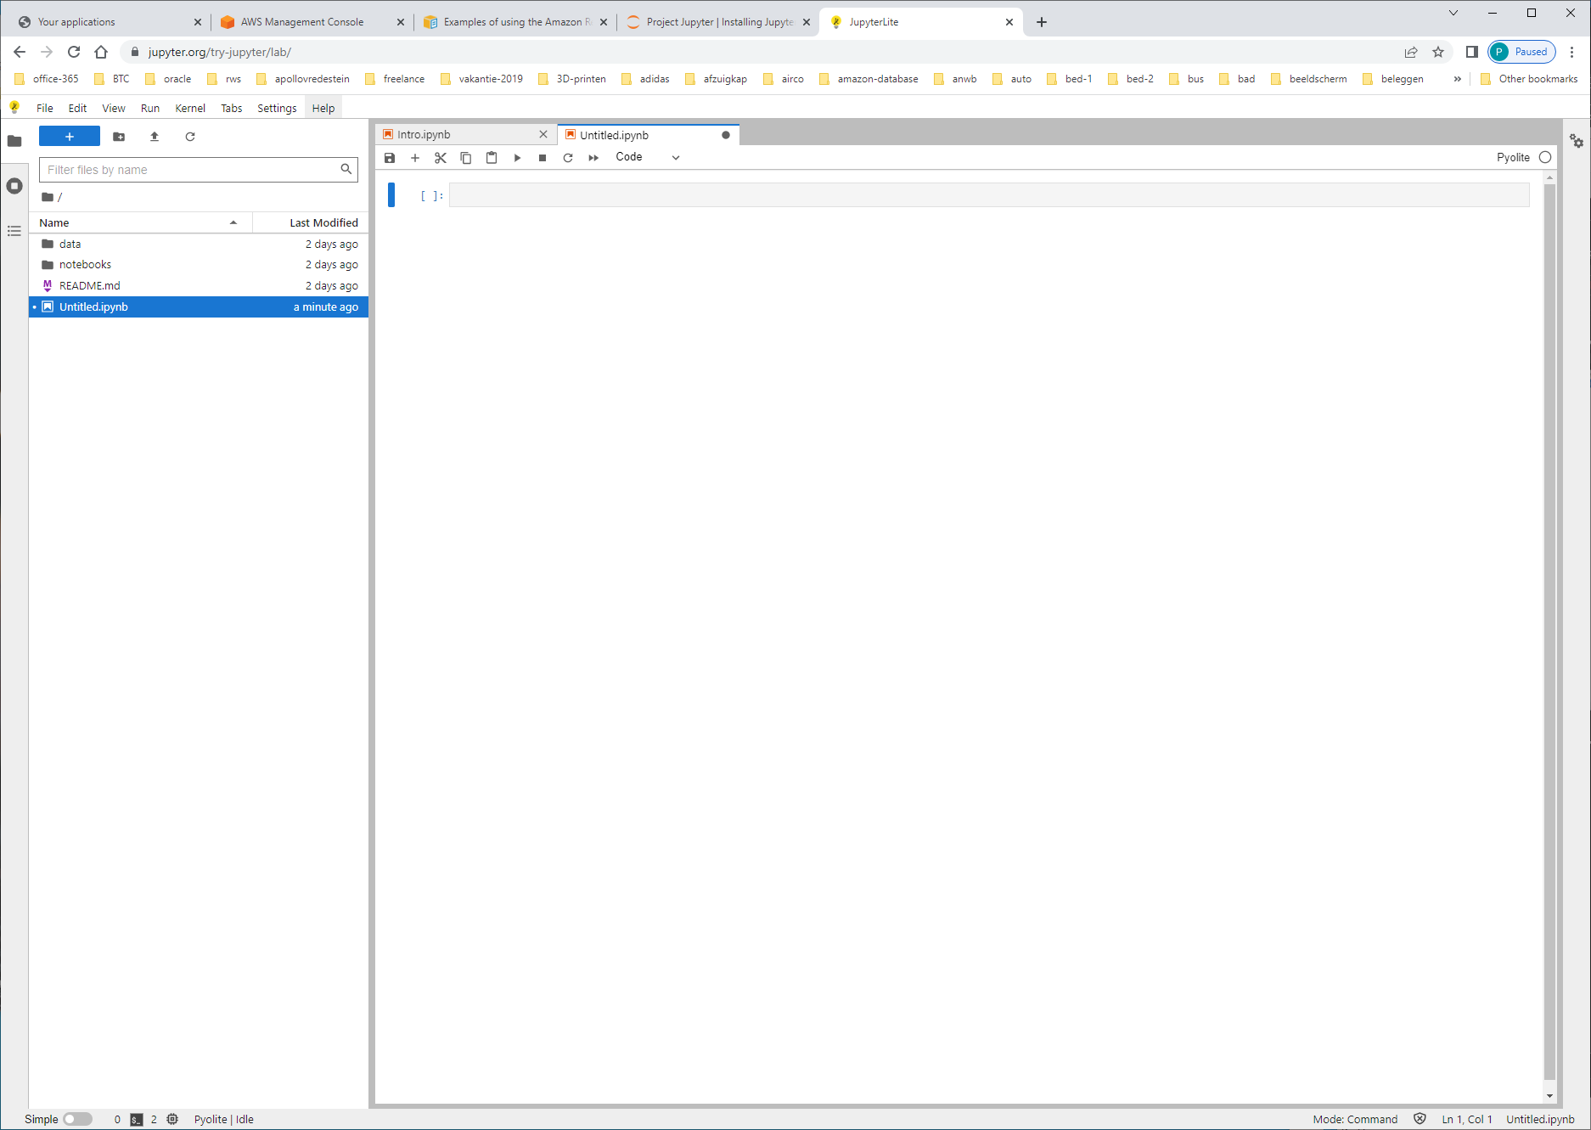

En wordt er een jpynb-file/project aangemaakt, waarmee je kunt werken.

conn = redshift_connector.connect(

host='**examplecluster.abc123xyz789.us-west-1.redshift.amazonaws.com**',

database='dev',

user='**awsuser**',

password='**my_password**'

)

Querying a table

To select all rows from the table book, run the following command.

>>> cursor.execute("select * from book")

Retrieving the query result set

To retrieve the query result set, run the following command.

>>> result: tuple = cursor.fetchall()

print(result)

Test vanuit eigen omgeving met apollo-AWS-redshift omgeving:

import redshift_connector

conn = redshift_connector.connect(

host=' redshift-cluster-rna.csvpwdknrhzd.ap-south-1.redshift.amazonaws.com',

port=5429,

database=' db_dev_lims',

user=' **lims_dev_user**',

password=' a1dFR09mn!6lk'

)

GA NAAR: pypi.org

Zoek op redshift connector

Klik [download files]

Save: redshift_connector-2.0.905-py3-none-any.whl

## [Installing from PyPI](https://packaging.python.org/en/latest/tutorials/installing-packages/#id18)

The most common usage of [pip](https://packaging.python.org/en/latest/key_projects/#pip) is to install from the [Python Package Index](https://packaging.python.org/en/latest/glossary/#term-Python-Package-Index-PyPI) using a [requirement specifier](https://packaging.python.org/en/latest/glossary/#term-Requirement-Specifier). Generally speaking, a requirement specifier is composed of a project name followed by an optional [version specifier](https://packaging.python.org/en/latest/glossary/#term-Version-Specifier). [**PEP 440**](https://www.python.org/dev/peps/pep-0440) contains a [**full specification**](https://www.python.org/dev/peps/pep-0440#version-specifiers) of the currently supported specifiers. Below are some examples.

To install the latest version of “SomeProject”:

Unix/macOSWindows

py -m pip install "SomeProject"

To install a specific version:

Unix/macOSWindows

py -m pip install "SomeProject==1.4"

To install greater than or equal to one version and less than another:

Unix/macOSWindows

py -m pip install "SomeProject>=1,<2"

To install a version that’s [**“compatible”**](https://www.python.org/dev/peps/pep-0440#compatible-release) with a certain version: [4](https://packaging.python.org/en/latest/tutorials/installing-packages/#id10)

Unix/macOSWindows

py -m pip install "SomeProject~=1.4.2"

In this case, this means to install any version “==1.4.*” version that’s also “>=1.4.2”.

# **Installing the Amazon Redshift Python connector**

[**PDF**](https://docs.aws.amazon.com/redshift/latest/mgmt/redshift-mgmt.pdf#python-driver-install)

[**Kindle**](https://www.amazon.com/dp/B07643KV1C)

[**RSS**](https://docs.aws.amazon.com/redshift/latest/mgmt/CMDochistory.rss)

You can use any of the following methods to install the Amazon Redshift Python connector:

* Python Package Index (PyPI)
* Conda
* Cloning the GitHub repository

## Installing the Python connector from PyPI

To install the Python connector from the Python Package Index (PyPI), you can use pip. To do this, run the following command.

LET OP: start eerst PYTHON op: c:\py

>>> pip install redshift_connector

Of:  
**c:\py -m pip install redshift_connector**

You can install the connector within a virtual environment. To do this, run the following command.

>>> pip install redshift_connector

Optionally, you can install pandas and NumPy with the connector.

>>> pip install "redshift_connector[full]"