ISSUE Query-editor-V2

select lc, af from sc_unilab_ens.utlcaf ;

I got result in few seconds.

Then go to QUERY-EDITOR-V2

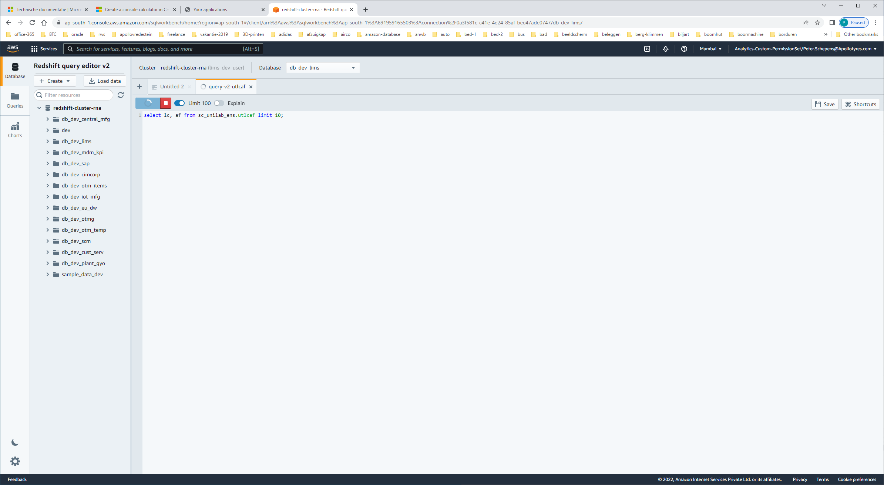

Type the same query as I used in query-editor before, and RUN.

Result: Nothing happens, the query keeps "running". The result isn't shown in the output-window immediately.

Only if I leave the query-editor-v2 en reconnect again, the screen is rebuild with data from the cache, and the output is shown without running the query again.

But a better solution is to give a [F5=refresh window], even without cancelling the current-query:

The output of the query is shown.

So, the output-result-data seems to be some kind of cache, and is only shown after a refresh or reconnect.

Additional Question: Is there a way I can call/show the output-window again after closing the window by mistake, without have to run a query again?