UTAD (629x)  
-AD  
-is_user   
-ad_tp   
-person  
-def_up  
-email  
-ss

UTUP (47x)  
-UP  
-description  
-DD  
-language  
-active  
-ss

**Ad_tp:**  
user  
supplier

UTUPUS (1292x)  
-UP  
-US

UTSTGKSCCREATEUP (478765x)  
-sccreateup   
-st

**UTUP (47x)  
UP DESCRIPTION COUNT(US)**  
1 Application management 1 40

2 Viewers 3 83   
3 Preparation lab 2 38

4 Preparation lab mgt 2 1

5 Physical lab 2 80

6 Physical lab mgt 2 16

7 Chemical lab 2 48

8 Chemical lab mgt 2 2

9 Certificate control 2 29

10 Tyre testing std 7 71

11 Tyre testing std mgt 7 44

12 Tyre testing adv. 2 24

13 Tyre testing adv mgt 7 32

14 Process tech. VF 9 30

15 Process tech. VF mgt 9 1

16 Process tech. BV 9 23

17 Process tech. BV mgt 9 1

18 User Mgt 1 7

19 User Group 1 34

20 Purchasing 1 5

21 Obsolete users 3 29

22 Material lab mgt 2 34

23 QEA 8 3

24 Compounding 5 120

25 Reinforcement 5 19

26 Construction PCT 5 243

27 Research 5 19

28 Proto PCT 6 44

29 Proto Extrusion 6 13

30 Proto Mixing 6 12

31 Proto Tread 6 1

32 Proto Calander 6 14

33 Construction AT 5 23

34 Proto AT 6 2

35 Construction SM 5 14

36 FEA 5 9

37 FEA mgt 5 8

38 Tyre Order 2 13

39 BAM mgt 2 5

40 BAM 5 5

41 Raw material mgt 5 9

42 Construction TBR 5 17

43 Raw Matreials 5 7

44 Construction TWT 5 4

45 Raw Materials Chennai 5 2

46 Purchasing mgt 5 4

47 Tyre mounting std 7 10

UTAD (629x)  
**ad ad_tp person def_up**AAF 1 user Armin Afkhamifar 26

ABU 1 user Axel Bult 26

ACH 1 user Arup Chandra 2

etc

UTUPUS   
**606 unieke USERS  
20 approved-users zonder ROL  
Aan alle rollen min 1x user**

UTAD (629x)  
-579 users APPROVED  
-46 users OBSOLETE  
-4 users IN-EXECUTION

Users kunnen buiten normaal profiel-authorisatie ook rechtstreks voor een applicatie behorende tot een andere UP geautoriseerd worden.

**0:1..N**

**1:1..N**

UTSTGKSCCREATEUP (47x)  
SCREATEUP COUNT(ST)  
BAM mgt 4

Certificate control 6751

Chemical lab 10573

Compounding 263

Construction AT 23

Construction PCT 73084

Construction SM 7

Construction TBR 2

Material lab mgt 28608

Physical lab 12981

Preparation lab 10535

Process tech. BV 74089

Process tech. BV mgt 74089

Process tech. VF 13

Process technology B&V 9576

Process technology B&V mgt 9576

Proto AT 4

Proto Calander 9

Proto Extrusion 225

Proto Mixing 4

Proto PCT 14

Raw material mgt 1

Reinforcement 189

Research 27

Tyre testing adv mgt 134

Tyre testing adv. 143

Tyre testing advanced mgt 9

Tyre testing standard 9576

Tyre testing standard mgt 9641

Tyre testing std 74340

Tyre testing std mgt 74275

UTSTGKSCCREATEUP(478765x)  
-11743 distinct ST   
-31 SCCREATEUP

UTSTGKSCLISTUP (655478x)  
-sclistup   
-st

UTSTGKSCCREATEUP (47x)  
SCREATEUP COUNT(ST)  
BAM mgt 12

Certificate control 15572

Chemical lab 27316

Chemical lab mgt 1

Compounding 17163

Construction AT 23

Construction PCT 72855

Construction SM 7

Construction TBR 2

Lab mgt 374

Material lab mgt 28614

Physical lab 28529

Physical lab mgt 374

Preparation lab 27292

Preparation lab mgt 184

Process tech. BV 75255

Process tech. BV mgt 74462

Process tech. VF 11218

Process tech. VF mgt 374

Process technology B&V 9576

Process technology B&V mgt 9576

Proto AT 1

Proto Calander 9

Proto Mixing 10043

Proto PCT 14

Purchasing 16738

QEA 16738

Raw material mgt 1

Reinforcement 11408

Research 16765

Tyre Order 25

Tyre testing adv mgt 132

Tyre testing adv. 141

Tyre testing advanced mgt 1

Tyre testing standard mgt 9576

Tyre testing std 83923

Tyre testing std mgt 74263

Viewers 16921

UTSTGKSCLISTUP(655478x)  
-11743 distinct ST   
-38 SCLISTUP

UTST (115094x)  
-ST  
-description  
-sc_uc  
-ss  
-AR1 t/m AR16 (R/W/N)

UTST (115094x)  
-distinct 13215 ST   
SS distinctST  
@A 11627

@E 2869

@O 4099

BL 11312

CF 647

ER 171

TC 272

UTSS (39x))  
SS NAME  
@< Checked In

@> Checked Out

@/ Historic

@E In Editing

@A Approved

@O Obsolete

@T In Test

@@ Default

@P Planned

@C Cancelled

@~ Initial

2P To PIBS

AV Available

BL Blocked

CF Configured

CM Completed

DP Disposition

DV Development

ER Error

FA For Approval

FR For Review

GS Get SQL defaults

IE In Execution

IR Irrelevant

OS Out of spec

OR Ordered

OW Out of warning

RE Ready for execution

RJ Rejected

SC Out of Spec Conf.

ST Stopped

SU Submit

TC To Configure

TT Toggle Template

TV To validate

VA Validated

WA Wait

WC Out of Warning Conf.

WH Warehouse

UTRT (463x)  
-RT  
-description  
-sc_uc  
-active  
-ss  
-AR1 t/m AR16 (R/W/N)

UTRT 463x)  
-distinct 59 RT   
SS distinctRT  
@A 53

@E 9

@O 16

UTSTGKSCRECEIVERUP (655478x)  
-screceiverup   
-st

UTSTGKSCCREATEUP (47x)  
SCREATEUP COUNT(ST)  
Certificate control 462

Chemical lab ` 12492

Material lab mgt 17107

Physical lab 13853

Preparation lab 18144

Proto Calander 9

Proto Mixing 10039

Tyre Order 25

Tyre testing adv mgt 126

Tyre testing adv. 131

Tyre testing std 74464

Tyre testing std mgt 74276

UTSTGKSCRECEIVERUP(221128x)  
-11478 distinct ST   
-12 SCRECEIVERUP

UTRTGKRQCREATEUP (569x)  
-RQcreateup   
-rt

UTRTGKRQCREATEUP(569x)  
-40 distinct RT   
-27 RQCREATEUP

UTRTGKRQLISTUP (x)  
-rqlistup   
-rt

UTRTGKRQLISTUP(932x)  
-39 distinct RT   
-29 RQLISTUP

UTRTGKREQUESTERUP (657x)  
-requesterup   
-rt

UTRTGKREQUESTERUP(657x)  
-58 distinct RT   
-20 REQUESTERUP

UTRTGKRQCREATEUP (27x)  
RQREATEUP COUNT(RT)  
Application management 2

BAM mgt 1

Chemical lab 1

Compounding 58

Construction AT 14

Construction PCT 166

Construction SM 5

Construction TBR 1

Construction TWT 1

FEA 9

FEA mgt 9

Material lab mgt 34

Physical lab 1

Process tech. VF 4

Proto AT 2

Proto Calander 14

Proto Extrusion 19

Proto PCT 13

Purchasing 1

Raw Materials Chennai 1

Raw Matreials 1

Raw material mgt 2

Reinforcement 25

Research 11

Tyre testing adv mgt 52

Tyre testing adv. 52

Tyre testing std mgt 70

UTRTGKRQLISTUP (27x)  
RQLISTUP COUNT(RT)  
Application management 2

BAM mgt 1

Chemical lab 38

Compounding 69

Construction AT 14

Construction PCT 142

Construction SM 5

Construction TBR 1

Construction TWT 1

FEA 9

FEA mgt 9

Material lab mgt 56

Physical lab 54

Preparation lab 43

Proto AT 2

Proto Calander 14

Proto Extrusion 19

Proto PCT 23

Proto Tread 1

Purchasing 1

Raw Materials Chennai 1

Raw Matreials 1

Raw material mgt 2

Reinforcement 15

Research 133

Tyre testing adv mgt 60

Tyre testing adv. 60

Tyre testing std 78

Tyre testing std mgt 78

UTRTGKREQUESTERUP (27x)  
REQUESTERUP COUNT(RT)  
Application management 3

Chemical lab 1

Compounding 233

Construction AT 14

Construction PCT 200

Construction SM 5

Construction TBR 1

Construction TWT 1

FEA 9

FEA mgt 9

Physical lab 3

Process tech. VF 51

Proto Extrusion 7

Purchasing 1

Raw Materials Chennai 1

Raw Matreials 1

Raw material mgt 2

Reinforcement 36

Research 26

Tyre testing adv. 53

UTAPPLIC(20 x)  
-applic  
-description

UTAPPLIC (20x)  
**applic description**addef define address

analyzer analyzer

costcalc Cost calculation

database Database

eqdef define equipment

gkdef define group key

lcdef define life cycle

lydef define layouts

radef Remote Archiving

rqmgt request management

scmgt sample code management

stdef define sample types

stplan sample planning

tkdef define tasks

u4iweb Internet application

ucdef define unique code mask

unicnct Uniconnect

updef user profile configuration

wlmgt Worklist

wsmgt Worksheet management

UTUPUSFAC(56 x)  
-UP  
-US  
-applic  
-topic

UTUPFAC(751 x)  
-UP  
-applic  
-topic

UTTK (699x)  
-TK  
-tk_tp  
-description  
-col_id  
-col_tp  
-seq

UTUPTK (400x)  
-UP  
-TK  
-TK_TP  
-seq

UTUP  
13 UP zonder UPFA  
-5 UP zonder UPTK

Complete lijst met ALLE TASKS

UTPREF (274x)  
-PREF_TP  
-PREF_NAME  
-PREF_VALUE  
-APPLICABLE_OBJ  
-CATEGORY  
-description

Complete lijst met   
ALLE PREFERENCES

UTPREFLIST (x)  
-PREF_TP  
-PREF_NAME  
-PREF_VALUE

PREFERENCE-domein-waarden

UTUPPREF (998x)  
-UP  
-PREF_NAME  
-PREF_VALUE

UTUPUSPREF (561x)  
-UP  
-US  
-PREF_NAME  
-PREF_VALUE

UTDD (16x)  
-DD  
-description

UTDD (16x)  
DD DESCRIPTION COUNT(UP)  
1 Application management 4

2 Materials laboratorium 11

3 Viewers 2

**4 Purchasing 0**  
5 Specialists 15

6 Trial production 6

7 Tyre testing 4

8 QEA 1

9 Production 4  
**10 10 0**

**11 11 0**

**12 12 0**

**13 13 0**

**14 14 0**

**15 15 0**

**16 16 0**

UTDD  
-8 DD met UP  
-8 DD zonder UP

RT.AR01 t/m AR16 komen overeen met DD1 tm/ DD16

RT.AR01 t/m AR16 komen overeen met DD1 tm/ DD16

UTUPUSPREF   
40 UP min.1x pref  
7 UP geen pref

UTUPUSPREF   
32 UP min.1x pref  
15 UP geen pref

UTUPTKF   
-70 distinct TK  
-87 distinct TK,TK_TP  
-42 UP min.1 TK  
-5 UP geen TK

UTTK   
81 UNIEKE TK  
76 TK >1 TK_TP  
104 UNIEKE TK,TK_TP  
49 TK zonder UP  
65 TK,TK_TP zonder UP

UTPREF-CATEGORY (x)  
**category @PREF**Assign Full Testplan 1

Change status 7

Copy behaviour 22

Creation behaviour 55

Data access 6

Data input 4

Default 2

Default layout 66

Default task 22

Equipment Management 1

Hand held device 44

SAP interface 2

Security 1

Web 13

Web Creation behaviour 3

XSLT 5

20

UTPREF-PREF_TP (4x)  
**PREF_TP @PREF**tk 118  
up 138  
xml_exp 10  
xml_imp 8

Hierbij het overzicht van de gebruikte tabellen voor access rights en workflow doeleinden.

Gebruikers: **UTAD**

User Profiles (rollen): **UTUP** (gekoppeld aan users door **UTUPUS**)

EXTRA UITLEG

UTSTGKSTLISTGROUP STLISTGROUP

UTSTGKSCRECIEVEUP SCRECIEVEUP

UTSTGKSCRECEIVERUP SCRECEIVERUP

UTSTGKSCLISTUP SCLISTUP

UTSTGKSCCREATEUP SCCREATEUP

UTSTGKPRODUCTGROUP PRODUCTGROUP

UTSTGKPARTGROUP PARTGROUP

UTSTGKOLD_PRODUCTGROUP OLD_PRODUCTGROUP

UTSTGKDATE_SEND_TO_SUPPLIE DATE_SEND_TO_SUPPLIE

UTSDTP ALLOW_UPFRONT_UNIT

UTSDTP ALLOW_UPFRONT

UTSCMEGKUSER_GROUP USER_GROUP

UTSCMEGKEXECUTING_UP EXECUTING_UP

UTSCGKSCRECEIVERUP SCRECEIVERUP

UTSCGKSCLISTUP SCLISTUP

UTSCGKSCCREATEUP SCCREATEUP

UTSCGKPARTGROUP PARTGROUP

UTSAPCODEGROUP SAP_CODE_GROUP

UTSAPCODE SAP_CODE_GROUP

UTRTGKRQLISTUP RQLISTUP

UTRTGKRQCREATEUP RQCREATEUP

UTRTGKREQUESTERUP REQUESTERUP

UTPTTP ALLOW_UPFRONT_UNIT

UTPTTP ALLOW_UPFRONT

UTUPUSFA APPLIC

UTUPFA APPLIC

UTUCAUDITTRAIL APPLIC

UTSTGKCOMPOUND_APPLICATION COMPOUND_APPLICATION

UTPRINTCMDS64 APPLIC

UTPRINTCMDS61SP1 APPLIC

UTPRINTCMDS APPLIC

UTPREF APPLICABLE_OBJ

UTJOURNALLOG APPLIC

UTFA APPLIC

UTEVTIMED APPLIC

UTEVSTAT EV_APPLIC

UTEVSINK APPLIC

UTEVRULESDELAYED APPLIC

UTEVRULES APPLIC

UTEVLOG APPLIC

UTEV APPLIC

UTERROR APPLIC

UTAPPLIC APPLIC

--users

select count(*) from UTAD;

SELECT COUNT(*) FROM UTUP;

Select up.up, up.description, up.dd, count(us.us) from utup up,utupus us where up.up = us.up group by up.up,description,dd order by up.up,description,dd;

SELECT COUNT(*) FROM UTUPUS;  
select count(distinct us) from utupus;  
select count(*) from utad where ss='@A' and ad not in (select us from utupus);  
select count(*) from utup where up not in (select up from utupus);

--

select count(*) from utst;  
select count(distinct st) from utst;  
select ss, count(distinct st) from utst group by ss order by ss;

select count(*) from UTSTGKSCCREATEUP;  
select SCCREATEUP, count(*) from UTSTGKSCCREATEUP group by SCCREATEUP order by SCCREATEUP;  
select count(DISTINCT ST) from UTSTGKSCCREATEUP ;  
select count(DISTINCT SCCREATEUP) from UTSTGKSCCREATEUP ;

select count(*) from UTSTGKSCLISTUP ;  
select sclistup, count(*) from UTSTGKSCLISTUP group by sclistup order by sclistup;  
select count(DISTINCT ST) from UTSTGKSCLISTUP ;  
select count(DISTINCT sclistup) from UTSTGKSCLISTUP ;

select count(*) from UTSTGKSCRECEIVERUP ;  
select screceiverup, count(*) from UTSTGKSCRECEIVERUP group by screceiverup order by screceiverup;  
select count(DISTINCT ST) from UTSTGKSCRECEIVERUP;  
select count(DISTINCT screceiverup) from UTSTGKSCRECEIVERUP;

--

select count(*) from utrt;  
select count(distinct Rt) from utRt;  
select ss, count(distinct Rt) from utRt group by ss order by ss;

select count(*) from UTRTGKRQCREATEUP;  
select RQCREATEUP, count(*) from UTRTGKRQCREATEUP group by RQCREATEUP order by RQCREATEUP;  
select count(DISTINCT RT) from UTRTGKRQCREATEUP ;  
select count(DISTINCT RQCREATEUP) from UTRTGKRQCREATEUP ;

select count(*) from UTRTGKRQLISTUP ;  
select RQlistup, count(*) from UTRTGKRQLISTUP group by RQlistup order by RQlistup;  
select count(DISTINCT RT) from UTRTGKRQLISTUP ;  
select count(DISTINCT RQlistup) from UTRTGKRQLISTUP ;

select count(*) from UTRTGKREQUESTERUP ;  
select REQUESTERUP, count(*) from UTRTGKREQUESTERUP group by REQUESTERup order by REQUESTERup;  
select count(DISTINCT RT) from UTRTGKREQUESTERUP;  
select count(DISTINCT REQUESTERup) from UTRTGKREQUESTERUP;

select count(*) from utupusfa;

select count(*) from utupusfa fa where not exists (select '' from utupus where utupus.up = fa.up and utupus.us = fa.us);

select count(*) from utupfa;

select count(*) from utupfa fa where not exists (select '' from utup where utup.up = fa.up);

select count(*) from utup UP where not exists (select '' from utupFA fa where up.up = fa.up);

--

select count(*) from uttk;

select count(*) from utUPtk;

select count(*) from utup UP where not exists (select '' from utupTK tk where up.up = tk.up);

--

SELECT count(*) from utpref;

select count(*) from UTUPUSPREF ;

select up, count(*) from UTUPUSPREF group by up order by up;

select count(*) from UTUPPREF ;

select up, count(*) from UTUPPREF group by up order by up;

--

select up, count(*) from UTUPTK group by up order by up;

select up, count(*) from UTUPTK group by up order by up;

select TK, count(*) from UTUPTK group by TK order by TK;

select TK, tk_tp, count(*) from UTUPTK group by TK,tk_tp order by TK,tk_tp;

SELECT COUNT(DISTINCT TK) FROM UTTK;

SELECT COUNT(*), TK, TK_TP FROM UTTK GROUP BY TK, TK_TP order by TK, TK_TP;

select count(*), TK from uttk group by tk having count(*) > 1;

SELECT COUNT(*) FROM UTTK WHERE NOT EXISTS (SELECT * FROM UTUPTK WHERE UTUPTK.TK = UTTK.TK and UTUPTK.TK_TP = UTTK.TK_TP);

UNILAB-CONFIGURATOR: USER-PROFILE

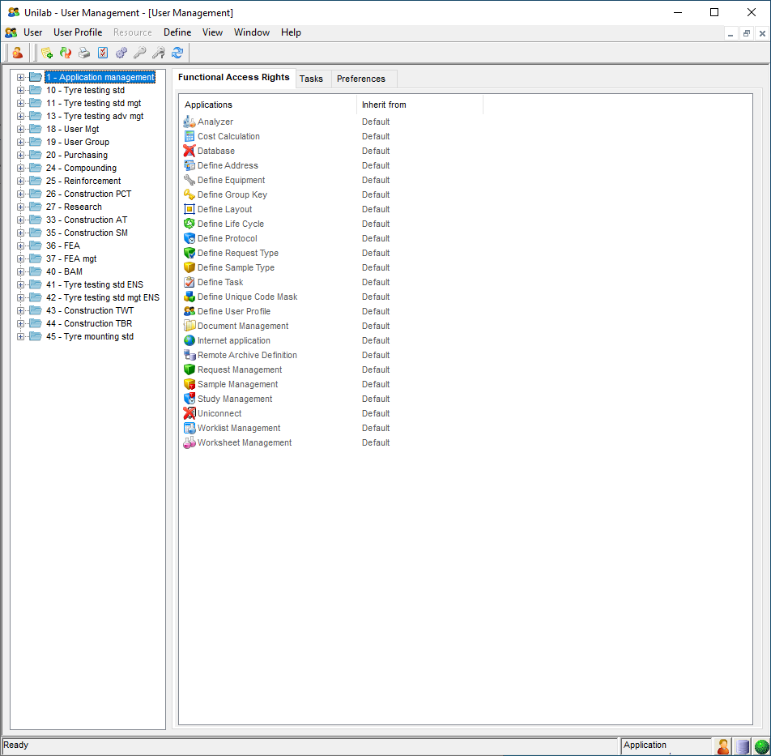

EN REQUEST-TYPE (BASIC-TASK)

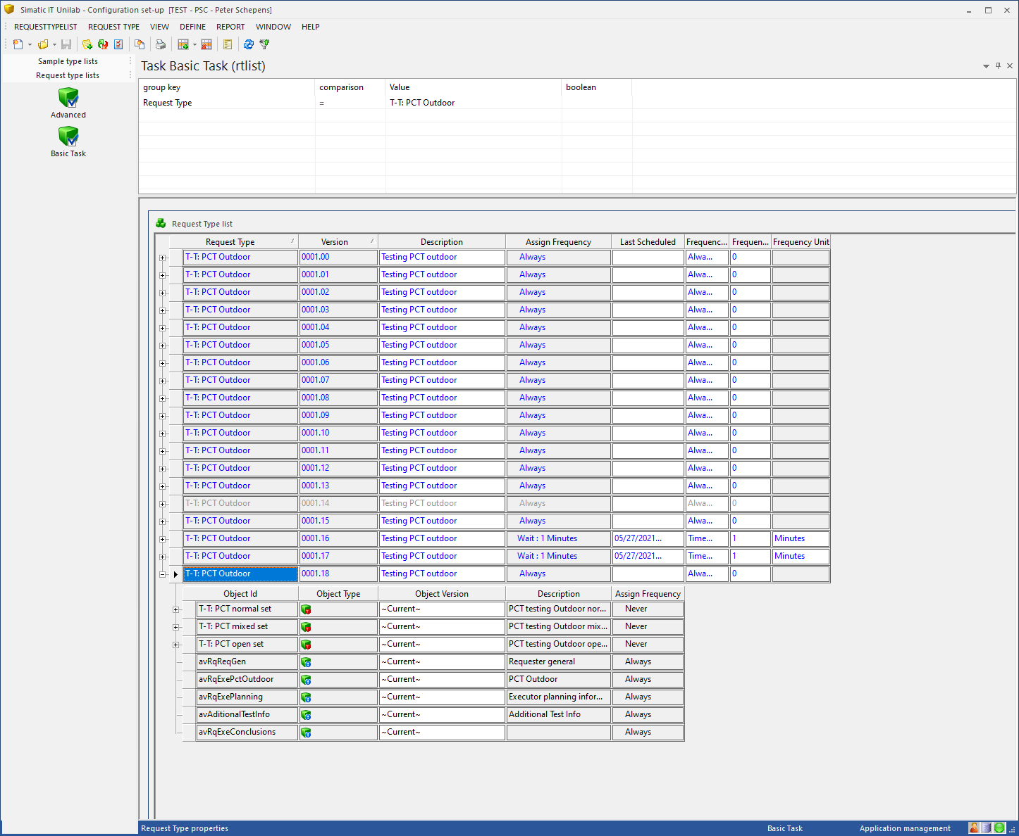

KLIK PROPERTIES VANUIT REQUEST-TYPE

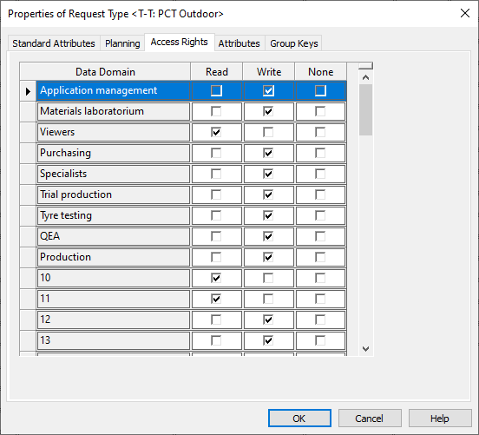

SELECT distinct rqcreateup, rt FROM UTRTGKRQCREATEUP WHERE RT LIKE 'T-T: PCT Outdoor';

Construction PCT T-T: PCT Outdoor  
Tyre testing adv mgt T-T: PCT Outdoor  
Tyre testing adv. T-T: PCT Outdoor

SELECT UP, DESCRIPTION, DD FROM UTUP WHERE DESCRIPTION IN ('Construction PCT');

26 Construction PCT 5

SELECT UP, DESCRIPTION, DD FROM UTUP WHERE DESCRIPTION IN ('Tyre testing adv mgt');

13 Tyre testing adv mgt 7

SELECT UP, DESCRIPTION, DD FROM UTUP WHERE DESCRIPTION IN ('Tyre testing adv.');

12 Tyre testing adv. 2

CONCLUSIE: DEZE DD'S KOMEN NIET OVEREEN MET WAT IK IN DE PROPERTIES ZIE BIJ HET RT.

Select * from utrtgkuserprofiles where rt like 'T-T: PCT Outdoor';

Tyre testing advanced mgt T-T: PCT Outdoor 0001.18  
Tyre testing adv. T-T: PCT Outdoor 0001.18  
Construction PCT T-T: PCT Outdoor 0001.18

Select * from utrtgkrqlistup where rt like 'T-T: PCT Outdoor'

Tyre testing adv mgt T-T: PCT Outdoor 0001.18  
Tyre testing adv. T-T: PCT Outdoor 0001.18  
Research T-T: PCT Outdoor 0001.18  
Construction PCT T-T: PCT Outdoor 0001.18

Tabel: UTDD

Dd

**1 Application management**

2 Materials laboratorium

3 Viewers

4 Purchasing

5 Specialists

6 Trial production

7 Tyre testing

8 QEA

9 Production

10 10

11 11

12 12

13 13

14 14

15 15

16 16

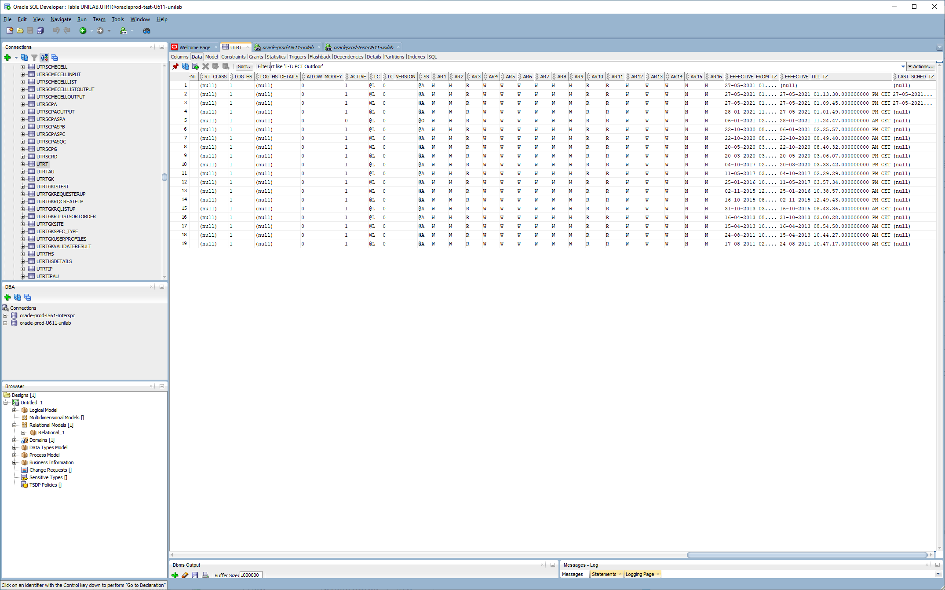

De AR-attributen uit UTRT komen overeen met de UTDD.DD-voorkomens

1 W  
2 W  
3 R  
4 W  
5 W  
6 W  
7 W  
8 W  
9 W  
10 R  
11 R  
12 W  
13 W  
14 W  
15 N  
16 N

Vanuit UTUP ligt relatie naar een UTDD.DD

Select dd.dd, dd.description, up.up, up.description from utup up, utdd dd where up.dd = dd.dd;

1 Application management 1 Application management

1 Application management 18 User Mgt

1 Application management 19 User Group

1 Application management 20 Purchasing

2 Materials laboratorium 3 Preparation lab

2 Materials laboratorium 4 Preparation lab mgt

2 Materials laboratorium 5 Physical lab

2 Materials laboratorium 6 Physical lab mgt

2 Materials laboratorium 7 Chemical lab

2 Materials laboratorium 8 Chemical lab mgt

2 Materials laboratorium 9 Certificate control

2 Materials laboratorium 12 Tyre testing adv.

2 Materials laboratorium 22 Material lab mgt

2 Materials laboratorium 38 Tyre Order

2 Materials laboratorium 39 BAM mgt

3 Viewers 2 Viewers

3 Viewers 21 Obsolete users

5 Specialists 24 Compounding

5 Specialists 25 Reinforcement

5 Specialists 26 Construction PCT

5 Specialists 27 Research

5 Specialists 33 Construction AT

5 Specialists 35 Construction SM

5 Specialists 36 FEA

5 Specialists 37 FEA mgt

5 Specialists 40 BAM

5 Specialists 41 Raw material mgt

5 Specialists 42 Construction TBR

5 Specialists 43 Raw Matreials

5 Specialists 44 Construction TWT

5 Specialists 45 Raw Materials Chennai

5 Specialists 46 Purchasing mgt

6 Trial production 28 Proto PCT

6 Trial production 29 Proto Extrusion

6 Trial production 30 Proto Mixing

6 Trial production 31 Proto Tread

6 Trial production 32 Proto Calander

6 Trial production 34 Proto AT

7 Tyre testing 10 Tyre testing std

7 Tyre testing 11 Tyre testing std mgt

7 Tyre testing 13 Tyre testing adv mgt

7 Tyre testing 47 Tyre mounting std

8 QEA 23 QEA

9 Production 14 Process tech. VF

9 Production 15 Process tech. VF mgt

9 Production 16 Process tech. BV

9 Production 17 Process tech. BV mgt

Select dd.dd, dd.description from utdd dd where not exists (select '' from utup up where up.dd = dd.dd) order by dd.dd;

10 10

11 11

12 12

13 13

14 14

15 15

16 16

4 Purchasing

Conclusie: Dit betekent eigenlijk dat attributen AR3 + AR10 t/m AR16 geen enkele waarde hebben !!!