JOBS

SYS.DBMS_SCHEDULER.CREATE_JOB

(

job_name => 'UNILAB.UNI_J_REGULARRELEASE'

,start_date => TO_TIMESTAMP_TZ('2022/02/08 16:51:44.000000 +01:00','yyyy/mm/dd hh24:mi:ss.ff tzh:tzm')

,repeat_interval => 'FREQ = MINUTELY; INTERVAL = 1'

,end_date => NULL

,job_class => 'UNI_JC_OTHER_JOBS'

,job_type => 'PLSQL_BLOCK'

,job_action => 'DECLARE r NUMBER; BEGIN r:= APAOREGULARRELEASE.EvaluateTimeCountBased; END;'

,comments => NULL

);

cxapp.startalldbjobs

apaoaction.set_connection

unapigen.setconnection  
client_id := 'SamplePlanner’  
_us :=l_dba_name = 'UNILAB'; *--&Username;*

a_password = ‘ ‘

al_applic := 'acplan’

l_numeric_characters := 'DB';

l_date_format := ''DDfx/fxMM/RR HH24fx:fxMI:SS';  
l_time_zone = SERVER  
l_up =   
l_user_profile =   
l_language =   
l_tk =

UNAPIGEN.SETCONNECTION4INSTALL

UNAPIGEN.SETCONNECTION4INSTALL (incl. timezone)

ALGEHELE CONNECTIE-PROCEDURE NA INLOGGEN OP DATABASE.

APAOREGULARRELEASE.TIMECOUNTBASED(SC, 'job')

LOOP LVQ.ST

cxapp.stopalldbjobs

DBMS_SCHEDULER.DROP_JOB(l_job_id)

RegularRelease

APAOREGULARRELEASE.EvaluateTimeCountBasedl

UTSYSTEM  
DBA_NAME = UNILAB

JOBS_DATE_FORMAT = DDfx/fxMM/RR HH24fx:fxMI:SS

END LOOP LVQ.SC

DELETE from ATAOREGULARRELEASE_PLANNED (SC, PG, PGNODE )

UNAPIGEN.BEGINTRANSACTION

SELECT SC, PG, PGNODE   
FROM ATAOREGULARRELEASE_PLANNED

ORDER BY SC, PGNODE;

UNAPIGEN.ENDTRANSACTION

COMMIT;

UNAPIEV.P_SC = sc  
UNAPIEV.P_PG = pg  
UNAPIEV.PGNODE = pgnode

DATAMODEL

ATAOREGULARRELEASE  
st  
release_date

ATAOREGULARRELEASE_PLANNED  
sc  
pg  
pgnode

ATAOREGULARRELEASE  
st release_date  
GR_6311_TEX_STE 03-12-2021 09.02.40.000000000 AM

GR_5131_IND_PET 16-02-2022 11.09.43.000000000 AM

GR_2131_EVO_BOT 08-06-2011 11.52.41.000000000 AM

GR_2121_KRE_KRE 07-05-2015 10.53.05.000000000 AM

GR_4411_DUS_SAL 11-10-2013 03.24.47.000000000 PM

GR_5212_RHE_MAN 19-08-2020 07.40.57.000000000 AM

EM_920 13-11-2018 03.04.00.000000000 AM

GR_5311_OMG_FRA 01-11-2013 08.50.16.000000000 AM

EM_786 15-06-2020 09.19.19.000000000 AM

EM_652 14-05-2014 08.01.30.000000000 PM

EM_772 16-02-2022 06.07.32.000000000 PM

EM_753 16-02-2022 07.56.45.000000000 AM

EM_732 15-02-2022 10.23.45.000000000 PM

GR_5216_BEH_PER 18-01-2011 09.30.41.000000000 AM

GR_3311_ORG_URE 07-01-2022 10.48.39.000000000 AM

GR_4242_MLC_MAR 30-09-2020 02.58.36.000000000 PM  
…  
<TOTAAL = 585 SAMPLETYPES>

Unilab

CONFIGURATOR

Ga naar PARAMETER-GROUP = COA

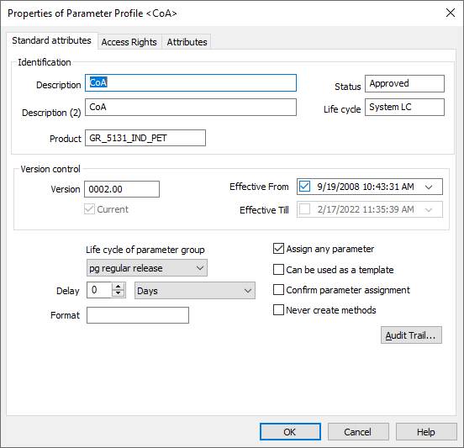

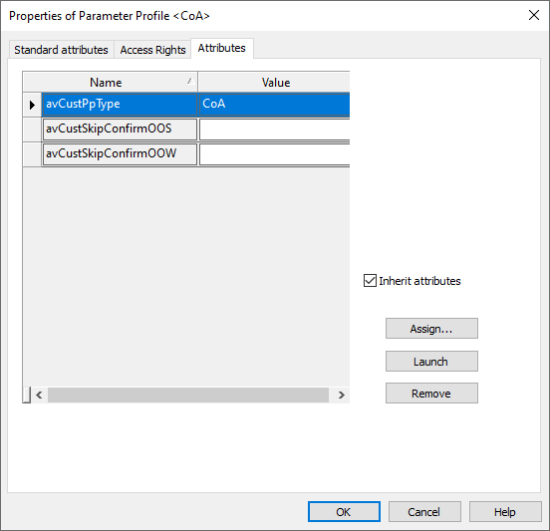 attribuut = avCustPpType komt niet als ATTRIBUTE voor

Attributen avCustSkipConformOOS + avCustSkipConfirmOOW komen WEL als ATTRIBUTES in CONFIGURATOR voor.

ANALYZER

Create-sample

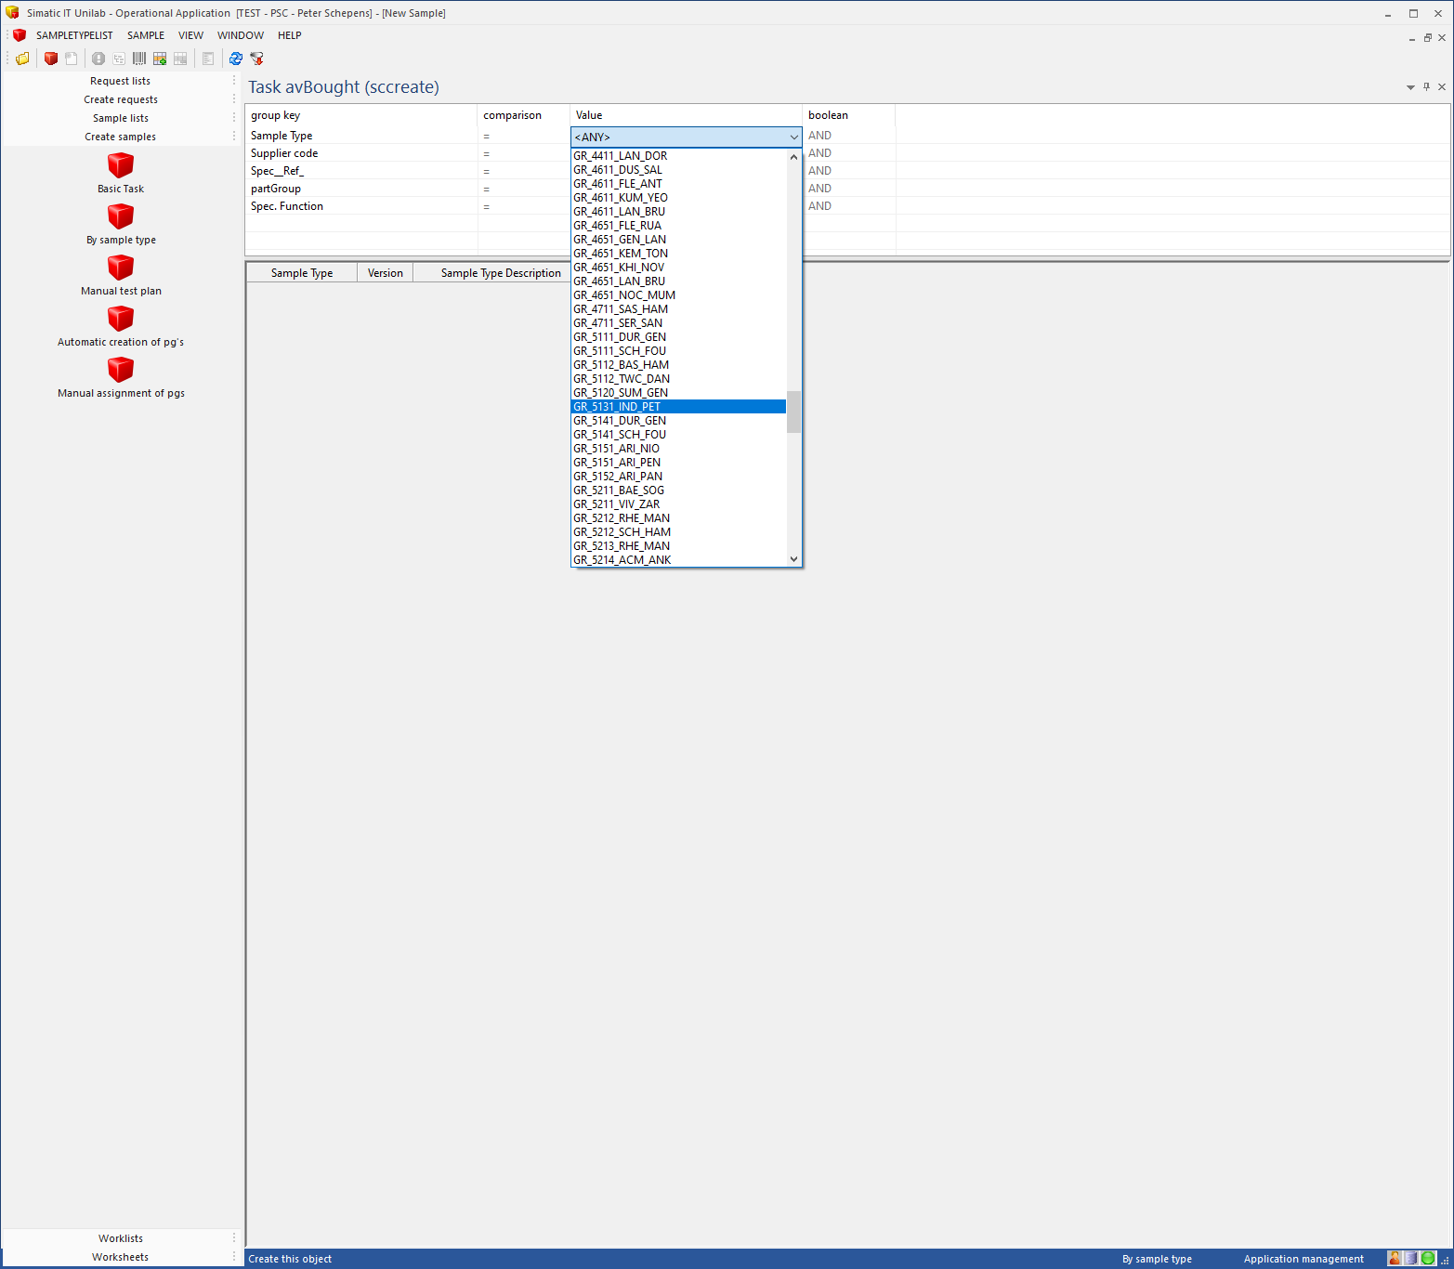

Of OPZOEKEN via SAMPLE-LIST

Bij tweede sample zie ik onder RESULTS wel een COA-PARAMETER-GROUP:

SC = 1831000630

Maar bij andere weer niet:

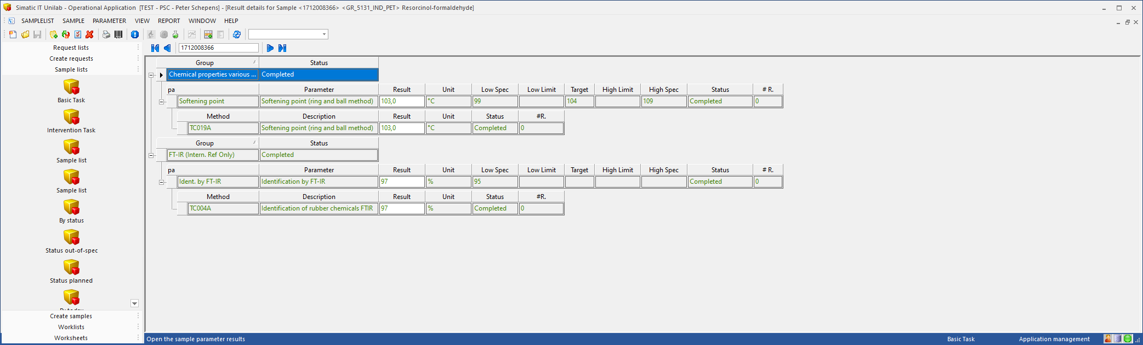 SC = 1712008366

UNACTION.IC_A01

--------------------------------------------------------------------------------

-- IC_A01: Write XML for PIBS

--------------------------------------------------------------------------------

FUNCTION IC_A01

RETURN APAOGEN.RETURN_TYPE IS

lcs_function_name CONSTANT APAOGEN.API_NAME_TYPE := ics_package_name||'.'||'IC_A01';

lvs_sqlerrm APAOGEN.ERROR_MSG_TYPE;

lvi_ret_code APAOGEN.RETURN_TYPE;

BEGIN

lvi_ret_code := APAOACTION.WRITEXML(UNAPIEV.P_SC);

RETURN UNAPIGEN.DBERR_SUCCESS;

EXCEPTION

WHEN OTHERS THEN

IF SQLCODE != 1 THEN

APAOGEN.LogError (lcs_function_name, SQLERRM);

END IF;

RETURN UNAPIGEN.DBERR_GENFAIL;

END IC_A01;

APAOACTION.WRITEXML

FUNCTION WriteXML(avs_sc IN VARCHAR)

RETURN APAOGEN.RETURN_TYPE IS

--------------------------------------------------------------------------------

-- Constants

--------------------------------------------------------------------------------

lcs_function_name CONSTANT APAOGEN.API_NAME_TYPE := ics_package_name || '.WriteXML';

--------------------------------------------------------------------------------

-- Variables

--------------------------------------------------------------------------------

lvi_ret_code APAOGEN.RETURN_TYPE;

--------------------------------------------------------------------------------

-- Cursors

--------------------------------------------------------------------------------

BEGIN

lvi_ret_code:= APAO_XML.WRITETOXML(avs_sc);

RETURN lvi_ret_code;

EXCEPTION

WHEN OTHERS THEN

IF SQLCODE != 1 THEN

APAOGEN.LogError (lcs_function_name, SQLERRM);

END IF;

RETURN SQLCODE;

END WriteXML;

APAO_XML.WRITETOXML

FUNCTION WriteToXML(avs_sc IN VARCHAR2)

RETURN NUMBER IS

--------------------------------------------------------------------------------

-- Types

--------------------------------------------------------------------------------

--------------------------------------------------------------------------------

-- Constants

--------------------------------------------------------------------------------

lcs_function_name CONSTANT VARCHAR2(40) := ics_package_name||'.'||'WriteToXML(2)';

--------------------------------------------------------------------------------

-- Cursors

--------------------------------------------------------------------------------

--------------------------------------------------------------------------------

-- Variables

--------------------------------------------------------------------------------

lvs_sqlerrm VARCHAR2(255);

lvi_ret_code NUMBER;

--------------------------------------------------------------------------------

-- Local functions and/or procedures

--------------------------------------------------------------------------------

BEGIN

lvi_ret_code := WriteToXML( 'XML',

'SELECT * FROM avao_sc_xml WHERE sc = ''' || avs_sc || '''');

RETURN lvi_ret_code;

EXCEPTION

WHEN OTHERS THEN

IF SQLCODE != 1 THEN

UNAPIGEN.LogError (lcs_function_name, SQLERRM);

END IF;

RETURN UNAPIGEN.DBERR_GENFAIL;

END WriteToXML;

VIEW: AVAO_SC_XML

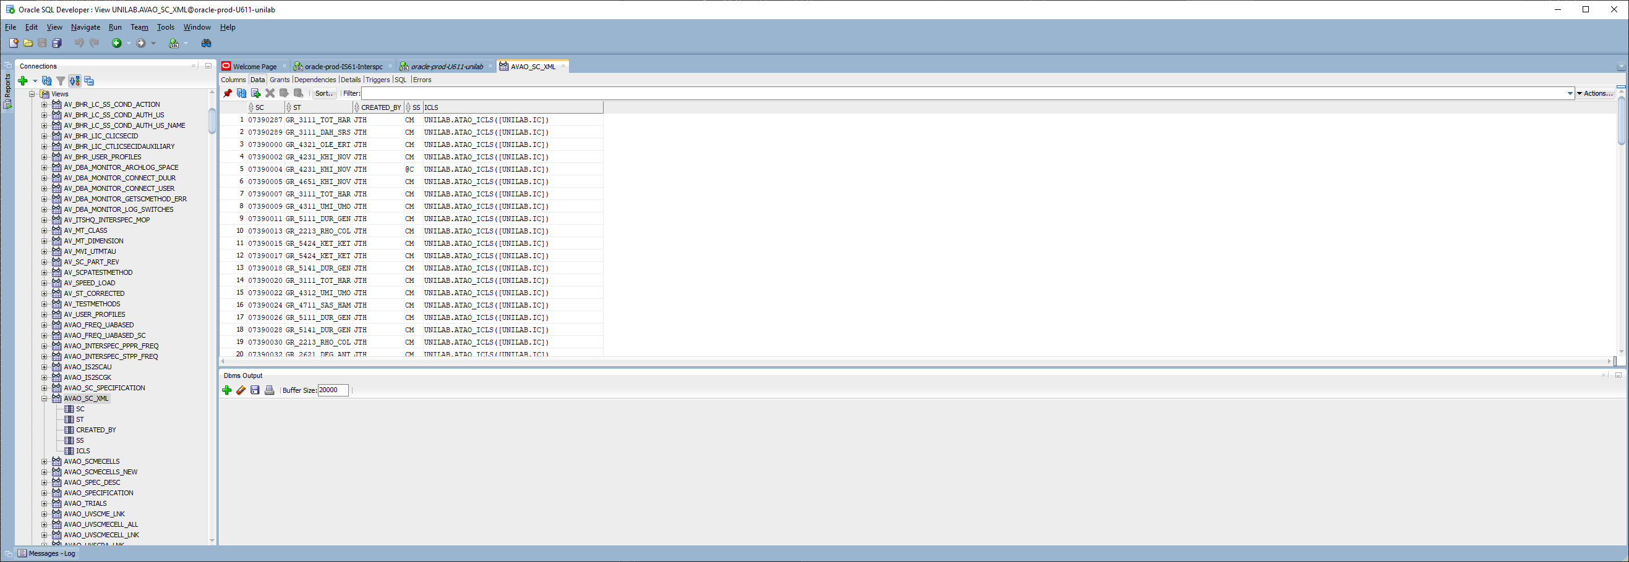

ICLS = UNILAB.ATAO_ICLS(UNILAB.IC)

BIJV. SC = 07390287

TYPE = ATAO_ICLS

create or replace TYPE "ATAO_ICLS" AS TABLE OF ic;

TYPE = IC

create or replace TYPE "IC" AS OBJECT (

IC VARCHAR2(20),

ICNODE NUMBER(9),

IP_VERSION VARCHAR2(20),

DESCRIPTION VARCHAR2(40),

WINSIZE_X NUMBER(4),

WINSIZE_Y NUMBER(4),

IS_PROTECTED CHAR (1),

HIDDEN CHAR (1),

MANUALLY_ADDED CHAR (1),

NEXT_II VARCHAR2(20),

IC_CLASS VARCHAR2(2),

LOG_HS CHAR (1),

LOG_HS_DETAILS CHAR (1),

ALLOW_MODIFY CHAR (1),

AR CHAR (1),

ACTIVE CHAR (1),

LC VARCHAR2(2),

LC_VERSION VARCHAR2(20),

SS VARCHAR2(2),

**IILS ATAO_IILS 🡪 VANUIT OBJECT IC WORDT weer STRUCTUUR VAN IILS AANGEROEPEN !!!**

);

create or replace TYPE "ATAO_IILS" AS TABLE OF ii;

ATAO_IILS TABLE OF UNILAB.II

Name Null? Type

-------------- ----- -------------------

II VARCHAR2(20 CHAR)

IINODE NUMBER(9)

IE_VERSION VARCHAR2(20 CHAR)

IIVALUE VARCHAR2(2000 CHAR)

POS_X NUMBER(4)

POS_Y NUMBER(4)

IS_PROTECTED CHAR(1 CHAR)

MANDATORY CHAR(1 CHAR)

HIDDEN CHAR(1 CHAR)

DSP_TITLE VARCHAR2(40 CHAR)

DSP_LEN NUMBER(4)

DSP_TP CHAR(1 CHAR)

DSP_ROWS NUMBER(3)

II_CLASS VARCHAR2(2 CHAR)

LOG_HS CHAR(1 CHAR)

LOG_HS_DETAILS CHAR(1 CHAR)

ALLOW_MODIFY CHAR(1 CHAR)

AR CHAR(1 CHAR)

ACTIVE CHAR(1 CHAR)

LC VARCHAR2(2 CHAR)

LC_VERSION VARCHAR2(20 CHAR)

SS VARCHAR2(2 CHAR)

DEZE STRUCTUUR KOMT INDERDAAD OVEREEN MET HETGEEN IN DE XML IN DE II-SECTIE KOMT TE STAAN !!!

VRAAG: HOE WORDT DEZE STRUCTUUR GEVULD? EN WAAR KOMT DE REST VAN DE XML-DATA VANDAAN?

<II>

<II>avRelease</II>

<IINODE>5000000</IINODE>

<IE_VERSION>0001.00</IE_VERSION>

<IIVALUE>0</IIVALUE>

<POS_X>156</POS_X>

<POS_Y>200</POS_Y>

<IS_PROTECTED>0</IS_PROTECTED>

<MANDATORY>0</MANDATORY>

<HIDDEN>1</HIDDEN>

<DSP_TITLE>Release on sample</DSP_TITLE>

<DSP_LEN>40</DSP_LEN>

<DSP_TP>B</DSP_TP>

<DSP_ROWS>0</DSP_ROWS>

<II_CLASS/>

<LOG_HS>1</LOG_HS>

<LOG_HS_DETAILS>1</LOG_HS_DETAILS>

<ALLOW_MODIFY>1</ALLOW_MODIFY>

<AR>W</AR>

<ACTIVE>0</ACTIVE>

<LC/>

<LC_VERSION/>

<SS/>

</II>

FUNCTION WriteToXML( avs_uc IN VARCHAR2,

avs_query IN VARCHAR2)

RETURN NUMBER IS

--------------------------------------------------------------------------------

-- Types

--------------------------------------------------------------------------------

--------------------------------------------------------------------------------

-- Constants

--------------------------------------------------------------------------------

lcs_function_name CONSTANT VARCHAR2(40) := ics_package_name||'.'||'WriteToXML(3)';

--------------------------------------------------------------------------------

-- Cursors

--------------------------------------------------------------------------------

--------------------------------------------------------------------------------

-- Variables

--------------------------------------------------------------------------------

lvs_sqlerrm VARCHAR2(255);

lvi_ret_code NUMBER;

--------------------------------------------------------------------------------

-- Local functions and/or procedures

--------------------------------------------------------------------------------

BEGIN

lvi_ret_code := WriteToXML( 'XML_OUT',

GenerateNextCodemask(avs_uc),

avs_query);

RETURN lvi_ret_code;

EXCEPTION

WHEN OTHERS THEN

IF SQLCODE != 1 THEN

UNAPIGEN.LogError (lcs_function_name, SQLERRM);

END IF;

RETURN UNAPIGEN.DBERR_GENFAIL;

END WriteToXML;

FUNCTION WriteToXML(avs_directory IN VARCHAR2,

avs_filename IN VARCHAR2,

avs_query IN VARCHAR2)

RETURN NUMBER IS

--------------------------------------------------------------------------------

-- Types

--------------------------------------------------------------------------------

--------------------------------------------------------------------------------

-- Constants

--------------------------------------------------------------------------------

lcs_function_name CONSTANT VARCHAR2(40) := ics_package_name||'.'||'WriteToXML(4)';

--------------------------------------------------------------------------------

-- Cursors

--------------------------------------------------------------------------------

--------------------------------------------------------------------------------

-- Variables

--------------------------------------------------------------------------------

lvs_sqlerrm VARCHAR2(255);

lvi_ret_code NUMBER;

queryCtx dbms_xmlstore.ctxType;

ctx dbms_xmlstore.ctxHandle;

lv_xml_clob CLOB;

lv_clob_len PLS_INTEGER;

--------------------------------------------------------------------------------

-- Local functions and/or procedures

--------------------------------------------------------------------------------

BEGIN

ctx := dbms_xmlgen.newContext(avs_query);

dbms_xmlgen.setRowTag(ctx, 'SC');

dbms_xmlgen.setRowSetTag(ctx, 'SCLS');

dbms_xmlgen.setNullHandling(ctx, dbms_xmlgen.EMPTY_TAG);

lv_xml_clob := dbms_xmlgen.getXML(ctx);

lv_clob_len := dbms_lob.getlength(lv_xml_clob);

lvi_ret_code := ClobToFile( avs_directory,

avs_filename,

lv_xml_clob);

dbms_xmlgen.closeContext(ctx);

RETURN lvi_ret_code;

EXCEPTION

WHEN OTHERS THEN

IF SQLCODE != 1 THEN

UNAPIGEN.LogError (lcs_function_name, SQLERRM);

END IF;

RETURN UNAPIGEN.DBERR_GENFAIL;

END WriteToXML;

UITPLUIZEN VAN DE SQL

SELECT * FROM avao_sc_xml WHERE sc = '07390287';

DIRECTORY:   
XML_OUT DIRECTORY_NAME XML_OUT  
 DIRECTORY_PATH D:\unilink\out  
 Privilege list READ, WRITE

EXPORT_DIR DIRECTORY_NAME EXPORT_DIR  
 DIRECTORY_PATH D:\Export\U611  
 Privilege list READ, WRITE

Roep deze procedure aan: bijv. met directory = EXPORT-DIR, om te voorkomen dat file door unilink of pibs wordt opgepakt…

Set serveroutput on

DECLARE

L_result number;

Begin

L_result := APAO_XML.WRITETOXML('EXPORT_DIR', 'COA_peter.xml', 'SELECT * FROM avao_sc_xml WHERE sc = '||''''||'07390287'||'''' );

Dbms_output.put_line('result: '||l_result);

End;

/

CREATE OR REPLACE FORCE VIEW "UNILAB"."AVAO_SC_XML"

( "SC"

, "ST"

, "CREATED_BY"

, "SS"

, "ICLS")

AS

SELECT m.sc

, m.st

, m.created_by

, m.ss

, CAST (MULTISET (SELECT ic  
 , icnode

, ip_version

, description

, winsize_x

, winsize_y

, is_protected

, hidden

, manually_added

, next_ii

, ic_class

, log_hs

, log_hs_details

, allow_modify

, ar

, active

, lc

, lc_version

, ss

, CAST (MULTISET (SELECT ii

, iinode

, ie_version

, iivalue

, pos_x

, pos_y

, is_protected

, mandatory

, hidden

, dsp_title

, dsp_len

, dsp_tp

, dsp_rows

, ii_class

, log_hs

, log_hs_details

, allow_modify

, ar

, active

, lc

, lc_version

, ss

FROM uvscii

WHERE sc(+) = a.sc

AND ic = a.ic

AND icnode = a.icnode

) AS atao_iils

) iils

FROM uvscic a

WHERE a.sc(+) = m.sc

) AS atao_icls

) icls

FROM utsc m

;

--

GRANT SELECT ON "UNILAB"."AVAO_SC_XML" TO "LIMS";

**LET OP: DE DB-TYPES (ATAO_IILS/ATAO_ICLS) zijn noodzakelijk voor gebruik in de VIEW !!! Geef je deze een andere ALIAS-naam dan krijg je ERROR bij creatie van de VIEW.**

Er wordt nu een XML-BESTAND aangemaakt in directory EXPORT_DIR

<?xml version="1.0"?>

<SCLS>

<SC>

<SC>07390287</SC>

<ST>GR_3111_TOT_HAR</ST>

<CREATED_BY>JTH</CREATED_BY>

<SS>CM</SS>

<ICLS>

<IC>

<IC>avBoughtRm</IC>

<ICNODE>1000000</ICNODE>

<IP_VERSION>0001.07</IP_VERSION>

<DESCRIPTION>Raw Materials default</DESCRIPTION>

<WINSIZE_X>290</WINSIZE_X>

<WINSIZE_Y>155</WINSIZE_Y>

<IS_PROTECTED>0</IS_PROTECTED>

<HIDDEN>0</HIDDEN>

<MANUALLY_ADDED>1</MANUALLY_ADDED>

<NEXT_II>avKlars</NEXT_II>

<IC_CLASS/>

<LOG_HS>1</LOG_HS>

<LOG_HS_DETAILS>1</LOG_HS_DETAILS>

<ALLOW_MODIFY>1</ALLOW_MODIFY>

<AR>W</AR>

<ACTIVE>0</ACTIVE>

<LC>@L</LC>

<LC_VERSION>0</LC_VERSION>

<SS>@E</SS>

<IILS>

<II>

<II>avAssignPg</II>

<IINODE>1000000</IINODE>

<IE_VERSION>0001.02</IE_VERSION>

<IIVALUE>CoA</IIVALUE>

<POS_X>155</POS_X>

<POS_Y>115</POS_Y>

<IS_PROTECTED>0</IS_PROTECTED>

<MANDATORY>0</MANDATORY>

<HIDDEN>0</HIDDEN>

<DSP_TITLE>Assign Pg</DSP_TITLE>

<DSP_LEN>40</DSP_LEN>

<DSP_TP>C</DSP_TP>

<DSP_ROWS>5</DSP_ROWS>

<II_CLASS/>

<LOG_HS>1</LOG_HS>

<LOG_HS_DETAILS>1</LOG_HS_DETAILS>

<ALLOW_MODIFY>1</ALLOW_MODIFY>

<AR>W</AR>

<ACTIVE>0</ACTIVE>

<LC/>

<LC_VERSION/>

<SS/>

</II>

<II>

<II>avAssignPgButton</II>

<IINODE>5000000</IINODE>

<IE_VERSION>0001.00</IE_VERSION>

<IIVALUE/>

<POS_X>355</POS_X>

<POS_Y>115</POS_Y>

<IS_PROTECTED>0</IS_PROTECTED>

<MANDATORY>0</MANDATORY>

<HIDDEN>0</HIDDEN>

<DSP_TITLE>Assign Pg</DSP_TITLE>

<DSP_LEN>20</DSP_LEN>

<DSP_TP>P</DSP_TP>

<DSP_ROWS>0</DSP_ROWS>

<II_CLASS/>

<LOG_HS>1</LOG_HS>

<LOG_HS_DETAILS>1</LOG_HS_DETAILS>

<ALLOW_MODIFY>1</ALLOW_MODIFY>

<AR>W</AR>

<ACTIVE>0</ACTIVE>

<LC/>

<LC_VERSION/>

<SS/>

</II>

<II>

<II>avCertificateLotnr</II>

<IINODE>9000000</IINODE>

<IE_VERSION>0001.00</IE_VERSION>

<IIVALUE>135007</IIVALUE>

<POS_X>155</POS_X>

<POS_Y>69</POS_Y>

<IS_PROTECTED>0</IS_PROTECTED>

<MANDATORY>0</MANDATORY>

<HIDDEN>0</HIDDEN>

<DSP_TITLE>Lotnr (Certificate)</DSP_TITLE>

<DSP_LEN>20</DSP_LEN>

<DSP_TP>I</DSP_TP>

<DSP_ROWS>1</DSP_ROWS>

<II_CLASS/>

<LOG_HS>1</LOG_HS>

<LOG_HS_DETAILS>1</LOG_HS_DETAILS>

<ALLOW_MODIFY>1</ALLOW_MODIFY>

<AR>W</AR>

<ACTIVE>0</ACTIVE>

<LC/>

<LC_VERSION/>

<SS/>

</II>

<II>

<II>avCertificateSeq</II>

<IINODE>8000000</IINODE>

<IE_VERSION>0001.01</IE_VERSION>

<IIVALUE>5746</IIVALUE>

<POS_X>155</POS_X>

<POS_Y>46</POS_Y>

<IS_PROTECTED>0</IS_PROTECTED>

<MANDATORY>0</MANDATORY>

<HIDDEN>0</HIDDEN>

<DSP_TITLE>Volgnr</DSP_TITLE>

<DSP_LEN>12</DSP_LEN>

<DSP_TP>I</DSP_TP>

<DSP_ROWS>1</DSP_ROWS>

<II_CLASS/>

<LOG_HS>1</LOG_HS>

<LOG_HS_DETAILS>1</LOG_HS_DETAILS>

<ALLOW_MODIFY>1</ALLOW_MODIFY>

<AR>W</AR>

<ACTIVE>0</ACTIVE>

<LC/>

<LC_VERSION/>

<SS/>

</II>

<II>

<II>avKlars</II>

<IINODE>2000000</IINODE>

<IE_VERSION>0001.00</IE_VERSION>

<IIVALUE/>

<POS_X>155</POS_X>

<POS_Y>184</POS_Y>

<IS_PROTECTED>0</IS_PROTECTED>

<MANDATORY>0</MANDATORY>

<HIDDEN>0</HIDDEN>

<DSP_TITLE>KLARS-code</DSP_TITLE>

<DSP_LEN>20</DSP_LEN>

<DSP_TP>I</DSP_TP>

<DSP_ROWS>1</DSP_ROWS>

<II_CLASS/>

<LOG_HS>1</LOG_HS>

<LOG_HS_DETAILS>1</LOG_HS_DETAILS>

<ALLOW_MODIFY>1</ALLOW_MODIFY>

<AR>W</AR>

<ACTIVE>0</ACTIVE>

<LC/>

<LC_VERSION/>

<SS/>

</II>

<II>

<II>avPibsLotNr</II>

<IINODE>4000000</IINODE>

<IE_VERSION>0001.03</IE_VERSION>

<IIVALUE/>

<POS_X>155</POS_X>

<POS_Y>92</POS_Y>

<IS_PROTECTED>0</IS_PROTECTED>

<MANDATORY>0</MANDATORY>

<HIDDEN>0</HIDDEN>

<DSP_TITLE>Lotnr (PIBS)</DSP_TITLE>

<DSP_LEN>80</DSP_LEN>

<DSP_TP>I</DSP_TP>

<DSP_ROWS>1</DSP_ROWS>

<II_CLASS/>

<LOG_HS>1</LOG_HS>

<LOG_HS_DETAILS>1</LOG_HS_DETAILS>

<ALLOW_MODIFY>1</ALLOW_MODIFY>

<AR>W</AR>

<ACTIVE>0</ACTIVE>

<LC/>

<LC_VERSION/>

<SS/>

</II>

<II>

<II>avRelease</II>

<IINODE>3000000</IINODE>

<IE_VERSION>0001.00</IE_VERSION>

<IIVALUE>0</IIVALUE>

<POS_X>155</POS_X>

<POS_Y>207</POS_Y>

<IS_PROTECTED>0</IS_PROTECTED>

<MANDATORY>0</MANDATORY>

<HIDDEN>1</HIDDEN>

<DSP_TITLE>Release on sample</DSP_TITLE>

<DSP_LEN>40</DSP_LEN>

<DSP_TP>B</DSP_TP>

<DSP_ROWS>0</DSP_ROWS>

<II_CLASS/>

<LOG_HS>1</LOG_HS>

<LOG_HS_DETAILS>1</LOG_HS_DETAILS>

<ALLOW_MODIFY>1</ALLOW_MODIFY>

<AR>W</AR>

<ACTIVE>0</ACTIVE>

<LC/>

<LC_VERSION/>

<SS/>

</II>

<II>

<II>avSpecRef</II>

<IINODE>6000000</IINODE>

<IE_VERSION>0001.02</IE_VERSION>

<IIVALUE>AV_3111S_1</IIVALUE>

<POS_X>155</POS_X>

<POS_Y>138</POS_Y>

<IS_PROTECTED>0</IS_PROTECTED>

<MANDATORY>0</MANDATORY>

<HIDDEN>0</HIDDEN>

<DSP_TITLE>Specification reference</DSP_TITLE>

<DSP_LEN>40</DSP_LEN>

<DSP_TP>C</DSP_TP>

<DSP_ROWS>3</DSP_ROWS>

<II_CLASS/>

<LOG_HS>1</LOG_HS>

<LOG_HS_DETAILS>1</LOG_HS_DETAILS>

<ALLOW_MODIFY>1</ALLOW_MODIFY>

<AR>W</AR>

<ACTIVE>0</ACTIVE>

<LC/>

<LC_VERSION/>

<SS/>

</II>

<II>

<II>avSupplierCode</II>

<IINODE>7000000</IINODE>

<IE_VERSION>0001.04</IE_VERSION>

<IIVALUE>TOTAL</IIVALUE>

<POS_X>155</POS_X>

<POS_Y>161</POS_Y>

<IS_PROTECTED>0</IS_PROTECTED>

<MANDATORY>0</MANDATORY>

<HIDDEN>0</HIDDEN>

<DSP_TITLE>Supplier Code</DSP_TITLE>

<DSP_LEN>40</DSP_LEN>

<DSP_TP>C</DSP_TP>

<DSP_ROWS>3</DSP_ROWS>

<II_CLASS/>

<LOG_HS>1</LOG_HS>

<LOG_HS_DETAILS>1</LOG_HS_DETAILS>

<ALLOW_MODIFY>1</ALLOW_MODIFY>

<AR>W</AR>

<ACTIVE>0</ACTIVE>

<LC/>

<LC_VERSION/>

<SS/>

</II>

</IILS>

</IC>

</ICLS>

</SC>

</SCLS>

UNACTION.PG_A04

--------------------------------------------------------------------------------

-- PG_A04: CoA:

-- Takes parameters out of other parameter profiles if PPPRAU: "CoA" = "Y"

-- and overwrites description in case PPPRAU-description. The names for the UA's

-- are configuratble in de ATOACONSTANT table.

-- also spec limits are copied

--------------------------------------------------------------------------------

FUNCTION PG_A04

RETURN APAOGEN.RETURN_TYPE IS

--------------------------------------------------------------------------------

-- Types

--------------------------------------------------------------------------------

--------------------------------------------------------------------------------

-- Constants

--------------------------------------------------------------------------------

lcs_function_name CONSTANT APAOGEN.API_NAME_TYPE := ics_package_name||'.'||'PG_A04';

--------------------------------------------------------------------------------

-- Cursors

--------------------------------------------------------------------------------

CURSOR lvq_add_pa (avs_st IN VARCHAR2, avs_st_version IN VARCHAR2) IS

SELECT c.pp original_pp, c.version original_pp_version, c.pp_key1 original_pp_key1,

c.pp_key2 original_pp_key2, c.pp_key3 original_pp_key3,

c.pp_key4 original_pp_key4, c.pp_key5 original_pp_key5,

c.seq original_seq, e.pr, e.version pr_version, NVL(f.value,'Do Nothing') description

FROM utstpp a, utpp b, utpppr c, utppprau d, utpr e, utppprau f

WHERE a.st = avs_st

AND a.version = avs_st_version

AND a.pp <> UNAPIEV.P_PG

AND a.pp = b.pp

AND a.pp_key1 = avs_st

AND b.version_is_current = '1'

AND b.version = c.version

AND a.pp = c.pp

AND a.pp_key1 = c.pp_key1

AND a.pp_key1 = b.pp_key1

AND a.pp = d.pp

AND a.pp_key1 = d.pp_key1

AND b.version = d.version

AND d.au = 'CoA'

AND d.value = 'Y'

AND c.pr_version = '~Current~'

AND d.pr_version = '~Current~'

AND c.pr = d.pr

AND c.pr = e.pr

AND e.version_is_current = '1'

AND c.pp = f.pp (+)

AND c.version = f.version (+)

AND c.pr = f.pr (+)

AND f.pr_version (+) = '~Current~'

AND c.pp_key1 = f.pp_key1 (+)

AND f.au(+) = ics_au_cust_description

ORDER BY a.seq ASC, c.seq ASC;

--------------------------------------------------------------------------------

-- Variables

--------------------------------------------------------------------------------

lvs_sqlerrm APAOGEN.ERROR_MSG_TYPE;

lvi_ret_code APAOGEN.RETURN_TYPE;

lvi_count PLS_INTEGER;

lvs_st APAOGEN.NAME_TYPE;

lvs_st_version APAOGEN.VERSION_TYPE;

lvn_panode APAOGEN.NODE_TYPE;

--------------------------------------------------------------------------------

-- Local functions and/or procedures

--------------------------------------------------------------------------------

BEGIN

-----------------------------------------------------------------------------

-- Check if attribute is present if not leave function

-----------------------------------------------------------------------------

SELECT COUNT(*)

INTO lvi_count

FROM utppau

WHERE pp = UNAPIEV.P_PG

AND au = ics_au_cust_pp_type;

IF lvi_count = 0 THEN

RETURN UNAPIGEN.DBERR_SUCCESS;

END IF;

-----------------------------------------------------------------------------

-- Get the sampletype from active sample

-----------------------------------------------------------------------------

SELECT st, st_version

INTO lvs_st, lvs_st_version

FROM utsc

WHERE sc = UNAPIEV.P_SC;

FOR lvr_add_pa IN lvq_add_pa (avs_st=>lvs_st, avs_st_version=>lvs_st_version) LOOP

--------------------------------------------------------------------------

-- Make sure the panode is always empty

--------------------------------------------------------------------------

lvn_panode := NULL;

lvi_ret_code := APAOFUNCTIONS.AssignParameter

(avs_sc =>UNAPIEV.P_SC,

avs_pg =>UNAPIEV.P_PG, avn_pgnode=>UNAPIEV.P_PGNODE, avs_pp_version=>lvr_add_pa.original_pp_version,

avs_pp_key1 =>lvr_add_pa.original_pp_key1,

avs_pp_key2 =>lvr_add_pa.original_pp_key2,

avs_pp_key3 =>lvr_add_pa.original_pp_key3,

avs_pp_key4 =>lvr_add_pa.original_pp_key4,

avs_pp_key5 =>lvr_add_pa.original_pp_key5,

avs_pa =>lvr_add_pa.pr, avn_panode=>lvn_panode, avs_pr_version=>lvr_add_pa.pr_version,

avs_modify_reason=>'Created by lifecycleaction ' || lcs_function_name || '.',

avb_with_details => FALSE);

--------------------------------------------------------------------------

-- Check if we have to update the description

--------------------------------------------------------------------------

IF lvr_add_pa.description <> 'Do Nothing' THEN

UPDATE utscpa

SET description = lvr_add_pa.description

WHERE sc = UNAPIEV.P_SC

AND pg = UNAPIEV.P_PG AND pgnode = UNAPIEV.P_PGNODE

AND pa = lvr_add_pa.pr AND panode = lvn_panode;

END IF;

--------------------------------------------------------------------------

-- Add the specifications

--------------------------------------------------------------------------

INSERT

INTO utscpaspa (sc, pg, pgnode, pa, panode,

low_limit, high_limit, low_spec, high_spec,

low_dev, rel_low_dev, target, high_dev, rel_high_dev)

SELECT UNAPIEV.P_SC, UNAPIEV.P_PG, UNAPIEV.P_PGNODE, lvr_add_pa.pr, lvn_panode,

low_limit, high_limit, low_spec, high_spec,

low_dev, rel_low_dev, target, high_dev, rel_high_dev

FROM utppspa

WHERE pp = lvr_add_pa.original_pp

AND version = lvr_add_pa.original_pp_version

AND pp_key1 = lvr_add_pa.original_pp_key1

AND pr = lvr_add_pa.pr

AND seq = lvr_add_pa.original_seq;

INSERT

INTO utscpaspb (sc, pg, pgnode, pa, panode,

low_limit, high_limit, low_spec, high_spec,

low_dev, rel_low_dev, target, high_dev, rel_high_dev)

SELECT UNAPIEV.P_SC, UNAPIEV.P_PG, UNAPIEV.P_PGNODE, lvr_add_pa.pr, lvn_panode,

low_limit, high_limit, low_spec, high_spec,

low_dev, rel_low_dev, target, high_dev, rel_high_dev

FROM utppspb

WHERE pp = lvr_add_pa.original_pp

AND version = lvr_add_pa.original_pp_version

AND pp_key1 = lvr_add_pa.original_pp_key1

AND pr = lvr_add_pa.pr

AND seq = lvr_add_pa.original_seq;

INSERT

INTO utscpaspc (sc, pg, pgnode, pa, panode,

low_limit, high_limit, low_spec, high_spec,

low_dev, rel_low_dev, target, high_dev, rel_high_dev)

SELECT UNAPIEV.P_SC, UNAPIEV.P_PG, UNAPIEV.P_PGNODE, lvr_add_pa.pr, lvn_panode,

low_limit, high_limit, low_spec, high_spec,

low_dev, rel_low_dev, target, high_dev, rel_high_dev

FROM utppspc

WHERE pp = lvr_add_pa.original_pp

AND version = lvr_add_pa.original_pp_version

AND pp_key1 = lvr_add_pa.original_pp_key1

AND pr = lvr_add_pa.pr

AND seq = lvr_add_pa.original_seq;

END LOOP;

-----------------------------------------------------------------------------

-- Always return success in an action

-----------------------------------------------------------------------------

RETURN UNAPIGEN.DBERR_SUCCESS;

EXCEPTION

WHEN OTHERS THEN

IF SQLCODE != 1 THEN

APAOGEN.LogError (lcs_function_name, SUBSTR ('sc='||UNAPIEV.P_SC||', pg= '||UNAPIEV.P_PG||': '||SQLERRM, 1, 255));

END IF;

-----------------------------------------------------------------------------

-- Always return success in an action

-----------------------------------------------------------------------------

RETURN UNAPIGEN.DBERR_SUCCESS;

END PG_A04;

LIFECYCLE aanroep van PG_A04

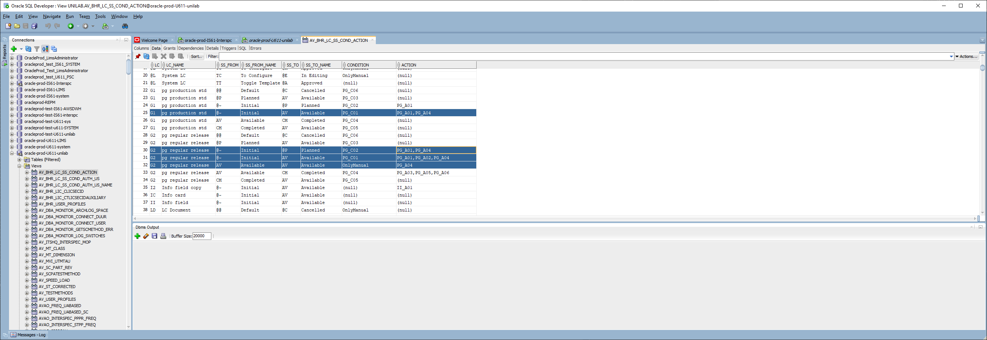 Dit gebeurt dus vanuit LC="pg production std" EN "pg regular release"

Tabel UTSCPAAU

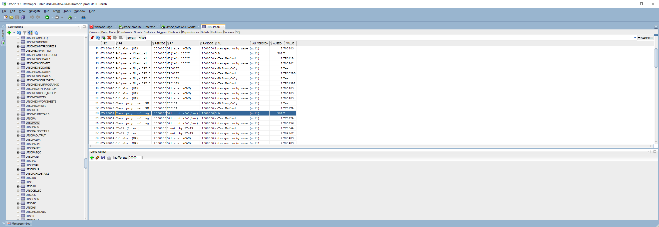 Hier zien we AU=COA met waarde=Y

Tabel UTSCPA

Tabel UTSCPASPA

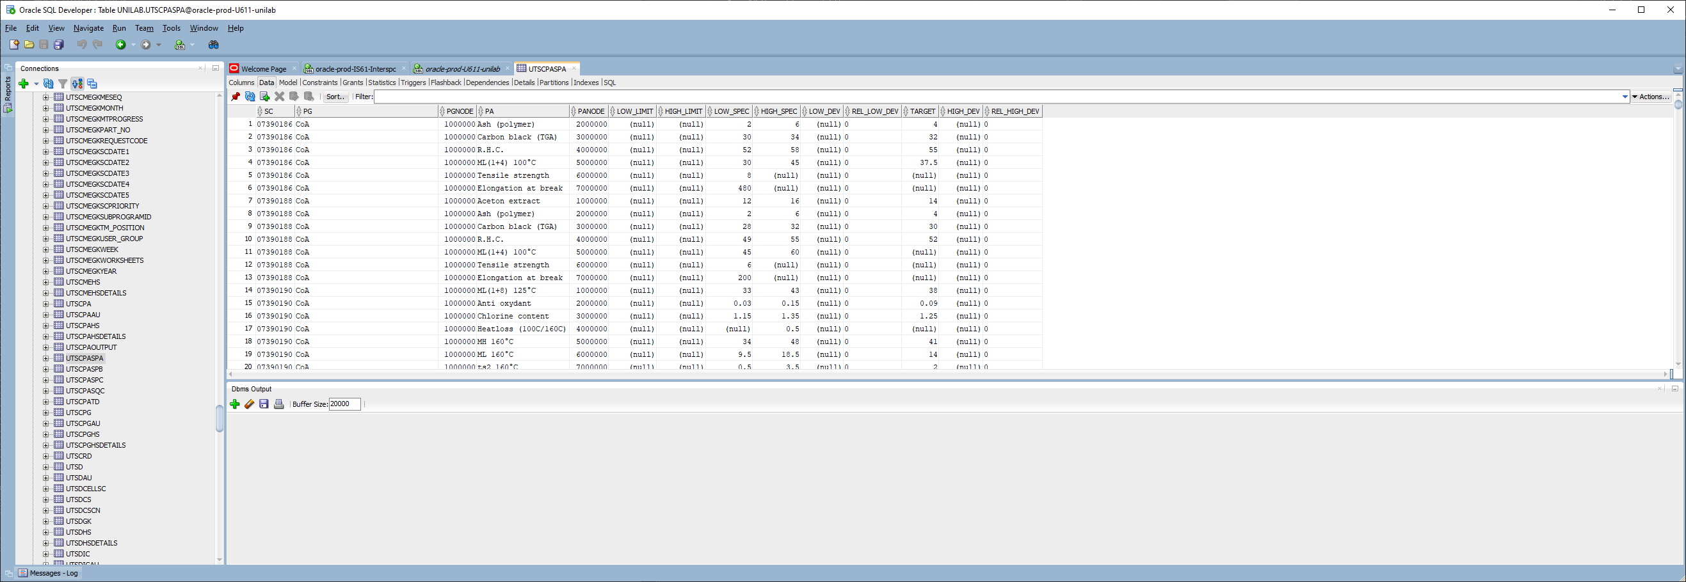 Tabellen UTSCPASPB + UTSCPASPC zijn leeg !!!!

Vergelijking van de db-types MET de db-tabellen

II

Name Null? Type

-------------- ----- -------------------

II VARCHAR2(20 CHAR)

IINODE NUMBER(9)

IE_VERSION VARCHAR2(20 CHAR)

IIVALUE VARCHAR2(2000 CHAR)

POS_X NUMBER(4)

POS_Y NUMBER(4)

IS_PROTECTED CHAR(1 CHAR)

MANDATORY CHAR(1 CHAR)

HIDDEN CHAR(1 CHAR)

DSP_TITLE VARCHAR2(40 CHAR)

DSP_LEN NUMBER(4)

DSP_TP CHAR(1 CHAR)

DSP_ROWS NUMBER(3)

II_CLASS VARCHAR2(2 CHAR)

LOG_HS CHAR(1 CHAR)

LOG_HS_DETAILS CHAR(1 CHAR)

ALLOW_MODIFY CHAR(1 CHAR)

AR CHAR(1 CHAR)

ACTIVE CHAR(1 CHAR)

LC VARCHAR2(2 CHAR)

LC_VERSION VARCHAR2(20 CHAR)

SS VARCHAR2(2 CHAR)

Tabel UTSCII

SC VARCHAR2(20 CHAR)

IC VARCHAR2(20 CHAR)

ICNODE NUMBER(9,0)

II VARCHAR2(20 CHAR)

IINODE NUMBER(9,0)

IE_VERSION VARCHAR2(20 CHAR)

IIVALUE VARCHAR2(2000 CHAR)

POS_X NUMBER(4,0)

POS_Y NUMBER(4,0)

IS_PROTECTED CHAR(1 CHAR)

MANDATORY CHAR(1 CHAR)

HIDDEN CHAR(1 CHAR)

DSP_TITLE VARCHAR2(40 CHAR)

DSP_LEN NUMBER(4,0)

DSP_TP CHAR(1 CHAR)

DSP_ROWS NUMBER(3,0)

II_CLASS VARCHAR2(2 CHAR)

LOG_HS CHAR(1 CHAR)

LOG_HS_DETAILS CHAR(1 CHAR)

ALLOW_MODIFY CHAR(1 CHAR)  
<ar>

ACTIVE CHAR(1 CHAR)

LC VARCHAR2(2 CHAR)

LC_VERSION VARCHAR2(20 CHAR)

SS VARCHAR2(2 CHAR)

AR1 CHAR(1 CHAR)

AR2 CHAR(1 CHAR)

AR3 CHAR(1 CHAR)

AR4 CHAR(1 CHAR)

AR5 CHAR(1 CHAR)

AR6 CHAR(1 CHAR)

AR7 CHAR(1 CHAR)

AR8 CHAR(1 CHAR)

AR9 CHAR(1 CHAR)

AR10 CHAR(1 CHAR)

AR11 CHAR(1 CHAR)

AR12 CHAR(1 CHAR)

AR13 CHAR(1 CHAR)

AR14 CHAR(1 CHAR)

AR15 CHAR(1 CHAR)

AR16 CHAR(1 CHAR)