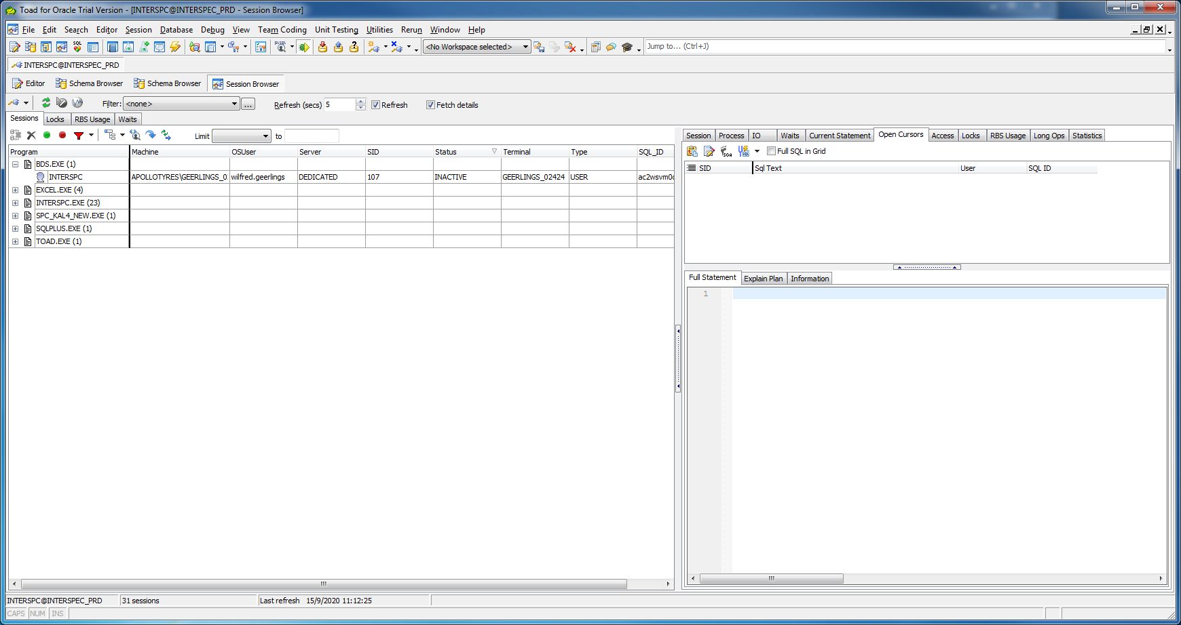

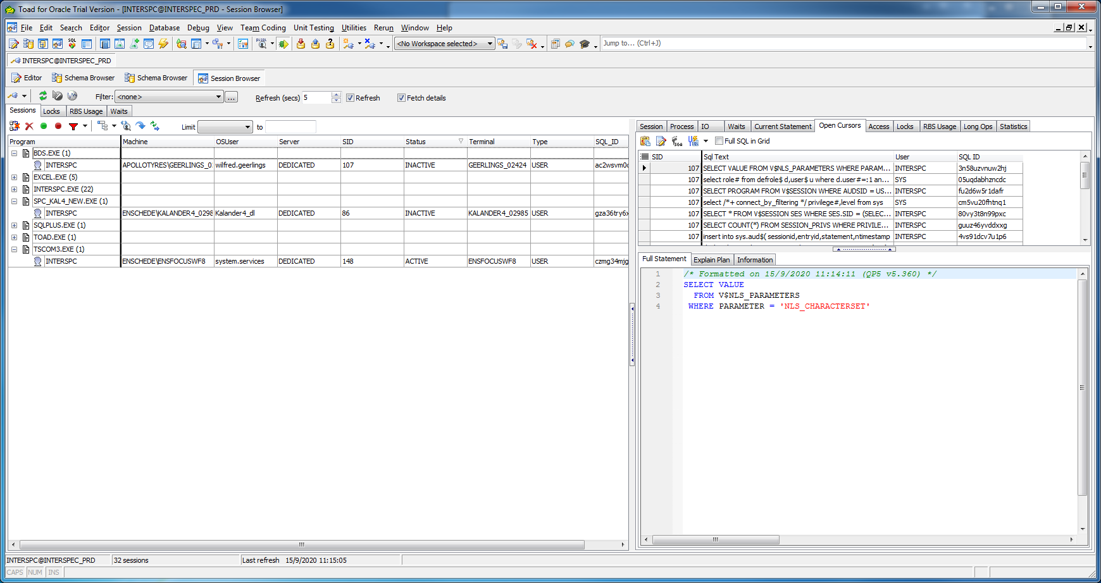

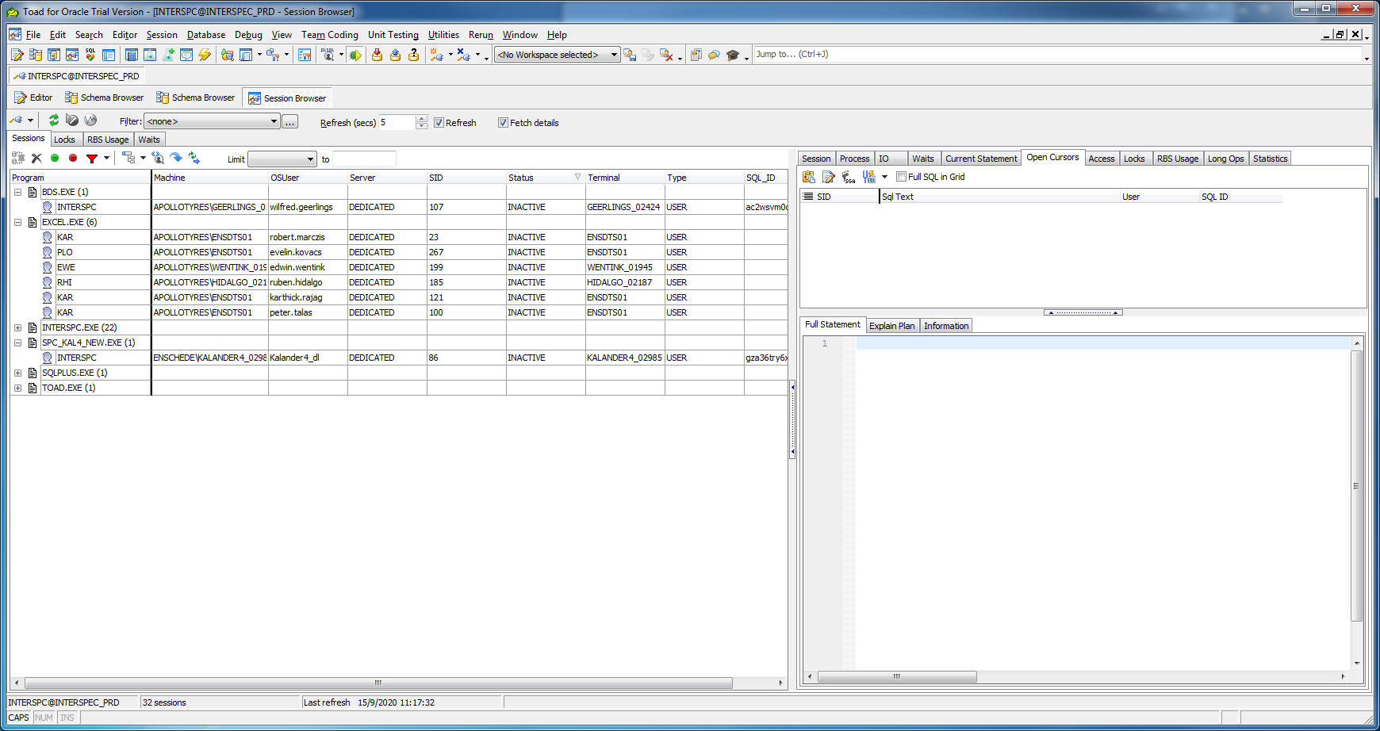

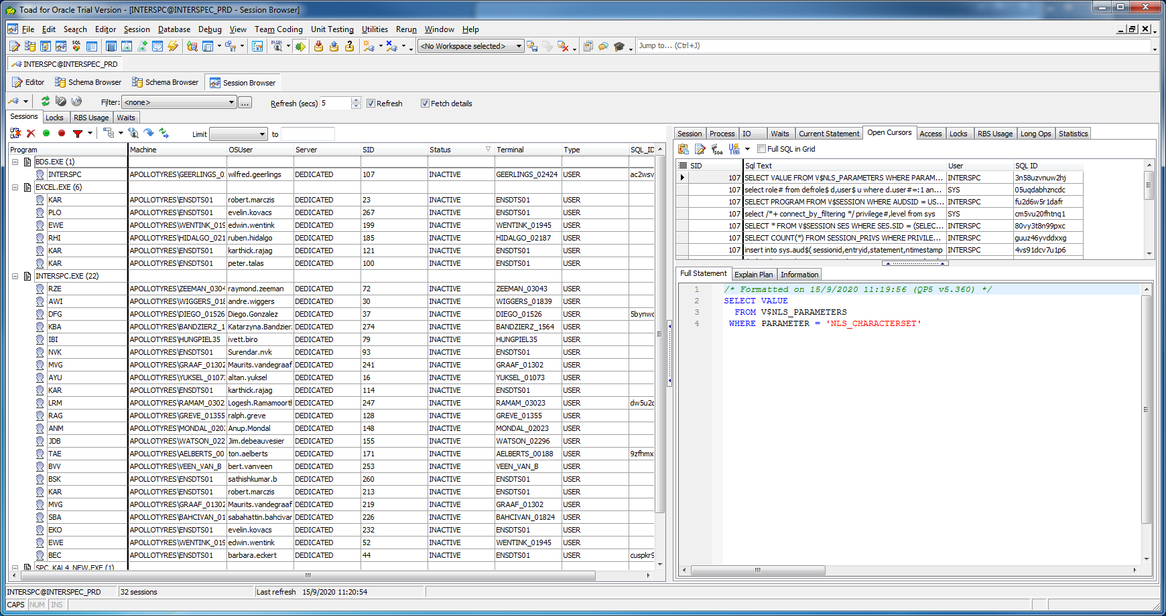

BDS.EXE INTERSPC Wilfred.Geerlings

EXCEL.EXE KAR Robert.marczis (APOLLOTYRES\ENSDTS01)  
 PLO evelin.kovacs (APOLLOTYRES\ENSDTS01)  
 EWE Edwin.wentink (APOLLOTYRES\WENTINK_015)  
 RHI Ruben.hidalgo (APOLLOTYRES\HIDALGO_021)

SPC_KAL4_NEW.EXE INTERSPC Kalander4_dl (ENSCHEDE\KALANDER4_0298)

TSCOM3.EXE system.services (ENSCHEDE\ENSFOCUSWF8)

INTERSPC.EXE RZE Raymond.zeeman (APOLLOTYRES\ZEEMAN_0304)  
 NVK surendar.nvk (APOLLOTYRES\ENSDTS01)