<https://www.educba.com/xml-encoding/>

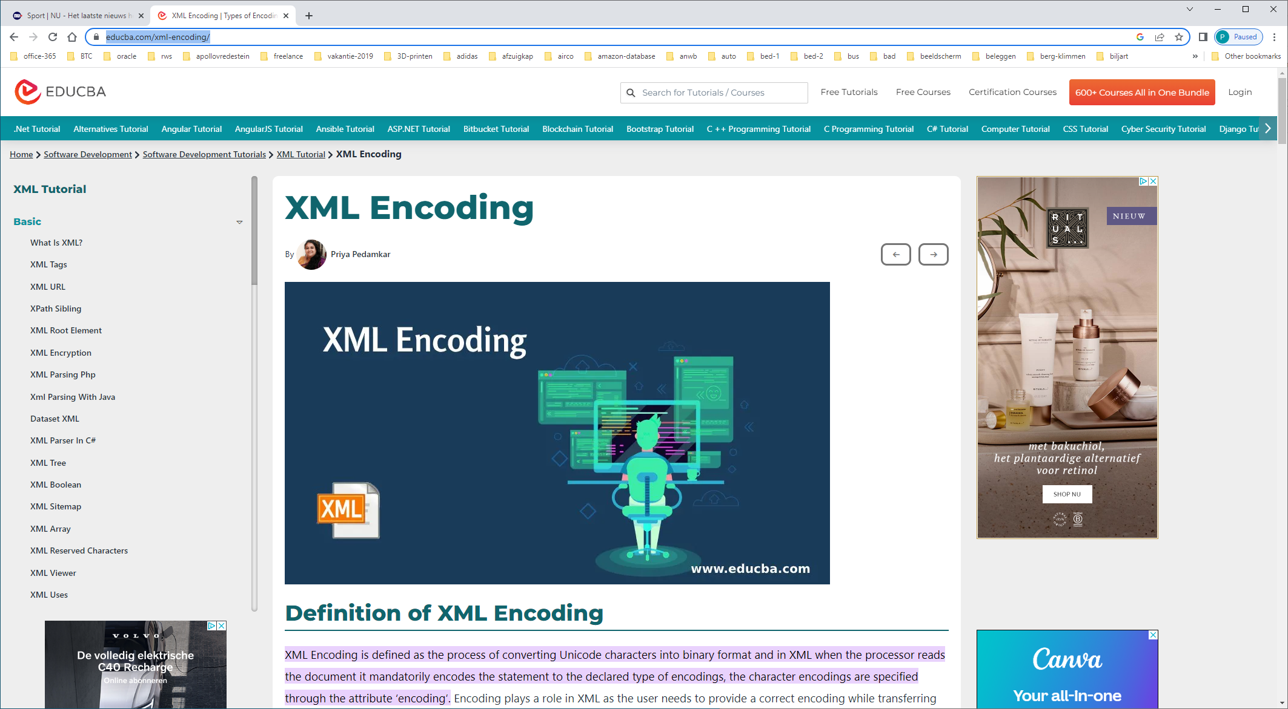

**UTF-8 Syntax**

<?xml version = "1.0" encoding = "UTF-8" standalone = "no" ?>  
- It’s a pure ASCII character.

For Western European Character set the declaration is as follows as they use non-English characters (Latin-1).

<xml version="1.0" encoding="ISO-8859-1" >