https://www.oracle.com/webfolder/technetwork/tutorials/obe/db/apex/r51/testing_and_debugging_sqldeveloper/testing_and_debugging_sqldeveloper.html

The procedure created in the earlier section was created with an error. You can locate errors in the code by debugging the code. You have to run a script before you actually start the debug process

Before you Debug

In order to debug a sub program you should have **DEBUG** privileges.

1. To check the privileges you can execute a SQL statement

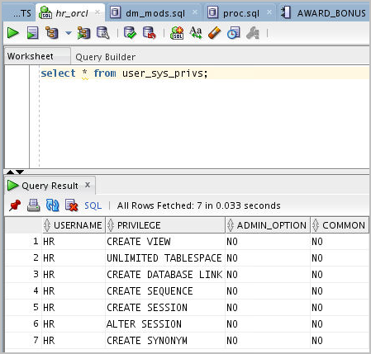[Description of this image](https://www.oracle.com/webfolder/technetwork/tutorials/obe/db/apex/r51/testing_and_debugging_sqldeveloper/files/tab05_01_01.txt)

You can see that the hr user doesn't have **DEBUG CONNECT** and **DEBUG** privileges

1. If you don't have the required **DEBUG** privileges, a **SYSDBA** role user has to assign them. Login as a **SYSDBA** user

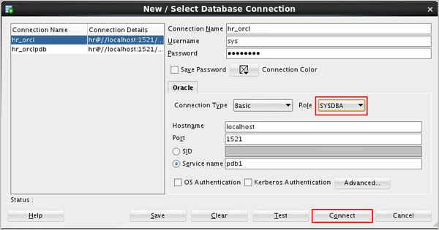[Description of this image](https://www.oracle.com/webfolder/technetwork/tutorials/obe/db/apex/r51/testing_and_debugging_sqldeveloper/files/tab05_01_02.txt)

1. Execute the grant commands and ACL(Access Control List) script shown as a SYSDBA user

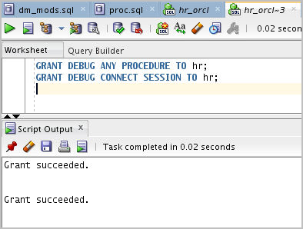[Description of this image](https://www.oracle.com/webfolder/technetwork/tutorials/obe/db/apex/r51/testing_and_debugging_sqldeveloper/files/tab05_01_03-2.txt)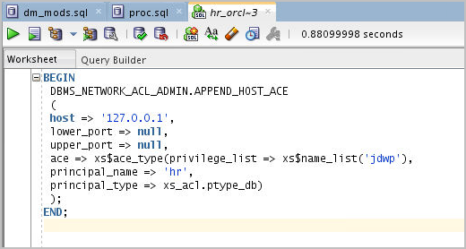[Description of this image](https://www.oracle.com/webfolder/technetwork/tutorials/obe/db/apex/r51/testing_and_debugging_sqldeveloper/files/tab05_01_03.txt)

1. Now login as hr user, who has a non-sysdba user role

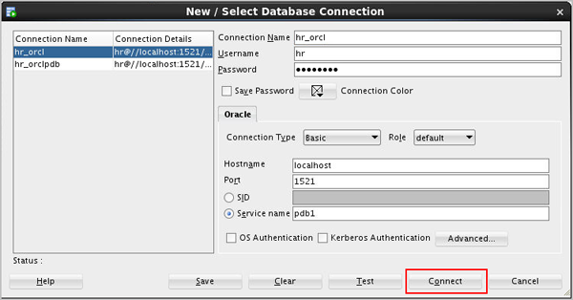[Description of this image](https://www.oracle.com/webfolder/technetwork/tutorials/obe/db/apex/r51/testing_and_debugging_sqldeveloper/files/tab05_01_04.txt)

1. Execute the SQL statement shown to check whether required privileges are granted to hr user

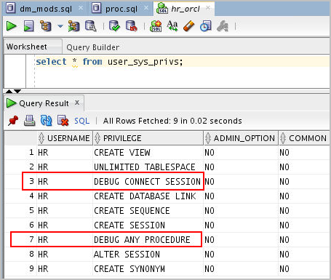[Description of this image](https://www.oracle.com/webfolder/technetwork/tutorials/obe/db/apex/r51/testing_and_debugging_sqldeveloper/files/tab05_01_05.txt)

Debugging

1. Now open the AWARD_BONUS procedure you created earlier. Compile the procedure

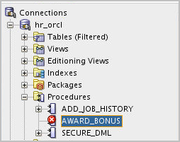[Description of this image](https://www.oracle.com/webfolder/technetwork/tutorials/obe/db/apex/r51/testing_and_debugging_sqldeveloper/files/tab05_02_01.txt)

You can see the error message in the compiler log. It specifies a line number where the error occurred

1. Modify the code in line 13 by adding a semi colon. Select the **Compile** icon.

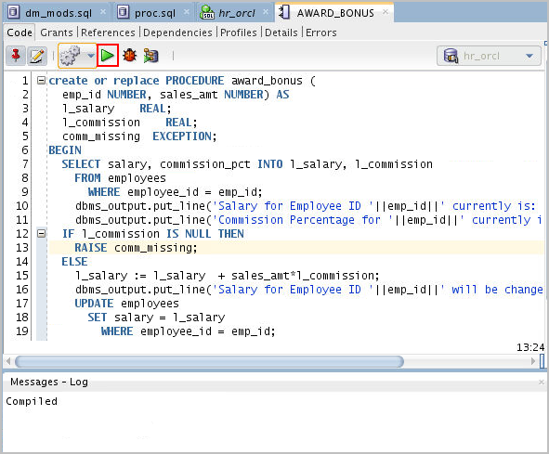[Description of this image](https://www.oracle.com/webfolder/technetwork/tutorials/obe/db/apex/r51/testing_and_debugging_sqldeveloper/files/tab05_02_05.txt)

Run the procedure by clicking on Run icon.

1. The Run PL/SQL dialog window appears. Notice that the values for EMP_ID and SALES_AMT are currently set to 1.

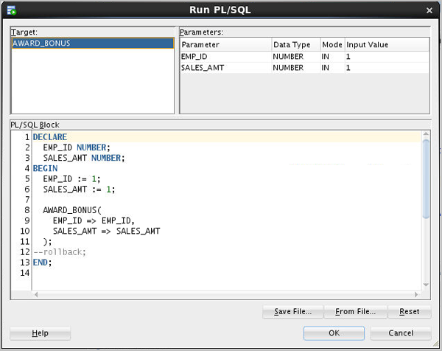[Description of this image](https://www.oracle.com/webfolder/technetwork/tutorials/obe/db/apex/r51/testing_and_debugging_sqldeveloper/files/tab05_02_07.txt)

1. Change the default values to **149** for EMP_ID and **2000** for SALES_AMT and click **OK**.

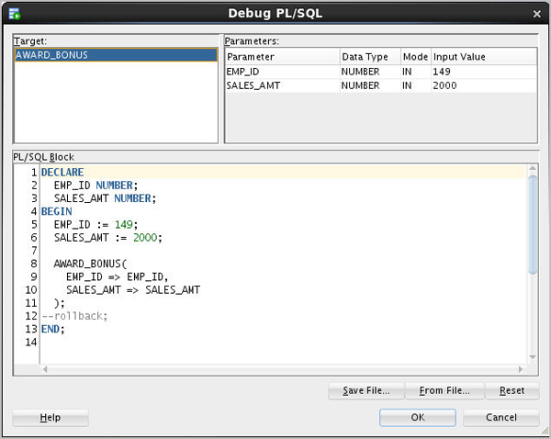[Description of this image](https://www.oracle.com/webfolder/technetwork/tutorials/obe/db/apex/r51/testing_and_debugging_sqldeveloper/files/tab05_02_10.txt)

1. Note that the procedure executed successfully and the value for salary was changed. To see how debug works, you create a break point. Click the line number **7**.

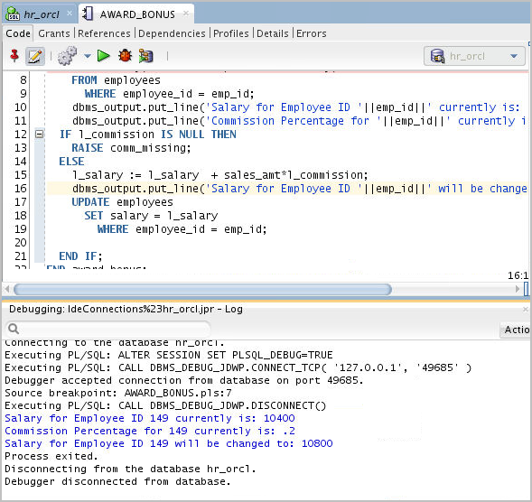[Description of this image](https://www.oracle.com/webfolder/technetwork/tutorials/obe/db/apex/r51/testing_and_debugging_sqldeveloper/files/tab05_02_17.txt)

1. When a break point is created at line 7, the execution will break at line 7 and allows developer to monitor the data held in different variables. Click the **Debug** icon.

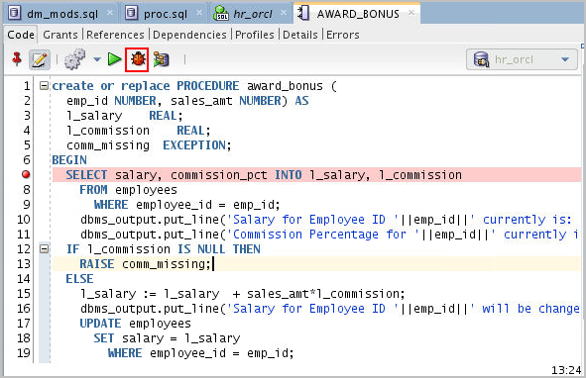[Description of this image](https://www.oracle.com/webfolder/technetwork/tutorials/obe/db/apex/r51/testing_and_debugging_sqldeveloper/files/tab05_02_09.txt)

1. Click **OK** to accept the same input values as before.

[Description of this image](https://www.oracle.com/webfolder/technetwork/tutorials/obe/db/apex/r51/testing_and_debugging_sqldeveloper/files/tab05_02_10.txt)

1. The debugger is running and has stopped at line 8. Click the **Smart Data** tab. The Smart Data tab holds the values of variables in the PL/SQL block. These are currently set to NULL.

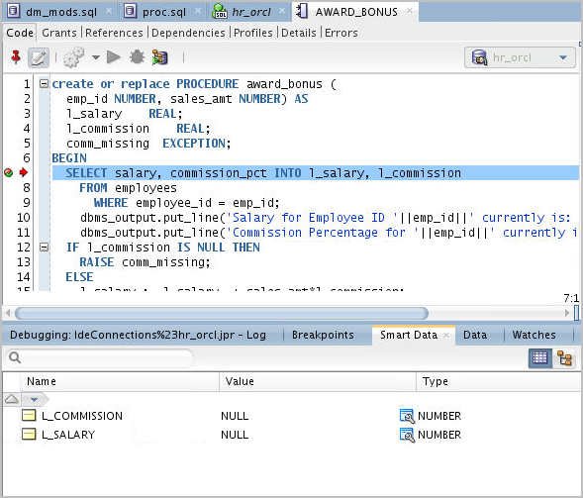[Description of this image](https://www.oracle.com/webfolder/technetwork/tutorials/obe/db/apex/r51/testing_and_debugging_sqldeveloper/files/tab05_02_11.txt)

1. You can see all the data manipulated in the procedure in the **Data** tab.

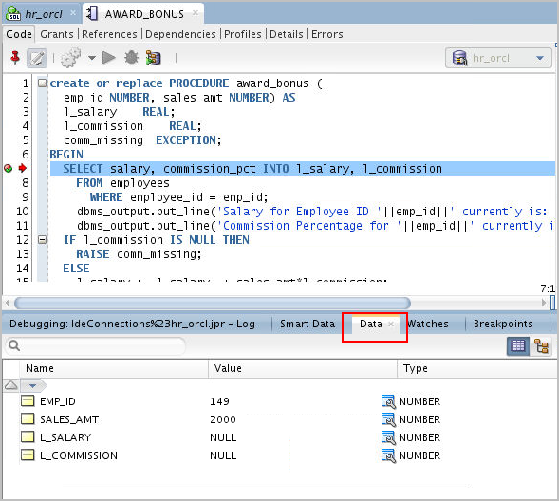[Description of this image](https://www.oracle.com/webfolder/technetwork/tutorials/obe/db/apex/r51/testing_and_debugging_sqldeveloper/files/tab05_02_12.txt)

You see that the current values of l_salary and l_commission are NULL.

1. Click the **Step Over** icon to move to the next statement in the procedure.

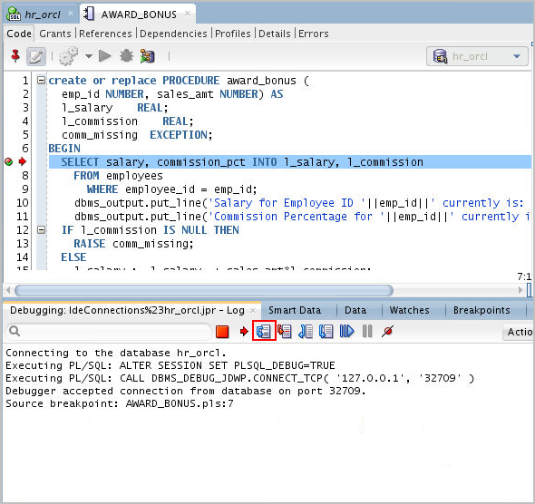[Description of this image](https://www.oracle.com/webfolder/technetwork/tutorials/obe/db/apex/r51/testing_and_debugging_sqldeveloper/files/tab05_02_13.txt)

1. Notice the values for l_salary and l_commission have changed to the existing values in the database, as the execution of select statement is complete, you can see the values from the database are fetched into the variables in the procedure.

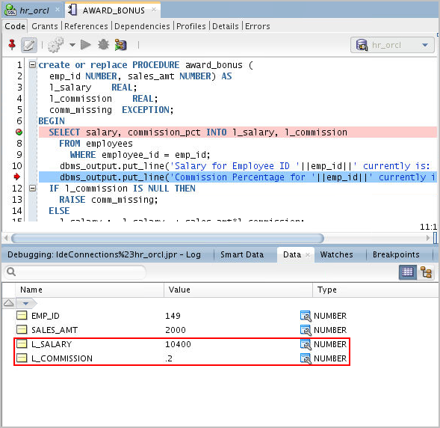[Description of this image](https://www.oracle.com/webfolder/technetwork/tutorials/obe/db/apex/r51/testing_and_debugging_sqldeveloper/files/tab05_02_14.txt)

1. Click the **Step Over** icon again to move to the next statement.As the execution of the update statement completes, you can see the new values of salary and commission in the Data tab

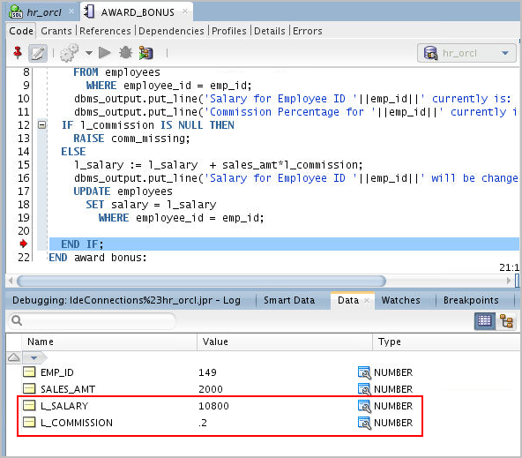[Description of this image](https://www.oracle.com/webfolder/technetwork/tutorials/obe/db/apex/r51/testing_and_debugging_sqldeveloper/files/tab05_02_15.txt)

1. Notice that the debugger moved to the next statement in the procedure. You want to run the rest of the procedure, click the **Resume** icon.

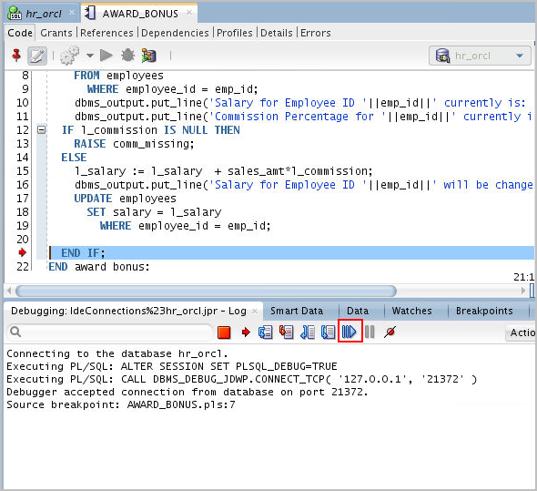[Description of this image](https://www.oracle.com/webfolder/technetwork/tutorials/obe/db/apex/r51/testing_and_debugging_sqldeveloper/files/tab05_02_16.txt)

1. Procedure execution and debugging is complete. In the next topic, you create a test repository so that you can create and run a unit test.

[Description of this image](https://www.oracle.com/webfolder/technetwork/tutorials/obe/db/apex/r51/testing_and_debugging_sqldeveloper/files/tab05_02_17.txt)