Introducing PL/SQL Unwrapper for SQL Developer



I’m using from time to time the free service [Unwrap it!](http://www.codecrete.net/UnwrapIt) or Niels Teusink’s Python script [unwrap.py](http://blog.teusink.net/2010/04/unwrapping-oracle-plsql-with-unwrappy.html) to unwrap PL/SQL code. Recently I’m confronted more with wrapped code since a customer is about to migrate to a new banking platform which is using wrapped PL/SQL code extensively. While investigating migration errors we experienced that unwrapping the called PL/SQL packages helped us a lot to identify the root cause faster. But since the unwrapping and debugging process is still a bit cumbersome for a series of PL/SQL packages a colleague asked me: “Wouldn’t it be nice if we could unwrap PL/SQL packages directly in SQL Developer?” and I answered “This should be simple. I’ve already written an extension for SQL Developer and the code in unwrap.py does not look too complicated.”

And on a rainy weekend I analyzed [Niels Teusink’s public domain Phyton script unwrap.py](http://blog.teusink.net/2010/04/unwrapping-oracle-plsql-with-unwrappy.html) and used it as a starting point for the development of a PL/SQL Unwrapper for SQL Developer.

Niels Teusink’s Python script unwrap.py (copy)

Even if this code looked straight forward on the first sight, it took me a moment or two to understand it. In fact I googled and found the following information helpful:

* David Litchfield’s [The Oracle Hacker’s Handbook: Hacking and Defending Oracle](http://www.amazon.de/Oracle-Hackers-Handbook-Hacking-Defending-ebook/dp/B000SEIC3K/ref=sr_1_1?s=digital-text&ie=UTF8&qid=1431864147&sr=1-1&keywords=kindle+The+Oracle+Hacker%27s+Handbook%3A+Hacking+and+Defending+Oracle) (chapter 5)
* Pete Finnigan’s [How to Unwrap PL/SQL](https://www.blackhat.com/presentations/bh-usa-06/BH-US-06-Finnigan.pdf). Pete provides a lot of useful resources on his [blog](http://www.petefinnigan.com/weblog/entries/) and has shown in this [post](http://www.petefinnigan.com/weblog/archives/00001298.htm), that he owns unwrappers for 9i and 10g, which should be capable to handle every wrapped code.
* Anton Scheffler’s blog post about [Unwrapping 10g wrapped PL/SQL](https://technology.amis.nl/2009/02/03/unwrapping-10g-wrapped-plsql/)
* [Automatic Detection of Vulnerabilities in Wrapped Packages in Oracle](http://webcourse.cs.technion.ac.il/236349/Spring2009/ho/WCFiles/final_report.pdf) by Yaron Gur-Arieh, Nikita Zubrilov and Ilya Kolchinsky
* Marcel Lambrechts’ blog about [Unwrapping Wrapped PL/SQL in Oracle 10gR2 – 12cR1](http://marcel.vandewaters.nl/oracle/security/unwrapping-wrapped-plsql-in-10g-and-11g)

After flipping through all these pages I had some second thoughts about publishing an unwrapper, especially since David, Pete and Anton were a bit secretive about certain details such as the substitution table. Obviously I decided to publish it nonetheless. Is this really harmful? There are already a couple of other 10g unwrapper available, such as:

* <http://www.codecrete.net/UnwrapIt>
* <http://marcel.vandewaters.nl/tools>
* <http://blog.teusink.net/2010/04/unwrapping-oracle-plsql-with-unwrappy.html>
* <https://code.google.com/p/plsqlunwrapper/>

In the end this is just another PL/SQL Unwrapper. However, I believe it delivers some additional value, if Oracle’s SQL Developer is the IDE of your choice. This is how it looks like on Windows:

[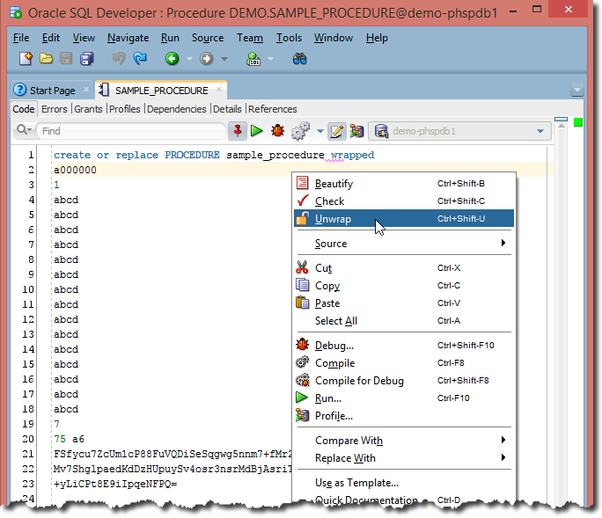](https://www.salvis.com/blog/wp-content/uploads/2015/05/unwrapper-windows.png)

The wrapped code will be replaced in the editor by the unwrapped code…

[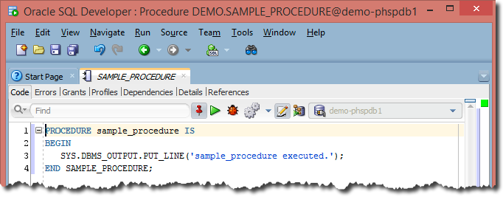](https://www.salvis.com/blog/wp-content/uploads/2015/05/unwrapper-windows-2.png)

…you have to pay attention to not save the unwrapped code by accident.

Grab your copy of Trivadis PL/SQL Unwrapper from the [download area](https://www.salvis.com/blog/download/). I hope it is useful.

36 Comments

1. ***Michal*** says:

[*2015-10-26 at 10:52*](https://www.salvis.com/blog/2015/05/17/introducing-plsql-unwrapper-for-sql-developer/#comment-3404)

Thanks a lot, saves a lot of time!

[Reply](https://www.salvis.com/blog/2015/05/17/introducing-plsql-unwrapper-for-sql-developer/#comment-3404)

1. ***Luis A*** says:

[*2015-11-05 at 16:47*](https://www.salvis.com/blog/2015/05/17/introducing-plsql-unwrapper-for-sql-developer/#comment-3454)

Awesome. I don’t need to go other places to unwrap the packages. I have all that I need in my SQL Developer tool.  
Thanks a lot for this post.

[Reply](https://www.salvis.com/blog/2015/05/17/introducing-plsql-unwrapper-for-sql-developer/#comment-3454)

1. ***Ashly*** says:

[*2016-02-09 at 23:53*](https://www.salvis.com/blog/2015/05/17/introducing-plsql-unwrapper-for-sql-developer/#comment-3701)

Hi Phillip – Thanks a ton for this unwrap extension to SQL Developer , saved me so much time and effort! Kudos to your efforts!

Thanks,

Ashly.

[Reply](https://www.salvis.com/blog/2015/05/17/introducing-plsql-unwrapper-for-sql-developer/#comment-3701)

1. ***Oleg*** says:

[*2016-02-18 at 22:00*](https://www.salvis.com/blog/2015/05/17/introducing-plsql-unwrapper-for-sql-developer/#comment-3706)

Phillip, I’ve downloaded .jar file. What I need to do further in order to get the final result: “Unwrap” submenu in “right click”-menu of SQLDeveloper’s editor. Sorry, I’m not a Java developer. Thanks in advance. Oleg

[Reply](https://www.salvis.com/blog/2015/05/17/introducing-plsql-unwrapper-for-sql-developer/#comment-3706)

* + [***Philipp Salvisberg***](http://www.salvis.com/) says:

[*2016-02-18 at 22:41*](https://www.salvis.com/blog/2015/05/17/introducing-plsql-unwrapper-for-sql-developer/#comment-3707)

Hello Oleg,

You have to start SQL Developer and install the downloaded Unwrapper_for_SQLDev_0.1.1.zip file. Please follow the instructions under “Installation” at the bottom of [https://www.salvis.com/blog/downloads/plsql-unwrapper-for-sql-developer/](https://www.salvis.com/blog/plsql-unwrapper-for-sql-developer/). See also the FAQ section, specifically <https://www.salvis.com/blog/faq/i-cannot-install-any-extension-on-windows/> if you are using Windows.

Best Regards,  
Philipp

# PL/SQL Unwrapper for SQL Developer https://github.com/Trivadis/plsql-unwrapper-sqldev

## Introduction

PL/SQL Unwrapper for SQL Developer is a free extension to unwrap PL/SQL code wrapped with the wrap utility of the Oracle Database Server version 10g, 11g, 12c, 18c or 19c.

## Example

Open a wrapped PL/SQL unit (procedure, function, package specification, package body, type specification or type body) in a SQL Developer editor

[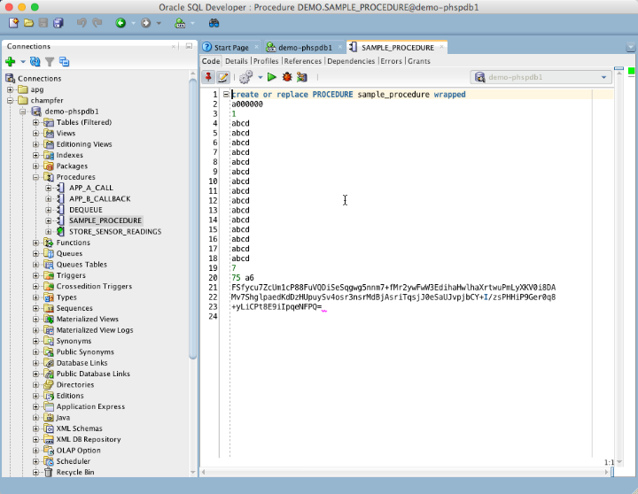](https://github.com/Trivadis/plsql-unwrapper-sqldev/blob/main/images/unwrapper-1.png)

Right-click within editor to show the pop-up-menu. Select Unwrap or simply press Ctrl-Shift-U to unwrap the code.

[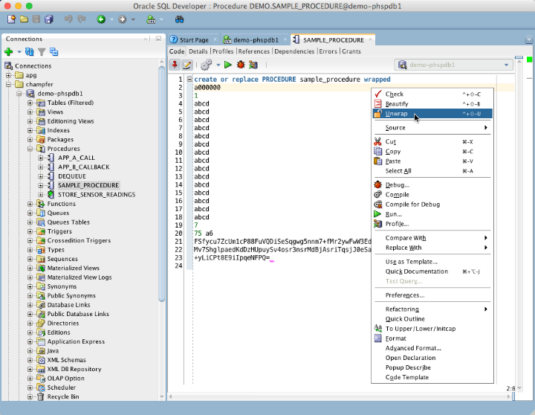](https://github.com/Trivadis/plsql-unwrapper-sqldev/blob/main/images/unwrapper-2.png)

The editor content is replaced by the unwrapped code.

[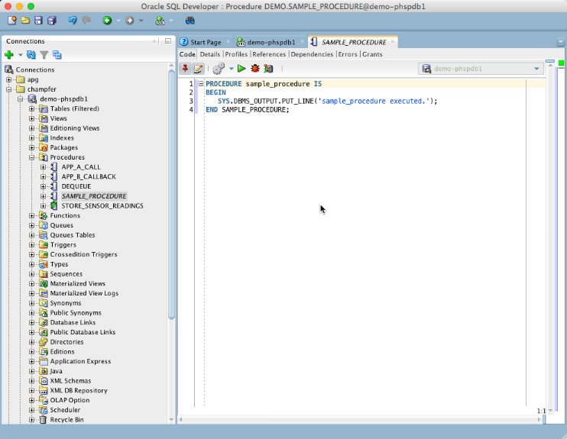](https://github.com/Trivadis/plsql-unwrapper-sqldev/blob/main/images/unwrapper-3.png)

By default the unwrapped code does not contain a valid DDL statement. In this case the CREATE is missing. You may change this behaviour in in the preferences.

[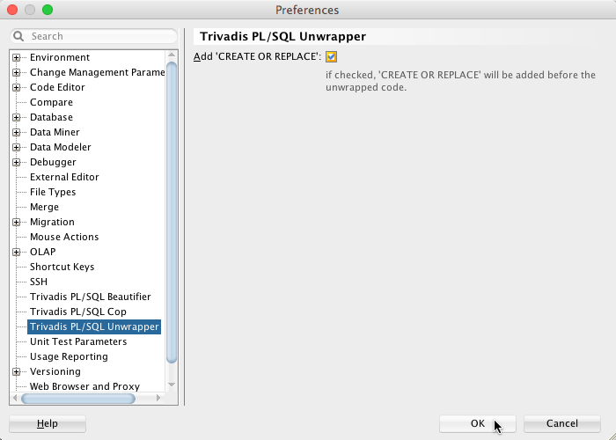](https://github.com/Trivadis/plsql-unwrapper-sqldev/blob/main/images/unwrapper-4.png)

Check the Add ‘CREATE OR REPLACE' option to get a complete DDL statement.

[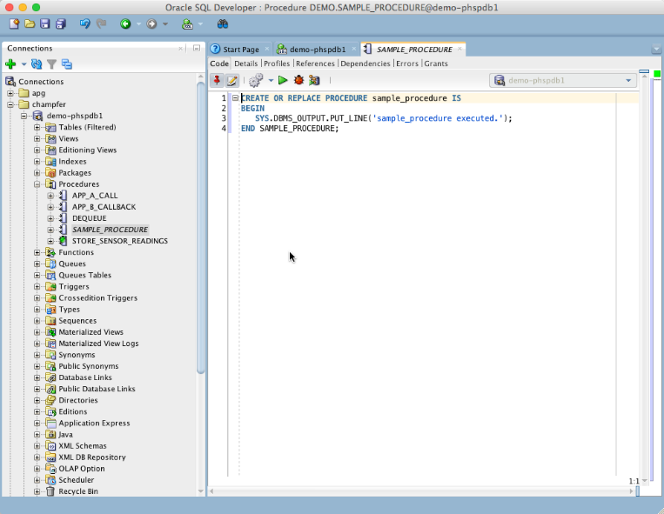](https://github.com/Trivadis/plsql-unwrapper-sqldev/blob/main/images/unwrapper-5.png)

## Bulk Unwrap

If you install [oddgen for SQL Developer](https://www.oddgen.org/) you will see a PL/SQL Unwrapper node in the Generators window:

[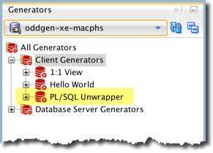](https://github.com/Trivadis/plsql-unwrapper-sqldev/blob/main/images/generators.png)

Open the PL/SQL Unwrapper node to show all wrapped objects in the navigator tree. Select one or more objects to unwrap. The following audioless video shows how to unwrap all package bodies in a schema in one go:

[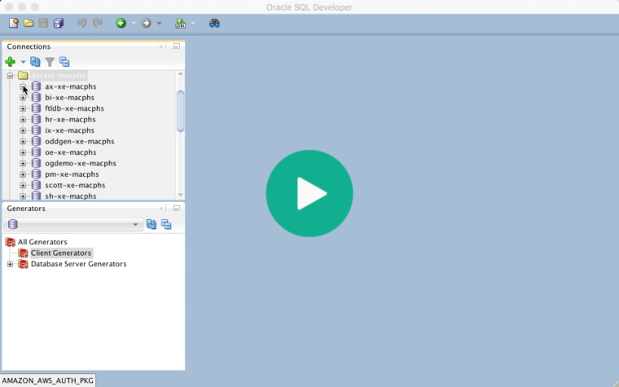](https://trivadis.github.io/plsql-unwrapper-sqldev/unwrapper.mp4)

## Configure Update Center

Click the Help menu and select Check for Updates…. Press the Add button to register the update center <http://update.salvis.com/> . If you have troubles to configure the proxy settings, because your company requires some additional authentication or similar, then I suggest to download PL/SQL Unwrapper for SQL Developer from [here](https://github.com/Trivadis/plsql-unwrapper-sqldev/releases) and use the Install From Local File option.

[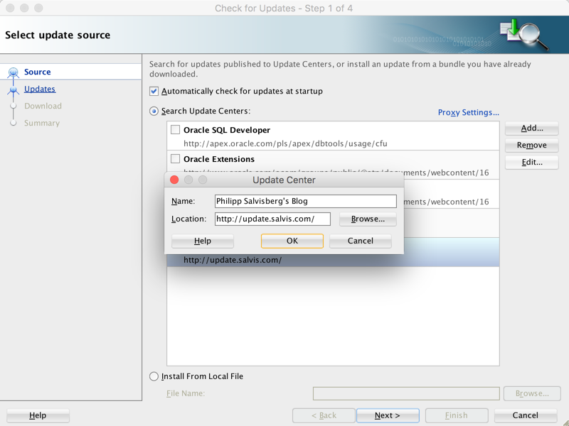](https://github.com/Trivadis/plsql-unwrapper-sqldev/blob/main/images/salvis-update-center.png)

## Releases

You find all releases and release information [here](https://github.com/Trivadis/plsql-unwrapper-sqldev/releases).

## Issues

Please file your bug reports, enhancement requests, questions and other support requests within [Github's issue tracker](https://help.github.com/articles/about-issues/).

* [Questions](https://github.com/trivadis/plsql-unwrapper-sqldev/issues?q=is%3Aissue+label%3Aquestion)
* [Open enhancements](https://github.com/trivadis/plsql-unwrapper-sqldev/issues?q=is%3Aopen+is%3Aissue+label%3Aenhancement)
* [Open bugs](https://github.com/trivadis/plsql-unwrapper-sqldev/issues?q=is%3Aopen+is%3Aissue+label%3Abug)
* [Submit new issue](https://github.com/trivadis/plsql-unwrapper-sqldev/issues/new)

## Frequently Asked Questions

see [Frequently Ased Questions](https://github.com/Trivadis/plsql-unwrapper-sqldev/blob/main/FAQ.md).

## License

PL/SQL Unwrapper is licensed under the Creative Commons Attribution-NonCommercial-NoDerivs 3.0 Unported License. You may obtain a copy of the License at <https://creativecommons.org/licenses/by-nc-nd/3.0/>.