**https://github.com/Trivadis/plsql-unwrapper-sqldev**

**PL/SQL Unwrapper for SQL Developer**

**Introduction**

PL/SQL Unwrapper for SQL Developer is a free extension to unwrap PL/SQL code wrapped with the wrap utility of the Oracle Database Server version 10g, 11g, 12c, 18c or 19c.

**Example**

Open a wrapped PL/SQL unit (procedure, function, package specification, package body, type specification or type body) in a SQL Developer editor

[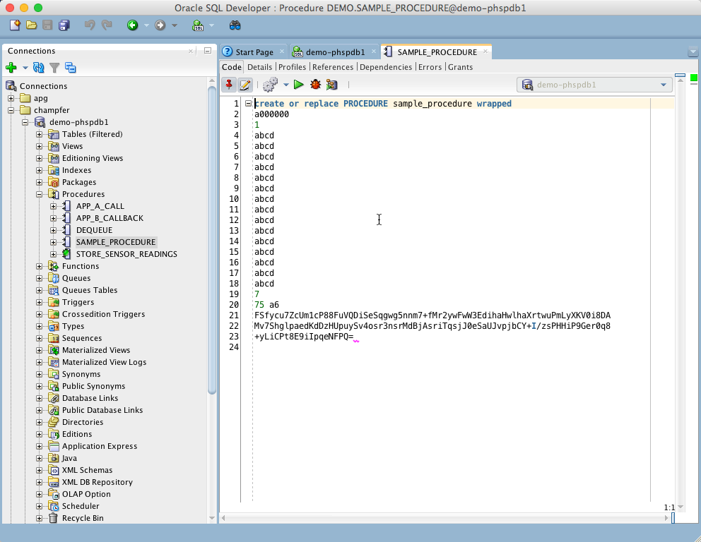](https://github.com/Trivadis/plsql-unwrapper-sqldev/blob/main/images/unwrapper-1.png)

Right-click within editor to show the pop-up-menu. Select Unwrap or simply press Ctrl-Shift-U to unwrap the code.

[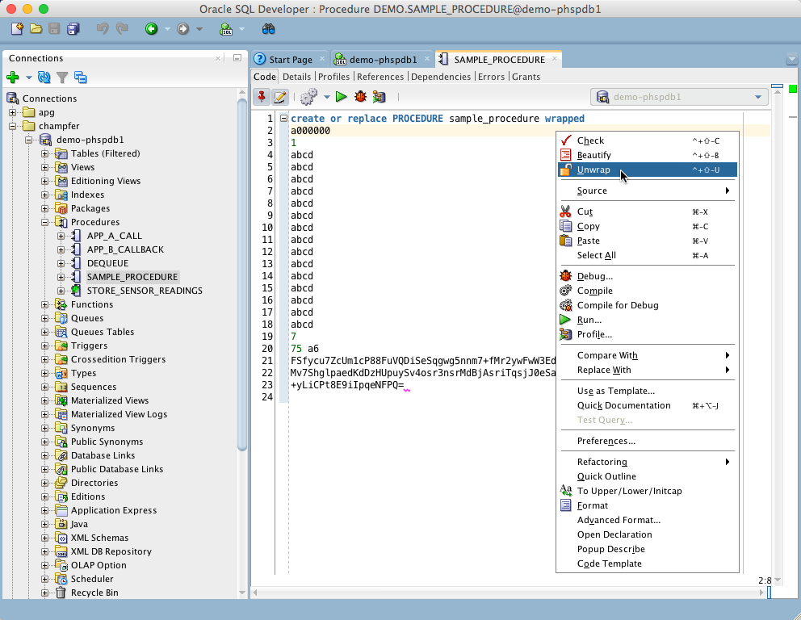](https://github.com/Trivadis/plsql-unwrapper-sqldev/blob/main/images/unwrapper-2.png)

The editor content is replaced by the unwrapped code.

[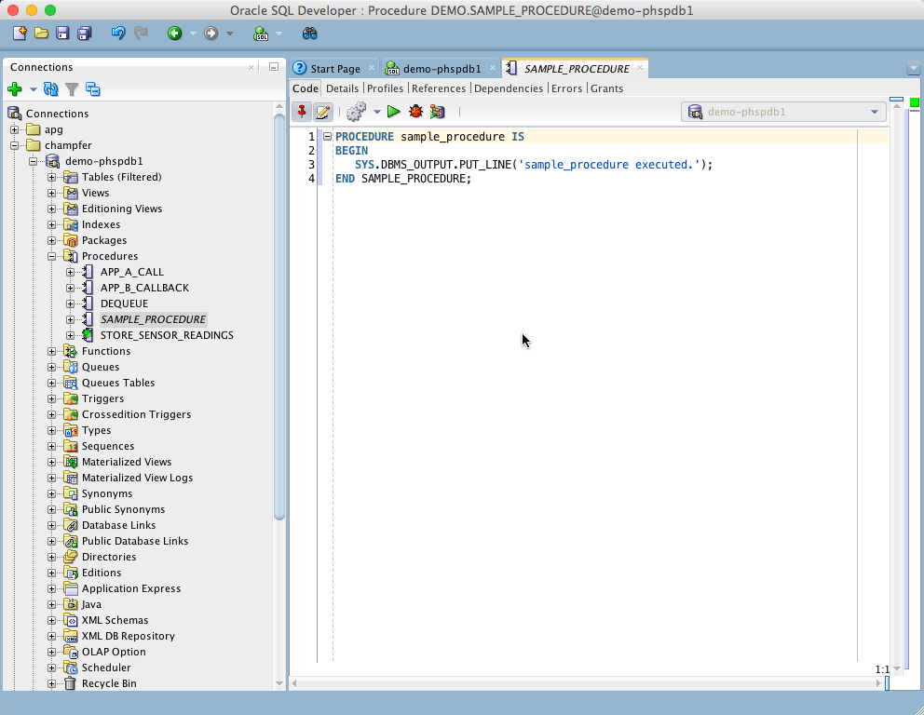](https://github.com/Trivadis/plsql-unwrapper-sqldev/blob/main/images/unwrapper-3.png)

By default the unwrapped code does not contain a valid DDL statement. In this case the CREATE is missing. You may change this behaviour in in the preferences.

[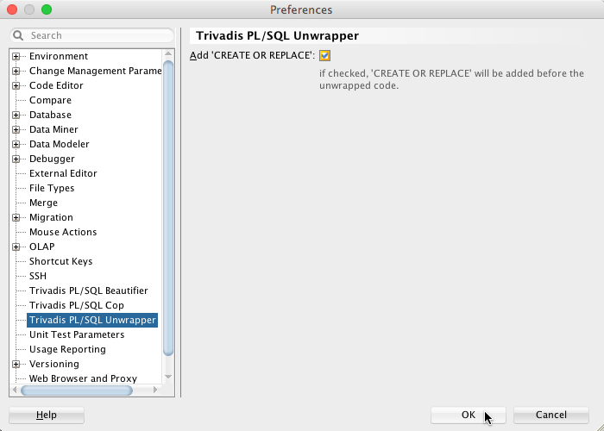](https://github.com/Trivadis/plsql-unwrapper-sqldev/blob/main/images/unwrapper-4.png)

Check the Add ‘CREATE OR REPLACE' option to get a complete DDL statement.

[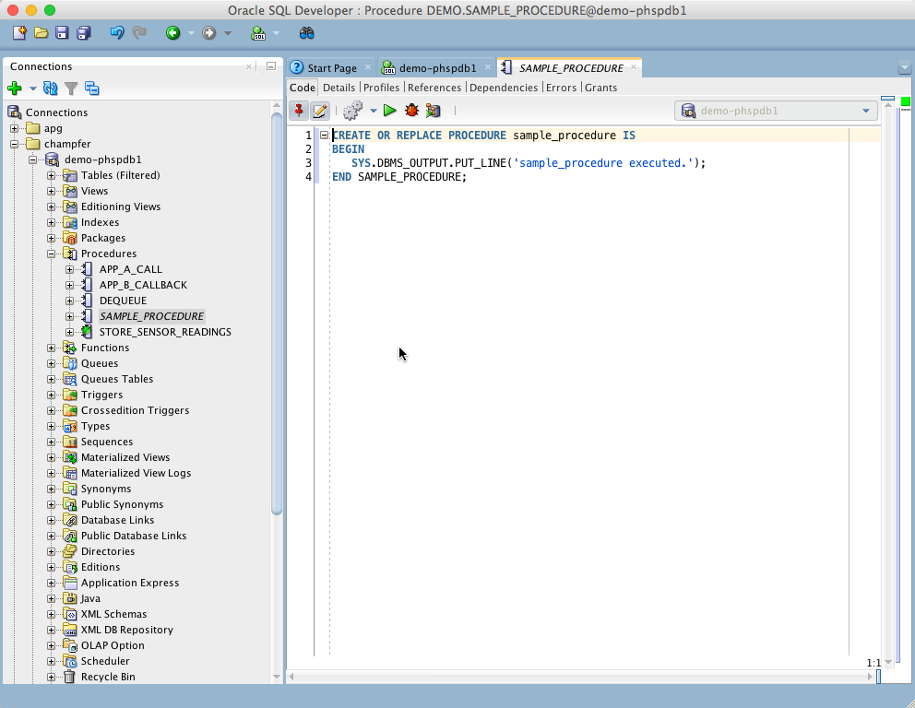](https://github.com/Trivadis/plsql-unwrapper-sqldev/blob/main/images/unwrapper-5.png)

**Bulk Unwrap**

If you install [oddgen for SQL Developer](https://www.oddgen.org/) you will see a PL/SQL Unwrapper node in the Generators window:

[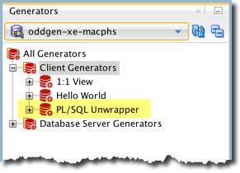](https://github.com/Trivadis/plsql-unwrapper-sqldev/blob/main/images/generators.png)

Open the PL/SQL Unwrapper node to show all wrapped objects in the navigator tree. Select one or more objects to unwrap. The following audioless video shows how to unwrap all package bodies in a schema in one go:

[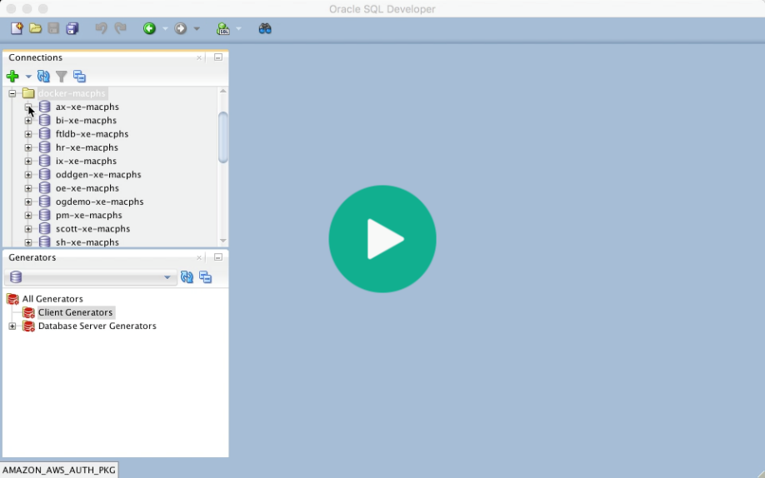](https://trivadis.github.io/plsql-unwrapper-sqldev/unwrapper.mp4)

**Configure Update Center**

Click the Help menu and select Check for Updates…. Press the Add button to register the update center <http://update.salvis.com/>. If you have troubles to configure the proxy settings, because your company requires some additional authentication or similar, then I suggest to download PL/SQL Unwrapper for SQL Developer from [here](https://github.com/Trivadis/plsql-unwrapper-sqldev/releases) and use the Install From Local File option.

[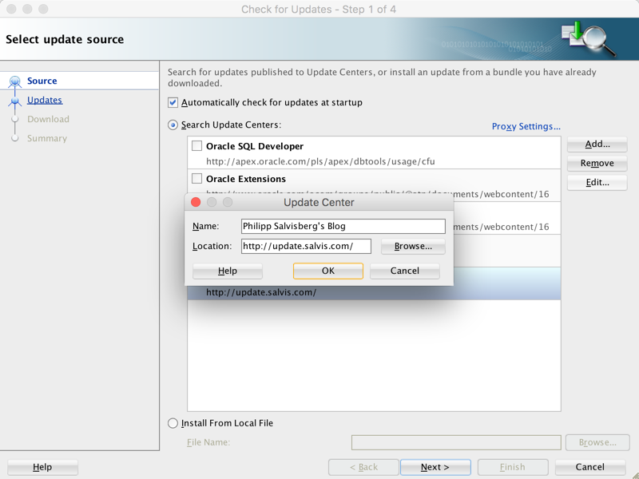](https://github.com/Trivadis/plsql-unwrapper-sqldev/blob/main/images/salvis-update-center.png) <http://update.salvis.com/>

INDIEN site = http/update.salvis.com al toegevoegd is, maar unwrapper geupdate moet worden

select site = update.salvis.com

(HIER ZIE JE OOK DE OPTIE OM EEN EXTENTIE VIA LOCAL-FILE TE INSTALLEREN…)

Klik NEXT

select unwrapper

er zijn geen updates nu.

**Releases**

You find all releases and release information [here](https://github.com/Trivadis/plsql-unwrapper-sqldev/releases).

**Issues**

Please file your bug reports, enhancement requests, questions and other support requests within [Github's issue tracker](https://help.github.com/articles/about-issues/).

* [Questions](https://github.com/trivadis/plsql-unwrapper-sqldev/issues?q=is%3Aissue+label%3Aquestion)
* [Open enhancements](https://github.com/trivadis/plsql-unwrapper-sqldev/issues?q=is%3Aopen+is%3Aissue+label%3Aenhancement)
* [Open bugs](https://github.com/trivadis/plsql-unwrapper-sqldev/issues?q=is%3Aopen+is%3Aissue+label%3Abug)
* [Submit new issue](https://github.com/trivadis/plsql-unwrapper-sqldev/issues/new)

**Frequently Asked Questions**

see [Frequently Ased Questions](https://github.com/Trivadis/plsql-unwrapper-sqldev/blob/main/FAQ.md).

**License**

PL/SQL Unwrapper is licensed under the Creative Commons Attribution-NonCommercial-NoDerivs 3.0 Unported License. You may obtain a copy of the License at <https://creativecommons.org/licenses/by-nc-nd/3.0/>.