-arch-log-space:

db name space-limit-gb space-used-gb space-available-gb space-reclaimable number-of-files  
U611 E:\FlashRecovery\U611\ARCHIVELOG 122 36 86 0 3208  
IS61 E:\FlashRecovery\IS61\IS61\ARCHIVELOG 75 36 39 0 2253

CONCLUSIE: ER IS VOLDOENDE RUIMTE !!!

UTERROR

UnExecDml "SQL(1):SELECT part_no FROM avao_trials WHERE part_no LIKE 'XEF%' AND ( ped BETWEEN SYSDATE - TO_NUMBER('1000') AND SYSDATE + 1 ) AND CREATED_BY LIKE 'DIT' ORDER BY part_no DESC"

UnExecDml "ORA-00257: archiver error. Connect internal only, until freed. ORA-02063: preceding line from INTERSPEC"

HUNGPEIP07 scmgt IBI 13-12-2021 09.24.07.000000000 AM 13-12-2021 09.24.07.000000000 AM CET InitScParameter ORA-20000: No corresponding version found by UNAPIGEN.ValidatePpVersion for pp=Indoor testing#version_in=0001.21#pp_key1= #pp_key2= #pp_key3= #pp_key4= #pp_key5=

GREVE_01355 scmgt RAG 05-01-2021 10.39.54.000000000 AM 05-01-2021 10.39.54.000000000 AM CET GetFullTestPlan "ORA-20000: No corresponding version found by UNAPIGEN.ValidateVersion for object_type=mt#object_id=PT410AA#version_in=~Current~ ORA-06512: at "UNILAB.UNAPIGEN", line 7238"

ENSDTS01 scmgt JUK 03-02-2021 10.19.34.000000000 AM 03-02-2021 10.19.34.000000000 AM CET UnExecDml "ORA-00257: archiver error. Connect internal only, until freed. ORA-02063: preceding line from INTERSPEC"

ENSDTS01 scmgt JUK 03-02-2021 10.19.54.000000000 AM 03-02-2021 10.19.54.000000000 AM CET UnExecDml "ORA-00257: archiver error. Connect internal only, until freed. ORA-02063: preceding line from INTERSPEC"

SYS> archive log list;

toad

Is db-job wat draait.

HERSTART VAN JOBS

We zien soortgelijke jobs terug…wel nieuwe sessies !!! SID = 241 / 172 / 58

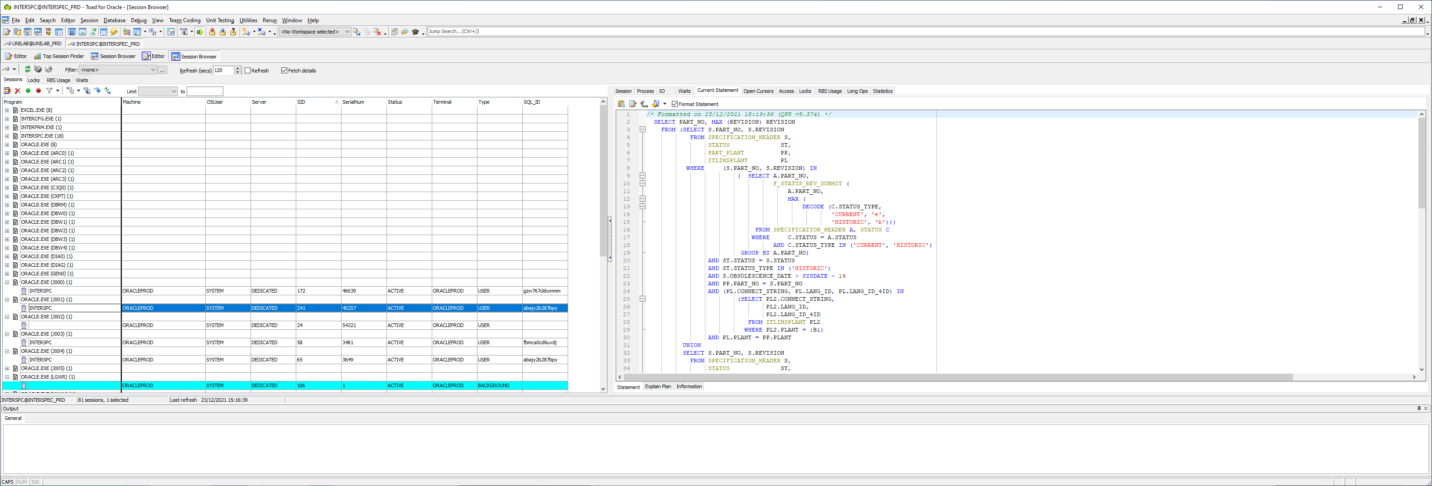

SELECT PART_NO, MAX (REVISION) REVISION

FROM (SELECT S.PART_NO, S.REVISION

FROM SPECIFICATION_HEADER S,

STATUS ST,

PART_PLANT PP,

ITLIMSPLANT PL

WHERE (S.PART_NO, S.REVISION) IN

( SELECT A.PART_NO,

F_STATUS_REV_SUBMIT (

A.PART_NO,

MAX (

DECODE (C.STATUS_TYPE,

'CURRENT', 'e',

'HISTORIC', 'b')))

FROM SPECIFICATION_HEADER A, STATUS C

WHERE C.STATUS = A.STATUS

AND C.STATUS_TYPE IN ('CURRENT', 'HISTORIC')

GROUP BY A.PART_NO)

AND ST.STATUS = S.STATUS

AND ST.STATUS_TYPE IN ('HISTORIC')

AND S.OBSOLESCENCE_DATE > SYSDATE - 14

AND PP.PART_NO = S.PART_NO

AND (PL.CONNECT_STRING, PL.LANG_ID, PL.LANG_ID_4ID) IN

(SELECT PL2.CONNECT_STRING,

PL2.LANG_ID,

PL2.LANG_ID_4ID

FROM ITLIMSPLANT PL2

WHERE PL2.PLANT = :B1)

AND PL.PLANT = PP.PLANT

UNION

SELECT S.PART_NO, S.REVISION

FROM SPECIFICATION_HEADER S,

STATUS ST,

PART_PLANT PP,

ITLIMSPLANT PL

WHERE (S.PART_NO, S.REVISION) IN

( SELECT A.PART_NO,

F_STATUS_REV_SUBMIT (

A.PART_NO,

MAX (

DECODE (C.STATUS_TYPE,

'CURRENT', 'e',

'OBSOLETE', 'a')))

FROM SPECIFICATION_HEADER A, STATUS C

WHERE C.STATUS = A.STATUS

AND C.STATUS_TYPE IN ('CURRENT', 'OBSOLETE')

GROUP BY A.PART_NO)

AND ST.STATUS = S.STATUS

AND ST.STATUS_TYPE IN ('OBSOLETE')

AND S.OBSOLESCENCE_DATE > SYSDATE - 14

AND PP.PART_NO = S.PART_NO

AND (PL.CONNECT_STRING, PL.LANG_ID, PL.LANG_ID_4ID) IN

(SELECT PL2.CONNECT_STRING,

PL2.LANG_ID,

PL2.LANG_ID_4ID

FROM ITLIMSPLANT PL2

WHERE PL2.PLANT = :B1)

AND PL.PLANT = PP.PLANT)

GROUP BY PART_NO

/* Formatted on 23/12/2021 15:20:28 (QP5 v5.374) */

DECLARE

job BINARY_INTEGER := :job;

next_date DATE := :mydate;

broken BOOLEAN := FALSE;

BEGIN

DECLARE

lnRetVal iapiType.ErrorNum_Type;

BEGIN

lnRetVal := iapiEmail.SendEmails;

END;

:mydate := next_date;

IF broken

THEN

:b := 1;

ELSE

:b := 0;

END IF;

END;

/* Formatted on 23/12/2021 15:21:02 (QP5 v5.374) */

DECLARE

job BINARY_INTEGER := :job;

next_date DATE := :mydate;

broken BOOLEAN := FALSE;

BEGIN

iapiQueue.ExecuteQueue;

:mydate := next_date;

IF broken

THEN

:b := 1;

ELSE

:b := 0;

END IF;

END;

/* Formatted on 23/12/2021 15:22:10 (QP5 v5.374) */

DECLARE

job BINARY_INTEGER := :job;

next_date DATE := :mydate;

broken BOOLEAN := FALSE;

BEGIN

pa_limsspc.f_transferallhistobs;

:mydate := next_date;

IF broken

THEN

:b := 1;

ELSE

:b := 0;

END IF;

END;