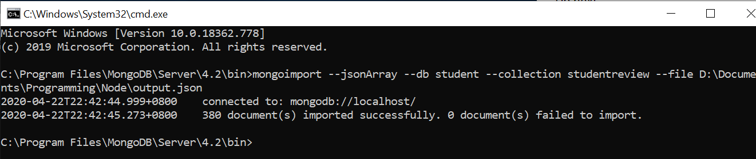

Please import the data file using the tool above to the mongo db.

