IMPLEMENTASAUN SISTEMA DATA MINING
BA TURIZMU IHA TIMOR-LESTE
Sentiment Analysis, Destination Category Classification
no Text Clustering ho K-Means

Prepara husi
Naran Kompletu | NIM
Maurino D.C Araujo
Sandro D.S Santos
Jorge S.D.S
Charles Sarmento

Dosente: __________________________________
DILI INSTITUTE OF TECHNOLOGY (DIT)
Engineering and Science
Department of Computer Science
2026

ABSTRACT — ENGLISH
Online reviews provide evidence for examining tourism experiences, as discussed by Calderón-Fajardo et al. (2024) and Rui et al. (2025). This project develops a data mining system for sentiment analysis, destination category classification, and text clustering in Timor-Leste. The current pipeline reads four stored Google Maps/Apify JSON snapshots directly and combines overlapping observations without an intermediate CSV-import stage. The snapshots cover 705 distinct destinations and produce 5,506 flattened records; preprocessing removes 10 duplicate-content rows and retains 5,496 records: 5,270 reviews and 226 no-review destination placeholders. Of the reviews, 3,218 contain original text and 3,062 remain usable for K-Means clustering. The system combines a multilingual sentiment lexicon, manual destination labels with transparent rule-based category fallback, TF-IDF, Naive Bayes, Logistic Regression, Linear SVM, Random Forest, K-Means, and Agglomerative Clustering. Sentiment supervision uses 2,990 reviews (2,242 train; 748 test); Logistic Regression has the best cross-validation macro-F1 and obtains 85.16% accuracy and 0.4763 macro-F1 on the test set. Its accuracy is below the majority baseline (86.76%), while its macro-F1 is higher (0.3097 baseline). Category evaluation has only 57 test records; Linear SVM reaches 29.82% accuracy and 0.1181 macro-F1, and the test set has no Religious examples. Four-cluster K-Means has a silhouette of 0.0373; k=8 is highest in the tested sweep at 0.0754. Weak separation, rating-proxy sentiment labels, 50 manually labelled destinations, class imbalance, and pending human validation limit the conclusions. Results are shown in the current Streamlit dashboard and Power BI exports; collection is on-demand/batch, not real-time.
Keywords: Timor-Leste; tourism reviews; sentiment analysis; classification; TF-IDF; clustering.

ABSTRAKTU — TETUM
Review online bele ajuda estudu esperiénsia vizitante, hanesan hatudu iha peskiza Calderón-Fajardo et al. (2024) no Rui et al. (2025). Projetu ida-ne’e dezenvolve sistema data mining ba sentiment analysis, destination category classification no text clustering iha Timor-Leste. Pipeline atual lee direta snapshots JSON Google Maps/Apify haat ne’ebé rai iha sistema, no kombina observasaun ne’ebé iha overlap. Snapshots ne’e kobre destinasaun 705; flattening produz registu 5.506. Preprocessing hasai duplicate-content 10 no rai registu 5.496: review 5.270 no placeholder 226 ba destinasaun ne’ebé la iha review. Review 3.218 iha teksu orijinál, no review 3.062 iha teksu utilizável ba K-Means. Sistema kombina multilingual sentiment lexicon, anotasaun manual ba kategoria ho rule-based fallback, TF-IDF, Naive Bayes, Logistic Regression, Linear SVM, Random Forest, K-Means no Agglomerative Clustering. Sentiment supervision uza review 2.990 (train 2.242; test 748); Logistic Regression iha cross-validation macro-F1 aas liu no hetan test accuracy 85,16% ho macro-F1 0,4763. Accuracy ne’e menus husi majority baseline (86,76%), maibé macro-F1 baseline mak 0,3097. Category evaluation iha deit test record 57; Linear SVM hetan accuracy 29,82% no macro-F1 0,1181, no test set la iha ezemplu Religious. K-Means ho cluster haat hetan silhouette 0,0373; iha k sweep, k=8 hetan valor aas liu 0,0754. Cluster separation fraku, sentiment proxy husi rating, anotasaun manual iha destinasaun 50 deit, class imbalance no human validation ne’ebé seidauk remata limita konkluzaun. Rezultadu aprezenta iha dashboard Streamlit atual no Power BI exports; data collection la’ós real-time.
Liafuan-xave: Timor-Leste; tourism reviews; sentiment analysis; classification; TF-IDF; clustering.

ACKNOWLEDGEMENT
Ami hato’o obrigadu ba dosente unidade kurikulár Mining and Exploring tanba orientasaun durante dezenvolvimentu projetu ida-ne’e. Ami mós agradese ba Dili Institute of Technology, membru grupu no ema sira ne’ebé fó apoiu iha preparasaun dataset, implementasaun sistema no hakerek relatóriu. Liuhusi servisu ida-ne’e, ami aprende oinsá liga problema prátiku ho data processing, machine learning no model evaluation. Responsabilidade ba kontéudu no interpretasaun rezultadu iha relatóriu ida-ne’e kontinua iha ami hanesan autór.
TABLE OF CONTENTS
ABSTRACT — ENGLISH i
ABSTRAKTU — TETUM ii
ACKNOWLEDGEMENT iii
CHAPTER 1 INTRODUCTION 1
1.1. Antesedente 1
1.2. Identifikasaun Problema 2
1.3. Pergunta peskiza 3
1.4. Objetivupeskiza 4
1.4.1. Objetivu jerál 4
1.4.2. Objetivu espesífiku 4
1.5. Benefísiupeskiza 4
1.6. Scope no Limitasaun 5
1.7. Sistematika Relatóriu 5
CHAPTER 2 LITERATURE REVIEW / BACKGROUND 7
2.1. Online Reviews ihapeskiza Turizmu 7
2.2. Sentiment Analysis no Star Rating 7
2.3. Text Preprocessing no TF-IDF 7
2.4. Classification no Clustering 8
2.5.peskiza Anteriór no Pozisaun Projetu 8
CHAPTER 3 METHODOLOGY 9
3.1. System Design no Architecture 9
3.2. Pipeline no Responsabilidade Module 10
3.3. Implementasaun Rule-Based Model no Lexicon 11
3.4. Implementasaun Supervised Models 11
3.5. Implementasaun Text Clustering 12
3.6. Output no Dashboard Integration 12
CHAPTER 4 DATA COLLECTION AND PREPROCESSING 13
4.1. Data Source no Collection Period 13
4.2. Kolekta Dadus liuhusi Apify API no Prosesamentu Snapshot 13
4.3. Duplicate no Missing Values 15
4.4. Text Preprocessing no Feature Engineering 16
4.5. Label Preparation no Dataset ba Model 16
CHAPTER 5 EDA AND DATA MINING RESULTS 19
5.1. Dataset Overview 19
5.2. Sentiment Distribution 19
5.3. Category Distribution 20
5.4. Clustering Results 22
5.5. Dashboard Results 23
CHAPTER 6 EVALUATION AND DISCUSSION 24
6.1. Sentiment Model Evaluation 24
6.2. Sentiment Error Analysis 25
6.3. Category Model Evaluation 26
6.4. Clustering Evaluation 27
6.5. Human Validation no Limitasaun 28
CHAPTER 7 CONCLUSION AND RECOMMENDATION 30
7.1. Konkluzaun 30
7.2. Kontribuisaun Projetu 30
7.3. Rekomendasaun 31
REFERENCES 32
APPENDICES 34
Appendix A — Source Code 34
Appendix B — Dashboard Screenshots 35
Appendix C — Data Dictionary 35
Appendix D — Evaluation Files no Demonstration 38

CHAPTER 1
INTRODUCTION

1.1. Antesedente
Komentáriu online permite vizitante hakerek nia esperiénsia kona-ba fatin ne’ebé nia vizita. Iha komentáriu ida, vizitante bele ko’alia kona-ba paisajen, estrada, fasilidade, servisu no problema ne’ebé nia hasoru. Informasaun ne’e normalmente hakerek iha teksu livre, nune’e nia la organiza automaticamente tuir nesesidadepeskiza. Calderón-Fajardo et al. (2024) uza data mining atu estuda esperiénsia destinasaun, enkuantu Rui et al. (2025) liga komentáriu turista ho karakterístika espasiál. Iha projetu ida-ne’e, ami uza komentáriu Google Maps kona-ba lokal iha Timor-Leste atu dezenvolve sistema ne’ebé bele organiza, analiza no aprezenta dadus ho maneira ne’ebé klaru. Fokupeskiza mak dataset ne’ebé ami iha, no la’ós opiniaun turista hotu iha Timor-Leste.
Star rating fó pontuasaun númerika ba esperiénsia vizitante, maibé nia la esplika diretamente razaun ne’ebé lori vizitante fó pontuasaun ne’e. Review ho estrela lima bele iha komentáriu ne’ebé badak tebes, enkuantu review seluk bele ko’alia kona-ba aspetu di’ak no aat iha teksu ida deit. Nicolau et al. (2025) estuda komportamentu hakerek review no fó rating, no Chen et al. (2025) estuda atributu esperiénsia destinasaun tuir tempu. Tanba ne’e, ami analiza teksu hamutuk ho rating, data no lokalizasaun. Prosesu ne’e permite haree informasaun ne’ebé luan liu duké média rating deit, maski interpretasaun nafatin depende ba kualidade dadus.
Dataset ne’ebé ami uza iha review multilingue, text badak, missing values no observasaun ne’ebé repete entre snapshots. Pipeline atual lee direta ficheiru JSON snapshot haat iha data/raw/; la presiza konverte JSON ba CSV antes collection. Husi 5.506 observasaun raw, preprocessing hasai duplicate-content 10 no produz 5.496 rows, ne’ebé inklui review 5.270 no placeholder 226 ba destinasaun sem review. Review 3.218 iha teksu orijinál; depois preprocessing, 156 la iha token utilizável no 3.062 tama ba clustering. Yohannes et al. (2025) no Zhang et al. (2026) fó konteksu kona-ba text representation no short-text clustering. Númeru observasaun raw, review ho teksu no text utilizável mak medida diferente; relatóriu distingue kontajen sira atu la aumenta númeru ho duplicate ka placeholder.
Atu analiza dataset ne’e, ami implementa sentiment analysis, destination category classification no text clustering. Sentiment analysis determina Positive, Neutral ka Negative; category classification uza Historical, Religious, Traditional no Modern; clustering buka padraun iha teksu sem define tema kada cluster antes. Karim et al. (2025) fó ezemplu sentiment classification ho TF-IDF, no Jamalian no Vahdat-Nejad (2025) estuda text clustering evaluation. Iha sistema ami nian, tarefa sira-ne’e implementa iha module diferente maibé uza dataset ne’ebé liga malu. Ami distingue rezultadu kada tarefa, tanba sentiment label, category label no cluster ID la iha signifikadu hanesan.
Projetu ne’e la limita ba halo predisaun no hatudu gráfiku. Ami mós kompara model, kalkula evaluation metrics no dokumenta limitasaun ne’ebé mosu. Cavique et al. (2025) no Sun et al. (2024) fó ezemplu utilizasaun review atu esplora konseitu no tema turizmu. Iha projetu atual, ami aprezenta rezultadu iha Streamlit dashboard no prepara CSV export ba Power BI. Kontribuisaun ne’ebé ami pretende mak sistema ne’ebé bele ajuda esplora dadus, ho prosesu ne’ebé dokumentadu no bele hala’o fali. Model ne’ebé hetan rezultadu fraku mós relata ho loos, tanba nia sai evidénsia importante ba melhoria futura.

1.2. Identifikasaun Problema
Problema prinsipal mak oinsá transforma review turizmu ne’ebé seidauk organiza ba informasaun ne’ebé bele analiza no avalia. Problema ne’e envolve data structure, missing values, text preprocessing, label quality no model evaluation. Karim et al. (2025) no Jamalian no Vahdat-Nejad (2025) sai fundamentu ba tarefa classification no clustering ne’ebé ami uza. Bazeia ba dataset no implementasaun projetu, ami identifika problema tuirmai:
Aumentu dadus la bele sukat liuhusi soma rows snapshots deit, tanba snapshots bele kobre review hanesan. Iha dataset atual, raw observations 5.506 la hanesan rows processadu 5.496; diferensa mak duplicate-content records 10. Dataset final kobre destinasaun 705, review 5.270 no placeholder 226 ba destinasaun ne’ebé la iha review. Nicolau et al. (2025) no Calderón-Fajardo et al. (2024) fó konteksu ba interpretasaun review evidence; kontajen sira-ne’e mai husi pipeline no CSV atuais. Provenance dokumenta husi snapshots raw, collection log, preprocessing metadata no output layers; pipeline atual la kria intermediate CSV. Problema kalidade dadus kontinua, liuliu text/rating mamuk, city value la padroniza no category fallback ne’ebé presiza verifikasaun.
- JSONtuanrua presiza konverte ba CSV; depois CSV fontes tolu hamutuk ba review-level raw CSV.
- Dataset iha duplicate, review sem teksu no rating mamuk.
- Review multilingue no teksu badak bele afeta model performance.
- Sentiment evaluation seidauk iha human annotation kompleta no uza rating hanesan proxy label.
- Manual category annotation kobre parte ki’ik husi lokal iha dataset.
- Class imbalance bele halo accuracy aas maski model la deteta klase minoritária ho di’ak.
- Cluster ne’ebé mosu presiza avaliasaun no leitura review antes ami fó interpretasaun tema.

1.3. Pergunta peskiza
Perguntapeskiza define tuir dadus no funsaun ne’ebé sistema implementa. Literatura kona-ba tourism review analysis, hanesan Calderón-Fajardo et al. (2024) no Sun et al. (2024), fó konteksu ba pergunta kona-ba sentiment no tema. Ami formula pergunta ne’ebé bele responde ho output projetu, sem assume antes katak model sei hetan rezultadu di’ak.
Pergunta prinsipal:
Oinsá dezenvolve no avalia sistema data mining ne’ebé integra sentiment analysis, destination category classification no text clustering ba review turizmu iha Timor-Leste?
Pergunta espesífiku:
- Oinsá pipeline lee snapshots JSON ne’ebé rai, trata overlap no missing values, no prepara dadus ba EDA no model evaluation?
- Oinsá distribuisaun rating, sentiment no kategoria destinasaun iha dataset?
- Oinsá performance model sentiment bainhira kompara ho proxy label husi rating?
- Oinsá performance model category classification bazeadu ba manual annotation?
- Padraun liafuan saida mak K-Means identifika, no oinsá kualidade cluster?
- Oinsá dashboard aprezenta rezultadu no limitasaun atu utilizadór bele lee ho loos?

1.4. Objetivupeskiza

1.4.1. Objetivu jerál
Objetivu jerál mak dezenvolve no avalia sistema data mining ba review turizmu iha Timor-Leste, hodi integra data collection, preprocessing, EDA, sentiment analysis, category classification, clustering no dashboard. Calderón-Fajardo et al. (2024) no Karim et al. (2025) fó fundamentu ba utilizasaun data mining no text classification. Iha projetu ami nian, objetivu ne’e realiza ho Python no Streamlit. Ami la haree deit se programa bele hala’o, maibé mós se rezultadu model supera baseline no saida mak limitasaun ne’ebé presiza esplika.

1.4.2. Objetivu espesífiku
- Dokumenta data source, collection date no dataset structure.
- Lee snapshots JSON iha data/raw/ diretamente, aplika preprocessing no deduplication, no grava metadata no output ba layers ne’ebé bele audita.
- Trata duplicate, missing values no teksu ne’ebé la bele uza.
- Realiza EDA ba rating, sentiment, kategoria, língua no lokalizasaun.
- Implementa no kompara lexicon ho supervised models ba sentiment.
- Implementa no avalia category classification.
- Uza TF-IDF no K-Means ba text clustering.
- Kompara model ho baseline no evaluation metrics.
- Aprezenta rezultadu iha dashboard.
- Dokumenta limitasaun no proposta melhoria.

1.5. Benefísiupeskiza
Projetu ne’e fó benefísiu akadémiku tanba ami aplika prosesu data mining kompletu iha dataset ne’ebé iha problema prátiku. Benefísiu tékniku mak source code ne’ebé organiza tuir module, ho output no evaluation report ne’ebé bele verifica. Benefísiu prátiku ne’ebé espera mak fasilita leitura review no komparasaun informasaun destinasaun. Rui et al. (2025) no Cavique et al. (2025) fó konteksu ba utilizasaun teksu ihapeskiza turizmu. Maski nune’e, ami seidauk halo user testing atu prova katak dashboard melhora desizaun jestór. Benefísiu ba jestaun turizmu, tanba ne’e, aprezenta hanesan utilizasaun potensiál sistema.

1.6. Scope no Limitasaun
Investigasaun limita ba Google Maps review snapshots ne’ebé rai iha projetu. Dataset ne’e la reprezenta turista hotu ka destinasaun hotu iha Timor-Leste. Apify collection bele husu fali manualmente ka husi dashboard bainhira token konfiguradu; pipeline no dashboard analiza snapshot ne’ebé rai, la’ós monitorizasaun contínua. Google Places API direta la uza. Literatura Nicolau et al. (2025) no Chen et al. (2025) fó konteksu ba interpretasaun rating no esperiénsia, maibé konkluzaun projetu tenke tuir kobertura amostra. Sistema la implementa booking, payment ka personalized recommendation. Limitasaun hirak-ne’e importante atu utilizadór la interpreta funsaun liu kapasidade ne’ebé implementa ona.
Scope espesífiku:
- Data source: Google Maps liuhusi Apify.
- Dataset atual: destinasaun 705; rows processadu 5.496 (review 5.270 no placeholder 226); review ho teksu 3.218.
- Scraped timestamps iha snapshots kobre 21 Agostu–14 Outubru 2026; pipeline results ne’ebé uza iha relatóriu gera iha 14 Outubru 2026.
- Review period: 29 Jullu 2012–14 Outubru 2026. Screenshot dashboard foun captura iha 22 Outubru 2026.
- Sentiment classes: Positive, Neutral no Negative.
- Category classes: Historical, Religious, Traditional no Modern.
- Manual category annotation: destinasaun 50 husi 705 (270 review records); restu uza operational rules, la’ós ground truth manual.
- Sentiment reference label: proxy husi rating.
- Human validation: seidauk kompleta.
- Religious category: la iha sample iha test set atual.
- Sistema la inklui booking, payment ka personalized recommendation.

1.7. Sistematika Relatóriu
Relatóriu hahú ho problema no objetivu, depois esplika literatura, implementasaun sistema, dataset, rezultadu no avaliasaun. Calderón-Fajardo et al. (2024) no Karim et al. (2025) uza hanesan referénsia metodolójika, enkuantu númeru rezultadu mai husi output projetu. Chapter 2 diskute literatura; Chapter 3 esplika sistema ne’ebé ami halo ona; Chapter 4 deskreve data collection no preprocessing; Chapter 5 aprezenta EDA no mining results; Chapter 6 avalia no diskute rezultadu; no Chapter 7 hato’o konkluzaun no rekomendasaun. References no appendices rai iha parte ikus.

CHAPTER 2
LITERATURE REVIEW / BACKGROUND

2.1. Online Reviews ihapeskiza Turizmu
Online reviews permite investigador lee esperiénsia ne’ebé utilizadór hakerek kona-ba destinasaun no servisu. Calderón-Fajardo et al. (2024) kombina sentiment analysis, topic modelling no classification, enkuantu Chen et al. (2025) analiza mudansa atributu esperiénsia iha tempu. Literatura ne’e relevante ba projetu tanba nia hatudu katak review bele uza ba analiza ne’ebé liu kontajen rating. Iha sistema ami nian, review liga ho place_id, data no informasaun lokal, atu permite analiza tuir unidade ne’ebé klaru. Ami distingue total review husi total lokal, tanba lokal ida bele iha review barak. Ami mós la uza review count hanesan substitutu ba númeru turista.

2.2. Sentiment Analysis no Star Rating
Sentiment analysis buka determina orientasaun sentiment iha teksu, enkuantu star rating mak pontuasaun ne’ebé utilizadór fó. Karim et al. (2025) kompara model ba sentiment classification, no Nicolau et al. (2025) analiza review no rating behaviour. Iha projetu, ami distingue prediction husi teksu no proxy label husi estrela. Distinsaun ne’e importante tanba review ho rating aas bele hakerek ho liafuan neutru, ka review ida bele mistura apresiasaun no keixa. Model evaluation atual sukat konkordánsia ho proxy rating. Atu sukat sentiment teksu ho independente, ami presiza human annotation ne’ebé bazeia ba leitura komentáriu.

2.3. Text Preprocessing no TF-IDF
Text preprocessing prepara teksu antes nia tama ba feature extraction. TF-IDF transforma token ba numerical features ne’ebé model bele uza. Karim et al. (2025) uza TF-IDF iha sentiment analysis, no Yohannes et al. (2025) uza TF-IDF depois semantic feature expansion iha Amharic document clustering. Iha projetu ami nian, ami uza TF-IDF ho unigram no bigram, maibé la implementa semantic expansion hanesan estudu Amharic. Nune’e, liafuan ho signifikadu hanesan iha língua diferente bele sai feature diferente. TF-IDF bele ajuda identifika termu importante, maibé nia la automaticamente komprende signifikadu kompletu frase ka relasaun entre língua sira.

2.4. Classification no Clustering
Classification uza target label ne’ebé define antes, enkuantu clustering buka estrutura iha dadus sem label tema. Cavique et al. (2025) uza semantic representation no clustering ba konseitu, no Sun et al. (2024) uza LDA ba tema review turizmu. Iha projetu, category classification no K-Means clustering la iha objetivu hanesan. Category classification prevee Historical, Religious, Traditional ka Modern. Clustering agrupa review tuir text features. Maski sistema uza cluster haat, ne’e la signifika cluster ida tenke reprezenta kategoria ida. Cluster bele reflete tema, língua, frase ne’ebé repete ka karakterístika teksu seluk.

2.5.peskiza Anteriór no Pozisaun Projetu
Jamalian no Vahdat-Nejad (2025) uza clustering metrics atu kompara rezultadu, no Zhang et al. (2026) estuda short text clustering ho augmentation no contrastive learning. Literatura ne’e fó alternativa ba melhoria futura, maibé ami la deklara katak implementa ona metode hotu. Projetu ami nian foka ba integrasaun data pipeline, model comparison no dashboard ba dataset Timor-Leste. Kontribuisaun ne’e iha natureza aplikada. Ami la propoin algoritmu foun no la deklara katak sistema supera artigu sira. Komparasaun ho literatura halo ba metode no interpretasaun, tanba dataset, língua no evaluation protocol la hanesan.
Tabela 2.1. Literatura no nia relevánsia
Estudu | Foku | Relevánsia ba projetu
Calderón-Fajardo et al., 2024 | Tourism data mining | Fundamentu analiza review
Rui et al., 2025 | Sentimentu no spatial features | Review no lokalizasaun
Chen et al., 2025 | Destination experience | Interpretasaun atributu
Nicolau et al., 2025 | Review no rating behaviour | Limitasaun rating proxy
Karim et al., 2025 | Sentiment classification | TF-IDF no model comparison
Cavique et al., 2025 | Semantic analysis no clustering | Interpretasaun kontéudu
Sun et al., 2024 | Tourism topics | Esplorasaun tema
Yohannes et al., 2025 | Document clustering | Text representation
Jamalian & Vahdat-Nejad, 2025 | Clustering evaluation | Silhouette no Davies–Bouldin
Zhang et al., 2026 | Short text clustering | Limitasaun no melhoria futura

CHAPTER 3
METHODOLOGY

3.1. System Design no Architecture
Sistema uza Python 3.11; src/pipeline.py mak orchestrator. src/data_collection.py lee snapshot JSON iha data/raw/, halo flatten husi place ba review-level records, no liga anotasaun manual husi data/place_category_labels.csv. src/preprocessing.py limpa no deduplicate, depois pipeline hala’o category rules, sentiment lexicon, TF-IDF/K-Means, supervised models, EDA no evaluation. Módulus hotu uza pandas DataFrame entre etapa sira. Output rai separadu iha raw, processed, feature no output layers, ho summary no model metrics iha reports/. Calderón-Fajardo et al. (2024) no Cavique et al. (2025) fó konteksu ba tourism review analysis; arkitetura iha ne’e reflete implementasaun code atual, la’ós pipeline CSV import ne’ebé la iha ona.
Tabela 3.1. System architecture no fluxo implementadu
Etapa | Input / prosesu / output
1. Data collection | Snapshot JSON iha data/raw/ → flatten review records + collection metadata
2. Preprocessing | Raw DataFrame → cleaning, deduplication, missing-value flags, features (5,496 rows)
3. Data mining | Manual category labels + rule fallback; sentiment lexicon + rating fallback
4. Modeling | TF-IDF, K-Means, Agglomerative, Naive Bayes, Logistic Regression, Linear SVM, Random Forest
5. EDA no evaluation | Statistics, baseline comparison, confusion matrices, cluster metrics and figures
6. Outputs no dashboard | Processed/features/output CSVs, reports, Power BI exports and Streamlit tabs

3.2. Pipeline no Responsabilidade Module
Fluxu sistema hahú ho data_collection lee snapshot JSON no flatten reviews; depois preprocessing halo cleaning, deduplication no feature engineering. Pipeline aplika manual category labels ho rule fallback, sentiment lexicon ho rating fallback, clustering no supervised models, depois EDA, evaluation no Power BI export. Output dashboard lee husi files processadu no metrics ne’ebé rai; la halo scrape foun bainhira ema loke dashboard. Karim et al. (2025) no Jamalian no Vahdat-Nejad (2025) fó fundamentu ba text classification no clustering. Separasaun etapa ne’e permite kompara raw records ho processed output no evita konfunde data collection ho analysis.
Tabela 3.2. Módulos no responsabilidade
Module | Funsaun
pipeline.py | Orkestrasaun data collection, preprocessing, mining, EDA, evaluation no exports
config.py | Paths, categories, colors, source metadata no project settings
data_collection.py | Lee snapshots JSON, flatten reviews, junta manual category labels, collection log
preprocessing.py | Deduplication, missing-value flags, text cleaning no feature engineering
category_classifier.py | Manual category labels ho rule-based fallback
sentiment_analysis.py | Multilingual sentiment lexicon no rating fallback
clustering.py | TF-IDF, K-Means, k-sweep, Agglomerative no SVD visualization
supervised_models.py | Training-only cross-validation, model comparison and holdout prediction
eda.py | Estatístika, tables no figures
model_evaluation.py | Metrics, baselines, confusion matrices, manual-validation status
export_powerbi.py | CSV exports no data dictionary ba Power BI
dashboard/app.py | Streamlit dashboard, filters, collection workflow no result tabs

3.3. Implementasaun Rule-Based Model no Lexicon
Ba sentiment, ami implementa multilingual lexicon ho positive/negative terms iha Tetun, Indonéziu, Portugés no Inglés. Programa lee text_clean, konta term sentiment no trata negasaun simples. Se text la utilizável, sistema uza rating fallback; se la iha evidénsia suficiente, label sai Unknown. Ba category, sistema uza anotasaun manual iha nivel destinasaun bainhira disponivel; otherwise, rule-based fallback uza keyword no contexto lokal. Tanba label destinasaun aplika ba review hotu iha fatin ida, category la muda tuir review individual. Karim et al. (2025) no Nicolau et al. (2025) fó konteksu ba distinsaun text sentiment no rating proxy; regra espesífika sira-ne’e mak implementasaun projetu nian.

3.4. Implementasaun Supervised Models
Ami implementa supervised tasks rua: sentiment classification ho target sentiment_true_proxy, no category classification ho target category_label. Kada task kompara Multinomial Naive Bayes, Logistic Regression, Linear SVM no Random Forest ho TF-IDF features. Model selection uza training-only cross-validation; review-level sentiment uza StratifiedKFold, category uza group split tuir place_id atu review husi destinasaun hanesan la tama iha train no test hamutuk. Report metrics separa operational labels ne’ebé aplikadu ba dataset tomak husi ML predictions ne’ebé avalia iha holdout. Karim et al. (2025) no Calderón-Fajardo et al. (2024) fó konteksu ba classification evaluation; scores ne’e mai husi model_evaluation.json atual.
Sentiment supervision iha reviews 2.990, ho training 2.242 no testing 748. Category supervision iha records 135, ho training 78 no testing 57. Sentiment split hala’o iha review level ho stratification; category split separa place_id. Model selection uza média macro-F1 husi five-fold cross-validation iha training partition: StratifiedKFold ba sentiment no GroupKFold ba category. Sentiment Logistic Regression nia cross-validation macro-F1 mak 0,4331; category Linear SVM nia valor mak 0,2288, besik Naive Bayes 0,2287. Test set la uza ba hili model. random_state=42 ajuda reproduz rezultadu, no splits atual dokumenta iha sentiment_split no category_split.

3.5. Implementasaun Text Clustering
Clustering uza review text ne’ebé nafatin iha token depois preprocessing; dataset atual iha texts 3.062. TF-IDF uza max_features=500, unigram no bigram, min_df=2, max_df=0.85 no sublinear_tf=True. Programa hala’o k-sweep husi k=2 to’o k=8 no grava inertia, silhouette, Davies–Bouldin no Calinski–Harabasz. Final K-Means uza k=4 tuir konfigurasaun sistema; Agglomerative Clustering ho Ward linkage uza ba komparasaun. TruncatedSVD ho komponente rua prepara scatter plot, maibé plot ne’e deit ilustrasaun; evaluation lee metrika iha TF-IDF feature space orijinál. Jamalian no Vahdat-Nejad (2025) no Zhang et al. (2026) fó fundamentu ba interpretasaun no avaliasaun cluster.

3.6. Output no Dashboard Integration
Dadus rai iha raw, processed, feature no output layers. reviews_processed.csv, review_features.csv no reviews_mined.csv rai dataset ba prosesu oioin; model_evaluation.json no eda_summary.json rai metrika no rezumu. ML predictions iha sentiment_pred_ml no category_pred_ml la substitui operational labels ba dataset tomak. Dashboard atual iha aba Data Collection, Overview & EDA, Text Clustering, Model Evaluation no Data & Methodology. Filtro muda records ne’ebé utilizadór haree, maibé global evaluation metrics kontinua refere ba test set fixa. Rui et al. (2025) no Chen et al. (2025) fó konteksu ba leitura informasaun destinasaun.

CHAPTER 4
DATA COLLECTION AND PREPROCESSING

4.1. Data Source no Collection Period
Fonte dadus mak Google Maps Places & Reviews, asesadu liuhusi Apify REST API atu executa actor compass/crawler-google-places; sistema la uza Google Places API oficial diretamente. Token APIFY_API_TOKEN rai iha .env. Bainhira utilizador husu kolekta fali (on-demand/batch), sistema hatoo input peskiza ba actor, kria run foun, no verifica status run kada 10 segundu to'o SUCCEEDED (limite hein 30 minutu). Depois, sistema download dataset JSON husi Apify iha pajina to'o item 1.000 kada request. Dadus foun backup no merge ba snapshot raw: destinasaun kompara tuir placeId no review foun kompara tuir reviewId, depois rai iha data/raw/dataset_turris.json no regista metadata koleksaun. Ida-ne'e laos kolekta automatica/real-time. Rezultadu ne'ebe analiza iha relatoriu mai husi snapshot JSON haat ne'ebe rai ona, laos request foun bainhira dashboard loke. Snapshot raw iha collection log kobre 21 Agostu to'o 14 Outubru 2026; review dates kobre 29 Jullu 2012 to'o 14 Outubru 2026. Analysis run ne'ebe dokumenta iha relatoriu hahuu iha 14 Outubru 2026 20:37 UTC; scrapedAt ikus mak 14 Outubru 2026 18:02 UTC. Rui et al. (2025) no Nicolau et al. (2025) fo konteksu ba tourism review data; kontajen sira mai husi snapshot no output pipeline atual.

4.2. Kolekta Dadus liuhusi Apify API no Prosesamentu Snapshot
Resposta Apify API rai uluk hanesan raw JSON atu preserva dadus orijinal. Pipeline lee snapshot JSON haat iha data/raw/, integra observasaun ne'ebe sobrepoin, halo flatten ba lista review-level (1 linha ba review) no kria placeholder ba destinasaun ne'ebe la iha review. La iha etapa konversaun ba CSV intermediaria antes preprocessing. Husi snapshot haat, kolekta 5.506 raw rows: review observations 5.280 no placeholders 226. Depois preprocessing, duplicate content 10 hasai no total sai 5.496 rows (review 5.270 no placeholders 226). data_collection_log.json no eda_summary.json dokumenta data no dataset scope; JSON raw mantein hanesan evidensia orijinal ba auditoria.
Tabela 4.1. Source observations antes cleaning
Fonte / etapa | Input | Destinasaun | Review/placeholder rows | Raw / processed rows
Snapshot JSON (*.json) | 4 ficheiru iha data/raw/ | 705 distinct | 5,280 reviews + 226 placeholders | 5,506 raw rows
Duplicate content | Preprocessing | — | 10 removed | 10 rows
Invalid observations removed | Preprocessing | — | 0 | 0 rows
Processed output | reviews_processed.csv | 705 | 5,270 reviews + 226 placeholders | 5,496 rows

Collection no preprocessing la halo sentiment labeling iha raw layer. Pipeline flatten snapshots no rai metadata collection; preprocessing trata duplicate-content rows, missing fields, text cleaning no feature engineering. Duplicate review IDs removals 0 iha run atual; duplicate content 10. Invalid rows hasai 0. Snapshot output hasai ba processed rows 5.496, kobre destinasaun 705, review 5.270 no placeholder 226. Provenance atual mak raw JSON, collection log no preprocessing metadata; processed output la iha source-file/hash kolona. Karim et al. (2025) no Jamalian no Vahdat-Nejad (2025) fó konteksu ba input preparation.
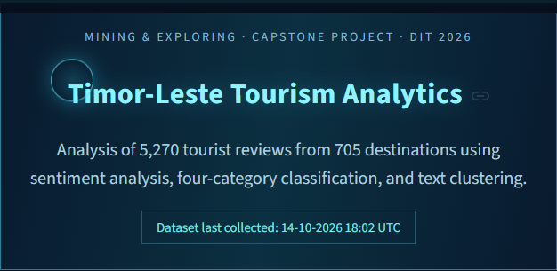
Figura 4.1. Header atual do dashboard ho kontajen dataset no data kolesaun ikus. Fonte: Dashboard Streamlit, captura 22 Outubru 2026.

4.3. Duplicate no Missing Values
Preprocessing hasai duplicate-content rows 10; duplicate review IDs 0 no invalid rows removed 0 iha run atual. Missing values la halo drop sistemátiku; has_review, has_text no has_rating marka disponibilidade, city tenta imputa husi address, no coordenada mamuk esklui deit husi mapa. Rezultadu mak 5.496 rows husi 705 destinasaun: review records 5.270 no placeholders 226. Iha processed rows, review text missing 2.278 (inklui placeholders), no review stars missing 298; rating-only reviews mantein. Metadata hatudu city 303 nafatin Unknown depois imputation. Outlier long-review 270 marka ho flag deit, la hasai. Cleaning policy ne’e preserva informasaun ba audit no evita hasai review sem teksu.
Tabela 4.2. Rekonsiliasaun raw no processed rows
Cleaning operation | Rows
Raw flattened rows | 5,506
Duplicate review IDs removed | 0
Duplicate-content rows removed | 10
Invalid rows removed | 0
Processed rows | 5,496
Valid reviews + no-review placeholders | 5,270 + 226

4.4. Text Preprocessing no Feature Engineering
Text cleaning muda letra ba lowercase, hasai URL, emoji, númeru no símbolu tuir regra kode, no organiza espasu. Tokenization hasai stopwords no tokens ho karakter menus husi rua. Feature engineering kria n_tokens, n_chars, date fields, recency no rating deviation. Husi review ho original text 3.218, 156 sai mamuk depois cleaning; texts 3.062 tama ba clustering ho vocabulary tokens 10.501. Média token count ba reviews ho text mak 17,88. IQR deteta long-review outliers 270; sistema marka deit, la hasai. Yohannes et al. (2025) no Zhang et al. (2026) fó konteksu ba text representation. Remove emoji/stopwords bele hamenus informasaun sentiment, nune’e regra cleaning presiza konsidera iha melhoria tuirmai.
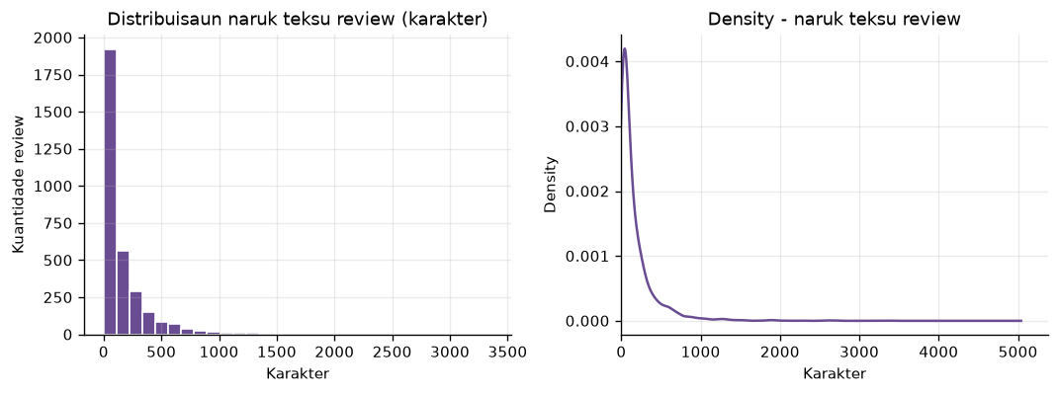
Figura 4.2. Distribuisaun naruk review text no token depois preprocessing. Fonte: reports/figures/02_distribuisaun_naruk_teksu.png; pipeline run 14 Outubru 2026.

4.5. Label Preparation no Dataset ba Model
Sentiment proxy label define husi rating: 4–5 sai Positive, 3 sai Neutral no 1–2 sai Negative. Ba supervised sentiment, review ho tokens utilizável no rating proxy válidu totaliza 2.990 (train 2.242; test 748). Ba supervised category, anotasaun manual kobre destinasaun 50 no liga ba 270 review records; husi ne'e, 135 deit iha text/token limpu ne'ebé model bele uza. Review 135 seluk la iha text utilizável depois cleaning. Nune'e dataset category model mak 135 review husi 26 destinasaun, fahe ba 78 train no 57 test. Split tuir place_id atu review husi destinasaun ida la tama iha train no test hamutuk; Religious iha destinasaun modelável ida deit, nune'e hela iha train no la iha test support. Review ho text 3.218 no review valid 5.270; total ba model ki'ik liu tanba presiza text no label válidu. Total valid review atinji target 5.000, maibé human annotation independente seidauk kompleta.
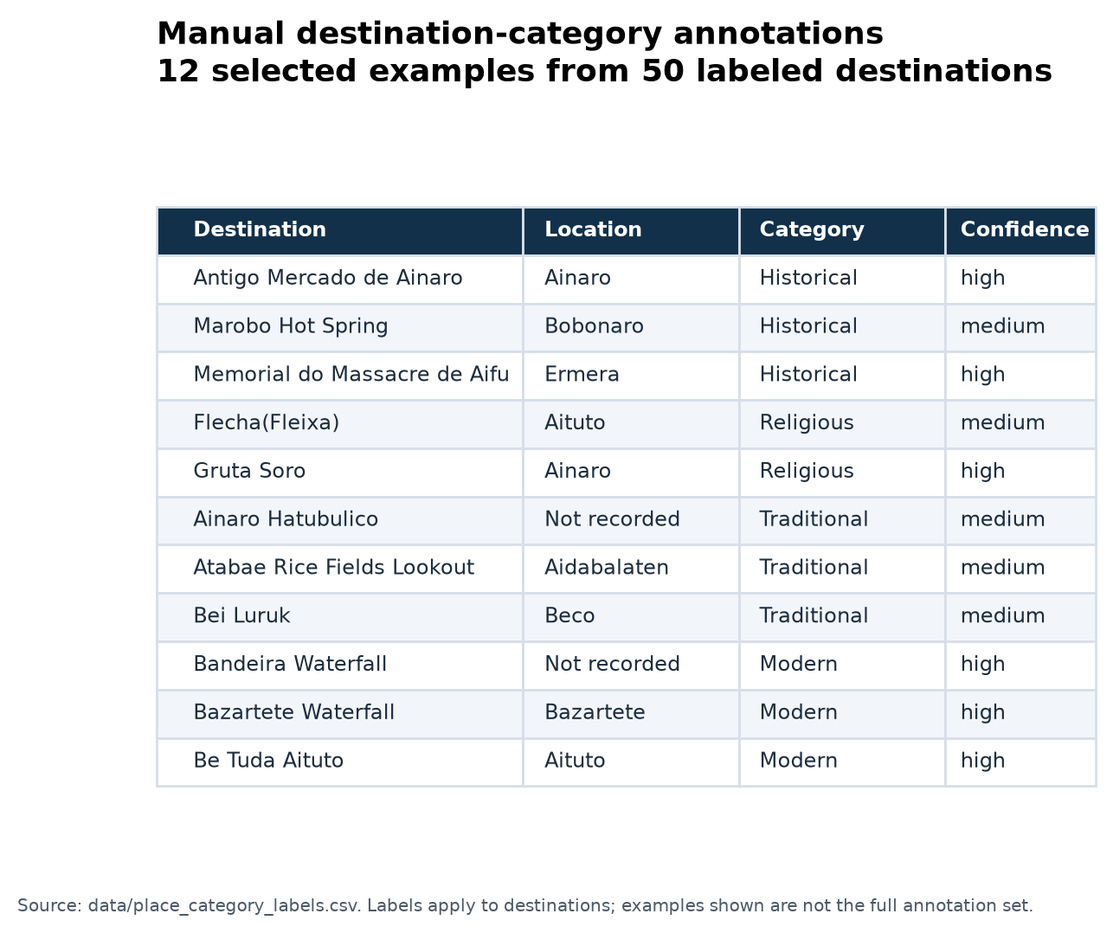
Figura 4.3. Ezemplu anotasaun manual ba 12 husi 50 destinasaun. Fonte: data/place_category_labels.csv; label sira aplika iha nivel destinasaun.
Tabela 4.3. Dataset atual depois preprocessing
Indikadór | Kontajen
Snapshot JSON input files | 4
Distinct destinations | 705
Raw flattened rows | 5,506
Duplicate-content rows removed | 10
Processed rows | 5,496
Valid review records | 5,270
No-review placeholders | 226
Reviews with original text | 3,218
Rating-only reviews | 2,052
Empty texts after cleaning | 156
Texts used for clustering | 3,062
Sentiment supervised data (train/test) | 2,990 (2,242 / 748)
Category supervised data (train/test) | 135 (78 / 57)

Fonte: reports/eda_summary.json, reports/model_evaluation.json, reports/data_collection_log.json, data/place_category_labels.csv no data/output/reviews_mined.csv. Pipeline run: 14 Outubru 2026.

CHAPTER 5
EDA AND DATA MINING RESULTS

5.1. Dataset Overview
EDA hatudu destinasaun 705, processed rows 5.496, valid reviews 5.270 no placeholders 226. Review ho text mak 3.218; valid individual ratings mak 5.198, média 4,42 no mediana 5. Review dates kobre 29 Jullu 2012 to’o 14 Outubru 2026. Sentiment source iha reviews valid: text 3.064 no rating fallback 2.206. Metadata língua mai husi source review records, la’ós model language-detection foun ne’ebé ami treina. Review counts no language labels tenke lee hanesan karakterístika amostra online, la’ós perfil turista hotu iha Timor-Leste.
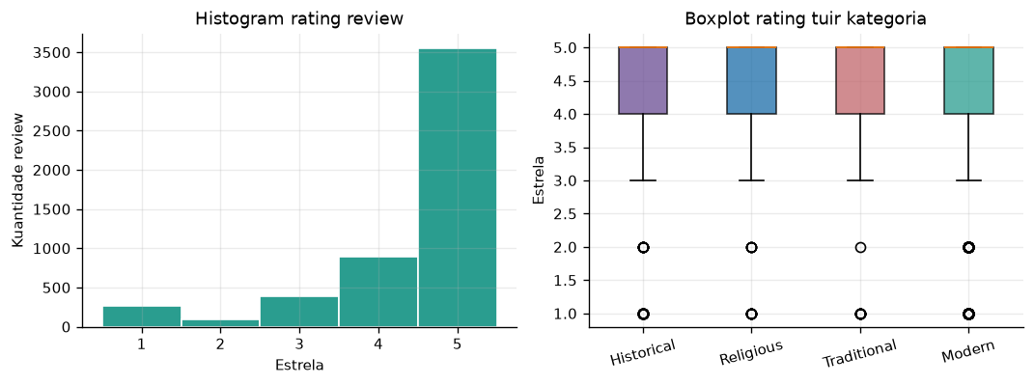
Figura 5.1. Individual rating distribution ba 5.198 ratings válidu. Fonte: reports/figures/01_distribuisaun_rating.png; pipeline run 14 Outubru 2026.

5.2. Sentiment Distribution
Operational sentiment iha valid reviews 5.270: Positive 3.805, Neutral 1.167 no Negative 298; Unknown 226 mak destination placeholders ne’ebé la iha review. Label sira-ne’e mai husi lexicon no rating fallback, la’ós Logistic Regression predictions ba dataset tomak. Sentiment source ba valid reviews mak text 3.064 no rating 2.206. Karim et al. (2025) no Nicolau et al. (2025) fó konteksu ba distinsaun text no rating. Positive representa 72,2%, Neutral 22,1% no Negative 5,7% husi review válidu; Unknown la’ós Neutral no placeholders la tama iha denominator sentiment.
Tabela 5.1. Operational sentiment distribution
Sentiment label | Records
Positive | 3,805
Neutral | 1,167
Negative | 298
Unknown (no review evidence) | 226
Total rows | 5,496

5.3. Category Distribution
Iha valid reviews 5.270, category Historical iha 715, Religious 229, Traditional 225 no Modern 4.101. Manual annotation mak prioridade bainhira iha; records seluk uza rule-based fallback. Manual labels kobre destinasaun 50 no output category-source dokumenta metodu. Positive shares ba category ida-idak mak Historical 65,7%, Religious 69,0%, Traditional 63,6% no Modern 74,0%. Modern nia keyword rules mós sai fallback ba local ne’ebé la hetan match spesífiku; tanba ne’e nia prevalénsia la prova katak turizmu nasaun domina husi infraestrutura moderna. Calderón-Fajardo et al. (2024) no Rui et al. (2025) fó konteksu ba destination analysis, maibé distribuisaun ne’e reflete dataset no rules, la’ós estatístika nasional.
Dadus permite haree review trend tuir review_date_parsed, category no sentiment tuir localidade, hanesan aspeto ne’ebé Rui et al. (2025) no Chen et al. (2025) diskute iha tourism analysis. Municipality/city metadata iha valores ne’ebé la padroniza no Unknown, nune’e mapa no city aggregation tenke lee ho kuidadu. Review trend mak published review dates husi 2012–2026, la’ós visitor arrival statistics. Relasaun entre rating no text features mak deskriptivu deit no la prova causa-efeitu. Filtro dashboard ajuda inspeksaun subset, maibé la altera global evaluation set.
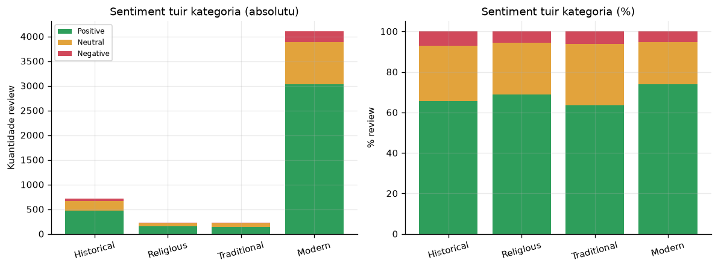
Figura 5.2. Review sentiment tuir category operational. Fonte: reports/figures/03_kategoria_vs_sentiment.png; pipeline run 14 Outubru 2026.
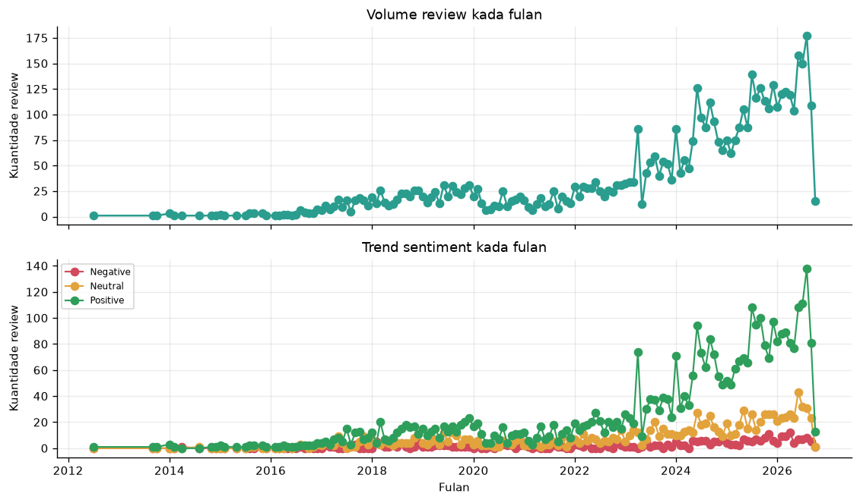
Figura 5.3. Review trend tuir published date; la’ós visitor arrival statistics. Fonte: reports/figures/04_trend_tempu.png; pipeline run 14 Outubru 2026.
Tabela 5.2. Category distribution no positive share
Category | Valid review records | Positive (%)
Historical | 715 | 65.7
Religious | 229 | 69.0
Traditional | 225 | 63.6
Modern | 4,101 | 74.0
Total valid reviews | 5,270 | —

5.4. Clustering Results
K-Means k=4 uza texts 3.062 no produz cluster sizes ne’ebé la balansu: cluster 0 iha 1.489 (48,6%), cluster 1 iha 1.216 (39,7%), cluster 2 iha 171 (5,6%) no cluster 3 iha 186 (6,1%). Top terms cluster 0 inklui food, place, great, beautiful no beach; cluster 1 inklui timor, leste, fatin, furak no bagus; cluster 2 inklui nice place, great place no beach; cluster 3 inklui good, food, service no view. Cavique et al. (2025) no Sun et al. (2024) fó konteksu ba leitura konseitu no tema. Top terms ajuda interpreta pattern, maibé la konfirma tema ho independente. Língua no review phrase komún bele influensia clusters; cluster ID la’ós category destinasaun.
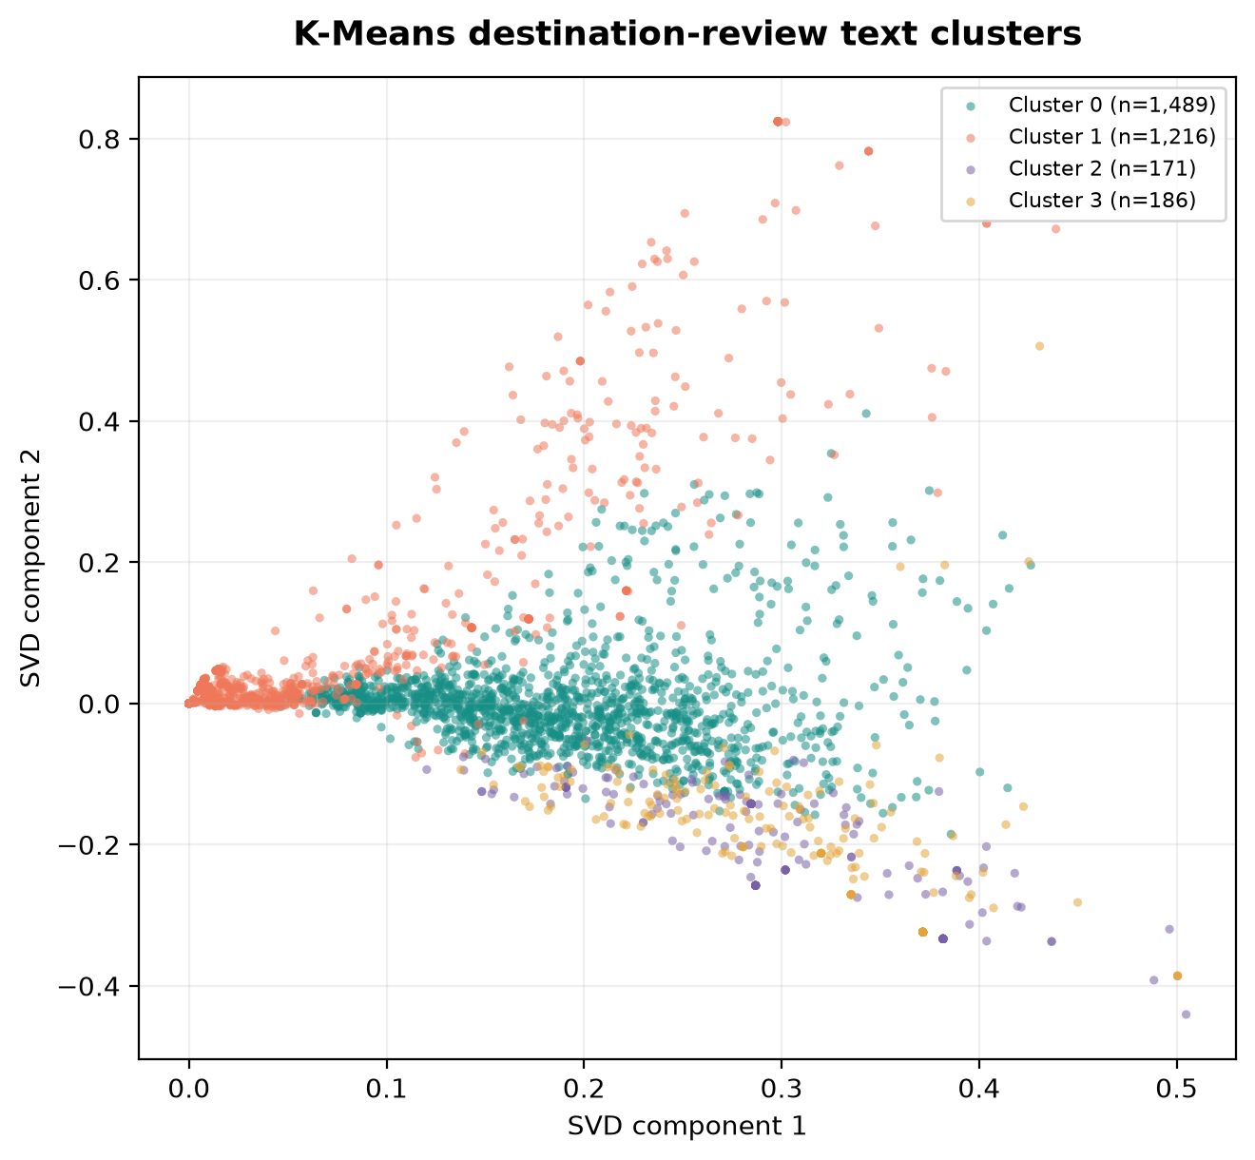
Figura 5.4. K-Means cluster ba review text iha projeisaun SVD. Fonte: reports/figures/current_cluster_scatter_readable.png; pipeline run 14 Outubru 2026.
Tabela 5.3. Cluster profiles husi texts 3.062.
Cluster | Texts | Share (%) | Top terms
0 | 1,489 | 48.6 | food, place, great, beautiful, beach
1 | 1,216 | 39.7 | timor, leste, fatin, furak, bagus
2 | 171 | 5.6 | nice, nice place, great place, beach, coffee
3 | 186 | 6.1 | good, food, good food, service, view

5.5. Dashboard Results
Dashboard Streamlit atual iha Data Collection, Overview & EDA, Text Clustering, Model Evaluation no Data & Methodology. Overview hatudu KPI, sentiment/category charts, mapa no trends; Clustering hatudu SVD plot, k sweep no top terms; Model Evaluation hatudu model metrics, baselines no confusion matrices; Data & Methodology hatudu detailed records, data dictionary no manual labels. Dashboard la hala’o data collection foun automatikamente. Screenshots iha relatóriu atualiza husi aplikasaun lokal iha 22 Outubru 2026; dataset/model results mak pipeline run 14 Outubru 2026, ho filters default. Sentiment percentages exclude records 226 ne’ebé la iha review evidence. CSV exports no report figures mosu iha output folders ba análize offline.
Figura 5.5. Dashboard hero ho dataset atual: 705 destinasaun no 5.270 valid reviews. Fonte: Dashboard Streamlit, captura 22 Outubru 2026.

CHAPTER 6
EVALUATION AND DISCUSSION

6.1. Sentiment Model Evaluation
Iha sentiment test reviews 748, Logistic Regression hili tanba training cross-validation macro-F1 0,4331 (aas liu model sira seluk). Nia test accuracy mak 0,8516 no macro-F1 0,4763. Lexicon hetan accuracy 0,6377 no macro-F1 0,4207; majority baseline hetan accuracy 0,8676 maibé macro-F1 0,3097. Karim et al. (2025) no Calderón-Fajardo et al. (2024) fó konteksu ba classification evaluation. Logistic Regression supera baselines iha macro-F1, la’ós accuracy. Test set domina Positive (649), ho Neutral 61 no Negative 38; Naive Bayes prevee Positive ba test records hotu, nune’e accuracy aas la hatudu deteksaun di’ak ba minority classes.
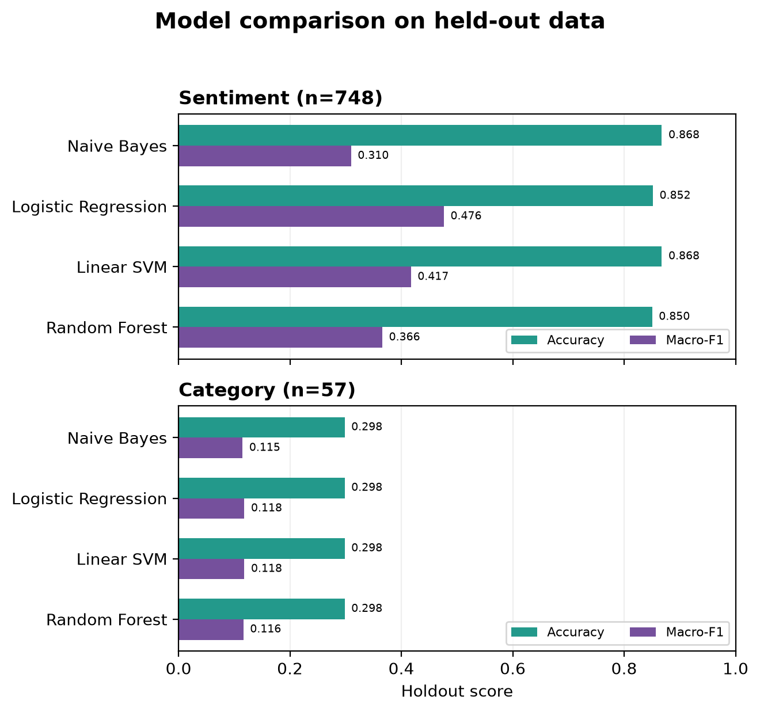
Figura 6.1. Komparasaun accuracy no macro-F1 iha holdout set ba sentiment no categoria. Fonte: reports/figures/current_model_comparison_readable.png; pipeline run 14 Outubru 2026.
Tabela 6.1. Sentiment evaluation; test n=748.
Model | Accuracy | Precision macro | Recall macro | Macro-F1
Lexicon | 0.6377 | 0.4636 | 0.4612 | 0.4207
Majority baseline | 0.8676 | 0.2892 | 0.3333 | 0.3097
Naive Bayes | 0.8676 | 0.2892 | 0.3333 | 0.3097
Logistic Regression (best CV macro-F1) | 0.8516 | 0.5480 | 0.4477 | 0.4763
Linear SVM | 0.8676 | 0.6305 | 0.3928 | 0.4172
Random Forest | 0.8503 | 0.4276 | 0.3613 | 0.3658

6.2. Sentiment Error Analysis
Confusion matrix Logistic Regression hatudu katak model identifika loos Positive 618 husi 649, Neutral 11 husi 61 no Negative 8 husi 38. Husi Negative, 23 sai prediction Positive no 7 sai Neutral; minority-class recognition nafatin limitadu. Negative class nia F1 mak 0,2963. Karim et al. (2025) no Nicolau et al. (2025) fó konteksu ba text classification no rating; error analysis presiza human reading tanba reference label mak rating proxy. Destination overlap iha review-level training/test 201, nune’e resultu estima held-out reviews la’ós destinasaun foun. Destination holdout ka temporal holdout bele uza iha evaluation tuirmai.
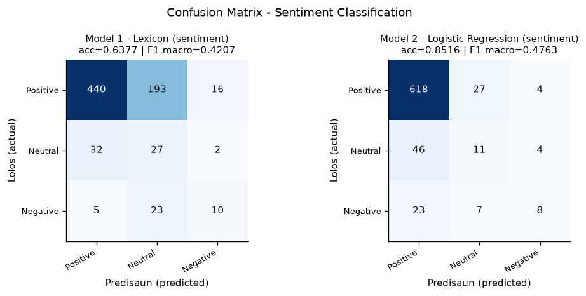
Figura 6.2. Sentiment confusion matrix ba Logistic Regression no lexicon. Fonte: reports/figures/09_confusion_matrix_sentiment.png; pipeline run 14 Outubru 2026.
Tabela 6.2. Confusion matrix ba selected Logistic Regression
Actual / Predicted | Positive | Neutral | Negative
Positive | 618 | 27 | 4
Neutral | 46 | 11 | 4
Negative | 23 | 7 | 8

6.3. Category Model Evaluation
Category test set iha review records 57 husi 26 destinasaun modelável no kobre Historical 38, Religious 0, Traditional 2 no Modern 17. Linear SVM nia training cross-validation macro-F1 aas liu iha 0,2288, maibé test accuracy mak 0,2982 no macro-F1 0,1181; majority baseline nia accuracy mak 0,2982 no macro-F1 0,1149. Macro-F1 ki'ik, no diferensa ho baseline ki'ik tebes; tanba ne'e, rezultadu hatudu katak model categoria seidauk forte. Rule-based text evaluation iha sample 57 hetan accuracy 0,3158 no macro-F1 0,1420, maibé la hanesan supervised test protocol. Religious la iha test sample tanba label modelável ba categoria ne'e mai husi destinasaun ida deit, ne'ebé hela iha training split. Manual labels ki'ik no class imbalance limita generalizasaun. Calderón-Fajardo et al. (2024) no Karim et al. (2025) fó konteksu ba classification evaluation.
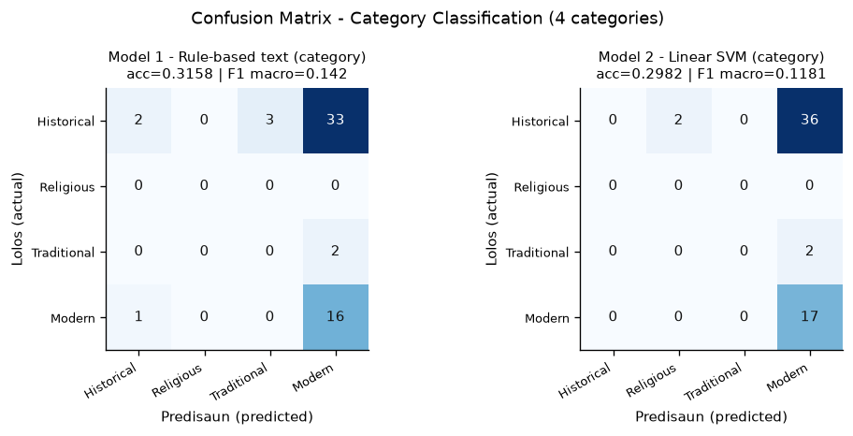
Figura 6.3. Category confusion matrices; Religious laiha test support. Fonte: reports/figures/10_confusion_matrix_kategoria.png; pipeline run 14 Outubru 2026.
Tabela 6.3. Category evaluation; test n=57.
Model | Accuracy | Macro-F1
Text-only rule-based | 0.3158 | 0.1420
Majority baseline | 0.2982 | 0.1149
Naive Bayes | 0.2982 | 0.1149
Logistic Regression | 0.2982 | 0.1181
Linear SVM (best CV macro-F1) | 0.2982 | 0.1181
Random Forest | 0.2982 | 0.1164

6.4. Clustering Evaluation
K-Means k=4 hetan silhouette 0,0373, Davies–Bouldin 5,8047 no Calinski–Harabasz 45,9472. Iha k sweep, silhouette aas liu mak k=8 ho 0,0754 no Davies–Bouldin 2,9696. Agglomerative Ward hetan silhouette 0,0685 no Davies–Bouldin 2,5868. Jamalian no Vahdat-Nejad (2025) no Zhang et al. (2026) fó konteksu ba clustering evaluation. Silhouette ki’ik hatudu separation fraku; k=4 nafatin konfigurasaun fixa iha sistema, la’ós k optimal ne’ebé hili automaticamente. SVD 2D retén variance 4,07% deit, nune’e scatter plot la substitui evaluation iha TF-IDF space orijinál. Top terms presiza akompaña ho leitura review.
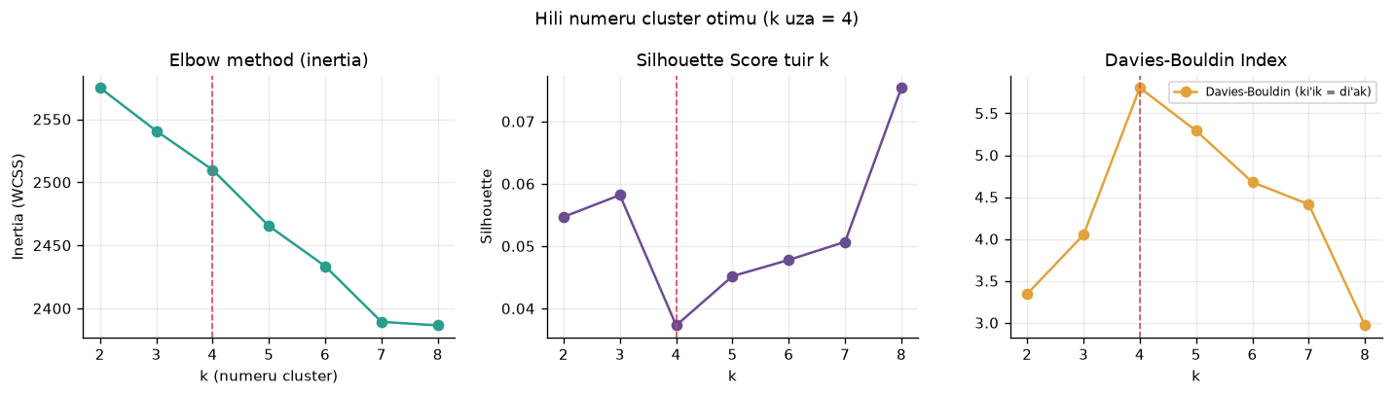
Figura 6.4. K sweep; k=8 iha silhouette aas liu iha range k=2–8, maibé sistema uza k=4. Fonte: reports/figures/11_elbow_silhouette.png; pipeline run 14 Outubru 2026.
Tabela 6.4. Clustering evaluation iha TF-IDF space
Configuration | Silhouette | Davies–Bouldin
K-Means, k=4 (system setting) | 0.0373 | 5.8047
K-Means, k=8 (best tested silhouette) | 0.0754 | 2.9696
Agglomerative, Ward | 0.0685 | 2.5868

6.5. Human Validation no Limitasaun
Human validation iha status pending: sample review 30 prepara ona, maibé sentiment no category human labels válidu seidauk iha. Tanba ne'e, ami la deklara katak output sistema valida kompletu ona husi ema. Yohannes et al. (2025) no Zhang et al. (2026) fó konteksu ba text representation limitations; limitasaun projetu identifika husi dataset no evaluation output. Category annotation la'ós independent review-level ground truth: label kobre 50 destinasaun (270 review records), maibé category model uza 135 review deit ne'ebé iha text limpu, ho destinasaun ida-idak hela deit iha train ka test. Test set ki'ik (57) no laiha Religious support; macro-F1 0,1181 dehan katak model seidauk bele uza ba klasifikasaun kategori ne'ebé konfiável. Limitasaun seluk inklui sentiment label proxy husi rating, class imbalance, rule fallback no multilingual reviews. Model differences mak komparasaun deskriptiva; statistical significance test seidauk hala'o. Sistema apropriadu ba exploratory analysis ho verifikasaun manual.
Kuantidade dadus ne’ebé aumenta la resolve automaticamente label quality. Manual category labels kobre destinasaun 50 husi 705, no category test sample la iha Religious records. Sentiment supervision uza rating proxy, la’ós human text annotation. Nicolau et al. (2025) no Karim et al. (2025) fó konteksu ba diferensa entre text sentiment no rating. Fatin sira ne’ebé la iha anotasaun manual uza operational rules; iha dashboard, source field permite utilizadór distingue anotasaun manual husi fallback. Aumenta labels no halo independent human validation mak prioridade antes uza model ba desizaun prátiku.

CHAPTER 7
CONCLUSION AND RECOMMENDATION

7.1. Konkluzaun
Ami implementa sistema ne’ebé lee JSON snapshots diretamente, halo preprocessing, sentiment analysis, category classification, clustering, EDA no evaluation, depois hatudu outputs iha dashboard. Raw rows 5.506 transforma ba processed rows 5.496 iha destinasaun 705: review valid 5.270 no placeholders 226. Review ho teksu mak 3.218 no texts 3.062 uza ba clustering. Calderón-Fajardo et al. (2024) no Cavique et al. (2025) fó fundamentu ba tourism review analysis; realizasaun ne’e mai husi code atual. Pergunta kona-ba distribuisaun responde ho EDA, performance ho evaluation metrics no patterns ho cluster profiles. Target review records 5.000 atinji, maibé review ho teksu no manual labels mak subset ki’ik liu. Sistema ajuda esplora dataset, la reprezenta opiniaun turista hotu.
Logistic Regression nia sentiment macro-F1 0,4763 aas liu lexicon no majority baselines, maibé accuracy 0,8516 menus husi majority accuracy 0,8676; Negative detection nafatin limitadu. Category Linear SVM nia macro-F1 0,1181 iha test records 57, no test sample la iha Religious support. Clustering silhouette k=4 mak 0,0373, ne’ebé hatudu separation fraku. Karim et al. (2025) no Jamalian no Vahdat-Nejad (2025) fó konteksu ba model comparison no clustering evaluation. Konkluzaun importante mak sistema realiza funsaun téknika ne’ebé implementa, maibé model quality presiza melhoria. Dataset anotadu, balance entre classes no human evaluation tenke aumenta; human-validation sample records 30 seidauk kompleta.

7.2. Kontribuisaun Projetu
Kontribuisaun projetu mak pipeline Python ne’ebé lee snapshots raw, metadata collection, preprocessing, feature/output layers, model comparison ho baselines no dashboard ne’ebé liga rezultadu ho dataset. Ami preserva JSON snapshots originais no separa raw, processed, feature no output layers. Operational labels distingue husi supervised test predictions; category split separa destinos hodi evita place overlap. Rui et al. (2025) no Chen et al. (2025) fó konteksu ba utiliza informasaun destinasaun. Collection logs, pipeline metadata, model metrics no CSV exports ajuda verifica etapa sira. Projetu la propoin algoritmu foun; nia kontribuisaun mak implementasaun, dokumentasaun no avaliasaun ba dataset ne’ebé ami hili, ho limitasaun ne’ebé hatudu ho transparente.

7.3. Rekomendasaun
Prioridade melhoria mak label quality no evaluation coverage antes aumenta model complexity. Yohannes et al. (2025) no Zhang et al. (2026) fó alternativa ba text representation no clustering, maibé alternativa ne’e presiza testa ho protocol klaru. Dashboard atual di’ak liu uza hanesan ferramenta exploratory analysis ho manual review ba rezultadu importante. Data collection Apify presiza hala’o ho API token no kontrole quota; pipeline snapshot la’ós real-time. Mudansa dataset ka model tenke dokumenta atu komparasaun entre run bele halo ho loos. Rekomendasaun ami mak:
- Kompleta human sentiment annotation bazeadu ba teksu, la’ós kopia rating.
- Aumenta manual category labels, liuliu ba rare classes.
- Prepara independent test samples ba Religious.
- Revê definisaun Modern no fallback category.
- Avalia Tetum reviews no multilingual preprocessing.
- Kompara review-level split ho destination-level split ba sentiment.
- Testa TF-IDF settings no cluster stability.
- Dokumenta periodic data collection.
- Halo dashboard user testing.
- Atu kompleta entrega final, prenxe identidade grupu, GitHub link no YouTube demonstration; screenshots dashboard atualizada iha 22 Outubru 2026 ona insere iha relatóriu.

REFERENCES
Artigu hotu iha lista ne’e mak artigu jurnal ScienceDirect Open Access, ho publication year 2024–2026. Tinan iha DOI bele diferente husi tinan edisaun jurnal.
Calderón-Fajardo, V., Anaya-Sánchez, R., & Molinillo, S. (2024). Understanding destination brand experience through data mining and machine learning. Journal of Destination Marketing & Management, 31, 100862.
DOI: 10.1016/j.jdmm.2024.100862
Cavique, M., Ribeiro, R., Batista, F., & Correia, A. (2025). From host’s descriptions to guests’ reviews: Semantic similarities. Annals of Tourism Research Empirical Insights, 6(2), 100187.
DOI: 10.1016/j.annale.2025.100187
Chen, J., Wu, J., Wang, D., & Stantic, B. (2025). Beyond static rankings: A tourist experience-driven approach to measure destination competitiveness. Tourism Management, 106, 105022.
DOI: 10.1016/j.tourman.2024.105022
Jamalian, M., & Vahdat-Nejad, H. (2025). Effective clustering of big text data: Empirical evaluation and comparative analysis. Egyptian Informatics Journal, 32, 100812.
DOI: 10.1016/j.eij.2025.100812
Karim, A., Mansab, M., Shahroz, M., Mushtaq, M. F., & Jeong, I. C. (2025). Anticipating impression using textual sentiment based on ensemble LRD model. Expert Systems with Applications, 263, 125717.
DOI: 10.1016/j.eswa.2024.125717
Nicolau, J. L., Bigné, E., Bulchand-Gidumal, J., & William, E. (2025). From booking to rating activities: A holistic analysis of online review behavior in a destination. Journal of Destination Marketing & Management, 36, 100995.
DOI: 10.1016/j.jdmm.2025.100995
Rui, J., Xu, Y., Cai, C., & Li, X. (2025). Leveraging large language models for tourism research based on 5D framework: A collaborative analysis of tourist sentiments and spatial features. Tourism Management, 108, 105115.
DOI: 10.1016/j.tourman.2024.105115
Sun, X., Wang, Z., Zhou, M., Wang, T., & Li, H. (2024). Segmenting tourists’ motivations via online reviews: An exploration of the service strategies for enhancing tourist satisfaction. Heliyon, 10(1), e23539.
DOI: 10.1016/j.heliyon.2023.e23539
Yohannes, D., Sinshaw, Y. B., Asefa, S. H., & Assabie, Y. (2025). Amharic document clustering using semantic information from neural word embedding and encyclopedic knowledge. Scientific African, 28, e02657.
DOI: 10.1016/j.sciaf.2025.e02657
Zhang, W., Wu, X., Zhou, M., & Guan, R. (2026). Improving short text clustering through hybrid augmentation and contrastive learning. Neurocomputing, 677, 133130.
DOI: 10.1016/j.neucom.2026.133130

APPENDICES

Appendix A — Source Code
GitHub repository: https://github.com/sd8778515-cmykr/timor-leste-tourism-analytics________________________
Tabela A.1. Source code no data configuration
Komponente | File
Main pipeline | src/pipeline.py
Configuration | src/config.py
Data collection | src/data_collection.py
Preprocessing | src/preprocessing.py
Category classification | src/category_classifier.py
Sentiment analysis | src/sentiment_analysis.py
Supervised models | src/supervised_models.py
Clustering | src/clustering.py
EDA | src/eda.py
Model evaluation | src/model_evaluation.py
Evaluation interpretation | src/evaluation_interpretation.py
Power BI export | src/export_powerbi.py
Dashboard | dashboard/app.py
Raw snapshots | data/raw/*.json
Manual category labels | data/place_category_labels.csv
Processed, features and mined outputs | data/processed/ · data/features/ · data/output/

Appendix B — Dashboard Screenshots
Screenshots dashboard husi sistema atual inseri besik diskusaun ne’ebé relevante; tabela iha kraik hatudu seksaun ne’ebé screenshot refere.
- Overview & EDA: Chapter 5, seksaun 5.5.
- Text Clustering: Chapter 5, seksaun 5.4.
- Model Evaluation: Chapter 6, seksaun 6.1; confusion matrix iha seksaun 6.2.
- Data & Methodology: Chapter 4, seksaun 4.2 no 4.5; data dictionary iha Appendix C.
Screenshot capture: 22 Outubru 2026. Dataset no model results: pipeline run 14 Outubru 2026; data last collected 14 Outubru 2026 18:02 UTC. Default filters; placeholders inklui iha total records, la inklui iha valid sentiment percentages.
Figura B.1. K-Means cluster ba review text iha projeisaun SVD. Fonte: reports/figures/current_cluster_scatter_readable.png; pipeline run 14 Outubru 2026.

Appendix C — Data Dictionary
Tabela C.1. Data dictionary rezumidu
Column | Data type | Deskrisaun
place_id | Text | ID destinasaun (Google place ID)
place_name | Text | Naran destinasaun turizmu
review_id | Text | ID review uniku
review_text | Text | Komentáriu orijinál turista
review_stars | Numeric | Rating individual husi review
review_date_parsed | Datetime | Data review publika (UTC)
city | Text | Cidade/localidade; bele Unknown
lat, lng | Decimal | Koordenada GPS destinasaun
has_review | Boolean | Record iha review ka placeholder
has_text | Boolean | Review iha teksu
has_rating | Boolean | Review iha star rating
text_clean | Text | Teksu depois text cleaning
tokens_joined | Text | Token input ba TF-IDF/clustering
category_label | Text | Label manual ba supervised evaluation
category | Text | Operational category (4 classes)
category_source | Text | Anotasaun manual ka rule-based fallback
category_rule_text / context / keywords | Text | Evidénsia rule ne’ebé match ba category
sentiment | Text | Operational sentiment: Positive/Neutral/Negative/Unknown
sentiment_source | Text | Text lexicon, rating fallback ka none
sentiment_true_proxy | Text | Reference label husi rating proxy
sentiment_pred_ml | Text | ML prediction ba test records
category_pred_ml | Text | ML prediction ba test records
cluster | Integer | K-Means cluster ID
cluster_x, cluster_y | Decimal | Koordenada SVD ba vizualizasaun
sentiment_lexicon | Text | Sentiment lexicon evidence
sentiment_score | Numeric | Score husi lexicon sentiment
cluster_hier | Integer | Agglomerative cluster ID
split | Text | Train/test marker ba supervised sample
sentiment_split | Text | Sentiment train/test assignment
category_split | Text | Category train/test assignment

Data dictionary kompletu: reports/DATA_DICTIONARY.md. Manual category labels: data/place_category_labels.csv.
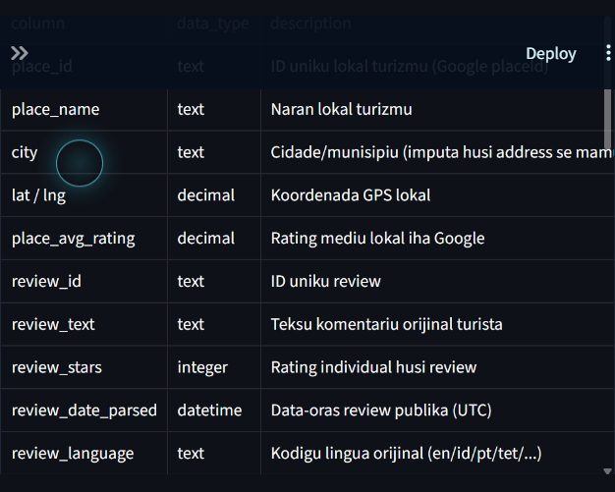
Figura C.1. Data dictionary atual no field definitions iha dashboard.
Fonte: Dashboard Streamlit atual, captura 22 Outubru 2026; pipeline run 14 Outubru 2026.

Appendix D — Evaluation Files no Demonstration
- Collection log: reports/data_collection_log.json.
- EDA summary: reports/eda_summary.json.
- Model evaluation: reports/model_evaluation.json.
- Metrics table: reports/tables/model_metrics.csv.
- Human validation sample: reports/tables/sample_validasaun_manual.csv.
- Figures: reports/figures/.
YouTube demonstration: ______________________________
Published dashboard, se disponivel: ______________________________

