PYTHON ACTIVITY:

CASE STUDIES 1-10:

CASE 1: University Scholarship Allocation

1.PROBLEM STATEMENT:
Design a system that evaluates applicants using aggregate marks, subject-wise minimum scores, attendance, and income criteria, ranks eligible students, and resolves ties using predefined rules.

2.OBJECTIVES:
To check scholarship eligibility automatically.
• To verify aggregate and subject-wise minimum marks.
• To check attendance and family income criteria.
• To rank eligible students based on their performance.
• To resolve ties using predefined rules.
• To reduce manual work and save time.

3.ASSUMPTIONS:
• The minimum aggregate marks required are 75%.
• The minimum mark required in each subject is 60%.
• The minimum attendance required is 75%.
• The maximum eligible annual family income is ₹2,50,000.
• Eligible students are ranked by aggregate marks in descending order.
• If aggregate marks are equal, higher attendance gets the higher rank.
• If aggregate marks and attendance are equal, lower family income gets the higher rank.
• All marks and attendance values are between 0 and 100.

4.ALGORITHM:
• Start the program.
• Enter the number of students.
• For each student, enter name, aggregate marks, subject marks, attendance, and annual family income.
• Check whether the aggregate marks are at least 75%.
• Check whether every subject mark is at least 60%.
• Check whether attendance is at least 75%.
• Check whether annual family income is at most ₹2,50,000.
• If all conditions are satisfied, mark the student as eligible; otherwise, mark the student as not eligible.
• Sort eligible students by aggregate marks (highest first), attendance (highest first), and family income (lowest first).
• Display the eligible students with their ranks and display the ineligible students separately.
• Stop the program.

5.FLOWCHART:
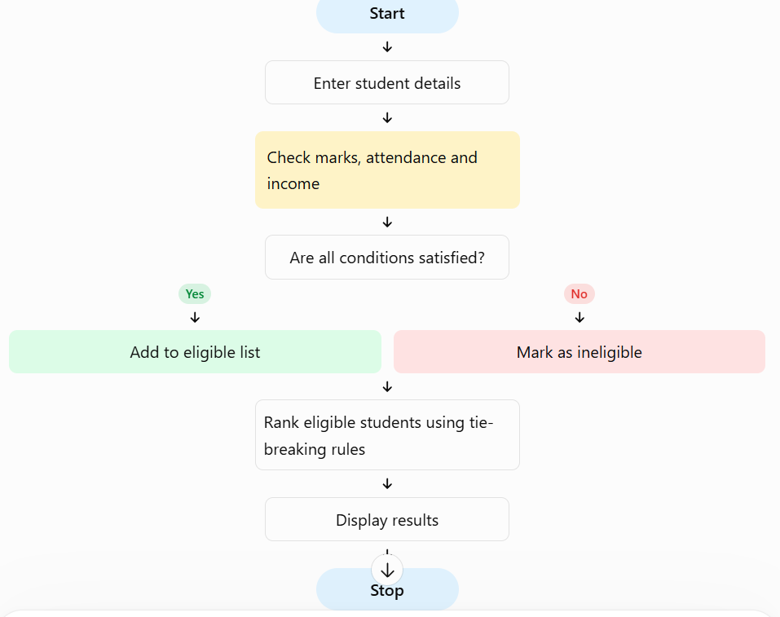

6.PSEUDO CODE:
START

INPUT number of students

FOR each student:
INPUT name
INPUT aggregate marks
INPUT subject marks
INPUT attendance
INPUT family income

IF aggregate marks >= 75 AND
every subject mark >= 60 AND
attendance >= 75 AND
family income <= 250000:
Mark student as ELIGIBLE
ELSE:
Mark student as NOT ELIGIBLE

SORT eligible students by:
1. Aggregate marks in descending order
2. Attendance in descending order
3. Family income in ascending order

DISPLAY eligible students with ranks
DISPLAY ineligible students

STOP

7.PYTHON SOURCE CODE:
students = []
n = int(input("Enter number of students: "))

for i in range(n):
print("\nStudent", i + 1)

name = input("Enter name: ")
aggregate = float(input("Enter aggregate marks: "))

s1 = float(input("Enter subject 1 marks: "))
s2 = float(input("Enter subject 2 marks: "))
s3 = float(input("Enter subject 3 marks: "))

attendance = float(input("Enter attendance percentage: "))
income = float(input("Enter annual family income: "))

if (aggregate >= 75 and min(s1, s2, s3) >= 60
and attendance >= 75 and income <= 250000):
status = "Eligible"
else:
status = "Not Eligible"

students.append({
"name": name,
"aggregate": aggregate,
"attendance": attendance,
"income": income,
"status": status
})

eligible = [s for s in students if s["status"] == "Eligible"]
ineligible = [s for s in students if s["status"] == "Not Eligible"]

eligible.sort(key=lambda s: (
-s["aggregate"],
-s["attendance"],
s["income"]
))

print("\n--- Scholarship Results ---")

for rank, s in enumerate(eligible, start=1):
print(rank, s["name"], "- Eligible")

for s in ineligible:
print(s["name"], "- Not Eligible")

8.TEST CASE:
Test Cases: The program is tested with different student details. Asha, with 90% aggregate marks, 80 marks in every subject or above, 90% attendance, and ₹2,00,000 family income, is eligible. Kiran, with 70% aggregate marks, is not eligible. Neha, with 55 marks in one subject, is not eligible. Sita, with ₹3,00,000 family income, is not eligible. The test cases verify that the program correctly checks all eligibility conditions and ranks eligible students.

9.OUTPUT: 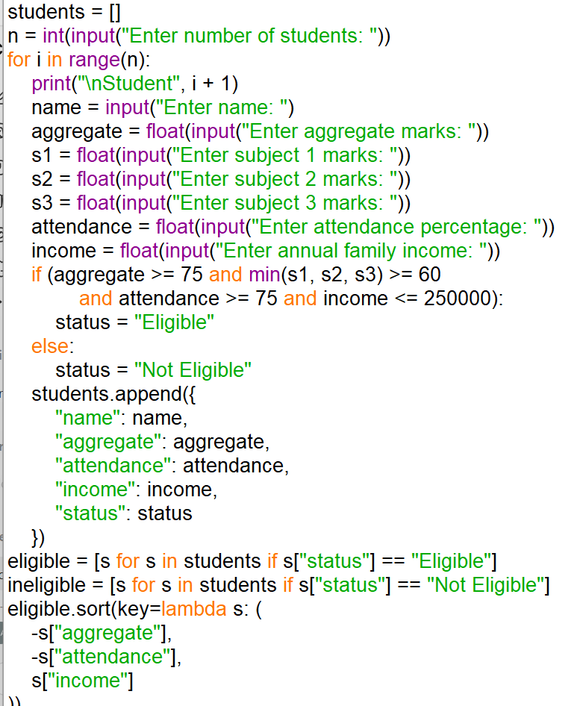

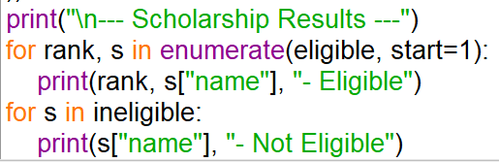
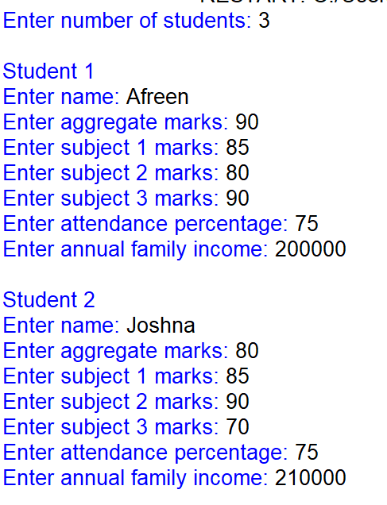
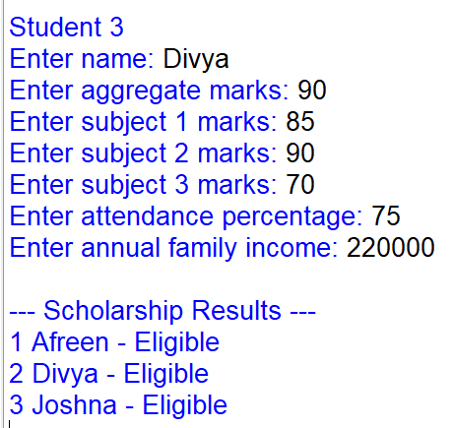

10.CONCLUSION:
The University Scholarship Allocation System checks student eligibility using aggregate marks, subject-wise marks, attendance, and family income. It ranks eligible students according to their academic performance and resolves ties using attendance and family income. This program reduces manual work, saves time, and makes scholarship selection easier and more systematic.

CASE 2: PROGRESSIVE ELECTRICITY BILLING

1.PROBLEM STATEMENT:
Calculate household bills using multiple consumption slabs, fixed charges, surcharges, and rebates, then compare bills across several months and identify unusual increases.

2.OBJECTIVES:
To calculate electricity bills using different unit slabs.
To add fixed charges and surcharges.
To apply rebates when applicable.
To compare bills across multiple months.

To identify unusual increases in electricity bills.

3.ASSUMPTIONS:
The first 100 units cost ₹2 per unit.
• The next 100 units cost ₹3 per unit.
• Units above 200 cost ₹5 per unit.
• Fixed charge is ₹50 per month.
• Surcharge is 5% of the energy charge.
• A 10% rebate is given if consumption is below 100 units.
• A bill increase greater than 30% compared with the previous month is considered unusual.

4.ALGORITHM:
- Start the program.
- Enter the electricity units consumed each month.
- Calculate the energy charge using the given slabs.
- Add the fixed charge.
- Calculate the surcharge.
- Apply the rebate if consumption is below 100 units.
- Calculate the final bill.
- Compare each month's bill with the previous month's bill.
- Display the monthly bills and identify unusual increases.
- Stop the program.

5.FLOWCHART:
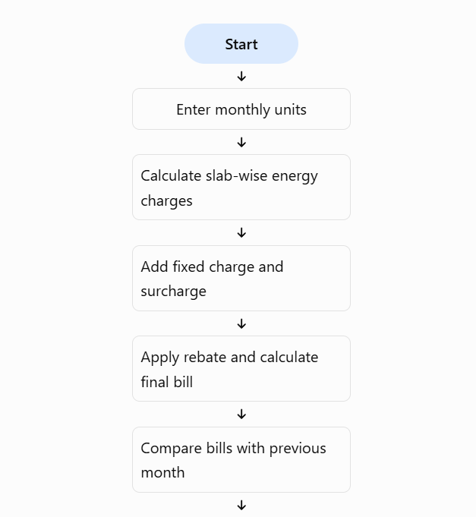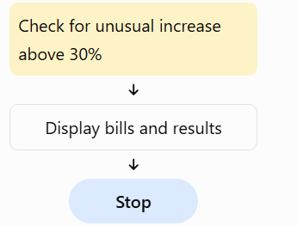

6.PSEUDO CODE:
START

INPUT number of months

FOR each month:
INPUT units consumed

IF units <= 100:
energy_charge = units * 2
ELSE IF units <= 200:
energy_charge = 100 * 2 + (units - 100) * 3
ELSE:
energy_charge = 100 * 2 + 100 * 3
+ (units - 200) * 5

fixed_charge = 50
surcharge = energy_charge * 0.05

IF units < 100:
rebate = energy_charge * 0.10
ELSE:
rebate = 0

bill = energy_charge + fixed_charge
+ surcharge - rebate

STORE bill

COMPARE each bill with previous month's bill

IF increase > 30%:
DISPLAY "Unusual increase"

DISPLAY all monthly bills

STOP

7.PYTHON SOURCE CODE:
bills = []
months = int(input("Enter number of months: "))

for i in range(months):
print("\nMonth", i + 1)
units = float(input("Enter units consumed: "))

if units <= 100:
energy = units * 2
elif units <= 200:
energy = 100 * 2 + (units - 100) * 3
else:
energy = 100 * 2 + 100 * 3 + (units - 200) * 5

fixed = 50
surcharge = energy * 0.05

if units < 100:
rebate = energy * 0.10
else:
rebate = 0

bill = energy + fixed + surcharge - rebate
bills.append(bill)

print("Electricity Bill: Rs.", round(bill, 2))

print("\n--- Monthly Bill Comparison ---")

for i in range(months):
print("Month", i + 1, ": Rs.", round(bills[i], 2))

if i > 0:
increase = ((bills[i] - bills[i - 1])
/ bills[i - 1]) * 100

if increase > 30:
print("Unusual increase detected!")
else:
print("No unusual increase.")

8.TEST CASE:
The program is tested with different monthly electricity consumption values. For 80 units, the bill is ₹201.20 after applying the rebate. For 150 units, the bill is ₹417.50. For 250 units, the bill is ₹837.50. When a monthly bill increases by more than 30% compared with the previous month's bill, the program identifies it as an unusual increase.

9.OUTPUT:
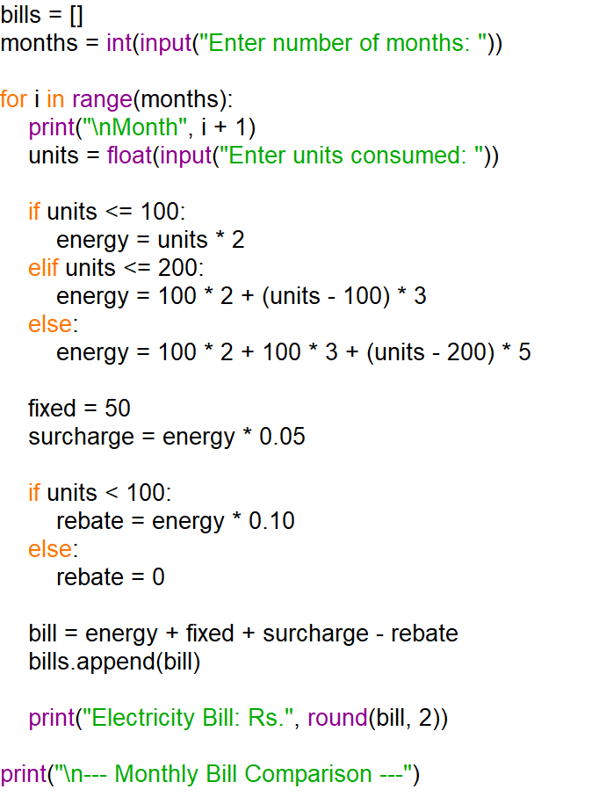
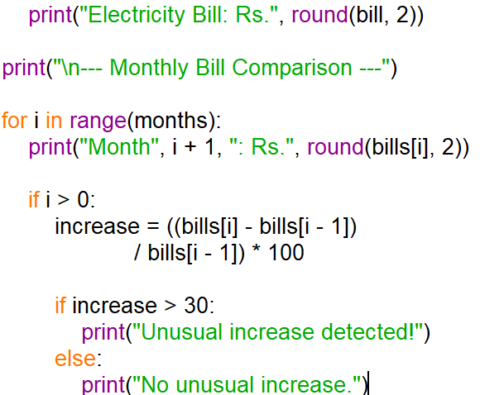
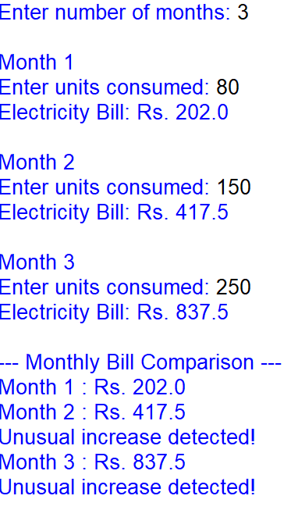

10.CONCLUSION:
The Progressive Electricity Billing System calculates household electricity bills using unit slabs, fixed charges, surcharges, and rebates. It compares monthly bills and detects unusual increases. This program reduces manual calculations and helps households monitor their electricity expenses.

CASE 3:HOSPITAL BILLING AND PATIENT CLASSIFICATION.

1.PROBLEM STATEMENT:
Process consultation, diagnostic, and treatment charges, apply conditional concessions, validate billing.

2.OBJECTIVES:
• To calculate the total hospital bill.
• To include consultation, diagnostic, and treatment charges.
• To apply concessions for eligible patients.
• To validate billing details and prevent invalid charges.
• To classify patients according to their payment policy.

3.ASSUMPTIONS:
- Consultation charge is ₹500.
- Diagnostic charges are entered by the user.
- Treatment charges are entered by the user.
- Senior citizens receive a 10% concession on the total bill.
- Patients with a valid insurance policy are classified as insured.
- Patients without insurance must pay the final bill themselves.
- Charges cannot be negative.
- The final bill cannot be less than zero.

4.ALGORITHM:
- Start the program.
- Enter the patient's name.
- Enter diagnostic and treatment charges.
- Set the consultation charge to ₹500.
- Check whether the entered charges are valid and non-negative.
- Calculate the total bill by adding all charges.
- If the patient is a senior citizen, apply a 10% concession.
- Calculate the final bill after the concession.
- Classify the patient as insured or self-paying.
- Display the bill details and stop the program.

5.FLOWCHART:
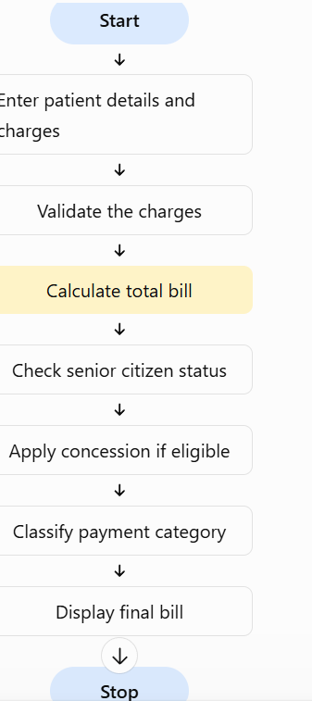

6.PSEUDO CODE:
START

INPUT patient name
INPUT diagnostic charges
INPUT treatment charges
INPUT senior citizen status
INPUT insurance status

IF diagnostic charges < 0 OR treatment charges < 0:
DISPLAY "Invalid charges"
ELSE:
consultation = 500
total = consultation + diagnostic + treatment

IF senior citizen:
concession = total * 0.10
ELSE:
concession = 0

final_bill = total - concession

IF insurance is YES:
category = "Insured"
ELSE:
category = "Self-paying"

DISPLAY total, concession, final_bill
DISPLAY category

STOP

7.PYTHON SOURCE CODE:
name = input("Enter patient name: ")
diagnostic = float(input("Enter diagnostic charges: "))
treatment = float(input("Enter treatment charges: "))

senior = input("Is the patient a senior citizen? (yes/no): ").lower()
insurance = input("Does the patient have insurance? (yes/no): ").lower()

if diagnostic < 0 or treatment < 0:
print("Invalid charges. Please enter non-negative values.")

elif senior not in ("yes", "no") or insurance not in ("yes", "no"):
print("Invalid patient details.")

else:
consultation = 500
total = consultation + diagnostic + treatment

if senior == "yes":
concession = total * 0.10
else:
concession = 0

final_bill = total - concession

if insurance == "yes":
category = "Insured"
else:
category = "Self-paying"

print("\n--- Hospital Bill ---")
print("Patient Name:", name)
print("Consultation Charges: Rs.", consultation)
print("Diagnostic Charges: Rs.", diagnostic)
print("Treatment Charges: Rs.", treatment)
print("Total Bill: Rs.", total)
print("Concession: Rs.", concession)
print("Final Bill: Rs.", final_bill)
print("Patient Category:", category)

8.TEST CASE:
The program is tested with different patient details. A senior citizen with valid charges receives a 10% concession. A patient with insurance is classified as insured, while a patient without insurance is classified as self-paying. If diagnostic or treatment charges are negative, the program displays an invalid charges message. These test cases verify billing calculations, concessions, and patient classification.

9.OUTPUT:
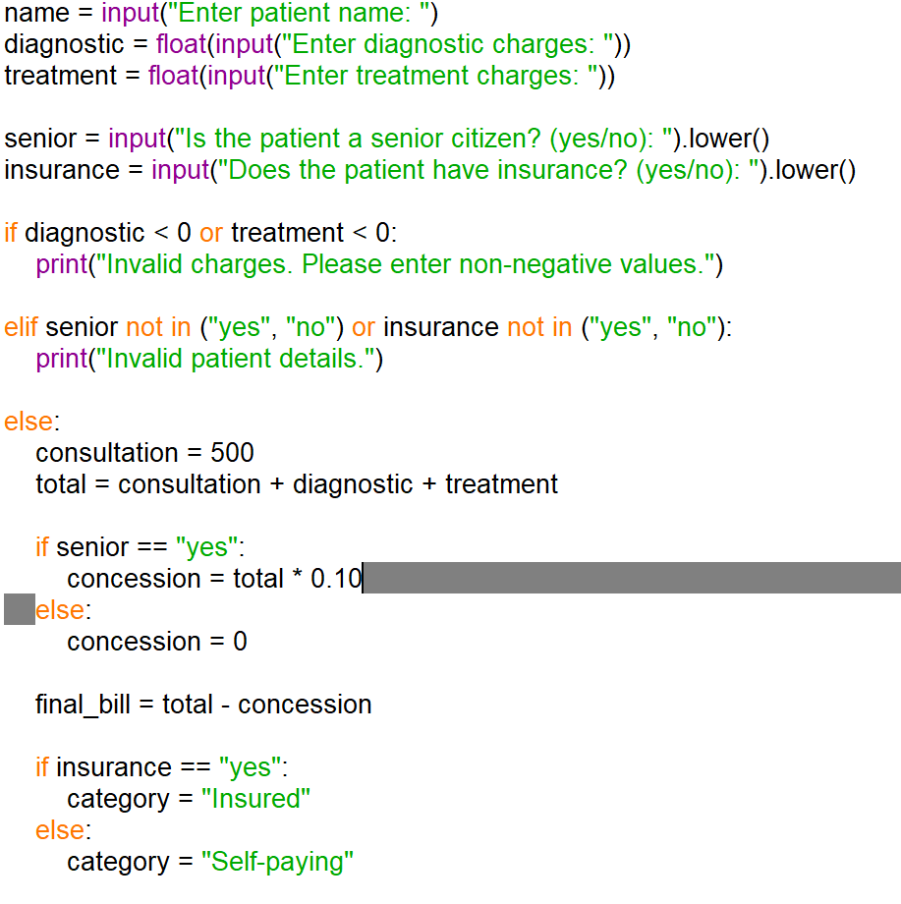

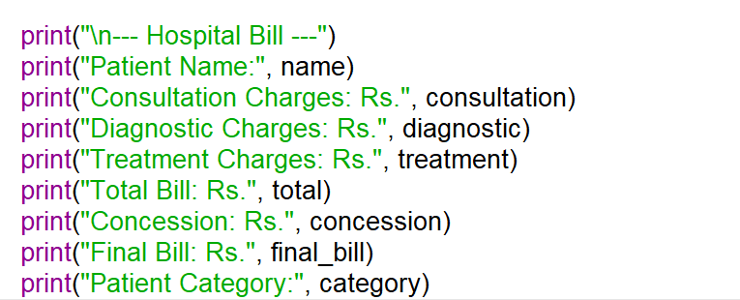

10.CONCLUSION:
The Hospital Billing and Patient Classification System calculates hospital bills using consultation, diagnostic, and treatment charges. It applies concessions to eligible senior citizens, validates charges, and classifies patients according to their insurance status. This program makes billing easier, faster, and more accurate.

CASE 4: Employee Payroll and Deduction Analysis

1.PROBLEM STATEMENT:
Calculate gross salary from basic pay, allowances, overtime, and incentives; apply progressive deductions and generate a formatted salary statement.

2.OBJECTIVES:
• To calculate gross salary.
• To calculate overtime pay and incentives.
• To apply progressive salary deductions.
• To calculate the final net salary.
• To display a formatted salary statement.

3.ASSUMPTIONS:
• Basic pay is entered by the user.
• Allowances are 20% of basic pay.
• Overtime pay is calculated using the overtime hours and hourly rate.
• Incentives are entered by the user.
• Progressive deductions are calculated as follows:
- First ₹10,000: no deduction.
- Next ₹10,000: 5% deduction.
- Amount above ₹20,000: 10% deduction.
• Net salary is gross salary minus deductions.
• All salary amounts and overtime hours must be non-negative.

4.ALGORITHM:
• Start the program.
• Enter employee name and basic pay.
• Calculate allowances as 20% of basic pay.
• Enter overtime hours, hourly rate, and incentives.
• Calculate overtime pay.
• Calculate gross salary by adding basic pay, allowances, overtime pay, and incentives.
• Calculate progressive deductions using the salary slabs.
• Calculate net salary by subtracting deductions from gross salary.
• Display the formatted salary statement.
• Stop the program.

5.FLOW CHART:
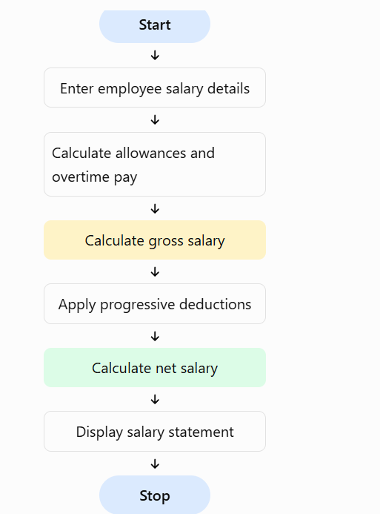

6.PSEUDO CODE:
START

INPUT employee name
INPUT basic pay
INPUT overtime hours
INPUT hourly rate
INPUT incentives

IF any input is negative:
DISPLAY "Invalid input"
ELSE:
allowances = basic pay * 0.20
overtime pay = overtime hours * hourly rate

gross salary = basic pay + allowances
+ overtime pay + incentives

IF gross salary <= 10000:
deduction = 0
ELSE IF gross salary <= 20000:
deduction = (gross salary - 10000) * 0.05
ELSE:
deduction = 500 + (gross salary - 20000) * 0.10

net salary = gross salary - deduction

DISPLAY salary statement

STOP

7.PYTHON SOURCE CODE:
name = input("Enter employee name: ")
basic = float(input("Enter basic pay: "))
hours = float(input("Enter overtime hours: "))
rate = float(input("Enter hourly rate: "))
incentives = float(input("Enter incentives: "))

if min(basic, hours, rate, incentives) < 0:
print("Invalid input. Values cannot be negative.")

else:
allowances = basic * 0.20
overtime = hours * rate

gross = basic + allowances + overtime + incentives

if gross <= 10000:
deduction = 0
elif gross <= 20000:
deduction = (gross - 10000) * 0.05
else:
deduction = 500 + (gross - 20000) * 0.10

net = gross - deduction

print("\n--- Employee Salary Statement ---")
print("Employee Name:", name)
print("Basic Pay: Rs.", round(basic, 2))
print("Allowances: Rs.", round(allowances, 2))
print("Overtime Pay: Rs.", round(overtime, 2))
print("Incentives: Rs.", round(incentives, 2))
print("Gross Salary: Rs.", round(gross, 2))
print("Deductions: Rs.", round(deduction, 2))
print("Net Salary: Rs.", round(net, 2))

8.TEST CASE:
The program is tested with different salary amounts. If the gross salary is ₹8,000, no deduction is applied. If the gross salary is ₹15,000, the deduction is ₹250. If the gross salary is ₹26,500, the deduction is ₹1,150. Negative input values are rejected as invalid. These test cases verify salary calculations and progressive deductions.

9.OUTPUT:
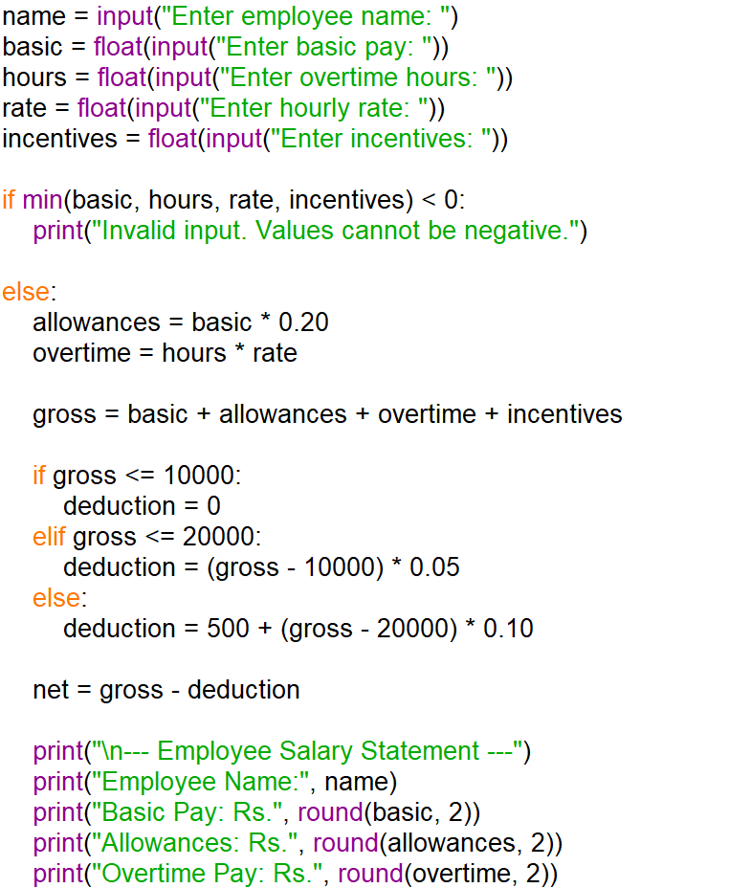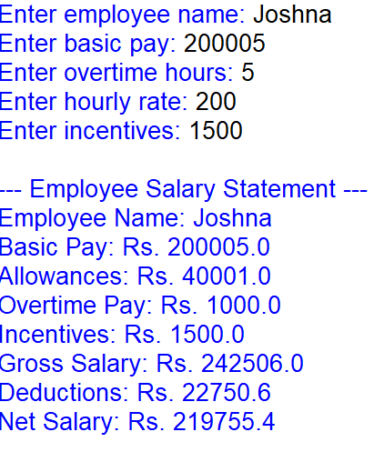

10.CONCLUSION:
The Employee Payroll System calculates gross salary using basic pay, allowances, overtime, and incentives. It applies progressive deductions and calculates net salary. The formatted salary statement makes payroll calculations simple, accurate, and easy to understand.

CASE 5: Multi-Plan Telecommunications Cost Optimization

1.PROBLEM STATEMENT:
Evaluate several mobile plans against usage, validity, and budget constraints; calculate excess charges and identify the most economical eligible plan.

2.OBJECTIVES:
• To compare multiple mobile plans.
• To check data usage, call minutes, validity, and budget.
• To calculate extra usage charges.
• To identify plans that satisfy all requirements.
• To select the cheapest eligible plan.

3.ASSUMPTIONS:
• The user enters required data in GB, call minutes, validity in days, and budget in rupees.
• Each plan has a fixed price, data limit, call-minute limit, and validity.
• Extra data costs ₹10 per GB.
• Extra calls cost ₹1 per minute.
• A plan is eligible if its validity meets the requirement and its total cost is within the budget.
• The plan with the lowest total cost among eligible plans is selected.
• If no plan meets all requirements, the system displays a suitable message.

4.ALGORITHM:
• Start the program.
• Enter required data usage, call minutes, validity, and budget.
• Store the details of different mobile plans.
• Calculate excess data and call charges for each plan.
• Calculate the total cost of each plan.
• Check whether the plan validity meets the requirement.
• Check whether the total cost is within the budget.
• Select the eligible plan with the lowest total cost.
• Display the plan details and total cost.
• If no plan is eligible, display a suitable message.
• Stop the program.

5.FLOW CHART:
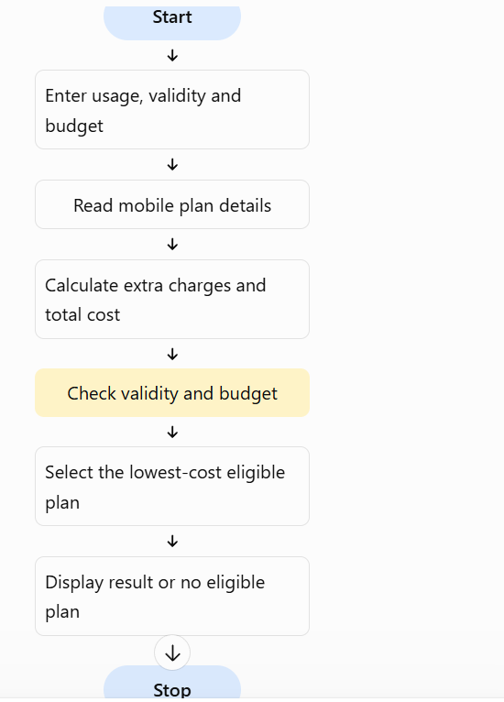

6.PSEUDO CODE:
START

INPUT required data, calls, validity, budget

CREATE list of mobile plans

FOR each plan:
extra_data = maximum of (0, required data - plan data)
extra_calls = maximum of (0, required calls - plan calls)

extra_charge = extra_data * 10 + extra_calls * 1
total_cost = plan price + extra_charge

IF plan validity >= required validity
AND total_cost <= budget:
ADD plan to eligible list

IF eligible list is not empty:
SELECT plan with lowest total cost
DISPLAY selected plan and total cost
ELSE:
DISPLAY "No eligible plan found"

STOP

7. PYTHON SOURCE CODE:
plans = [
{"name": "Basic", "price": 149, "data": 2,
"calls": 100, "validity": 28},

{"name": "Standard", "price": 199, "data": 3,
"calls": 200, "validity": 28},

{"name": "Premium", "price": 249, "data": 5,
"calls": 300, "validity": 56}
]

data = float(input("Enter required data in GB: "))
calls = int(input("Enter required call minutes: "))
days = int(input("Enter required validity in days: "))
budget = float(input("Enter budget in Rs.: "))

eligible = []

for plan in plans:
extra_data = max(0, data - plan["data"])
extra_calls = max(0, calls - plan["calls"])

extra_charge = extra_data * 10 + extra_calls * 1
total = plan["price"] + extra_charge

print("\nPlan:", plan["name"])
print("Extra Charges: Rs.", round(extra_charge, 2))
print("Total Cost: Rs.", round(total, 2))

if plan["validity"] >= days and total <= budget:
eligible.append((total, plan["name"]))

print("\n--- Best Mobile Plan ---")

if eligible:
eligible.sort()
print("Selected Plan:", eligible[0][1])
print("Total Cost: Rs.", round(eligible[0][0], 2))
else:
print("No eligible plan found.")

8.TEST CASES:

The program is tested with different data usage, call minutes, validity, and budgets. If the user requires 3 GB of data, 120 call minutes, 28 days of validity, and a budget of ₹250, the Basic plan costs ₹179 after extra charges, the Standard plan costs ₹199, and the Premium plan costs ₹249. The Basic plan is selected because it is the cheapest eligible plan. If the budget is below the cost of every eligible plan, the program displays that no eligible plan is found.

9.OUTPUT:
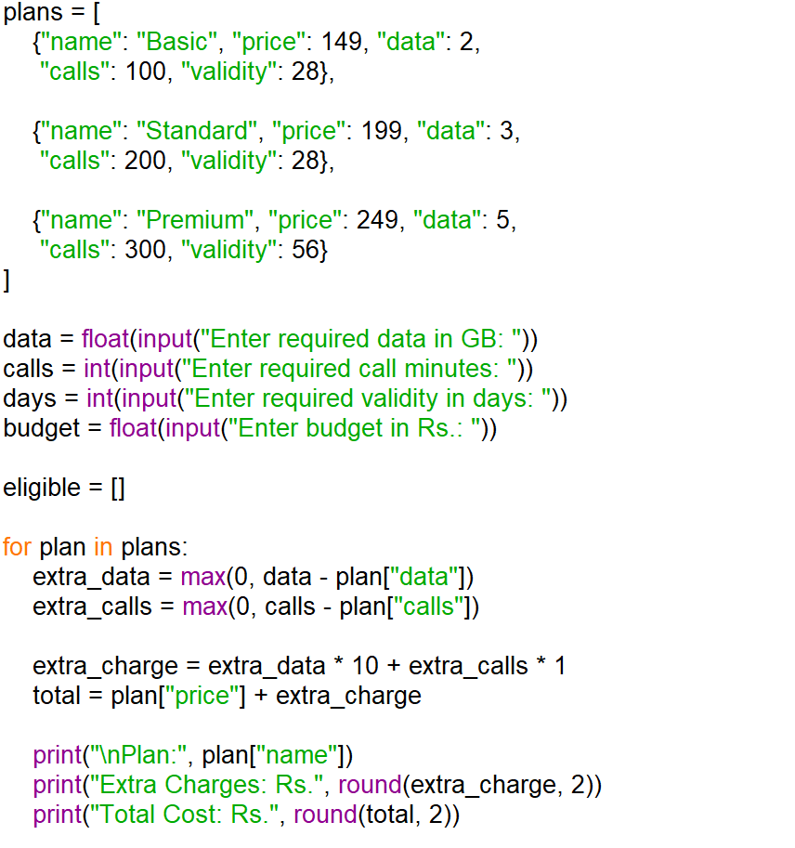
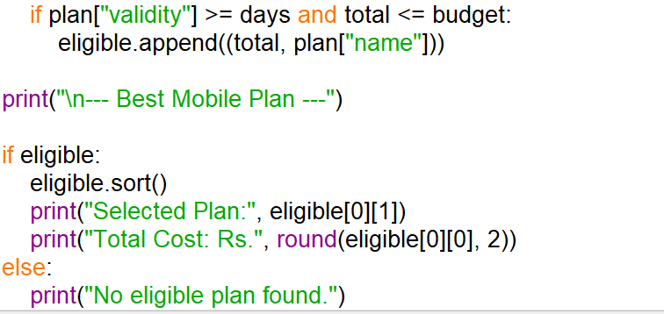
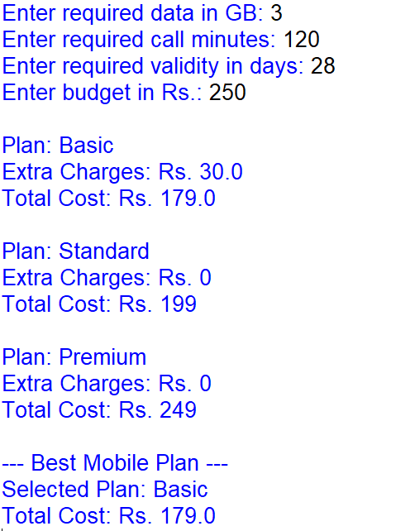

10.CONCLUSION:
The Multi-Plan Telecommunications Cost Optimization System compares mobile plans based on data usage, call minutes, validity, and budget. It calculates excess charges and selects the most economical eligible plan. This program helps users choose suitable mobile plans and manage their expenses efficiently.

CASE 6: Railway Fare and Reservation Calculator

1.PROBLEM STATEMENT:
Calculate fares for multiple passengers using distance slabs, travel classes, age-based concessions, reservation fees, and specified cancellation penalties.

2.OBJECTIVES:
• To calculate railway fares based on distance.
• To calculate fares for multiple passengers.
• To apply age-based concessions.
• To check seat availability.
• To display the total fare and reservation status.

3.ASSUMPTIONS:
• Sleeper class fare is ₹2 per kilometre.
• AC class fare is ₹4 per kilometre.
• Children below 5 years travel free.
• Passengers aged 60 years and above receive a 10% concession.
• A reservation charge of ₹20 is added for each paying passenger.
• The number of available seats is entered by the user.
• Reservations are confirmed only when sufficient seats are available.
• These are assumed rates for this assignment, not actual railway fares.

4.ALGORITHM:
- Start the program.
- Enter the travel distance, ticket class, and number of passengers.
- Enter each passenger's name and age.
- Calculate the fare based on distance and ticket class.
- Apply age-based concessions where applicable.
- Add the reservation charge for each paying passenger.
- Check seat availability.
- If sufficient seats are available, confirm the reservation and display the total fare.
- Otherwise, display that seats are unavailable.
- Stop the program.

5.FLOW CHART:
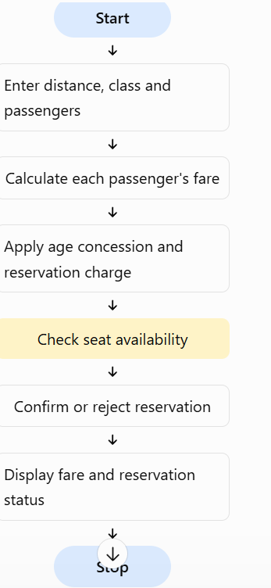

6.PSUEDO CODE:
START

INPUT distance
INPUT ticket class
INPUT number of passengers
INPUT available seats

IF distance <= 0 OR number of passengers <= 0:
DISPLAY "Invalid input"
ELSE:
IF ticket class is Sleeper:
rate = 2
ELSE IF ticket class is AC:
rate = 4
ELSE:
DISPLAY "Invalid class"

IF valid class AND enough seats:
FOR each passenger:
INPUT name and age

IF age < 5:
fare = 0
ELSE:
fare = distance * rate

IF age >= 60:
fare = fare * 0.90

fare = fare + 20

distance = float(input("Enter distance in km: "))
ticket_class = input("Enter class (Sleeper/AC): ").lower()
n = int(input("Enter number of passengers: "))
seats = int(input("Enter available seats: "))

if distance <= 0 or n <= 0 or seats < 0:
print("Invalid input.")

elif ticket_class not in ("sleeper", "ac"):
print("Invalid ticket class.")

elif seats < n:
print("Reservation not confirmed. Seats unavailable.")

else:
if ticket_class == "sleeper":
rate = 2
else:
rate = 4

total = 0

for i in range(n):
print("\nPassenger", i + 1)
name = input("Enter passenger name: ")
age = int(input("Enter age: "))

if age < 0:
print("Invalid age.")
break

if age < 5:
fare = 0
else:
fare = distance * rate

if age >= 60:
fare *= 0.90

fare += 20

total += fare
print("Passenger:", name)
print("Fare: Rs.", round(fare, 2))

else:
print("\n--- Railway Reservation ---")
print("Distance:", distance, "km")
print("Class:", ticket_class.title())
print("Passengers:", n)
print("Reservation Confirmed")
print("Total Fare: Rs.", round(total, 2))
DISPLAY "Reservation Confirmed"
DISPLAY total fare
ELSE:
DISPLAY "Reservation Not Confirmed"

STOP

7.PYTHON SOURCE CODE:
distance = float(input("Enter distance in km: "))
ticket_class = input("Enter class (Sleeper/AC): ").lower()
n = int(input("Enter number of passengers: "))
seats = int(input("Enter available seats: "))

if distance <= 0 or n <= 0 or seats < 0:
print("Invalid input.")

elif ticket_class not in ("sleeper", "ac"):
print("Invalid ticket class.")

elif seats < n:
print("Reservation not confirmed. Seats unavailable.")

else:
if ticket_class == "sleeper":
rate = 2
else:
rate = 4

total = 0

for i in range(n):
print("\nPassenger", i + 1)
name = input("Enter passenger name: ")
age = int(input("Enter age: "))

if age < 0:
print("Invalid age.")
break

if age < 5:
fare = 0
else:
fare = distance * rate

if age >= 60:
fare *= 0.90

fare += 20

total += fare
print("Passenger:", name)
print("Fare: Rs.", round(fare, 2))

else:
print("\n--- Railway Reservation ---")
print("Distance:", distance, "km")
print("Class:", ticket_class.title())
print("Passengers:", n)
print("Reservation Confirmed")
print("Total Fare: Rs.", round(total, 2))

8.TEST CASES:
The program is tested with multiple passengers travelling the same distance. A passenger aged 30 travelling 100 km in Sleeper class pays ₹220, including the reservation charge. A passenger aged 65 receives a 10% concession on the distance-based fare. A child below 5 years travels free under the assumed rules. If the number of passengers exceeds available seats, the reservation is not confirmed.

9.OUTPUT:
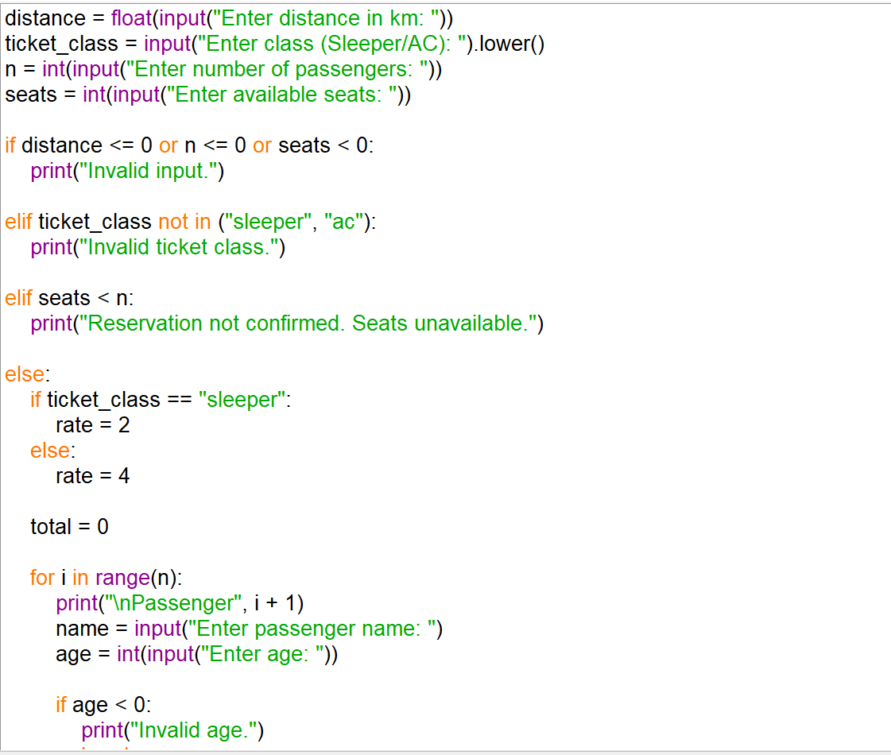
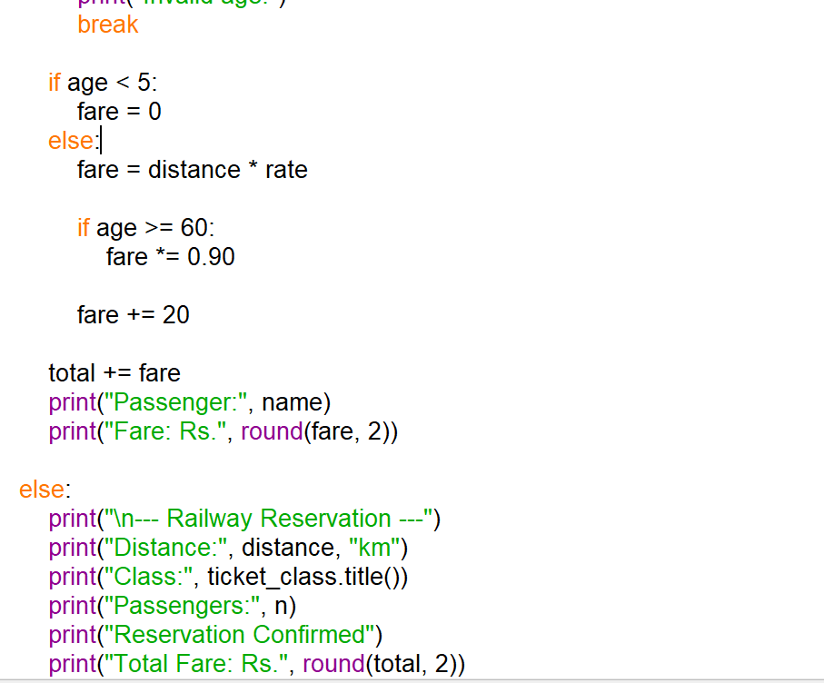

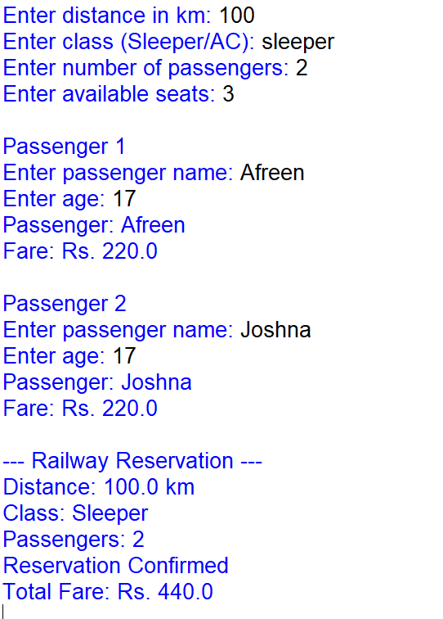

10.CONCLUSION:
The Railway Fare and Reservation Calculator calculates fares for multiple passengers based on distance and ticket class. It applies age-based concessions, checks seat availability, and displays the total fare. This system makes fare calculations simple and helps manage basic reservation details efficiently.

CASE 7: Retail Billing with Multiple Discount Rule

1.PROBLEM STATEMENT:
Process multiple products, quantities, categoryspecific taxes, threshold discounts, and maximum concession limits to generate an itemized invoice.

2.OBJECTIBVES:
• To calculate the cost of multiple products.
• To apply taxes based on product categories.
• To provide discounts based on purchase amount.
• To limit discounts to a maximum concession amount.
• To generate an itemized invoice with the final bill.

3.ASSUMPTIONS:
1.Food products have a 5% tax.
2.Clothing products have a 5% tax.
3.Electronics have an 18% tax.
4.If the subtotal is ₹2,000 or more, a 10% discount is applied.
5.The maximum discount is ₹50
6.Tax is calculated after deducting the discount.
7.Product prices and quantities must be positive.
8.These tax rates and discount rules are assumed for this assignment.

4. Algorithm
- Start the program.
- Enter the number of products.
- Enter each product's name, category, price, and quantity.
- Calculate the total price of each product.
- Calculate the subtotal of all products.
- Apply a 10% discount if the subtotal is ₹2,000 or more, limited to ₹500.
- Calculate category-specific tax on the discounted amount.
- Calculate the final bill by adding tax to the discounted subtotal.
- Display the itemized invoice.
- Stop the program.

5.FLOW CHART:
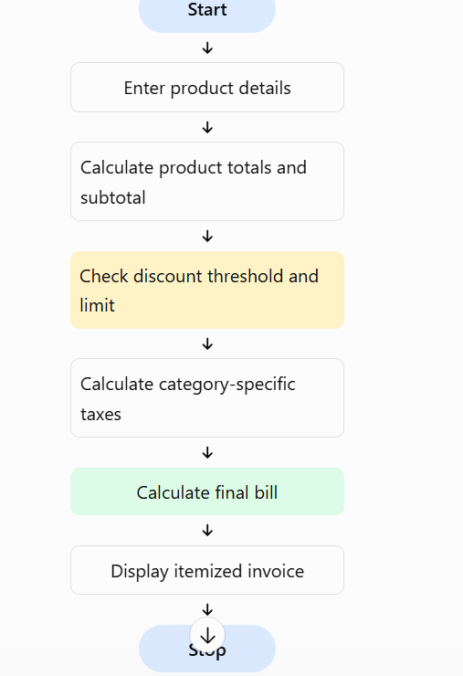

6.PSEUDO CODE:
START

INPUT number of products
subtotal = 0

FOR each product:
INPUT name, category, price, quantity
item_total = price * quantity
ADD item_total to subtotal

IF subtotal >= 2000:
discount = subtotal * 10 / 100
IF discount > 500:
discount = 500
ELSE:
discount = 0

discounted_subtotal = subtotal - discount

FOR each product:
CALCULATE tax based on category
APPLY proportional discount to item total
CALCULATE item tax

final_bill = discounted_subtotal + total tax

DISPLAY itemized invoice
DISPLAY final bill

STOP

7.PYTHON SOURCE CODE:
products = []
n = int(input("Enter number of products: "))

for i in range(n):
print("\nProduct", i + 1)

name = input("Enter product name: ")
category = input("Enter category (food/clothing/electronics): ").lower()
price = float(input("Enter price: "))
quantity = int(input("Enter quantity: "))

if category not in ("food", "clothing", "electronics"):
print("Invalid category.")
break

if price <= 0 or quantity <= 0:
print("Invalid price or quantity.")
break

products.append({
"name": name,
"category": category,
"price": price,
"quantity": quantity,
"total": price * quantity
})
else:
subtotal = sum(p["total"] for p in products)

if subtotal >= 2000:
discount = min(subtotal * 0.10, 500)
else:
discount = 0

print("\n--- ITEMIZED INVOICE ---")
print("Subtotal: Rs.", round(subtotal, 2))
print("Discount: Rs.", round(discount, 2))

total_tax = 0

for p in products:
share = p["total"] / subtotal if subtotal else 0
item_discount = discount * share
taxable_amount = p["total"] - item_discount

if p["category"] in ("food", "clothing"):
tax_rate = 0.05
else:
tax_rate = 0.18

tax = taxable_amount * tax_rate
total_tax += tax

print(
p["name"], "- Qty:", p["quantity"],
"- Amount: Rs.", round(p["total"], 2),
"- Tax: Rs.", round(tax, 2)
)

final_bill = subtotal - discount + total_tax

print("Total Tax: Rs.", round(total_tax, 2))
print("Final Bill: Rs.", round(final_bill, 2))

8.TEST CASES:
The program is tested with different products and quantities. If the subtotal is below ₹2,000, no discount is applied. If the subtotal is ₹2,000, a 10% discount of ₹200 is applied. If the subtotal is ₹6,000, the discount is limited to ₹500. Different tax rates are applied to food, clothing, and electronics. Invalid prices, quantities, or categories are rejected.

9.OUTPUT:
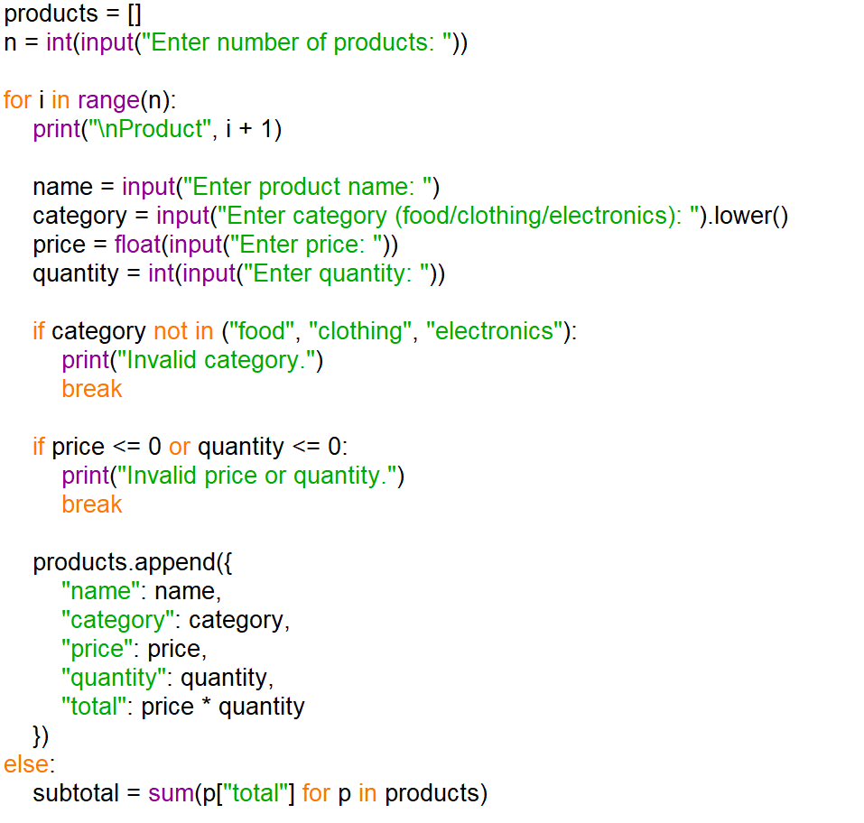
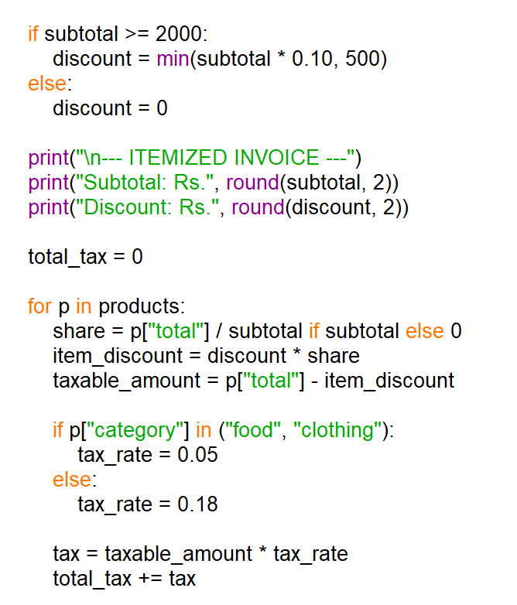
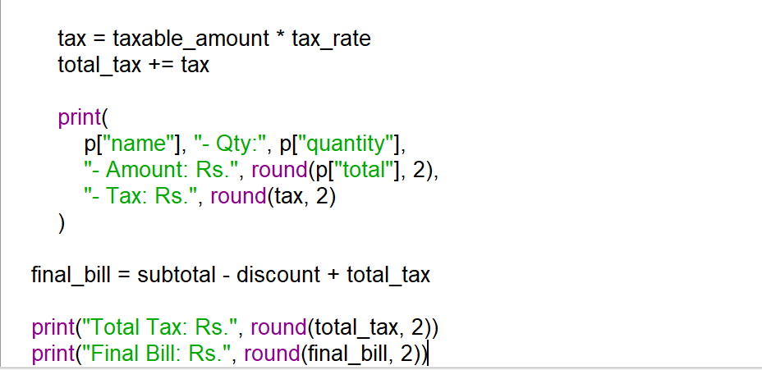

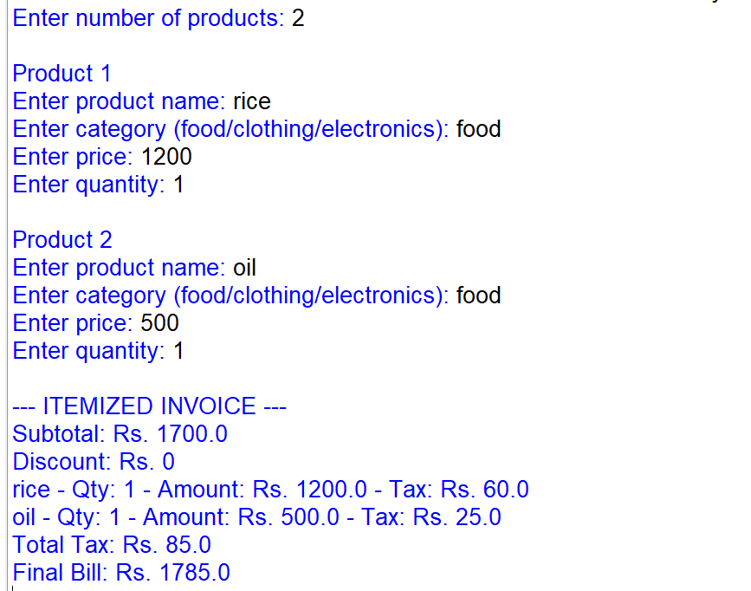

10.CONCLUSION:
The Retail Billing System calculates product costs, applies discounts with a maximum limit, and calculates taxes based on product categories. It generates an itemized invoice showing the subtotal, discount, tax, and final bill. This system makes retail billing faster, easier, and more accurate.

CASE 8: Manufacturing Cost and Profitability Analysis

1.PROBLEM STATEMENT:
Calculate material costs, labour charges, wastage, machine costs, and selling prices; identify whether production meets a specified profit target.

2.OBJECTIVES:
- To calculate material and labour costs.
- To calculate material wastage costs.
- To include machine operating costs.
- To calculate total production cost and profit.
- To check whether the required profit target is achieved.

3. ASSUMPTIONS:
- Material cost and labour charges are entered by the user.
- Wastage is calculated as a percentage of material cost.
- Machine cost is calculated using machine hours and hourly rate.
- Selling price per unit is entered by the user.
- Total revenue equals selling price per unit multiplied by the quantity produced.
- Profit equals total revenue minus total production cost.
- The target profit percentage is entered by the user.
- All cost values, quantities, and rates must be non-negative, and production quantity must be greater than zero.

4. ALGORITHM:
- Start the program.
- Enter the quantity produced.
- Enter material cost, labour cost, and wastage percentage.
- Enter machine hours and machine hourly rate.
- Enter selling price per unit and target profit percentage.
- Calculate wastage cost and machine cost.
- Calculate total production cost.
- Calculate total revenue and profit.
- Calculate profit percentage.
- Compare the profit percentage with the target.
- Display the production cost and profitability result.
- Stop the program.

5.FLOW CHART:
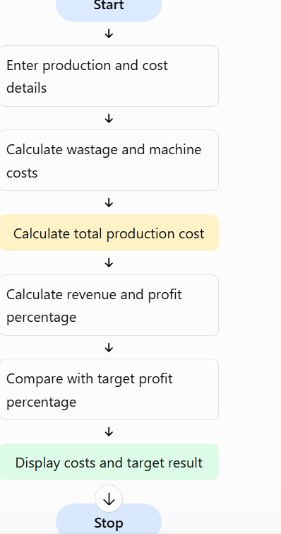

6.PSEUDO CODE:
START

INPUT quantity
INPUT material cost
INPUT labour cost
INPUT wastage percentage
INPUT machine hours
INPUT machine hourly rate
INPUT selling price per unit
INPUT target profit percentage

IF any input is negative OR quantity <= 0:
DISPLAY "Invalid input"
ELSE:
wastage cost = material cost * wastage percentage / 100
machine cost = machine hours * machine hourly rate

total cost = material cost + labour cost
+ wastage cost + machine cost

revenue = selling price per unit * quantity
profit = revenue - total cost
profit percentage = profit / total cost * 100

IF profit percentage >= target:
DISPLAY "Profit target achieved"
ELSE:
DISPLAY "Profit target not achieved"

DISPLAY total cost, revenue and profit

STOP

7.PYTHON SOURCE CODE:
quantity = int(input("Enter quantity produced: "))
material = float(input("Enter material cost: "))
labour = float(input("Enter labour charges: "))
wastage_rate = float(input("Enter wastage percentage: "))
hours = float(input("Enter machine hours: "))
machine_rate = float(input("Enter machine hourly rate: "))
selling_price = float(input("Enter selling price per unit: "))
target = float(input("Enter target profit percentage: "))

if (quantity <= 0 or min(material, labour, wastage_rate,
hours, machine_rate, selling_price, target) < 0):
print("Invalid input.")

else:
wastage = material * wastage_rate / 100
machine_cost = hours * machine_rate

total_cost = material + labour + wastage + machine_cost
revenue = selling_price * quantity
profit = revenue - total_cost

if total_cost > 0:
profit_percent = profit / total_cost * 100
else:
profit_percent = 0

print("\n--- Manufacturing Cost Report ---")
print("Material Cost: Rs.", round(material, 2))
print("Labour Charges: Rs.", round(labour, 2))
print("Wastage Cost: Rs.", round(wastage, 2))
print("Machine Cost: Rs.", round(machine_cost, 2))
print("Total Production Cost: Rs.", round(total_cost, 2))
print("Total Revenue: Rs.", round(revenue, 2))
print("Profit/Loss: Rs.", round(profit, 2))
print("Profit Percentage:", round(profit_percent, 2), "%")

if profit_percent >= target:
print("Profit target achieved.")
else:
print("Profit target not achieved.")

8.TEST CASES:
The program is tested using different production costs and selling prices. If the total production cost is ₹10,000 and the revenue is ₹15,000, the profit is ₹5,000 and the profit percentage is 50%. If the target is 40%, the target is achieved. If the profit percentage is below the target, the program displays that the target is not achieved. Invalid negative inputs are rejected.

9.OUTPUTS:
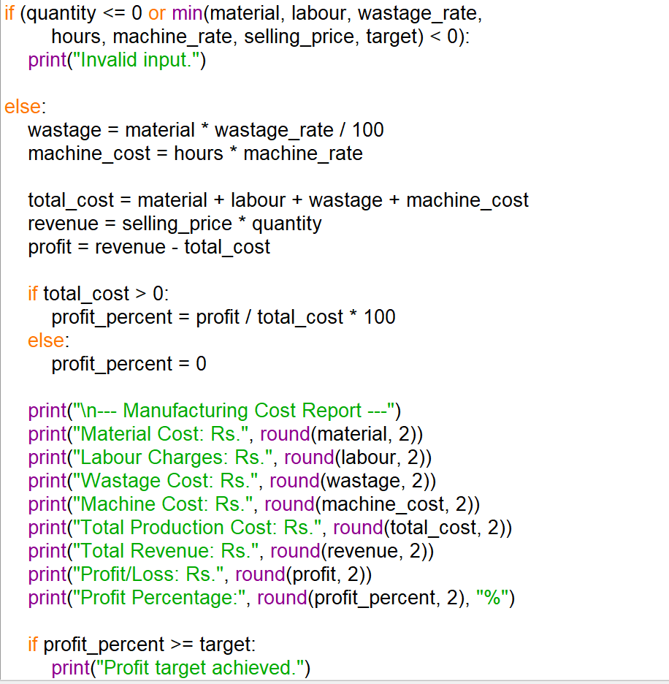

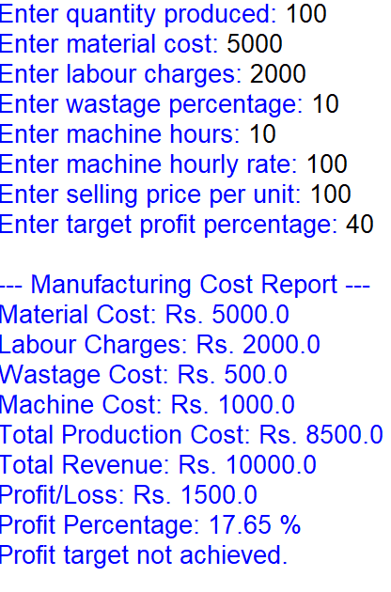

10.CONCLUSION:
The Manufacturing Cost and Profitability Analysis System calculates production costs, revenue, and profit by considering material costs, labour, wastage, and machine expenses. It compares the actual profit percentage with the target and helps manufacturers understand whether their production is profitable.

CASE 9: Multi-Currency Travel Budget Analysis

1.PROBLRM STATEMENT:
Convert travel expenses using supplied exchange rates, incorporate conversion fees, compare planned spending against a budget, and identify the largest expense category.

2.OBJECTIVES;
- Convert expenses into INR using exchange rates.
- Calculate conversion fees.
- Find total travel expenses.
- Compare expenses with the budget.
- Identify the largest expense category.

3.ASSEMPTIONS:
- The user enters expenses for different categories.
- Exchange rates are supplied by the user.
- Conversion fee is 2% of the converted amount.
- The travel budget is entered in INR.
- Expense amounts and exchange rates must be positive.

4.ALGORITHM:
- Start the program.
- Enter the travel budget in INR.
- Enter the expense categories, amounts, and exchange rates.
- Convert each expense into INR.
- Calculate the conversion fee for each expense.
- Add the converted amount and fee.
- Calculate total expenses.
- Compare total expenses with the budget.
- Find the largest expense category.
- Display the report and stop.

5.FLOW CHART:
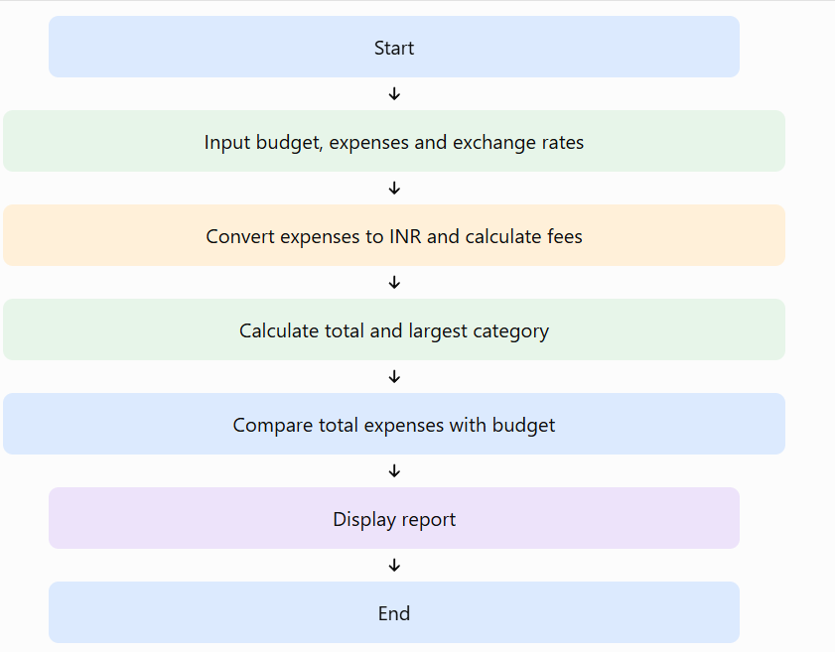

6.PSEUDO CODE:
START
INPUT budget
SET total = 0
SET largest_expense = 0

FOR each expense category
INPUT amount and exchange rate
converted_amount = amount * exchange_rate
fee = converted_amount * 2 / 100
final_amount = converted_amount + fee
ADD final_amount to total
FIND largest expense category
END FOR

DISPLAY total expenses

IF total <= budget
DISPLAY "Within budget"
ELSE
DISPLAY "Budget exceeded"
END IF

DISPLAY largest expense category
STOP

7.PYTHON SOURCE CODE:

budget = float(input("Enter travel budget in INR: "))

expenses = {
"Hotel": (200, 83),
"Food": (100, 83),
"Shopping": (150, 83),
"Transport": (50, 83)
}

total = 0
largest_category = ""
largest_amount = 0

print("\n--- Travel Expense Report ---")

for category, details in expenses.items():
amount, rate = details

if amount <= 0 or rate <= 0:
print("Invalid expense or exchange rate.")
break

converted = amount * rate
fee = converted * 0.02
final_amount = converted + fee

total += final_amount

print("\nCategory:", category)
print("Converted Amount: Rs.", round(converted, 2))
print("Conversion Fee: Rs.", round(fee, 2))
print("Final Amount: Rs.", round(final_amount, 2))

if final_amount > largest_amount:
largest_amount = final_amount
largest_category = category

else:
print("\nTotal Expenses: Rs.", round(total, 2))
print("Largest Expense Category:", largest_category)

if total <= budget:
print("Status: Within budget")
print("Remaining Budget: Rs.", round(budget - total, 2))
else:
print("Status: Budget exceeded")
print("Extra Amount: Rs.", round(total - budget, 2))

8.TEST CASES:
The program is tested with different travel budgets to check its accuracy. When the budget is ₹50,000, the total expenses are ₹42,330, so the program displays “Within budget” with ₹7,670 remaining. When the budget is ₹40,000, it displays “Budget exceeded” by ₹2,330. When the budget is ₹0, the program reports that the budget is exceeded. When the budget is ₹60,000, it displays “Within budget” with ₹17,670 remaining. In all cases, the program identifies Hotel as the largest expense category.

9.OUTPUT:

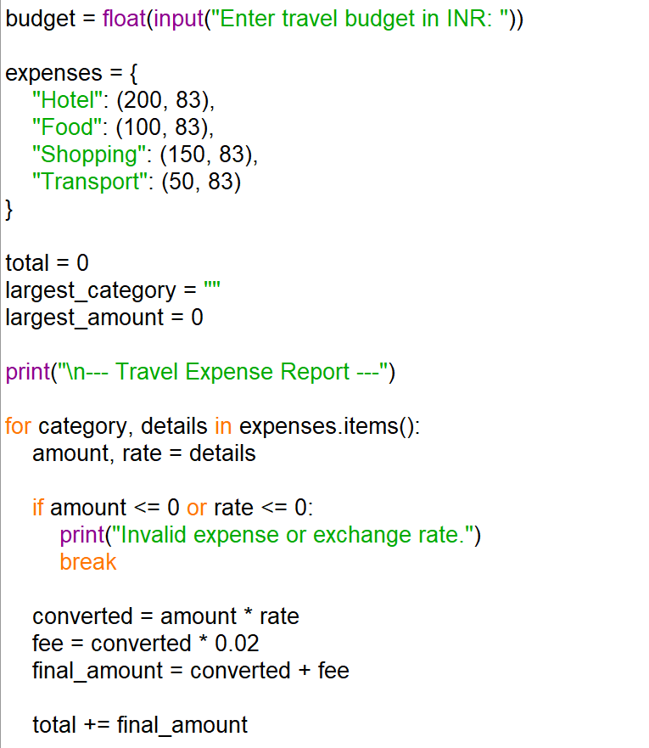

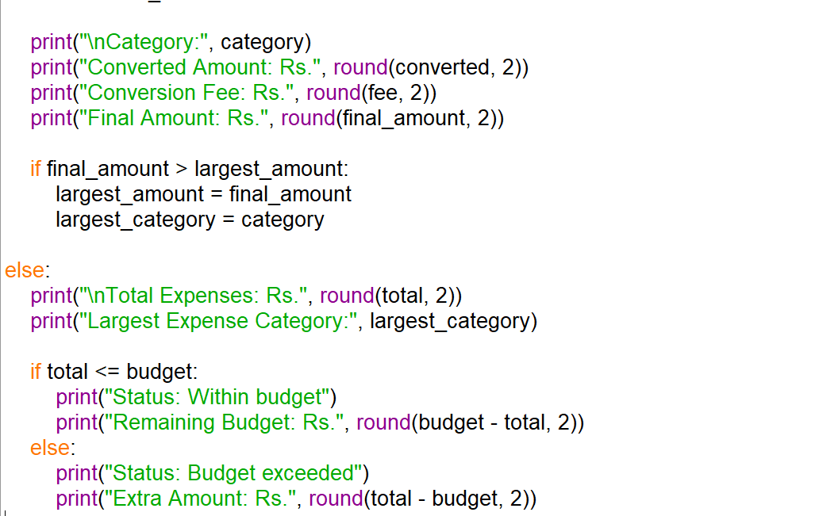
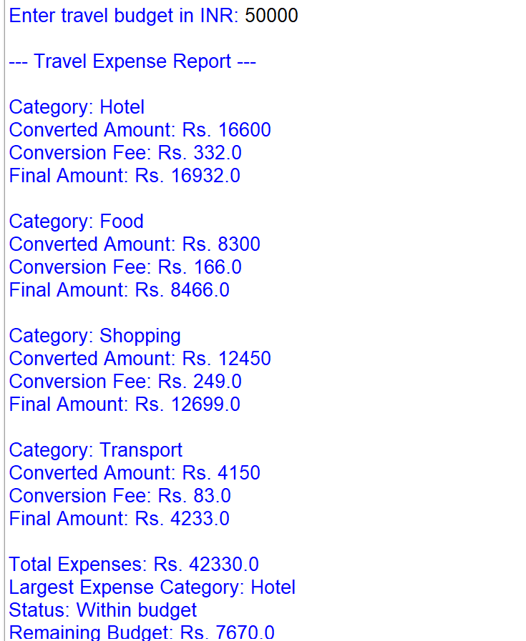

10.CONCLUSION:
This Python program converts travel expenses into Indian Rupees using exchange rates and calculates conversion fees. It checks whether total spending is within the planned budget and identifies the largest expense category. It helps travellers manage their expenses effectively.

CASE 10: Campus Event Financial Planning

1.PROBLEM STATEMENT:
Calculate venue, equipment, catering, transport, and certificate costs; determine participant contributions, sponsorship shortfalls, and the minimum registration count needed to break even.

2.OBJECTIVES:
- Calculate the total event cost.
- Calculate the contribution required from each participant.
- Calculate the remaining sponsorship amount needed.
- Find the minimum registrations required to break even.
- Display the event financial report.

3. ASSUMPTIONS:
- All costs are entered in Indian Rupees (INR).
- Venue and equipment costs are fixed expenses.
- Catering, transport, and certificate costs are calculated per participant.
- Sponsorship and registration fees are entered by the user.
- All costs and amounts must be non-negative.

4. ALGORITHM:
- Start the program.
- Input venue and equipment costs.
- Input catering, transport, and certificate costs per participant.
- Input expected participants, sponsorship, and registration fee.
- Calculate fixed and variable expenses.
- Calculate the total event cost.
- Calculate the sponsorship shortfall, if any.
- Calculate the minimum registrations needed to break even.
- Display the financial report.
- Stop.

5.FLOW CHART:
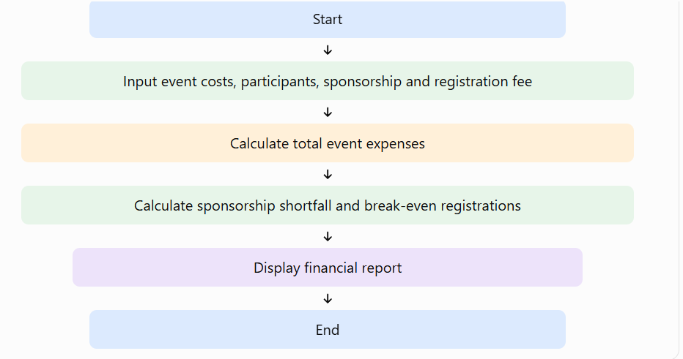

6.PSEUDO CODE:
START
INPUT venue cost, equipment cost
INPUT catering, transport, certificate cost per participant
INPUT expected participants, sponsorship, registration fee

fixed_cost = venue cost + equipment cost
variable_cost = catering + transport + certificate cost
total_cost = fixed_cost + variable_cost * participants

shortfall = MAX(0, total_cost - sponsorship)
participant_contribution = shortfall / participants

IF registration fee > variable_cost
break_even = CEILING(
(fixed_cost - sponsorship) /
(registration fee - variable_cost)
)
ELSE
DISPLAY "Break-even not possible with this fee"
END IF

DISPLAY total cost, contribution, shortfall, break-even

7.PYTHON SOURCE CODE:

import math

venue = float(input("Enter venue cost: Rs. "))

equipment = float(input("Enter equipment cost: Rs. "))

catering = float(input("Enter catering cost per participant: Rs. "))

transport = float(input("Enter transport cost per participant: Rs. "))

certificate = float(input("Enter certificate cost per participant: Rs. "))

participants = int(input("Enter expected participants: "))

sponsorship = float(input("Enter sponsorship amount: Rs. "))

registration_fee = float(input("Enter registration fee per participant: Rs. "))

if (min(venue, equipment, catering, transport,

certificate, sponsorship, registration_fee) < 0

or participants <= 0):

print("Invalid input.")

else:

fixed_cost = venue + equipment

variable_cost = catering + transport + certificate

total_cost = fixed_cost + variable_cost * participants

shortfall = max(0, total_cost - sponsorship)

contribution = shortfall / participants

print("\n--- Campus Event Financial Report ---")

print("Fixed Cost: Rs.", round(fixed_cost, 2))

print("Variable Cost per Participant: Rs.", variable_cost)

print("Total Event Cost: Rs.", round(total_cost, 2))

print("Sponsorship: Rs.", round(sponsorship, 2))

print("Sponsorship Shortfall: Rs.", round(shortfall, 2))

print("Contribution per Participant: Rs.",

round(contribution, 2))

if registration_fee > variable_cost:

break_even = max(

0,

math.ceil((fixed_cost - sponsorship) /

(registration_fee - variable_cost))

)

print("Minimum Registrations to Break Even:",

break_even)

else:

print("Break-even is not possible at this registration fee.")

8.TEST CASES:
The program is tested using different event costs, sponsorship amounts, participant counts, and registration fees. When sponsorship covers the total event cost, the sponsorship shortfall is zero. When sponsorship is insufficient, the program calculates the remaining amount and the contribution required from each participant. When the registration fee is greater than the variable cost per participant, the program calculates the minimum registrations required to break even. If the registration fee is equal to or less than the variable cost, the program displays that break-even is not possible under the given conditions.

9.OUTPUT:

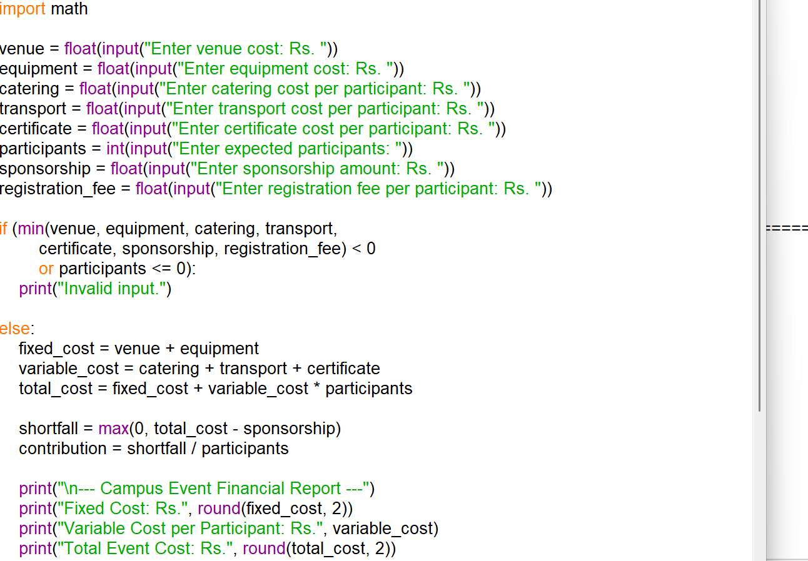
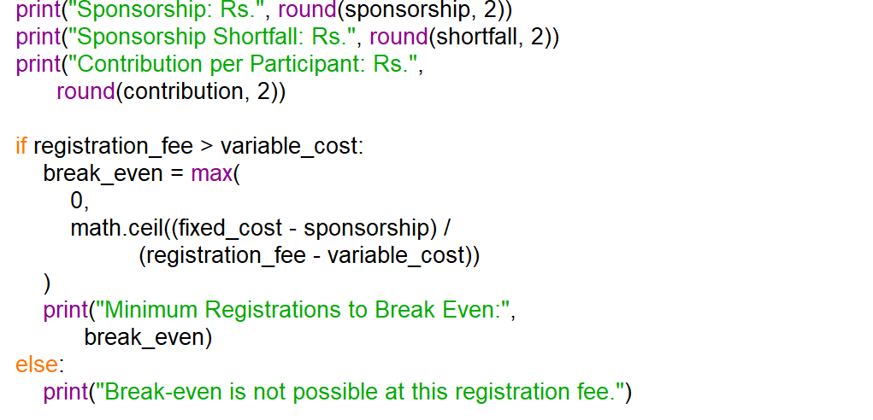
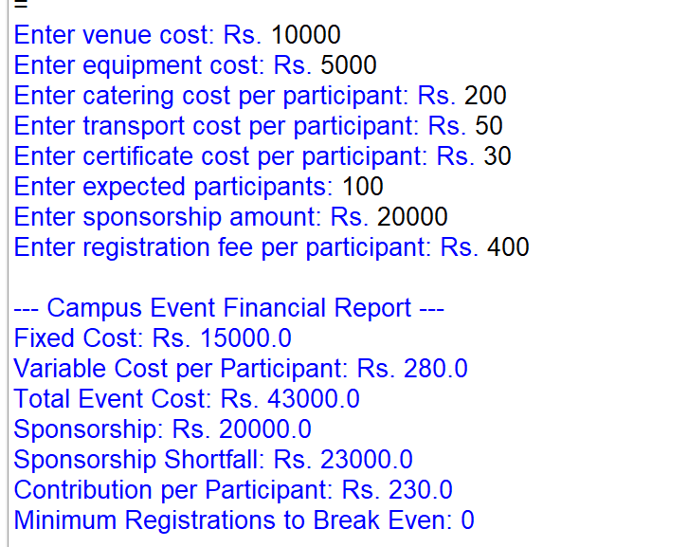

10.CONCLUSION:
This Python program calculates campus event expenses and participant contributions. It identifies sponsorship shortfalls and determines the minimum registrations required to break even. It helps college organizers plan their event budget and manage finances effectively.

