1.) Canny has two thresholds that control the edge thresholding process. What is their purpose?

The thresholds control and upper bound above which points are assumed to be edges and a lower bound below which points are assumed to be non edges. For points which fall between these values, they are edges if they are connected to points above the max threshold or if they are connected to other points which have a connection to points above the max threshold.

2. ) What is the purpose of the aperture parameter? What is the result of changing it from 3 to 5, 7, 9 or greater?

The purpose of this parameter is to select the dimension of the Sobel operator used after Gaussian smoothing. This operator is then convolved with the image to detect the edges. Larger values reduce its sensitivity to noise

3.) The Hough transform has two parameters that specify the resolution of the accumulator. Their default values are 1 and π/180. What is the effect of increasing the first and reducing the second?

Rho defines the step of the distance accumulator and theta defines the step of the angle accumulator.
Therefore increasing Rho and decreasing theta means that in the matrix of accumulators there are more columns and less rows. This means that closer values of theta get seperated into different buckets, leading to a higher accuracy

4.) The Hough transform has a pair of parameters that determine the minimum length of a line that can be accepted, and the maximum gap between two segments if they are to be considered part of the same line. What is the effect of changing these values?

Increasing minimum length will reduce the number of lines returned as shorter lines are ignored, so in turn, less lines are found.

Increasing the maximum gap allowed will result in less lines being returned as more segments are considered apart of the same line. Reducing this generally results in more, shorter lines.

5.) How close are the computed horizons to where you think the horizon should be? What might cause any discrepancy?
For Horizon 1 and 2, clouds make the curve much harder to calculate as even when you change all of you parameters, lots of edges are still detected by Canny. This is made harder as you can’t just filter out the lines according to a stricter angle as the horizon is also angled, so those would be filtered out too.
Horizon 2 turned out very well, but I think this is mostly owed to the lack of clouds.
Horizon 3 was almost perfect, which I think demonstrates how much a difference clouds make.
What makes this one easier also is that most of the vertical lines are very vertical, so they are much easier to filter out

Images

Horizion1.jpg
After Canny
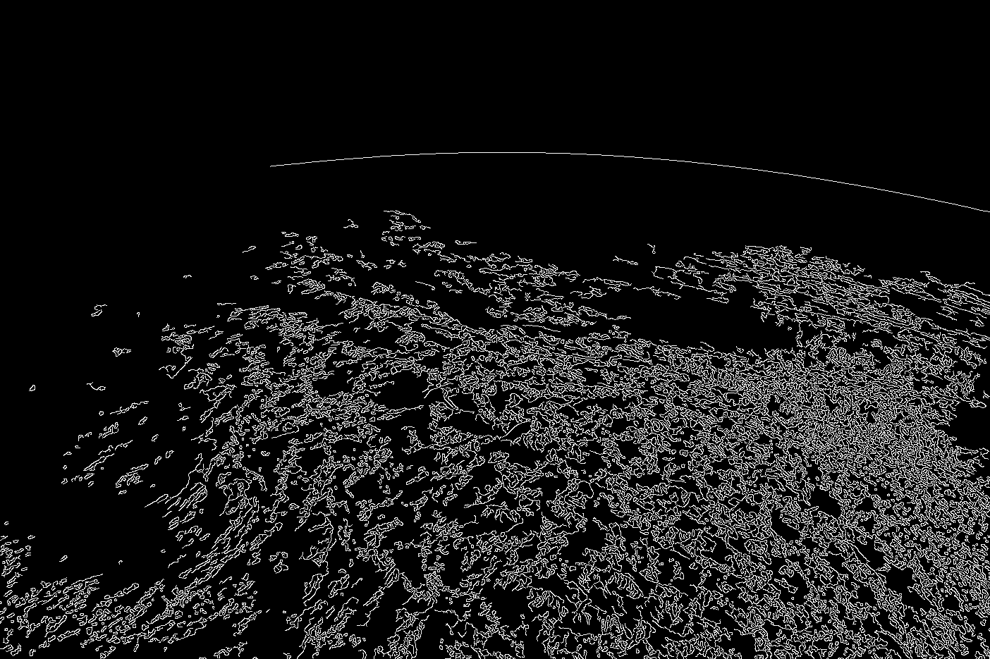
After Hough
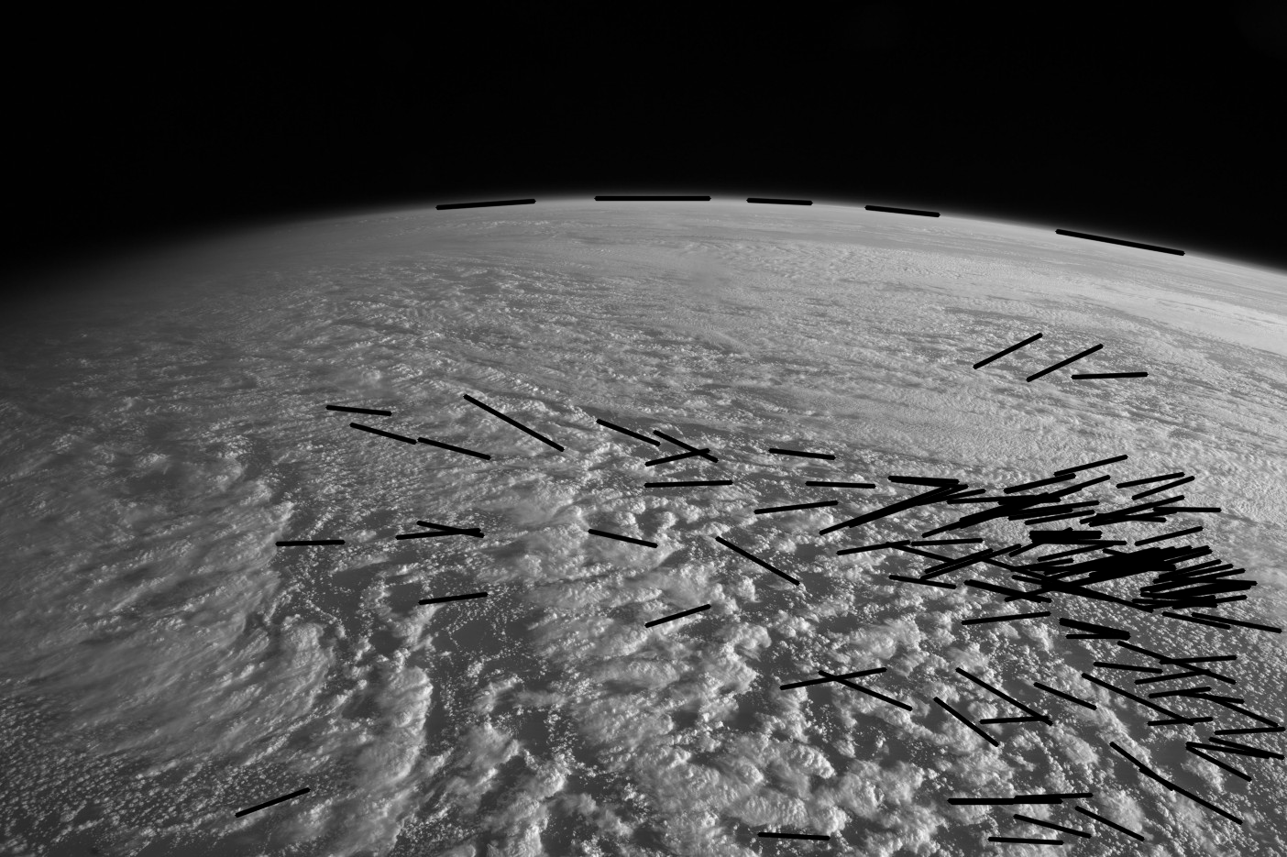
After filtering
Calculated curve
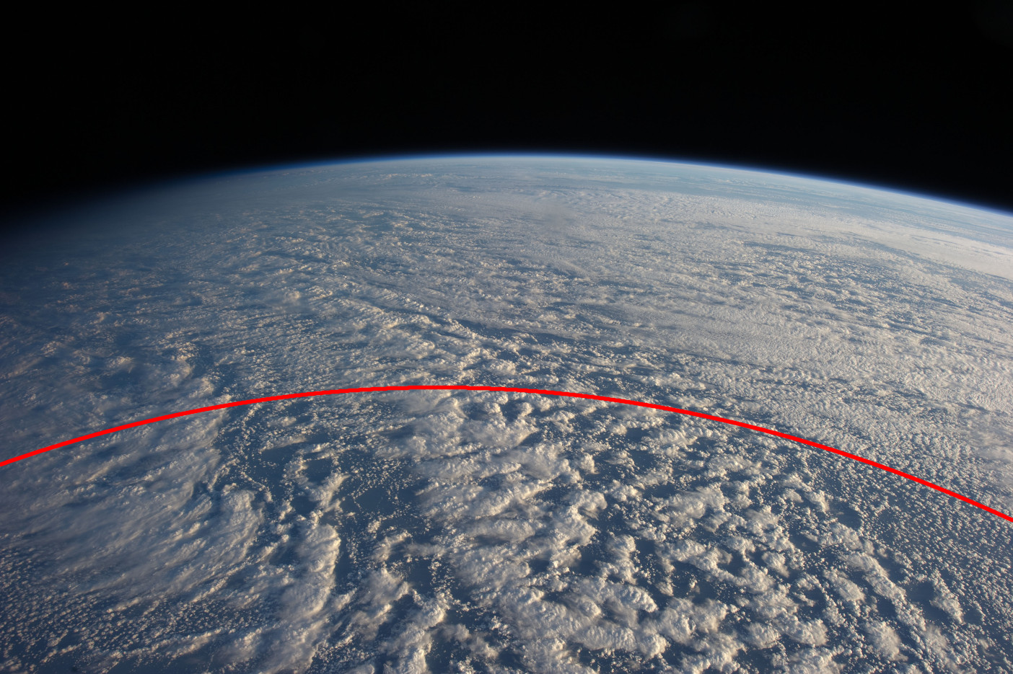
Horizion2.png
After Canny
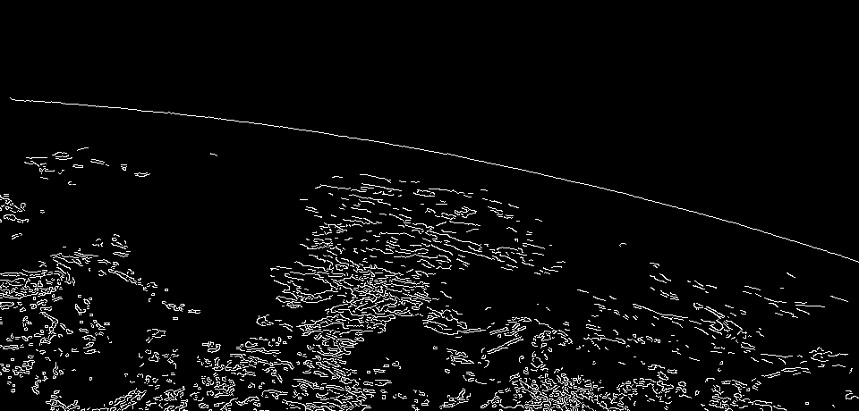
After Hough
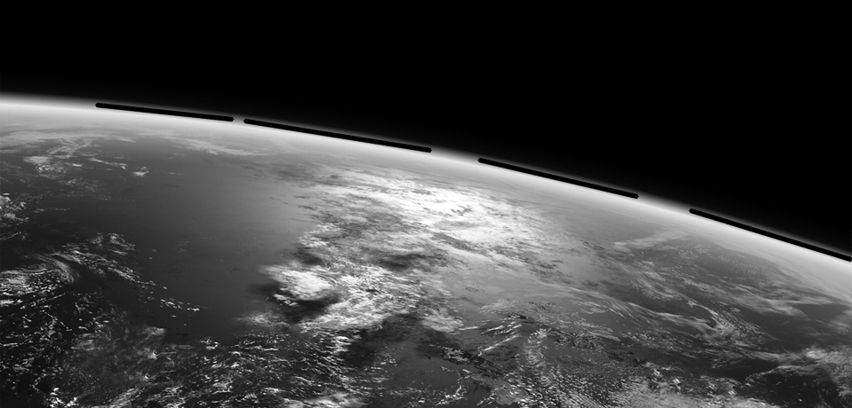
After filtering

Calculated curve
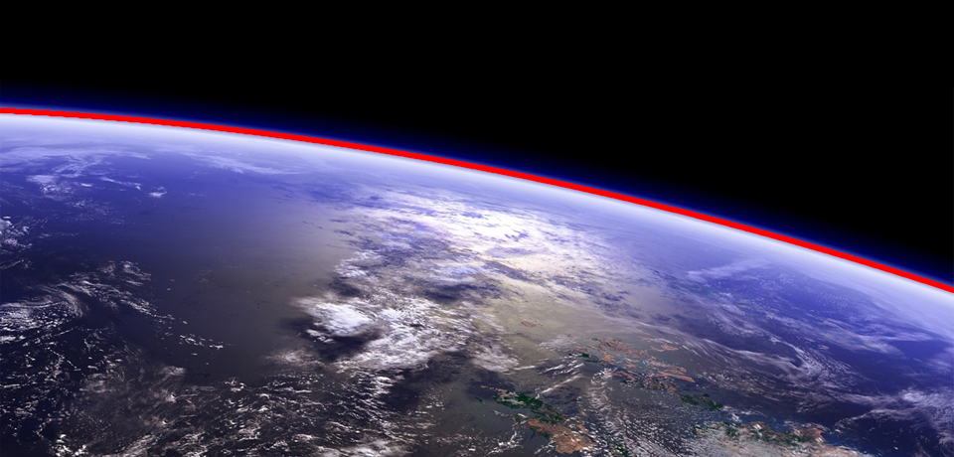
Horizon3.jpg
After Canny
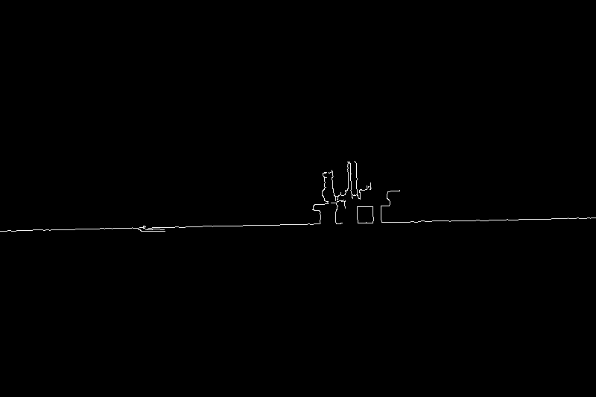
After Hough
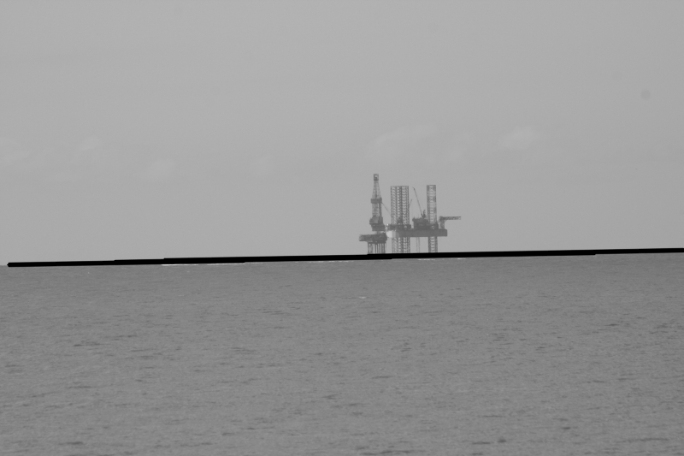
After filtering
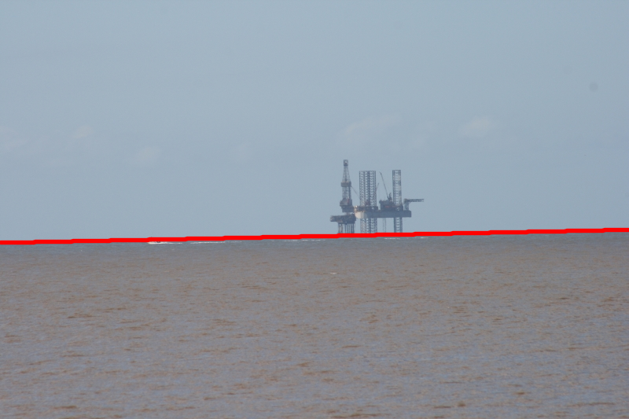
Calculated curve

