# Version: 1

# Signoff

Daragh:

Clint:

# Historical Aggregation

The aim of this module is to provide aggregate values/statistics for a trip.

Expected Input: Span IDs comprising a trip.

Expected Output: Average Speed, Total Idling Time, Total Stationary Time etc

# Architecture

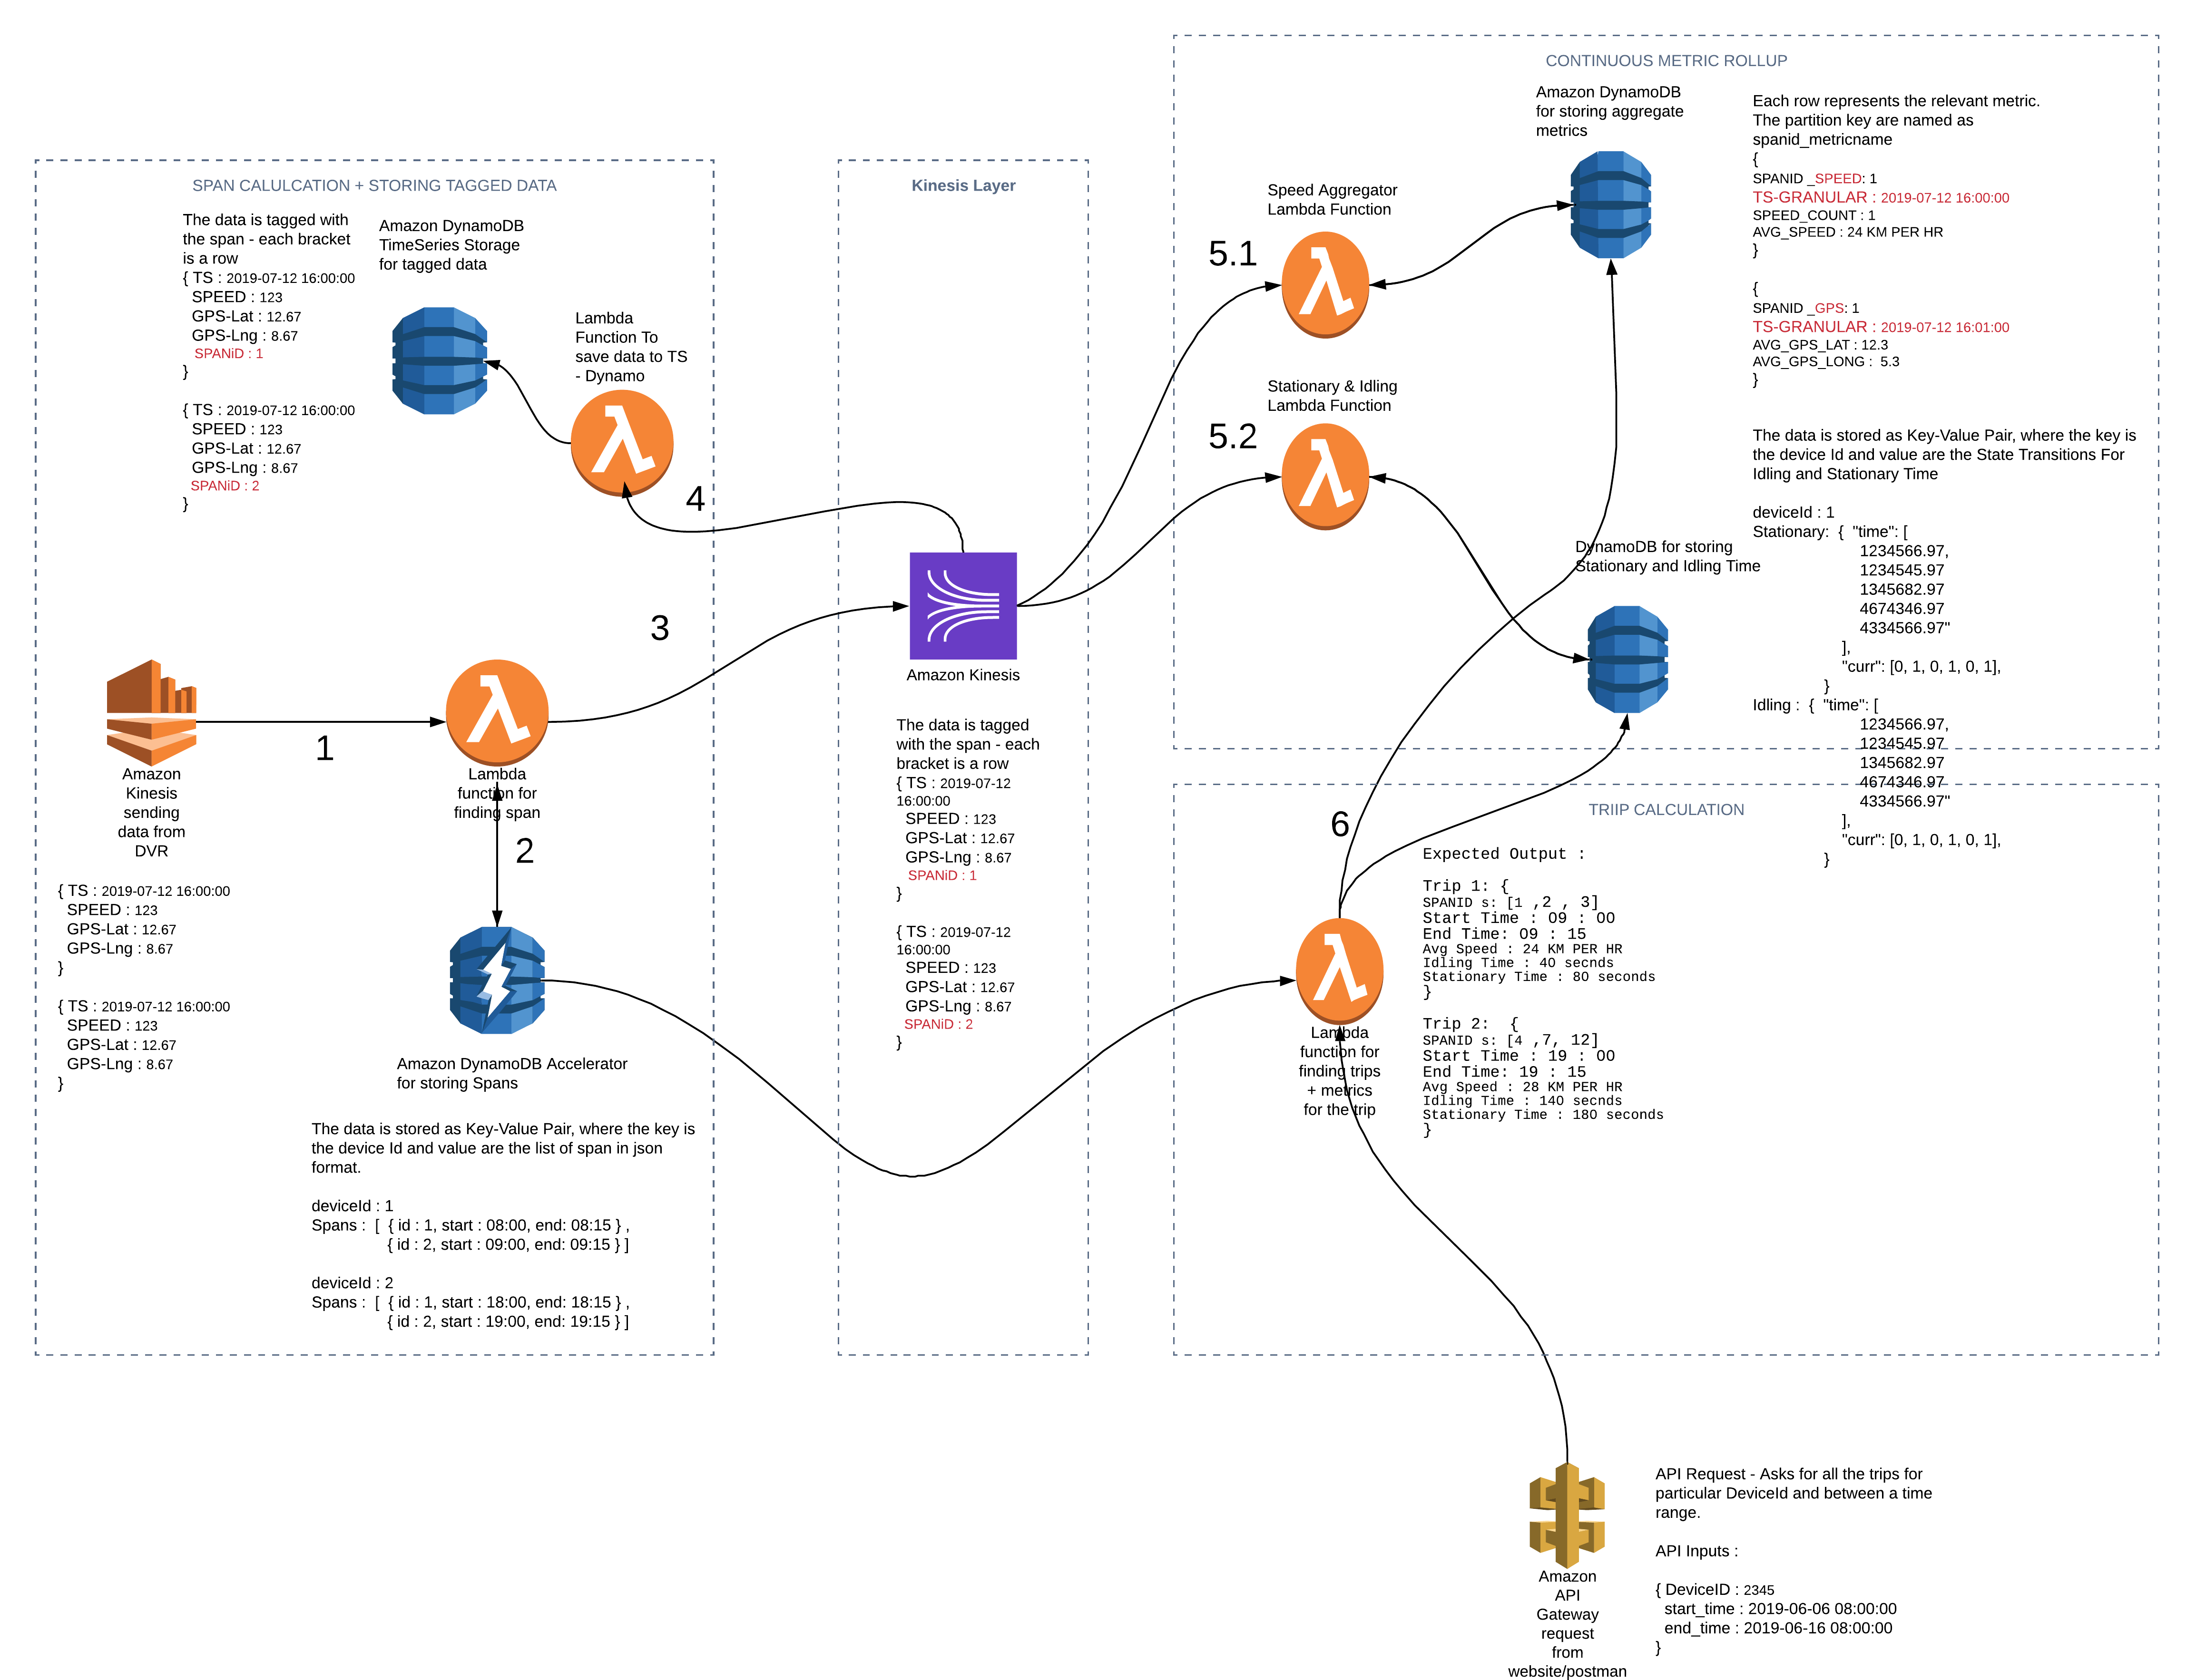

# 1 – Ingestion from Kinesis

The DVR sends data to Kinesis. Each data point sent by the DVR has **at least** the following attributes:

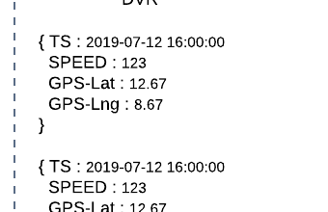

These data points are converts into records which contain 10-such data points. Our aim is to process as many data points as we can.

# 2 – Span Calculation

**Aim**: Tag the data points with SpanID and save them to Timeseries Database.

This module starts with ingesting datapoints from Kinesis. Each data point is the data inside the {}. The data points contain a timestamp, GPS coordinates, Speed etc. The lambda function ingests the data from the Kinesis and queries the Dynamo Table which stores the Span for devices. The algorithm then finds the spanID and tags the data point with it. This tagged Data is shown in Red colour, which is sent to a separate Kinesis Stream. The implementation of the algorithm is not in scope of this document. (Refer to the Span Calculation Module/GitHub Repo for implementation detail)

# 3 – Sending tagged data to Kinesis Stream

Once we tag the data with the span, we send this data to a Kinesis Stream which will persist it for later use and also perform other aggregations!

# 4 - Persisting tagged data to timeseries DynamoDB

Here we have a lambda function which takes the tagged data from Kinesis and does a Batch Write to Dynamo DB to persist. The TS DynamoDB database looks like below :

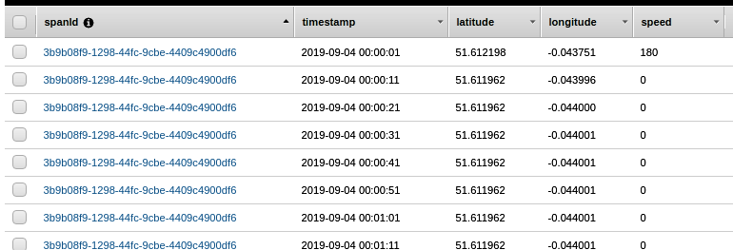

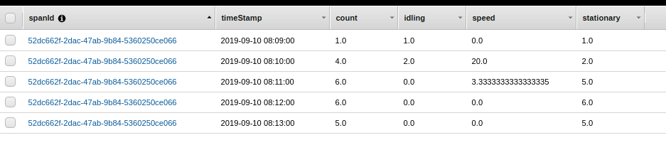

# 5 – Continuous Metric Rollup

This section is intended to be a modular layer, which computes different metrics as needed. Each Lambda Function takes data from the Kinesis Stream and updates the relevant aggregate in the DynamoDB. In the following sub-section, we will discuss how each metric is aggregated.

## 5.1 - Speed Aggregation Function

**Implementation**

When new data comes in from DBStream object, we extract the data from the batch and convert the timestamp from string to datetime type and round the data to the minute.

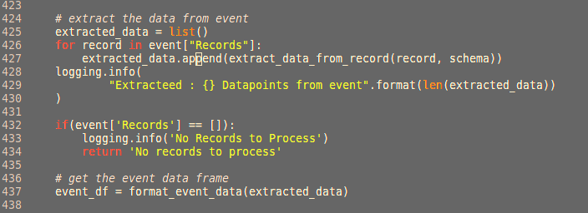

Then we find the spanID and timestamps from the Kinesis Event, as we need to get data for those specific spans and timestamps from the Dynamo to update them.

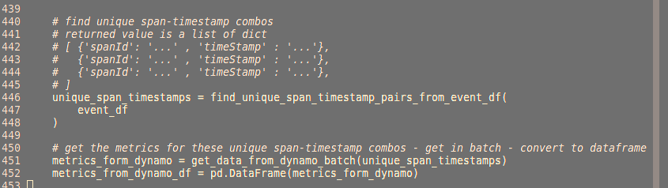

After that we update the metrics for those spans and timestamp 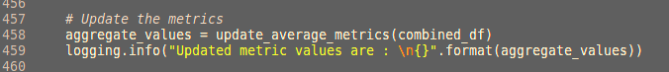

Write the updated metrics back to Dynamo DB in batches of 25 items.

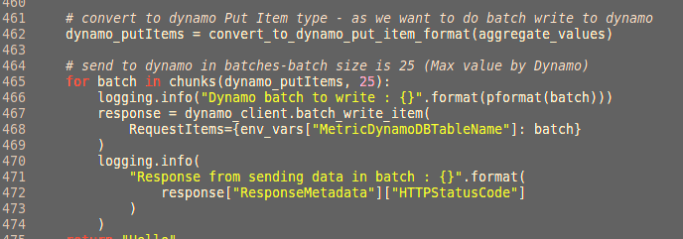

**Updating Speed Example**

Dynamo Aggregate Table

|  |  |  |  |
| --- | --- | --- | --- |
| SpanID | Granular Timestamp | count | speed |
| 123 | 00:01 | 6 | 25 |
|  | 00:02 | 6 | 25.2 |
|  | 00:03 | 5 | 27 |
|  | 00:04 | 1 | 22 |
|  |  |  |  |
| 124 | 19:36 | 1 | 28 |
|  |  |  |  |
| 125 | 16:04 | 5 | 24 |
|  | 16:05 | 6 | 24 |
|  | 16:06 | 6 | 24.8 |
|  | 16:07 | 6 | 28 |
|  | 16:08 | 6 | 32 |

DBStream Event: {

TS: 2019-07-12 16:04:36

SPEED: 123

GPS-Lat: 12.67

GPS-Lng : 8.67

SPANID: 125

EVENTNAME : 'INSERT"

}

Consider the above DynamoDB table, and the DBStream Event. We can see that the spanID is 25 and the timestamp’s minute is **04**. So, we first go to dynamo and retrieve the row with spanID 125 and Granular Timestamp as 16:04.

|  |  |  |  |
| --- | --- | --- | --- |
| SpanID | Granular Timestamp | count | speed |
| 125 | 16:04 | 5 | 24 |

Then we do the following calculation:

Count * speed + New Event Speed 24 *5 + 123

New Speed = --------------------------------------------------- = -------------------------- = 40.5

Count + 1 5 + 1

New Count = Count + 1 = 5 + 1 = 6

We then write these new values for speed and count to our Dynamo Table, which is shown in red

|  |  |  |  |
| --- | --- | --- | --- |
| SpanID | Granular Timestamp | count | speed |
| 123 | 00:01 | 6 | 25 |
|  | 00:02 | 6 | 25.2 |
|  | 00:03 | 5 | 27 |
|  | 00:04 | 1 | 22 |
|  |  |  |  |
| 124 | 19:36 | 1 | 28 |
|  |  |  |  |
| 125 | 16:04 | 6 | 40.5 |
|  | 16:05 | 6 | 24 |
|  | 16:06 | 6 | 24.8 |
|  | 16:07 | 6 | 28 |
|  | 16:08 | 6 | 32 |

## 5.2 - Stationary and Idling Time Aggregation

**Implementation**

**Incoming Data**

**Green = first invocation for lambda**

**Red = second invocation for lambda**

**Black = third invocation for lambda**

We seperate the incoming data for simulating out of order data points received from DVR.

S = Stationary, if the speed was zero at that data point

|  |  |
| --- | --- |
| Timestamp |  |
| 10:10 |  |
| 10:11 | S |
| 10:12 | S |
| 10:13 | S |
| 10:14 |  |
| 10:15 | S |
| 10:16 | S |
| 10:17 |  |
| 10:18 |  |
| 10:19 |  |
| 10:20 | S |
| 10:21 | S |
| 10:22 | S |

Step 1:

Get State Transition table from Dynamo, which will not exist for the device at first. So we create an empty table.

|  |  |
| --- | --- |
| Timestamp | State |

Step 2:

The data comes in random order (no data point is ordered). (First Batch)

Insert the data into the table as it comes

|  |  |
| --- | --- |
| Timestamp | State |
| 10:18 |  |
| 10:19 |  |
| 10:20 | S |
| 10:21 | S |
| 10:22 | S |

Step 3:

Order the data in the table according to the timestamp in ascending order

|  |  |
| --- | --- |
| Timestamp | State |
| 10:18 |  |
| 10:19 |  |
| 10:20 | S |
| 10:21 | S |
| 10:22 | S |

Step 4:

Remove rows which are consecutive in terms of time and which also have the same state.

|  |  |
| --- | --- |
| Timestamp | State |
| 10:18 |  |
| 10:19 | Consecutive Row + Same state as prev row (Remove This row) |
| 10:20 | S |
| 10:21 | S <- (delete this) |
| 10:22 | S <- (delete this) |

|  |  |
| --- | --- |
| Timestamp | State |
| 10:18 |  |
| 10:20 | S |

Step 5:

Save this above table in DynamoDB.

Step 1-5 for second invocation (red batch)

Step 1: Get table

|  |  |
| --- | --- |
| Timestamp | State |
| 10:18 |  |
| 10:20 | S |

Step 2: Insert Data as it comes

|  |  |
| --- | --- |
| Timestamp | State |
| 10:18 |  |
| 10:20 | S |
| 10:10 |  |
| 10:11 | S |
| 10:12 | S |
| 10:13 | S |
| 10:14 |  |

Step 3: Order Data according to timestamp

|  |  |
| --- | --- |
| Timestamp | State |
| 10:10 |  |
| 10:11 | S |
| 10:12 | S |
| 10:13 | S |
| 10:14 |  |
| 10:18 |  |
| 10:20 | S |

Step 4: Remove Consecutive (in terms of timestamp) rows with same state.

|  |  |
| --- | --- |
| Timestamp | State |
| 10:10 |  |
| 10:11 | S |
| 10:14 |  |
| 10:20 | S |

Step 5: Save the above table to DynamoDB

Follow Step 1 –5 again for the third invocation to get the following Table after step 4

|  |  |
| --- | --- |
| Timestamp | State |
| 10:10 |  |
| 10:11 | S |
| 10:14 |  |
| 10:15 | S |
| 10:17 |  |
| 10:20 | S |

# 6 - Trip Calculation and metric for trips

Aim: Provide the user with their trips for specific device and relevant metrics/stats for the trip.

In this module we calculate the trips and find the average metrics for those trips.