**Requirement**

**and**

**Analysis Phase**

Name: Daisyna Shrestha

Submitted to: Kiran Rana

# **Functional and Non-functinal requirements of the project**

## **Functional requirements**

Those requirements which defines the functionality of the system i.e. what the system should do. And the requirement depends upon the type of software being developed. For example: for my project Pharmacy management system, its functional requirement can be;

* Add, Update, Delete medicine
* Search medicine
* Generate bill of the medicine etc.

## **Non-functional requirements**

Those requirements which defines the overall characteristics of the system i.e. it specifies how the system will perform a certain function. And the non-functional requirements for my project are as follow;

* User-friendly interface
* Security
* Accessibility
* Reliable etc.

|  |  |  |
| --- | --- | --- |
| Functional and Non-functional determination | Requirements | MoSCoW prioritization |
| F(R1) | Registration for Pharmacist | M |
| F(R2) | Login system | M |
| F(R3) | Store data of medicine and its related information | M |
| F(R4) | Update medicine information | M |
| F(R5) | Delete medicine information | S |
| F(R6) | Add medicine information | M |
| F(R7) | Effective search of medicine | M |
| F(R8) | Show stock details | M |
| F(R9) | Notify when stock is low | S |
| F(R10) | Generate bill for the medicine | M |
| NF(R11) | User-friendly interface | M |
| F(R12) | Keep details of vendor | S |
| F(R13) | Change password | S |
| F(R14) | Change profile of pharmacist | C |
| F(R15) | Verify password | M |
| NF(R16) | Secure operation | M |
| NF(R17) | Usability | M |
| NF(R18) | Reliable | S |
| NF(R19) | Good performance | S |
| NF(R20) | Independent of working platform | C |
| NF(R21) | Maintainability | C |
| NF(R22) | Accessibility | C |
| F(R23) | Add category | M |
| F(R24) | Update category | M |
| F(R25) | Delete category | M |

# **Use case diagram**

Use case diagram is a tool which portray broad interaction between actors and the system through its functionality defined as use case. It helps in requirement analysis as well as modelling the behavioral structure of the system. And, here actor represents the user and use case represents the function of the system.

The use case diagram representing actors and their functionality is below;

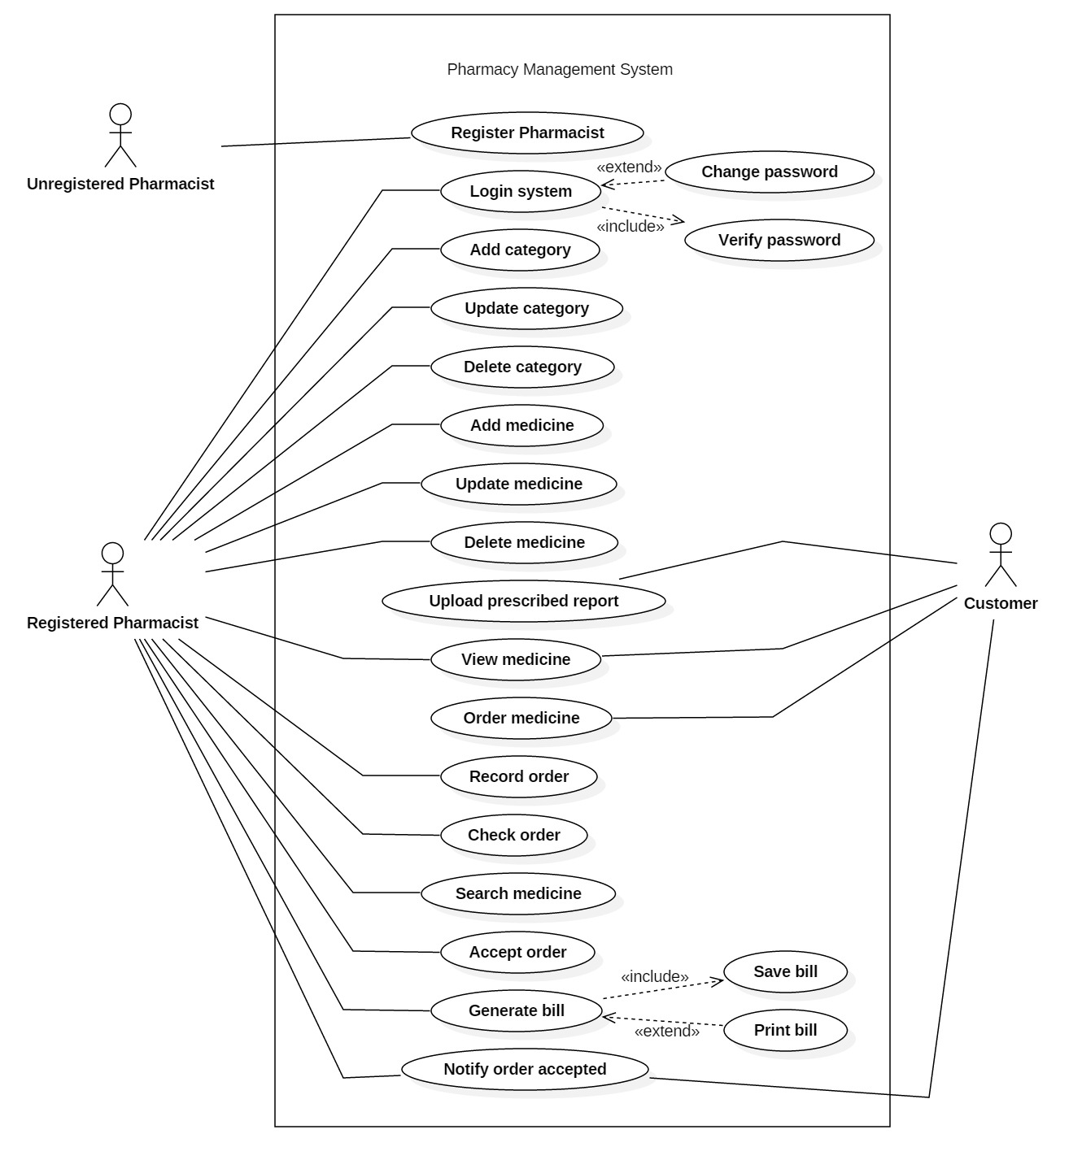

# **ER-diagram**

Entity relationship diagram is the analytical structure of entities and their relationship in order to organize all the data within information system. Here, ER-diagram is developed with the help of UML Visual Paradigm. The aim of ER model is to develop a model of data that is non-technical and free of opacity.

The ER-diagram of the project is shown below;

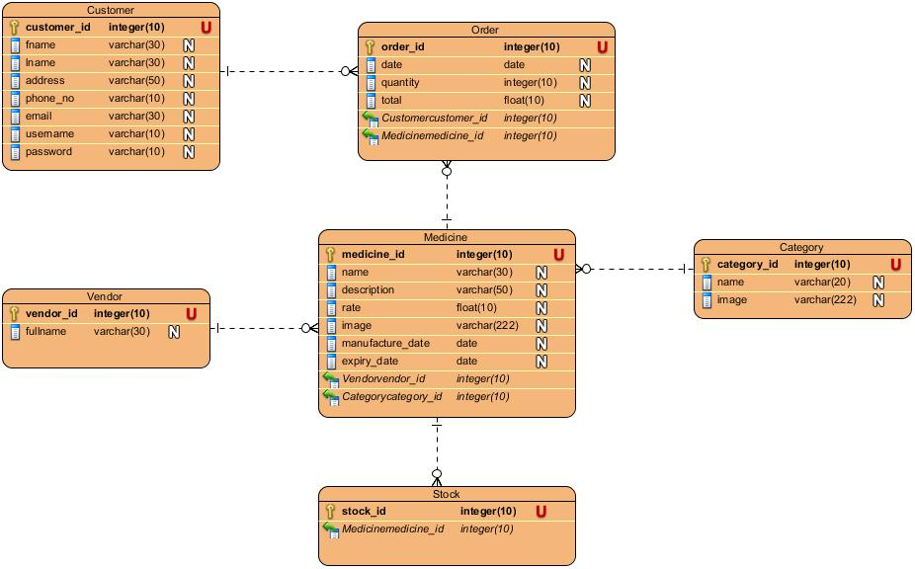

# **Initial class diagram**

The static structure providing the overview of the system through classes and defining the relationships among the classes.

And the initial class diagram is shown below;

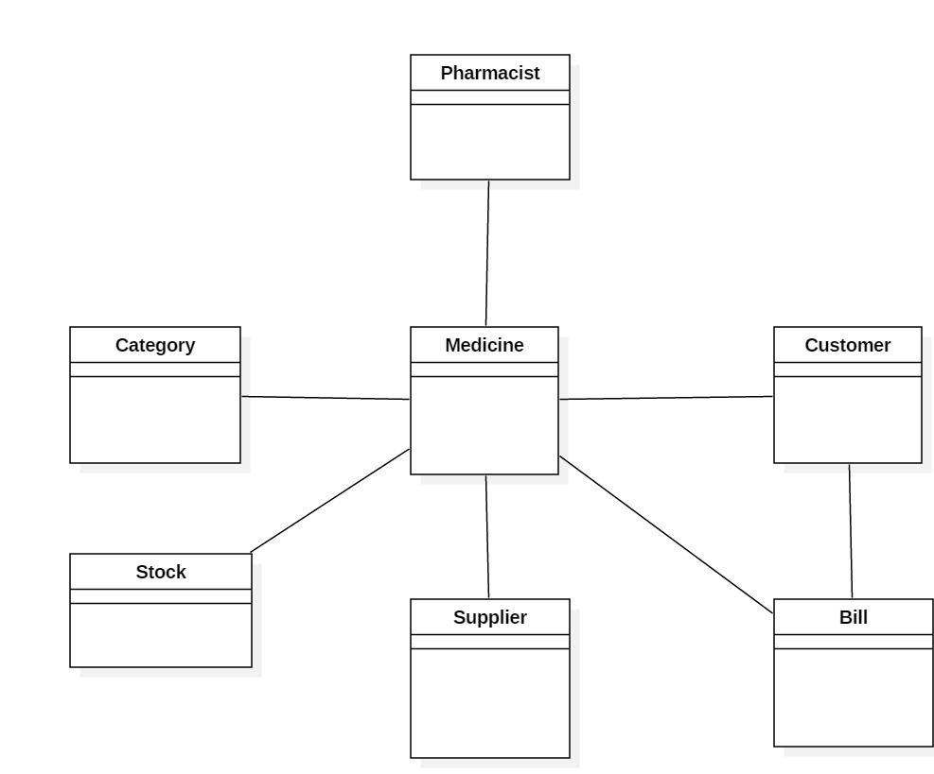

# **UI design**

The user interface of the are as follow;

## **Navigation bar**

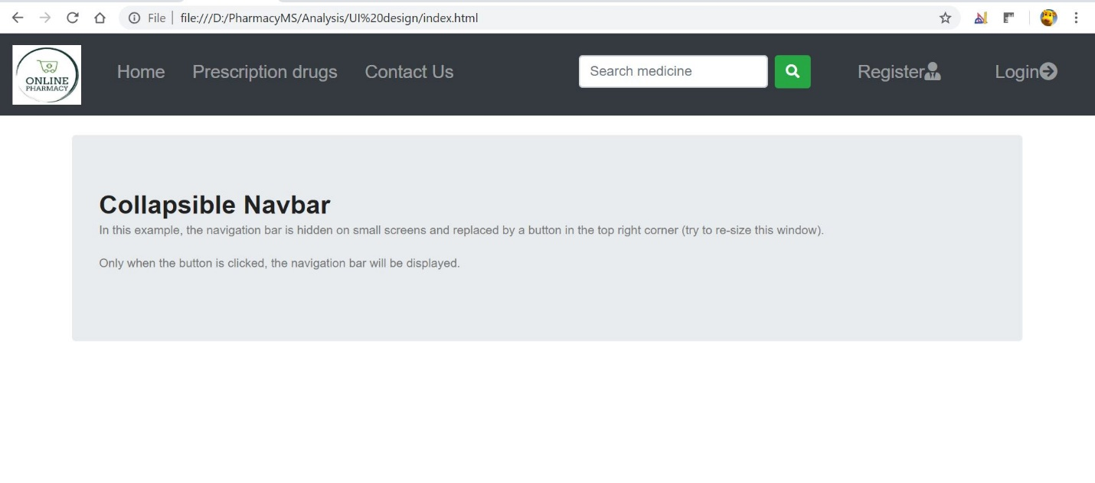

**Registration form**

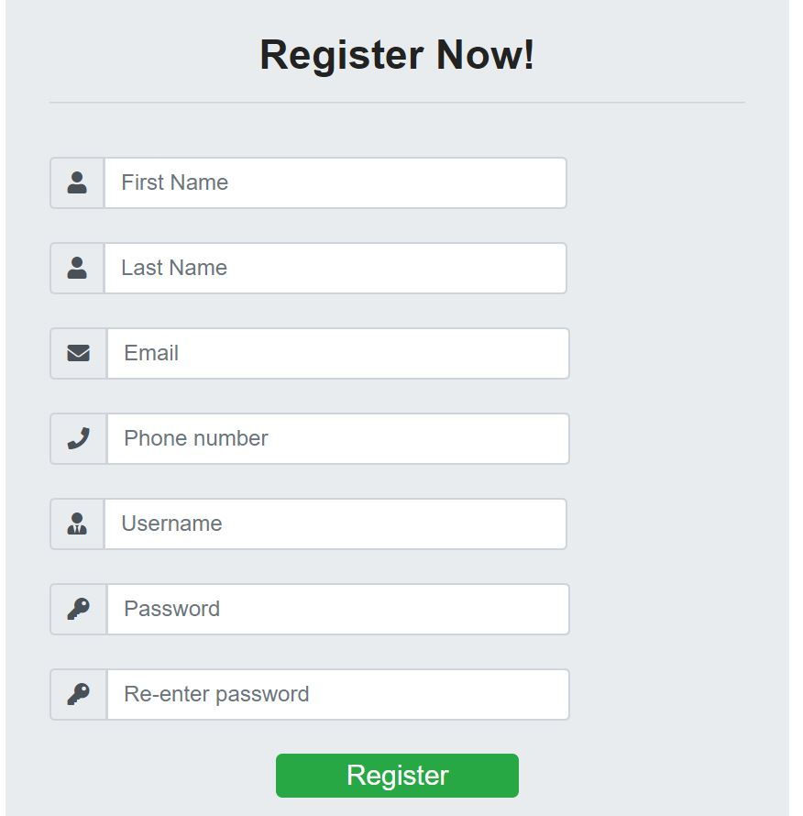

## **Login form**

