**Design Phase**

Name: Daisyna Shrestha

Submitted to: Kiran Rana

Batch: 21

Date: 13th Feb,2019

# **Class diagram**

## **Initial class diagram**

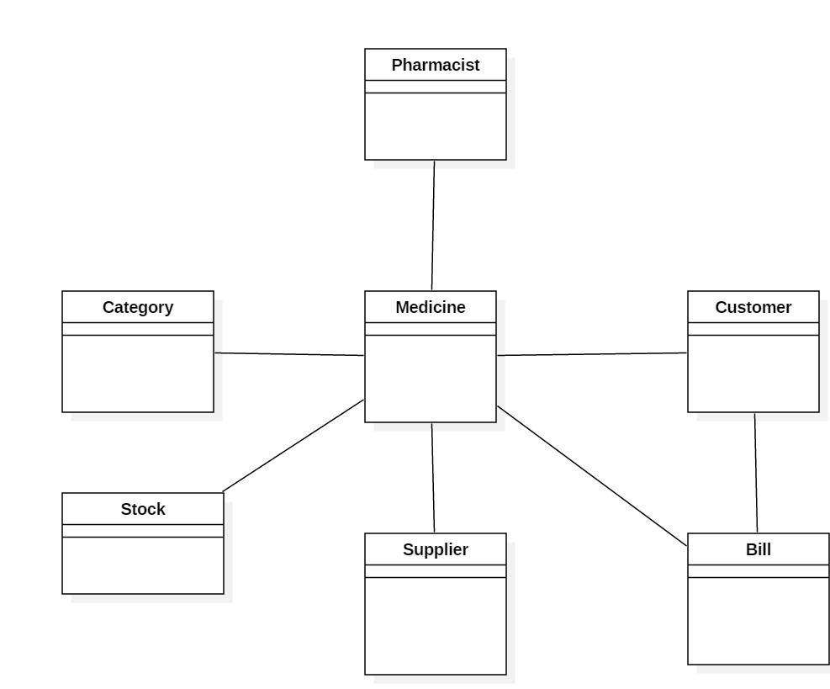

## **Final class diagram**

# **Entity-Relationship diagram**

## **ER-diagram**

