PS C:\Users\Satyaprasad_Dakinedi\Desktop\AI_Solutions_Implementations\langchaindemos\TruLens_Demos> & C:/Users/Satyaprasad_Dakinedi/AppData/Local/Microsoft/WindowsApps/python3.11.exe c:/Users/Satyaprasad_Dakinedi/Desktop/AI_Solutions_Implementations/langchaindemos/TruLens_Demos/rag_mcp_client.py
### TruLens imports successful!
🦑 Initialized with db url sqlite:///default.sqlite .
🛑 Secret keys may be written to the database. See the `database_redact_keys` option of `TruSession` to prevent this.
#### All other imports successful!
Before init: RAG system is not initialized
c:\Users\Satyaprasad_Dakinedi\Desktop\AI_Solutions_Implementations\langchaindemos\TruLens_Demos\rag_mcp_server1.py:100: LangChainDeprecationWarning: The class `Chroma` was deprecated in LangChain 0.2.9 and will be removed in 1.0. An updated version of the class exists in the :class:`~langchain-chroma package and should be used instead. To use it run `pip install -U :class:`~langchain-chroma` and import as `from :class:`~langchain_chroma import Chroma``.
self.vectordb = Chroma(
[07/17/25 14:06:45] INFO Anonymized telemetry enabled. See https://docs.trychroma.com/telemetry for more information. posthog.py:22Creating new vector store...
[07/17/25 14:07:28] INFO HTTP Request: POST https://ai-proxy.lab.epam.com/openai/deployments/text-embedding-ada-002/embeddings?api-version=2024-02-01 "HTTP/1.1 200 OK" _client.py:1038c:\Users\Satyaprasad_Dakinedi\Desktop\AI_Solutions_Implementations\langchaindemos\TruLens_Demos\rag_mcp_server1.py:116: LangChainDeprecationWarning: Since Chroma 0.4.x the manual persistence method is no longer supported as docs are automatically persisted.
self.vectordb.persist()
Created vector store with 18 entries
### RAG system initialized successfully!
[07/17/25 14:07:46] INFO HTTP Request: POST https://ai-proxy.lab.epam.com/openai/deployments/text-embedding-ada-002/embeddings?api-version=2024-02-01 "HTTP/1.1 200 OK" _client.py:1038[07/17/25 14:07:49] INFO HTTP Request: POST https://ai-proxy.lab.epam.com/openai/deployments/gpt-4o/chat/completions?api-version=2024-02-01 "HTTP/1.1 200 OK" _client.py:1038####################
Query Response: The system must provide online help, FAQs, customer support, and sitemap options for customer assistance. It should allow users to select the type of support, enter customer and product information, display support contact numbers, and enable users to provide their contact number for callback by support personnel.
####################
After init: RAG system is initialized with document chunks in vector store
############ chunks is: 60
[07/17/25 14:08:07] INFO Anonymized telemetry enabled. See https://docs.trychroma.com/telemetry for more information. posthog.py:22
[07/17/25 14:08:17] INFO HTTP Request: POST https://ai-proxy.lab.epam.com/openai/deployments/text-embedding-ada-002/embeddings?api-version=2023-07-01-preview "HTTP/1.1 200 OK" _client.py:1038Total entries in the vectordb is: 60
[07/17/25 14:08:21] INFO HTTP Request: POST https://ai-proxy.lab.epam.com/openai/deployments/text-embedding-ada-002/embeddings?api-version=2023-07-01-preview "HTTP/1.1 200 OK" _client.py:1038[07/17/25 14:08:24] INFO HTTP Request: POST https://ai-proxy.lab.epam.com/openai/deployments/gpt-35-turbo/chat/completions?api-version=2023-07-01-preview "HTTP/1.1 200 OK" _client.py:1038[07/17/25 14:08:26] INFO HTTP Request: POST https://ai-proxy.lab.epam.com/openai/deployments/text-embedding-ada-002/embeddings?api-version=2023-07-01-preview "HTTP/1.1 200 OK" _client.py:1038[07/17/25 14:08:27] INFO HTTP Request: POST https://ai-proxy.lab.epam.com/openai/deployments/gpt-35-turbo/chat/completions?api-version=2023-07-01-preview "HTTP/1.1 200 OK" _client.py:1038[07/17/25 14:08:28] INFO HTTP Request: POST https://ai-proxy.lab.epam.com/openai/deployments/text-embedding-ada-002/embeddings?api-version=2023-07-01-preview "HTTP/1.1 200 OK" _client.py:1038[07/17/25 14:08:29] INFO HTTP Request: POST https://ai-proxy.lab.epam.com/openai/deployments/gpt-35-turbo/chat/completions?api-version=2023-07-01-preview "HTTP/1.1 200 OK" _client.py:1038[07/17/25 14:08:30] INFO HTTP Request: POST https://ai-proxy.lab.epam.com/openai/deployments/text-embedding-ada-002/embeddings?api-version=2023-07-01-preview "HTTP/1.1 200 OK" _client.py:1038[07/17/25 14:08:32] INFO HTTP Request: POST https://ai-proxy.lab.epam.com/openai/deployments/gpt-35-turbo/chat/completions?api-version=2023-07-01-preview "HTTP/1.1 200 OK" _client.py:1038[07/17/25 14:08:33] INFO HTTP Request: POST https://ai-proxy.lab.epam.com/openai/deployments/text-embedding-ada-002/embeddings?api-version=2023-07-01-preview "HTTP/1.1 200 OK" _client.py:1038[07/17/25 14:08:35] INFO HTTP Request: POST https://ai-proxy.lab.epam.com/openai/deployments/gpt-35-turbo/chat/completions?api-version=2023-07-01-preview "HTTP/1.1 200 OK" _client.py:1038[07/17/25 14:08:36] INFO HTTP Request: POST https://ai-proxy.lab.epam.com/openai/deployments/text-embedding-ada-002/embeddings?api-version=2023-07-01-preview "HTTP/1.1 200 OK" _client.py:1038[07/17/25 14:08:37] INFO HTTP Request: POST https://ai-proxy.lab.epam.com/openai/deployments/gpt-35-turbo/chat/completions?api-version=2023-07-01-preview "HTTP/1.1 200 OK" _client.py:1038######### test_set is: {'Software Requirements': ['What are the specific requirements of the product according to the document?', 'What are the design constraints related to standard development tools mentioned in the context?'], 'E-Store Project': ['What are the specific requirements related to functionality for the e-Store project?', 'How does the e-Store project handle email confirmation and customer communication through email?']}
✅ In Groundedness, input source will be set to __record__.app.first.steps__.context.invoke.rets[:].page_content.collect() .
✅ In Groundedness, input statement will be set to __record__.main_output or `Select.RecordOutput` .
✅ In Answer Relevance, input prompt will be set to __record__.main_input or `Select.RecordInput` .
✅ In Answer Relevance, input response will be set to __record__.main_output or `Select.RecordOutput` .
✅ In Context Relevance, input question will be set to __record__.main_input or `Select.RecordInput` .
✅ In Context Relevance, input context will be set to __record__.app.first.steps__.context.invoke.rets[:].page_content .
[07/17/25 14:09:16] WARNING Object (of type list is a sequence containing more than one dictionary. Lookup by item or attribute `rets` is ambiguous. Use a lookup by index(es) or slice first to serial.py:352 disambiguate.
[07/17/25 14:09:17] WARNING Object (of type list is a sequence containing more than one dictionary. Lookup by item or attribute `rets` is ambiguous. Use a lookup by index(es) or slice first to serial.py:352 disambiguate.
WARNING Object (of type list is a sequence containing more than one dictionary. Lookup by item or attribute `rets` is ambiguous. Use a lookup by index(es) or slice first to serial.py:352 disambiguate.
[07/17/25 14:09:19] WARNING Object (of type list is a sequence containing more than one dictionary. Lookup by item or attribute `rets` is ambiguous. Use a lookup by index(es) or slice first to serial.py:352 disambiguate.
WARNING Object (of type list is a sequence containing more than one dictionary. Lookup by item or attribute `rets` is ambiguous. Use a lookup by index(es) or slice first to serial.py:352 disambiguate.
[07/17/25 14:09:20] WARNING Object (of type list is a sequence containing more than one dictionary. Lookup by item or attribute `rets` is ambiguous. Use a lookup by index(es) or slice first to serial.py:352 disambiguate.
[07/17/25 14:09:21] WARNING Could not find an instance of DummyEndpoint. trulens will create an endpoint for cost tracking. endpoint.py:525 WARNING Could not find an instance of DummyEndpoint. trulens will create an endpoint for cost tracking. endpoint.py:525[07/17/25 14:09:23] WARNING Could not find an instance of DummyEndpoint. trulens will create an endpoint for cost tracking. endpoint.py:525 WARNING Could not find an instance of DummyEndpoint. trulens will create an endpoint for cost tracking. endpoint.py:525 WARNING Could not find an instance of DummyEndpoint. trulens will create an endpoint for cost tracking. endpoint.py:525[07/17/25 14:09:25] INFO HTTP Request: POST https://ai-proxy.lab.epam.com/openai/deployments/text-embedding-ada-002/embeddings?api-version=2023-07-01-preview "HTTP/1.1 200 OK" _client.py:1038 WARNING Could not find an instance of DummyEndpoint. trulens will create an endpoint for cost tracking. endpoint.py:525[07/17/25 14:09:26] WARNING Could not find an instance of DummyEndpoint. trulens will create an endpoint for cost tracking. endpoint.py:525[07/17/25 14:09:28] INFO HTTP Request: POST https://ai-proxy.lab.epam.com/openai/deployments/gpt-35-turbo/chat/completions?api-version=2023-07-01-preview "HTTP/1.1 200 OK" _client.py:1038[07/17/25 14:09:29] WARNING Could not find an instance of DummyEndpoint. trulens will create an endpoint for cost tracking. endpoint.py:525[07/17/25 14:09:32] WARNING Could not find an instance of DummyEndpoint. trulens will create an endpoint for cost tracking. endpoint.py:525 WARNING Could not find an instance of DummyEndpoint. trulens will create an endpoint for cost tracking. endpoint.py:525[07/17/25 14:09:34] WARNING Could not find an instance of DummyEndpoint. trulens will create an endpoint for cost tracking. endpoint.py:525[07/17/25 14:09:35] WARNING Could not find an instance of DummyEndpoint. trulens will create an endpoint for cost tracking. endpoint.py:525[07/17/25 14:09:36] WARNING Could not find an instance of DummyEndpoint. trulens will create an endpoint for cost tracking. endpoint.py:525[07/17/25 14:09:38] WARNING Could not find an instance of DummyEndpoint. trulens will create an endpoint for cost tracking. endpoint.py:525 INFO HTTP Request: POST https://api.openai.com/v1/chat/completions "HTTP/1.1 200 OK" _client.py:1038[07/17/25 14:09:39] WARNING Could not find an instance of DummyEndpoint. trulens will create an endpoint for cost tracking. endpoint.py:525[07/17/25 14:09:41] INFO HTTP Request: POST https://api.openai.com/v1/chat/completions "HTTP/1.1 200 OK" _client.py:1038 WARNING Could not find an instance of DummyEndpoint. trulens will create an endpoint for cost tracking. endpoint.py:525[07/17/25 14:09:44] WARNING Could not find an instance of DummyEndpoint. trulens will create an endpoint for cost tracking. endpoint.py:525[07/17/25 14:09:47] INFO HTTP Request: POST https://ai-proxy.lab.epam.com/openai/deployments/text-embedding-ada-002/embeddings?api-version=2023-07-01-preview "HTTP/1.1 200 OK" _client.py:1038[07/17/25 14:09:48] WARNING Could not find an instance of DummyEndpoint. trulens will create an endpoint for cost tracking. endpoint.py:525[07/17/25 14:09:49] INFO HTTP Request: POST https://api.openai.com/v1/chat/completions "HTTP/1.1 200 OK" _client.py:1038[07/17/25 14:09:50] INFO HTTP Request: POST https://api.openai.com/v1/chat/completions "HTTP/1.1 200 OK" _client.py:1038 WARNING Could not find an instance of DummyEndpoint. trulens will create an endpoint for cost tracking. endpoint.py:525[07/17/25 14:09:51] WARNING Could not find an instance of DummyEndpoint. trulens will create an endpoint for cost tracking. endpoint.py:525[07/17/25 14:09:54] INFO HTTP Request: POST https://ai-proxy.lab.epam.com/openai/deployments/gpt-35-turbo/chat/completions?api-version=2023-07-01-preview "HTTP/1.1 200 OK" _client.py:1038 WARNING Could not find an instance of DummyEndpoint. trulens will create an endpoint for cost tracking. endpoint.py:525[07/17/25 14:09:55] INFO HTTP Request: POST https://api.openai.com/v1/chat/completions "HTTP/1.1 200 OK" _client.py:1038[07/17/25 14:09:56] INFO HTTP Request: POST https://api.openai.com/v1/chat/completions "HTTP/1.1 200 OK" _client.py:1038 INFO HTTP Request: POST https://api.openai.com/v1/chat/completions "HTTP/1.1 200 OK" _client.py:1038[07/17/25 14:09:59] WARNING Could not find an instance of DummyEndpoint. trulens will create an endpoint for cost tracking. endpoint.py:525[07/17/25 14:10:00] WARNING Could not find an instance of DummyEndpoint. trulens will create an endpoint for cost tracking. endpoint.py:525[07/17/25 14:10:01] WARNING Could not find an instance of DummyEndpoint. trulens will create an endpoint for cost tracking. endpoint.py:525[07/17/25 14:10:02] WARNING Could not find an instance of DummyEndpoint. trulens will create an endpoint for cost tracking. endpoint.py:525 WARNING Could not find an instance of DummyEndpoint. trulens will create an endpoint for cost tracking. endpoint.py:525[07/17/25 14:10:03] WARNING Could not find an instance of DummyEndpoint. trulens will create an endpoint for cost tracking. endpoint.py:525[07/17/25 14:10:04] INFO HTTP Request: POST https://api.openai.com/v1/chat/completions "HTTP/1.1 200 OK" _client.py:1038[07/17/25 14:10:06] WARNING Could not find an instance of DummyEndpoint. trulens will create an endpoint for cost tracking. endpoint.py:525 WARNING Could not find an instance of DummyEndpoint. trulens will create an endpoint for cost tracking. endpoint.py:525[07/17/25 14:10:07] INFO HTTP Request: POST https://api.openai.com/v1/chat/completions "HTTP/1.1 200 OK" _client.py:1038 INFO HTTP Request: POST https://api.openai.com/v1/chat/completions "HTTP/1.1 200 OK" _client.py:1038 INFO HTTP Request: POST https://api.openai.com/v1/chat/completions "HTTP/1.1 200 OK" _client.py:1038 WARNING Could not find an instance of DummyEndpoint. trulens will create an endpoint for cost tracking. endpoint.py:525[07/17/25 14:10:10] INFO HTTP Request: POST https://ai-proxy.lab.epam.com/openai/deployments/text-embedding-ada-002/embeddings?api-version=2023-07-01-preview "HTTP/1.1 200 OK" _client.py:1038 WARNING Could not find an instance of DummyEndpoint. trulens will create an endpoint for cost tracking. endpoint.py:525[07/17/25 14:10:12] INFO HTTP Request: POST https://api.openai.com/v1/chat/completions "HTTP/1.1 200 OK" _client.py:1038 WARNING Could not find an instance of DummyEndpoint. trulens will create an endpoint for cost tracking. endpoint.py:525[07/17/25 14:10:13] WARNING Could not find an instance of DummyEndpoint. trulens will create an endpoint for cost tracking. endpoint.py:525[07/17/25 14:10:15] INFO HTTP Request: POST https://api.openai.com/v1/chat/completions "HTTP/1.1 200 OK" _client.py:1038[07/17/25 14:10:16] INFO HTTP Request: POST https://ai-proxy.lab.epam.com/openai/deployments/gpt-35-turbo/chat/completions?api-version=2023-07-01-preview "HTTP/1.1 200 OK" _client.py:1038 WARNING Could not find an instance of DummyEndpoint. trulens will create an endpoint for cost tracking. endpoint.py:525[07/17/25 14:10:17] WARNING Could not find an instance of DummyEndpoint. trulens will create an endpoint for cost tracking. endpoint.py:525[07/17/25 14:10:19] WARNING Could not find an instance of DummyEndpoint. trulens will create an endpoint for cost tracking. endpoint.py:525 WARNING Could not find an instance of DummyEndpoint. trulens will create an endpoint for cost tracking. endpoint.py:525 INFO HTTP Request: POST https://api.openai.com/v1/chat/completions "HTTP/1.1 200 OK" _client.py:1038[07/17/25 14:10:20] WARNING Could not find an instance of DummyEndpoint. trulens will create an endpoint for cost tracking. endpoint.py:525[07/17/25 14:10:21] WARNING Could not find an instance of DummyEndpoint. trulens will create an endpoint for cost tracking. endpoint.py:525 WARNING Could not find an instance of DummyEndpoint. trulens will create an endpoint for cost tracking. endpoint.py:525[07/17/25 14:10:22] WARNING Could not find an instance of DummyEndpoint. trulens will create an endpoint for cost tracking. endpoint.py:525[07/17/25 14:10:23] INFO HTTP Request: POST https://api.openai.com/v1/chat/completions "HTTP/1.1 200 OK" _client.py:1038 WARNING Could not find an instance of DummyEndpoint. trulens will create an endpoint for cost tracking. endpoint.py:525 INFO HTTP Request: POST https://api.openai.com/v1/chat/completions "HTTP/1.1 200 OK" _client.py:1038[07/17/25 14:10:24] WARNING Could not find an instance of DummyEndpoint. trulens will create an endpoint for cost tracking. endpoint.py:525 WARNING Could not find an instance of DummyEndpoint. trulens will create an endpoint for cost tracking. endpoint.py:525 WARNING Could not find an instance of DummyEndpoint. trulens will create an endpoint for cost tracking. endpoint.py:525[07/17/25 14:10:25] INFO HTTP Request: POST https://api.openai.com/v1/chat/completions "HTTP/1.1 200 OK" _client.py:1038[07/17/25 14:10:27] INFO HTTP Request: POST https://api.openai.com/v1/chat/completions "HTTP/1.1 200 OK" _client.py:1038 INFO HTTP Request: POST https://ai-proxy.lab.epam.com/openai/deployments/text-embedding-ada-002/embeddings?api-version=2023-07-01-preview "HTTP/1.1 200 OK" _client.py:1038[07/17/25 14:10:28] INFO HTTP Request: POST https://api.openai.com/v1/chat/completions "HTTP/1.1 200 OK" _client.py:1038 WARNING Could not find an instance of DummyEndpoint. trulens will create an endpoint for cost tracking. endpoint.py:525[07/17/25 14:10:29] WARNING Could not find an instance of DummyEndpoint. trulens will create an endpoint for cost tracking. endpoint.py:525 INFO HTTP Request: POST https://api.openai.com/v1/chat/completions "HTTP/1.1 200 OK" _client.py:1038[07/17/25 14:10:30] WARNING Could not find an instance of DummyEndpoint. trulens will create an endpoint for cost tracking. endpoint.py:525[07/17/25 14:10:33] INFO HTTP Request: POST https://ai-proxy.lab.epam.com/openai/deployments/gpt-35-turbo/chat/completions?api-version=2023-07-01-preview "HTTP/1.1 200 OK" _client.py:1038[07/17/25 14:10:34] INFO HTTP Request: POST https://api.openai.com/v1/chat/completions "HTTP/1.1 200 OK" _client.py:1038 WARNING Could not find an instance of DummyEndpoint. trulens will create an endpoint for cost tracking. endpoint.py:525[07/17/25 14:10:35] WARNING Could not find an instance of DummyEndpoint. trulens will create an endpoint for cost tracking. endpoint.py:525[07/17/25 14:10:36] WARNING Could not find an instance of DummyEndpoint. trulens will create an endpoint for cost tracking. endpoint.py:525[07/17/25 14:10:37] WARNING Could not find an instance of DummyEndpoint. trulens will create an endpoint for cost tracking. endpoint.py:525Recording complete. Saving results to database...
[07/17/25 14:10:38] WARNING Could not find an instance of DummyEndpoint. trulens will create an endpoint for cost tracking. endpoint.py:525
TruLens dashboard will be available at: http://localhost:8501
[07/17/25 14:10:39] INFO HTTP Request: POST https://api.openai.com/v1/chat/completions "HTTP/1.1 200 OK" _client.py:1038
Starting dashboard ...
[07/17/25 14:10:40] INFO HTTP Request: POST https://api.openai.com/v1/chat/completions "HTTP/1.1 200 OK" _client.py:1038[07/17/25 14:10:41] INFO HTTP Request: POST https://api.openai.com/v1/chat/completions "HTTP/1.1 200 OK" _client.py:1038 INFO HTTP Request: POST https://api.openai.com/v1/chat/completions "HTTP/1.1 200 OK" _client.py:1038 WARNING Could not find an instance of DummyEndpoint. trulens will create an endpoint for cost tracking. endpoint.py:525[07/17/25 14:10:43] INFO HTTP Request: POST https://api.openai.com/v1/chat/completions "HTTP/1.1 200 OK" _client.py:1038[07/17/25 14:10:45] INFO HTTP Request: POST https://api.openai.com/v1/chat/completions "HTTP/1.1 200 OK" _client.py:1038 WARNING Could not find an instance of DummyEndpoint. trulens will create an endpoint for cost tracking. endpoint.py:525[07/17/25 14:10:49] INFO HTTP Request: POST https://api.openai.com/v1/chat/completions "HTTP/1.1 200 OK" _client.py:1038 WARNING Could not find an instance of DummyEndpoint. trulens will create an endpoint for cost tracking. endpoint.py:525[07/17/25 14:10:52] INFO HTTP Request: POST https://api.openai.com/v1/chat/completions "HTTP/1.1 200 OK" _client.py:1038

Collecting usage statistics. To deactivate, set browser.gatherUsageStats to false.

Result is Error during evaluation: Dashboard failed to start in time. Please inspect dashboard logs for additional information. <traceback object at 0x000002533C549380> None

You can now view your Streamlit app in your browser.

Local URL: http://localhost:8501

Dashboard started at http://10.245.70.50:8501 .
Network URL: http://10.245.70.50:8501

External URL: http://203.170.48.2:8501
############### Screenshots
Dashboard
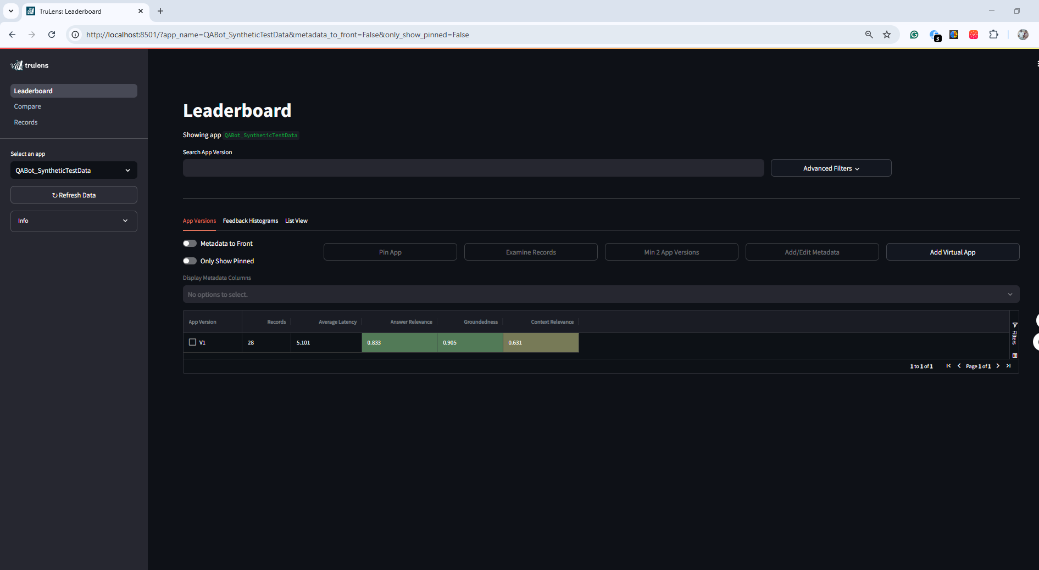

Examine Records

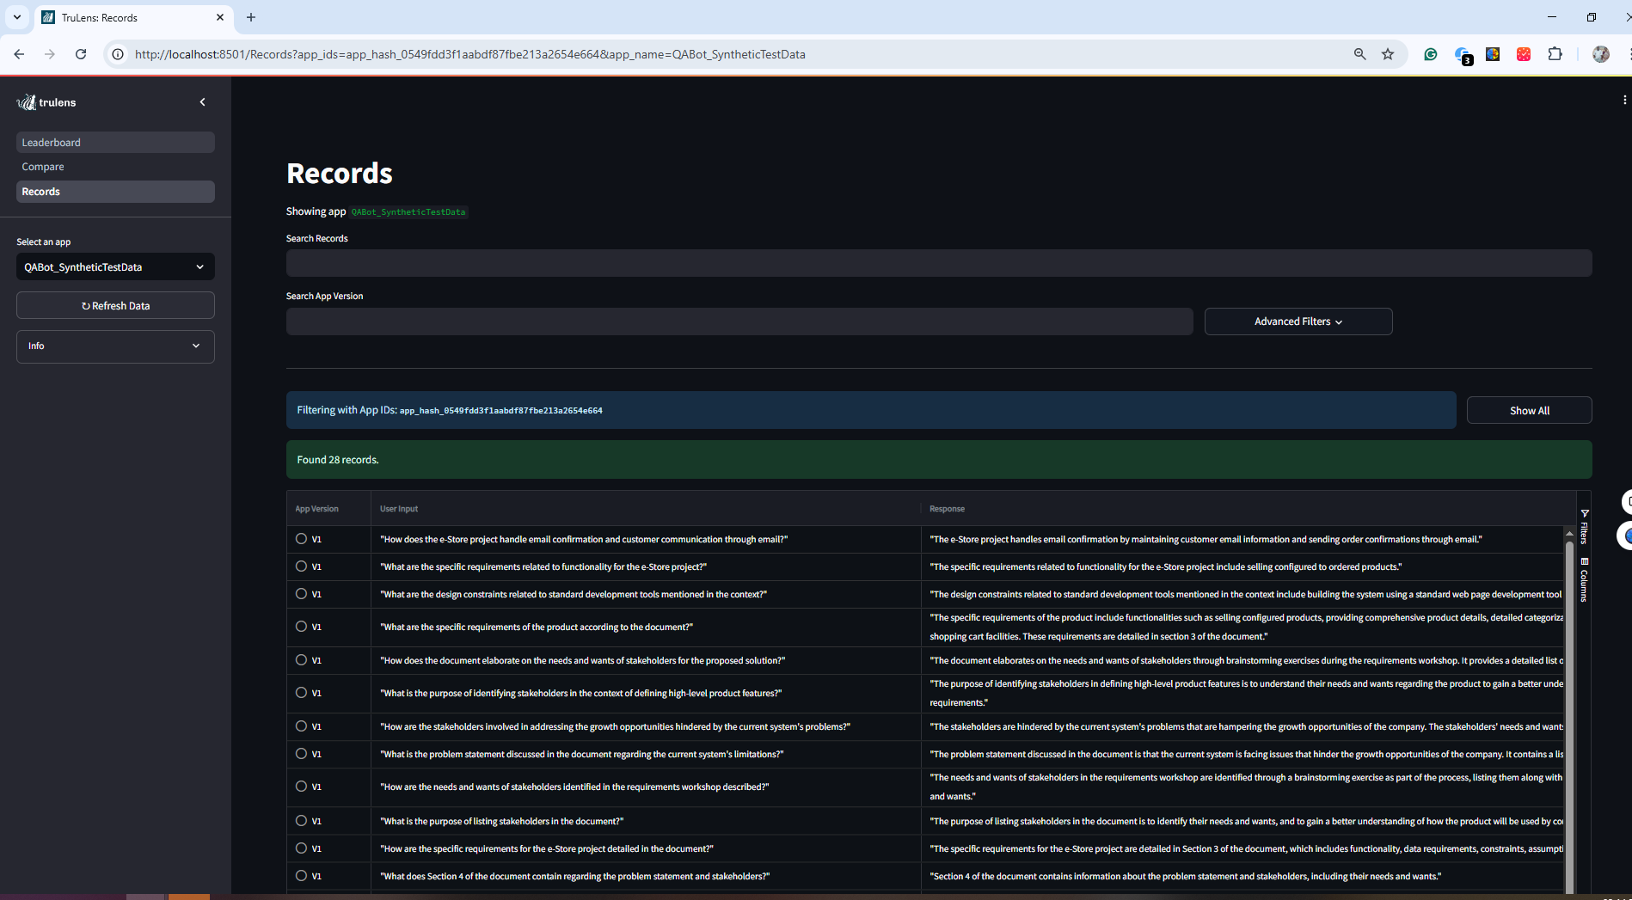

Details about traces and statuses
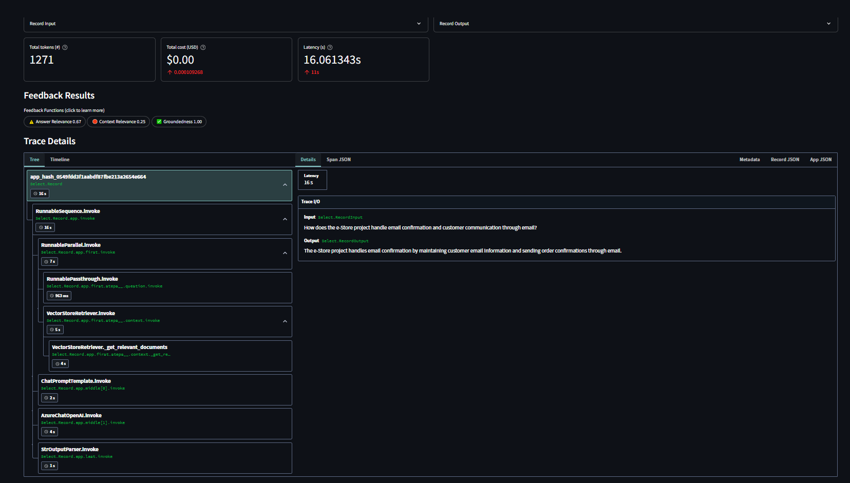
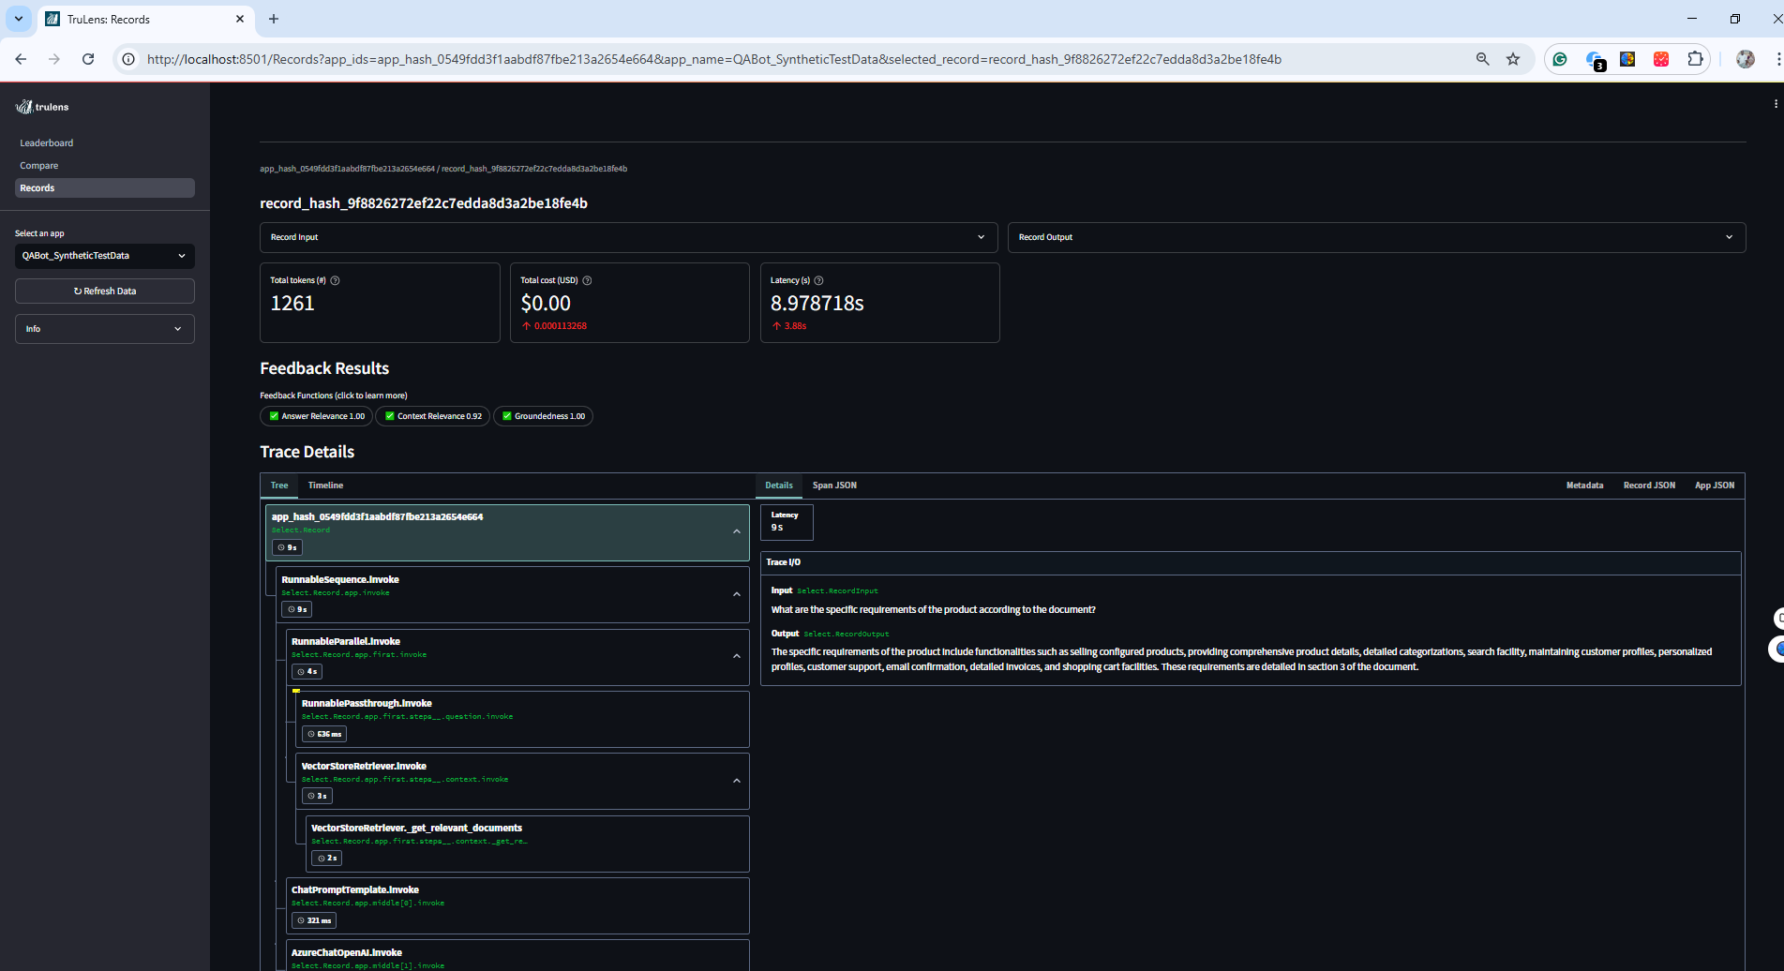

RAG Triad Metrics
