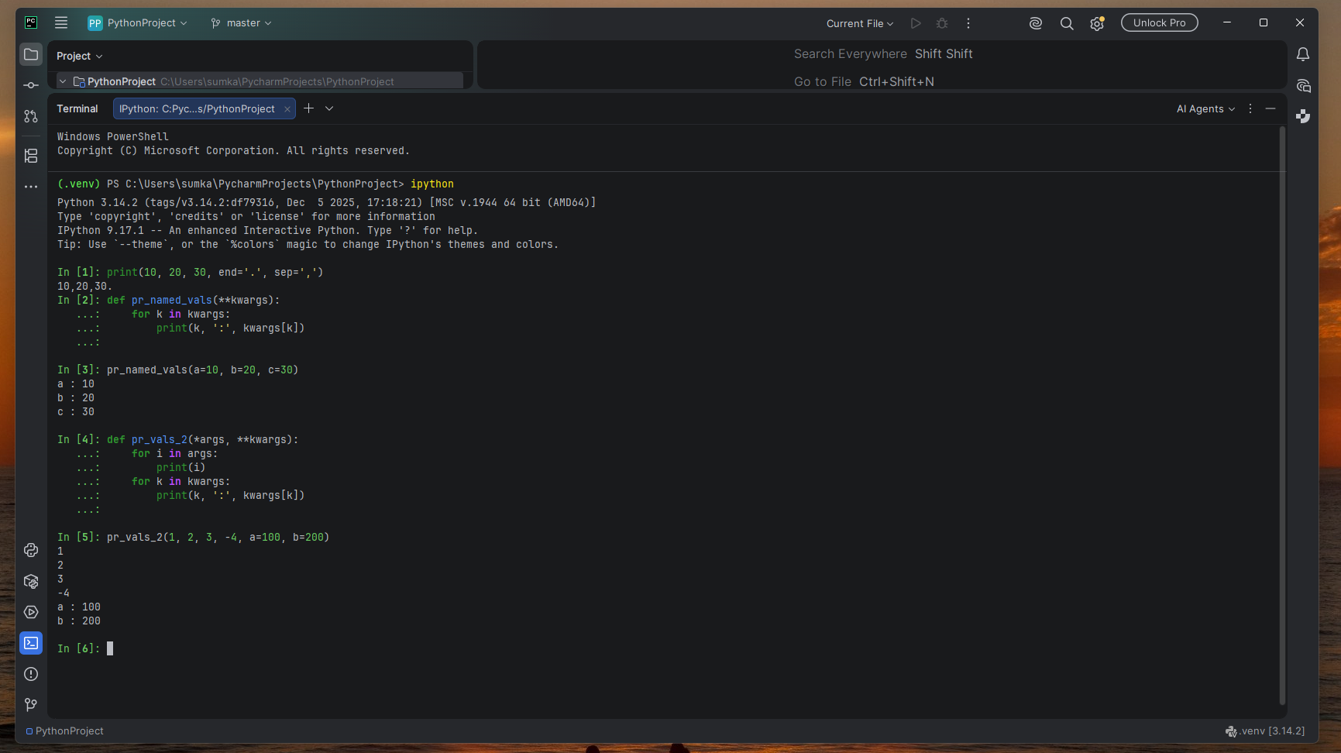
Advantages of using **kwargs
- It makes functions more flexible because different keyword arguments can be passed depending on what is needed.
- It allows a function to accept any number of names arguments without having to list every possible argument in the function definition.
- The keyword arguments are stored in a dictionary, which makes it easy to access both the argument names and their values.
Disadvantages of using **kwargs
- Misspelled keywords arguments may be harder to notice because it can accept names that were not specifically defined.
- Using too many keyword arguments can make a function more complicated and harder to debug or maintain.
- It can make a function harder to understand because the expected arguments are not always obvious from the function definition.

