Summer Daley
9/2/2026

Error: 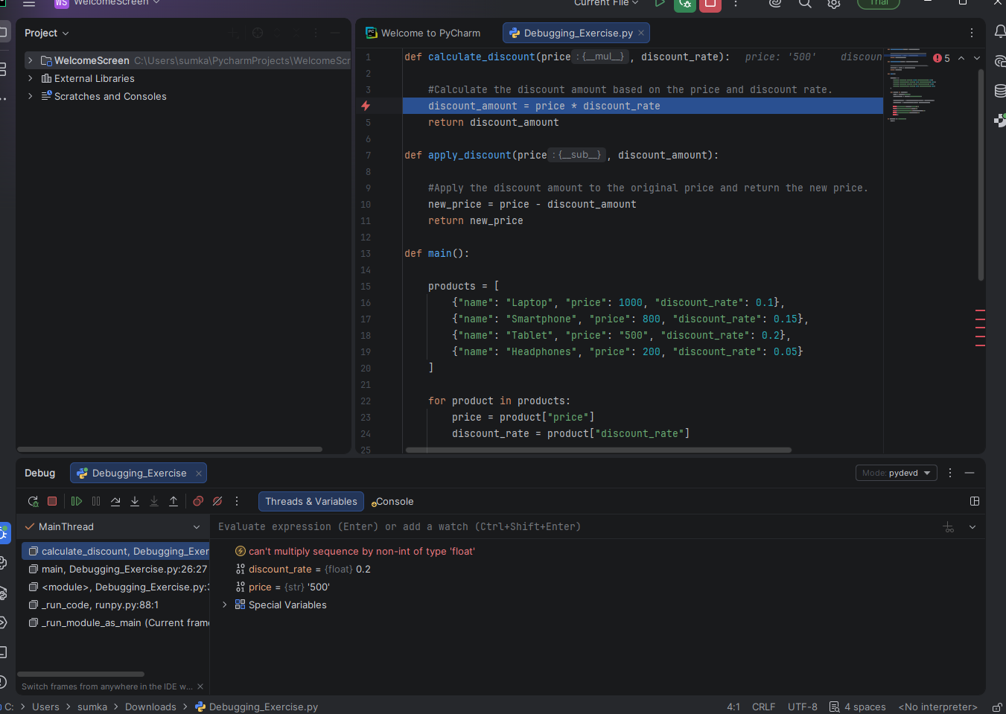
Fix: 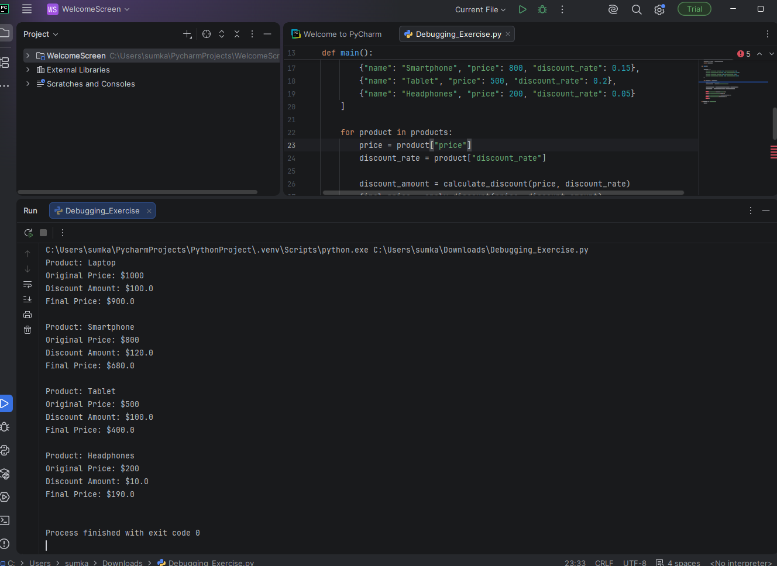
Explanation: The error occurred because when I ran the debugging it showed the error being because it can’t multiply sequence by non-int of type ‘float’ and showed the Tablet price of 500 and 0.2. When I looked at that section, I realized that the 500 price was in quotation marks which was making it a string and the discount rate is a float. You can’t multiply a string and a float so I took off the quotations from the 500 to fix the error.

