Stephen D’Amico

CMPEN 473

Homework 7 Report

3/29/2021

**Note**: I had to remove the gyroscope readings from my program because the function from the header file would stop reading data at a random time throughout the program causing my program to get stuck.

**Introduction**

This reports pertains to readings from an IMU that was mounted on a car. The car had three modes (m0, m1, m2). M0 mode recorded readings from the IMU at 20 readings per second. M1 mode gave the user manual control of the car using a keyboard and recorded IMU readings at 20 readings per second. In m2 mode, the car self-drove around a track made of electrical tape while recording IMU readings at 20 readings per second. The commands that are valid in each mode are displayed to the user when the program starts. IMU readings were saved to a text file depending on what mode you were in (three different text files).

**M0 Charts**

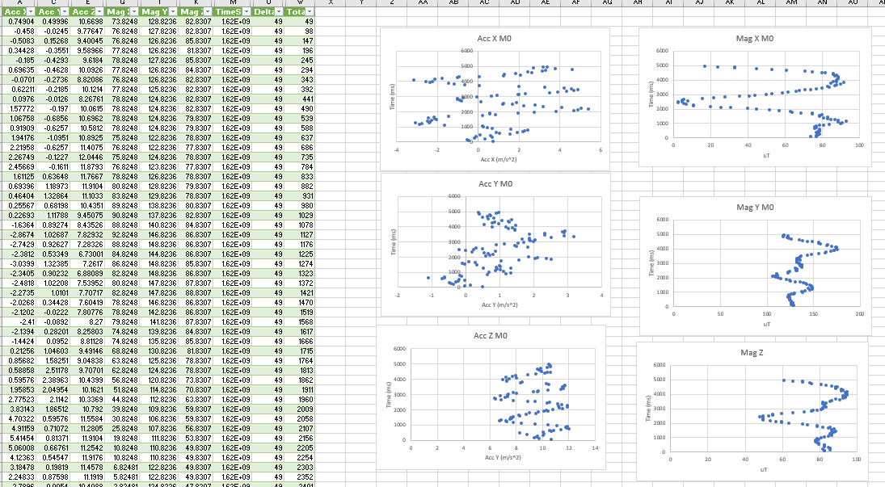Figure 1: Dot plot for each IMU reading for m0 mode (moving car up/down/left/right with hand)

**M1 Charts/Calculations**

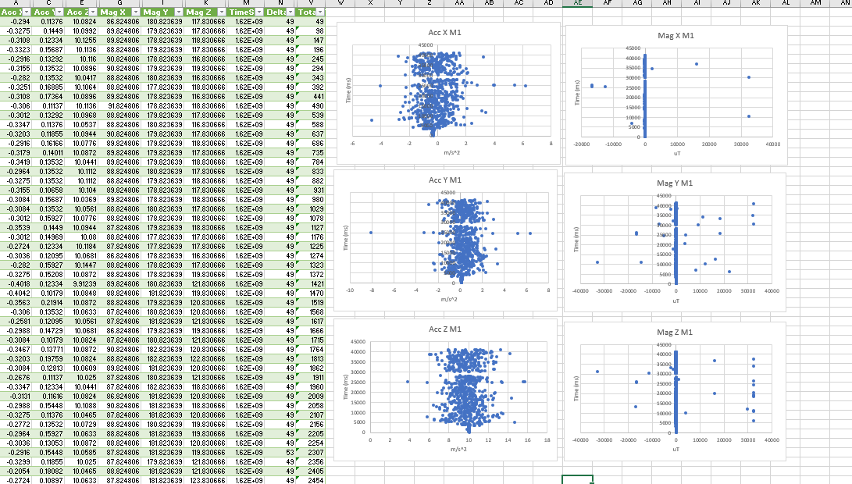Figure 2: Dot plot of each IMU reading for M1 mode

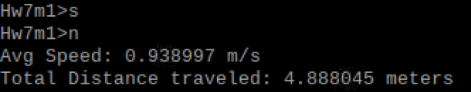

Figure 3: Avg Speed and Distance Calculation for M1 Manual Control Mode, command “n”

These values make sense because I would estimate the car went an average speed of 2.5mph while I was manually controlling it and around 15 feet, which corresponds to these readings in their respective units.

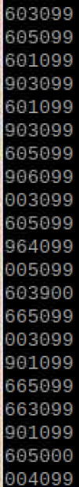

Figure 4: “p” command for m1 to display IMU readings

**M2 Charts/Calculations**

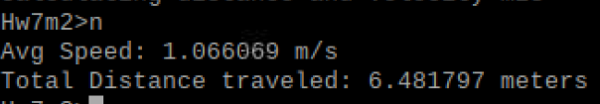

Figure 5: Average speed and distance calculations for m2 self-driving mode, command ‘n’

These readings for average distance and speed seem to be about right. They are somewhat inaccurate due to the accelerometer small reading values due to noise while the car was not accelerating.

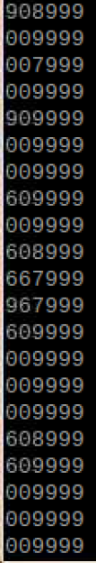

Figure 6: “p” command for m2 self-driving mode to display IMU readings

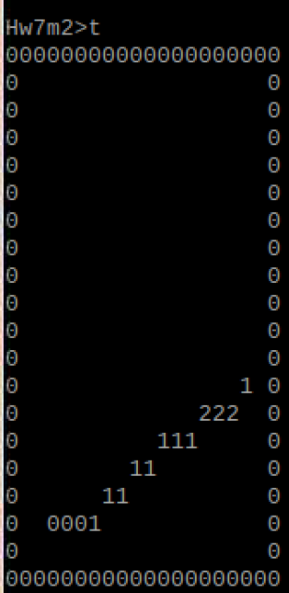

Figure 7: “t” command to display the map in self-driving mode

I struggled with the map. I was able to get the speed readings correct but the map is incorrect. I calculated the total x and y distances every second and used these to create the map. This was still difficult likely due to inaccurate readings at times.

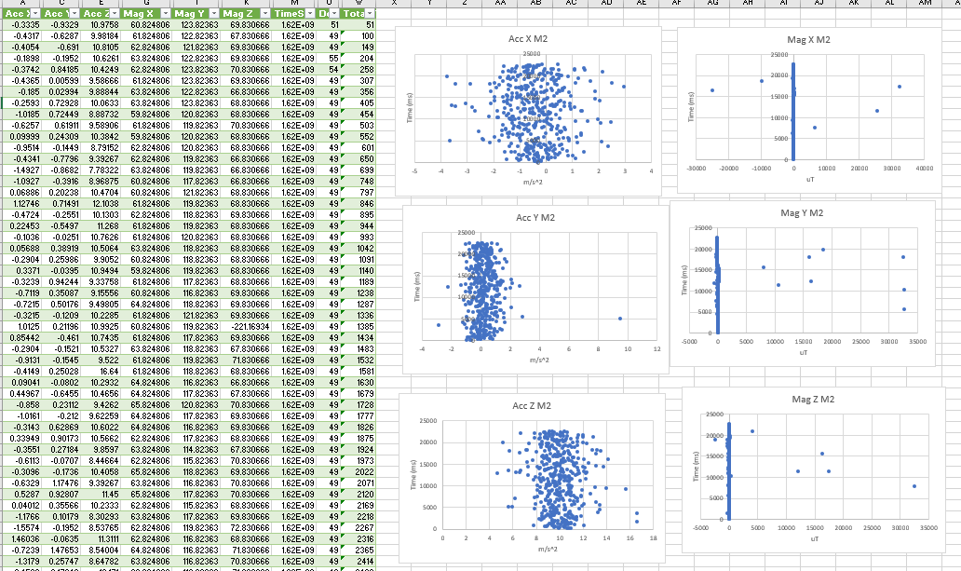Figure 9: Dot plot for each IMU Reading for M2 Mode

**Summary/Other information**

From analyzing the dot plots, we can see that the accelerometer’s y value was centered around 10m/s which shows that these readings were accurate (earth’s gravity is 9.8 m/s). In M1 mode, we see a slightly larger range of values from the Y acceleration, which makes sense because while I was manually driving the car, I made more turns than while the car was in self-driving mode. There are some outliers in all the charts which tells us that these readings were not 100% accurate and this could be reflected in the speed and distance calculations. The X acceleration for m2 had a smaller range than for m1 because the car sped up and slowed down more while I was manually driving as opposed to when it was self-driving around the track. I included the m1, m2, and m0 output text files with the readings that I plotted in this report in the zip file for this project. I also included the excel file where I created these plots.