Student Management System using Java and MySQL

# 1. Objective

The objective of this project is to build a console-based Student Management System using Java and MySQL. It performs basic CRUD operations on a 'students' table through JDBC connectivity, allowing users to add, view, update, delete, and fetch student records.

# 2. Technologies Used

- Java 17

- MySQL 8+

- JDBC API

- IntelliJ IDEA

- MySQL Connector/J (mysql-connector-j-9.3.0.jar)

# 3. System Requirements

- Java JDK 17

- MySQL Server

- MySQL JDBC Driver

- IDE (e.g., IntelliJ IDEA, Eclipse)

# 4. Project Structure

- Project2.java: Main class with full functionality

- Project.iml, misc.xml, modules.xml, workspace.xml: IntelliJ IDEA project files

- mysql-connector-j-9.3.0.jar: JDBC driver used for MySQL connection

- Screenshot.png: Sample output image

# 5. Functionality

1. Add Student(s)

2. View All Students

3. Update Student Age

4. Delete Student by ID

5. View Student by ID

0. Exit the program

# 6. Database Schema (students table)

CREATE TABLE IF NOT EXISTS students (  
 student_id INT PRIMARY KEY,  
 name VARCHAR(50),  
 email VARCHAR(100) UNIQUE,  
 age INT,  
 department VARCHAR(50),  
 city VARCHAR(50)  
);

# 7. Code Overview

- JDBC driver is loaded using Class.forName.

- Connection to MySQL is made via DriverManager.

- CRUD operations use Statement and PreparedStatement for execution.

- Data is displayed using ResultSet.

- Table is created dynamically if not exists.

# 8. Sample Output

Below is a sample menu and console output during program execution:

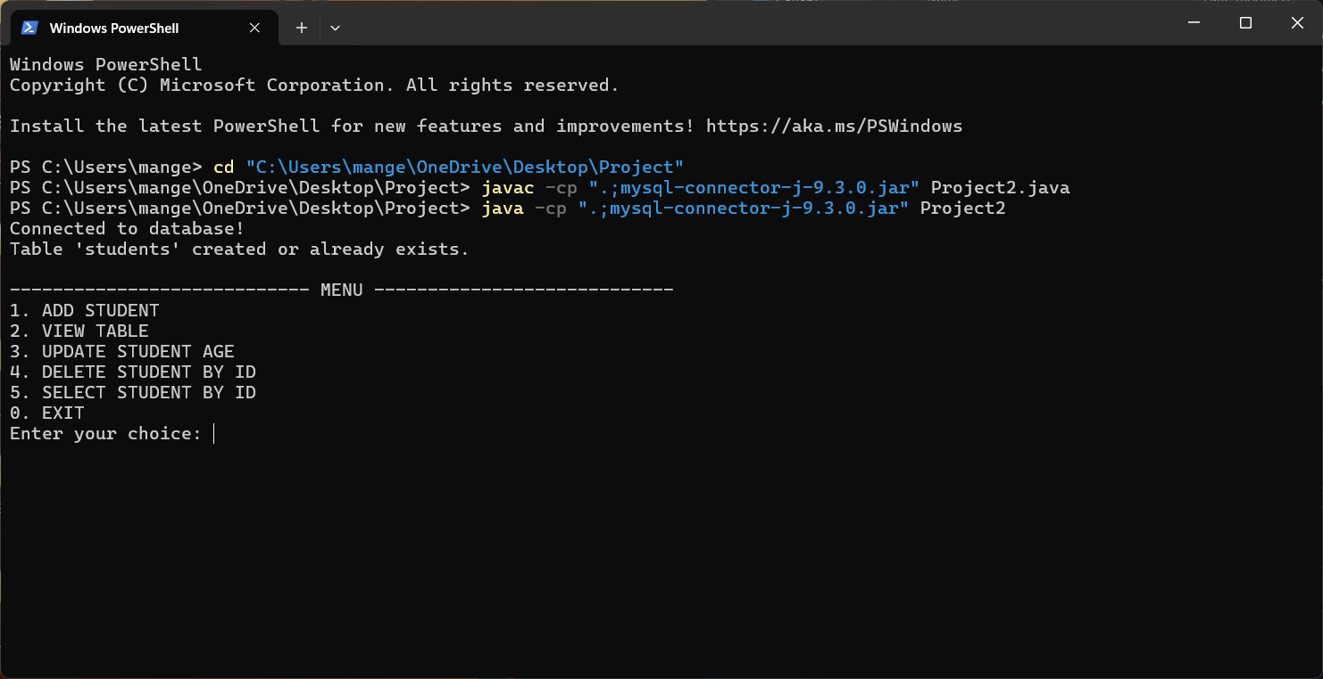

# 9. Conclusion

This project demonstrates the integration of Java and MySQL using JDBC, providing a fully functional student management system. The code structure is modular and can be easily extended to include additional features like GUI, validation, and data export.