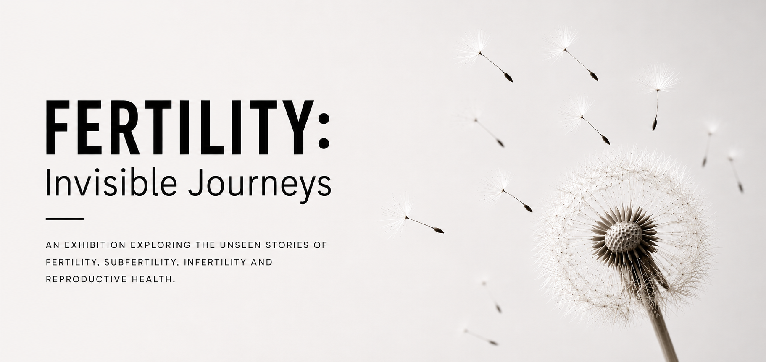

Submission Guidelines & Terms and Conditions
An exhibition exploring the unseen stories of fertility, subfertility, infertility and reproductive health.

THE EXHIBITION
Stories that deserve to be seen.
Fertility: Invisible Journeys is an open exhibition that invites artists and creatives based in London, the South East and East of England to explore the diverse realities of fertility and reproductive health. We welcome work that reflects the biological, emotional, social, cultural, and environmental dimensions of fertility, helping to raise awareness, encourage conversation, and reduce stigma.
We encourage diverse interpretations of these themes and welcome work that challenges assumptions, sparks dialogue, and promotes greater understanding.

Themes
- Fertility, subfertility and infertility
- Assisted reproduction and fertility treatment
- Pregnancy loss and reproductive grief
- Reproductive health and wellbeing
- Environmental and societal influences on fertility
- Personal lived experiences of subfertility and infertility

WHO CAN APPLY?
All perspectives are welcome.
- Visual artists
- Digital and mixed-media artists
- Sculptors
- Textile artists
- Printmakers
- Individuals with lived experience
No previous exhibition experience is required.

ACCEPTED MEDIA

What you can submit.
- Painting
- Photography
- Drawing
- Printmaking
- Sculpture
- Textile art
- Mixed media
- Short film
- Personal narrative / lived experience account*

*Personal narrative / lived experience account - a first-person account, reflection or story drawn from the artist's own experiences of fertility, subfertility, infertility or reproductive health. This may take the form of memoir, creative non-fiction, personal essay, poetry or another written format.

SELECTION PROCESS
How works will be selected.
- A five-member selection committee will select the works for the exhibition.
- The committee will comprise practising artists, gallery staff and individuals with lived experience of subfertility.
- The committee brings together artistic, curatorial and lived experience perspectives.
- The selection process will be conducted on a blind basis, with identifying information removed from submissions where reasonably practicable.

SUBMISSION & ARTIST COMMITMENT

What selected artists need to commit to:
- Selected artists must be able to deliver and collect their work in person.
- Work must be delivered to Oaklands Social on Saturday 14 November, from 10am to 2pm.
- Selected artists will be asked to help with 1–2 half-days of invigilation from 10am to 2pm.

KEY DATES

Submission and exhibition timeline.
- Submission deadline Friday 9 October 2026, 23:59
- Notification of selection Sunday 18 October
- Delivery of work Saturday 14 November, 10am–2pm
- Install date Sunday 15 November
- Exhibition Monday 16 November – Saturday 28 November
- Private view Thursday 19 November, 5 to 8 pm
- Take down and collection of work Sunday 29 November

VENUE

Oaklands Social – Bow Arts
Oaklands Social, Oaklands House, Old Oak Common Lane, London, NW10 6DU
- Nearest station(s): North Acton (Underground), Willesden Junction (Overground/Underground)
- Bus: 260, 266, 440, 487, BL-1, BL-2
- Parking: No Parking
- Bike: Yes

TERMS & CONDITIONS

1. Eligibility
- The open call is open to the applicant groups and perspectives described in these guidelines who are based in London, the South East and East of England.
- No previous exhibition experience is required.

2. Submission
- Submissions should respond to the exhibition themes and use one of the accepted media listed above.
- Artists may submit a maximum of two artworks, with a maximum of five images across both artworks. Each image must be no larger than 5 MB.
- Each file submitted must be named using the following format:
NameSurname_TitleOfWork_Year.jpg
- All wall-based or 2D artworks must be framed and ready for installation. Exceptions may be considered at the discretion of the organising team where the nature of the artwork requires an alternative method of presentation. Artists should clearly state any specific framing, mounting or installation requirements in the application form.
- Short films should be no longer than 10 minutes. Artists will be responsible for providing any specialist equipment required for playback unless otherwise agreed with the organising team.

3. Selection
- Works will be selected by a five-member selection committee.
- The committee comprises practising artists, gallery staff and individuals with lived experience of subfertility.
- Selection will be based on the work’s thematic relevance to the exhibition, as well as its suitability in terms of scale and dimensions for display within the gallery.
- The selection process will be conducted on a blind basis. Identifying information will be removed from submissions before they are shared with the selection committee, where reasonably practicable.
- The decision of the selection committee is final and we are unable to offer feedback.
- Selection does not guarantee inclusion if the artwork materially differs from that presented during the application process or does not meet the requirements of the exhibition.

4. Size
- All 2D works must be no larger than A2.
- Sculptural work must not exceed 100 cm in any dimension.
- Artists will need to provide their own plinths for sculptural work.

5. Delivery and deinstallation
- Selected artists must be able to deliver and collect their work in person.
- Delivery is scheduled for Saturday 14 November, from 10am to 2pm, at Oaklands Social.
- Collection will take place on Sunday 29 November at the same location from 10am to 2pm.

6. Installation and safety
All submitted work must be safe and suitable for public exhibition. The organising team reserves the right to decline the installation or display of work where it considers that the work presents a health, safety, accessibility or practical installation concern.

7. Transport and responsibility for artwork
- Artists are responsible for the safe transportation of their work to and from the exhibition venue.
- Artists should ensure that their work is appropriately packaged and protected during transport.

8. Collection of artwork and uncollected work
- Artists are responsible for collecting their work from the venue on the specified collection date.
- The organising team cannot guarantee storage of works after the collection date.
- Any alternative collection arrangements must be agreed with the organising team in advance.

9. Content and safeguarding
- Artists must identify any potentially sensitive, distressing or explicit content in their application in the “Notes on artwork” section of the submission form.
- The ublicizin team reserves the right to determine how such work is displayed and whether appropriate content information or warnings are required.

10. Exhibition
- Selected works will be exhibited at Oaklands Social – Bow Arts during the dates specified from 10am to 2pm.
- Selected artists will be asked to undertake 1–2 half-days of invigilation during the exhibition, from 10am to 2pm.

11. Costs
- This is a self-funded, not-for-profit project.
- There is no fee to participate in the exhibition.
- No commissions are taken for any sales you make.
- Artists are responsible for managing any sales of their work, including setting prices, arranging payment and fulfilling any sale following the exhibition.
- Artists are responsible for any costs associated with the creation, framing, packaging, transportation, installation, sale and collection of their work unless otherwise agreed with the organising team.
- The organising team will not be responsible for costs incurred by artists in connection with participation in the exhibition, including materials, framing, insurance, transport, travel or accommodation.

12. Insurance
- Artists are responsible for arranging appropriate insurance for their artwork and public liability cover. Proof of appropriate insurance will be requested if selected.
- Artists are responsible for ensuring that their work is appropriately insured against loss or damage during transportation and exhibition.
- Artists will be asked to complete a short risk assessment for the venue.

13. Copyright, reproduction and promotional image permissions
- By accepting selection for the exhibition, the artist grants the ublicizin team a non-exclusive, royalty-free licence to photograph, reproduce and publish images of their submitted artwork for the purposes of documenting, promoting and ublicizing the exhibition. This includes, but is not limited to, use on the exhibition website, social media platforms, press materials and other promotional communications. The artist will be credited wherever reasonably practicable.
- Where an artwork contains identifiable individuals, third-party images, music, text or other copyrighted material, artists are responsible for obtaining any necessary permissions and consents.

14. Ownership and originality of artwork
- Artists confirm that they are the creator and rights holder of the submitted work, or have obtained all necessary permissions to submit and exhibit it.
- Artists are responsible for ensuring that their work does not infringe the copyright, intellectual property or other rights of any third party.

15. Changes or cancellation of the exhibition
- Artist withdrawal: Selected artists must notify the organising team as soon as possible if they are no longer able to participate. The organising team reserves the right to withdraw an artist's work if agreed submission, delivery or installation requirements are not met.
- Cancellation or postponement: The organising team reserves the right to cancel, postpone or make reasonable changes to the exhibition, including to the dates, venue, format or participating artists, where circumstances beyond its reasonable control make this necessary.
- Unforeseen circumstances: If the exhibition is cancelled or postponed due to circumstances beyond the organising team's reasonable control, selected artists will be notified as soon as reasonably practicable.
- No guarantee of exhibition: Selection does not guarantee that the exhibition will proceed or that selected work will be exhibited for the full advertised exhibition period where circumstances beyond the organising team's reasonable control prevent this.

16. Data protection / use of application information
- Personal information provided as part of the application will be used for the purposes of administering the open call, contacting applicants, organising the exhibition and managing participation.
- Personal information will be handled in accordance with applicable data protection legislation.

