docker ps

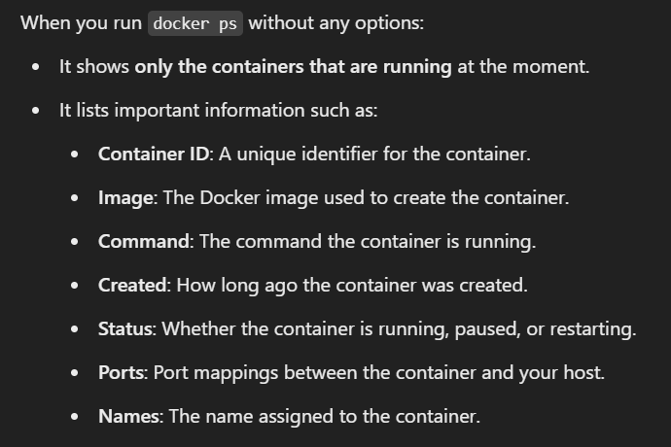

docker exec -it <CONTAINER ID> bash

psql -U postgres

