
2025 ERCOT System Planning
Long-Term Hourly Peak Demand and Energy Forecast
April 08, 2025

Executive Summary

The 2025 Long-Term Demand and Energy Forecast (LTDEF) for the ERCOT region is presented in this report, which includes information about the methodology, assumptions, and data used to create the forecast. The LTDEF is comprised of six forecast components: Economic Base Load Forecast, Electric Vehicle Forecast (EV), Behind the Meter Rooftop Photovoltaic Forecast (PV), Large-Flexible Load Forecast (LFL), Large Load Contracts, and Large Load Officer Letters. The LTDEF uses the waterfall method to combine each forecast to create the ERCOT Net Forecast. This document will break down how each forecast is derived and the impact to the system outlook and peaks.

Base Economic Load Forecast

This forecast is based on a set of econometric models describing the hourly load in the region as a function of the number of premises in various customer classes (e.g., residential, business, and industrial), weather variables (e.g., various temperature values), and calendar variables (e.g., day of week and holidays) to create the base load forecast. The premise forecasts that drive growth in the base forecast are created using a set of econometric autoregressive models (AR1) and are based on certain economic (e.g., non-farm payroll employment, housing stock, and population) data. A county-level forecast of economic and demographic data was obtained from Moody’s.

The Base Economic Load Forecast was produced with a set of linear regression models that combine weather, premise data, and calendar variables to capture and project the long-term trends extracted from the historical load data. Premise forecasts were also developed.

All model descriptions included in this document should be understood as referring to weather zones. The ERCOT forecast is calculated as the sum of all weather zone forecasts.

ERCOT consists of eight distinct weather zones (Figure 1). Weather zones represent a geographic region in which climatological characteristics are similar. Each weather zone has two or three weather stations that provide data for the assigned weather zone. To reflect the unique weather and load characteristics of each zone, separate load forecasting models were developed for each of the weather zones.

Premise Forecast Models for Base Economic Forecast

Figure 1: ERCOT Weather Zones

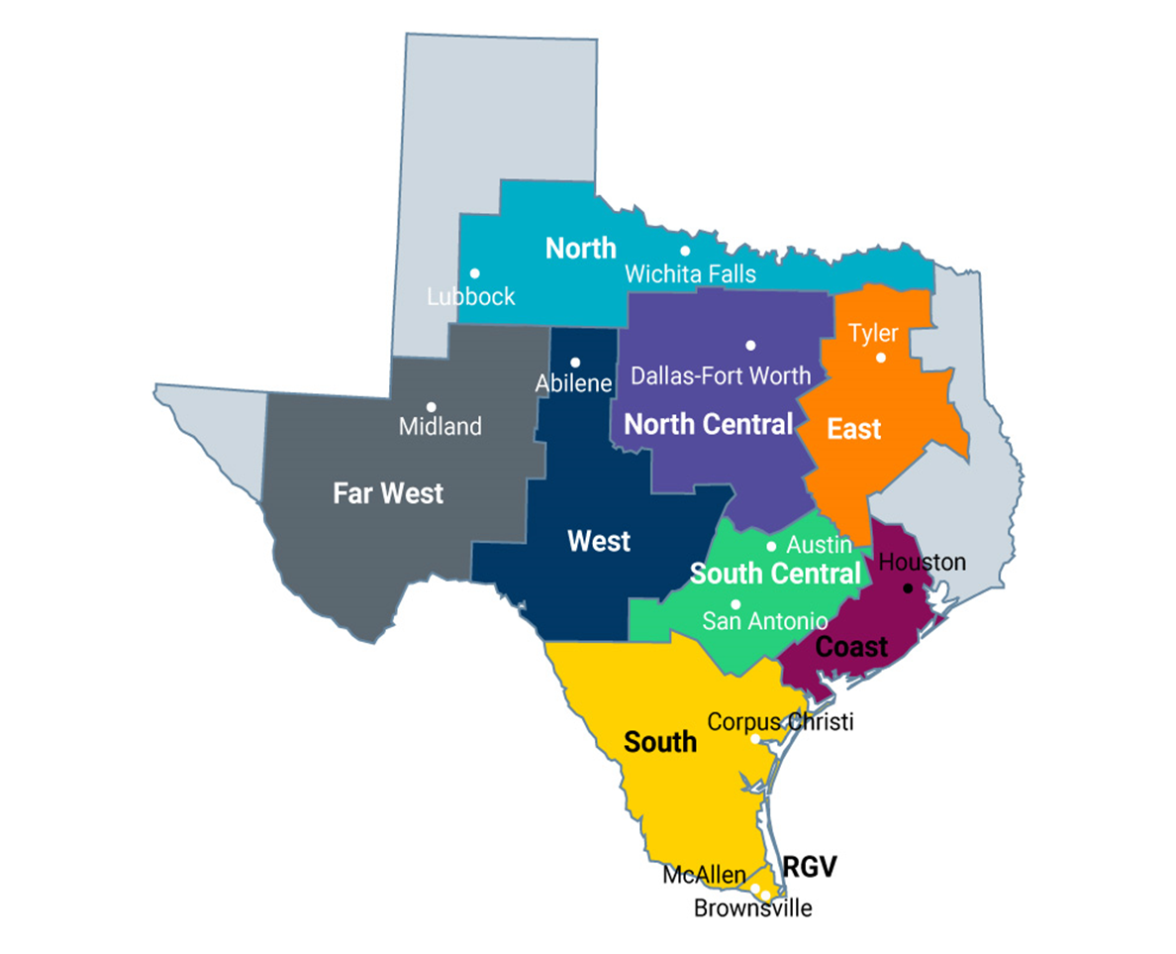

The key driver of the forecasted growth of demand and energy is the number of premises. County-level economic data was used to capture and project the long-term trends extracted from the historical premise data. County-level data was mapped into the weather zones (Figure 1).

Premises were separated into three different customer classes for modeling purposes:

- Residential (including lighting)
- Business (small commercial)
- Industrial (premises which are required to have an IDR meter)

All premise models were developed using historical data from January 2018 through May 2024. An autoregressive model (AR1) was used for all premise forecasts.

Residential, business, and industrial premise counts were modeled by estimating a relationship for each of the eight ERCOT weather zones between the dependent variable (residential, business, and industrial premises, respectively) and the following:

- Housing Stock
- Population
- Non-Farm Employment

Residential Premise Forecast

Residential premise counts were modeled by estimating a relationship for each of the eight ERCOT weather zones between the dependent variable (residential premises), and the above variables.

Business Premise Forecast

Business premise counts were modeled by estimating a relationship for each of the eight ERCOT weather zones between the dependent variable (business premises) and the above variables.

Industrial Premise Forecast

Industrial premise counts were modeled by estimating a relationship for each of the eight ERCOT weather zones between the dependent variable (industrial premises), and the above variables.

Electric Vehicle Forecast

The ERCOT Electric Vehicle Forecast was derived using a modeling tool that identifies primary use cases (vehicle weight class) using Texas registration data and assigns these vehicles to a given substation and location. The current number of vehicles in each class and the relative rate of EV adoption is then used to calculate the number of forecasted EVs. ZIP code level vehicle projections are converted to substation level projections based on non-coincident peak load of each substation. EV load profiles for each substation are generated by season/day.

Table 1 shows the forecasted maximum EV demand, by year.

Table 1: EV Peak Charging

EV Load (MW) Peak Charging
Year | EV Load (MW)
2025 | 474
2026 | 636
2027 | 851
2028 | 1130
2029 | 1507
2030 | 2006
2031 | 2641

Behind the Meter Rooftop Photovoltaic (PV) Forecast

The Behind the Meter Rooftop Photovoltaic Forecast was generated by customer class (Residential or Business) at the weather zone level. Usage per customer was modeled to create a typical profile of rooftop solar using weather and calendar drivers, specifically solar irradiance because it captures solar generation well. The modeling dataset contains historical weather and calendar data from January 2012 to July 2024. Recent growth rates that decline over time were used to generate the customer class forecast. The assumed installed capacity in 2031 was 8,027 MWh and the forecasted solar maximum generation was 6,049 MW.

Table 2: Rooftop PV Scenarios

Year | PV Max | PV on Summer Peak
2025 | -1203 | -737
2026 | -1627 | -1000
2027 | -2171 | -1340
2028 | -2860 | -1773
2029 | -3719 | -2315
2030 | -4773 | -2083
2031 | -6049 | -2410

Large Flexible Forecast

Large Flexible Loads are a new type of load that has been growing rapidly in the ERCOT service territory. This load can come online quickly and is very responsive to real time prices. Large Flexible Loads are categorized as:

1. Co-located, meaning that the load is behind existing generation
2. Non-co-located, meaning that the load is not behind existing generation

There is approximately 3,700 MW of LFLs on the ERCOT system. The LFL Forecast is derived using a linear model driven by seasonal variables and observed LFL behavior. The LFL pattern (Figure 2) indicates a reduction to 50% over the coincident peak hours for the months of June, July, August, and September and to 15% over the net-load peak hours for the months of June, July, August, and September.

Figure 2: LFL Summer Daily Profile

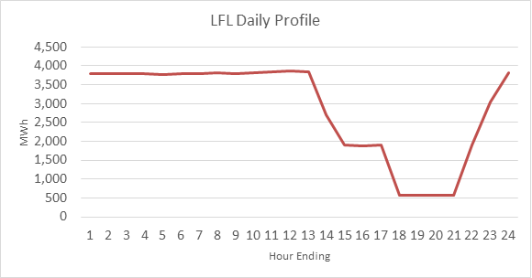

Transmission System Providers-Provided Large Load Additions

Figure 3: Large Load by Type
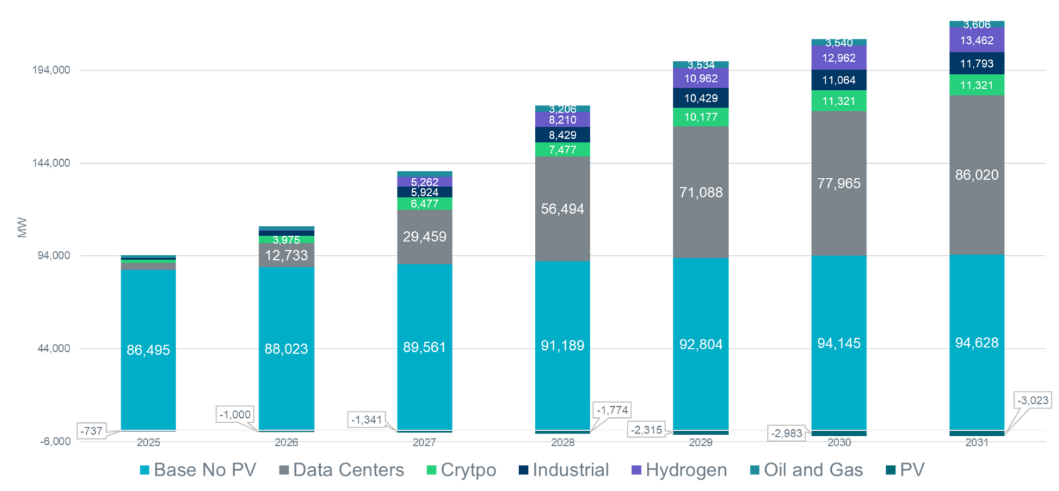

To provide information that best suits the growing needs of ERCOT studies and policies, ERCOT created a process to request up-to-date information from Transmission System Providers (TSPs) regarding proposed Large Load requests. To this report, these Large Load requests are broken down into two categories: Contracts and Officer Letters. Contracts are defined as prospective loads with a signed agreement from all parties and a financial commitment in place. Officer Letters are defined as a request without a signed agreement but the TSP attests to the viability of the request in a letter between an officer of the TSP and an officer of ERCOT.

TSPs provided Contracts and Officer Letters via a Request for Information (RFI). ERCOT applied forecast adjustment factors to these projections based on recent actual observations of Large Load projects. The Large Loads can generally be categorized in the following types of end uses:

- Hydrogen: Hydrogen in this context refers to hydrolysis plants that use electricity to turn water into hydrogen and oxygen.
- Data Centers: Data Centers are facilities designed for cloud storage and computing. They can also be designed for artificial intelligence training.
- Crypto: Crypto refers to certain data centers mines cryptocurrency that uses Graphics Processing Units to solve Blockchain equations.
- Oil and Gas: Oil and Gas refers to oil and natural gas exploration and recovery operations.
- Industrial: Industrial in this context refers to large manufacturing plants and other facilities that do not fall into one of the categories above.

ERCOT has produced two forecasts based on all the TSP-provided large loads. The first includes the Large Load projections as ERCOT received from the TSPs. This forecast can be found on the ERCOT Load Forecasting website under "TSP Provided Large Load Forecast". The second is an adjusted forecast based on observation of behavior and characteristics of these loads, including average project delay, load profile by type, and average project realization. This forecast is posted on the ERCOT Load Forecasting website as "ERCOT Adjusted Large Load Forecast" and will serve as the focus of this report.

ERCOT’s Adjustment to Large Load Forecast

Figure 4: ERCOT’s adjusted summer peak forecast
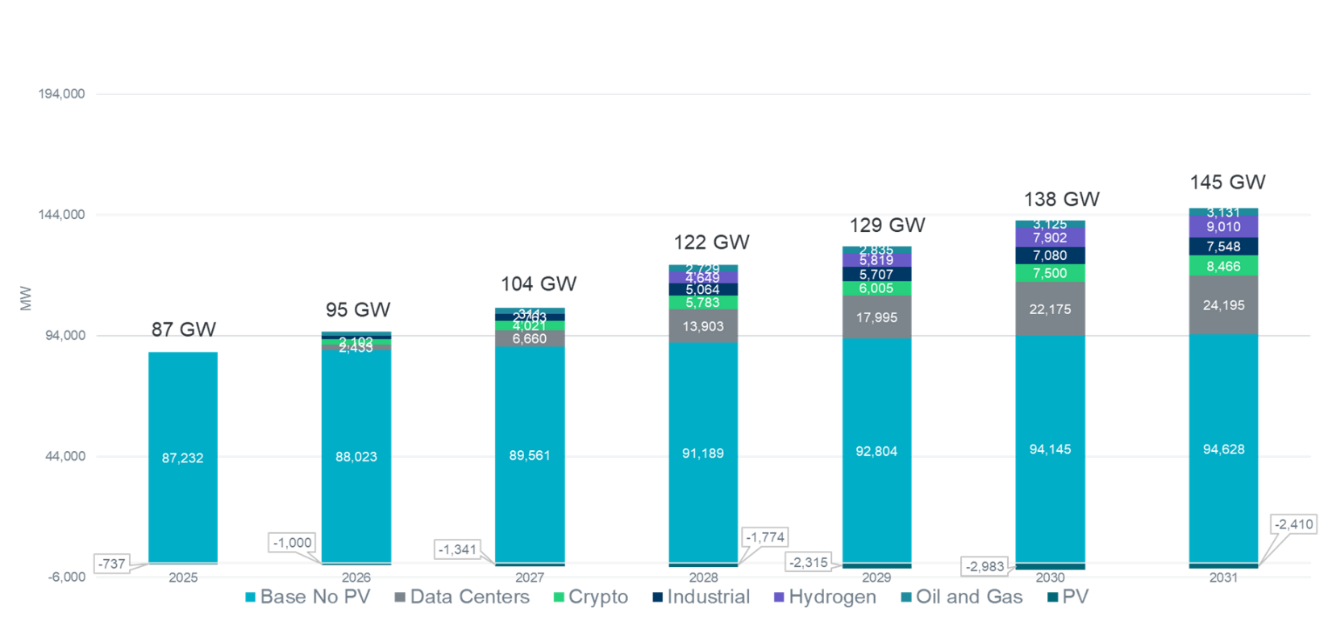
Definitions
- TSP Provided Large Load Forecast: All Contracts and Officer Letter Large Load additions were based on the ramp schedules and MW size that the TSPs provided.
- ERCOT Adjusted Load Forecast: Assumes 180 Day Delay to ramp schedules of Contracts and Officer Letter Large Load additions with Data Center Large Load additions reduced to 49.8% then Officer Letter Large Load additions reduced to 55.4%.
ERCOT adjusted the Large Load projections provided by the TSPs based on the patterns observed by recent projects. The first adjustment was based on the average project delay of 180 days from the original project requested energization date for projects with in-service dates in 2022 through 2024.

The next adjustment was applied to Data Centers. ERCOT studied requested MWs versus the peak consumption by Data Center site for Data Centers with in-service dates in 2022 through 2024. The average peak consumption
per site was 49.8% of the requested MW. This factor was applied to all non-crypto Data Center Load additions.

The final adjustment used the percentage of previously filed Officer Letter projects with in-service dates in 2024 that have energized (55.4%). This percentage is based on percentage of loads energized, not a ramp rate or current MWs consumed.

*The adjustment factors in this methodology will be updated to reflect observed performance as new Contracts and Officer Letter Large Loads are energized.

Figure 5: ERCOT Summer Peak Demand Forecast

As shown in Figure 6, historical annual energy for the calendar years 2014-2024 grew at an average annual growth rate (AAGR). of 3.1%. The forecasted AAGR for energy from 2025-2031 is 13.6%.

Figure 6: ERCOT Annual Energy Forecast

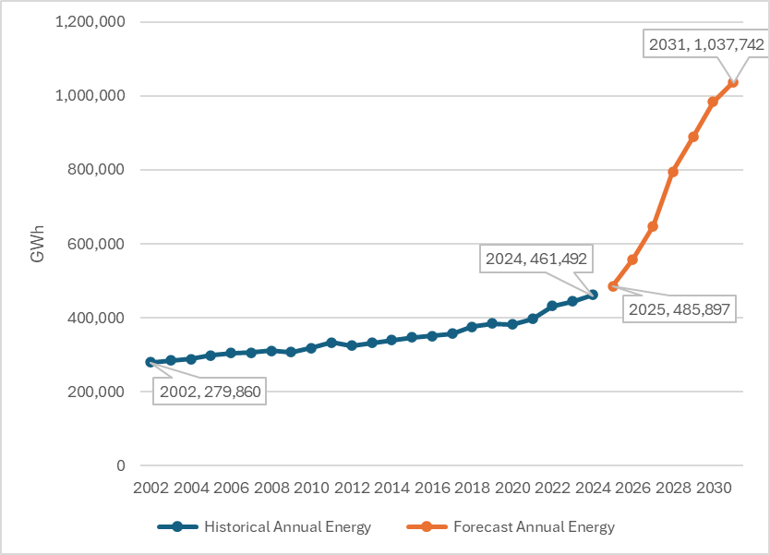

Waterfall Methodology

The method used to create the ERCOT net forecast is a waterfall approach that sequentially combines individual components of the forecast. The purpose of using the waterfall approach is to allow the ability to provide forecasts for many scenarios. The waterfall method allows discovery and insight on changes to the ERCOT system by examining individual components. Reconstitution was also used for the Behind-the-Meter Rooftop PV forecast to avoid double counting load. This is made possible by adding historical PV observations back to the native load before modeling occurs. Figure 6 demonstrates the waterfall method by appending the six major forecasts one at a time to create the ERCOT Winter Coincident Net Forecast.

As shown in the following formula, the LTDEF net forecast is the sum of base load, EV load, LFL forecasts, Contracted loads, and Officer Letter load ramps, less the Behind-the-Meter Rooftop PV forecast.

Net Forecast = Base Economic Forecast + EV Forecast + LFL Forecast + Adjusted Contracts + Adjusted Officer Letters – PV Forecast

Hourly Demand Models

The long-term trend in hourly demand was modeled by estimating a relationship for each of the eight ERCOT weather zones between the dependent variable (hourly demand) and the following:

- Month
- Day of Week
- Hour
- Weather Variables
  - Temperature including various lagged values
  - Temperature squared including various lagged values
  - Temperature cubed including various lagged values
- Interactions
  - Day of Week and Temperature variables
  - Hour and Day of Week
  - Hour and Temperature variables
  - Month and Temperature variables
- Number of premises
All the variables listed above are used to identify the best candidates for inclusion in the forecast models and to provide details on the types of variables that were evaluated in the creation of the models. Not every variable listed above was included in each model. Unique models were created for each weather zone to account for the different load characteristics of each zone.

Model Building Process

The model building dataset was comprised of a randomly selected 60% of the data from January 1, 2019, through May 31, 2024, with the remaining 40% of the data withheld. The model building dataset was used to create various forecast models. The model building process was an iterative process that was conducted multiple times.

The validation dataset consisted of a randomly selected 30% of data from January 1, 2019, through May 31, 2024, timeframe. The data in the validation dataset was withheld from the model building dataset. After model building was complete, the validation dataset was used to determine the accuracy of the various forecast models. Each model’s performance was calculated based on its forecasting performance on the validation dataset. The most accurate models were selected based on their performance.

The remaining randomly selected 10% of the data from January 1, 2019, through May 31, 2024, made up the test data set. After the most accurate models were selected based on their performance on the validation dataset, those models were run on the test data set to verify that the models performed well at predicting data they had not seen.

Using only five years of historical data and as much of the current year’s data as possible enables the model to reflect recent appliance stock, energy efficiency measures, price responsive load impacts, etc.

Weather Zone Load Forecast Scenarios

Actual weather data from calendar years 2008 through 2024 was used to create each weather zone’s forecast by applying the weather data from each historical year one-by-one to the load forecasting model. The process began by using actual weather data from 2008 as weather input into the model for all forecasted years (2025-2034). The actual weather data from all days in 2008 was copied into the same day and hour for each of the forecasted years (2025-2034). For example, the actual weather data for 1/1/2008 was copied into 1/1/2025, 1/1/2026, …, and 1/1/2034. Using 2008’s weather as input into each weather zone’s forecast model results in what is referred to as the 2008 weather load forecast scenario. The 2008 weather load forecast scenario is a forecast that assumes 2008’s weather would occur for each forecasted calendar year (2025-2034). This process was completed for each of the historical weather years (2008-2024) individually and resulted in seventeen weather load forecast scenarios for each weather zone for each of the forecasted years (2025-2034). It should be noted that the premise and economic forecasts are the same in each of these seventeen weather scenarios.

Figure 7: ERCOT Weather Year Scenario Forecast

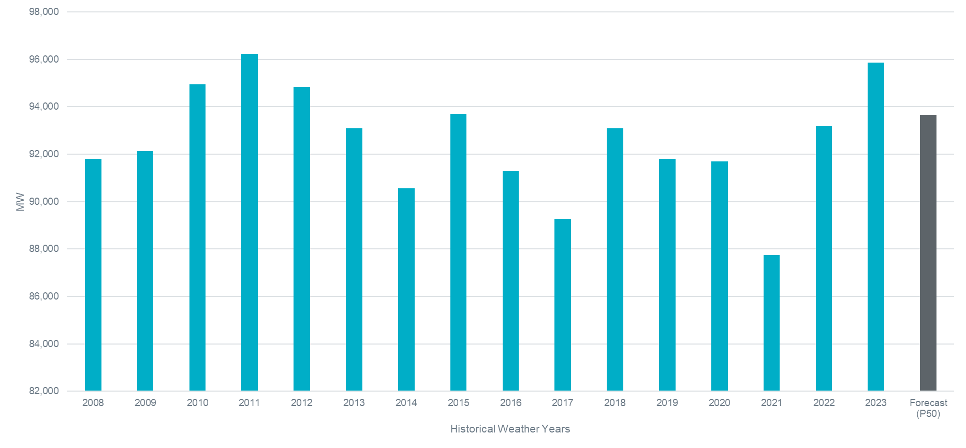

Weather Zone Normal Weather Hourly Forecast

The seventeen weather zone load forecast scenarios were used as the basis for creating the weather zone normal weather hourly forecast. Each of the seventeen hourly weather zone load forecast scenarios were separated into individual calendar year forecasts (covering calendar years 2025-2034). The calendar year forecasts were then divided by calendar month. Forecasted hourly values for each individual calendar month were ordered from the highest value to the lowest value. Then, for each ordered value, the average was calculated. This process is commonly referred to as the Rank-and-Average methodology.

For example, to determine the normal weather forecasted peak value for August 2025, take the highest forecasted value from each of the seventeen weather load forecast scenarios for August 2025 and average them. To determine the second highest value for August 2025, take the second highest forecasted value for each of the seventeen weather load forecast scenarios for August 2025 and average them. Repeat this process for all hours in August 2025.

After this process has been completed for all hours in August, a forecast will have been created for all 744 hours of August. At this point, the forecast was ordered from the highest value (indicated as rank 1) to the lowest value (indicated as rank 744). Note that the forecasted values have not yet been assigned to a day or hour. The values associated with a rank of 1 are the monthly forecasted peak demand values. The forecasted monthly peak values for August and January, however, are subject to an adjustment which is covered in the two sections immediately below.

Weather Zone Normal Weather Summer Peak Demand Forecast

The seventeen weather load forecast scenarios were used as the basis for creating the weather zone normal weather summer peak forecast. Each of the seventeen hourly weather load forecast scenarios were separated into individual calendar year forecasts (covering calendar years 2024-2033). The maximum forecasted hourly value occurring during the summer season (defined as June through September) was determined for each individual calendar year.

The summer peak demand values from the seventeen weather scenarios for a particular calendar year are averaged to determine the normal weather forecasted summer peak value. For example, to determine the normal weather forecasted summer peak value for calendar year 2025, take the highest forecasted value in months June through September from each of the seventeen weather load forecast scenarios for calendar year 2025 and average them. The forecasted summer peak demand is then assigned to August and replaces the previously calculated peak (rank 1) forecasted value for the month of August.

Weather Zone Normal Weather Winter Peak Demand Forecast

The seventeen weather load forecast scenarios were used as the basis for creating the weather zone normal weather winter peak forecast. Each of the seventeen hourly weather load forecast scenarios were separated into individual calendar year forecasts (covering calendar years 2024-2033). The maximum forecasted hourly value occurring during the winter season (defined as December through March) was determined for each year. The winter peak
demand values from each weather scenario for a particular year were averaged to determine the normal weather forecasted winter peak value. For example, to determine the normal weather forecasted winter peak value for 2024, take the highest forecasted value from each of the seventeen weather load forecast scenarios for December 2023 – March 2024 and average them. The forecasted winter peak demand was then assigned to January and replaces the previously calculated peak (rank 1) forecasted value for the month of January. The weather zone normal weather winter peak demand forecast was then summed with EV, Behind-the-Meter Rooftop PV, and LFL forecasts.

Figure 7: ERCOT Winter Coincident Peak Forecast

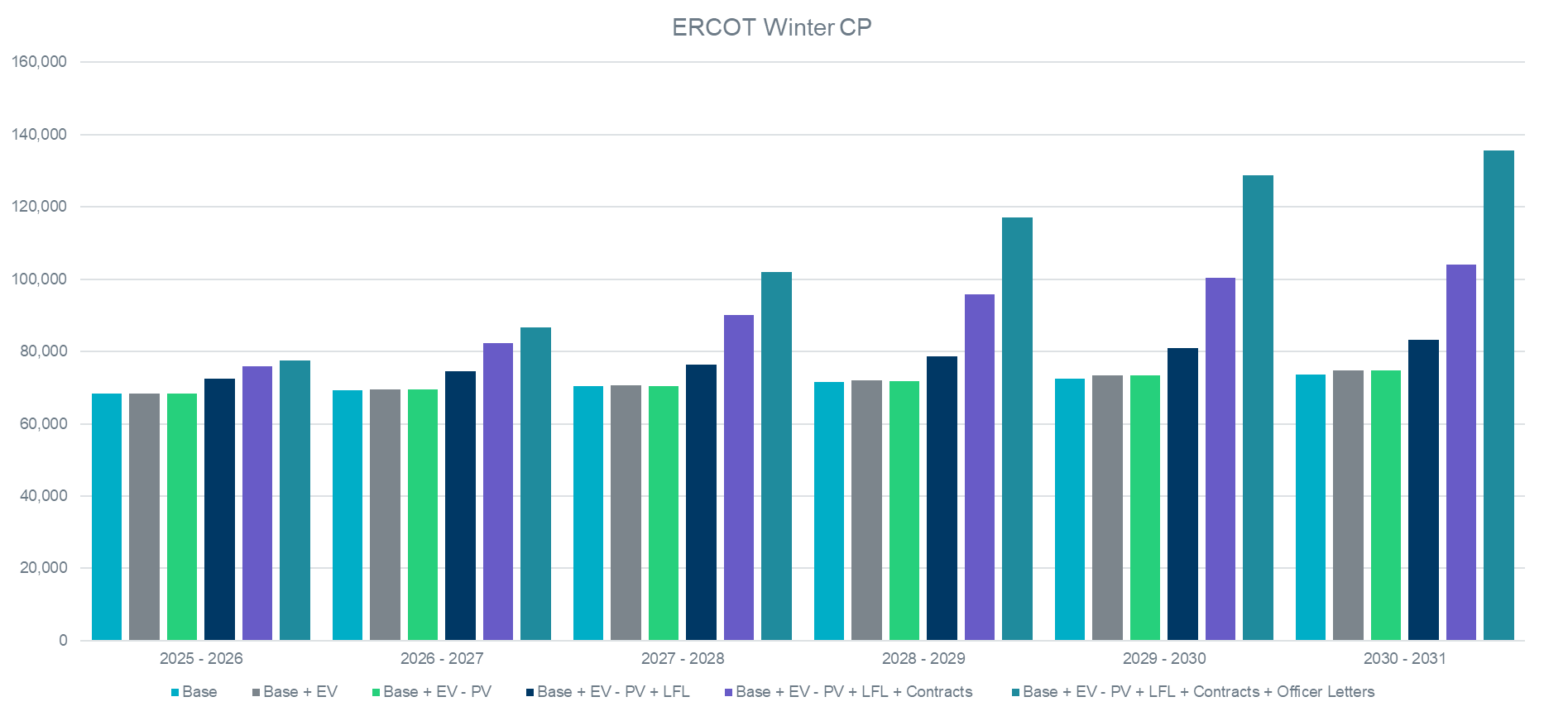

Weather Zone Normal Weather Hourly Forecast Mapping to Calendar

The next step is to map the weather zone average hourly forecasts into a representative calendar. Remember that the average hourly forecast is ranked from highest to lowest value within each forecasted month. The sorted hourly forecasted values need to be mapped into a representative time-sequenced shape. This was accomplished by looking at historical load data from calendar years 2008-2024. For each month in each historical year, the rank of all the observations for each day and hour was determined. Then, the corresponding forecasted average hourly values were mapped to the day and hour from the historical year with the same month and the same rank.

Example:
The Coast Gross Summer Peak Forecast for 2025 is 22,821 MW. Also remember that the forecasted summer peak value is assigned to the month of August. In 2016, Coast’s Summer Peak occurred on 8/11/2008 @ 1600. Using the 2008 mapping ranking, the Coast Summer Peak value was assigned to 8/11 @ 1600 for all forecasted years (2025-2034). This means that the Coast Summer Peak will always occur on 8/11 @ 1600 for all forecasted years that are mapped to 2008.

Figure 8: ERCOT Summer Coincident Peak Forecast

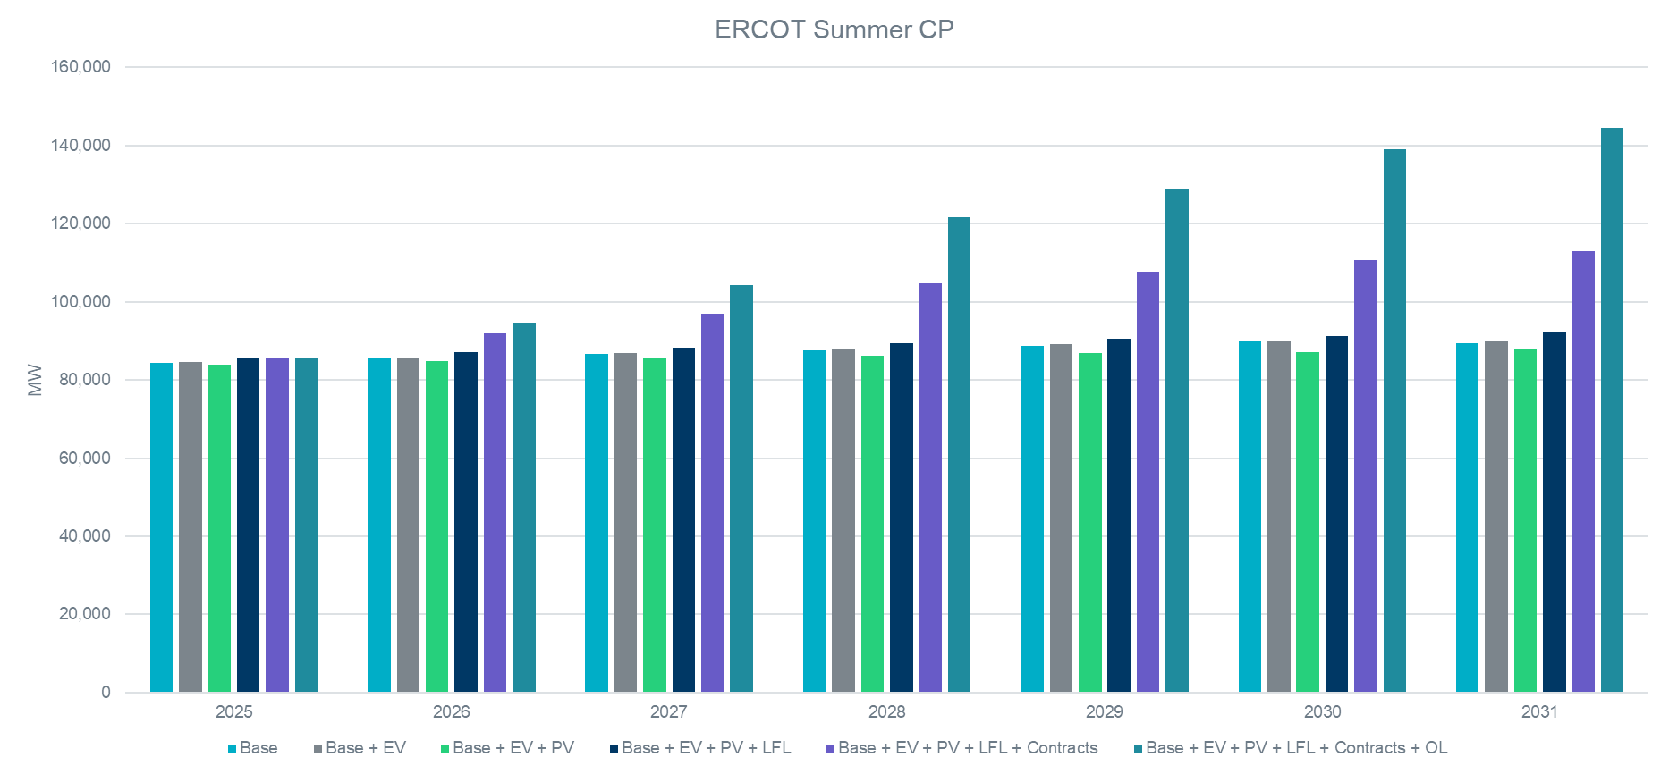

ERCOT Normal Weather (50th percentile) Hourly Forecast

Each of the seventeen different mapped hourly forecasts based on the historical calendar years of 2008-2024 for each weather zone were summed for each forecasted year, month, day, and hour. This resulted in seventeen different ERCOT hourly coincident forecasts. The differences among these forecasts were caused by the different timing of weather conditions across the ERCOT region. It bears repeating that all the underlying weather zone load forecasts have the same exact monthly peak demand and energy values.

To determine which hourly ERCOT coincident forecast to use as the primary and official ERCOT coincident forecast, an analysis was performed on these seventeen different hourly coincident forecasts. The distribution of ERCOT summer peak demand was determined. Seeing that it is very difficult to determine how weather conditions will align or not at the time of ERCOT’s summer peak, the forecast using historical factors from 2008 was deemed the ERCOT 50th percentile forecast. Using the 2008 historical factors resulted in the least amount of diversity between weather zone demand and ERCOT-wide demand at the time of ERCOT’s summer peak. As shown in Figure 7: ERCOT summer coincident peak shifts from 5:00 PM to 10:00 PM starting in 2034.
Load Forecast Scenarios (ERCOT system)

The weather zone load forecast scenarios are used as the basis for creating load forecast scenarios for the ERCOT system. The hourly values from each weather zone are summed for each year, month, day, and hour to get the ERCOT total forecasted hourly demand.

Weather Zone 90th Percentile Summer Peak Demand Forecast

Another forecast of interest is the 90th percentile (P90) weather zone summer peak demand forecast. The process for determining the P90 weather zone summer peak demand forecast is identical to the process used for calculating the 50th percentile forecast, except that instead of using the average of the seventeen-weather year load forecast scenarios, the P90 of the values were used. This is the methodology for the P90 forecast for planning purposes, the operational P90 forecast is subject to be changed to reflect seasonal conditions.

Weather Zone (P90) Summer Peak Demand Forecast for Far West

Although using weather variation from seventeen historical weather years to derive percentiles works well for most weather zones where load is highly dependent on weather, using weather to derive percentiles does not work well for Far West, where the load is relatively consistent across weather variations. Instead, economic variation, particularly the Moody’s high economic scenario, was used to derive a P90 forecast for Far West.

Other Forecast Adjustments

A portion of the load in the city of Lubbock was moved into the ERCOT Region in 2021, and the entire load was moved into ERCOT by the end of 2023. An hourly forecast was created for Lubbock based on Lubbock Power and Light’s (LP&L) peak forecast of its own growth. This separate forecast for Lubbock was added to the ERCOT forecast from LP&P’s projected integration date onward. LP&P’s forecasted load was added to the North weather zone.

Additional Rayburn Country Electric Cooperative (RCEC) load was included in the East weather zone. This load was initially added to the East weather zone in January 2020. A forecast was created based on data included from RCEC’s PUCT filing.

Winter Weather Scenarios: Uri and Elliott

Weather zone normal weather hourly forecasts from the 2025 LTDEF were used to anticipate the impacts of future winter storms to the ERCOT system. February 2021 weather was used to create forecasts that simulate the historical weather from Uri and reflect the economic growth in the region. Winter Storm Elliott (December 2022) was also used to create a weather scenario for future planning. Tables 3 and 4 show the winter peaks using the two weather scenarios described below. The scenarios in Tables 3 and 4 reflect the ERCOT Adjust Forecast.

Table 3: February 2021 Winter Weather Scenario (MW)
2025 | 2026 | 2027 | 2028 | 2029 | 2030 | 2031
97,351 | 106,539 | 121,961 | 136,696 | 148,177 | 155,250 | 160,630

Table 4: December 2022 Winter Weather Scenario (MW)

2025 | 2026 | 2027 | 2028 | 2029 | 2030 | 2031
88,782 | 98,026 | 113,454 | 128,191 | 139,651 | 146,701 | 152,046

Load Forecast Uncertainty

A long-term load forecast can be influenced by several factors. The volatility of these factors can have a major impact on the accuracy of the forecast. This section will cover the following four areas, weather, economics, energy efficiency, and price responsive loads.

Weather Uncertainty

Figure 8 suggests the significant impact of weather in forecasting. This figure shows what the 2025 forecasted peak demand would be using the actual weather from each of the past seventeen years as input into the model. As shown, there is considerable variability ranging from 78,594 MW using 2021’s weather to 85,006 MW using 2011’s weather. This equates to approximately an 8% difference in the forecast based on historical weather volatility. This variation is due to differences in weather and calendar factors between the seventeen historical weather years.

Economic Uncertainty

Economic uncertainty impacts the premise forecasts. Stated differently, significant changes in economic forecasts will have impacts on the premise forecasts which, in turn, will be reflected in the peak demand and energy forecasts. A recent example was the impact COVID-19 had on economic forecasts. Premise forecasts were created using the base economic scenario from Moody’s Analytics.

Energy Efficiency

Energy efficiency is another source of uncertainty. First, it must be recognized that the 2025 LTDEF used a “frozen efficiency” forecast. That means the forecast model employs statistical techniques that estimate the relationships between load, weather, and economics based on historical data from January 2018 through May 2024. The implicit assumption in the forecast is that there will be no significant change in the level of energy efficiency during the forecasted timeframe when compared to what occurred during the historical period used in the model building process. This means that the models assume the thermal characteristics of the housing stock and the characteristics of the mix of appliances will remain relatively the same throughout the forecast horizon.

Price Responsive Loads

Price responsive load behavior is another area of uncertainty. Determining the impact of these programs and reactions can be challenging. There are typically only a few hours in a year with very high prices. Leading to very small observation sets in which to model. There remains uncertainty around what future behaviors and proposed programs may do to influence demand when prices are high.

Appendix A

Peak Demand and Energy Forecast Summary

Year | Summer Peak Demand (MW) | Energy (TWh)
2025 | 85,759 | 486
2026 | 94,650 | 558
2027 | 104,295 | 648
2028 | 121,543 | 795
2029 | 128,851 | 889
2030 | 138,944 | 984
2031 | 144,522 | 1,038

See ERCOT Nodal Protocols, Section 2.
See ERCOT Nodal Protocols, Section 18.6.1.
https://www.ercot.com/files/docs/2022/10/13/2022.10.13%20Brattle%20EV-ERCOT%20RPG%20Presentation.pptx

