

Methodology for Calculating Maximum Daily Resource Planned Outage Capacity

Version 2.0

Document Revisions
Version | Description | Author(s) | Effective Date
1.0 | ERCOT Board approved Methodology for Calculating Maximum Daily Resource Planned Outage Capacity | ERCOT | 7/29/2022
2.0 | Apply risk-based approach for calculating Maximum Daily Resource Planned Outage Capacity for days more than seven days ahead of the Operating Day | ERCOT | 7/15/2025

1 Purpose 1
2 Maximum Daily Resource Planned Outage Capacity for days more than seven days ahead of the operating Day 1
2.1 Maximum Daily Resource Planned Outage Capacity for Thermal Generation Resources 1
2.2 Maximum Daily Resource Planned Outage Capacity for Intermittent Renewable Resources (IRR) 3
2.3 Maximum Daily Resource Planned Outage Capacity for Energy Storage Resources (ESRs) 3
2.4 Resource Planned Outage Plan Review for Other Resources 3
3 Maximum Daily Resource Planned Outage Capacity for Seven days or less prior to operating day 4
3.1 Maximum Daily Resource Planned Outage Capacity for Thermal Generation Resources 4
3.2 Maximum Daily Resource Planned Outage Capacity for Thermal Generation Resources 5
3.3 Maximum Daily Resource Planned Outage Capacity for Intermittent Renewable Resources (IRRs) 5
3.4 Maximum Daily Resource Planned Outage Capacity for Energy Storage Resources (ESRs) 6
3.5 Resource Planned Outage Request Review for Other Resources 6

Purpose
Paragraph (1) of Protocol Section 3.1.6.13, Maximum Daily Resource Planned Outage Capacity, requires ERCOT to calculate the maximum capacity of Resource Planned Outages that should be allowed on each day of the next 60 months. ERCOT must calculate the Maximum Daily Resource Planned Outage Capacity for days more than seven days ahead of the Operating Day and for days that are seven days or less prior to the Operating Day. Pursuant to paragraph (3) of Section 3.1.6.13, which requires ERCOT to post the methodology used to calculate the Maximum Daily Resource Planned Outage Capacity on the ERCOT website, this document describes the details of methodology used in the calculation of these Maximum Daily Resource Planned Outage Capacity values. As further described herein, ERCOT establishes distinct Maximum Daily Resource Planned Outage Capacity values for Thermal Resources, Energy Storage Resources (ESRs), and Intermittent Renewable Resources (IRRs). As required by paragraph (6) of Protocol Section 3.1.6, Outages of Resources Other than Reliability Resources, this methodology does not apply to outages of nuclear Generation Resources. This methodology also does not apply to certain outages of Generation Resources that are part of an industrial generation facility (“IGF") if the owner of the facility has notified ERCOT of that status, as required by paragraph (7) of Protocol Section 3.1.6, and provided the information required by that paragraph in the Resource’s Outage plan.

For each calendar year, ERCOT will review the current methodology and the calculated Maximum Daily Resource Planned Outage Capacity and report its findings to Technical Advisory Committee (TAC). The findings will include but not be limited to the following:
- The aggregated hours of Resource Outages, including Planned Outages, Maintenance Outages, and Forced Outages in the preceding calendar year.
- Comparison of the calculated Maximum Daily Resource Planned Outage Capacity and the aggregated hours of thermal Resource Planned Outages in the preceding calendar year.

Maximum Daily Resource Planned Outage Capacity for days more than seven days ahead of the operating Day
Significant anticipated load growth, limited long term resource commitment, and the changing resource mix increase uncertainty of resource adequacy when evaluating outage requests over a time horizon of 60 months. While it is imperative to support Resource Planned Outages, the impact of the Outage to grid reliability should be assessed to inform ERCOT system operators and Market Participants. ERCOT uses a risk-based approach to determine the Maximum Daily Resource Planned Outage Capacity and its associated risk. The Maximum Daily Resource Planned Outage Capacity is calculated in 1-day time resolution.

Maximum Daily Resource Planned Outage Capacity for Thermal Generation Resources
Maximum Daily Resource Planned Outage Capacity for thermal Generation Resources is determined considering the following items

- Installed thermal Generation Resource seasonal capacity, consistent with the calculation used in Protocol Section 3.2.6.4, Total Capacity Estimate, and excluding IRRs, Generation Resources in industrial generation facilities, ESRs, and DGR/DESRs
- Peak average capacity contribution of hydroelectric Generation Resources, consistent with the calculation used in Protocol Section 3.2.6.4
- Switchable capacity available to ERCOT, consistent with the calculation used in Protocol Section 3.2.6.4
- Available mothballed capacity, consistent with the calculation used in Protocol Section 3.2.6.4
- Capacity from Private Use Networks, consistent with the calculation used in Protocol Section 3.2.6.4
- Non-Synchronous tie capacity, consistent with the calculation used in Protocol Section 3.2.6.4
- Targeted reserve level, consistent with the Outage Adjustment Evaluation (OAE) in the Advance Action Notice (AAN) process described in Protocol Section 3.1.6.9, Withdrawal of Approval or Acceptance and Rescheduling of Approved or Accepted Planned Outages of Resource Facilities
- Installed and planned Wind Generation Resource (WGR) capacity contribution, represented by a probabilistic distribution based on the actual performance in the preceding three years
- Installed and planned Photo Voltaic Generation Resource (PVGR) capacity contribution, represented by a probabilistic distribution based on the actual performance in the preceding three years
- Capacity of planned thermal Generation Resources, consistent with the calculation used in Protocol Section 3.2.6.4
- Forecasted Demand reduction provided by price-responsive Demand, consistent with the Outage Adjustment Evaluation (OAE) in the Advance Action Notice (AAN) process described in Protocol Section 3.1.6.9
- Unplanned Outage capacity for thermal Generation Resources, represented by a probabilistic distribution based on actual performance in the preceding three years
- Load forecast for the next 60 months, represented by a probabilistic distribution considering the latest long-term load forecast report and the weather data in the preceding 15 years.
- Installed and planned Energy Storage Resource (ESR) capacity contribution, determined as the percentage of total installed and planned ESR capacity listed in the chart below.

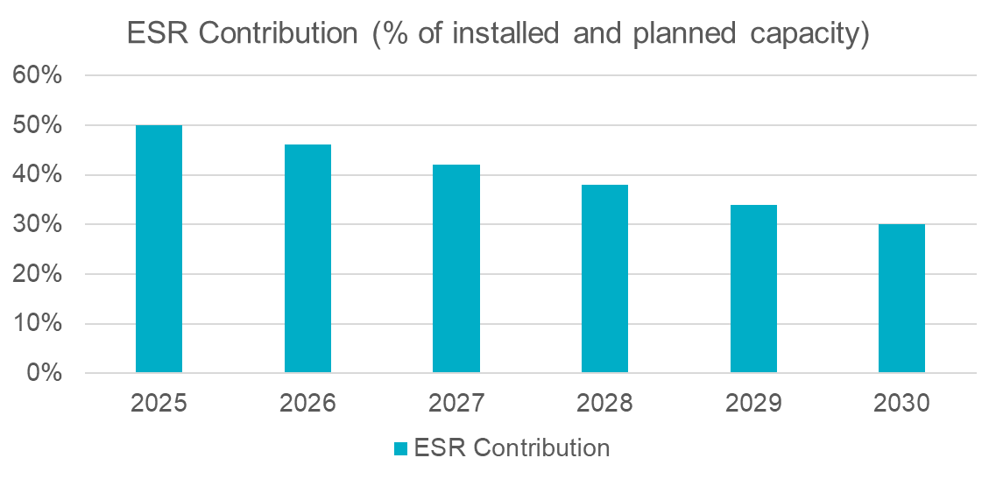
Historical Resource Planned Outages are also considered when determining the Maximum Daily Resource Planned Outage Capacity for thermal Generation Resources.
- ERCOT will use the Maximum Daily Resource Planned Outage Capacity determined for the first future year for all subsequent years in the future 60 months and will assess the associated risk.
- The average Maximum Daily Resource Planned Outage Capacity should be equal to or greater than 2500 MW for the summer months and 5000 MW for the winter months. Summer months are June, July, and August; winter months are December, January, and February.

Maximum Daily Resource Planned Outage Capacity for Intermittent Renewable Resources (IRR)
Maximum Daily Resource Planned Outage Capacity for IRRs is calculated as 110% of the historical maximum Resource Planned Outages for IRRs from the previous three years.

[Insert Section 2.3 below upon system implementation of the Real-Time Co-Optimization (RTC) project.]

Maximum Daily Resource Planned Outage Capacity for Energy Storage Resources (ESRs)
Maximum Daily Resource Planned Outage Capacity for ESRs is calculated based on 110% of the historical maximum Resource Planned Outages for ESRs from the previous three years.

Resource Planned Outage Plan Review for Other Resources

Nuclear Generation Resources
In accordance with paragraph (6) of Protocol Section 3.1.6, ERCOT will approve Planned Outages for nuclear Generation Resources without regard to Outage capacity available within the Maximum Daily Resource Planned Outage Capacity.

Industrial generation facilities
In accordance with paragraph (7) of Protocol Section 3.1.6, ERCOT will approve an Outage plan for a Generation Resource that is part of an IGF, even if the Outage would cause the Outage capacity to exceed the Maximum Daily Resource Planned Outage Capacity, if the plan states that the Generation Resource is part of an IGF, as described in Utilities Code § 39.151(l), and that the Outage is necessitated by the operational needs of an industrial Load normally served by the Generation Resource. However, ERCOT will not approve the Outage plan if ERCOT determines the Outage will impair its ability to ensure transmission security.

Distributed Generation Resources (DGR), and Distributed Energy Storage Resources (DESR)
The capacity contribution of DGRs and DESRs to meet system peak load is assumed to be zero. Therefore, ERCOT does not intend to apply the Maximum Daily Resource Planned Outage Capacity in reviewing DGR and DESR Planned Outage plans. However, Planned Outage plans for DGRs and DESRs are subject to transmission security assessment.

Maximum Daily Resource Planned Outage Capacity for Seven days or less prior to operating day
The Maximum Daily Resource Planned Outage Capacity is calculated to be consistent with the inputs used for an Outage Adjustment Evaluation (OAE) as described in Protocol Section 3.1.6.9.

Maximum Daily Resource Planned Outage Capacity for Thermal Generation Resources
Maximum Daily Resource Planned Outage Capacity for thermal Generation Resources = seasonal maximum capacity of Generation Resources for non-IRR and non-PUN + wind forecast + solar forecast + capacity from private use network + DC Tie capacity – unplanned outaged capacity of thermal Generation Resources – Load forecast – targeted reserve levels + the forecasted Demand reduction provided by price-responsive Demand + SODG and SOTG forecasts

where:
- (+) the seasonal maximum capacity of Generation Resource is computed by adding the seasonal net maximum capacity of the Generation Resource, as reported in its RARF, except for IRRs, private use network Generation Resources, ESRs, and DGRs/DESRs.
- (+) the selected Wind-powered Generation Resource Production Potential (WGRPP)
- (+) the selected PhotoVoltaic Generation Resource Production Potential (PVGRPP)
- (+) capacity from Generation Resources in the PUNs is consistent with calculation used in Protocol Section 3.2.6.4 for the applicable seasons
- (-) approved or accepted unplanned outage capacity as reported in the Outage Scheduler excluding IRRs, private use network Generation Resources, ESRs, and DGRs/DESRs
- (+) DC Tie capacity is consistent with the calculation used in Protocol Section 3.2.6.4 for the applicable seasons
- (-) the selected Load forecast
- (-) targeted reserve levels
- (+) forecasted Demand reduction provided by price-responsive Demand
- (+) SODG and SOTG forecast when available
- (+) 50% of available ESR capacity that is computed by adding the seasonal net maximum capacity of the ESRs
[Replace Section 3.2 above with the following upon system implementation of the Real-Time Co-Optimization (RTC) project]

Maximum Daily Resource Planned Outage Capacity for Thermal Generation Resources
Maximum Daily Resource Planned Outage Capacity for thermal Generation Resources = seasonal maximum capacity of Generation Resources for non-IRR and non-PUN + wind forecast + solar forecast + capacity from private use network + DC Tie capacity – unplanned outaged capacity of thermal Generation Resources – Load forecast – targeted reserve levels + the forecasted Demand reduction provided by price-responsive Demand + SODG and SOTG forecasts + capacity from ESR

where:
- (+) the seasonal maximum capacity of Generation Resource is computed by adding the seasonal net maximum capacity of the Generation Resource, as reported in its RARF, except for IRRs, private use network Generation Resources, ESRs, and DGRs/DESRs.
- (+) the selected Wind-powered Generation Resource Production Potential (WGRPP)
- (+) the selected PhotoVoltaic Generation Resource Production Potential (PVGRPP)
- (+) capacity from Generation Resources in the PUNs is consistent with calculation used in Protocol Section 3.2.6.4 for the applicable seasons
- (-) approved or accepted unplanned outage capacity as reported in the Outage Scheduler excluding IRRs, private use network Generation Resources, ESRs, and DGRs/DESRs
- (+) DC Tie capacity is consistent with the calculation used in Protocol Section 3.2.6.4. for the applicable seasons
- (-) the selected Load forecast
- (-) targeted reserve levels
- (+) forecasted Demand reduction provided by price-responsive Demand
- (+) SODG and SOTG forecast when available
- (+) 50% of available ESR capacity that is computed by adding the seasonal net maximum capacity of the ESRs

Maximum Daily Resource Planned Outage Capacity for Intermittent Renewable Resources (IRRs)
The Maximum Daily Resource Planned Outage Capacity for IRRs is determined as 110% of the historical maximum Resource Planned Outages for IRRs from the previous three years.
[Insert Section 3.4 below upon system implementation of the Real-Time Co-Optimization (RTC) project]

Maximum Daily Resource Planned Outage Capacity for Energy Storage Resources (ESRs)
Maximum Daily Resource Planned Outage Capacity for ESRs is calculated based on 110% of the historical maximum Resource Planned Outages for ESRs from the previous three years.

Resource Planned Outage Request Review for Other Resources

Nuclear Generation Resource
In accordance with paragraph (6) of Protocol Section 3.1.6, ERCOT will approve Planned Outages for nuclear Generation Resources without regard to Outage capacity available within the Maximum Daily Resource Planned Outage Capacity.

Industrial generation facilities
In accordance with paragraph (7) of Protocol Section 3.1.6, ERCOT will approve an Outage plan for a Generation Resource that is part of an IGF, even if the Outage would cause the Outage capacity to exceed the Maximum Daily Resource Planned Outage Capacity, if the plan states that the Generation Resource is part of an IGF, as described in Utilities Code § 39.151(l), and that the Outage is necessitated by the operational needs of an industrial Load normally served by the Generation Resource. However, ERCOT will not approve the Outage plan if ERCOT determines the Outage will impair its ability to ensure transmission security.

Distributed Generation Resources (DGR), and Distributed Energy Storage Resources (DESR)
The capacity contribution of DGRs and DESRs to meet system peak load is assumed to be zero. Therefore, ERCOT does not intend to apply the Maximum Daily Resource Planned Outage Capacity in reviewing DGR and DESR Planned Outage plans. However, Planned Outage plans for DGRs and DESRs are subject to transmission security assessment.

