**by**

**shirswak das**



**Introduction to database and sql command**

**MIP-DA-04**

**DATABASE:**

A database is a systematic or organized collection of related information that is stored in such a way that it can be easily accessed, retrieved, managed, and updated

* **Database Management System (DMS):**

The system software for creating and managing databases. A DBMS makes it possible for end users to create, protect, read, update and delete data in a database

There are three main types of DBMS data models.: relational, network, and hierarchical.  Most relational database management systems use the **SQL (**Structured query language**)** language to access the database.

* **Relational Database Management Systems (RDMS):**

The **software used to store, manage, query, and retrieve data stored in** a relational database is called a relational database management system (RDBMS).  RDBMS is the basis for all modern database systems such as MySQL, Microsoft SQL Server, Oracle, and Microsoft Access. RDBMS uses **SQL** queries to access the data in the database.

Structured query language (**SQL**):

Structured query language (**SQL**) is a programming language for storing and processing information in a relational database. It refers to a standard programming language utilized to extract, organize, manage, and manipulate data stored in relational databases. SQL is thereby referred to as a database language that can execute activities on databases that consist of tables made up of rows and columns

**EXAMPLE**:

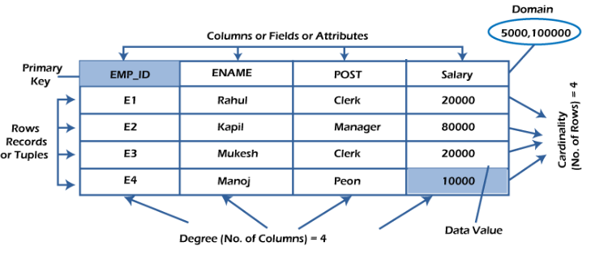

* The sql command are divided into five major categories: **data definition language (DDL)**, **data manipulation language (DML), Data Control Language (DCL),** **Transaction Control Language,** **Data Query Language (DQL).**

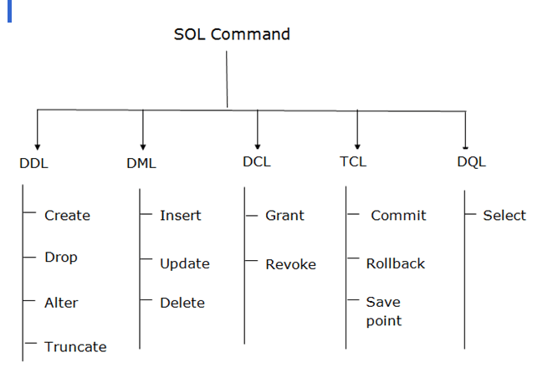

* **Data Manipulation Language** **(DML):**

The DML commands in Structured Query Language change the data present in the SQL database. We can easily access, store, modify, update and delete the existing records from the database using DML commands.

The primary DML commands in SQL include:

1. **INSERT**: This command is used to add new rows (records) to a table.

* Syntax: INSERT INTO table name (column1, column2, column3, ...) VALUES (value1, value2, value3, ...);

1. **UPDATE**: This command is used to modify the existing records in a table.

* Syntax: UPDATE table name SET column1 = value1, column2 = value2, ... WHERE condition;

1. **DELETE**: This command is used to remove one or more rows from a table

.

* Syntax: DELETE FROM table name WHERE condition;
* **Data definition language (DDL):**

It refers to the set of SQL commands that can create and manipulate the structures of a database. DDL statements are used to create, change, and remove objects including indexes, triggers, tables, and views. Common DDL statements include:

The primary DDL commands in SQL include:

1. **CREATE**: This command is used to create a new database object. For example, creating a new table, a view, or a database.
   * Syntax for creating a table: CREATE TABLE table name (column1 datatype, column2 datatype, ...);
2. **ALTER**: This command is used to modify an existing database object, such as adding, deleting, or modifying columns in an existing table.
   * Syntax for adding a column in a table: ALTER TABLE table name ADD column name datatype;
3. **DROP**: This command is used to delete an existing database object like a table, a view, or other objects.
   * Syntax for dropping a table: DROP TABLE table name;
4. **TRUNCATE**: This command is used to delete all data from a table, but the structure of the table remains. It’s a fast way to clear large data from a table

.

* + Syntax: TRUNCATE TABLE table name;

**Data Control Language (DCL):**

DCL includes commands such as GRANT and REVOKE which mainly deal with the rights, permissions, and other controls of the database system.

The primary DCL commands in SQL include:

* **GRANT**: This command is used to give users access privileges to the database. These privileges can include the ability to select, insert, update, delete, and so on, over database objects like tables and views.
* Syntax: GRANT privilege name ON object name TO usernames;
* **REVOKE**: This command is used to remove previously granted access privileges from a user.
* Syntax: REVOKE privilege name ON object name FROM usernames;
* **Transaction control language** **(TCL):**

Transaction Control Language (TCL) is a subset of SQL commands used to manage transactions in a database. Transactions are important for maintaining the integrity and consistency of data. They allow multiple database operations to be executed as a single unit of work, which either entirely succeeds or fails.

The primary TCL commands in SQL include:

* **COMMIT**: This command is used to permanently save all changes made in the current transaction.
  1. Syntax: COMMIT;
* **ROLLBACK**: This command is used to undo changes that have been made in the current transaction.
  1. Syntax: ROLLBACK;
* **SAVEPOINT**: This command creates points within a transaction to which you can later roll back. It allows for partial rollbacks and more complex transaction control.

1. Syntax: SAVEPOINT savepoint_name;

**Data Query Language (DQL):**

* Data Query Language (DQL) is a subset of SQL commands used primarily to query and retrieve data from existing database tables. In SQL, DQL is mostly centred around the SELECT statement, which is used to fetch data according to specified criteria. Here’s an overview of the SELECT statement and its common clauses:
* **SELECT**: The main command used in DQL, SELECT retrieves data from one or more tables.

1.Basic Syntax: SELECT column1, column2, ... FROM table name;

## Conclusion

In conclusion, SQL (Structured Query Language) is a standard programming language used for managing and manipulating relational databases. SQL supports various types of commands such as Data Definition Language (DDL), Data Manipulation Language (DML), Data Control Language (DCL), Transaction Control Language (TCL), and Data Query Language (DQL) commands. These commands allow you to perform operations such as creating, altering, and deleting tables and their associated constraints, as well as inserting, updating, and retrieving data from tables.