Arrays

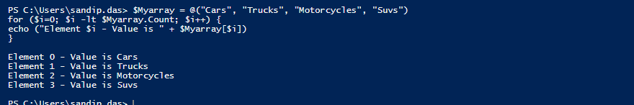

Switch-Default

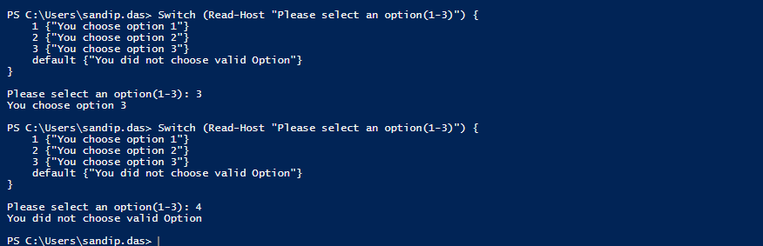

Functions

2Dimensional Array

HashTables

Try-catch-Exception

