**HELM**

1. What is Helm and why is it used?

Helm is a **package manager for Kubernetes** that helps you define, install, and upgrade complex Kubernetes applications using reusable templates called **charts**.

It’s used for:

* Simplifying deployment through **parameterized templates**.
* Managing **versioned releases** (rollback support).
* Enforcing consistency across environments (dev, staging, prod).
* Reducing YAML duplication and manual errors.

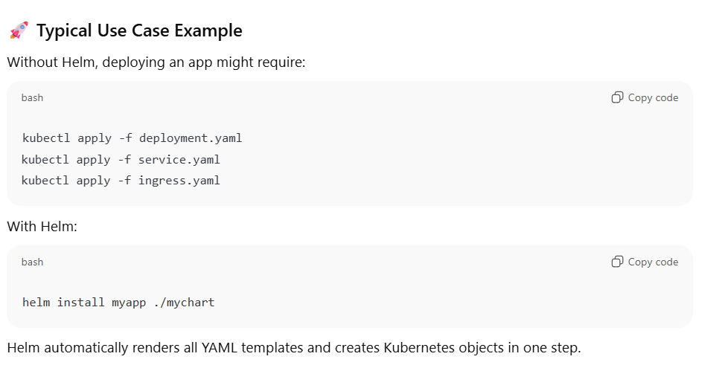

1. Explain the structure of a Helm Chart.

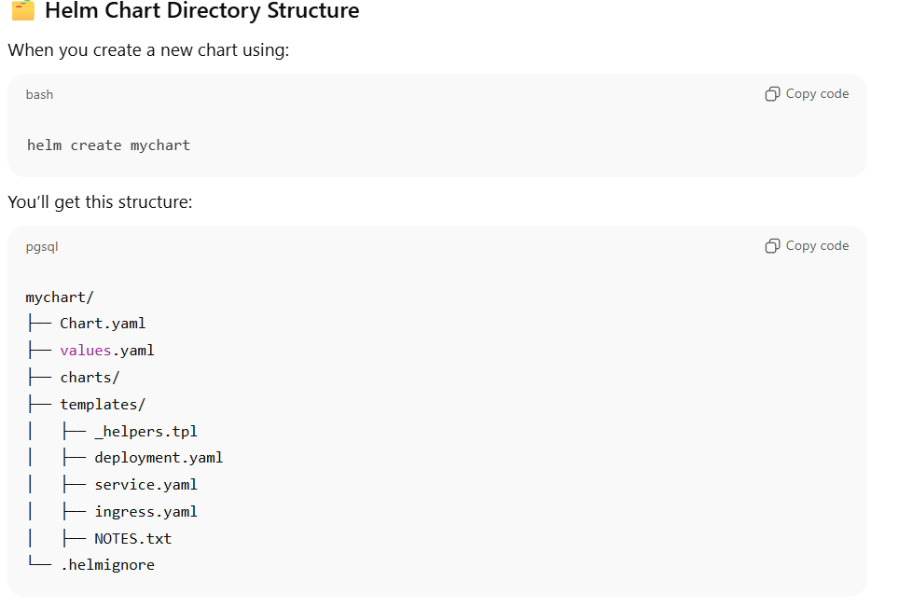

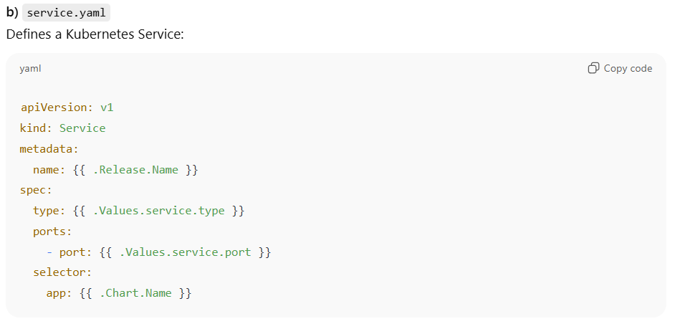

1. What are Helm values and how can they be overridden?

Helm values are variables used to parameterize chart templates.  
There are multiple precedence levels when overriding:

**Order of precedence (highest to lowest):**

1. --set key=value (CLI flag)
2. --values myvalues.yaml (custom values file)
3. Chart’s default values.yaml

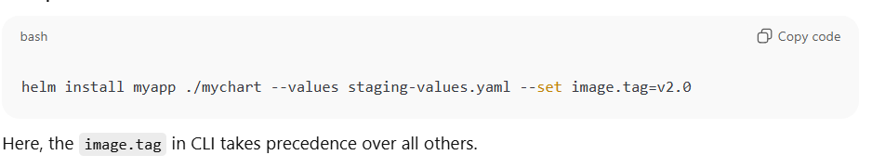

1. How do Helm dependencies (subcharts) work?

A Helm chart can depend on other charts using the dependencies: section in Chart.yaml.

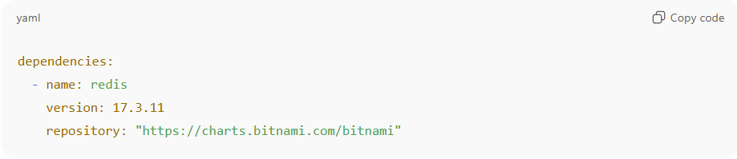

1. What are Helm hooks and when are they used?

Hooks allow you to **run specific jobs or resources at lifecycle events** (install, upgrade, delete).

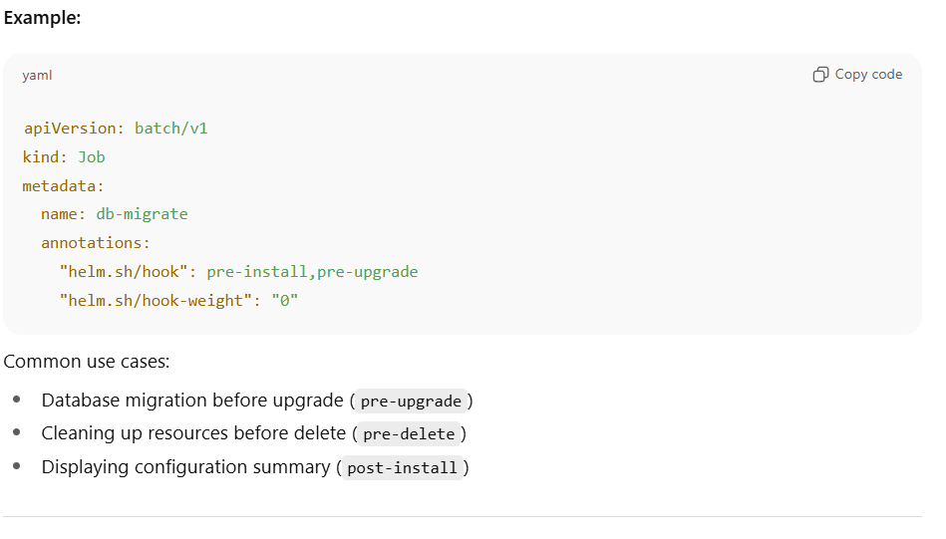

1. How do you perform Helm upgrade and rollback?

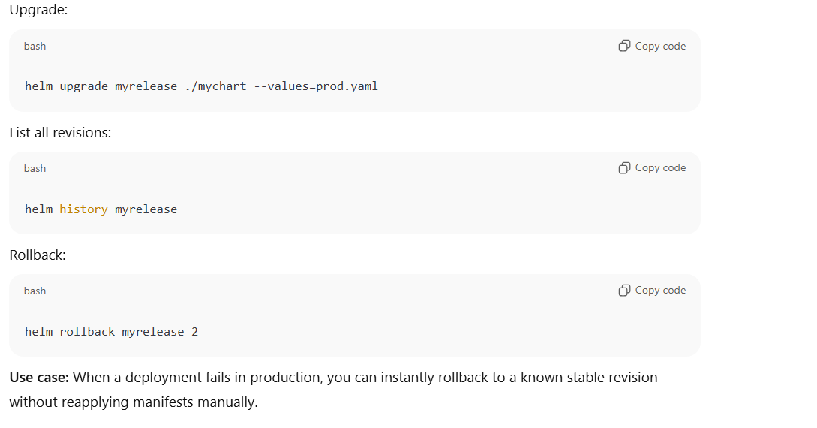

1. How can you debug Helm charts?

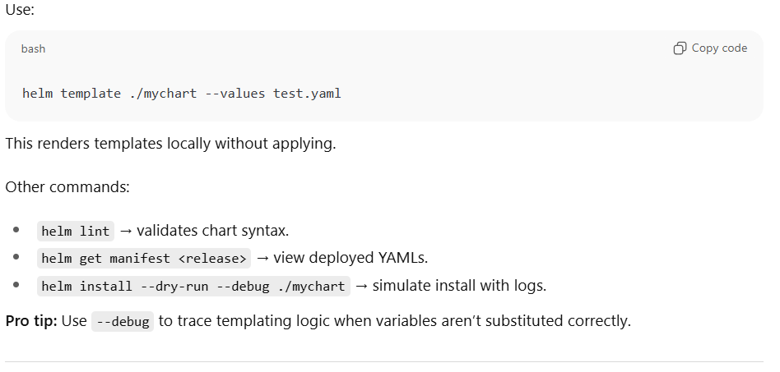

1. How do Helm chart variables work with environment-specific deployments?

1. What is a Helm release and how is it stored in Kubernetes?

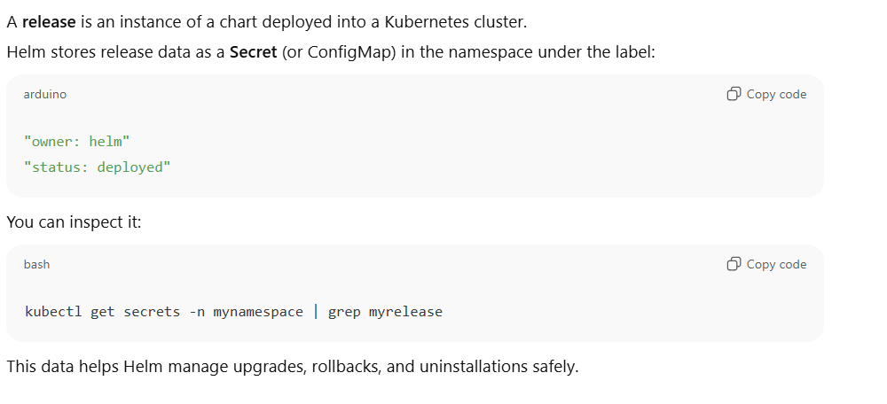

1. How do you integrate Helm with CI/CD pipelines (GitLab/GitHub Actions)?

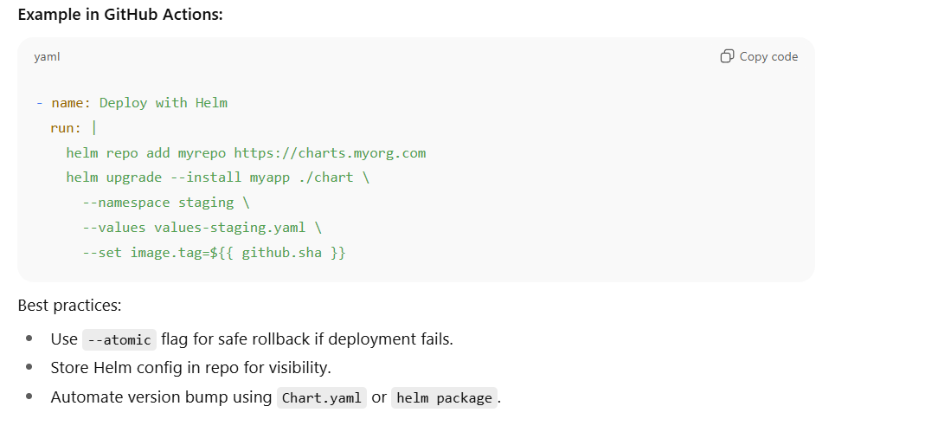

1. How do you share or distribute custom Helm charts?

1. What is _helpers.tpl in Helm charts?

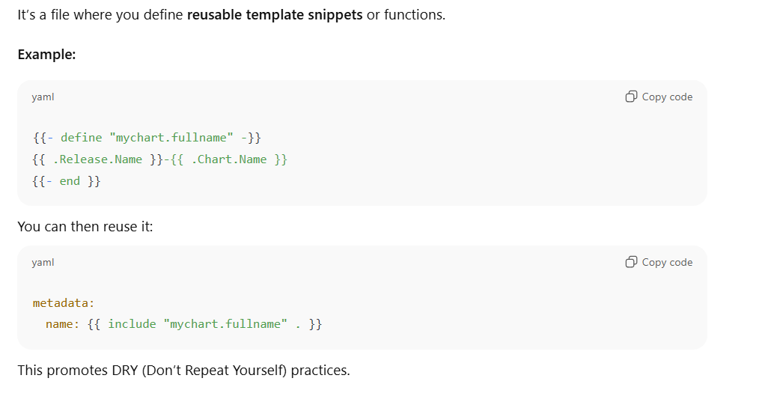

1. How do you enable optional resources like ingress only for some environments?

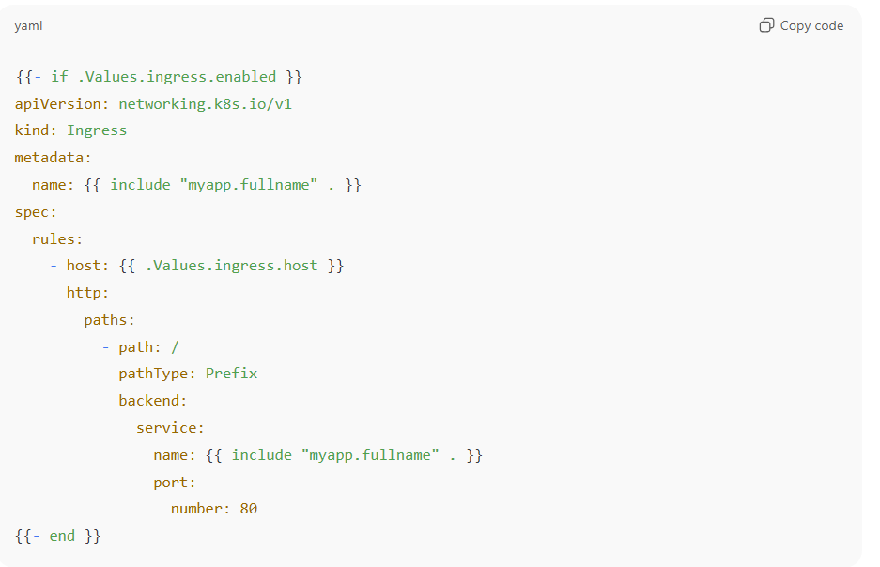

**EKS**

1. what is the usage of kubeconfig file ?

The **kubeconfig** file is a **configuration file used by kubectl, helm, and other Kubernetes clients** to know **how to connect** to a Kubernetes cluster — including **authentication, context, and cluster details**.

The kubeconfig file tells your kubectl **which cluster to connect to**, **how to authenticate**, and **which namespace/context to use**.

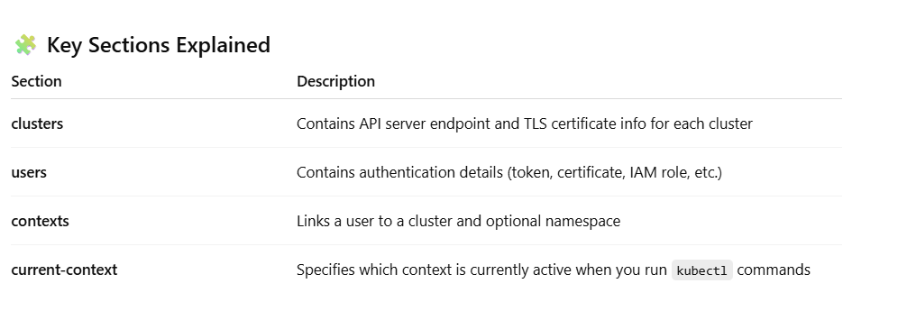

1. Explain how OIDC integration improves security in EKS.

OpenID Connect (OIDC) integration significantly **improves security in Amazon EKS (Elastic Kubernetes Service)** by enabling **secure, fine-grained, and temporary identity-based access** to AWS resources without relying on static credentials.

**🔐 1. What is OIDC in EKS?**

EKS integrates with **AWS IAM OIDC identity providers** to let Kubernetes service accounts assume IAM roles using **federated authentication**.  
This means instead of embedding long-lived AWS access keys in pods or ConfigMaps, pods get **short-lived, automatically rotated credentials** from AWS STS.

**⚙️ 2. How OIDC integration works**

When you enable OIDC in your EKS cluster:

1. EKS creates or links to an **OIDC identity provider** in IAM (using the cluster’s issuer URL).
2. You create an **IAM role** with a **trust policy** that allows tokens from this OIDC provider.
3. You associate the IAM role with a **Kubernetes service account** using annotations.
4. When a pod runs using that service account:
   * The pod gets a **signed OIDC token** from the Kubernetes API server.
   * AWS STS verifies the token against the OIDC provider.
   * If valid, it issues **temporary credentials** for the IAM role.

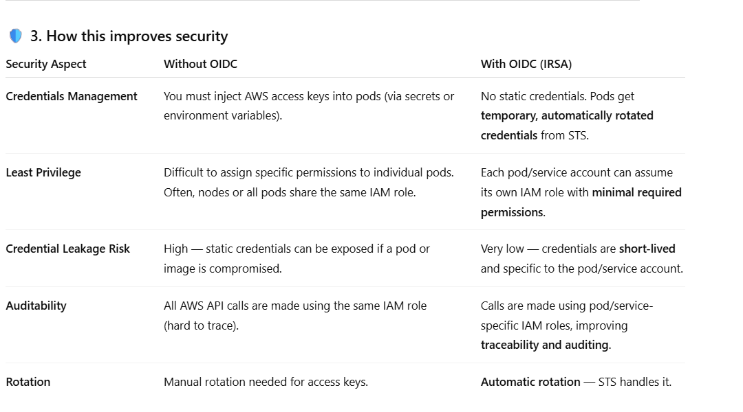

1. How do you securely provide AWS credentials to pods in EKS?

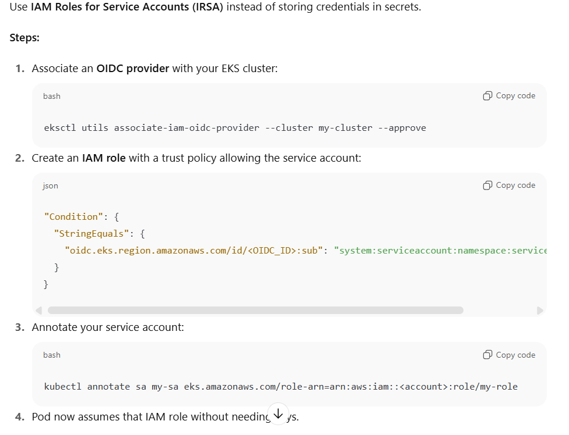

1. How does networking work in EKS?

**🧩 1. EKS Networking Overview**

EKS networking is a combination of:

* **AWS networking** (VPC, subnets, security groups, route tables)
* **Kubernetes networking** (CNI plugins, Services, Pods, Ingress, etc.)

EKS leverages both layers:

* AWS provides **infrastructure-level networking**
* Kubernetes provides **application-level networking**

**🌐 2. AWS VPC CNI Plugin — the Core of EKS Networking**

By default, EKS uses the **Amazon VPC CNI plugin** to manage pod networking.

**🔸 How it works**

* Each worker node (EC2 or Fargate) is attached to your **VPC** and gets an **ENI (Elastic Network Interface)**.
* Each **Pod** gets its own IP address **from the VPC subnet** — **same network as the node**.
* This means:
  + Pods are **first-class citizens** in the VPC.
  + You can reach a pod directly using its IP from any VPC resource (no NAT or overlay needed).

**🔸 Key Benefits**

✅ Native VPC networking  
✅ Simplified integration with AWS services  
✅ High performance (no encapsulation/overlay)  
✅ Direct security control using VPC security groups and NACLs

**⚙️ 3. Pod-to-Pod, Pod-to-Service, and External Communication**

Let’s see how packets actually flow:

**A. Pod-to-Pod (Same Node)**

* Communication happens via Linux virtual Ethernet pairs (veth) on the same node.
* Handled locally — doesn’t go out to the VPC.

**B. Pod-to-Pod (Different Nodes)**

* The Amazon VPC CNI attaches secondary ENIs to each node.
* Pods get IPs from those ENIs’ subnets.
* Packets are routed through the **VPC routing layer** just like any EC2-to-EC2 communication.

**C. Pod-to-Service (ClusterIP)**

* Services use **kube-proxy** (usually with iptables or IPVS).
* kube-proxy load-balances traffic to the backend pods.

**D. External Communication (Internet/AWS Services)**

* Outbound traffic goes via the node’s ENI to the **Internet Gateway (IGW)** or **NAT Gateway**, depending on subnet type.
* For AWS APIs (like S3, DynamoDB), use **VPC Endpoints** for private communication.

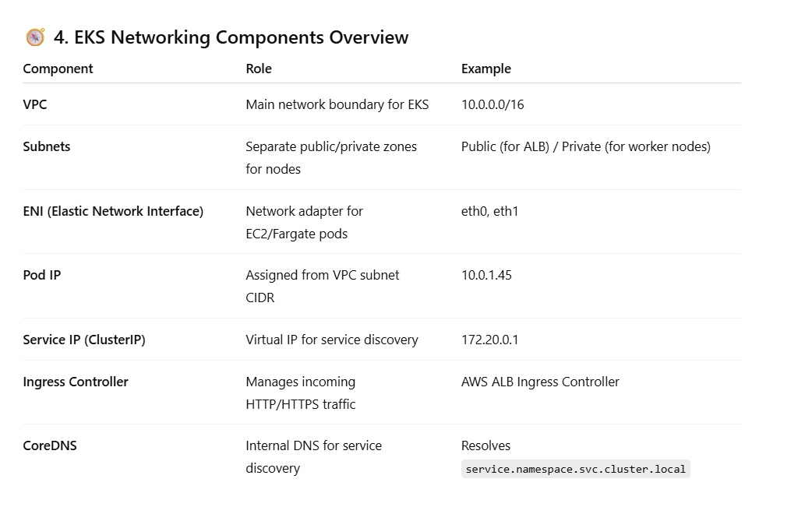

1. Explain the EKS architecture and how it differs from a self-managed Kubernetes cluster.

**Amazon Elastic Kubernetes Service (EKS)** is a **managed Kubernetes control plane** provided by AWS.  
It runs upstream Kubernetes (no AWS-specific fork) — but **AWS manages the control plane**, while you manage the worker nodes and workloads.

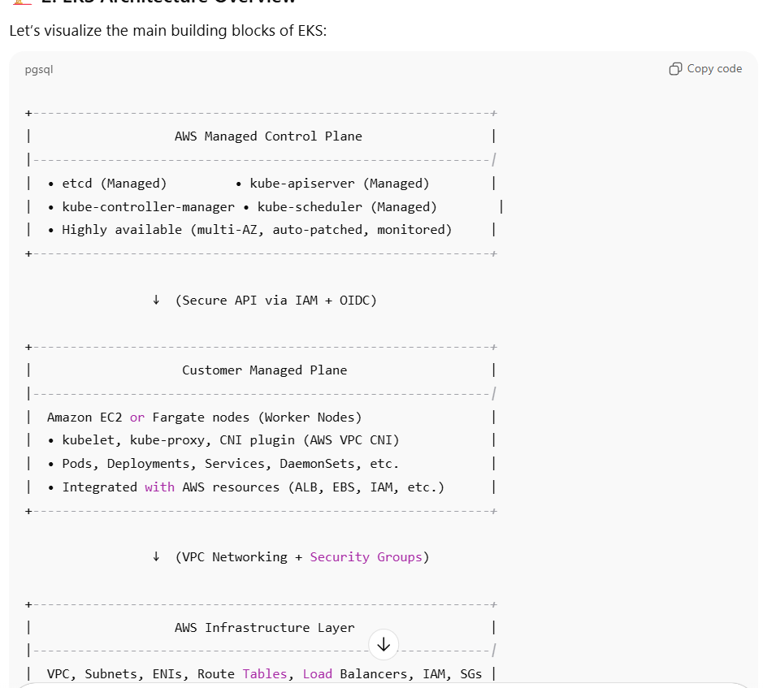

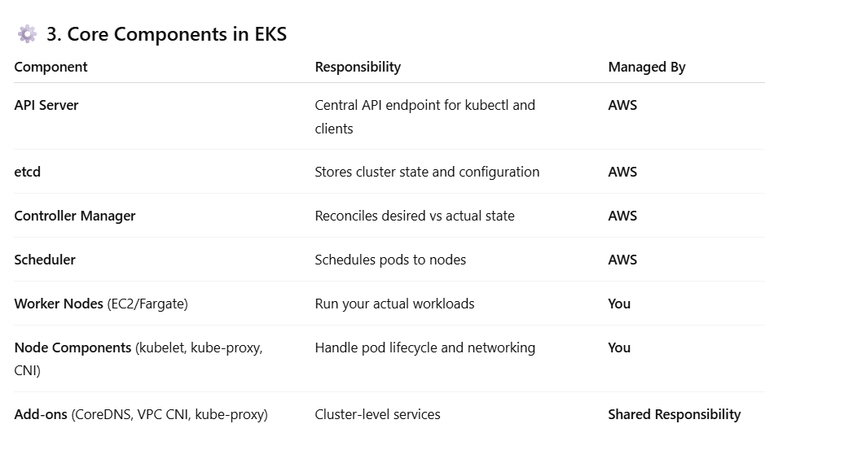

1. How do you troubleshoot pod networking issues in EKS?

**🧩 1. First — Understand the Context**

EKS networking = **Kubernetes networking** (pods, services, CNI) + **AWS networking** (VPC, subnets, ENIs, security groups, route tables).

So when pods can’t talk, the issue could be:

* At the **Kubernetes layer** (CNI, kube-proxy, service, DNS)
* At the **AWS layer** (VPC config, ENIs, routes, SGs)

We'll troubleshoot from **pod → node → VPC → AWS service**.



