LINUX BASH SCRIPTING

1. What is the difference between awk and sed in linux?

SED🡪 sed is a stream editor. It works with streams of characters on a per-line basis. I would tend to use sed where there are patterns in the text.

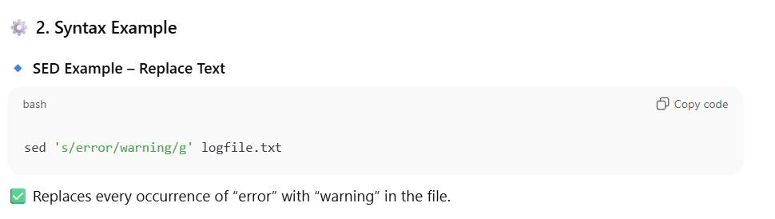

AWK🡪 awk is oriented toward delimited fields on a per-line basis. It has much more robust programming constructs including if/else, while, do/while and for (C-style and array iteration

I would use awk when the text looks more like rows and columns or, as awk refers to them "records" and "fields".

1. Difference between “cut” and “tr” .

both **cut** and **tr** are simple but very commonly used text-processing commands in Linux.

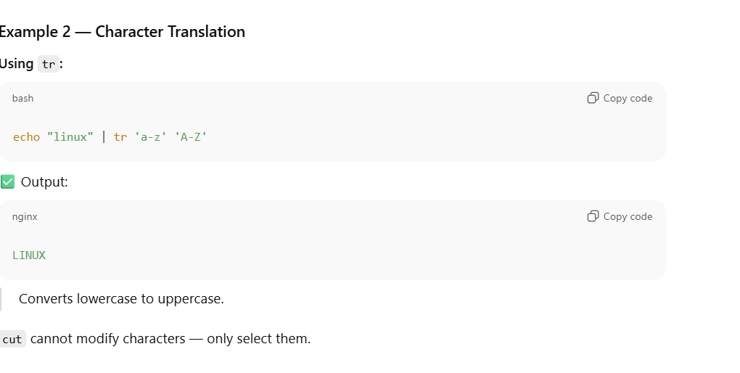

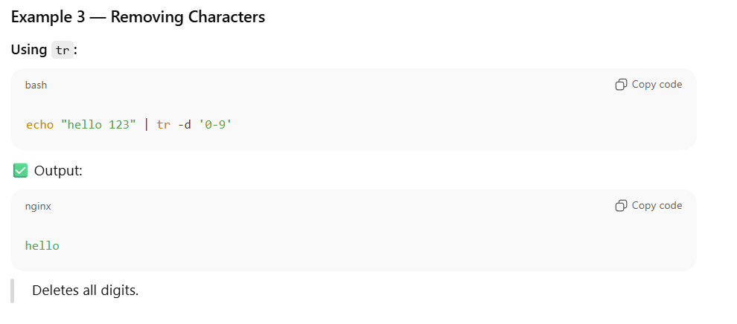

1. Variable Types in BASH

1. Accessing 1D elements in bash

1. Looping through Array elements

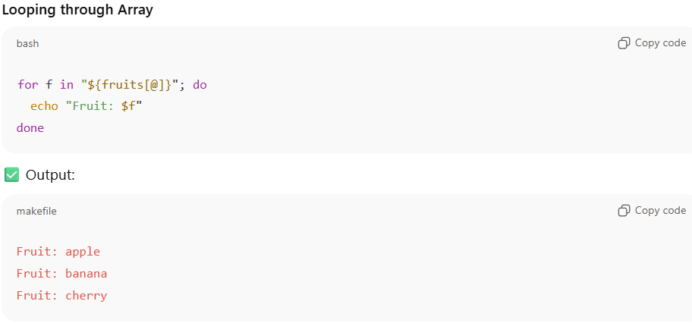

1. Associative Array (Key–Value Pair)

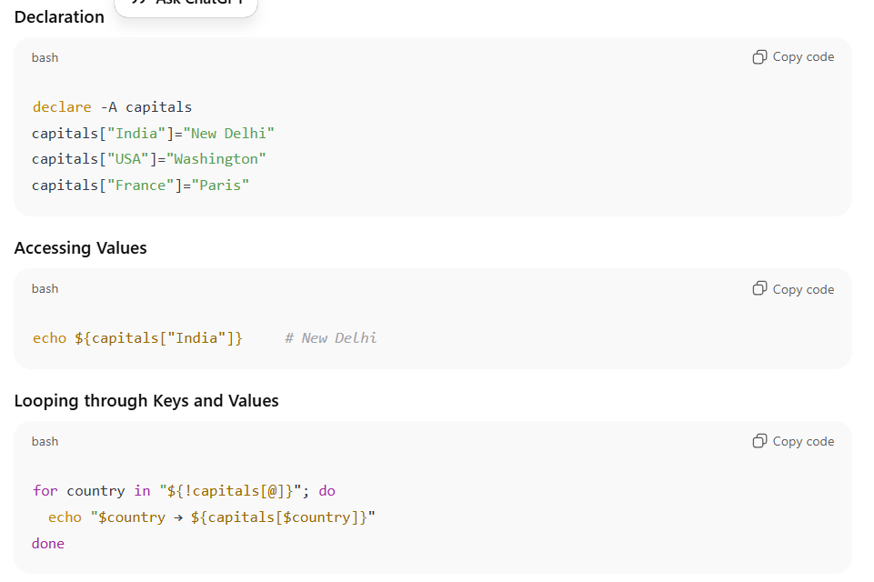

1. 2D Arrays in Bash (Simulated)

Bash doesn’t natively support true multidimensional arrays,  
but we can simulate them using **indexed arrays of arrays** or **associative arrays**.

1. Array Operations Summary

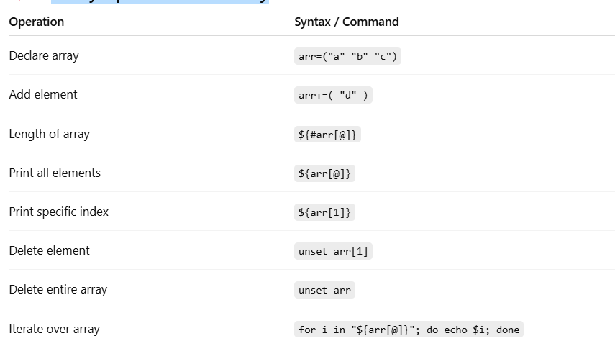

1. Build dynamically in a loop

If you want to **fill an empty 2D array on the fly** (dynamic size):

1. IF/ELSE – Syntax, Conditions (strings, numbers, files, logical, etc.)

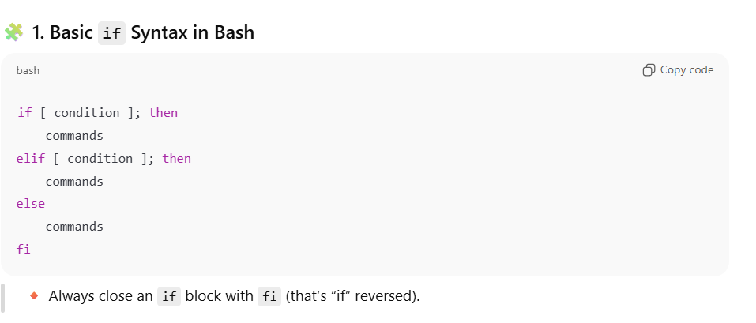

1. Array slicing 🡪 print second and third element of an array.

1. Reverse an array

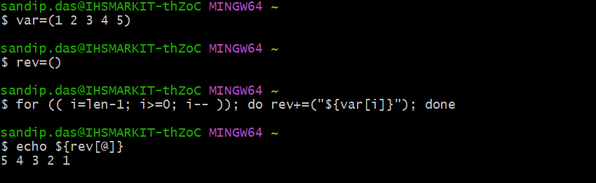

13 . How to reverse a string in bash?

var="12345"

rev=""

for(( i=0 ; i<${#var} ; i++ )); do rev="${var:i:1}$rev"; done

echo "var: $var, rev: $rev"

1. Find Duplicate Elements in an Array

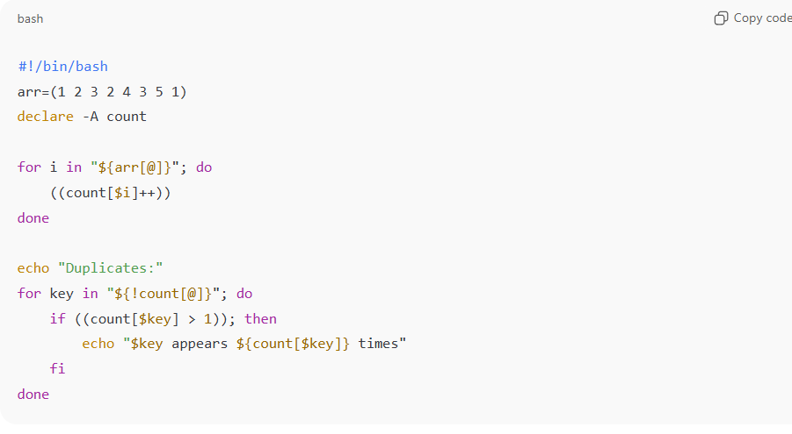======================================================================

**POWERSHELL**