Blueprint Automation
- Pre-requisites
- Java
- IDE: IntelliJ
- Android Development Tool Bundle.
- Appium above 1.10.
- Android device above 6.0.
- Git
- Maven

- Guide for Software Installations
- Java
- Go to below link, Click on Download JDK. For java latest version.
https://www.oracle.com/technetwork/java/javase/downloads/index.html

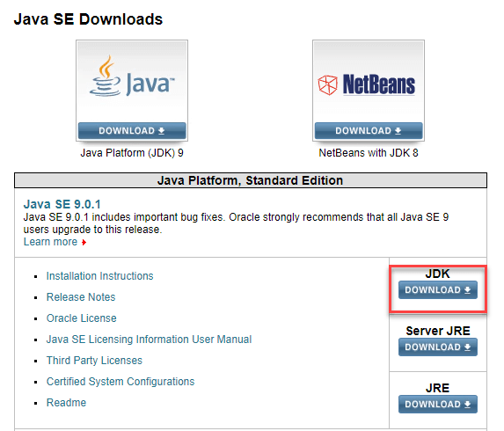
- Accept License Agreement
- Download latest Java JDK for your version(32 or 64 bit) of java for Windows.
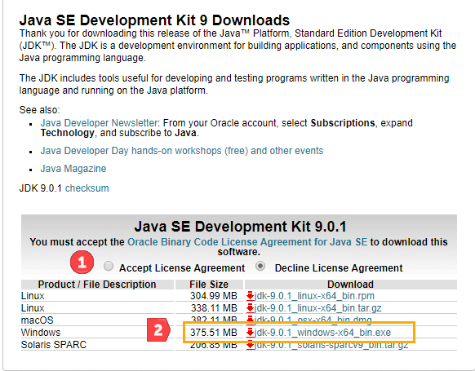
- Once the download is complete, run the exe for install JDK. Click Next

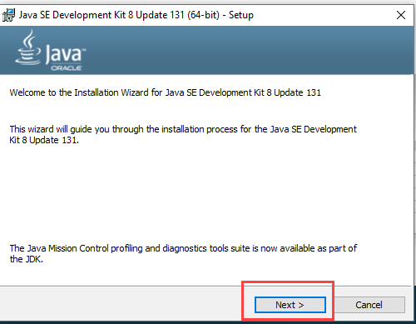

- Once installation is complete click Close

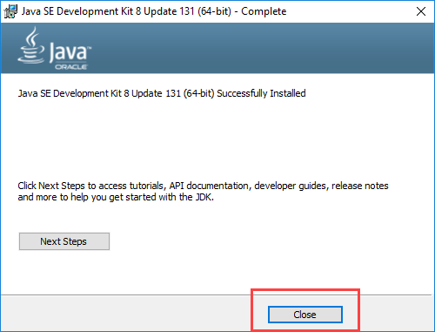

- Append path of bin folder of JDK under PATH environment variable

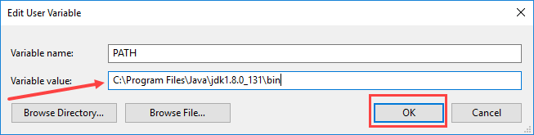
- Go to command prompt and type java -version commands,
If you see a screen like below, Java is installed.

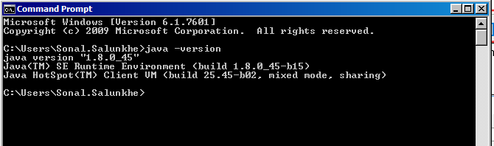

- IntelliJ
- Go to below link, Select Community Edition for windows
https://www.jetbrains.com/idea/download/#section=windows
- Download .exe file.
- Run the exe for install IntelliJ.

- Android Development Tool Bundle
- Go to below link, Select .zip file according to your processor.
https://developer.oculus.com/documentation/mobilesdk/0.6/concepts/mobile-dev-setup-android-win/
- Extract .zip file and save folder in c drive.
- Add ANDROID_HOME system variables, and point it to the sdk folder of Android Development Tool.
Example, C:\adt-bundle-windows-x86_64-20131030\sdk
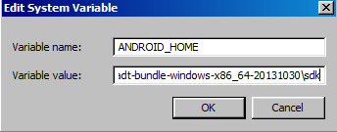
- Append path of tools folder of Android Development Tool Bundle under PATH environment variable.
Example. C:\adt-bundle-windows-x86_64-20131030\sdk\tools
- Append path of platform-tools folder of Android Development Tool Bundle under PATH environment variable
Example. C:\adt-bundle-windows-x86_64-20131030\sdk\platform-tools
- Type the following command line in command prompt by connecting your device.
- adb devices –l
- uiautomatorviewer
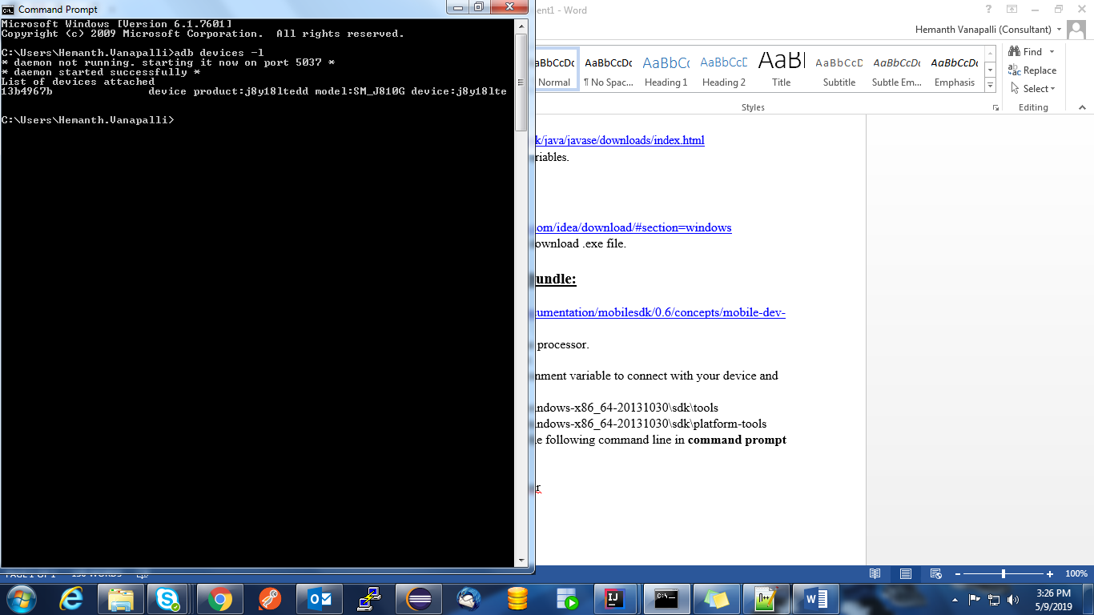
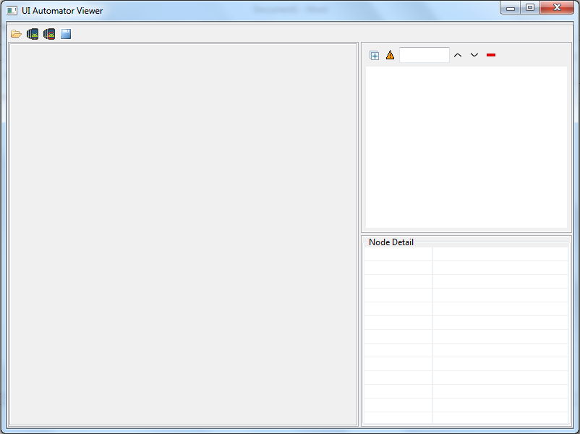

- Appium
- Go to below link and click on download Appium,
http://appium.io/
- Download AppiumForWindows.zip file for windows of latest version
- Run the downloaded exe for install Appium.
- Open Appium tool and click on edit configurations.
- Set ANDROID_HOME : paste the path of sdk folder of Android Development Tool Bundle
eg. C:\adt-bundle-windows-x86_64-20131030\sdk
- Set JAVA_HOME : paste the path of bin folder of JDK
Eg. C:\Program Files\Java\jdk1.8.0_181\bin
- Click on Save and Restart.

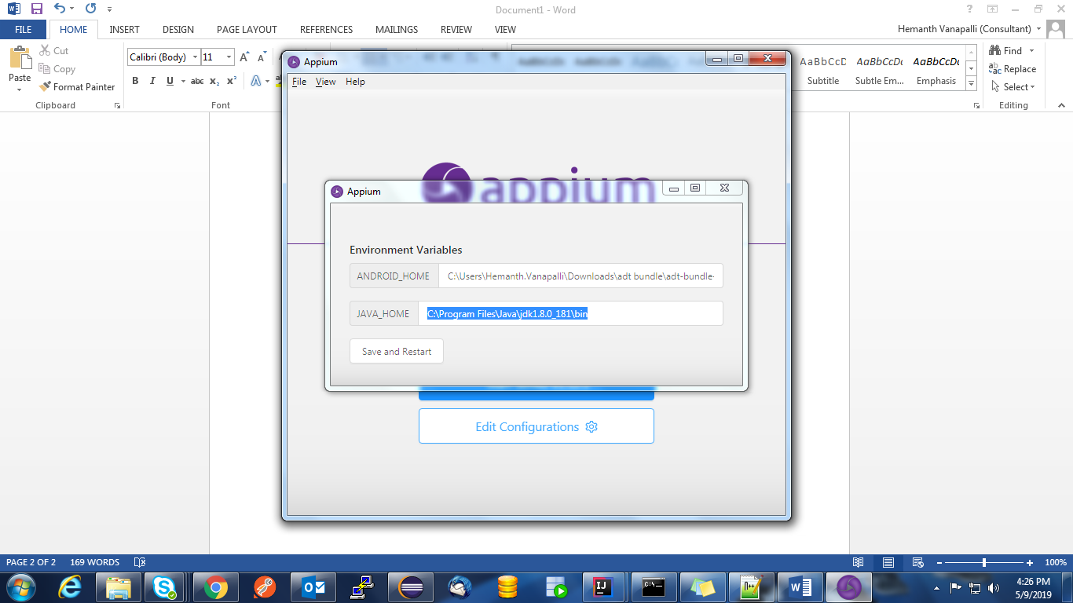

- Git
- Go to below link and download the latest Git for Windows.
https://gitforwindows.org/

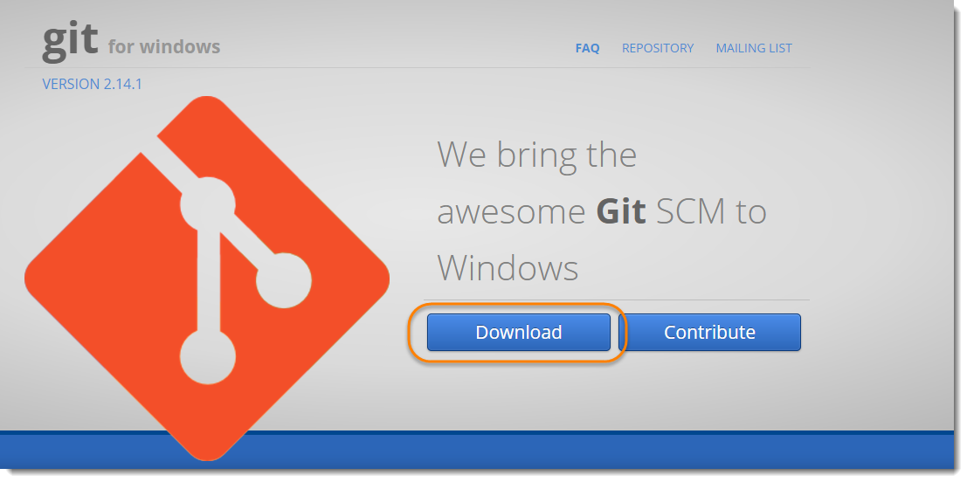

- Double click on the downloaded installer

- Select destination folder for Git where you want to install

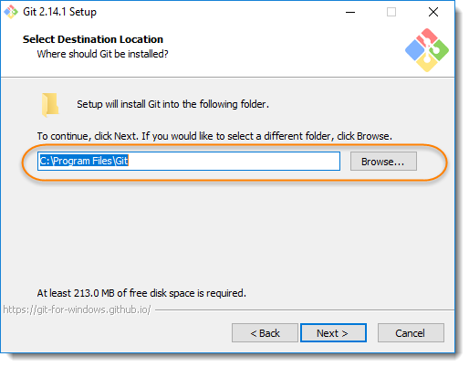

- Create shortcut of the Git under the Program Menu. And click on next.

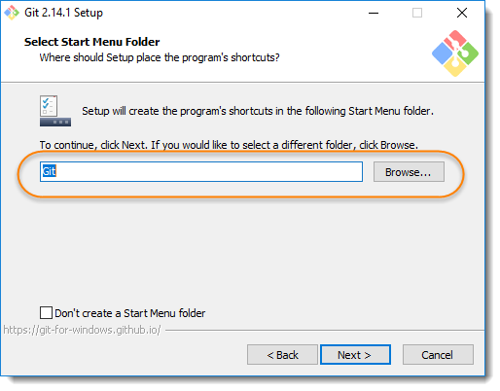

- Click on Use Git from the Windows Command Prompt and click on next.

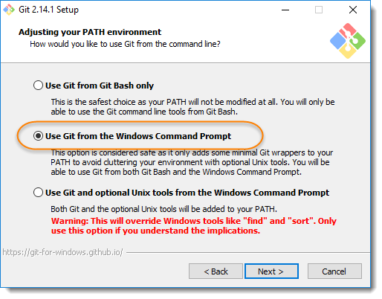

- If Putty/TortoiseSVN installed in machine, you may see this screen, otherwise just ignore this. Regardless, choose use the OpenSSL library option. And click on next.

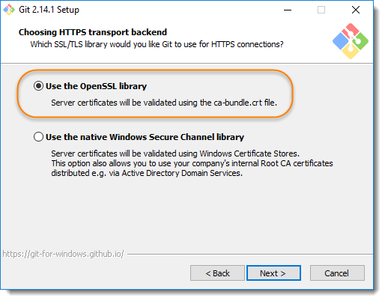

- Click on the option of Checkout Windows-style, commit Unix-style line endings. Select next once you have done this.
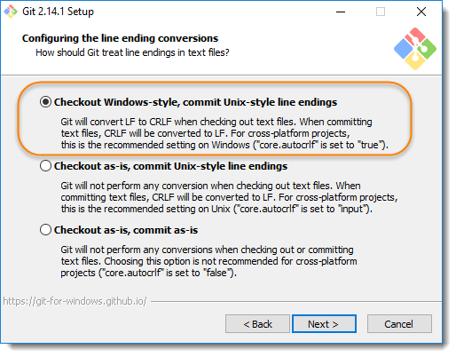
- Just go with default selection and move forward.

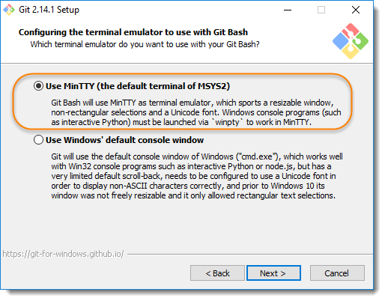

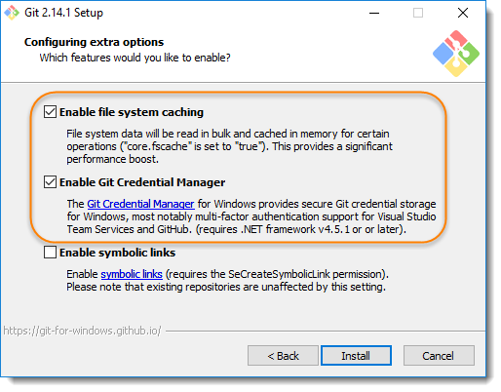

- Once done, just click on Finish button.

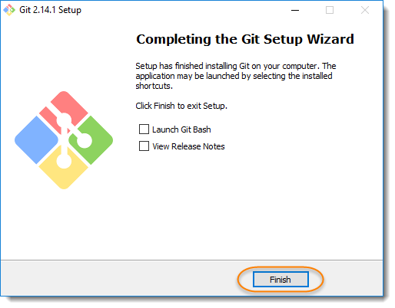

- Append path of bin folder of GIT under PATH environment variable.
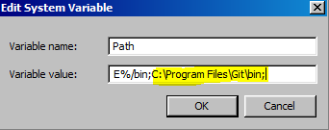

- Append path of cmd folder of GIT under PATH environment variable.
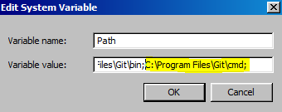

- Open command prompt and type git to check if git is successfully installed.

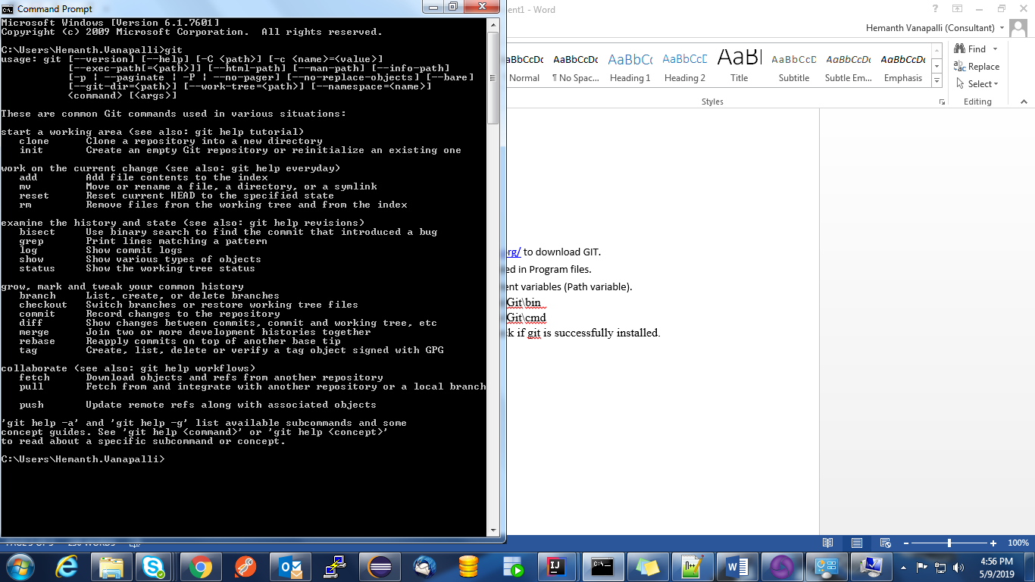

- Maven
  - Go to below link and download the Maven zip file.
https://maven.apache.org/download.cgi

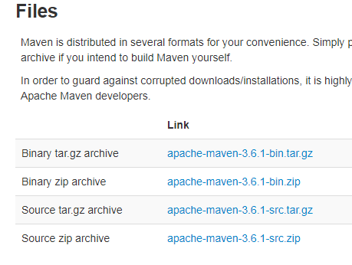

  - Unzip it into Program Files folder in C drive.
  - Add a MAVEN_HOME system variables, and point it to the Maven folder, Also append path upto bin folder of maven under PATH environment variable.
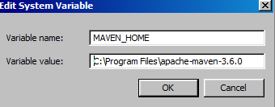

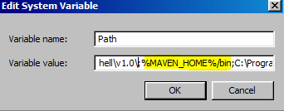

  - Open settings.xml file in conf folder of maven.
  - Change the proxy to fpproxy.in.ril.com in proxies tag. Refer below image to set the proxy.

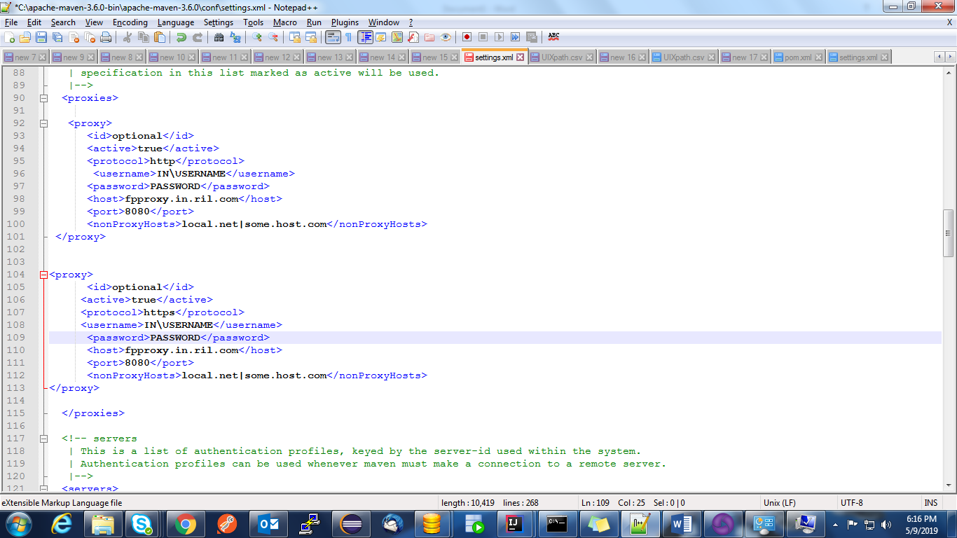

- Steps to Import Project in IntelliJ

  - Download the project from Sharepoint.
  - Open IntelliJ IDEA and close any existing project.
  - From the Welcome screen, click Import Project. The Select File or Directory to Import dialog opens.

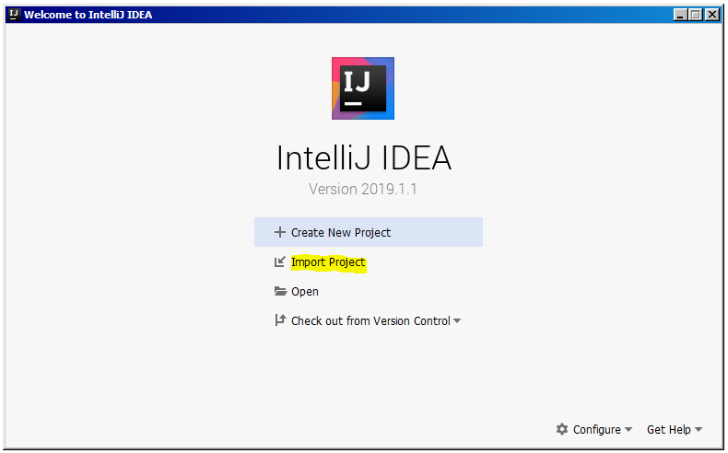
  - Navigate to your Maven project and select the top-level folder. For example, with a project named JFS_Automation

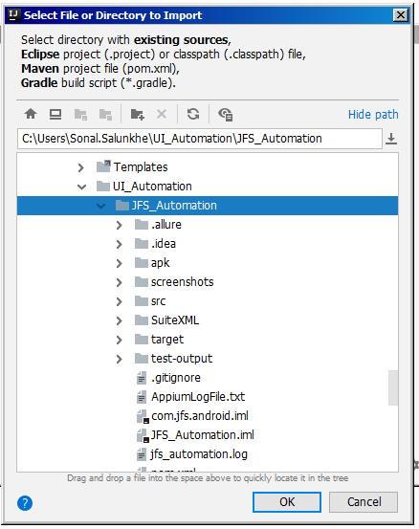
  - Click OK. Import Project Screen opens as below
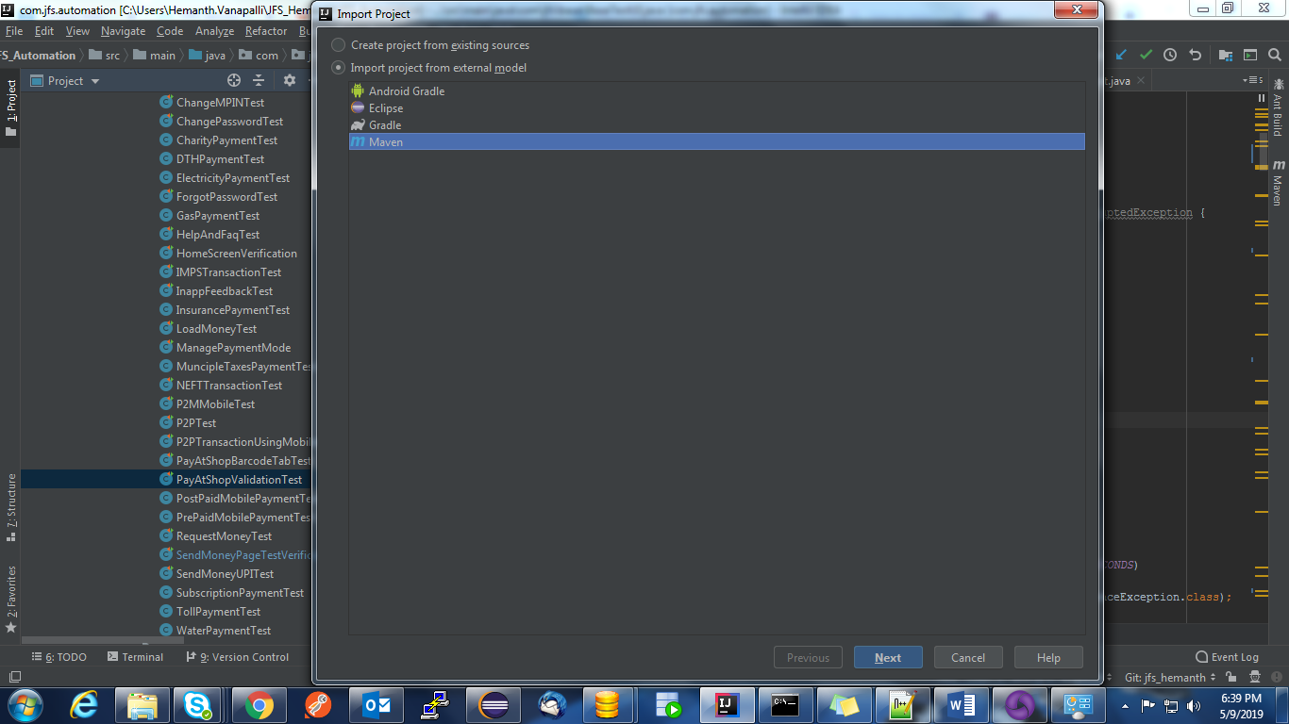

  - For the Import project from external model value, select Maven and click Next.
  - Select Import Maven projects automatically and leave the other fields with default values.
  - Click Next. Your Maven project should be selected for import

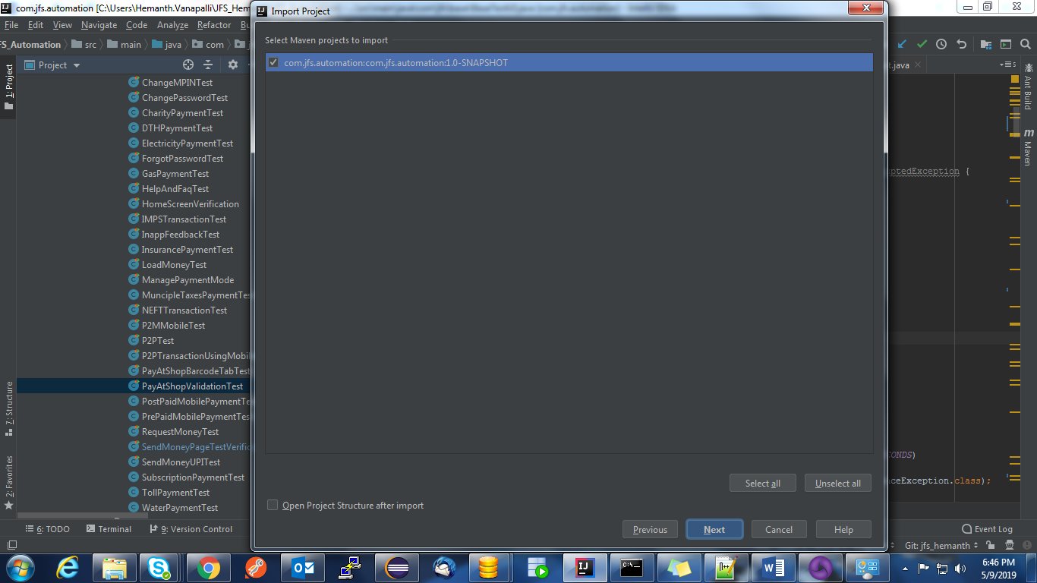

  - Click Next. The Please select project SDK screen opens.
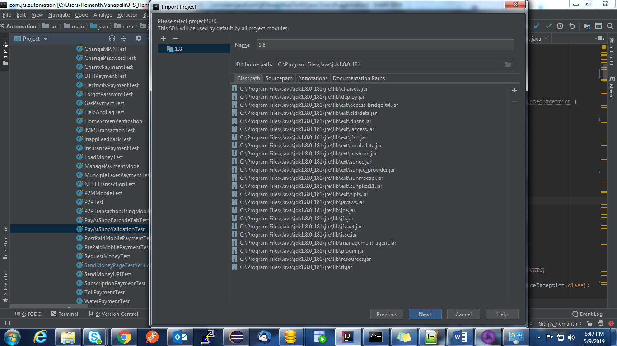

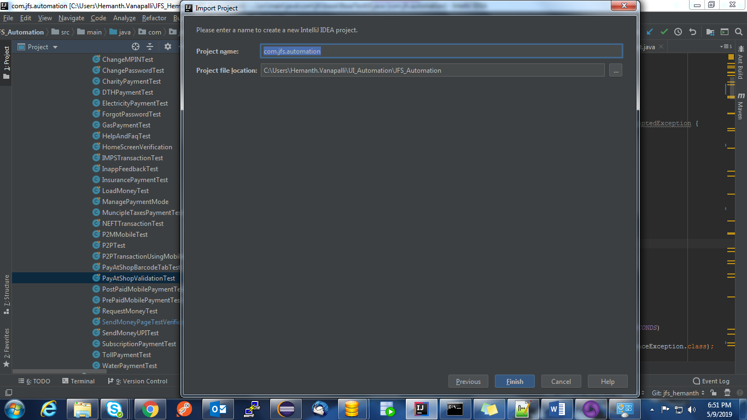
  - Make sure the correct JDC is selected and click Next.
  - Change the project name and location if you like, and click Finish.

