**day07_107856406_dsdipt_sudipto_4june2025**

**Employee Code:** 107856406

**Login ID:** dsdipt

**Email :** dsdipt@amazon.com

**Name:** Sudipto Das

**Date:** 4 June 2025 (Day 07)

### ***Task 1: Write a Java program to print “Hello guys!!!!” and “We are learning Java”.***

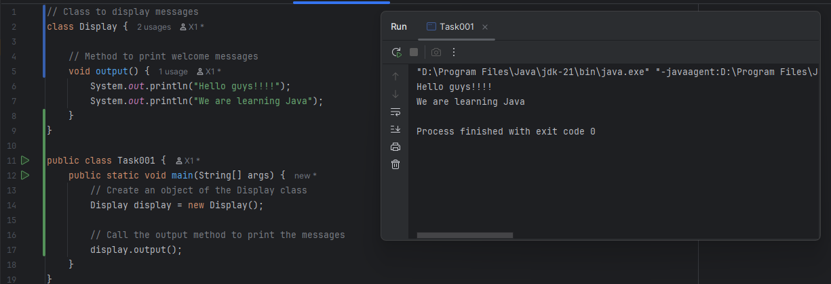

### ***Task 2:*** ***Write a Program in Java to Add two Numbers.***

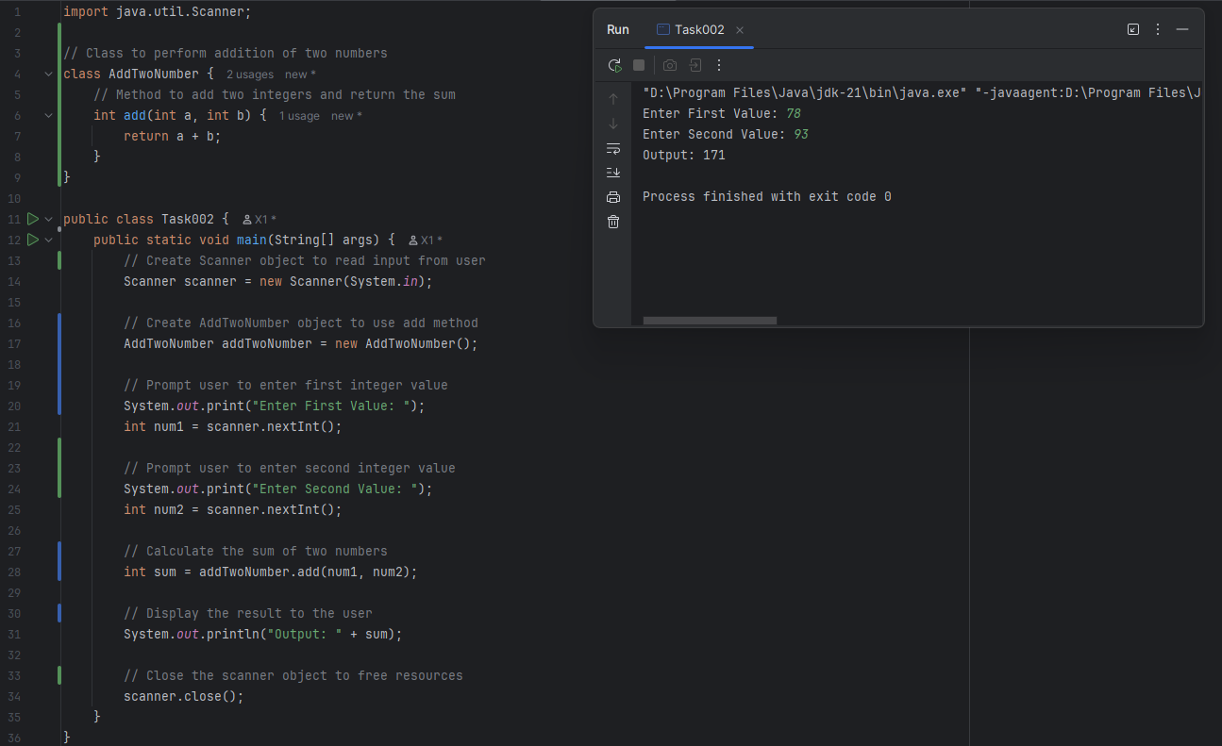

### ***Task 3:*** ***Write a Program to Swap Two Numbers.***

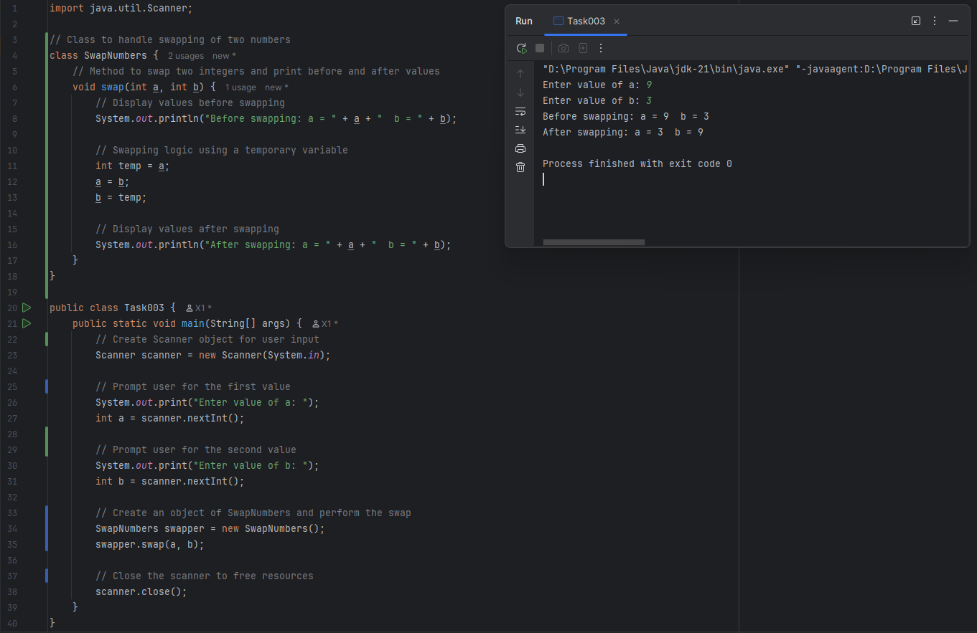

### ***Task 4: Java program with main() calling 4 methods (add, subtract, multiply, divide)***

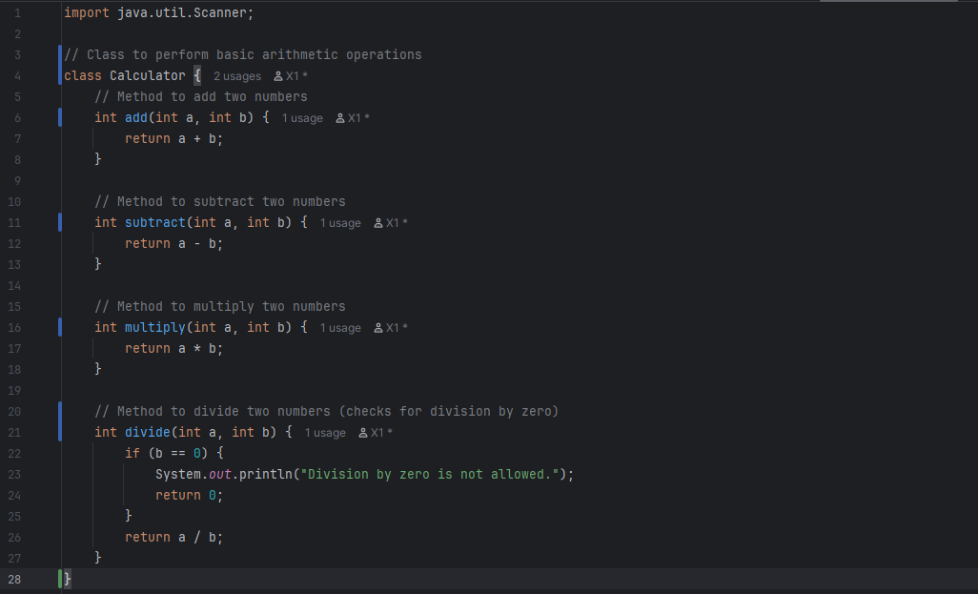

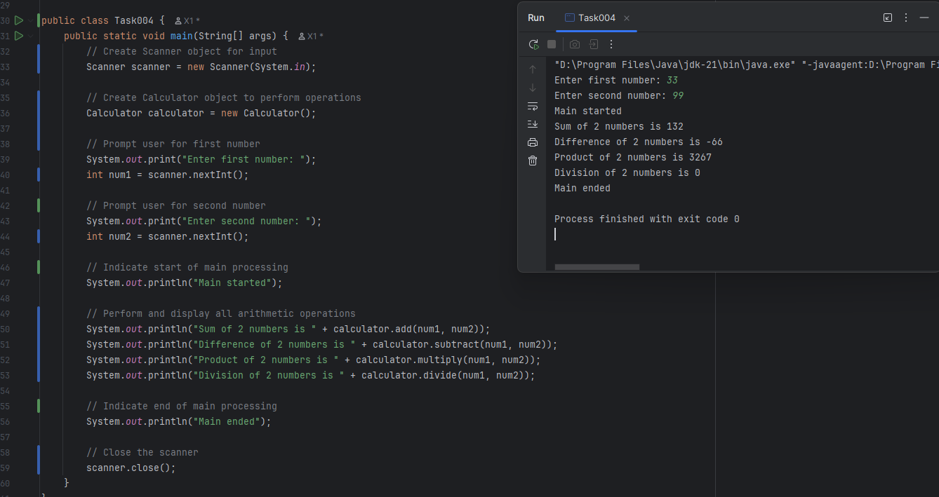

### ***Task 5: Write a Java program to check if a is greater than b using the ternary operator.***

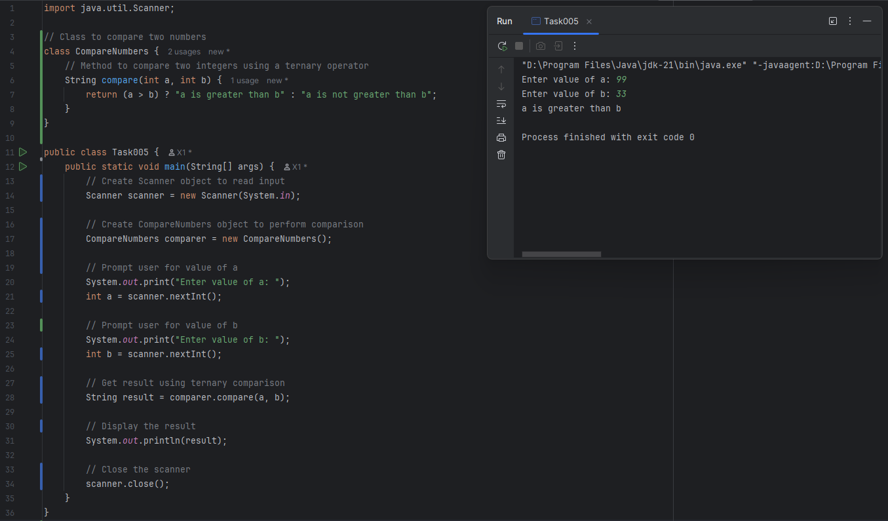

### ***Task 6: Write a Java program to take input from the user and display the same input.***

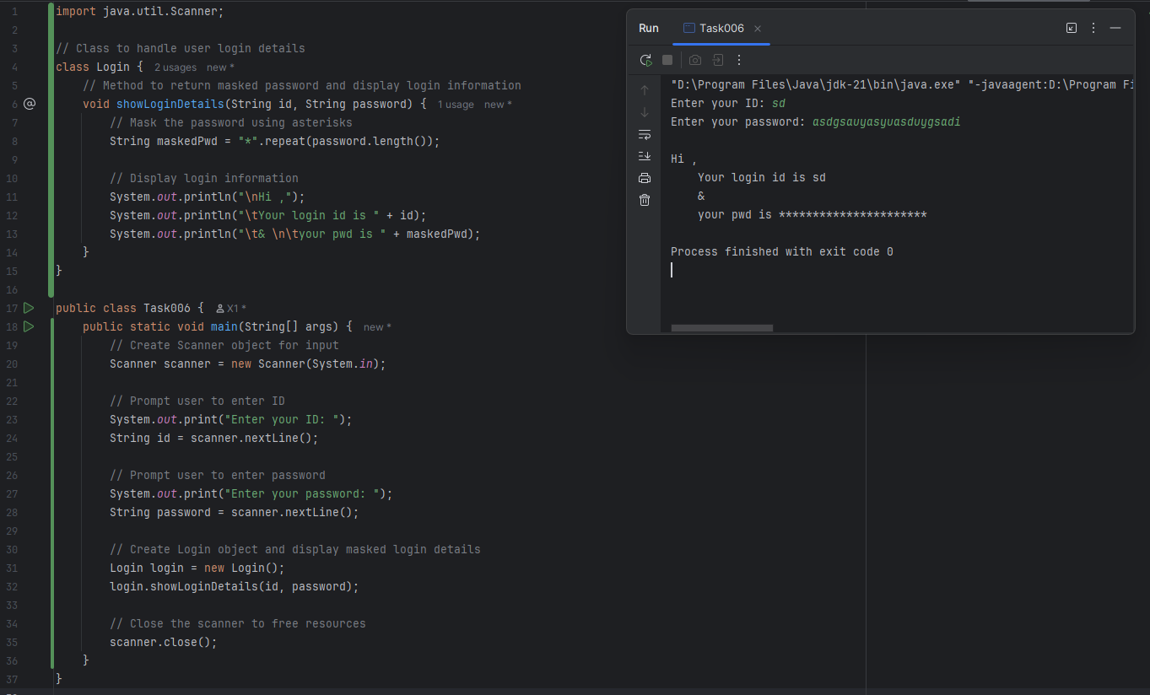

### ***Task 7: Write a Java program to create an object of a class.***

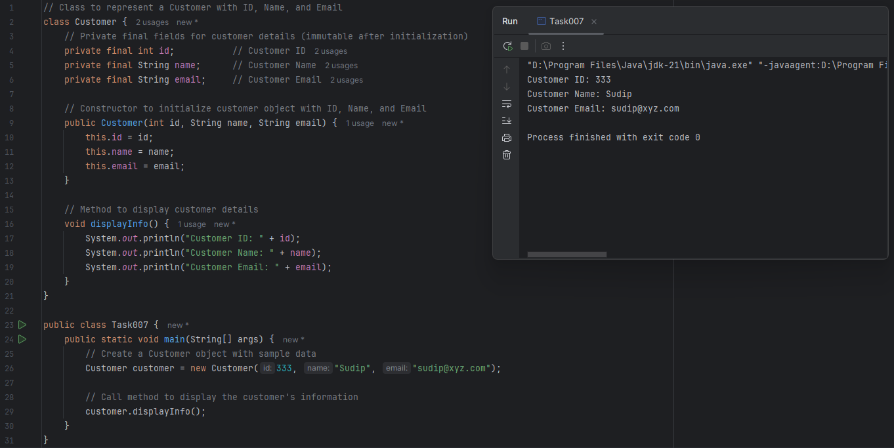

### ***Task 8: Write a program to check which of the two numbers is greater.***

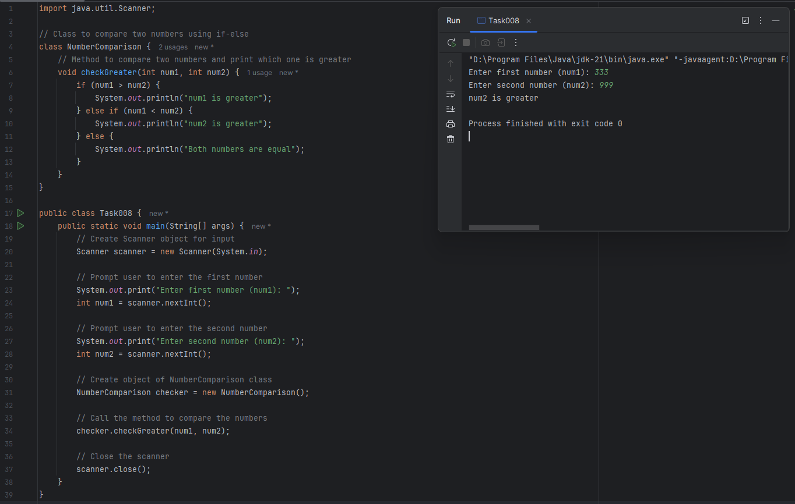

### ***Task 9: Check Greater of 3 Numbers (using else-if)***

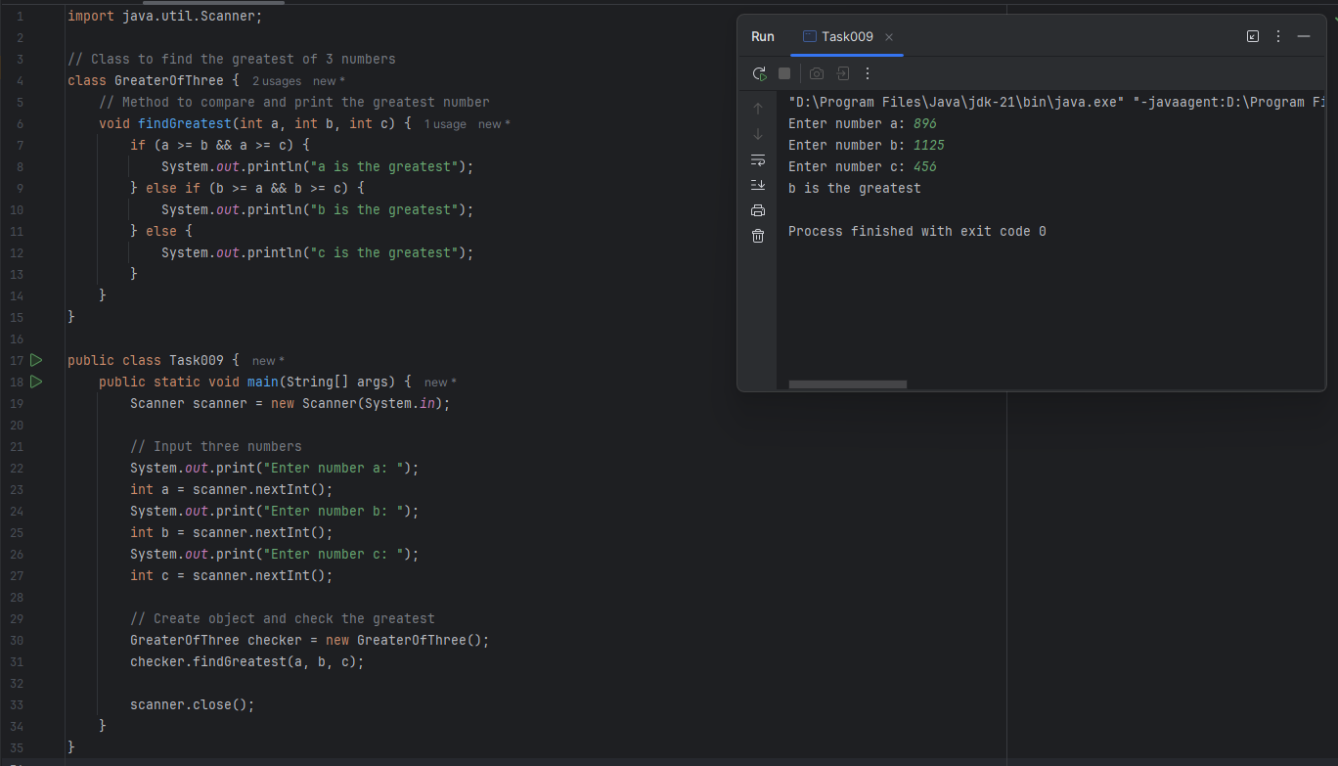

### ***Task 10: Display day of the week for a given number.***

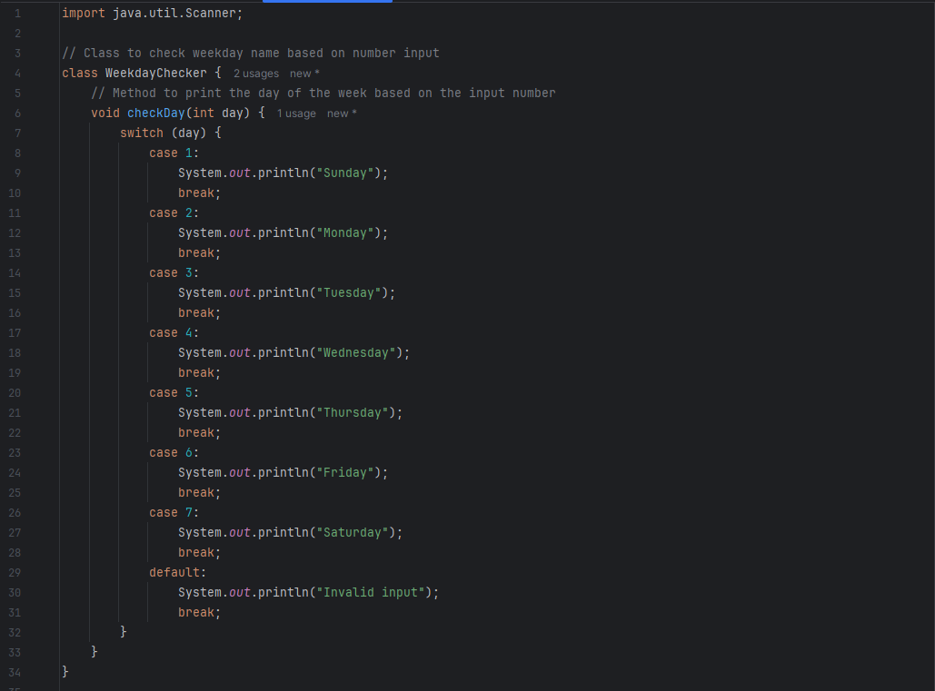

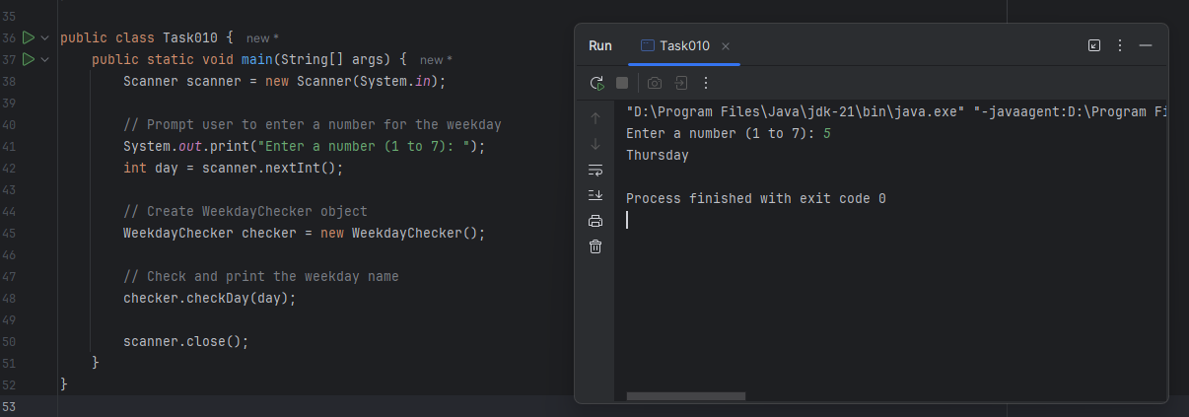

### ***Task 11: Write a program to validate login ID and password using a while loop.***

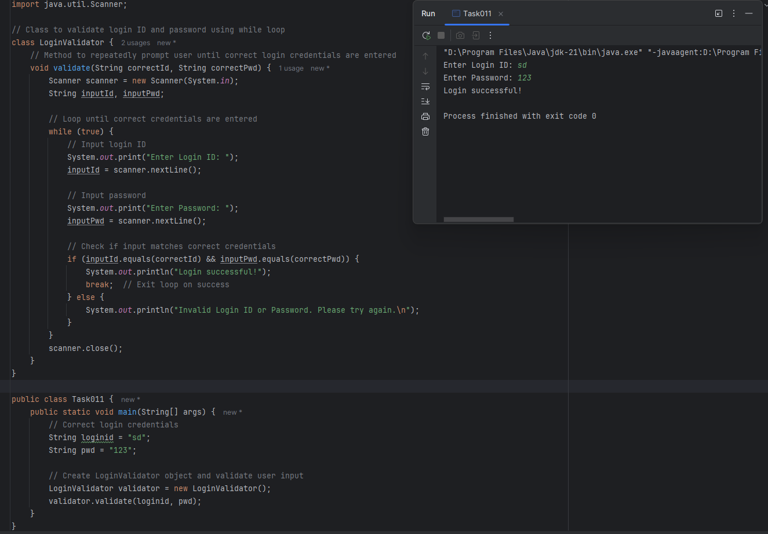

### ***Task 12: Write a program to validate login ID and password using a do-while loop.***

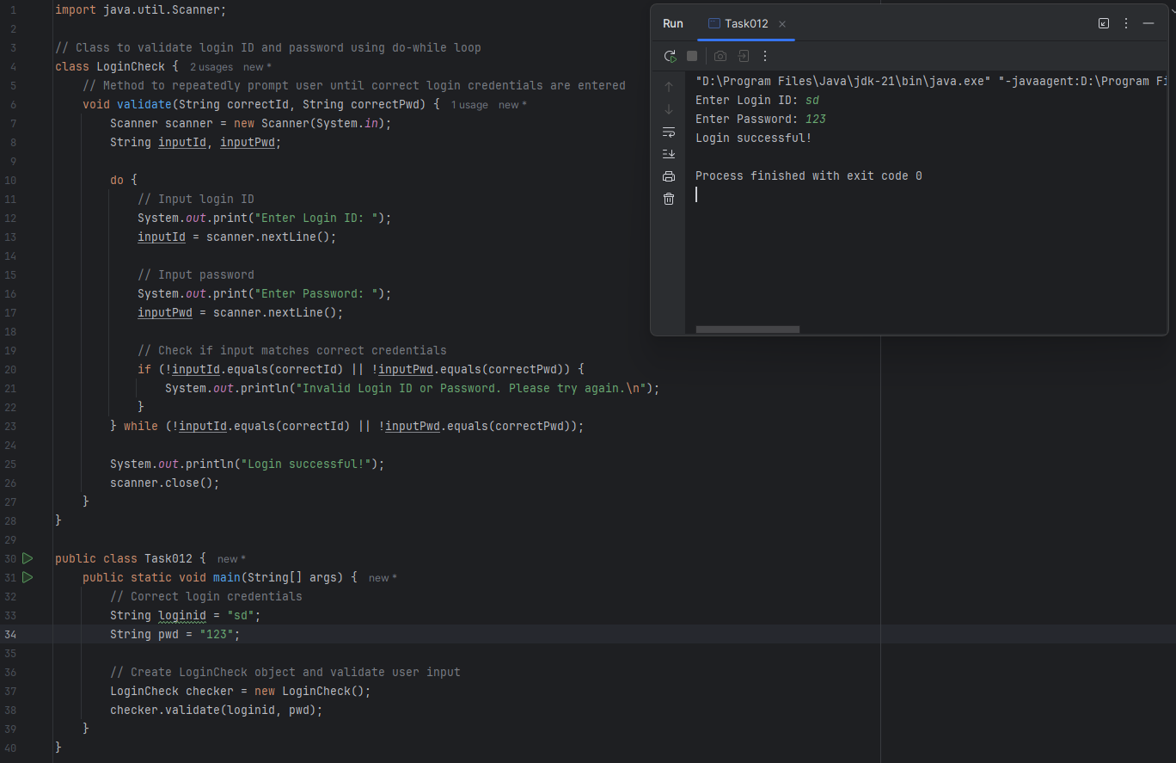

### ***Task 13: Print numbers from 10 to 1 skipping 7 and 5 using loop and continue.***

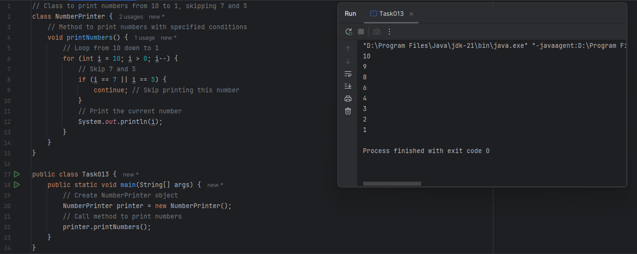

### ***Task 14: Try below code and show output.***

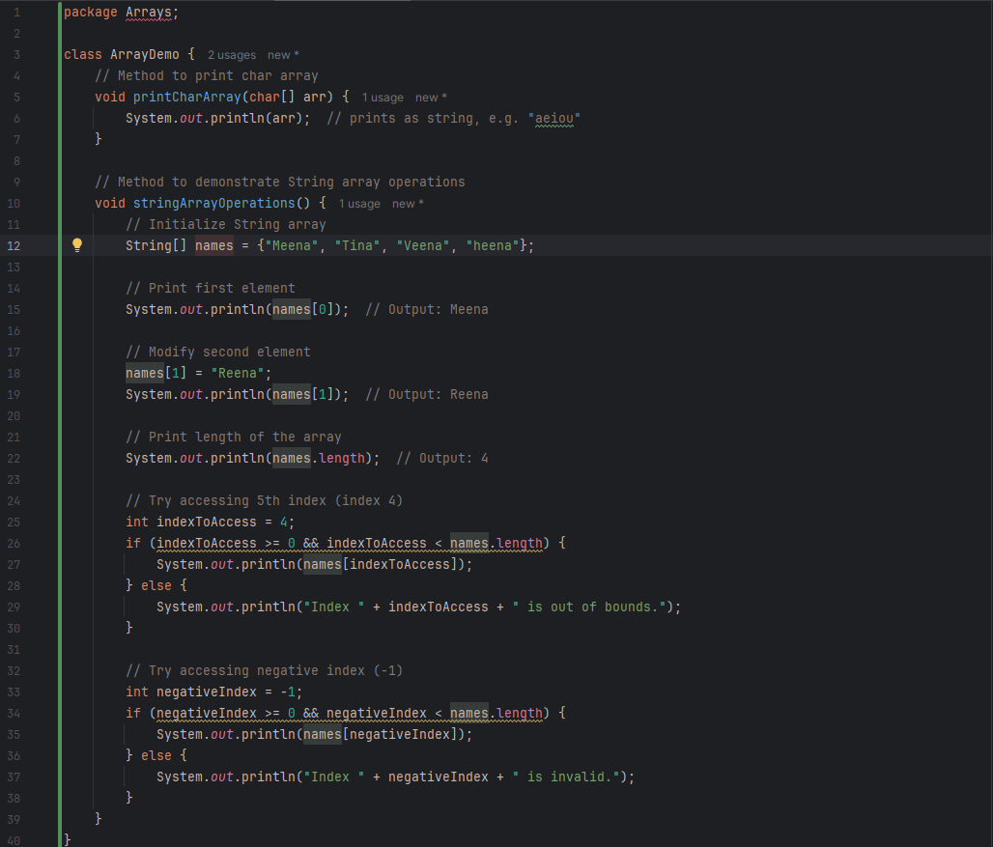

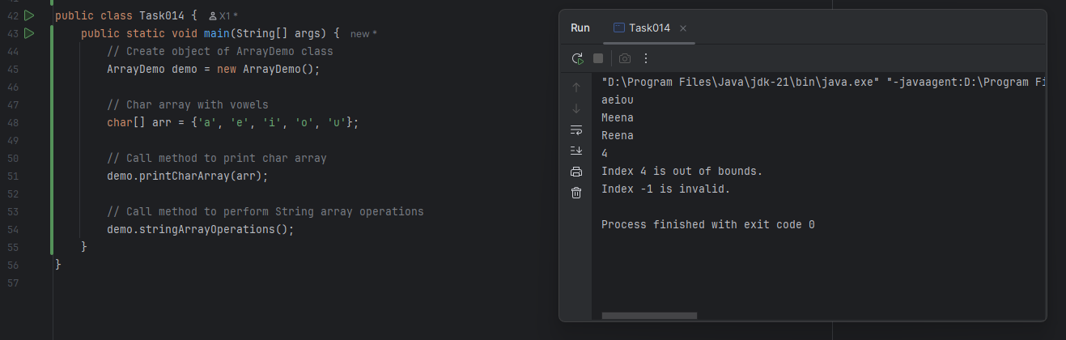

### ***Task 15: StringHandling***

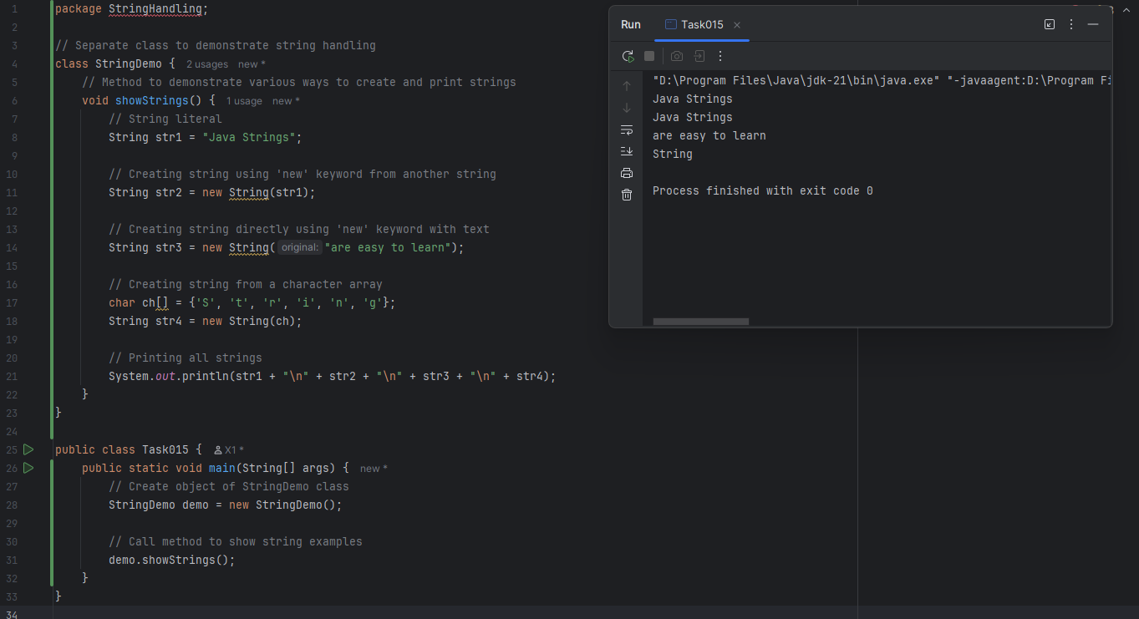

### ***Task 16: Enumerations***

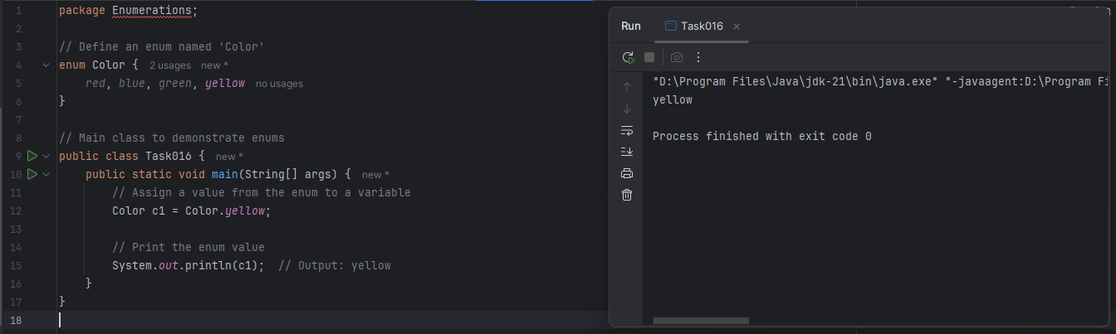

### ***Task 17: w/o calling Getter & Setter***

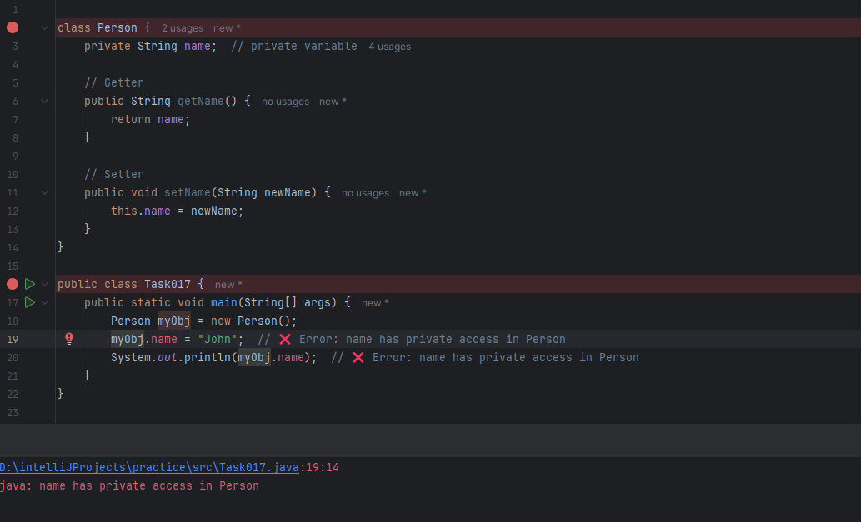

### ***Task 18: with Getter & Setter***

### 