**day08_107856406_dsdipt_sudipto_5june2025**

**Employee Code:** 107856406

**Login ID:** dsdipt

**Email :** dsdipt@amazon.com

**Name:** Sudipto Das

**Date:** 5 June 2025 (Day 08)

### ***Task 19: display the content of the enum***

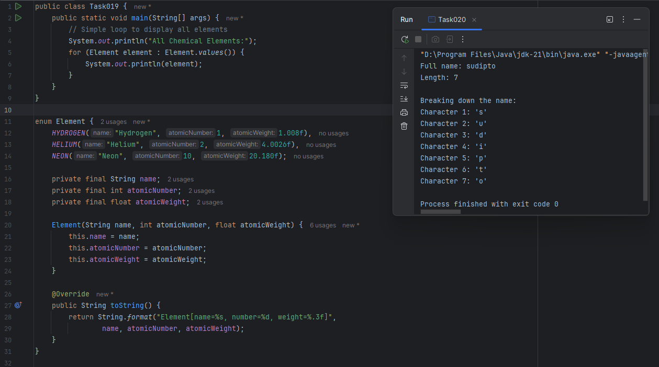

### ***Task 20: Create an array of your name & find length.***

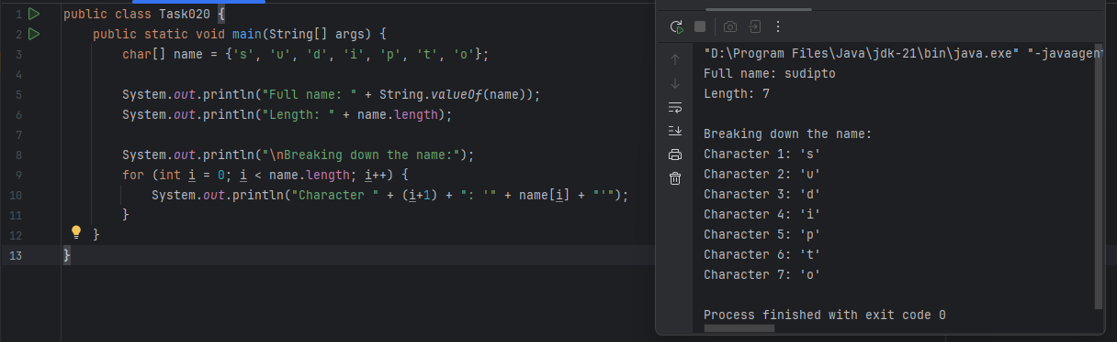

### ***Task 21: initialize an array and traverse it using a for loop***

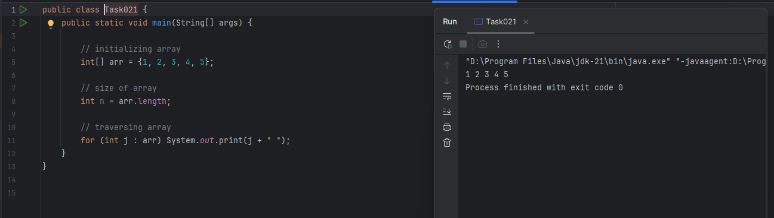

### ***Task 22: create an array with int value and print***

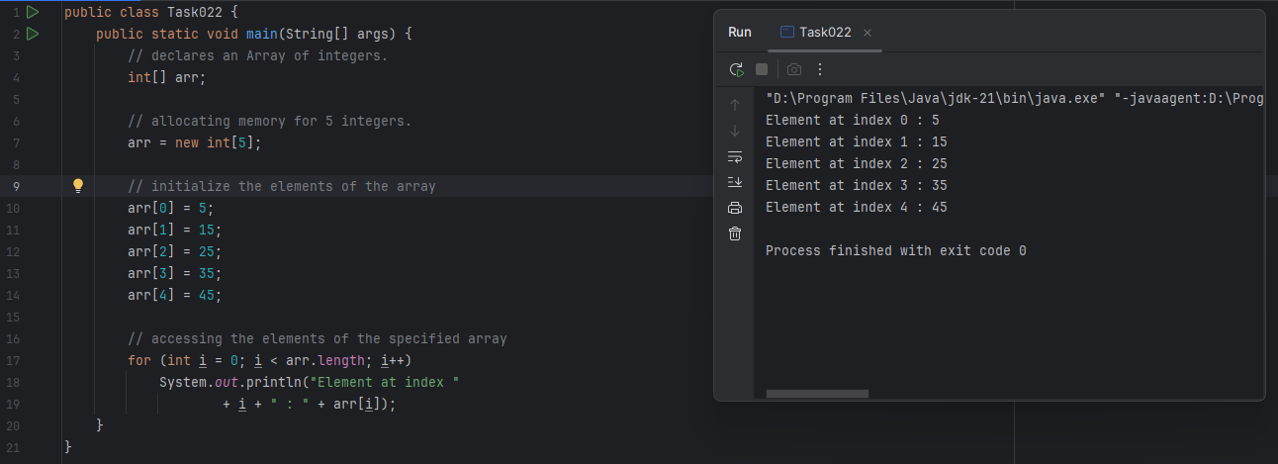

### ***Task 23: create an array of objects, method one.***

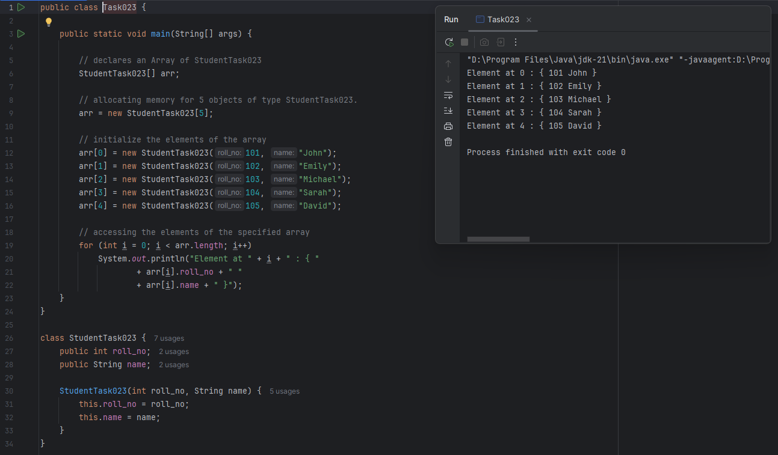

### ***Task 24: create an array of objects, method two.***

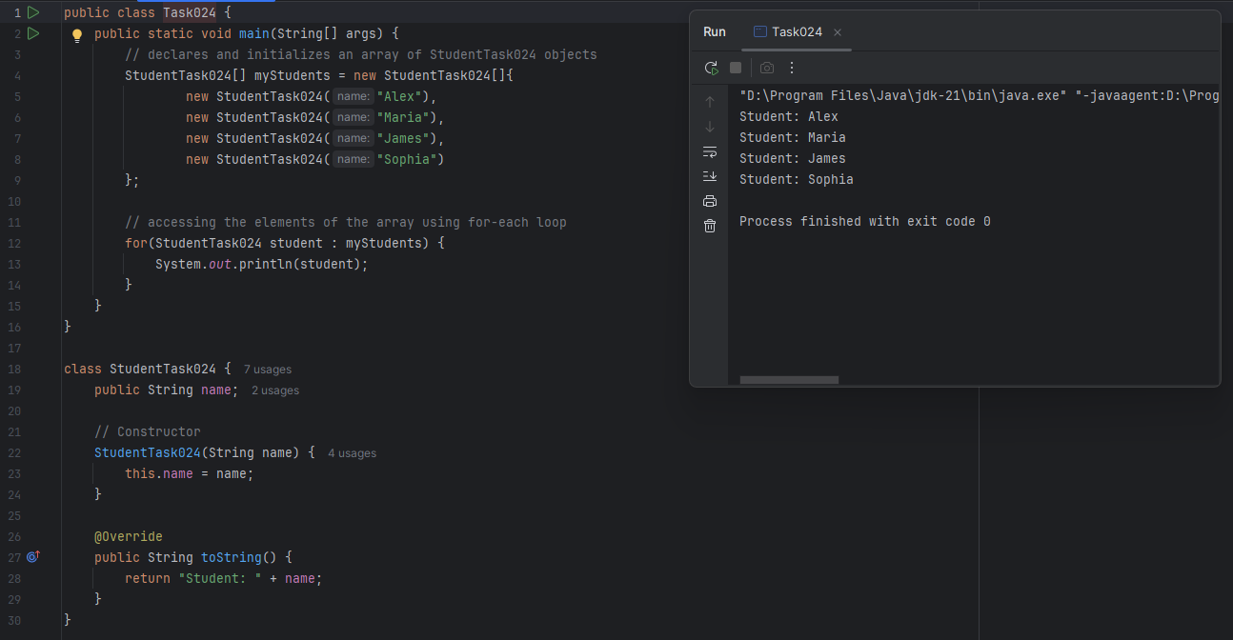

### ***Task 25: Code for showing error "ArrayIndexOutOfBoundsException"***

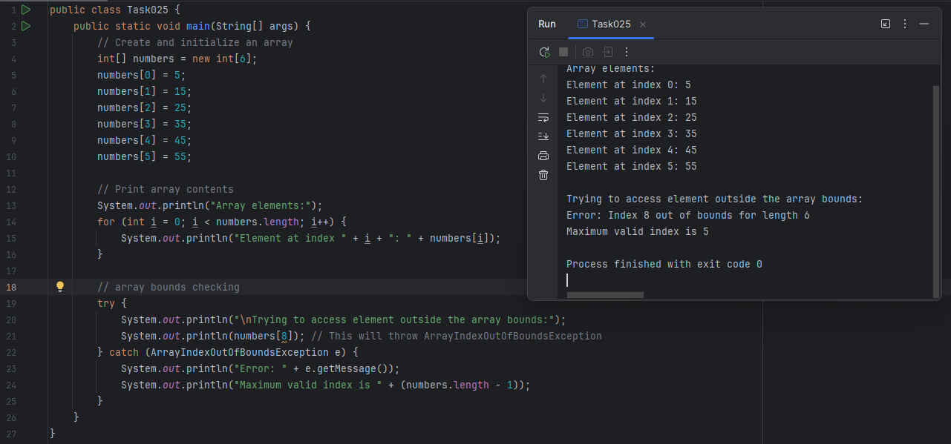

### ***Task 26: Java Multidimensional Array***

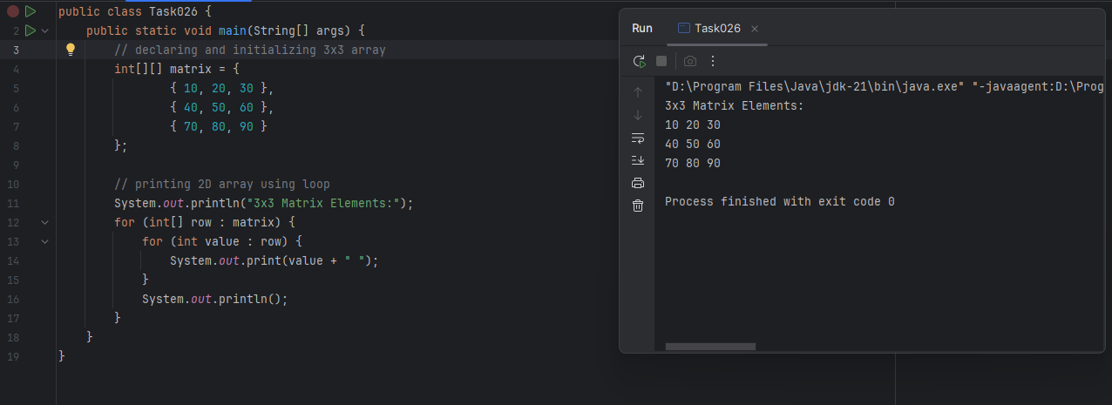

### ***Task 27: Passing Arrays to Methods***

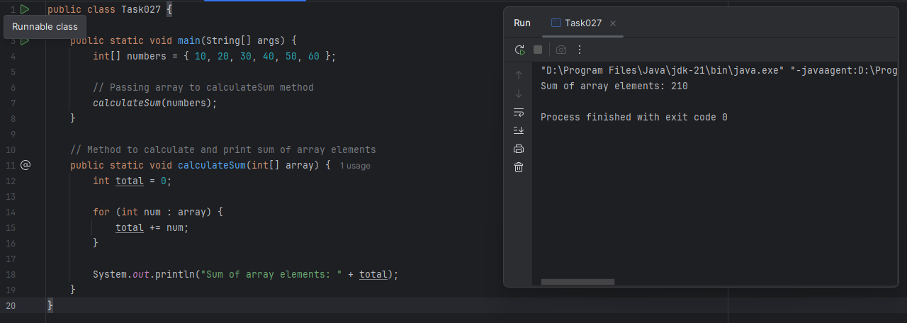

### ***Task 28: Returning Arrays from Methods***

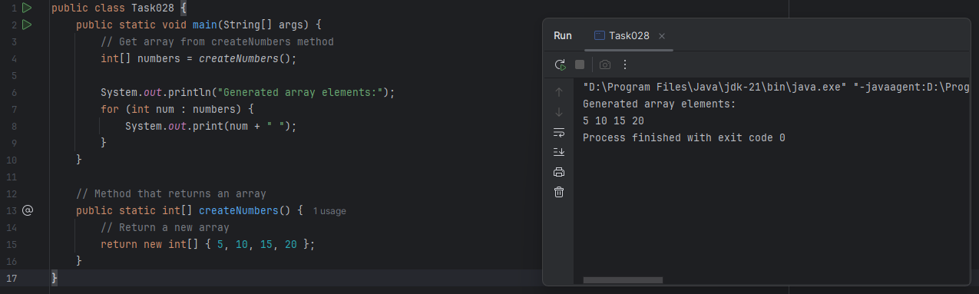

### ***Task 29: Cloning of Single-Dimensional Array***

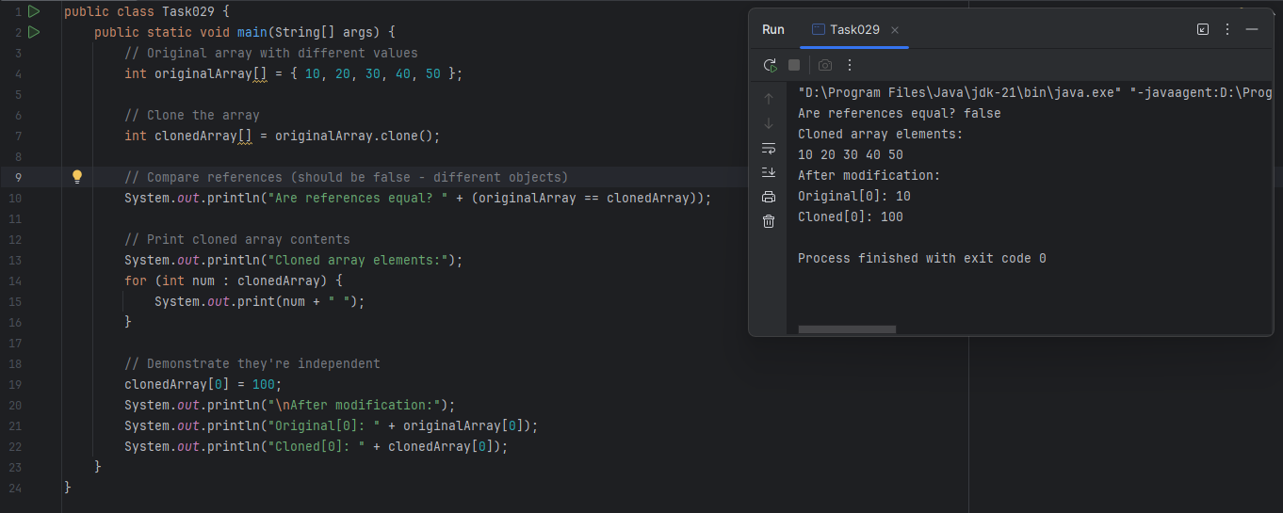

### ***Task 30: Cloning Multidimensional Array***

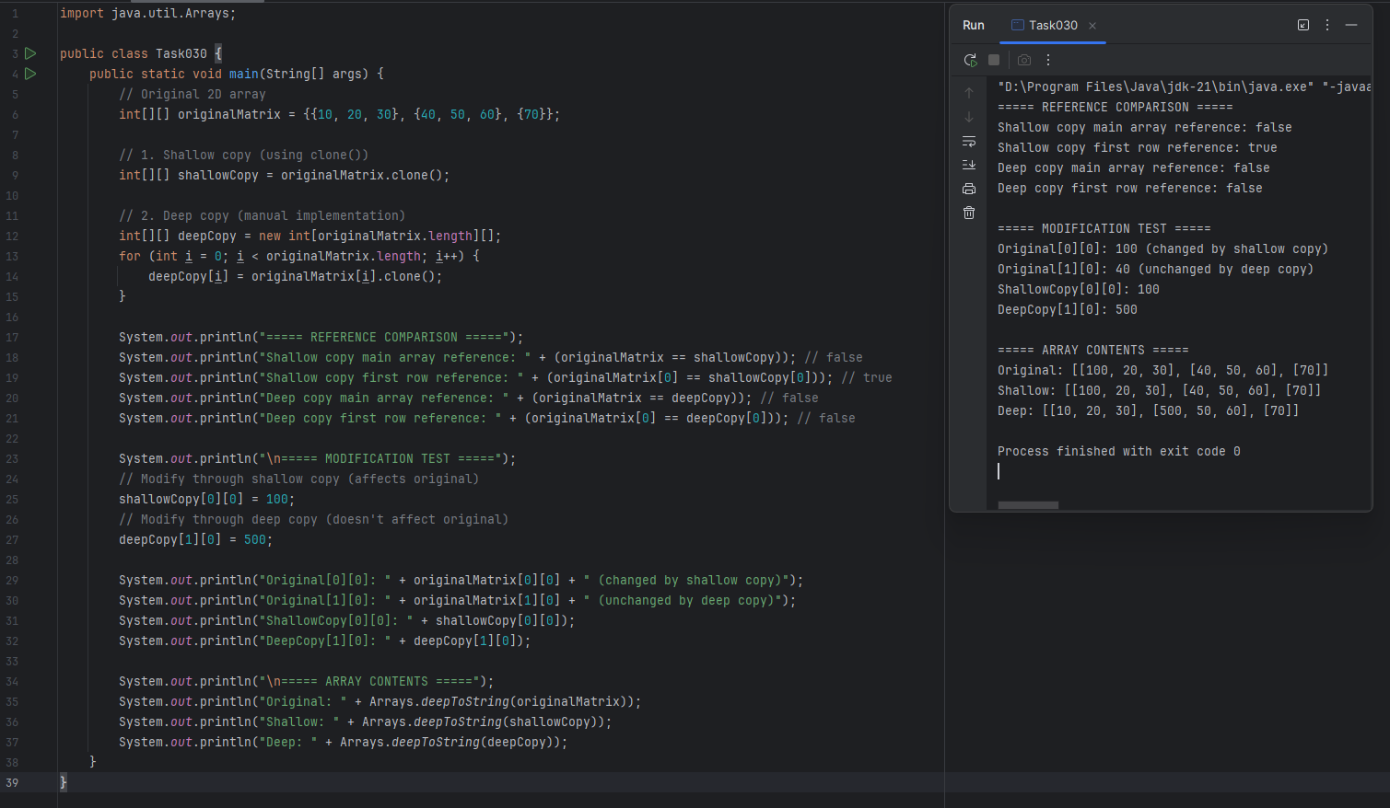

### ***Task 31: Implementing Multilevel Inheritance in a Calculator Hierarchy***

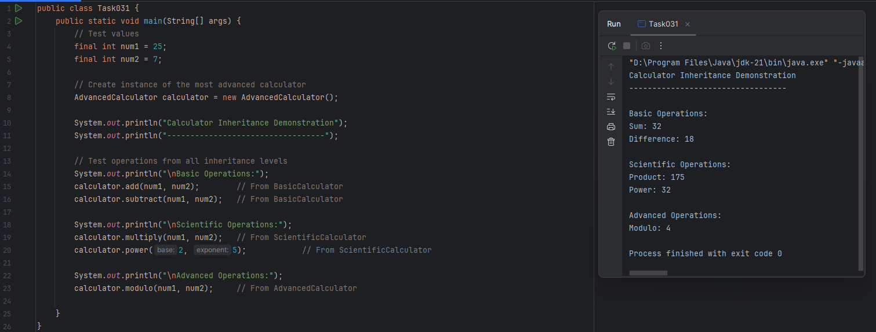

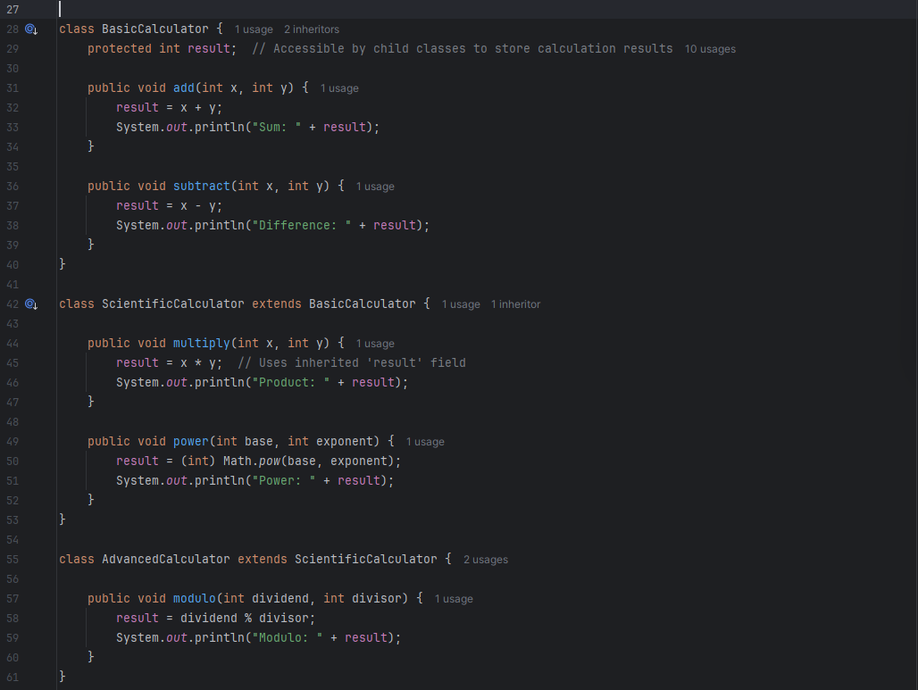

### ***Task 32: Multiple Inheritance Error in Java***

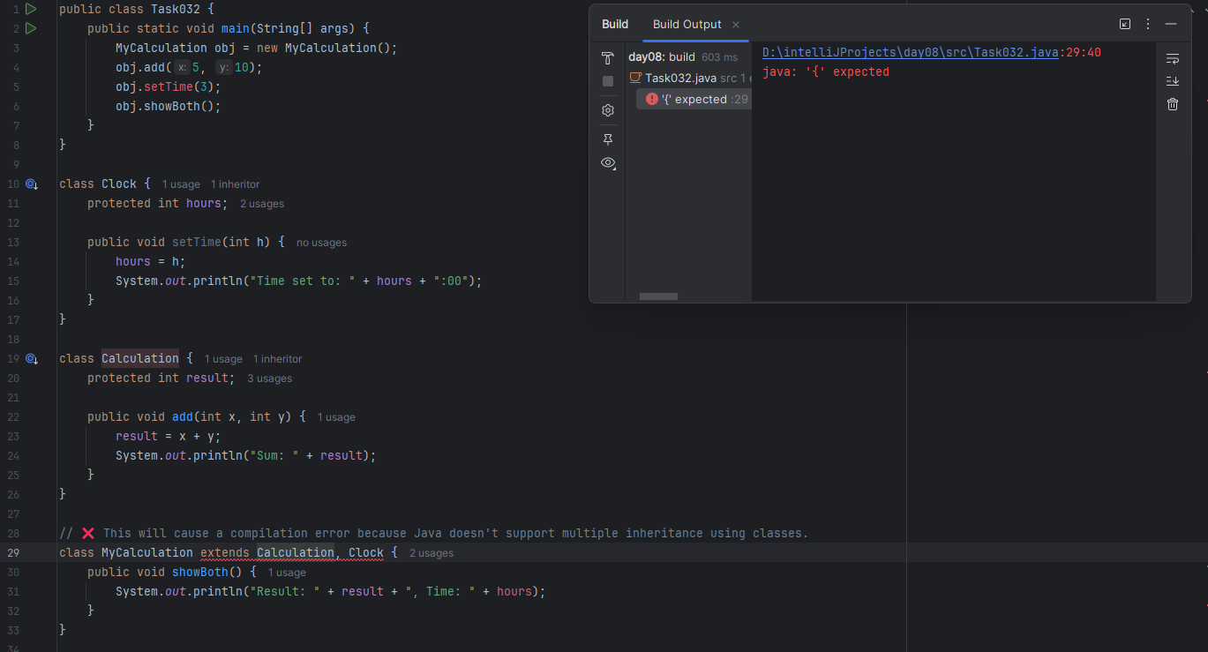

### ***Task 33: super Keyword Usage in Inheritance***

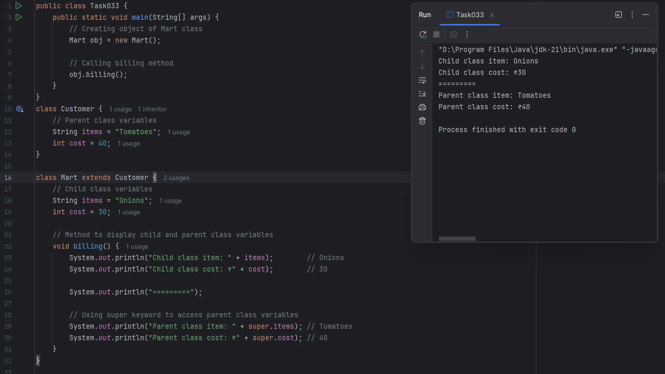

### ***Task 34: Method Overloading with Different Number of Parameters***

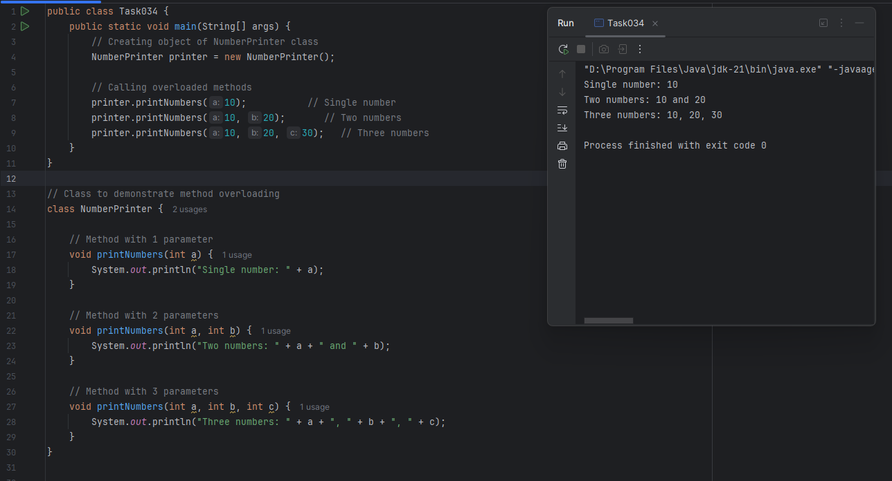

### ***Task 35: Method Overloading Based on Data Type***

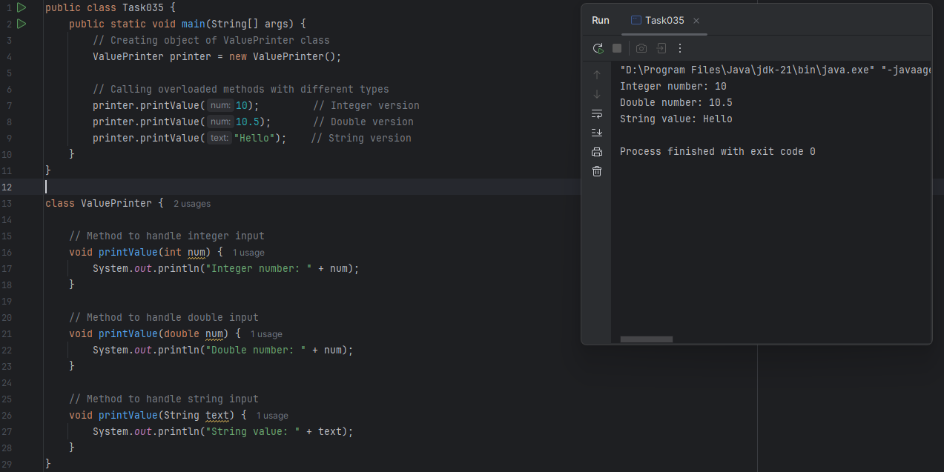

### ***Task 36: Method Overloading Based on Parameter Sequence***

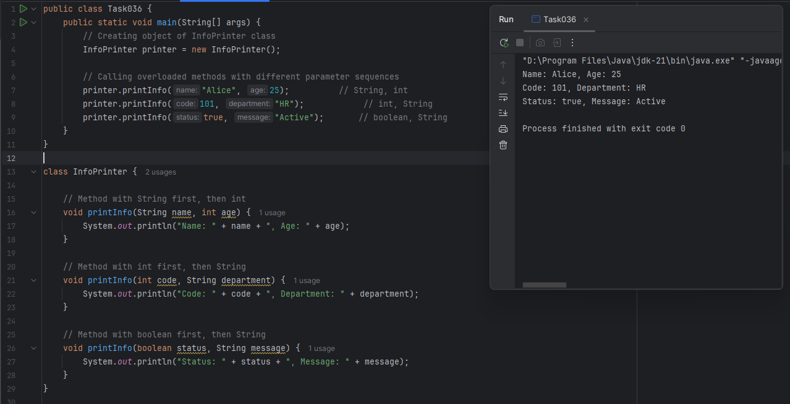

### ***Task 37: Encapsulation and Access Modifiers in Java***

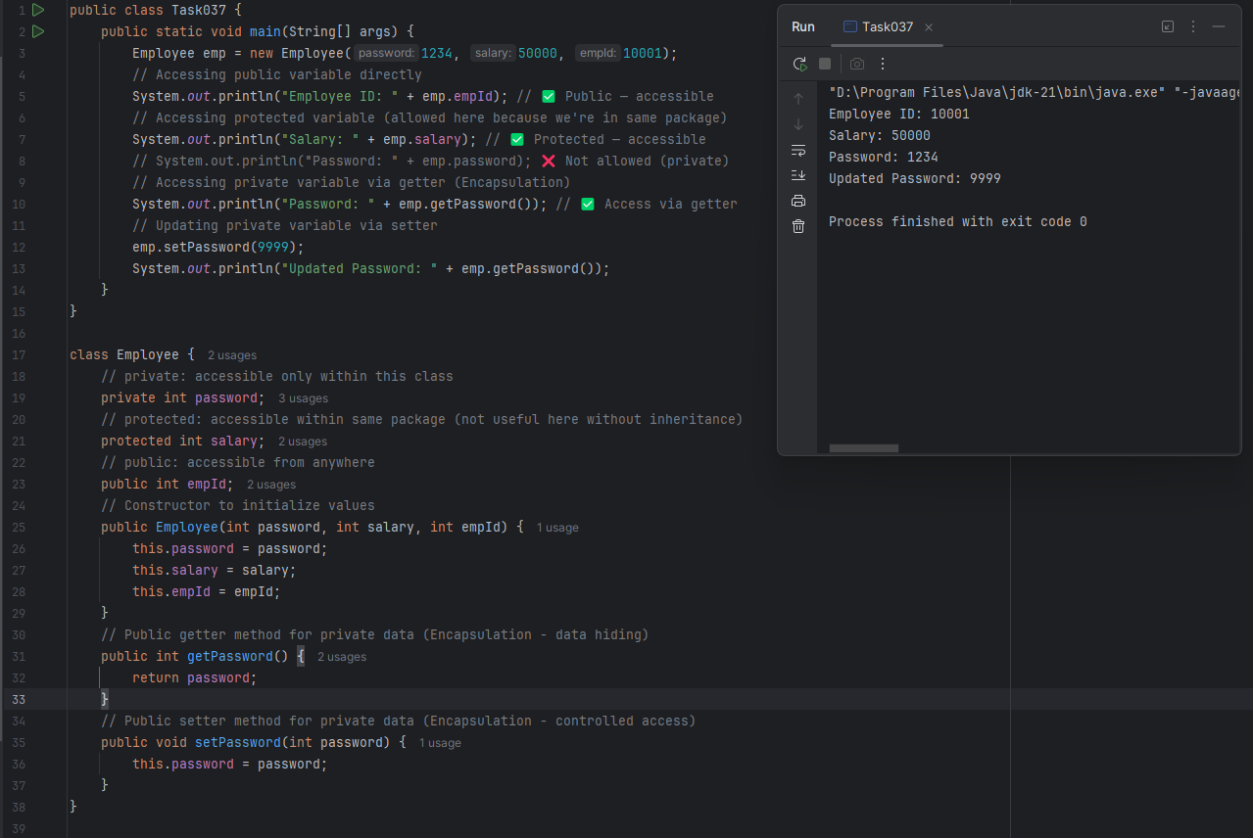

### ***Task 38: Demonstrating Abstract Class Instantiation Error in Java***

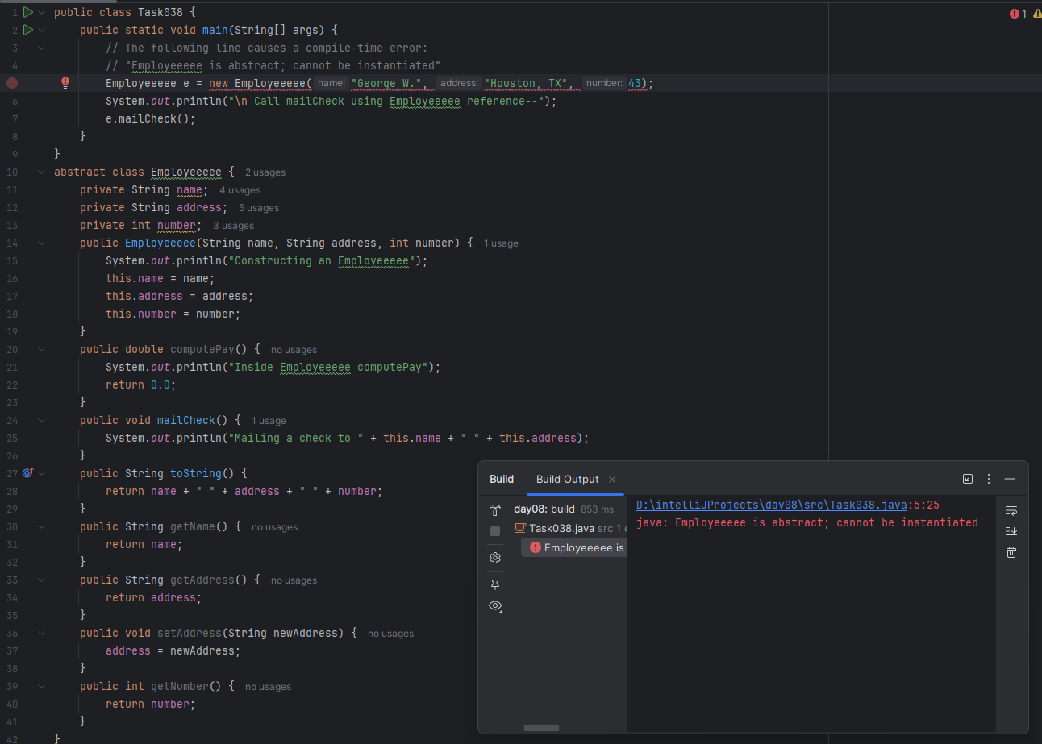

### ***Task 39: Instantiation of Abstract Class via Subclass***

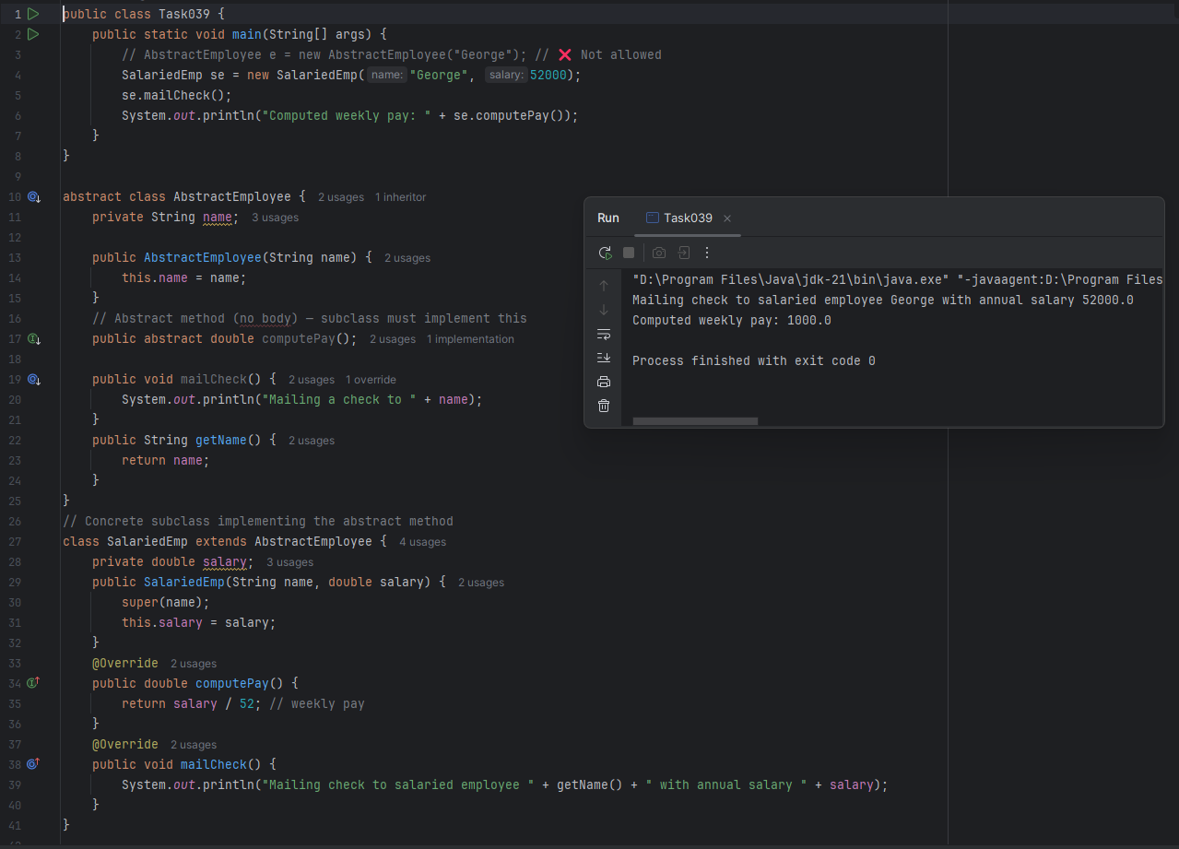

### ***Task 40: Abstraction in Java***

