**day20_107856406_dsdipt_sudipto_23july2025**

**Employee Code:** 107856406

**Login ID:** dsdipt

**Email :** dsdipt@amazon.com

**Name:** Sudipto Das

**Date:** 23 July 2025 (Day 20)

### ***Task 01: Create Student Class***

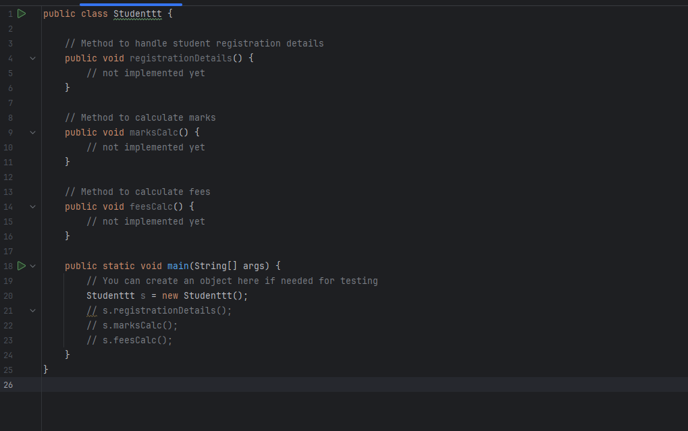

### ***Task 02: Implement SRP***

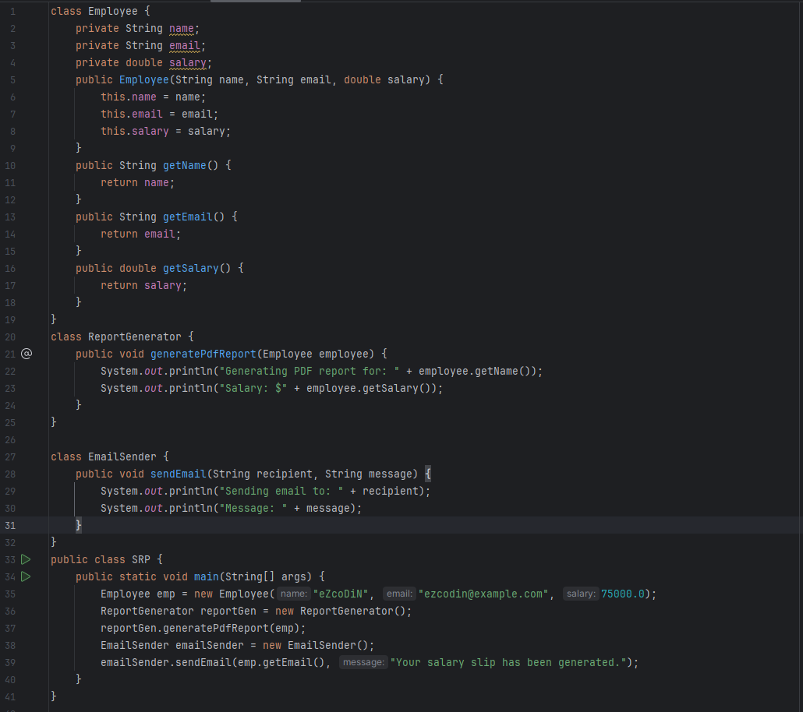

### ***Task 03: Implement OCP***

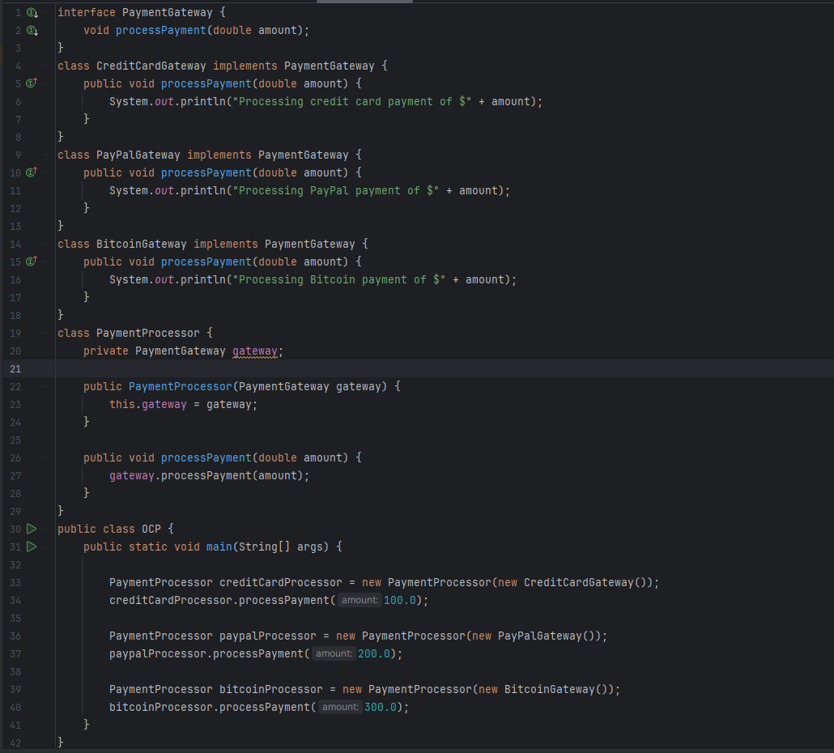

### ***Task 04: Create a Sequence Diagram for a Message Exchange Scenario***

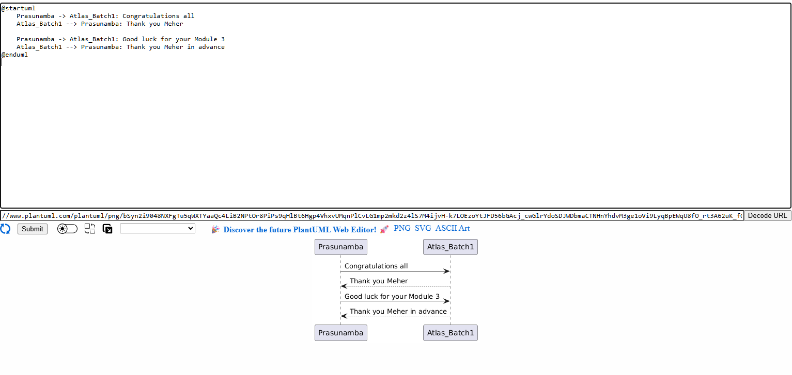

### ***Task 05: Create a Sequence Diagram Using Aliases for Participants***

