**day23_107856406_dsdipt_sudipto_31july2025**

**Employee Code:** 107856406

**Login ID:** dsdipt

**Email :** dsdipt@amazon.com

**Name:** Sudipto Das

**Date:** 31 July 2025 (Day 23)

### ***Task 01 : Unit Test***

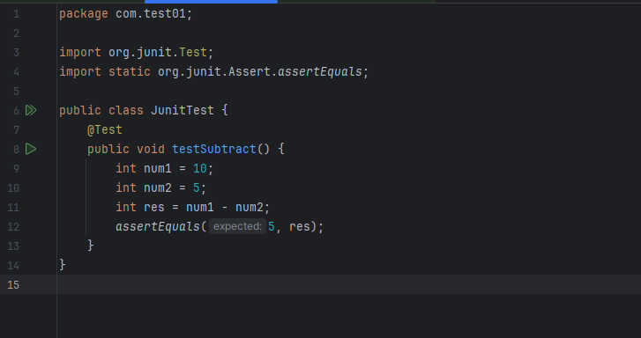

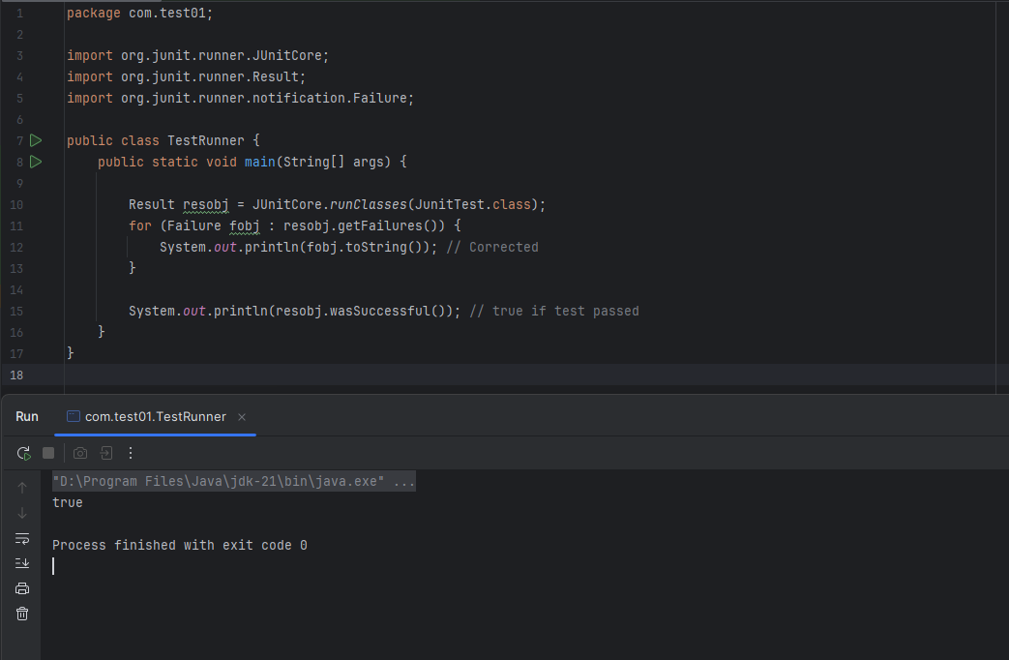

### ***Task 02 : Suite Test***

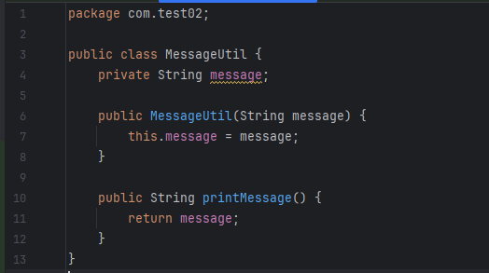

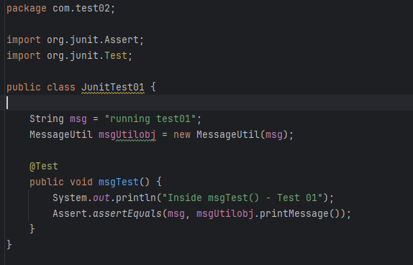

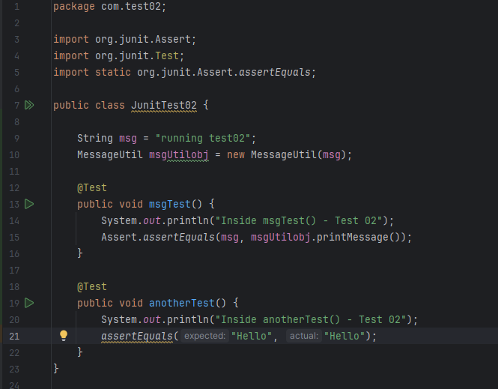

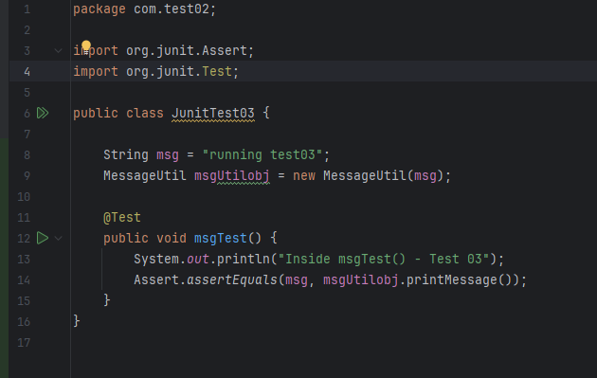

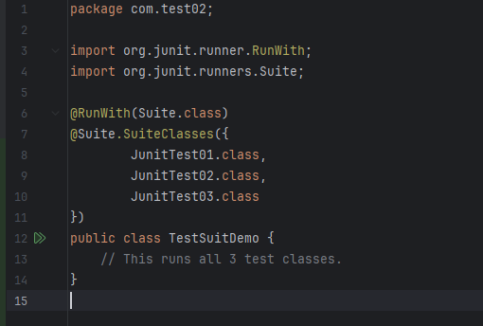

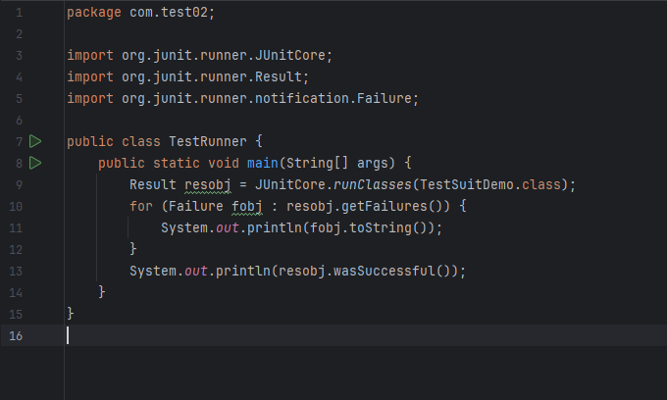

### ***Task 03 : Ignore Test***

### ***Task 04 : Timeout Test***

### ***Task 05 : Exception Test***

