**day32_107856406_dsdipt_sudipto_3september2025**

**Employee Code:** 107856406

**Login ID:** dsdipt

**Email:** dsdipt@amazon.com

**Name:** Sudipto Das

**Date:** 3 September 2025 (Day 32)

### ***Task 01: Create a Table using AWS Dynamo DB***

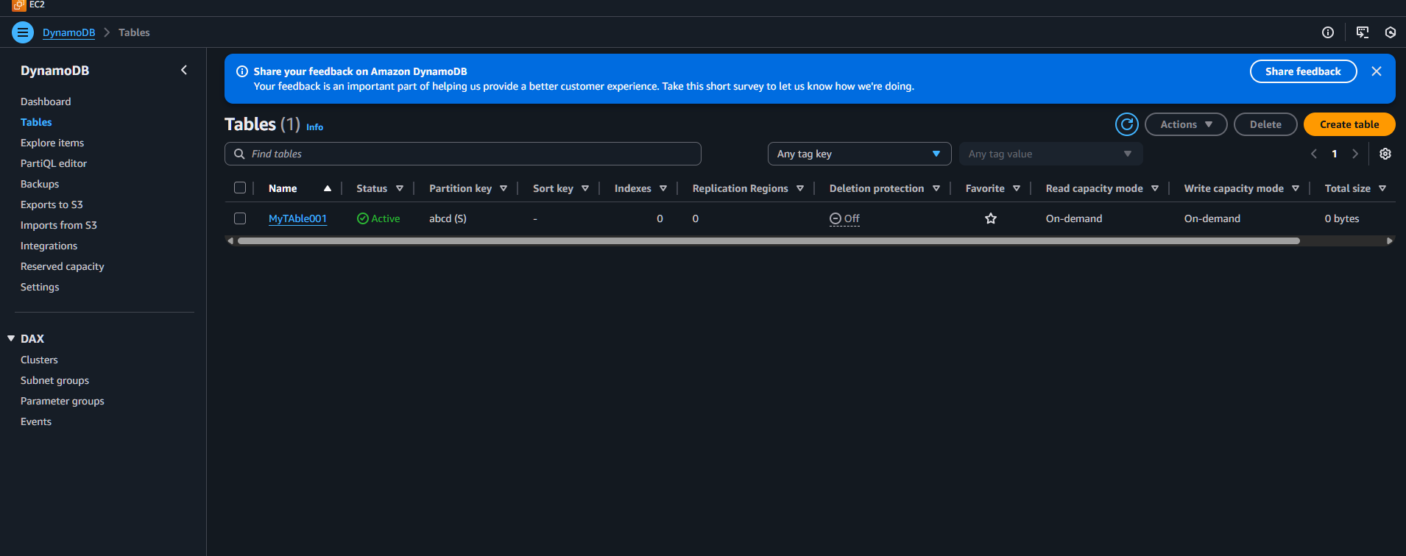

### ***Task 02: Perform CRUD using AWS Dynamo DB***

**Create Table:**

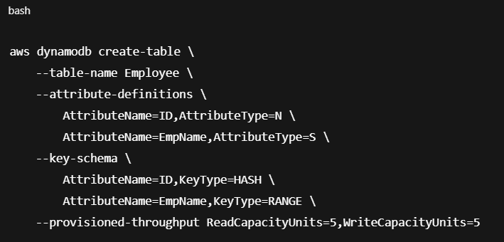

**Insert Item:**  
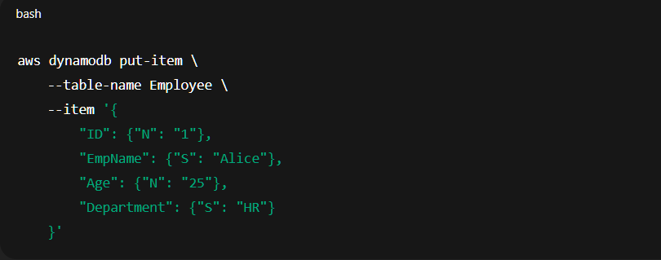  
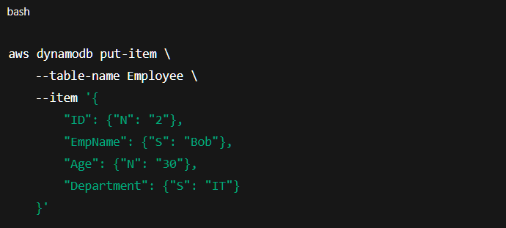

**Read:**

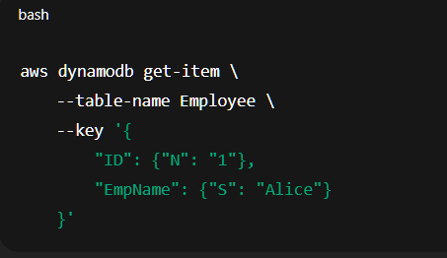

**Update:**

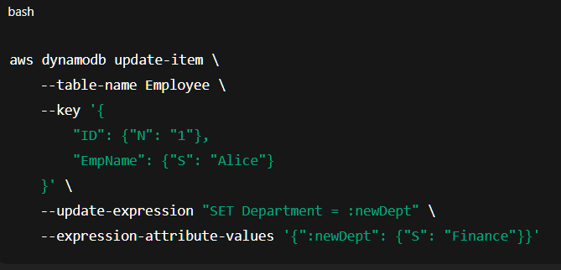

**Delete:**

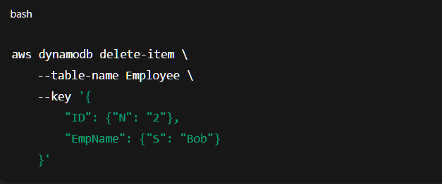

### ***Task 03: HOME TASK***

**Create Table:**

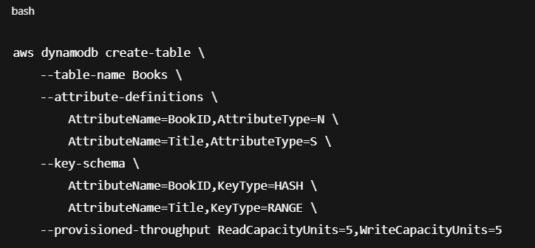

**Insert Five Records:**

Record 1:

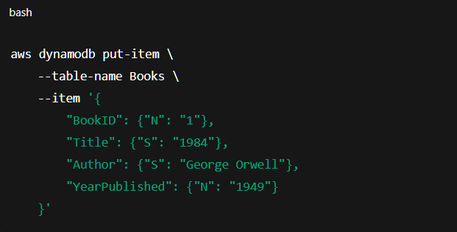

Record 2:

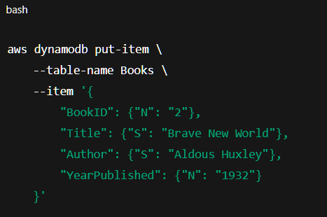

Record 3:

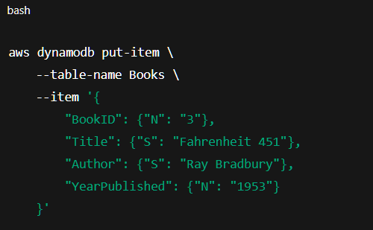

Record 4:

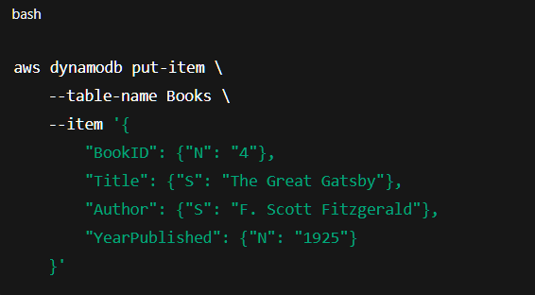

Record 5:

