**day38_107856406_dsdipt_sudipto_24september2025**

**Employee Code:** 107856406

**Login ID:** dsdipt

**Email:** dsdipt@amazon.com

**Name:** Sudipto Das

**Date:** 24 September 2025 (Day 38)

### ***Task 01: Hamcrest Demo***

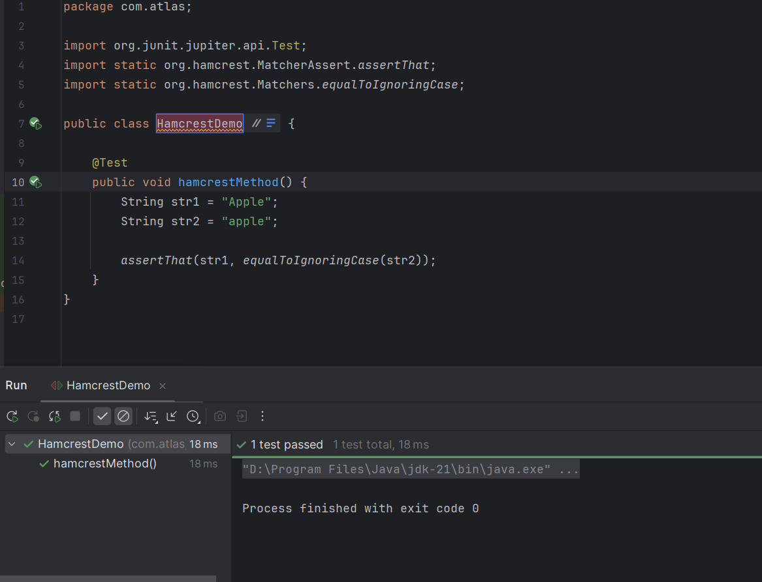

### ***Task 02: Object Matcher Demo***

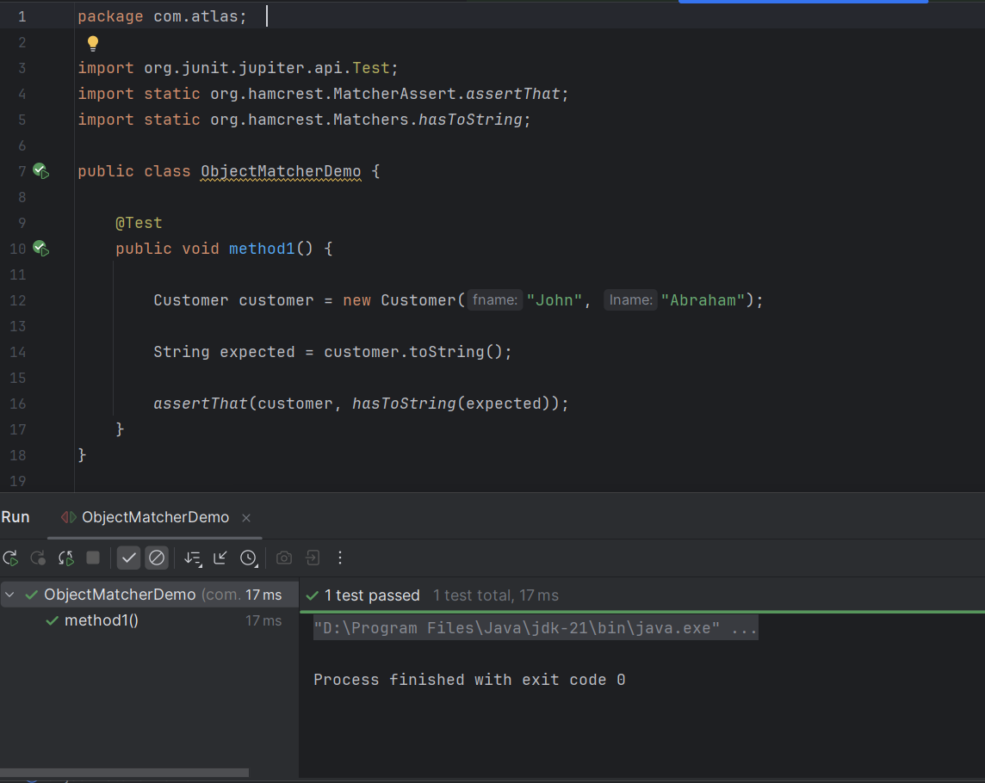

### ***Task 03: Bean Matcher***

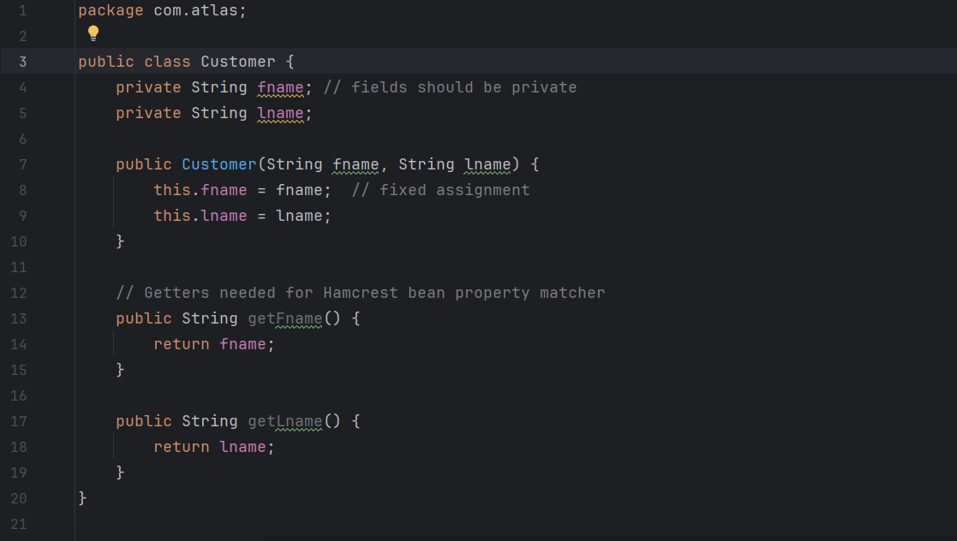

### ***Task 04: Bean Property Checker***

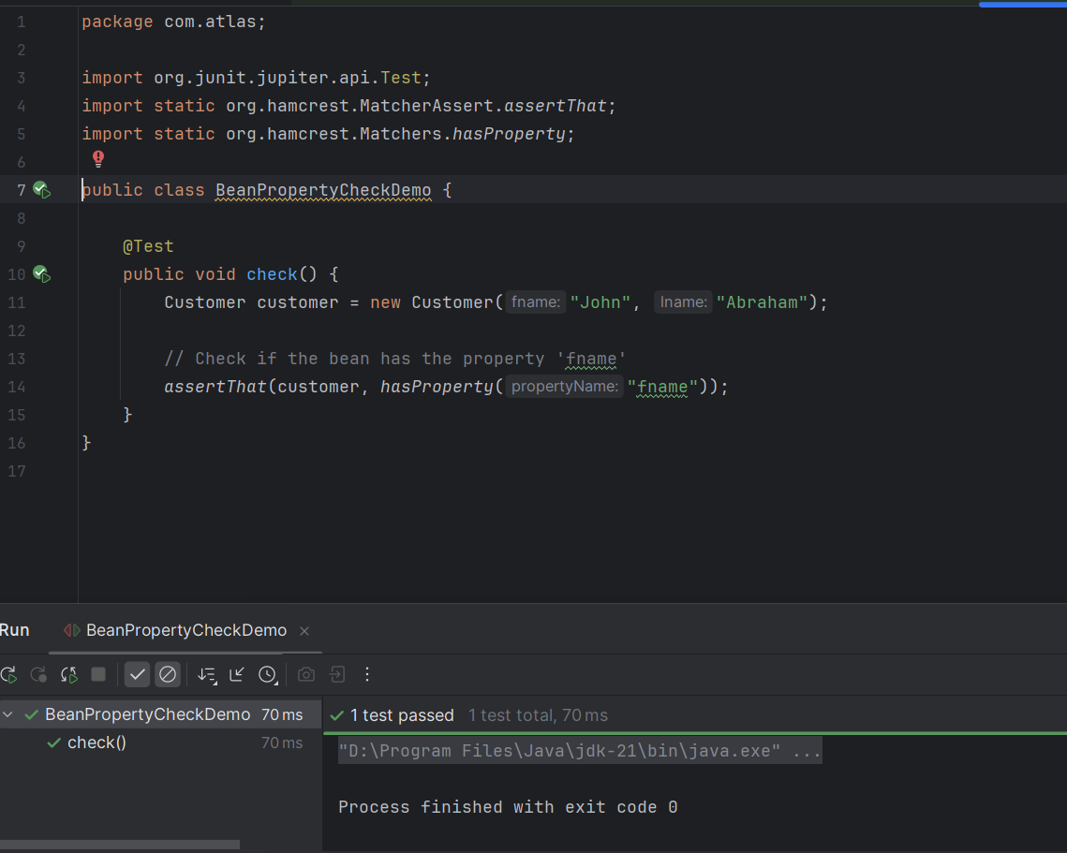

### ***Task 05: Collection Matcher***

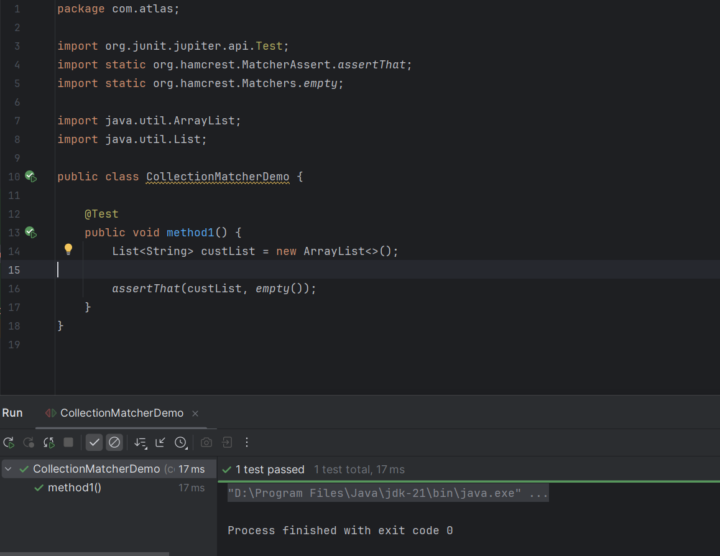

### ***Task 06: Collection Size Matcher***

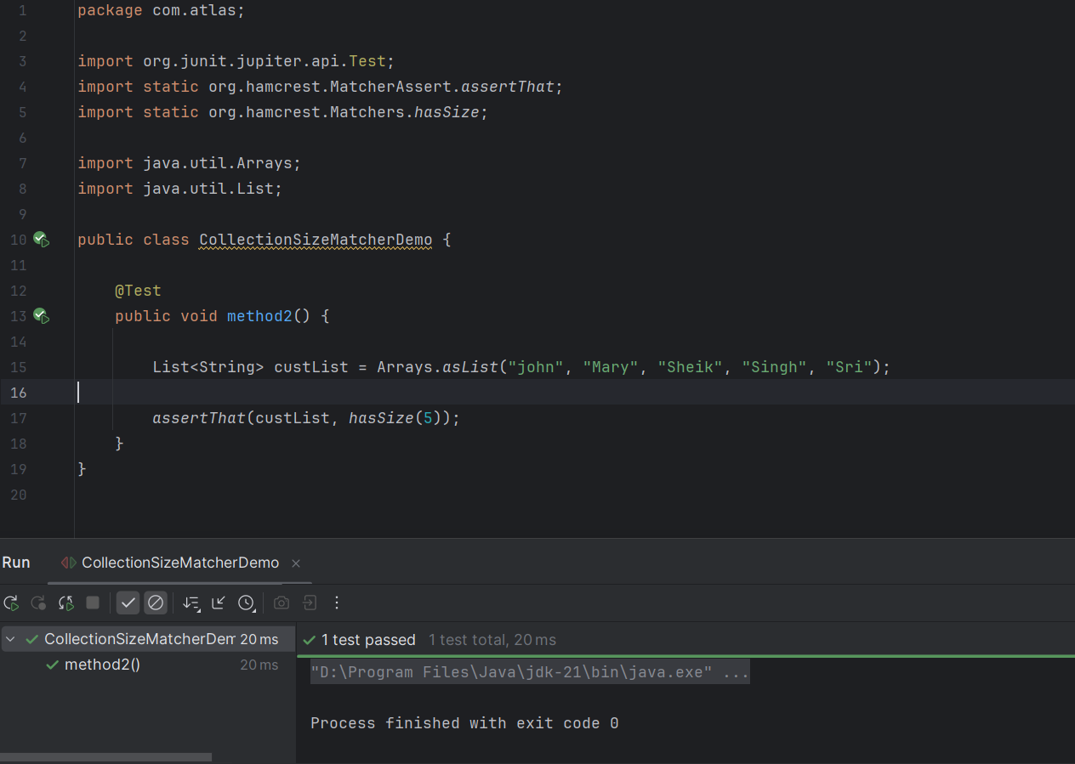

### ***Task 07: User, UserRepo, UserService***

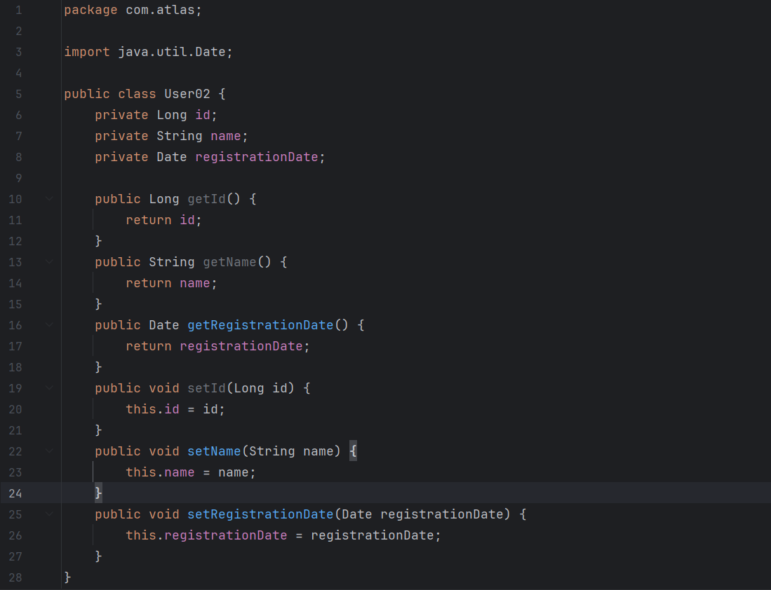  
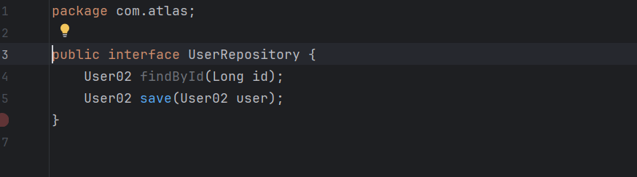  
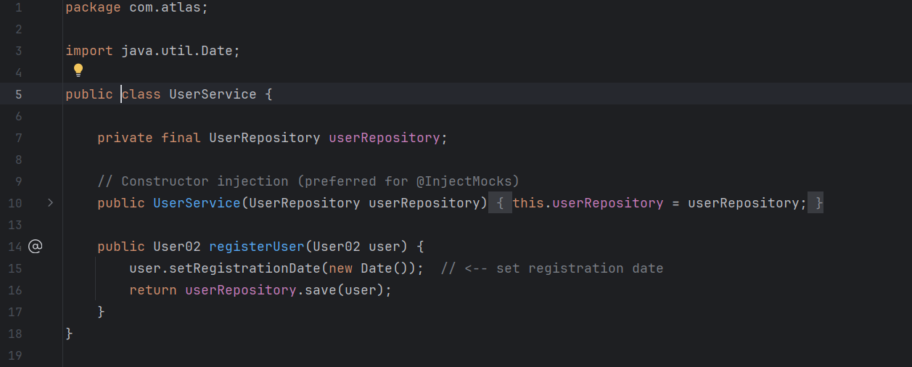

### ***Task 08: Demo Mockito Test***

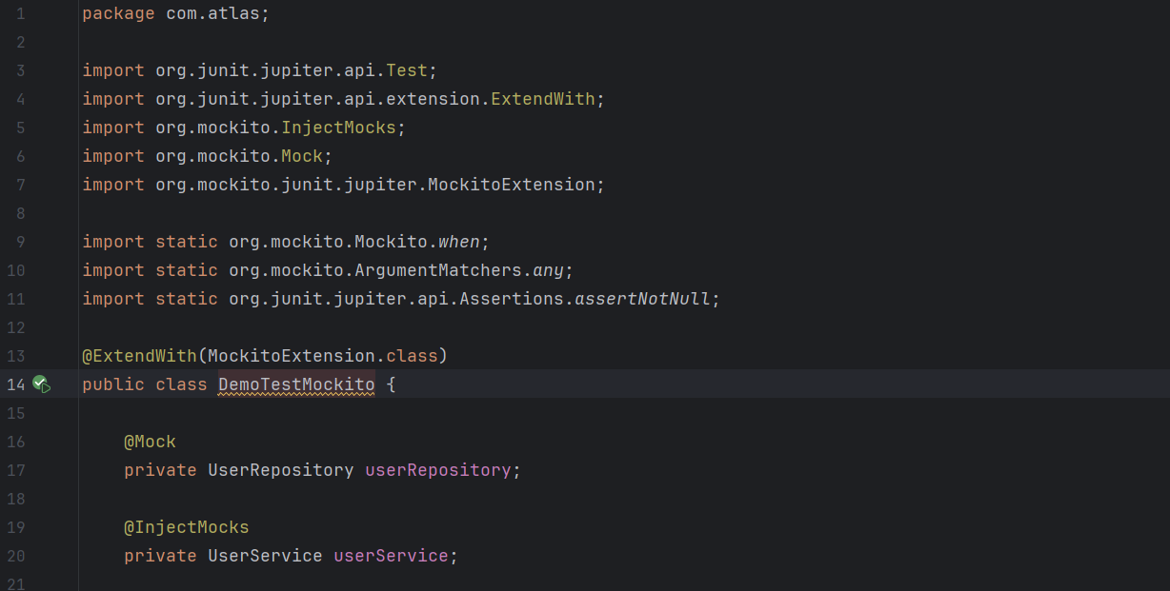  
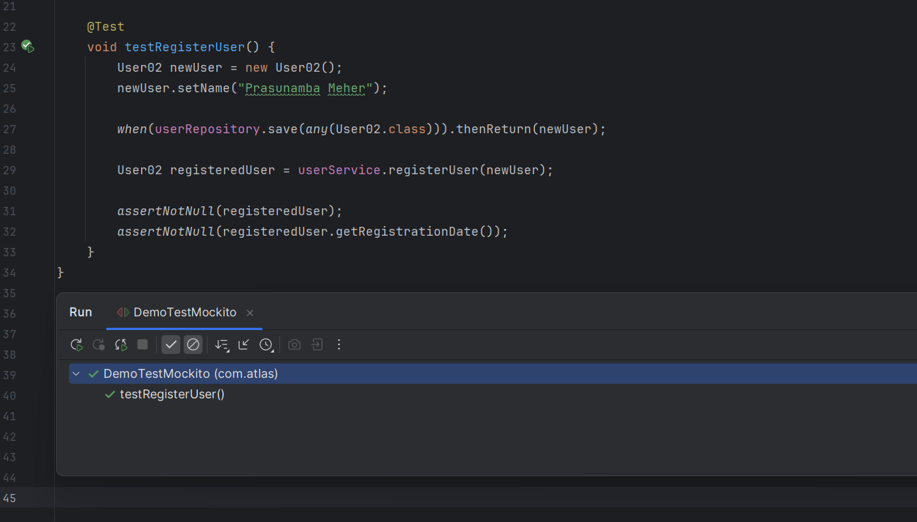

### ***Task 09: In the context of Automation Testing, how does the Page Object Model (POM) improve test maintainability?***

**POM abstracts UI elements as objects in separate classes, which isolates changes in the UI from the test logic.**

### ***Task 10: In a Page Object Model (POM) framework, where should test data ideally reside?***

**In external files such as JSON, Excel, or property files to separate logic from data.**

### ***Task 11: A team is building a Page Object Model (POM) automation framework. However, they observe test failures due to frequent changes in UI locators across environments. What should they focus on improving in their automation approach?***

**Store locators in external property files and abstract them within page classes to isolate UI changes.**

### ***Task 12: Why are mock objects commonly used in JUnit tests for services that call external APIs?***

**They simulate external APIs and allow testing of service logic in isolation without depending on actual API availability or response time.**

### ***Task 13: You’ve written a JUnit test for an API that sends email notifications. Running the test actually sends emails, causing issues. How should this be addressed?***

**Replace the test logic with a mock that simulates email service behavior.**

### ***Task 14: Which of the following best describes the role of test suites in JUnit?***

**Test suites allow grouping multiple test classes and running them together, often used for regression or integration testing.**

### ***Task 15: Why are mock objects used in JUnit testing, especially in enterprise applications?***

**They replace real dependencies like databases or web services to test components in isolation and ensure reliability.**

### ***Task 16: What does the annotation @Disabled do in a JUnit test?***

**It marks a test case to be skipped during execution without deleting or commenting out the code.**

### ***Task 17: What is the primary purpose of using assertions in JUnit tests?***

**Assertions define expected outcomes in tests and help automatically verify the correctness of code behavior.**

### ***Task 18: What is one of the key differences between manual testing and automation testing from a scalability perspective?***

**Automation testing is ideal for scaling regression tests across builds and environments as scripts can run unattended.**

### ***Task 19: What is the purpose of the assertThat() method in conjunction with the Hamcrest library in JUnit?***

**It provides a more flexible and readable way to define expectations using matchers like containsString, hasItems, etc.**

### ***Task 20: How does the concept of timeout help improve the reliability of test execution in JUnit?***

**Timeout helps identify tests that hang or take unusually long to execute, allowing early detection of performance issues.**