Name: Swarna Dasrao

Class: CSCI 331

Dated By: 03/08/2021

**UML FOR VACCINE DATABASE**

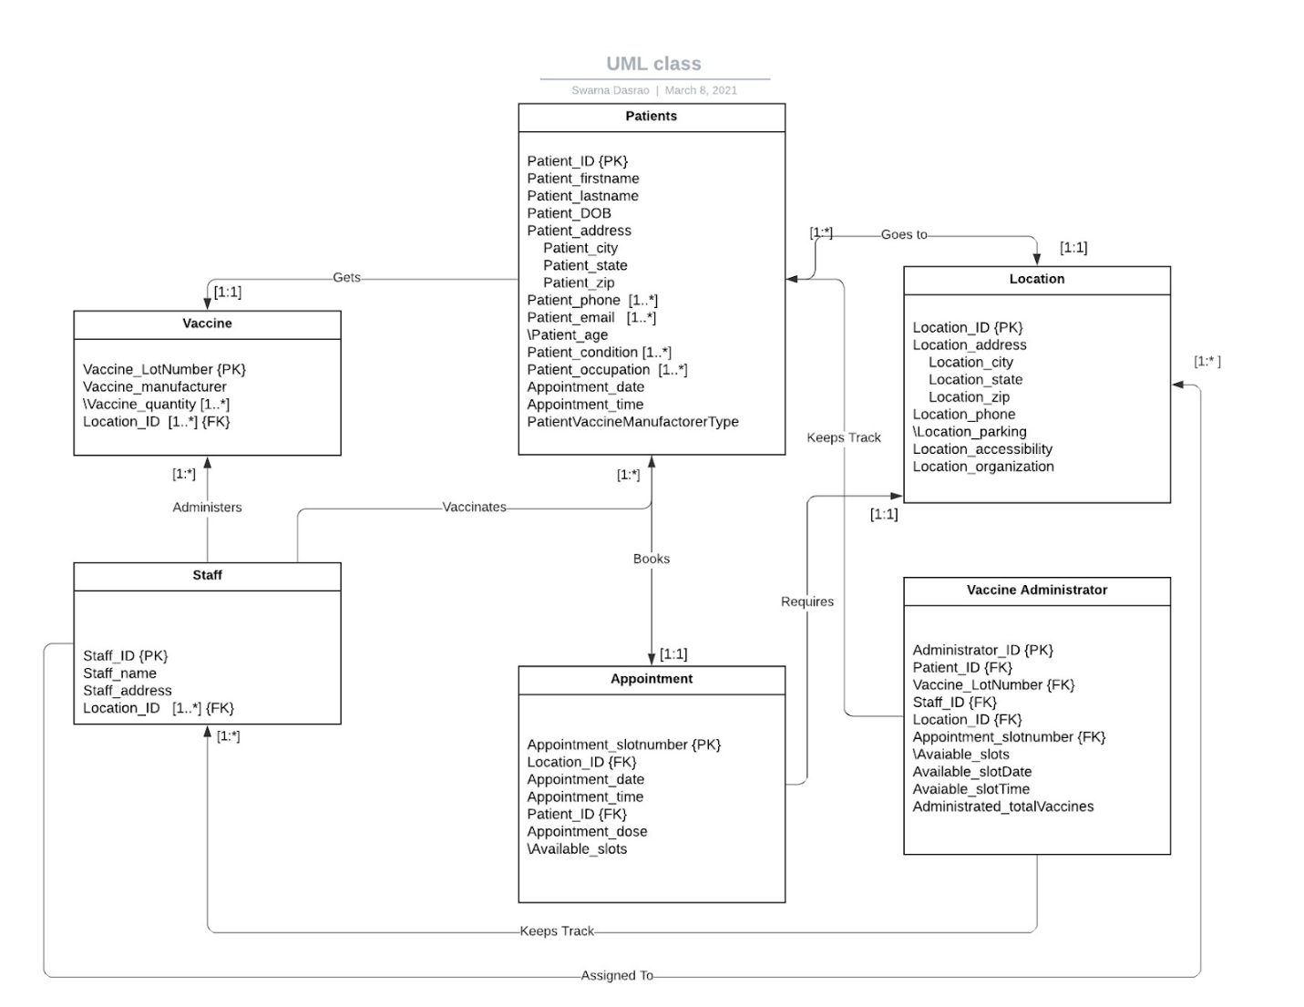

**Convert UML to Relations:**

* **The primary keys are displayed Underlined while the foreign keys are in *Italics*.**

Patients (Patient_ID, Patient_firstname, Patient_lastname, Patient_DOB, Patient_city Patient_state, Patient_zip, Patient_age, PatientVaccineManufactorerType, Appointment_time, Appointment_date,).

Patient_phone (Patient_ID, Patient_phone). (Note that Multivalue attribute)

Patient_email (Patient_ID, Patient_email). (Note that Multivalue attribute)

Patient_condition (Patient_ID, Patient_condition, Patient_allergy, Patient_medications). (Note that Multivalue attribute)

Patient_occupation (Patient_ID, Patient_occupation). (Note that Multivalue attribute)

Location (Location_ID, Location_city, Location_state, Location_zip, Location_phone, Location_parking, Location_accessibility, Location_organization).

Staff (staff_ID, staff_firstname, staff_lastname, staff_city, staff_state, staff_zip).

Staff_location (staff_ID, location_ID) (Note that Multivalue attribute)

Vaccine Administrator (Administrator_ID, *Patient_ID*,  *Vaccine_LotNumber*, *Staff_ID*, *Location_ID*,  *Appointment_slotnumber*, Avaiable_slots. Available_slotDate, Available_slotTime, Administrated_totalVaccines)

*(Note I am not really sure how an individual vaccine is identified so I used vaccine_LotNumber which is more like a Vaccine ID).*

Vaccine (Vaccine_LotNumber, Vaccine_manufactorer) .

Vaccine_quantity (Vaccine_LotNumber, Vaccine_quantity). (Note that Multivalue attribute)

Vaccine_Location: (Vaccine_LotNumber, location_ID), *Vaccine_quantity)*.

Vaccine Manufacturer: (Manufacturer_ID, Vaccine_quantity, *Location_ID, Vaccine_LotNumber)*

Apppointment (Appointment_slotnumber, *Location_ID*, Appointment_date, Appointment_time, *Patient_ID*, Appointment_dose, Available_slots).

**Domain:**

**Patients:**

Patient_ID: integer

Patient_firstname: character not more than length of 20

Patient_lastname: character not more than length of 20

Patient_DOB: integer

Patient_city: Valid NYC zip

Patient_state: NY

Patient_age: integer

PatientVaccineManufactorerType: {Moderna, Pfizer}

Appointment_time: integer

Appointment_date: integer – format MM/DD/YYYY

Patient_phone : integer

Patient_email : character not more than 50 in length.

Patient_condition : character

Patient_allergy: character

Patient_medications: character

Patient_occupation: character

**Location:**

Location_ID: integer

Location_city: valid nyc city

Location_state: NY

Location_zip: valid nyc zip

Location_phone: integer

Location_parking: {available, not available}

Location_accessibility: {yes, no}

Location_organization: character

**Staff:**

staff_ID: integer

staff_firstname/ staff_lastname: character not more than 20 in length

staff_city/staff_zip : valid NYC city/zip

staff_state: NY

**Vaccine Administrator:**

Administrator_ID:integer

Vaccine_LotNumber: integer

Administrated_totalVaccines: integer

**Appointment:**

Appointment_slotnumber/Avaiable_slots:integer

Appointment_dose: 1st, 2nd

Available_slotTime: integer

Available_slotDate: : integer – format MM/DD/YYYY

**Vaccine:**

Vaccine_manufactorer: {Moderna, Pfizer}

Vaccine_quantity: integer

Vaccine_quantity: integer

Manufacturer_ID: integer

Vaccine_quantity: integer

Appointment_slotnumber: integer,

Available_slot: integer

**Relational Algebra:**

Generate relational algebra to answer the queries below. • Use standard notation and replace all underlined terms with your own values and maintain the intent of the search. For instance: replace Yankee Stadium with another location and replace Monday with another day. • Create descriptive attribute labels.

1. Identify available appointment slots on March 1 at Yankee Stadium. Display the location, date and time slots available.

A(Appointment)

B(A× Vaccine Administrator.)

Answer (B)

 2. Identify patients with appointments today at Yankee Stadium. Display the patient name, vaccine manufacturer, patient address and email.

A (Appointment)

B (A×Patients)

Answer (B)

3. Identify patents that cancelled or didn’t show up for appointments yesterday at Yankee Stadium. Display the patient name, vaccine manufacturer, appointment date, time and location.

A (Appointment)

B (Patients) - (A)

C (B×Patients)

Answer (C)

4. Identify staff assigned to the Yankee Stadium vaccine administration site on March 1. Display the staff name.

A ← (Vaccine Administration)

B ← (A × staff)

Answer ← (B)

5. Identify eligible patients without appointments. Eligible could be based on age, occupation, preexisting medical conditions. Display the patient name, age address, pre-existing conditions and occupation.

A ← (Patient)

B (A) - (Appointments)

C (B×Patients)

Answer ← (C)

 6. Identify the number of vaccine doses available by borough now. Display two columns: Borough and number of vaccine doses available. Display one row for each distinct Borough. Use an aggregate function and grouping operation to answer this question.

AvailableNow (Vaccine_administrator)

A (AvailableNow × Vaccine Administrator) (A)

7. Identify the number of appointments scheduled by borough tomorrow. Display two columns: Borough and number of appointments requested. Display one row for each distinct Borough. Use an aggregate function and grouping operation to answer this question.

AvailableTomorrow (Vaccine Administrator)

A (AvailableTomorrow × Vaccine Administrator)

(A)

 8. There are insufficient available vaccine dosages to satisfy all the appointments tomorrow. Identify appointments of patients less than age 65 in Brooklyn. Display the patient name, address and email.

A (Patients)

B (A×Appointment)

Answer (B)

 9. Identify vaccine dosages administered in the last 6 months by patient zipcode. Display two columns: Patient zip code and number of dosages administered. Display one row for each distinct patient zipcode. Use an aggregate function and grouping operation to answer this question.

6Month (Appointment)

A (6month × (Patients))

B (A × )

(B)

10. Identify vaccine dosages administered in the last 6 months by vaccine manufacturer. Display two columns: Vaccine manufacturer and number of dosages administered. Display one row for each distinct vaccine manufacturer. Use an aggregate function and grouping operation to answer this question.

6Month (Appointment)

A (6month × Vaccine Manufacturer)

(B)