2024-BR-04-eng Organizing bracelets
6yo–8yo:  medium | 8yo–10yo:  – | 10yo–12yo:  – | 12yo–14yo:  – | 14yo–16yo:  – | 16yo–19yo:  –
Answer Type: Click To Choose (☐ keep order of multiple-choice/-select)
Categories (click to choose):  ☐ algorithms and programming  ☑ data structures and representations |  |  | ☐ computer processes and hardware  ☐ communication and networking  ☐ interactions, systems and society

Body
Victoria has a box where she organizes her bracelets.
There are seven compartments in this box and Victoria puts each bracelet in a compartment with the same color pattern.
The image below shows where she puts one of her bracelets.
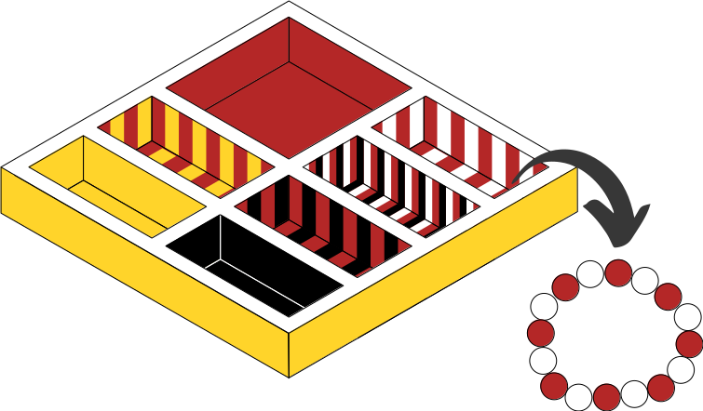

Question / Challenge
Which of these bracelets does NOT match any of the compartments in Victoria’s box?

Answer Options / Interactivity Description

A | B
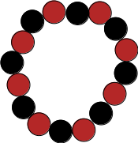 | 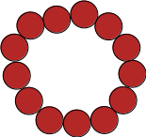
C | D
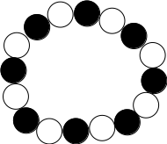 | 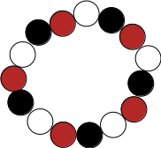

Answer Explanation
The correct answer is (C).
The image below shows the compartments where Victoria puts the bracelets from options (A), (B) and (D). Observe that the bracelets and the compartments have the same color pattern.
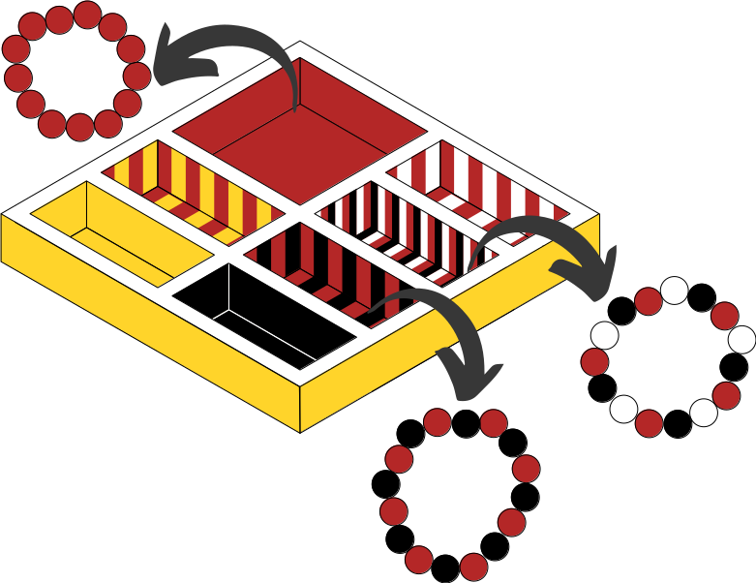
Note there is no compartment with the color pattern black-white in Victoria’s box, so there is no compartment for the bracelet in option (C) to match.

This is Informatics
We often have a lot of data to work with when trying to solve a question or problem. Just like in this task, where there are many aspects to the bracelets we could use to put them into the correct boxes. It is important to be able to filter out the data we don’t need, so it is easier to find the important data and find a solution. In this task, we only need to look at the colors, it doesn’t matter what shape the beads are, how many there are or in what pattern they occur. We don’t even need to see the whole bracelet to solve the question, only seeing a part of the images would be enough.

This is Computational Thinking
This task uses a simple form of abstraction. We need to ignore the unnecessary details of the bracelets in order to find the information we need to solve the task. In this task, it is important that we realize that it is the color that is important, that is the only information we need about bracelets to solve the task.

Informatics Keywords and Websites
EDIT HERE (delete this): give some keywords, useful to find further information on the web. The target are the teachers and interested students. // Indicate websites (in English and other languages) which offer further information on the particular domain of informatics mentioned in the “This is Informatics” section. Wikipedia is often a good start.

Computational Thinking Keywords and Websites
Keywords:
Pattern recognition

Websites:
https://www.learning.com/blog/pattern-recognition-in-computational-thinking/#:~:text=Pattern%20recognition%20as%20part%20of,have%20one%20or%20multiple%20similarities

Wording and Phrases
Victoria is a common name in Brazil. Fell free to change it, if necessary.

Comments
By: Sarah Chan (svn: chan)
on 2024-04-04
Assigned review
This task crashed my LibreOffice repeatedly. When I did manage to get it open, all the bracelet images appeared the same (solid black beads). I think there is an issue with the images, but I think I understand what the task is intended to be.

Are the patterns all meant to be in grayscale? Or is that a problem with my LibreOffice rendering? As I am seeing it, the grayscale patterns are not different enough from each other. More points of difference between the patterns (such as colours or different shapes) would really help.

I personally find pattern matching to be a weak Informatics connection although I accept it as a computational thinking skill. I also accept that this type of task can work well for younger students.
Thank you very much for your suggestions, Sarah. I have implemented all of them.
By: doyong kim (svn: doyong)
on 2024-04-05
Assigned review
I love this task. This problem gives to me a variety of imaginations in pattern matching. However, the Reason for the correct answer needs to be clearer.
Thank you very much for your suggestions, Doyong Kim. I have put more information into the solution.
By: LucÃa Crivelli (svn: crivelli)
on 2024-04-15
Non-assigned review
[AGE] Ok
[IDEA] Interesting
[TEXT] Ok
[EXPL] Ok
[TiI] OK
[TiCT] OK
[GRAPH] It would be nice to add color to the graphics.
Thank you very much for your suggestions, Lucia. I have implemented colors on the pictures.

By: Workgroup L8 (Alieke Stijf), astijf@eljakim.nl, 2024-05-15:
We agreed that this task is not about pattern recognition. We changed the TiI section to try to strengthen its ties to informatics. We also changed the TiCT section to tie the task to abstraction. We know the TiI link is quite weak, but for this young age group, it nicely covers the very beginnings of the informatics concepts.
Unfortunately we had to redraw all the pictures, as the original files were huge (MBytes), made open office very slow and could not be properly printed.

EDIT ABOVE (keep this template and add above this line): author, e-mail, date (YYYY-MM-DD): Comment, including documentation of and reasons for changes, and precautions to take when further developing this task. Especially mention if this task is based upon or directly connected to another task (even from the past).

Graphics and Other Files
2024-BR-04-eng.odt This file.
2024-BR-04i.svg
2024-BR-04-A.svg … 2024-BR-04-D.svg
2024-BR-04iii.svg
Graphics were originally made by Emily Cavalcanti and Leonardo Cavalcante, emily.cavalcanti@upmat.com.br, leonardo.cavalcante@upmat.com.br, Brazil but have been redrawn entirely by Kris.Coolsaet@ugent.be (Belgium) during de 2024 workshop (see comments)
EDIT ABOVE (keep this template and add above this line): filename, author, source/self-made, license
Please indicate:
- Source of each image or of each other file to produce the task image(s):
(URL and/or author)
- License for each image.
Note: If the source of an image is unclear, it might be copyrighted and cannot be used in the task.

Authors, Contributors, and Editors (incl. Graphics)
Author: Emily Cavalcanti, emily.cavalcanti@upmat.com.br, Brazil
Contributor: Leonardo Cavalcante, leonardo.cavalcante@upmat.com.br, Brazil
Contributor (workshop): Alieke Stijf, astijf@eljakim.nl, Netherlands
EDIT ABOVE (keep this template and add above this line): author / contributor / editor, e-mail, country.

License

Copyright © 2024 Bebras – International Challenge on Informatics and Computational Thinking. This work is licensed under a Creative Commons Attribution-ShareAlike 4.0 International License. https://creativecommons.org/licenses/by-sa/4.0/.

