2024-BE-01a-eng Keep Switching
6yo–8yo:  – | 8yo–10yo:  – | 10yo–12yo:  hard | 12yo–14yo:  medium | 14yo–16yo:  easy | 16yo–19yo:  –
Answer Type: Multiple-Choice with Images (☐ keep order of multiple-choice/-select)
Categories (click to choose):  ☑ algorithms and programming  ☐ data structures and representations |  |  | ☐ computer processes and hardware  ☐ communication and networking  ☐ interactions, systems and society

Body
On a board there are two rows of 6 cells, arranged as in the picture below. In the cells on the top row there are stacks of discs, each of different height(1, 6, 4, 2, 5, 3). In the bottom row there is a marker pointing to two cells in the top row.

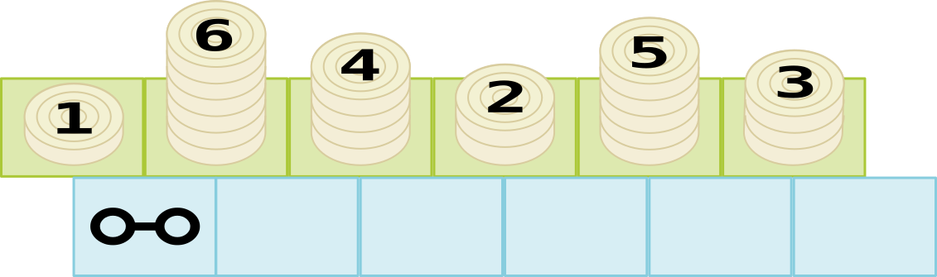

Starting from the configuration above you keep repeating the following ‘moves’
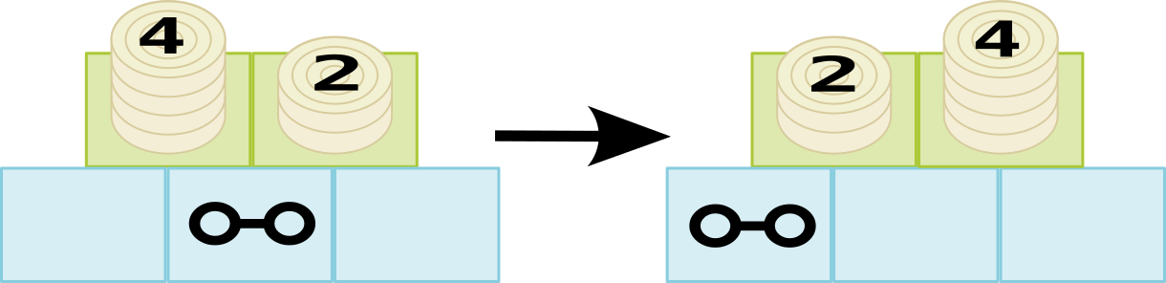
- If the left cell of marker is taller than the right cell, you switch two cells and move the marker to the left, if possible.
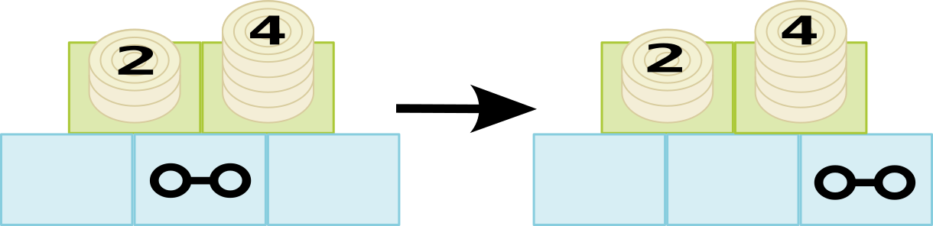
- If the left cell of marker is shorter than the right cell, you don’t need to switch and move the marker to the right.

You stop repeating these moves when the marker is in the rightmost cell.

Question / Challenge
What will the top row look like when the marker ends up in the rightmost cell?

Answer Options / Interactivity Description
A. 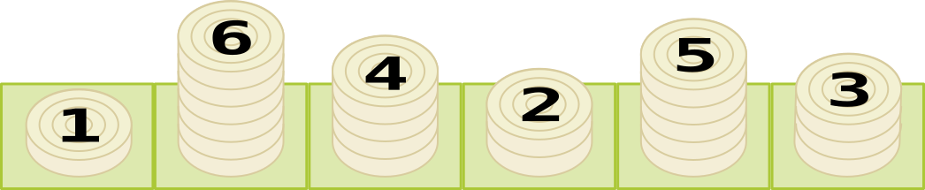

B. 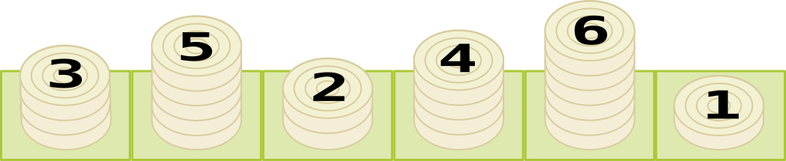

C. 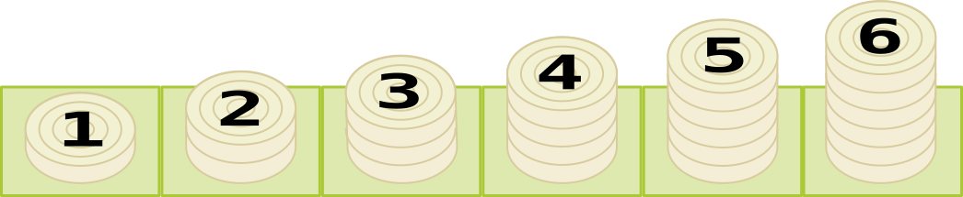

D. 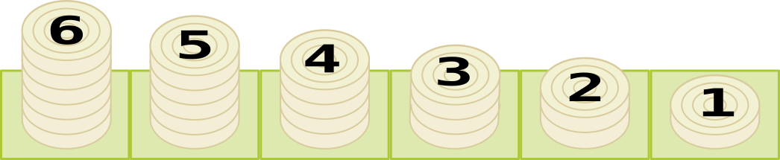

E. There is no solution – the marker never reaches the rightmost cell.

Answer Explanation
The correct answer is C.
You can get this answer by carefully making each move as described and seeing where you end up, but a faster way is to realize that what this task does is sorting the stacks.

In fact, as we move the marker, at each point the stacks to the left of the counter are sorted from low to high. Using move 2 the counter will move to the right as long as this order remains correct. If a stack is encountered that is not in the correct position, a series of moves 1 will ‘carry’ that stack into the correct position and the counter can start moving to the right again.

C is the answer in which all stacks are sorted correctly.

This is Informatics
In informatics, it is often necessary to rearrange data so that it is sorted in a particular order, from small to large, from cheap to expensive, and so on. One reason for this is that finding data in a sorted sequence is considerably much faster than finding data in an unsorted sequence.

The method described here is called 'Gnome Sort'. It is easy to understand and execute, and also easy to program, but it is not used in practice because it is much slower than the more sophisticated algorithms that are traditionally used (e.g. quick sort or merge sort).

This is Computational Thinking
Students must understand and execute an algorithm to find the answer to this question, although the clever step is to see that the algorithm does not have to be executed in full to answer the question.

Informatics Keywords and Websites
Sorting, gnome sort, https://en.wikipedia.org/wiki/Gnome_sort

Computational Thinking Keywords and Websites
Algorithm, pattern recognition

Wording and Phrases
Counter, stack, cell, move (noun)

Comments
Kris Coolsaet (BE), kris.coolsaet@ugent.be, 2024-03-17

- There is a related question 2024-BE-01b that uses the same story but is more difficult.
- Because my drawing skills are not so good, I used stacks of counters. The standard gnome sort story is about a garden gnome sorting a line of flower pots. If you find someone that can draw garden gnomes and flower pots, that might be a nice alternative. (On the other hand, for those students that have already heard of Gnome sorting, this might be a give-away.)
- It is perfectly possible to use only 4 of the 5 multiple choice options

Kris Coolsaet (BE), kris.coolsaet@ugent.be, 2024-04-27
Answer to reviews.txt for both 2024-BE-01a and 2024-BE-01b (not copied here)

- Darkened edges of counters #e9ddaf → #d8cc9e
- Moved difficulty up one age group because 2 out of 3 reviewers found the task harder than indicated
- Added ‘if possible’ add the end of the first rule. Because I made sure the case would not occur in which the counter was at the leftmost position and it would be asked to move even further to the left, I did not explain this situation. But I did not realize this could be done with only two words – thank you Tom! I dropped the last paragraph of the TiT section which explained that this exception is needed in the ‘official’ gnome sort.
- As a consequence I removed a sixth MC-option ‘There is no solution – the black counter must at some point move to the left of the leftmost cell, and this is not possible’, but anyhow, I personally would drop the ‘there is no solution’ options anyway.
- I did not implement the suggestion of making pictures for the first few sorting steps as part of the answer explanation because of the amount of work this requires (and the amount of space this will take on the page). Also it is not clear whether this should be done only for the correct answer or also for the incorrect ones. (If the working group specifies exactly what pictures needs to be made, I am willing to do help them with that.)
It is stated in the answer explanation that actually performing the moves is not really necessary to find the correct answer!

Dongyoon Kim and hongjin Yeh(KR), dykim@ajou.ac.kr, hjyeh@ajou.ac.kr, 2024-05-15

- Slightly reworded and simplify the sentences.

EDIT ABOVE (keep this template and add above this line): author, e-mail, date (YYYY-MM-DD): Comment, including documentation of and reasons for changes, and precautions to take when further developing this task. Especially mention if this task is based upon or directly connected to another task (even from the past).

Graphics and Other Files
2024-BE-01a-eng.odt This file.
All SVG files in the graphics folder - author Kris Coolsaet (BE), kris.coolsaet@ugent.be, 2024-03-17, self-made from scratch
All SVG files are modified to add numbers and a special character as a marker - hongjin Yeh(KR), hjyeh@ajou.ac.kr, 2024-05-15
EDIT ABOVE (keep this template and add above this line): filename, author, source/self-made, license
Please indicate:
- Source of each image or of each other file to produce the task image(s):
(URL and/or author)
- License for each image.
Note: If the source of an image is unclear, it might be copyrighted and cannot be used in the task.

Authors, Contributors, and Editors (incl. Graphics)
Kris Coolsaet (BE), kris.coolsaet@ugent.be, original author

Dongyoon Kim and hongjin Yeh(KR), dykim@ajou.ac.kr, hjyeh@ajou.ac.kr, contributors (incl. graphics)

EDIT ABOVE (keep this template and add above this line): author / contributor / editor, e-mail, country.

License

Copyright © 2024 Bebras – International Challenge on Informatics and Computational Thinking. This work is licensed under a Creative Commons Attribution-ShareAlike 4.0 International License. https://creativecommons.org/licenses/by-sa/4.0/.

