2024-BE-01b-eng Keep Switching
6yo–8yo:  – | 8yo–10yo:  – | 10yo–12yo:  hard | 12yo–14yo:  medium | 14yo–16yo:  medium | 16yo–19yo:  medium
Answer Type: Multiple-Choice with Images (☐ keep order of multiple-choice/-select)
Categories (click to choose):  ☑ algorithms and programming  ☐ data structures and representations |  |  | ☐ computer processes and hardware  ☐ communication and networking  ☐ interactions, systems and society

Body
On a board there are two rows of 6 cells, arranged as in the picture below. In the cells on the top row there are stacks of discs, each of different height(1, 6, 4, 2, 5, 3). In the bottom row there is a marker pointing to two cells in the top row.

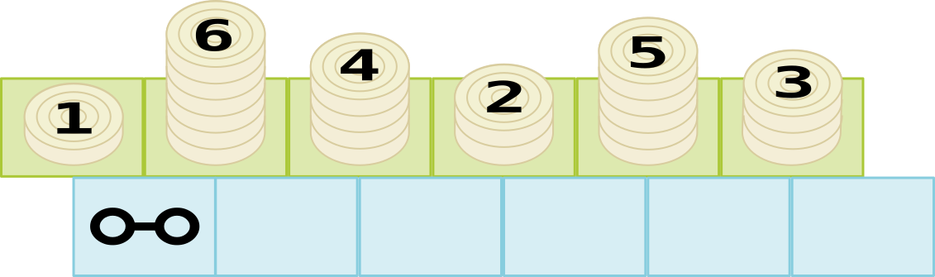

Starting from the configuration above you keep repeating the following ‘moves’
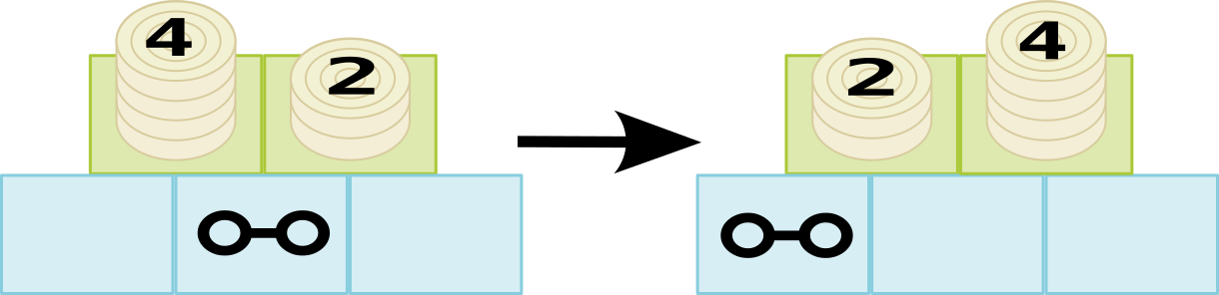
- If the left cell of marker is taller than the right cell, you switch two cells and move the marker to the left, if possible.
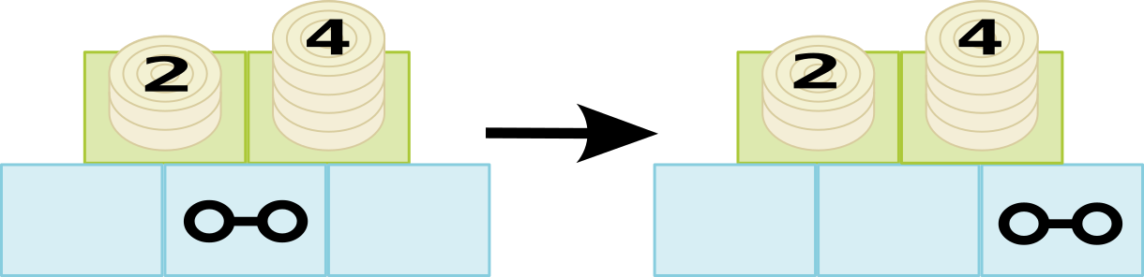
- If the left cell of marker is shorter than the right cell, you don’t need to switch and move the marker to the right.

You stop repeating these moves when the marker is in the rightmost cell.

Question / Challenge
Below are four different start configurations. Which of these will take the fewest moves for the marker to reach the rightmost cell?

Answer Options / Interactivity Description
A.
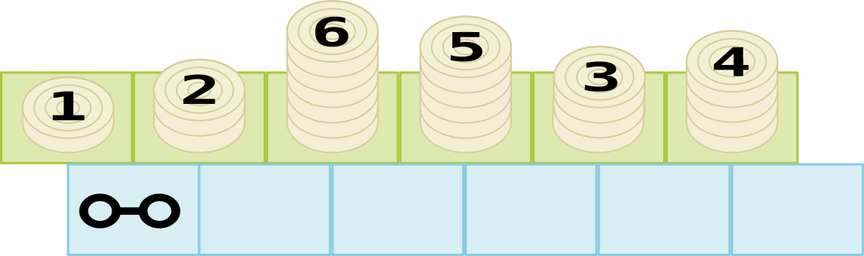
B.
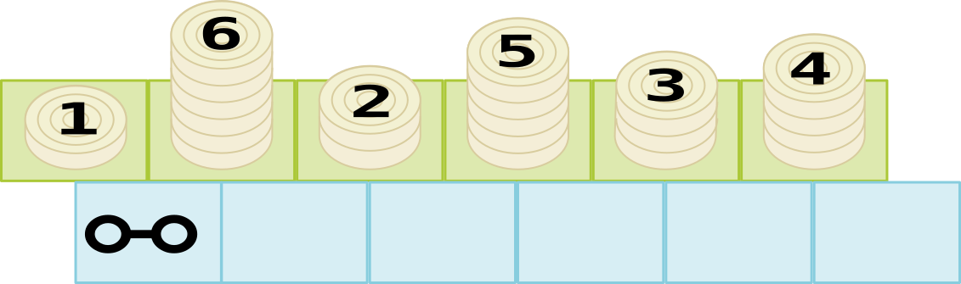
C.
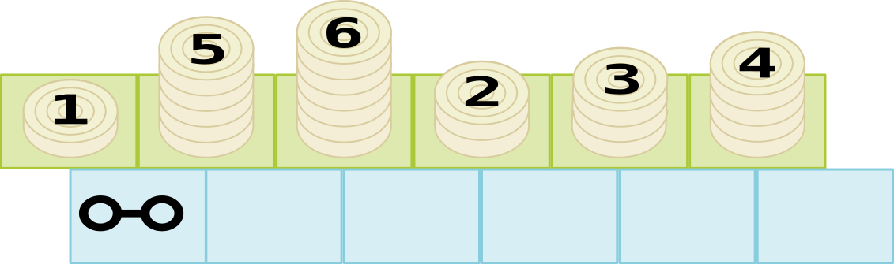
D.

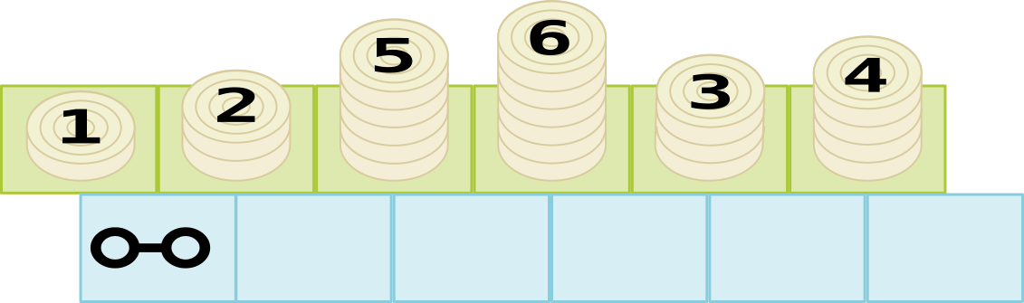
Answer Explanation
The correct answer is D.
To find the correct answer it is not necessary to execute each move as described in the task and count how many moves you need before the marker reaches the rightmost cell (and that for each of the four possibilities). Instead you can compare the number of moves between the four options without actually counting them all.
To simplify our explanation, we shall represent the stacks by numbers (how many discs there are in that stack) and the position of the marker by a dot. As follows:

Option A | 1 ● 2 6 5 3 4 | Option C | 1 ● 5 6 2 3 4
Option B | 1 ● 6 2 5 3 4 | Option D | 1 ● 2 5 6 3 4

Have a look at the first moves for option B. The marker first moves to the right (move 2.) then switches stacks and moves to the left (move 1.), i.e.,
1 ● 6 2 5 3 4 → 1 6 ● 2 5 3 4 → 1 ● 2 6 5 3 4
After 2 moves, the configuration is exactly the same as in configuration A. Hence B takes longer than A and cannot be the answer.

Now have a look at what the first moves are for option A
1 ● 2 6 5 3 4 → 1 2 ● 6 5 3 4 → 1 2 6 ● 5 3 4 →1 2 ● 5 6 3 4
and this is where option D will end up after exactly one move. Hence A takes longer than D.

These are the first few moves for option C
1 ● 5 6 2 3 4 1 5 ● 6 2 3 4 → 1 5 6 ● 2 3 4 → 1 5 ● 2 6 3 4 → 1 ● 2 5 6 3 4
which is the configuration in which D starts. Hence D takes the least number of moves.

This is Informatics
Note that all the options would eventually end up with 1 2 3 4 5 6 ●. In fact, it is easy to see that what this task does is sort the stacks by height.

In informatics, it is often necessary to rearrange data so that it is sorted in a particular order, from small to large, from cheap to expensive, and so on. One reason for this is that finding data in a sorted sequence is considerably much faster than finding data in an unsorted sequence.

The method described here is called 'Gnome Sort'. It is easy to understand and execute, and also easy to program, but it is not used in practice because it is much slower than the more sophisticated algorithms that are traditionally used (e.g. quick sort or merge sort).

This is Computational Thinking
Students must understand and execute an algorithm to find the answer to this question, although the clever step is to see that the algorithm does not have to be executed in full to answer the question.

Informatics Keywords and Websites
Sorting, gnome sort, https://en.wikipedia.org/wiki/Gnome_sort

Computational Thinking Keywords and Websites
Algorithm

Wording and Phrases
Counter, stack, cell, move (noun)

Comments
Kris Coolsaet (BE), kris.coolsaet@ugent.be, 2024-03-17

- There is a related question 2024-BE-01b that uses the same story but is easier.
- Because my drawing skills are not so good, I used stacks of counters. The standard gnome sort story is about a garden gnome sorting a line of flower pots. If you find someone that can draw garden gnomes and flower pots, that might be a nice alternative. (On the other hand, for those students that have heard of Gnome sorting, this might be a give-away.)

Kris Coolsaet (BE), kris.coolsaet@ugent.be, 2024-04-27

- Answer to reviews.txt for both 2024-BE-01a and 2024-BE-01b (not copied here)
- Darkened edges of counters #e9ddaf → #d8cc9e
- Changed the difficulty from easy to medium for the two oldest age groups
- Added ‘if possible’ add the end of the first rule. Because I made sure the case would not occur in which the counter was at the leftmost position and it would be asked to move even further to the left, I did not explain this situation. But I did not realize this could be done with only two words – thank you Tom! I dropped the last paragraph of the TiT section which explained that this exception is needed in the ‘official’ gnome sort.

Dongyoon Kim and hongjin Yeh(KR), dykim@ajou.ac.kr, hjyeh@ajou.ac.kr, 2024-05-15

- Slightly reworded and simplify the sentences.

EDIT ABOVE (keep this template and add above this line): author, e-mail, date (YYYY-MM-DD): Comment, including documentation of and reasons for changes, and precautions to take when further developing this task. Especially mention if this task is based upon or directly connected to another task (even from the past).

Graphics and Other Files
2024-BE-01b-eng.odt This file.
All SVG files in the graphics folder - author Kris Coolsaet (BE), kris.coolsaet@ugent.be, 2024-03-17, self-made from scratch
All SVG files are modified to add numbers and a special character as a marker - hongjin Yeh(KR), hjyeh@ajou.ac.kr, 2024-05-15

EDIT ABOVE (keep this template and add above this line): filename, author, source/self-made, license
Please indicate:
- Source of each image or of each other file to produce the task image(s):
(URL and/or author)
- License for each image.
Note: If the source of an image is unclear, it might be copyrighted and cannot be used in the task.

Authors, Contributors, and Editors (incl. Graphics)
Kris Coolsaet (BE), kris.coolsaet@ugent.be, original author

Dongyoon Kim and hongjin Yeh(KR), dykim@ajou.ac.kr, hjyeh@ajou.ac.kr, contributors (incl. graphics)

EDIT ABOVE (keep this template and add above this line): author / contributor / editor, e-mail, country.

License

Copyright © 2024 Bebras – International Challenge on Informatics and Computational Thinking. This work is licensed under a Creative Commons Attribution-ShareAlike 4.0 International License. https://creativecommons.org/licenses/by-sa/4.0/.

