Dexterity Software Manual

The Carmel Lab | Burke Medical Research Institute

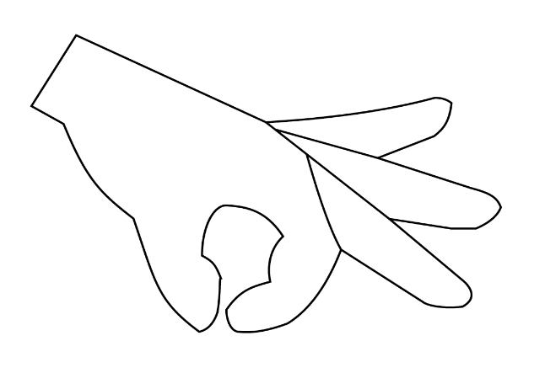

*Last Updated: February 8, 2017 by Sam Butensky*

**Software Overview**

*Hand function is critical for independence, and neurological injury often impairs dexterity. To measure hand function in people or forelimb function in animals, sensors are employed to quantify manipulation. These sensors make assessment easier and more quantitative and allow automation of these tasks. While automated tasks improve objectivity and throughput, they also produce large amounts of data that can be burdensome to analyze. We created software called Dexterity that simplifies data analysis of automated reaching tasks Dexterity is MATLAB software that enables quick analysis of data from automated manipulation tasks. Through a graphical user interface, files are loaded and data are automatically identified and analyzed. These data can be annotated or graphed directly. Analysis is saved, and the graph and corresponding data can be exported. For additional analysis, Dexterity provides easy access to custom scripts created by other users.*

*Previous analysis of automated tasks was performed with custom data analysis, requiring expertise with analysis software. Dexterity made the tools required to analyze, visualize and annotate data easy to use by investigators without data science experience. Dexterity increases accessibility to automated tasks that measure dexterity by making analysis of large data intuitive, robust, and efficient.*

**Software Programs**

1. Standard

Load, analyze, and visualize data using a standard workflow developed in our lab. Data can be graphed directly and/or annotated immediately after processing or after visualization by experimental parameters, i.e. groups and timeline. Processed data can be exported as well as an image of the graph. Lastly, an analysis session can be saved for resumption later.

1. Custom

Analyze and visualize data using custom written MATLAB scripts from the Carmel Lab, another lab, or your own lab. This serves as a means to collaborate with other labs using similar automated behavioral tasks or load in your own functions or another lab’s.

1. Previous

Resume previously saved analysis sessions without loading and analyzing data again.

Standard

1. Select “Standard” from the initial screen.



1. Locate the directory where animal data is and select the desired folder.



1. After selecting the directory, select the animals for analysis.
2. Keep or discard files that are incomplete or contain no data. When a file is kept, a zero is placed in the appropriate place for computed variables.



1. Choose whether to annotate the experiment now or later. The manual will discuss annotation from this step onward, but one can also annotate during visualization of all subjects. If Annotate Later is selected, skip to Step 14.
2. If “Annotate Now” is selected, a new window will open. Enter the Experiment Name, Group Names, Event Data, and total number of weeks in the experiment.

Space between groups/event data but not after last item.

One Word

1. Assign subjects to group.

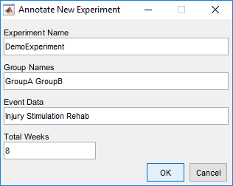

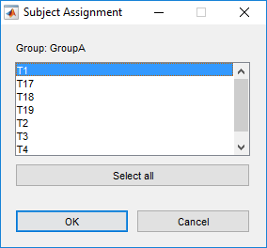

1. 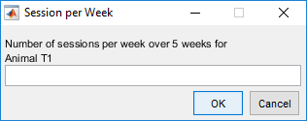Input how many data sessions are in each week or time point. NOTE: Input sessions separated by a space and make sure not to put a space after the last number i.e. (1 1 1 1).

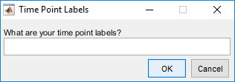

1. Input the time point labels. NOTE: Input labels separated by a space and make sure not to put a space after the last label i.e. (Pre Wk1 Wk2 Wk3).

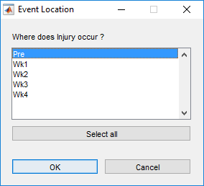

1. Select where the event occurred. If injury occurred at Week 2, then select Week 3 and the program will draw a line in the middle of Week 2 and Week 3.

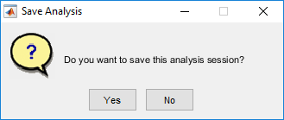

1. An option to save the analysis session will appear.
2. An overview of the unannotated data will show.

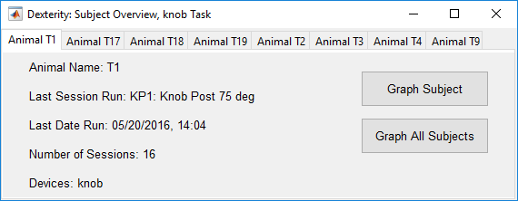

1. An overview of the annotated experiment will also show.

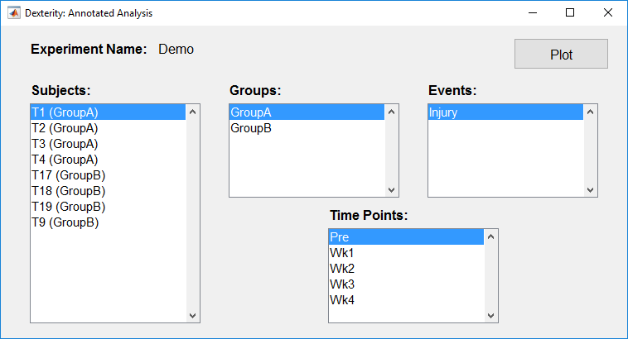

1. The unannotated data can be plotted by subject or all subjects by clicking “Graph Subject” or “Graph All Subjects.” (All Subjects shown)

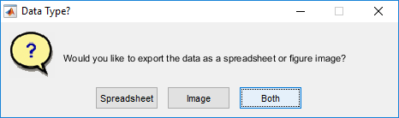

Export displayed data in spreadsheet format and the graph as an image file.

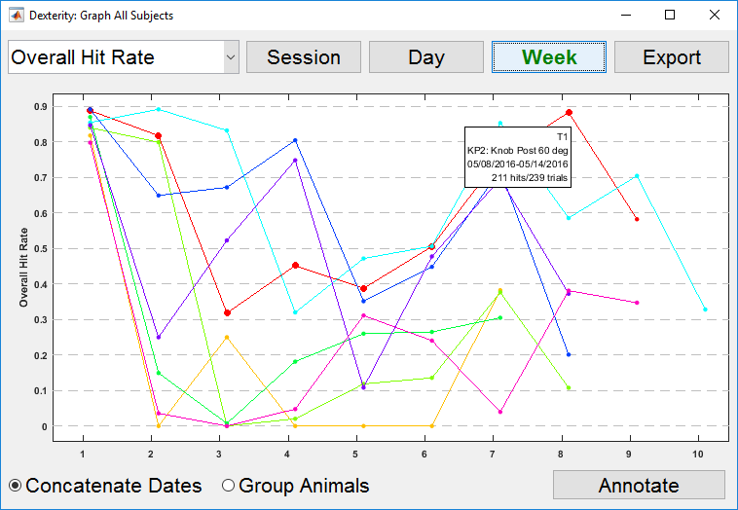

Click to align data by session and not date.

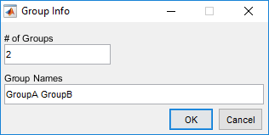

Click “Group Animals” to color code animals by group instead of individual colors. NOTE: Make sure to put a space between groups and not a space after the last item.

Plot all calculated variables.

Hover over a data point to see quick information about that data point. Click on the data point to view individual trials (NOTE: Only works in Session view).

Annotate the experiment and complete steps 6 through 10.

1. The annotated data can be plotted by clicking “Plot.”

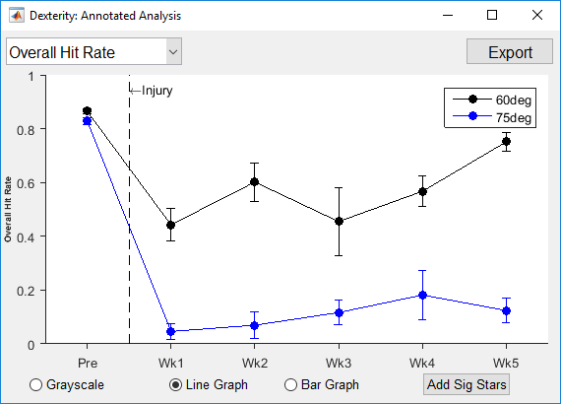

Export displayed data in spreadsheet format and the graph as an image file.

Plot all calculated variables.

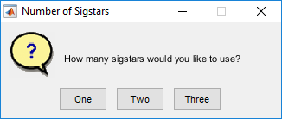

Add significance stars to the graph. NOTE: This does not perform any statistical analysis.

Switch to Grayscale.



Click to go home.

Custom

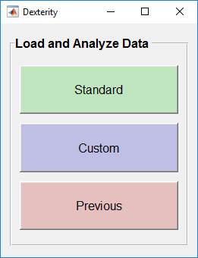

1. Select “Custom” from the initial screen.

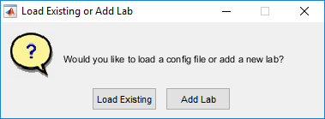

1. On initial startup, choose to add an existing lab or add a new lab.

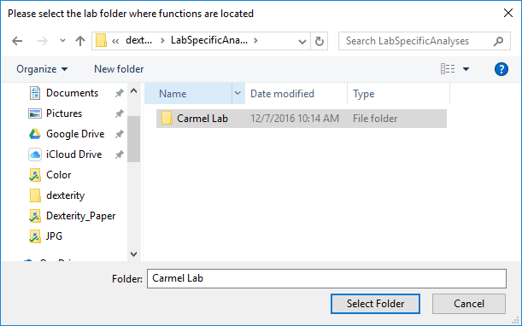

1. If “Load Existing” is selected, find the directory on the Master Repository and select the folder of the lab you want.

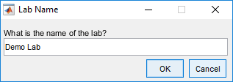

1. Or, select “Add Lab”. Add the name of the lab and select the directory, like in Step 3.
2. 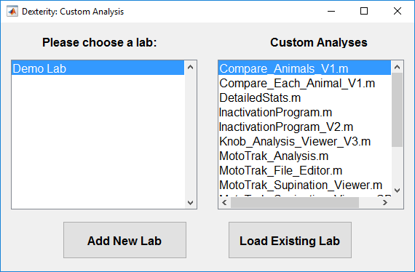After loading or adding a lab, a separate GUI will open to access the different labs and their custom functions. Single click on functions to run them.



Click to go home.

Previous



1. Select “Previous” from the initial screen.
2. 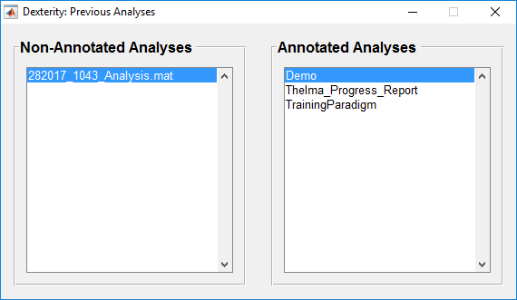Select between Non-Annotated and Annotated Analyses. Single click to open a saved analysis.



Click to go home.