About

The R library for ExamPA.net, the comprehensive, all-in-one solution to help you pass PA. Includes practice exams and quizzes and video tutorials. Don’t let PA stop you from earning your ASA!

5 years. That’s the average time required to pass all the exams to get an ASA.

The pass rate of PA is only 50%.  And this includes people who are taking PA for a second time.

Having to retake PA adds another 6 months to this journey.

| **Dataset** | **Description** |
| --- | --- |
| customer_phone_calls | Data used on June 18, 2020 Exam PA |
| patient_length_of_stay | Data used on June 16, 2020 Exam PA |
| patient_num_labs | Data used on June 19, 2020 Exam PA |
| actuary_salaries | DW Simpson actuarial salary data |
| june_pa | Auto crash data set from SOA June 2019 PA |
| customer_value | Customer value data set from December 2019 PA |
| exam_pa_titanic | Titanic passengers as used in ExamPA.net’s practice exam |
| apartment_apps | Apartment applications as used in ExamPA.net’s Practice Exam |
| health_insurance | Health insurance claims as used in ExamPA.net’s Practice Exam |
| student_success | SOA Student Success PA Sample Project, 2019 |
| readmission | SOA Hospital Readmissions Sample Exam, 2019 |
| auto_claim | Automotive claims |
| boston | Boston housing data set |
| bank_loans | Credit data from UCI Machine Learning Repository |

# Customer Phone Calls

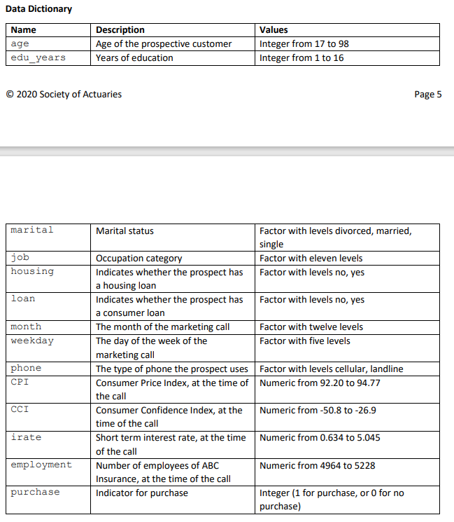

# Patient Length of Stay

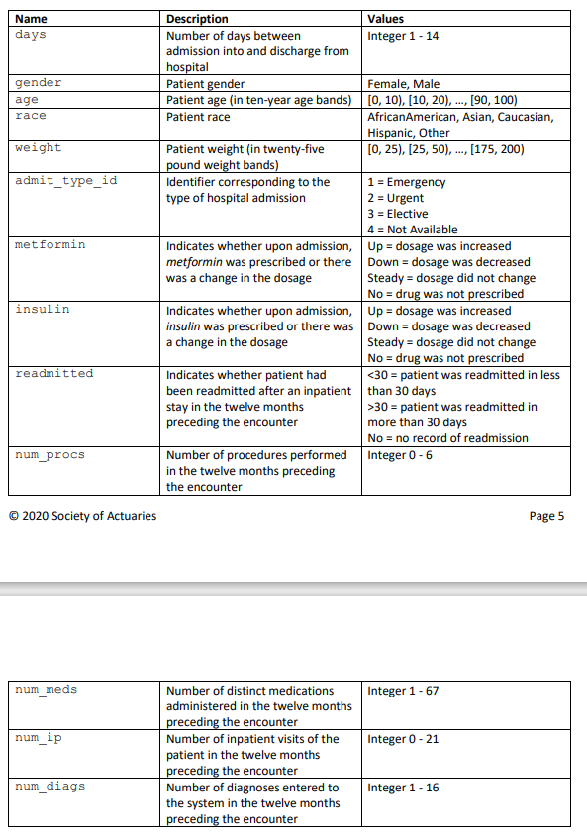

# Patient Number of Labs

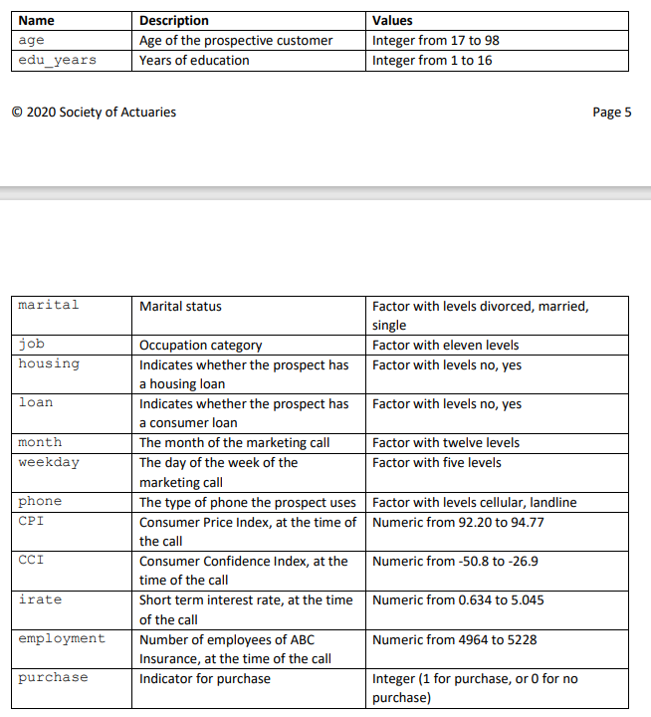

# Actuary Salaries

The data actuary_salaries contains the salaries of actuaries collected from the DW Simpson survey. Use this data to answer the exercises below.

|  |  |  |
| --- | --- | --- |
| **Variable** | **Description** | **Values** |
| industry | The industry of the actuary | Casualty, Health, Penson, Life |
| exams | The number of exams passed | ASA, FSA, 5,4,3,2,1 |
| experience | Years of experience | 1-20 |
| salary | Annual salary in $1,000 | 20 - 300 |
|  |  |  |
|  |  |  |

# June_pa

# 

# 

# Customer Value

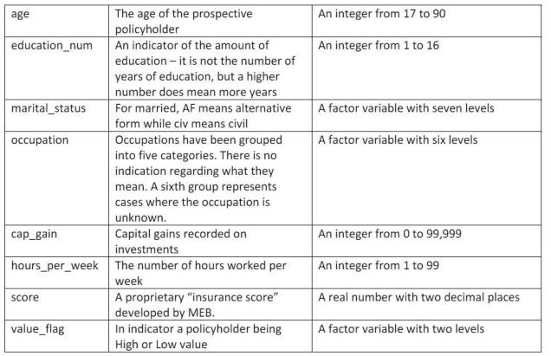

# Exam PA Titanic

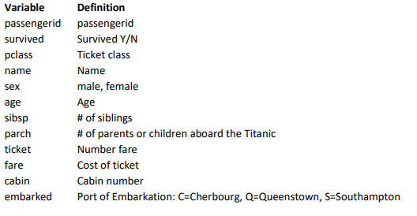

# Apartment Apps

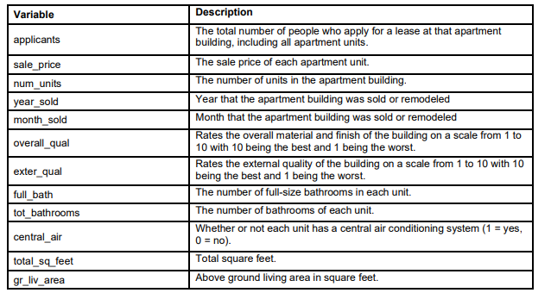

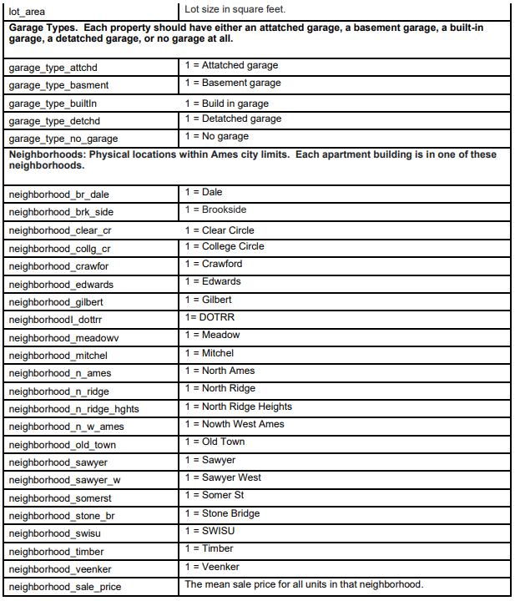

# Health insurance

Data set for the Health Costs Practice Exam. The data set consists of prior year’s health insurance claims, along with patient demographic information, from Freedom Health.

# 

# Student Success

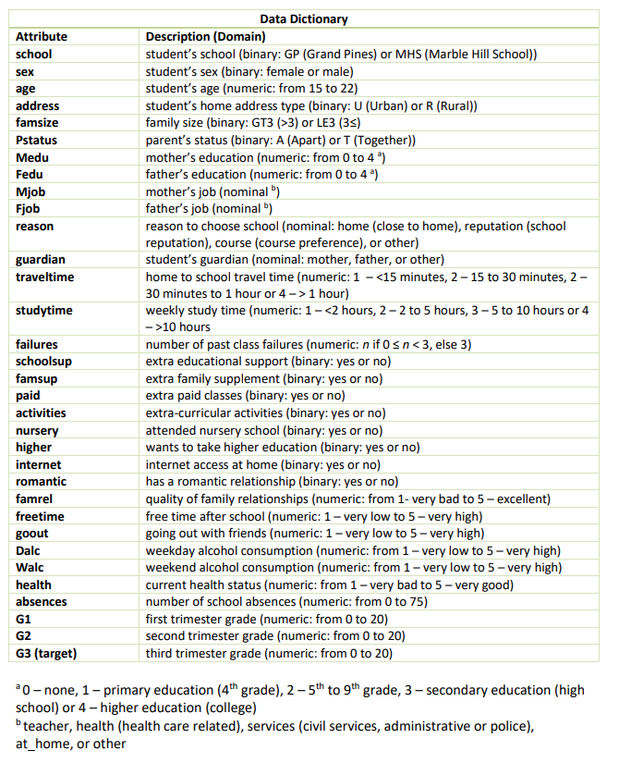

# Readmission

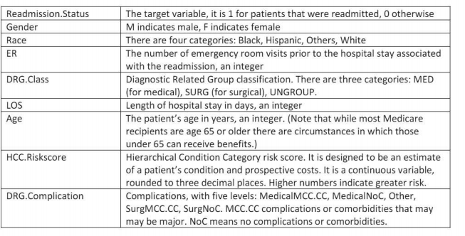

|  |  |  |
| --- | --- | --- |
| Variable | Description |  |
| POLICYNO | Policy number |  |
| POLCYDATE | Date that policy was signed |  |
| CLM_FREQ5 | Number of claims |  |
| CLM_AMT5 | Aggregate claim loss of policy (in thousands) |  |
| CLM_AMT |  |  |
| KIDSDRIV | Number of child passengers |  |
| TRAVTIME | Time to commute |  |
| CAR_USE | (1) Private or (2) commercial use |  |
| BLUEBOOK | (log) car value |  |
| RETAINED | Whether the policy was retained or not |  |
| NPOLICY | Number of policies |  |
| CAR_TYPE | (0-1 dummy variables) Type of car : (base) Panel Truck, (2) Pickup,(3) Sedan, (4) Sports Car, (5) SUV, (6) Van |  |
| RED_CAR | Whether the color of the car is (2) car or (1) not |  |
| REVOLKED | Whether the policyholder's license was (2) revoked in the past or (1) not |  |
| MVR_PTS | Number of motor vehicule record points |  |
| CLM_FLAG | Whether there was a claim or not |  |
| AGE | Age |  |
| HOMEKIDS | Number of children at home |  |
| YOJ | Year of job |  |
| INCOME | Annual income |  |
| GENDER | Gender of policyholder : (1) female or (2) male |  |
| MARRIED | Whether the policyholder is (2) married or (1) not |  |
| PARENT1 | Whether (2) the policyholder grew up in a single-parent family or (1) not |  |
| JOBCLASS | (0-1 dummy variables) Job class of policyholder: (base) Unknown, (2) Blue Collar, (3) Clerical, (4) Doctor, (5) Home Maker, (6) Lawyer, (7) Manager, (8) Professionnal, (9) Student |  |
| MAX_EDUC | (0-1 dummy variables) Maximal level of education of policyholder: (base) less than High School, (2) Bachelors, (3) High School, (4) Masters, (5) PhD |  |
| HOME_VAL | Value of home |  |
| SAMEHOME | Whether they grew up in the same home as their current home |  |
| AREA | (1) Rural or (2) urban area |  |
| IN_YY | Year |  |

# Boston

rim

per capita crime rate by town.

zn

proportion of residential land zoned for lots over 25,000 sq.ft.

indus

proportion of non-retail business acres per town.

chas

Charles River dummy variable (= 1 if tract bounds river; 0 otherwise).

nox

nitrogen oxides concentration (parts per 10 million).

rm

average number of rooms per dwelling.

age

proportion of owner-occupied units built prior to 1940.

dis

weighted mean of distances to five Boston employment centres.

rad

index of accessibility to radial highways.

tax

full-value property-tax rate per \$10,000.

ptratio

pupil-teacher ratio by town.

black

*1000(Bk - 0.63)^2* where *Bk* is the proportion of blacks by town.

lstat

lower status of the population (percent).

medv

median value of owner-occupied homes in \$1000s.

# Bank Loans

|  |  |
| --- | --- |
| **Variable** | **Description** |
| age | age (numeric) |
| job | type of job (categorical |
| marital | marital status (categorical |
| education (categorical | 'basic.4y','basic.6y','basic.9y','high.school','illiterate','professional.course','university.degree','unknown') |
| default | has credit in default? (categorical |
| housing | has housing loan? (categorical |
| loan | has personal loan? (categorical |
| contact | contact communication type (categorical |
| month | last contact month of year (categorical |
| day_of_week | last contact day of the week (categorical |
| duration | last contact duration, in seconds (numeric). Important note - this attribute highly affects the output target (e.g., if duration=0 then y='no'). Yet, the duration is not known before a call is performed. Also, after the end of the call y is obviously known. Thus, this input should only be included for benchmark purposes and should be discarded if the intention is to have a realistic predictive model. |
| campaign | number of contacts performed during this campaign and for this client (numeric, includes last contact) |
| pdays | number of days that passed by after the client was last contacted from a previous campaign (numeric; 999 means client was not previously contacted) |
| previous | number of contacts performed before this campaign and for this client (numeric) |
| poutcome | outcome of the previous marketing campaign (categorical |
| emp.var.rate | employment variation rate |
| cons.price.idx | consumer price index |
| cons.conf.idx | consumer confidence index |
| euribor3m | euribor 3 month rate |
| nr.employed | number of employees |
| y | has the client subscribed a term deposit? |