Q6: Class 06 Code Improvement Homework

Stephanie D. Curtis

1/25/2019

## Removing Calculation Duplication when Coding

Rather than reading into PDB three separate times, making three separate variables, and writing the same three lines of code for each, I have created **a single function** to perform the lookup and analysis, named pdbplotfxn. This function allows the comparison of protein structure under drug-treated and untreated condition (for example) by visualizing the amino acid sequence plotted against the B-factor under both conditions.

#load package  
library(bio3d)  
  
#pdbplotfxn outputs a graph of the amino acid sequence along the x-axis to assess what regions of the protein are structurally flexible (B-factor). Different structures from PDB can be input to analyze a protein's structural change in response to treatment, in this case to assess the effect of two drugs on a kinase's structure to see if either can inhibit its ability to bind/phosphorylate substrate, and whether they act on the same region of the protein.  
pdbplotfxn <- function(x){  
 y <- read.pdb(x)  
 sChainA <- trim.pdb(y,chain="A",elety="CA")  
 sb <- sChainA$atom$b  
 chainplot <- plotb3(sb,sse=sChainA,typ="l",ylab="Bfactor")}  
  
#Inputs to the function are the following three PDB ID's in their normal four-letter format as you would input them to a read.pdb function.   
pdbplotfxn("4AKE")

## Note: Accessing on-line PDB file

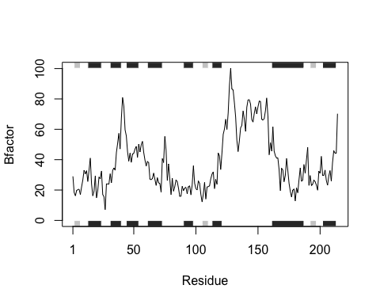

pdbplotfxn("1AKE")

## Note: Accessing on-line PDB file  
## PDB has ALT records, taking A only, rm.alt=TRUE

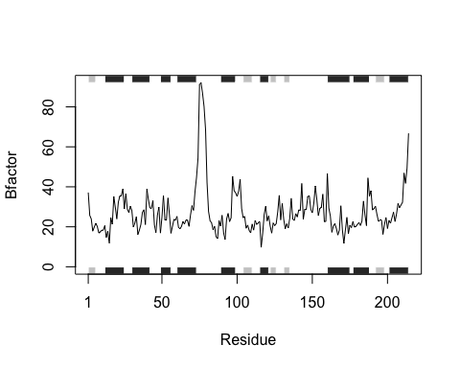

pdbplotfxn("1E4Y")

## Note: Accessing on-line PDB file



