Introduction to C- language

- C is a procedural programming language.
- C is a general-purpose programming language created by Dennis Ritchie at the Bell Laboratories in 1972.
- C is strongly associated with UNIX, as it was developed to write the UNIX operating system.
- C is very fast, compared to other programming languages,

C - Character set

- A set of all valid character (Alphabet ,numeric value or special symbols) is known as character set.
- Alphabet – a – z or A—Z
- Digit - 0—9
- Special character - @,#,$,_,-,+,(),{},[], etc
Note – C is a case sensitive language.

C TOKENS

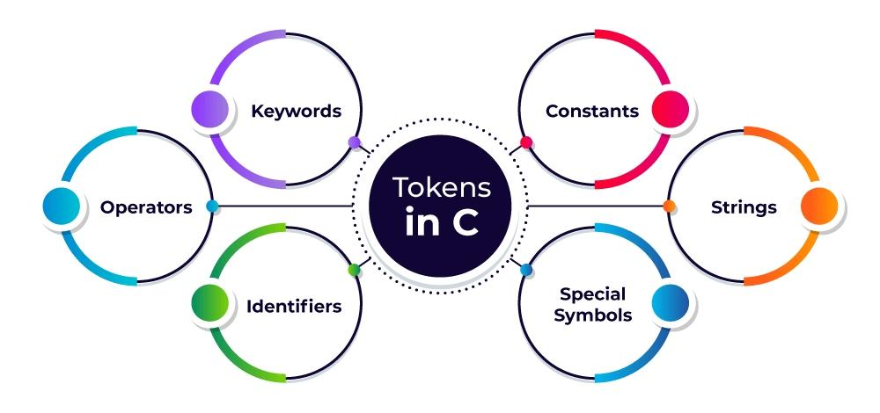
- In C language the smallest Individual unit are called token.
- Tokens in C language are of different types these are represented below
- Constant
- Identifiers
- Variable
- Keywords
- Operators
- String

Constant –
Constants are fixed values that do not change during program execution.

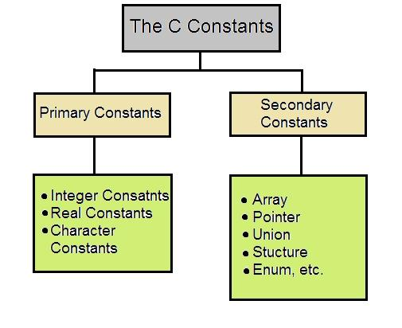
Identifiers-
Identifiers are fundamental concepts in programming that used to identify variables, functions, classes, modules, or other entities in a program.

Rules for creating identifiers –
- An identifier must begin with a letter or an underscore. It cannot start with a digit.
- No commas and blank spaces are allowed while creating identifiers.
- We can’t use keyword name to create identifiers.
- Special character not allowed except Underscore.
- C is case-sensitive, meaning that Variable, variable, and VARIABLE are considered different identifiers.

Variable –
A variable is a symbolic name associated with a memory location that stores data.

How to declare or initialize Variable?
First we define data type then variable name
Syntax –
<Data_type> <variable_name>;
Example -
int age; // Declaration of an integer variable
float salary; // Declaration of a float variable
char grade; // Declaration of a character variable
Variables can also be initialized at the time of declaration:
Int age = 30; // Declaration and initialization
Float salary = 50000.50; // Declaration and initialization

Keywords
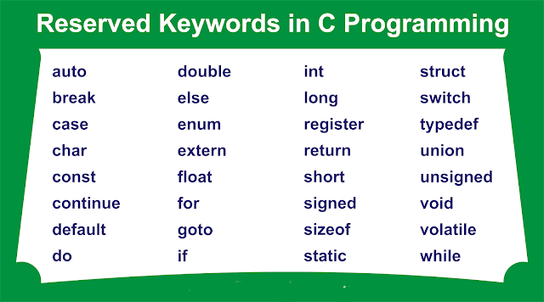
- Keywords are predefined, reserved words in C that have specific meanings and functions within the language .C has a total of 32 keywords.

Operators –
Operators are special symbols used to perform operations on variables and values
Like addition (+) , subtraction(-) etc
They can be classified into several categories based on the type of operation they perform.
We disscus about operator in detail in next chapter

Strings –

A String in C programming is a sequence of characters terminated with a null character '\0'
Example
Char str[] = “ computer”;

Input & Output Statement In C
The printf() and scanf() functions are used for input and output in C language. Both functions are inbuilt library functions, defined in stdio.h (header file).
printf() function
The printf() function is used for output. It prints the given statement to the console.
syntax –
printf(“format string”,argument_list);
- Format string specifies the format for the output (e.g., %d for integer).
- Argument_list provides the values to be printed.Example –
Printf(“Hello, World!”);
Printf(“Age: %d”, age);
- Printf(“Hello, World!”); prints the text “Hello, World!” to the console.
- Printf(“Age: %d”, age); prints the value of age as an integer.

scanf() function
The scanf() function is used for input. It reads data from the standard input (usually the keyboard) and stores it in specified variables.
Syntax –
Scanf(“format string”, &argument_list);
- Format string specifies the data type of input (e.g., %d for integer).
- & (address-of operator) is used before variable names to specify the location where the input will be stored.
Example –
Int age;
Scanf(“%d”, &age);
Explanation –
Scanf(“%d”, &age); takes an integer input from the user and stores it in age.

Format Specifiers
Format specifiers are placeholders used in printf() and scanf() functions to indicate the data type of values being printed or read.
Format Specifier | Data Type | Example
%d | Integer | int age; scanf(“%d”, &age);
%f | Floating-point | float salary; scanf(“%f”, &salary);
%c | Character | char grade; scanf(“%c”, &grade);
%s | String | char name[20]; scanf(“%s”, name);
%lf | Double | double score; scanf(“%lf”, &score);

Operators in C
C operators are symbols that are used to perform Sone specific operations on operands.
There are following types of operators in C.

- Arithmetic Operators
- Comparison (Relational) Operator
- Logical Operators
- Assignment Operators
- Bitwise Operators

1.Arithmetic Operators
Arithmetic operators are used to perform arithmetic operations on the operands. The following operators are known as C arithmetic operators.

Operator | Description | Example
+ | Addition | 10+20 = 30
- | Subtraction | 20-10 = 10
* | Multiplication | 10*20 = 200
/ | Division | 20/10 = 2
% | Modulus (Remainder) | 20%10 = 0
++ | Increment | Int a=10; a++; Now a = 11
-- | Decrement | Int a=10; a--; Now a = 9

2.Comparison Operators
The C comparison operator compares the two operands. The comparison operators are as follows:
Operator | Description | Example
== | Is equal to | 10==20 = false
!= | Not equal to | 10!=20 = true
> | Greater than | 20>10 = true
>= | Greater than or equal to | 20>=10 = true
< | Less than | 20<10 = false
<= | Less than or equal to | 20<=10 = false

3.Logical Operators
The following operators are known as C logical operators.
Operator | Description | Example
&& | Logical AND ( It returns true when both expression are true) | (10==20 && 20==33) = false
|| | Logical OR( It returns true when one of both equations is true) | (10==20 || 20==20) = true
! | Logical Not (It return true when expression give false) | !(10==20) = true

4.Assignment Operators
The following operators are known as C assignment operators.
Operator | Description | Example
= | Assign | var a=6;
+= | Add and assign | int a=10; a+=20; Now a = 30
-= | Subtract and assign | int a=20; a-=10; Now a = 10
*= | Multiply and assign | int a=10; a*=20; Now a = 200
/= | Divide and assign | int a=10; a/=2; Now a = 5
%= | Modulus and assign | int a=10; a%=2; Now a = 0

5.Bitwise Operators
The bitwise operators perform bitwise operations on operands. The bitwise operators are as follows:
Operator | Description | Example
& | Bitwise AND | 5 & 1 = 1  5 & 4 = 4
| | Bitwise OR | 5 | 1 = 5  5 | 4 = 5
^ | Bitwise XOR | 5 ^ 1 = 4  5 ^ 4 = 1
~ | Bitwise NOT | (~10) = -10
<< | Bitwise Left Shift | (10<<2) = 40
>> | Bitwise Right Shift | (10>>2) = 2

Note –
- Formula for left shift – number * 2n
- Formula for Right shift – number / 2n

Conditional Statements

Conditional statements are used to perform different actions based on different conditions. Very often when you write code, you want to perform different actions for different decisions.
In C programming we have the following conditional statements:
- If statement
- If else statement
- If else if statement
- Nested If statement
- Use if to specify a block of code to be executed, if a specified condition is true
- Use else to specify a block of code to be executed, if the same condition is false
- Use else if to specify a new condition to test, if the first condition is false

The if Statement
Use the if statement to specify a block of C code to be executed if a condition is true.
Syntax
if (condition) {
// block of code to be executed if the condition is true
}

The else Statement
Use the else statement to specify a block of code to be executed if the condition is false.
Syntax -
if (condition) {
// block of code to be executed if the condition is true
}
else {
// block of code to be executed if the condition is false
}

The else if Statement
Use the else if statement to specify a new condition if the first condition is false.
Syntax
if (condition1) {
// block of code to be executed if condition1 is true
}
else if (condition2) {
// block of code to be executed if the condition1 is false and condition2 is true
}
else {
// block of code to be executed if the condition1 is false and condition2 is false
}

While Loop in C
The while loop allows a block of code to be executed repeatedly as long as the condition specified remains true.

Syntax
While (condition) {
// Block of code to be executed while the condition is true
}
Explanation
Condition: The loop checks the condition before execution.
Body: If the condition is true, the code inside the loop is executed.
The process repeats until the condition becomes false.

For example
#include <stdio.h>
Int main() {
Int I = 1;
While (I <= 5) {
Printf(“Number: %d\n”, I);
I++; // Incrementing I
}
}
Output
Number: 1
Number: 2
Number: 3
Number: 4
Number: 5

