**CHAPTER 1**

**INTRODUCTION**

The development of a transportation system has been the generative power for human beings to have the highest civilization above creatures in the earth. Automobile has a great importance in life. It is utilized to go to the work place, keep in touch with the friends and family, and deliver the goods. But it can also bring disaster and even can kill people through accidents.

Speed is one of the most important and basic risk factors in driving. It not only affects the severity of a crash, but also increases risk of being involved in a crash. Despite many efforts taken by different governmental and non-governmental organizations all around the world by various programs to aware against careless driving, yet accidents are taking place every now and then. However, many lives could have been saved if the emergency service could get the crash information in time. As such, efficient automatic accident detection with an automatic notification to the emergency service with the accident location is a prime need to save the precious human life.

Quick treatment to the one who has met with accident is very much necessary to save the life. But the lack of in time accident reporting, accurate location reporting has made it difficult to provide the emergency treatment at right time. This requires an automated system which can notify the family members, friends and Hospital Ambulance about the accident along with the accurate location.

Considering the above scenario, by using ever-evolving IoT technology, advent of mobile phones and by embedding sensors to the vehicles to provide quick treatment or for reducing the accidents. By embedding road condition sensor, vehicle distance sensor, forward obstacle sensor, side obstacle sensor, air pressure sensor, rear obstacle sensor, GPS sensor, Driver monitoring sensor, fire detection sensor, vehicle speed, acceleration sensor etc. to the different parts of vehicle and by designing vehicle-to-vehicle communication system. These embedded sensors are made to communicate with people through the mobile by sending the messages when incident happens, which increases people safety which in-turn helps to avoid and controls many accidents.

Now a days Global positioning System is a very popular technology used in many applications such as vehicle tracking, navigation etc.

The paper focuses on utilizing GPS for finding the vehicle accident location detection and sensors for safety measure and to know the road condition and reason for accident. Even injured passengers’ medical history like blood types and allergy details will also be sent, which helps for the quick treatment.

A Considerable work has been done in this area for the implementation of Accident alert system using android phones as alternatives to the detection of accident using the hardware enabled devices to improve both usability and efficiency issues. It involves the detail study of existing system and limitations. The most common approach of accident detection was by human observation or by human communication. This approach is considered to be the traditional approach of accident detection. At these criteria, it cannot detect where the accident has occurred and hence no information related to it, leading to the death of an individual if there isn’t any human intervention. To address this problem, researchers have developed accident detection system that uses hardware configured with specific sensors for accident detection. The high demand of automobiles has also increased the traffic hazards and the road accidents. There is high risk for people’s life. This is because of the lack of accident detection at the right time and notification to the authorized emergency contacts, which will help in saving the valuable lives. An automatic alarm device for vehicle accidents is introduced. This design is a system which can detect accidents in significantly less time and sends the basic information to the monitoring server within a minutes covering geographical coordinates, the time and sensor details in which a vehicle accident had occurred. The application will use a common android phone which will immediately notify the concerned people about the accident. The aim is to detect accident in any type using Adaptive Algorithm. Because of the android platform, the system will be available at low cost and even low-end car owners can afford to use it.

Speed is one of the basic reasons for vehicle accident. Many lives could have been saved if emergency service could get accident information and reach in time. Nowadays, GPS has become an integral part of a vehicle system. The capability of a GPS receiver to monitor speed of a vehicle and detect accident basing on monitored speed and send accident location to an Alert Service Center. The GPS will monitor speed of a vehicle and compare with the previous speed in every second through a Microcontroller Unit. Whenever the speed will be below the specified speed, it will assume that an accident has occurred. The system

will then send the accident location acquired from the GPS along with the time and the speed by utilizing the GSM network. This will help to reach the rescue service in time and save the valuable human life.

Speed is one of the most significant causes of an accident. Nowadays, GPS receiver has become an integral part of a vehicle. Besides using in other purposes, the GPS can also monitor the speed and detect an accident. It can use a very cheap and popular GSM modem to send the accident location to the Alert Service Centre. It can also send the last speed before accident which will helps to assess the severity of the accident and can initiate a voice call.

Beside the automatic detection system, the vehicle occupant will be able to manually send the accident situation by pressing the Manual Detection Switch. A rescue measures in time with sufficient preparation at the correct place can save many lives. The proposed system can serve the humanity by a great deal as human life is valuable.

**CHAPTER 2**

**SYSTEM ARCHITECTURE**

Considering the fact that the vehicle is bound to the road this system this system utilizes the MM to monitor the vehicle and the accident caused. The accident is confirmed if the vehicle is off the road and the signal is sent to the rescue team. The System detects the speed of the vehicle using a GPS receiver which analysis the speed of the vehicle with comparison to previous values by using HI-204III Ultra Highly Sensitive GPS receiver. If detected it sends GPS alert to the service centre. If no GPS is not available then a SMS and a voice message is sent to the service centre. Researcher proposed a system which uses GPS to monitor the speed of a vehicle and detects the accident and sends location information.

Author uses Accident detection algorithm in which braking distance is proportional to the square of speed. So only speed is considered as a reason for the accident. Other than speed, other parameters like distance between the two vehicles, road conditions are not considered A vibration sense or Micro electro mechanical system (MEMS) sensor detects the accident and will send a message along with the GPS to the rescue team. SOSMART by SOS mart SPA is an automatic car crash detection app that detects the accident and sends the alarm along with the location to the contacts previously saved and waits for them to send the help. This is not useful if the contacted people don’t have the app or they are not reachable etc.

In this paper a pressure sensor along with the GPS module it is integrated into the car which send the location to the cloud. This rescue vehicle with GPS and GSM; with the provided location proceeds to the accident spot. The cloud sends the information about the rescue vehicle to the traffic signal which turn-on the RF receiver which turns the traffic signal green whenever emergency vehicle approaches the signal this reducing the delay.

This system is based on the computational intelligence techniques and is installed based on the study. But the false alarm rates are very high in this system and can be used by traffic departments.

The ASAD system that is installed in a vehicle and a smartphone sends text messages to the authorities about the accident occurred but the system is not compact and also does not provide the facility to send simultaneous messages to multiple contacts.

Lexus Enform uses a force sensor to detect the accident in the rear end and send the information to the service center but this costs about $260/year for the service.

Considering the fact that the vehicle is bound to the road this system this system utilizes the MM to monitor the vehicle and the accident caused. The accident is confirmed if the vehicle is off the road and the signal is sent to the rescue team. The System detects the speed of the vehicle using a GPS receiver which analysis the speed of the vehicle with comparison to previous values by using HI-204III Ultra Highly Sensitive GPS receiver. If detected it sends GPS alert to the service centre. If no GPS is not available then a SMS and a voice message is sent to the service centre. Researcher proposed a system which uses GPS to monitor the speed of a vehicle and detects the accident and sends location information. Author used Accident detection algorithm in which braking distance is proportional to the square of speed. So only speed is considered as a reason for the accident.

A vibration sense or Micro electro mechanical system (MEMS) sensor detects the accident and will send a message along with the GPS to the rescue team.

SOSMART by SOSmart SPA is an automatic car crash detection app that detects the accident and sends the alarm along with the location to the contacts previously saved and waits for them to send the help. This is not useful if the contacted people don’t have the app or they are not reachable etc.

GPS antenna is used to receive the stronger satellite signal hence to minimize the loss of signal when vehicle is in motion. This helps to get accurate location of the accident.

The proposed system uses three sensors such as Tilt sensor, IR Sensor and Vibration sensor for detecting accident. Flow chart of proposed system is shown below

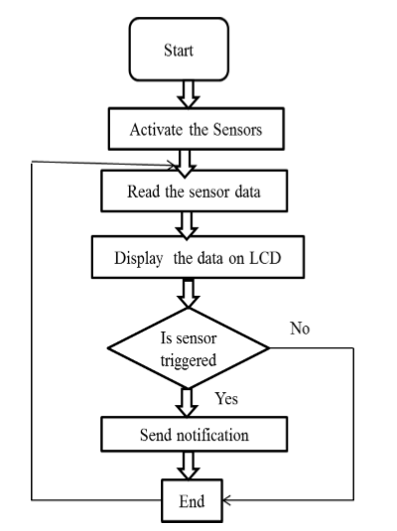

Fig.2.1. Flowchart of proposed system

In this system, Universal asynchronous receiver/Transmitter (UART) protocol is used to get the data from the GPS. UART transmit data received from GPS antenna to Microcontroller through the data bus. Since it is asynchronous clock signal is not required to synchronize transmitting UART and Receiving UART, but baud rate has to be matched.

Tilt, IR, Vibration sensors and produces the output. When an accident occurs, one of the sensors get triggered then the location will be sent through the GPS module along with passengers’ information to the respective contacts which can be accessed by Blynk app installed on the android smart phone.

The proposed system architecture shows how the components are connected with each other.

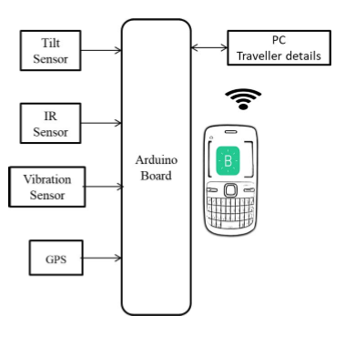

Fig.2.2-Proposed System Architecture

**CHAPTER 3**

**TECHNOLOGY USED**

ARDUINO Uno

It’s a microcontroller board with 14 I/O pins usb connection, power jack, ICSP header and reset button. This allows uploading the code without any external programmer as ATmega328P.

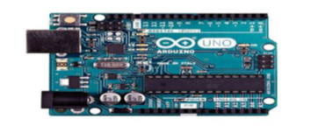

Fig 3.1-Arduino Board

TILT SENSOR

ADXL335 is used which can measure the static acceleration of gravity in tilt sensor application and even dynamic acceleration due to motion, vibration and shock. The user can select the bandwidths with a range of 0.5 Hz to 1600 Hz for the X and Y axes and 0.5 Hz to 550 Hz for the Z axis.

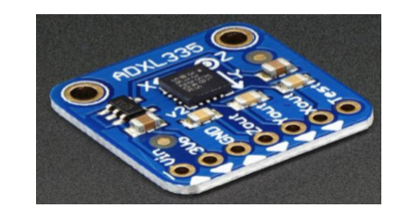

Fig.3.2-Tilt Sensor ADXL335

IR SENSOR

This sensor is used to detect the obstacles by transmitting continuous IR rays and receiver receiving the IR light back and later measuring the voltage based on the amount of reflected light received. The wavelength region of 0.75μm to 3 μm is called near infrared, the region from 3 μm to 6 μm is called mid infrared and the region higher than 6 μm is called far infrared.

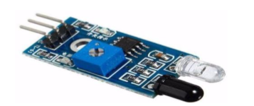

Fig.3.3- IR Sensor

VIBRATION SENSOR

The ADXL103 is a high performance, single-/dual axis accelerometer compatible with Sn/Pb- and Pb-free solder processes. The bandwidth is selected based on the application ranging from 0.5 Hz to 2.5 Capacitor CX and Capacitor CY at the XOUT and YOUT pins

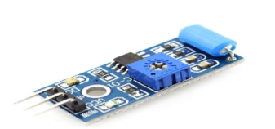

Fig 3.4-Vibration sensor

BLYNK APP

It is a digital dash board where graphical interface can be used to build application to control Arduino, Raspberry Pi with iOS and Android apps.

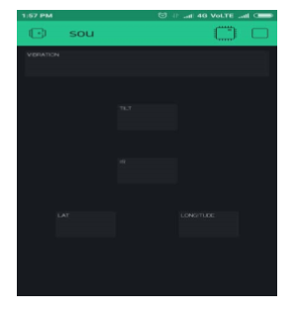

Fig. 3.5-Blynk App

GPS &. GPS antenna

GPS (Global Positioning System) is a satellite system with 24 satellites to determine accurate position of the receiver on the earth. The reception of the GPS signal can be boosted by using GPS antenna.

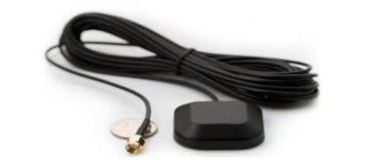

Fig.3.6-GPS Antenna

**CHAPTER 4**

**IMLEMENTATION AND RESULT**

In the paper a pressure sensor along with the GPS module is integrated into the car which send the location to the cloud. This rescue vehicle with GPS and GSM; with the provided location proceeds to the accident spot. The cloud sends the information about the rescue vehicle to the traffic signal which turn on the RF receiver which turns the traffic signal green whenever emergency vehicle approaches the signal this reducing the delay.

The system is based on the computational intelligence techniques and is installed based on the study. But the false alarm rates are very high in this system and can be used by traffic departments.

The ASAD system that is installed in a vehicle and a smartphone sends text messages to the authorities about the accident occurs but the system is not compact and also does not provide the facility to send simultaneous messages to multiple contacts.

Lexus Enform uses a force sensor to detect the accident in the rear end and send the information to the service center but this costs about $260/year for the service.

Considering the fact that the vehicle is bound to the road this system this system utilizes the MM to monitor the vehicle and the accident caused. The accident is confirmed if the vehicle is off the road and the signal is sent to the rescue team. The System detects the speed of the vehicle using a GPS receiver which analysis the speed of the vehicle with comparison to previous values by using HI-204III Ultra High Sensitive GPS receiver. If detected it sends GPS alert to the service Centre. If no GPS is not available then a SMS and a voice message is sent to the service Centre.

It is proposed that the system which uses GPS to monitor the speed of a vehicle and detects the accident and sends location information. Author uses Accident detection algorithm in which braking distance is proportional to the square of speed. So only speed is considered as a reason for the accident. Other than speed, other parameters like distance between the two vehicles, road conditions are not considered in this paper.

A vibration sense or Micro electro mechanical system (MEMS) sensor detects the accident and will send a message along with the GPS to the rescue team.

SOSMART by SO Smart SPA is an automatic car crash detection app that detects the accident and sends the alarm along with the location to the contacts previously saved and waits for them to send the help.

This is not useful if the contacted people don’t have the app or they are not reachable etc.

**RESULTS**

In the proposed system, sensors will be keep sensing the data, whenever data or values crosses the predefined particular threshold value or angle, then it is assumed

that accident occurred and it sends the message to the friends or registered users through Blynk server. Pseudo code of working of Tilt sensor is shown below.

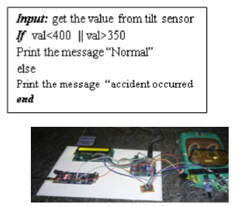

Fig.4.1. System Overview

After implementing the proposed system, the toy car is being embedded. Whenever there is 10cm gap between the toy car and other vehicles or obstacles IR sense gets activated and sends the message.

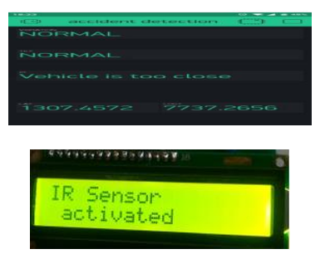

Fig.4.2. Screenshot of IR Sensor

If the vehicle tilts more than 400 and less than 350degree then its assumed that accident occurred due to vehicle’s tilted and fallen down; so immediately message will be sent. Screenshot is shown below.

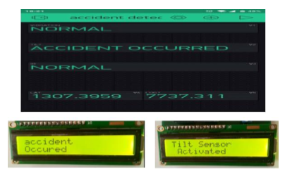

Fig.4.3. Screenshot of Tilt Sensor

If the vehicle starts vibrating heavily then the reason for accident is due to the vibration. Notification will be sent to the registered contact.

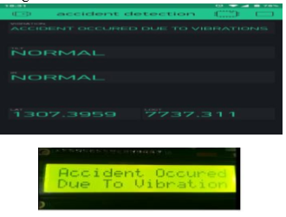

Fig.4.4. Screenshot of Vibration Sensor

In all these aforementioned scenarios geographical values of the accident location will be displayed on the LCD display for the reference.

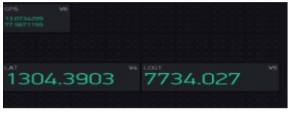

Fig.4.5. Screenshot of GPS location

**CHAPTER 5**

**APPLICATIONS**

The various healthcare applications of remote monitoring of patients, elderly care, remote medication, telemedicine and providing consultancy through smart applications.

Remote patient monitoring

This application is deployed for remotely monitoring the patient’s essential parameters through the use of sensors, devices and objects surrounding them. In this, the real time critical data of the patient is transmitted and shared between the patient and the caregivers. Its main relevance is for chronic disease management such as diabetes, cardiac disease monitoring, asthma etc.

Mobile personal assistance

This application makes use of the mobile technologies to enable remote access to current clinical systems or care giving institutions. The smart mobile apps, portals, websites etc easily available to all have made the automation of e-health systems easy.

Smart devices

Smart devices in healthcare are used to store and manage key care parameters and to manage the captured disease data. They are mainly deployed for providing fitness solutions by tracking target activities and diagnostic devices used for storing data from devices. Mainly they are used as fitness solutions for tracking patient activities and smart diagnostic devices such as blood pressure devices, pedometers, Google glass, etc used for capturing the data from the sensors for further analysis by doctor.

Telemedicine

This application provides virtual assistance through remote connectivity and efficient solutions enabling virtual care consultation, medicine delivery, education etc.

The diagnosis of providing remote medicinal assistance such as tele-consultations, mobile video solutions has become very common in countries and markets.

Elderly care

This application clinically monitors the aging population for making them independent. These devices include wearable and implanted sensors for monitoring the elderly patients without requiring individual intervention. The monitoring devices track the vital signs of elderly care and transmit them to a standard mobile device which serves as a node for transmitting the real time data to the doctors. The information thus collected can be used to provide medical assistance to the elders and in case of emergencies, nearby hospitals can be alerted.

Smartphone apps

An effective solution: Smartphone apps can be used as an interface to provide care giving to the needful. Various open source apps for providing healthcare solutions are developed to provide efficient healthcare facilities. The diagnosis apps (Diagnose, 5MCC, Prognosis, 5-minute infectious disease consult), drug reference apps (Medical doctor: reference tool, Epocrates, FDA drugs, Lab values), calculator apps (MedCalc, caddy medical calculator, uBurn lite), clinical communication apps (Voalte one, mVisum, Vocera) etc.

**CHAPTER 6**

**FUTURE SCOPE**

The open challenges and future scope related to healthcare IoT:

* With the rapid advancement of IoT, billions of smart devices and objects get connected to the internet. These smart devices collect huge amount of data that need to be processed, analyzed and even stored for future use. Hence scalability of IoT network and devices tend to be a major concern.
* Technological convergence helps in establishing a standardized framework for the IoT devices. Due to lack of standardization, interoperability of the things becomes a serious issue to consider and by working on it , can achieve the vision of very-well connected interoperable smart devices.
* An active participation of the government bodies towards building regulations for safety and security of objects, devices and people associated should be considered.
* In remote monitoring of the patients, sensors being implanted or wearable may refrain from attention may cause a threat to the security of patients that can become critical.
* Since IoT is an open network hence security requirements like confidentiality, integrity, and availability of patient’s data should be ensured so that threats related to security and privacy can be dealt with.
* As the IoT technology is improving at fast pace, the challenges pertaining to design issues need to meet in the future. These challenges include overcoming energy limitation, memory and computational limitations in IoT smart devices.
* Since effective healthcare is everyone’s right. Hence IoT-based healthcare services may be perceived as a low-cost technology
* Intelligent devices can provide instant response based on the health requirements. For instance, after a hard day at work, when people are exhausted, the watch could measure vital parameters and provide customized recommendations on diet and the type of relaxation exercises that might be in need.

**CONCLUSION**

In this paper it is being implemented an IoT system for accident detection by considering one of the three cases such as tilt, vibration and distance between the two objects. Since this is an automated system, it sends the message to the registered person quickly so it takes very less time, hence is works efficiently compare to manual notification. Hence plays an important role in providing the quick treatment along with additional information such as blood group, allergy etc. In addition, the GPS antenna helps in forwarding the accurate accident location.

As of now all the experiment results are stored in the database. In future, this is implemented in real time vehicle and outputs can be stored in a centralized server to find out the frequent accident zones. Which can be further utilized for the investigation, survey and improvise the accident zones. This survey helps to take proper action on the particular location to improve the road condition in turn helps to save the valuable life. In future, a manual button has to be implemented to reduce the faulty notification.

**Bibliography**

[1] Kavya K1, Dr. Geetha C R2 “Accident Detection and Ambulance Rescue using Raspberry Pi”, International Journal of Engineering and Techniques - Volume 2 Issue 3, May – June 2016

[2] Murat Ozbayoglu, Gokhan, Erdogan,” A Real-Time Autonomous Highway Accident Detection Model Based on Big Data Processing and Computational Intelligence”, 9781-4673-9005-7/16/$31.00 ©2016 IEEE

[3] Asad Ali and Mohamad Eid,” An Automated System for Accident Detection”, 978-1-4799-6144-6/15/$31.00 ©2015 IEEE

[4] "Enform." Lexus, Toyota. N.p., n.d. Web. 15 June 2014.

[5] Johnston, Casey. "The Pursuit of Connection: The $120K Lexus App and Car Combo." Ars Technica. N.p., n.d. Web. 15 June 2014.

[6] Md. Syedul Amin, Mohammad Arif Sobhan Bhuiyan, Mamun Bin Ibne Reaz, Salwa Sheikh Nasir,” GPS and Map Matching Based Vehicle Accident Detection System, 2013 IEEE Student Conference on Research and Development (SCOReD), 16 -17 December 2013, Putrajaya, Malaysia”

[7] Md. Syedul Amin, Jubayer Jalil, M. B. I. Reaz” Accident Detection and Reporting System using GPS, GPRS and GSM Technology”, 978-1-4673-1154-0/12/$31.00 ©2012 IEEE

[8] Md. Syedul Amin, Jubayer Jalil , M.B.I.Reaz ,”Accident Detection and Reporting System using GPS, GPRS and GSM Technology”, “IEEE/OSA/IAPR ICIEV, 2012 [9] C.Prabha 1, R.Sunitha 2, R.Anitha,” Automatic Vehicle Accident Detection and Messaging System Using GSM and GPS Modem” DOI: [10].15662/ijareeie.2014.0307062 [10] http://www.sosmartapp.com/

[11] [http://www.arduino.org/products/boards/arduino-uno]

[12] <https://www.azosensors.com/artcle.aspx?ArticleID=318>

[13] <https://www.elprocus.com/infrared-ir-sensor-circuit-andworking/>

[14]https://www.sparkfun.com/datasheets/Sensors/Acceleromete r/ADXL103_203.pdf

[15] <http://www.blynk.cc/>

[16] http://www.wisegeek.com/what-is-a-gps-antenna.html