**Student Name: Ashley Elliott**

**Access Code (located on the underside of the lid of your lab kit): AC-2JZCY3X**

**Pre-Lab Questions”**

1. What is the acceleration of a ball that is vertically tossed up when it reaches its maximum height?  
   **The acceleration would be 9.8m/s^2**

1. If you drop a ball, and then one second later drop a ball identical in mass, size and shape, what happens to the distance between them as they fall?

**The distance will not change and they will remain falling 1 second apart because they will fall at the speed of gravity (9.8m/s^2).**

1. What does a positive and negative slope represent for a velocity versus time graph?  
   **The line will slope up (meaning it is positive) if the acceleration is positive. The slope will be negative if the acceleration is negative (or deceleration).**
2. In one of your experiments, you will roll a marble down a ramp to provide an initial horizontal velocity. Suppose you start the marble at rest (*vo* = 0 m/s) and it travels a distance of, *d*, down the ramp. Use 1-D kinematics to predict the velocity of the ball (*vf* ) at the bottom of the ramp. Hint: the acceleration of the ball down the ramp is 9.81*sin(θ) m/s2 where θ is the angle of the ramp. Record you answer in variables (*you will calculate the velocity with magnitudes when you perform the experiment*).  
   **vF= √2gdsin**θ
3. Use the kinematic equations to derive a general equation for the time it takes a ball dropped from rest at vertical height, *h*, to reach the ground.  
   **vf=**√**2gd**
4. Use the result from Question 2 to write a general equation for the distance travelled by a projectile that is rolling off a table of height, *h*, with a horizontal speed, *v0x*.  
   **d= (2h/g) ½ sqr ox**

# **EXPERIMENT 1: DISTANCE OF FREE FALL**

Data Table

Table 1. Washer Free Fall Data

|  |  |  |
| --- | --- | --- |
| **Trial** | **Drop Height (m)** | **Time (s)** |
| **1** | **1.956 m** | **40** |
| **2** | **1.956 m** | **32** |
| **3** | **1.956 m** | **36** |
| **Average** | **1.956 m** | **36** |

### Auditory Observations of Equally Spaced Hex Nut Pattern: **the clinking sound intervals sounded the same as they hit the pan but I think as each one hit the sound that it made sounded a little louder each time**

### Auditory Observations of Unequally Spaced Hex Nut Pattern: **because of the spacing, the first clink sounds as they hit sounded really close together but the last one that hit sounded louder than them all**

## Post-Lab Questions

1. Record your hypothesis from Step 1 here. Use evidence from your results to explain if your hypothesis was supported or not.  
   **I think the more the amount of space increases between the nuts, the final sound will be louder. I think it will be louder because of the built up energy that accumulates before the last nut drops.**
2. What was the difference between the noise patterns for equally spaced hex nuts compared to the unequally spaced hex nuts?  
   **When they were evenly spaced and dropped it sounded very controlled like they were dropping consistently one after the other with the same is similar time in between. When they were unequally spaced, the sound of them hitting seemed to be more sporadic and closer.**
3. What caused the differing noise patterns?  
   **The hex nuts that were higher up on the string had longer to be affected by gravity therefore they accelerated differently than the hex nuts that were lower on the string and closer to the ground. The higher hex nuts were able to build more momentum as they fell to the ground.**
4. Define the independent and dependent variables in the experiment.  
   **Independent: the spacing between the nuts   
   Dependent: the noise pattern created when the hex nuts were dropped**

**EXPERIMENT 2: DISTANCE TRAVELED BY A PROJECTILE**

Data Table

Table 1. Range and Velocity of Projectile at Ramp Distance 1

|  |  |
| --- | --- |
| **Ramp Incline (degrees)** | **25 degrees** |
| **Ramp Distance (m):** | **.295m** |
| **Trial** | **Measured Distance (m)** |
| **1** | **.330** |
| **2** | **.341** |
| **3** | **.338** |
| **4** | **.340** |
| **Average** | **.337** |

Table 2. Range and Velocity of Projectile at Ramp Distance 2

|  |  |
| --- | --- |
| **Ramp Distance (m):** | **.19m** |
| **Trial** | **Measured Distance (m)** |
| **1** | **.299** |
| **2** | **.290** |
| **3** | **.300** |
| **4** | **.315** |
| **Average** | **.301** |

Table 3. Range and Velocity of Projectile at Ramp Distance 3

|  |  |
| --- | --- |
| **Ramp Distance (m):** | **.16** |
| **Trial** | **Measured Distance (m)** |
| **1** | **.300** |
| **2** | **.195** |
| **3** | **.300** |
| **4** | **.294** |
| **Average** | **.272** |

## Post-Lab Questions

1. Use your predictions of velocity and range from the Pre-Lab Questions and the data recorded from your experiment to complete Table 4.

Table 4. Velocity and Range Data for all Ramp Distances

|  |  |  |  |  |
| --- | --- | --- | --- | --- |
| **Ramp Distance (m)** | **Calculated**  **velocity (m/s)** | **Predicted Range (m)** | **Average Actual Range (m)** | **Percent Error** |
| **.84 m** | **4.52 m/s** | **.05** | **.7105** | **Approx. 10.2** |
| **1.4 m** | **5.30** | **.99** | **1** | **Aprox 1.61** |
| **1.3 m** | **5.99** | **1.20** | **1.255** | **4.016** |

1. How do your predictions compare to the observed data? Explain at least two reasons for the differences.

**I thought my predictions would be a little bit more accurate because I tried to take into account human error when it came to placing it in the same spot which would be probably the biggest reason for the difference. Another possible reason is that they stuck to my fingers as I was holding them and rolling them, this could chang minuscule things that could affect the outcome a lot like the direction and speed for instance.**

1. If you were to fire a paintball pellet horizontally and at the same time drop the same type of paintball pellet you fired from the paintball gun, which pellet would hit the ground first and why is this so?

**They would hit the ground at the same time because it depends on their vertical velocity which would be the same.**

1. Suppose you altered your existing ramp so that the marbles had twice their initial velocity right before leaving the ramp. How would this change the total distance traveled and the time that the marbles were in the air?

**The marbles would be in the air for the same amount of time but would still hit the ground at the same time because their vertical velocity would not change. However, I would think that the marbles would go twice as far due to the increase in their speed by double.**

1. Describe the acceleration of the marble after it leaves the ramp. Use kinematic equations to support your discussion.  
   **a=2x/t^2  
   y=y0+v0t+1/2 x at^2  
   movement from rest = y0=0. V0=0   
   y=1/2 x gt^2 --> t= square root 2y/g   
     
   (I do not know how to type certain math signs and special characters, apologies)**

**Take a photo of your ramp setup. Be sure to have your name handwritten in the background of the photo.**   
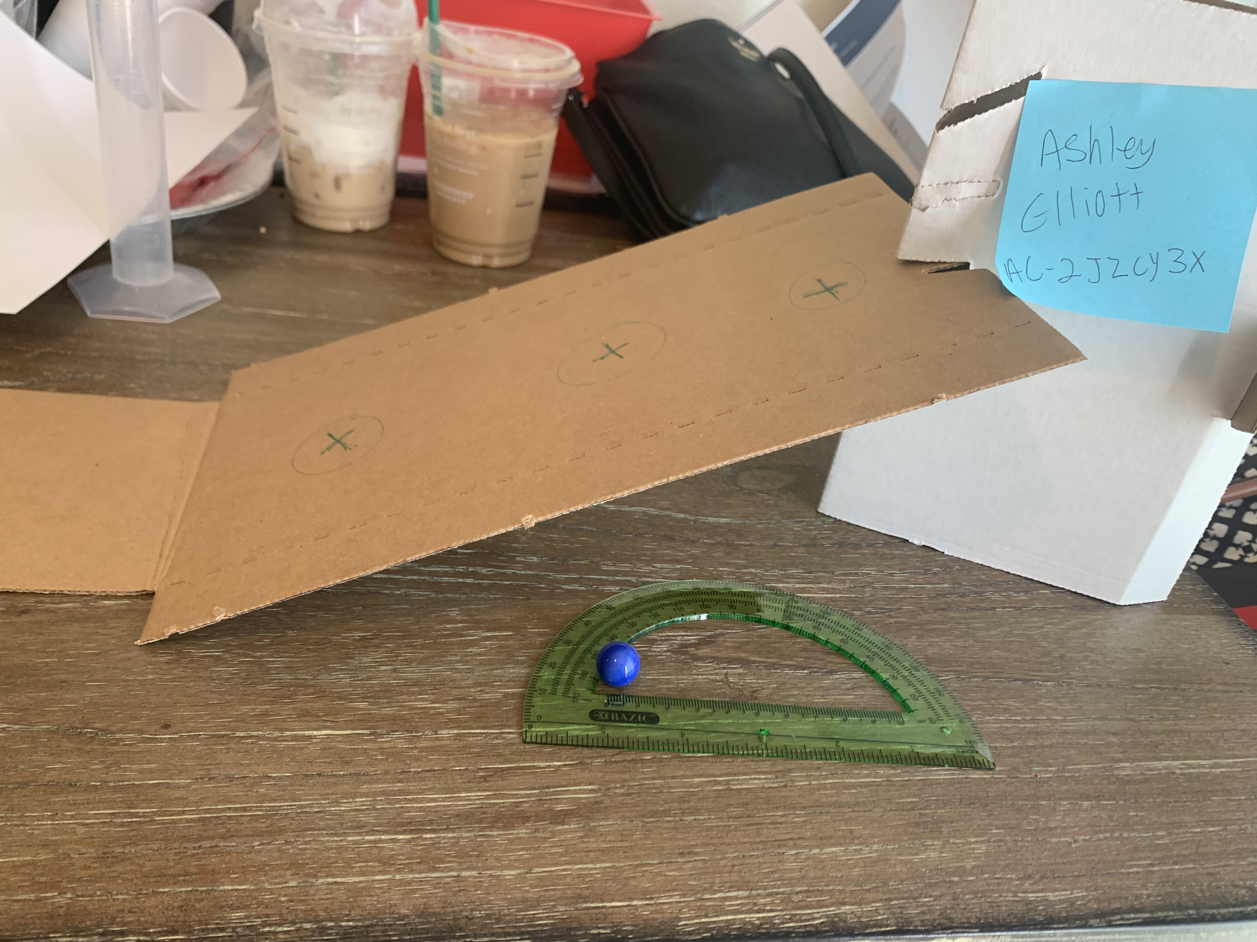

**EXPERIMENT 3: SQUEEZE ROCKETTM PROJECTILES**

Data Table

Table 5. Projectile Data for Rockets with Different Launch Angles

|  |  |  |  |  |  |  |  |
| --- | --- | --- | --- | --- | --- | --- | --- |
| **Launch Velocity**  **(m/s)** | **Initial Angle** | **Time (s)** | **Average Time (s)** | **Predicted Range (m)** | **Actual Range (m)** | **Average**  **Range (m)** | **Range**  **% Error** |
| **1.8 m.s** | **90 °** | **1.20** | **1.695** | **0 m** | **0** | **0** | **0** |
| **1.8 m.s** | **90 °** | **1.72** | **0 m** | **0** | **0** |
| **1.8 m.s** | **90 °** | **1.96** | **0 m** | **0** | **0** |
| **1.8 m.s** | **90 °** | **1.90** | **0 m** | **0** | **0** |
| **Launch Velocity**  **(m/s)** | **Initial Angle** | **Time (s)** |  | **Predicted Range (m)** | **Actual Range (m)** |  | **Range**  **% Error** |
| **1.8 m.s** | **45 degrees** | **1.50** | **1.563** | **3.0** | **1.90** | **1.975** | **57.9%** |
| **1.8 m.s** | **45 degrees** | **1.75** | **3.0** | **2.20** | **36.4%** |
| **1.8 m.s** | **45 degrees** | **1.50** | **3.0** | **1.90** | **57.9%** |
| **1.8 m.s** | **45 degrees** | **1.50** | **3.0** | **2.00** | **50%** |
| **Launch Velocity**  **(m/s)** | **Initial Angle** | **Time (s)** |  | **Predicted Range (m)** | **Actual Range (m)** |  | **Range**  **% Error** |
| **1.8 m.s** | **30 degrees** | **1.55** | **1.643** | **2.5** | **1.35** | **1.483** | **85.19%** |
| **1.8 m.s** | **30 degrees** | **1.62** | **2.5** | **1.64** | **58.54%** |
| **1.8 m.s** | **30 degrees** | **1.69** | **2.5** | **1.52** | **64.47%** |
| **1.8 m.s** | **30 degrees** | **1.71** | **2.5** | **1.42** | **76.06%** |
| **Launch Velocity**  **(m/s)** | **Initial Angle** | **Time (s)** |  | **Predicted Range (m)** | **Actual Range (m)** |  | **Range**  **% Error** |
| **1.8 m.s** | **25 degrees** | **1.55** | **1.508** | **.25** | **1.0** | **1.135** | **75%** |
| **1.8 m.s** | **25 degrees** | **1.47** | **.25** | **1.15** | **78%** |
| **1.8 m.s** | **25 degrees** | **1.60** | **.25** | **1.20** | **79.17%** |
| **1.8 m.s** | **25 degrees** | **1.41** | **.25** | **1.19** | **78.99%** |

## Post-Lab Questions

1. Which angle provides the greatest range? Which provides the least? Based on your results, which angle should give the greatest range for projectile motion?

**The 45-degree angle provided the greatest range. The 90-degree angle provided the least amount or range. I believe the 45-degree angle would provide the greatest range for projectile motion based on my experimental results. Even taking user error into effect it is clear the 45-degree angle shot the projectiles the farthest.**

1. What role does air resistance play in affecting your data?

**The rockets were very light and made of a foam material so the air affected them causing them to lose speed instantly, this can cause misleading data because of the air resistance causing drag.**

1. Discuss any additional sources of error, and suggest how these errors could be reduced if you were to redesign the experiment.

**Human error is one of the biggest contributing factors based on this type of experiment. It is impossible to use the stopwatch perfectly every time and stop and start at exactly the right time every time. Having multiple people use the stopwatch to start and stop the time and then calculate the error I think could help limit the amount of error or at least calculate better what the results are. Another potential source or errors is i noticed it was difficult to used the exact same pressure every single time when squeezing the bulb.**

1. How could kickers on a football team use their knowledge of physics to better their game? List at least two other examples in sports or other applications where this information would be important or useful.  
   **Football and soccer are two different sports that could benefit from actually using opposite techniques based on where they need their respective ball to go and how far. Both balls would start on the ground in the same position for a soccer player as well as the kicker for a football team. A soccer player’s goal is a low arc because the goal box is low, so by kicking at a 45-degree angle there would be a better chance is would end up in the goal box (assuming the shot was lined up). On the other hand, a football kicker needs the ball to go farther and higher so using a 90-degree angle would help the football kicker achieve this.**